Table 1 Material list.
Chemical | Manufacturer | Molecular structure | Purity
AMPS | Guangdong Wengjiang Chemical Reagent Corp. | 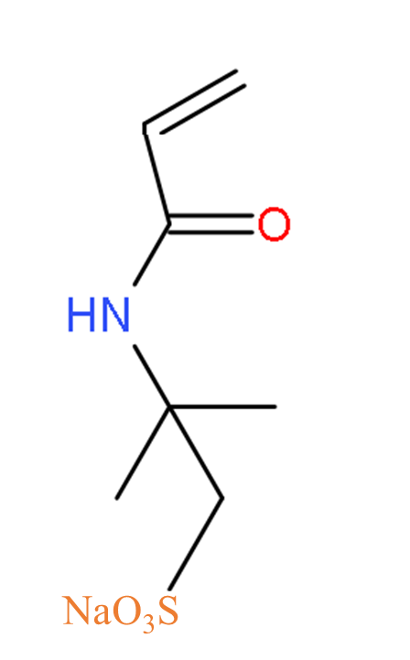 | AR
MA | Sinopharm Chemical Reagent Corp. | 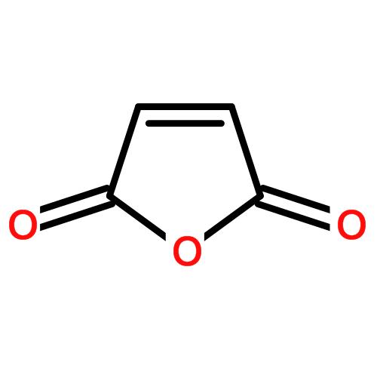 | CP
AA | Sinopharm Chemical Reagent Corp. | 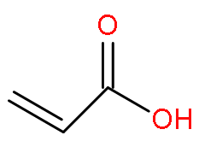 | CP
Quaternary cationics | House-made | 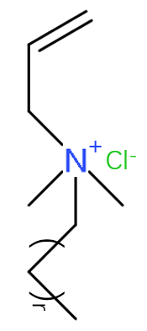 | -
sodium hydroxide | Sinopharm Chemical Reagent Corp. | NaOH | CP
sodium bisulfite | Sinopharm Chemical Reagent Corp. | NaHSO₃ | CP
ammonium peroxydisulfate | Sinopharm Chemical Reagent Corp. | (NH₄)₂S₂O₈ | CP

