Table 1. The clinical characteristics of the patients with reduced CTV2 radiotherapy
Parameter | Patients (N = 30, N%)
Sex
Male | 17（56.7%）
Femal | 13 （43.3%）
Age（20-75 year）
≤49 | 18（60.0%）
＞49 | 12 （40.0%）
T classiﬁcation
T1 | 1 （3.3%）
T2 | 8 （26.7）
T3 | 14（46.7%）
T4 | 7 （23.3%）
N classiﬁcation
N2 | 25（83.3%）
N3 | 5 （16.7%）
TNM stage
Ⅲ | 21（70.0%）
Ⅳa | 9（30.0%）
All data are presented as No. (%). Percentage values are rounded.

Table 2. The impact of gender, age, and TNM stage on the distribution pattern of cervical metastatic lymph nodes.
Parameter | χ² value | Df | P value
T stage | 23.096 | 33 | 0.900
gender | 14.604 | 11 | 0.201
Age | 13.280 | 11 | 0.280
TNM stage | 38.136 | 22 | 0.000*
Df, degree of freedom,

Table 3. Correlation analysis of each cervical lymph node levels [P(rs)]
Parameter | Ⅰb | Ⅱa | Ⅱb | Ⅲ | Ⅳa | Ⅳb | Ⅴa | Ⅴb | Ⅴc | Ⅶa | Ⅶb | Ⅷ
Ⅰb | - | 0.303  (0.072) | 0.160  (-0.098) | 0.176  (0.094) | 0.069  (0.126) | 0.782  (-0.019) | 0.004  (0.200) | 0.108  (0.111) | 0.078  (0.122) | 0.378  (0.061) | 0.782  (-0.019) | 0.694  (-0.027)
Ⅱa | 0.303  (0.072) | - | 0.220  (0.085) | 0.000  (0.276) | 0.011  (0.175) | 0.571  (0.039) | 0.062  (0.129) | 0.741  (0.023) | 0.324  (0.069) | 0.749  (0.022) | 0.571  (0.039) | 0.399  (-0.059)
Ⅱb | 0.160  (-0.098) | 0.220  (0.085) | - | 0.000  (0.380) | 0.029  (0.151) | 0.683  (0.028) | 0.020  (0.161) | 0.689  (0.028) | 0.477  (0.049) | 0.937  (-0.006) | 0.683  (0.028) | 0.563  (0.040)
Ⅲ | 0.176  (0.094) | 0.000  (0.276) | 0.000  (0.380） | - | 0.000  (0.370) | 0.316  (0.070) | 0.000  (0.429) | 0.000  (0.332) | 0.080  (0.121) | 0.170  (0.095) | 0.321  (-0.069) | 0.995  (0.000)
Ⅳa | 0.069  (0.126) | 0.011  (0.175) | 0.029  (0.151） | 0.000  (0.370) | - | 0.006  (0.188) | 0.093  (0.117) | 0.006  (0.190) | 0.003  (0.203) | 0.019  (0.162) | 0.713  (-0.026) | 0.097  (0.115)
Ⅳb | 0.782  (-0.019) | 0.571  (0.039) | 0.683  (0.028） | 0.316  (0.070) | 0.006  (0.188) | - | 0.037  (0.145) | 0.000  (0.309) | 0.904  (-0.008) | 0.442  (0.054) | 0.945  (-0.005) | 0.922  (-0.007)
Ⅴa | 0.004  (0.200) | 0.062  (0.129) | 0.020  (0.161） | 0.000  (0.309) | 0.000  (0.429) | 0.037  (0.145) | - | 0.000  (0.410) | 0.032  (0.149) | 0.000  (0.268) | 0.037  (0.145) | 0.003  (0.205)
Ⅴb | 0.108  (0.111) | 0.741  (0.023) | 0.689  (0.028） | 0.050  (0.136) | 0.000  (0.332) | 0.000  (0.309) | 0.000  (0.410) | - | 0.000  (0.350) | 0.068  (0.127) | 0.823  (-0.016) | 0.751  (-0.022)
Ⅴc | 0.078  (0.122) | 0.324  (0.069) | 0.477  (0.049） | 0.080  (0.121) | 0.003  (0.203) | 0.904  (-0.008) | 0.032  (0.149) | 0.000  (0.350) | - | 0.180  (0.093) | 0.904  (-0.008) | 0.865  (-0.012)
Ⅶa | 0.378  (0.061) | 0.749  (0.022) | 0.937  (-0.006） | 0.170  (0.095) | 0.019  (0.162) | 0.442  (0.054) | 0.000  (0.268) | 0.068  (0.127) | 0.180  (0.093) | - | 0.442  (0.054) | 0.275  (-0.019)
Ⅶb | 0.782  (-0.019) | 0.571  (0.039) | 0.683  (0.028） | 0.321  (-0.069) | 0.713  (-0.026) | 0.945  (-0.005) | 0.037  (0.145) | 0.823  (-0.016) | 0.904  (-0.008) | 0.442  (0.054) | - | 0.922  (-0.007)
Ⅷ | 0.694  (-0.027) | 0.399  (-0.059) | 0.563  (0.040） | 0.995  (0.000) | 0.097  (0.115) | 0.922  (-0.007) | 0.003  (0.205) | 0.751  (-0.022) | 0.865  (-0.012) | 0.275  (0.076) | 0.922  (-0.007) | -
Table Note: rs is the correlation coefficient, and the range of rs by Spearman correlation analysis is: [-1,1], the larger the absolute value, the stronger the correlation. When rs was positive, a positive correlation was considered. When rs is negative, a negative correlation is considered.

Table 4. Dosimetric comparison of tumor targets between conventional radiotherapy group and reduced CTV2 radiotherapy group.
Parameter | conventional radiotherapy group | reduced CTV2 radiotherapy group | P value
GTVnx
V93%（%） | 0.13 (0.01，0.63) | 0.09 (0.01，1.02) | 0.170
V100%（%） | 4.02±1.16 | 4.07±1.31 | 0.586
V110%（%） | 0.01 (0.00，0.21） | 0.01 (0.00，0.36) | 0.900
V115%（%） | 0 | 0 | 0.317
D95（Gy） | 70.06±0.38 | 70.13±0.55 | 0.601
V（cm3） | 83.21±47.19 | 84.36±47.06 | 0.289
Dmin（Gy） | 58.52±7.65 | 58.71±8.86 | 0.940
Dmax（Gy） | 77.04 (76.02，78.31） | 76.77 (75.17，79.13) | 0.940
Dmean（Gy） | 72.40±1.09 | 72.32±0.86 | 0.823
HI | 1.06±0.02 | 1.06±0.02 | 0.765
CI | 0.55±0.14 | 0.64±0.22 | 0.191
GTVnd
D95（Gy） | 67.68±2.42 | 66.65±1.53 | 0.165
V（cm3） | 64.96±51.13 | 59.06±40.91 | 0.501
Dmin（Gy） | 59.74±6.52 | 58.11±7.52 | 0.154
Dmax（Gy） | 75.54±3.01 | 72.46±7.70 | 0.115
Dmean（Gy） | 69.99±2.21 | 68.84±1.93 | 0.137
HI | 1.07±0.03 | 1.06±0.03 | 0.709
CI | 0.15±0.09 | 0.18±0.12 | 0.174
CTV1
V95%（%） | 3.10±1.68 | 3.26±1.76 | 0.654
D95（Gy） | 61.32±1.31 | 60.98±1.19 | 0.218
V（cm3） | 411.00±209.22 | 427.32±222.44 | 0.904
Dmin（Gy） | 41.68 (29.59，48.27) | 44.04 (37.84，47.35) | 0.145
Dmax（Gy） | 76.70±2.36 | 77.87±2.47 | 0.093
Dmean（Gy） | 67.14±1.69 | 67.66±1.64 | 0.140
HI | 1.20±0.02 | 1.20±0.04 | 0.765
CI | 0.92±1.03 | 0.65±.01 | 0.057
CTV2
V95%（%） | 2.97±1.70 | 2.52±1.73 | 0.490
D95（Gy） | 54.92±1.40 | 55.84±2.72 | 0.478
V（cm3） | 273.20±255.90 | 272.82±241.70 | 0.502
Dmin（Gy） | 47.44 (33.29，49.33) | 46.23 (39.70，49.43) | 0.737
Dmax（Gy） | 69.41 (65.99，76.51) | 71.96 (64.93，76.44) | 0.601
Dmean（Gy） | 59.05±3.07 | 59.42±5.31 | 0.654
HI | 1.18±0.10 | 1.19±0.11 | 0.526
CI | 0.29±0.28 | 0.38±0.41 | 0.279
Note: GTVnx, gross tumor volumes of the nasopharynx. GTVnd, gross tumor volumes of the lymph nodes. CTV, clinical target volume. The measurement data follows a normal distribution with the mean and standard deviation (𝑥 ̅ + s). The measurement data that deviated from the normal distribution were represented by their median and interquartile range [M (QL, QU)]. Percentage values are rounded. V93, V100, V110 and V115 mean percentage of volume receiving > 93, 100, 110 and 115 Gy radiation. D95 means the radiation dose received by 95% of the irradiated volume. Dmax, Dmean and Dmin mean maximum, minimum and mean dose to the targets, respectively. Conformity Index^{[1]}, CI=(PTV_{ref}/V_{PTV}) × (PTV_{ref}/V_{95%}). PTV_{ref} represents the volume of the planning target volume receiving 95% of the prescribed dose, while V_{PTV} denotes the total PTV volume and V_{95%} refers to the volume encompassed by 95% isodose coverage in the entire body. A higher conformity index (CI) value closer to 1, indicates better agreement between planned and delivered dose. Homogeneity Index, HI^{[2]}. HI=D_{5%}/D_{95%}. The D_{5%} and D_{95%} represent the dose received by 5% and 95% of the planning target volume (PTV), respectively. An ideal homogeneity index (HI) value is 1, which increases with plan inhomogeneity.

Table 5. Dosimetric comparison of organs at risk between conventional radiotherapy group and reduced CTV2 radiotherapy group.
Parameter | Conventional radiotherapy group | Reduced CTV2 radiotherapy group | Conventional-reduced CTV2 group  (Difference, %) | P value
Oral cavity (cm³) | 99.47±21.10
Dmax（Gy） | 71±56.91 | 70.07±3.76 | 0.93，1.31% | 0.192
Dmin （Gy） | 18.79±3.46 | 15.28±2.13 | 3.51，18.68% | 0.000
Dmean（Gy） | 37.25±2.06 | 30.56±2.25 | 6.69，17.95% | 0.000
V30（%） | 68.62±16.03 | 36.84±6.64 | 31.78，46.31% | 0.000
V40（%） | 26.92±7.32 | 16.25±4.32 | 10.66，39.60% | 0.000
V50（%） | 13.25±6.07 | 8.55±4.42 | 4.69，35.39% | 0.000
V60（%） | 5.56±4.23 | 3.00±2.18 | 2.55，45.86% | 0.000
Laryngeal cavity (cm³) | 37.33±12.62
Dmax（Gy） | 59.44±5.46 | 45.80±5.56 | 13.63，22.93% | 0.000
Dmin （Gy） | 25.17±4.73 | 19.50±4.40 | 5.66，22.48% | 0.000
Dmean（Gy） | 36.80±3.02 | 28.54±2.84 | 8.25，22.41% | 0.000
V30（%） | 86.60±14.80 | 39.84±17.83 | 46.76，53.99% | 0.000
V40（%） | 22.9(17.64,33.05) | 3.54(0.24,6.82) | 19.36，84.5% | 0.000
V50（%） | 4.01(1.26，7.95) | 0（0,0.01） | 4.01，100% | 0.000
V60（%） | 0.24(0.0.93) | 0(0,0) | 0.24，100% | 0.001
Esophagus (cm³) | 9.77±1.74
Dmax（Gy） | 55.20±7.67 | 41.14±7.95 | 14.06，25.47% | 0.000
Dmin （Gy） | 3.66（1.41,9.23） | 1.8（1.25,4.56） | 1.86，50.81% | 0.024
Dmean（Gy） | 30.13±7.11 | 20.66±6.04 | 9.47，31.43% | 0.000
V30（%） | 57.52±18.86 | 30.39±21.99 | 27.13，47.16% | 0.000
V40（%） | 19.11(5.81,38.27) | 0.61(0,5.10) | 18.5，96.80% | 0.001
V50（%） | 1.33(0.07,9.81) | 0(0,0) | 1.33，100% | 0.001
V60（%） | 0(0,0.24) | 0(0,0.0) | 0，0 | /
Trachea (cm³) | 26.31±1.28
Dmax（Gy） | 54.08±6.60 | 40.97±8.02 | 13.11，24.24% | 0.000
Dmin （Gy） | 4.01(1.96,9.69) | 2.6(1.24,5.40) | 1.41，35.16% | 0.026
Dmean（Gy） | 31.00±8.00 | 20.70±7.01 | 9.30，30.00% | 0.000
V30（%） | 59.81±20.90 | 30.24±25.27 | 29.57，49.43% | 0.000
V40（%） | 18.69(4.44,45.65) | 0(0,2.70) | 18.69，100% | 0.000
V50（%） | 1.47(0.01,8.32) | 0(0,0) | 1.47，100% | 0.000
V60（%） | 0(0,0) | 0（0,0） | 0,0 | /
Upper pharyngeal constrictor (cm³) | 9.31±0.57
Dmax（Gy） | 75.39(72.67,76.49) | 74.58(72.59,75.86) | 0.81,1.07% | 0.617
Dmin （Gy） | 36.36±5.55 | 34.44±4.02 | 1.92,5.28% | 0.177
Dmean（Gy） | 59.61±4.56 | 57.03±3.37 | 2.58, 4.33% | 0.002
V30（%） | 100(100,100) | 100(100,100) | 0,0% | /
V40（%） | 96.52(88.31,99.66) | 90.21(83.34,93.66) | 6.31,6.54% | 0.006
V50（%） | 78.00±14.42 | 68.32±18.59 | 9.68,12.41% | 0.007
V60（%） | 55.68±22.12 | 43.89±19.21 | 11.79,20.80% | 0.005
Middle pharyngeal constrictor (cm³) | 3.63±0.16
Dmax（Gy） | 60.32±6.19 | 57.56±6.97 | 2.76,4.57% | 0.058
Dmin （Gy） | 32.22±4.63 | 28.22±5.05 | 4.00,12.41% | 0.000
Dmean（Gy） | 42.02±4.66 | 36.99±4.59 | 5.03,11.97% | 0.000
V30（%） | 100(100,100) | 92.03(78.24,100) | 7.70,7.70% | 0.002
V40（%） | 53.20±24.13 | 30.61±19.16 | 23.19,43.59% | 0.000
V50（%） | 10.57(3.84,29.38) | 4.64(0.94,11.17) | 5.93,56.10% | 0.003
V60（%） | 0(0,3.49) | 0(0,0.49) | 0 | /
Low pharyngeal constrictor (cm³) | 4.68±0.30
Dmax（Gy） | 57.12±6.61 | 42.07±5.87 | 15.05，26.34% | 0.000
Dmin （Gy） | 31.45±6.11 | 23.48±6.17 | 7.97，25.34% | 0.000
Dmean（Gy） | 39.30±5.11 | 30.28±5.26 | 9.02，22.95% | 0.000
V30（%） | 100(93.05,100) | 64.73(18.64,88.85) | 35.27，35.27% | 0.000
V40（%） | 41.78±26.95 | 3.39±6.28 | 38.39，91.88% | 0.000
V50（%） | 4.67(0.57,13.80) | 0(0,0) | 4.67，100% | 0.000
V60（%） | 0(0,0.64) | 0(0,0) | 0，0 | /
Parotid gland (cm³) | 57.92±4.37
Dmax（Gy） | 71.37±4.15 | 68.63±5.15 | 2.74，3.84% | 0.000
Dmin （Gy） | 11.45±2.80 | 10.97±3.51 | 0.45，4.19% | 0.459
Dmean（Gy） | 36.90±3.89 | 29.75±4.06 | 7.15,19.38% | 0.000
V30（%） | 54.25±10.32 | 38.65±12.09 | 8.34,28.31% | 0.000
V40（%） | 29.46±9.87 | 24.12±10.78 | 5.34,18.13% | 0.000
V50（%） | 27.87±11.01 | 13.88±8.47 | 13.99,50.19% | 0.000
V60（%） | 15.97±10.87 | 6.03±6.12 | 9.94,62.24% | 0.000
Parotid gland (cm³) | 13.75±0.92
Dmax（Gy） | 63.34±4.24 | 56.02±5.99 | 7.32，11.56% | 0.000
Dmin （Gy） | 27.22±7.31 | 23.17±8.64 | 4.05，14.88% | 0.000
Dmean（Gy） | 47.59±6.83 | 36.88±7.49 | 10.71，22.50% | 0.000
V30（%） | 99.31(91.59,100) | 92.55 (57.86,99.87) | 10.89，10.97% | 0.000
V40（%） | 75.57±22.43 | 39.91±25.35 | 35.66，47.19% | 0.000
V50（%） | 50.57±23.77 | 10.28±11.62 | 40.29，79.67% | 0.003
V60（%） | 3.92(0,14.62) | 0（0,0.02） | 3.92，100% | 0.000
Submandibular gland (cm³) | 16.11±0.93
Dmax（Gy） | 69.17±4.83 | 65.18±4.84 | 3.99,5.77% | 0.000
Dmin （Gy） | 37.52(34.42,44.47) | 32.94(26.25,35.39) | 4.58,12.21% | 0.000
Dmean（Gy） | 56.56±5.49 | 47.31±6.40 | 9.25,16.35% | 0.000
V30（%） | 100(100,100) | 100(95.32,100) | 0,0% | /
V40（%） | 98.89(93.89,100) | 82.18(62.03,92.46) | 16.71,16.90% | 0.000
V50（%） | 77.15±18.47 | 42.28±20.05 | 34.87,45.20% | 0.000
V60（%） | 29.83(11.80,62.88) | 10.07(1.28,21.66) | 19.76,66.24% | 0.000
Note: The measurement data follows a normal distribution with the mean and standard deviation (𝑥 ̅ + s). The measurement data that deviated from the normal distribution were represented by their median and interquartile range [M (QL, QU)]. Percentage values are rounded.

Table 6：Anatomical boundaries of organs at risk.
Organ | Cranial | Caudal | Anterior | Posterior | Lateral | Medial
Oral cavity^{b} | Post. edge of the hard palate or soft palate | Disappearance of anterior belly of digastric muscle | Post. edge of mandible or is free | Palate, oropharynx, the palatine tonsil, hyoid bone | Med. edge of the mandible or inferior alveoli socket
Larynx | Cranial edge of epiglottis | Caudal edge of cricoid cartilage | Ant. edge of thyroid cartilage or cricoid cartilage | Including arytenoid cartilage, the superior and inferior horns of thyroid cartilage and post. edge of pharyngeal constrictor | Med. edge of hyoid bone, lat. edge of thyroid cartilage and cricoid cartilage， cervical vessels, nerves, and lateral thyroid
Upper pharyngeal constrictor | Caudal edge of pterygoid plates | Cranial edge of hyoid bone | Nasopharynx, oropharynx, laryngopharynx, base of tongue | Longus capitis m., longus colli m., body of cervical vertebra | Carotid sheath
Middle pharyngeal constrictor | Cranial edge of hyoid bone | Caudal edge of hyoid bone | Laryngopharynx | Longus capitis m., longus colli m., body of cervical vertebra | Hyoid bone
Inferior pharyngeal constrictor | Caudal edge of hyoid bone | Caudal edge of cricoid cartilage | Laryngopharynx or cricoids cartilage | Longus capitis m., longus colli m., body of cervical vertebra | Thyroid cartilage or thyroid gland
Trachea | Caudal edge of cricoid cartilage | Two centimeters below the caudal edge of the clavicular head | Post. edge of isthmus of thyroid gland | Ant. edge of esophagus | Lateral thyroid gland | One-two millimeters expanded from the lumen of trachea
Submandibular glandª | Inferior edge of medial pterygoid or the level of C3 | Appearance of fat space of submandibular triangle | surface of mylohyoid m. or hyoglossus m. | Parapharyngeal space, cervical vessels and post. belly of digastric m., sternocleidomastoid m. | Ramus of the mandible, subcutaneous fat or platysma | Cervical vessels, superior and middle pharyngeal constrictor m., hyoid bone, post. belly of the digastric m., mylohyoid m. or hyoglossus m.
Esophagus | Caudal edge of cricoid cartilage | Two centimeters below the caudal edge of the clavicular head | Trachea | Vertebral body or longus colli m. | Fat space or thyroid gland
Parotid glandª | External auditory canal, mastoid process | Appearance post. part submandibular space | Masseter m. post. border mandibular bone, medial pterygoid m. | Ant. belly sternocleidomastoid m., lat. side post. belly of the digastric m. (posterior medial), mastoid process | Submandibular fat, platysma | Post. belly of the digastric m., styloid process, parapharyngeal space， sternocleidomastoid
Thyroid glandª | Caudal edge of pyriform sinus or midpoint of thyroid cartilage | Body of fifth to seventh cervical vertebra | Sternohyoid or sternocleidomastoid | Cervical vessels or longus colli m. | Cervical vessels or sternocleidomastoid | Thyroid cartilage or cricoids cartilage or esophagus or pharyngeal constrictor
Abbreviations: TMJ, temporomandibular joint; ET, Eustachian tube; IAC, internal auditory canal; m., muscle.
a: The organs should be divided into left and right, and the standard TPS name of laterality is indicated by appending an underscore character (_), followed by L or R, respectively. For example, the left parotid is named Parotid_L. the right parotid is named Parotid_R.
b: includes the base of the tongue, body of tongue and mouth floor.

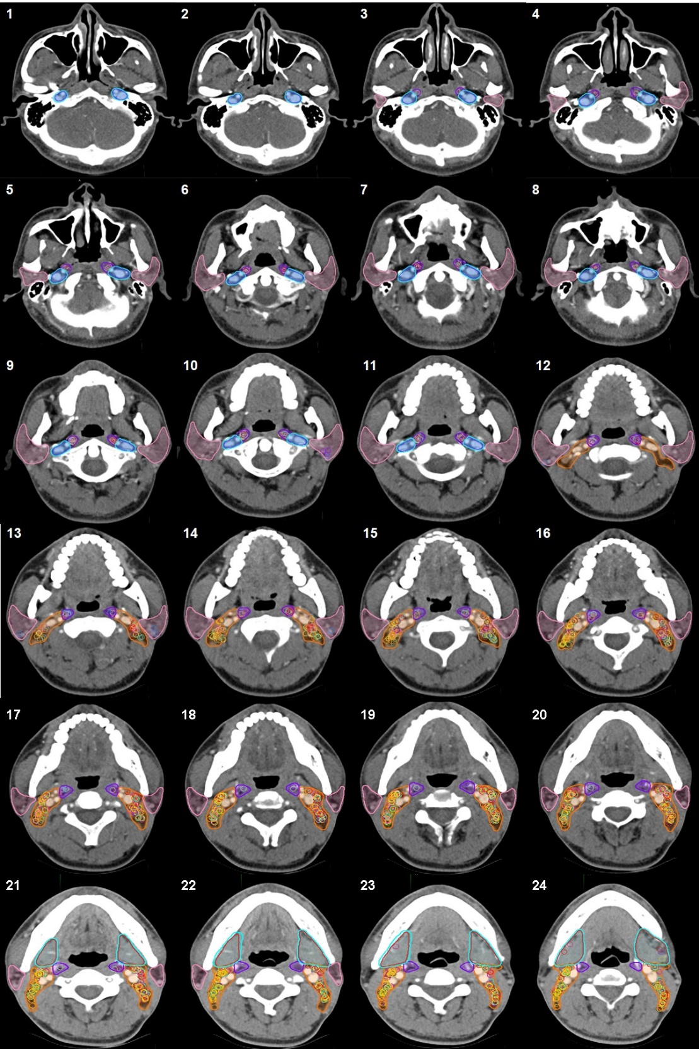
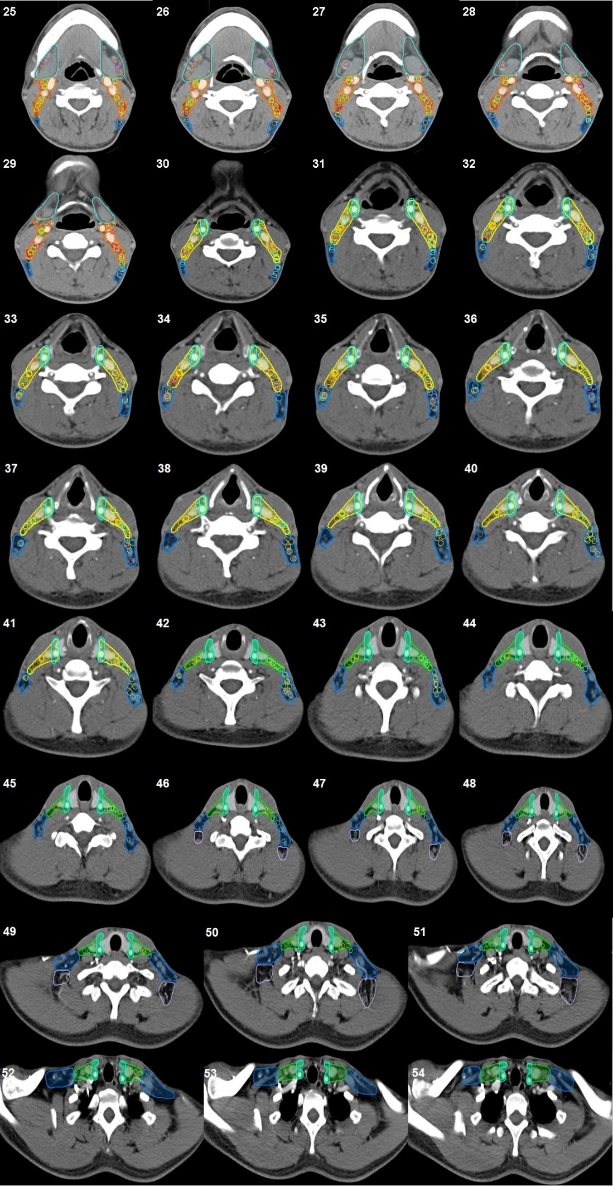
Figure A. Detail distribution patterns of cervical lymph nodes in each level
Red area: lymphatic drainage region in level Ib. Orange area: lymphatic drainage region in level II. Yellow area: lymphatic drainage region in level III. Green area: lymphatic drainage region in level Via. Blue area: lymphatic drainage region in level V. Purple area: Lymphatic drainage region in level VII. Pink area: lymphatic drainage region in level VIII. Colored circles represent metastatic lymph nodes for each patient. The light green areas pointed by the red arrows are the target reduction areas in figures 1,21,25,33 and 45. In this study, the radiation field was inevitably extended to include the part of level VIIb due to extensive invasion of the primary nasopharyngeal lesion. Induction chemotherapy can be considered as a potential strategy for tumor volume reduction.

References
1. Feuvret L, Noel G, Mazeron JJ, Bey P. Conformity index: a review. Int J Radiat Oncol Biol Phys. 2006;64(2):333-42.
2. Semenenko VA, Reitz B, Day E, Qi XS, Miften M, Li XA. Evaluation of a commercial biologically based IMRT treatment planning system. Med Phys. 2008;35(12):5851-60.

