Supporting Information

RuSiNPs@N,S-GQDs as self-enhanced anodic electrochemiluminescent immunobeacons for the highly sensitive quantitation of okadaic acid in shellfish

Silun Li^{1, a}, Jiawei Peng^{1, a, b, c}, Xueying Linª, Jing Chenª, Yanfang Wu^{d}, Quansheng Chenª, Xiaomei Chen^{a∗}
ªCollege of Ocean Food and Biological Engineering, Jimei University, Xiamen, 361021, China
^{b}National Engineering Research Center for Nanotechnology, Shanghai, 200241, China
^{c}Guoke Ningbo Life Science and Health Industry Research Institute, Zhejiang, 315000, China
^{d}School of Chemistry, The University of New South Wales, Sydney, New South Wales 2052, Australia

Supplementary materials

1. Experimental details
1.1 Reagents
1-ethyl-(3-dimethylaminopropyl) carbodiimide hydrochloride (EDC), N-hydroxysuccinimide (NHS), tetrachloroauric acid, and 3-(N-morpholine) propanesulfonic acid (MOPS) were obtained from Maclean Biochemical Co., Ltd., Shanghai. Okadaic acid (OA), bovine serum albumin (BSA), tris (2,2,-bipyridine) ruthenium hexahydrate chloride, Triton X-100, tetraethoxysilane (TEOS), and Tween-20 were purchased from Shanghai Sigma-Aldrich Co., Ltd. Sodium hydroxide, cyclohexane, n-hexanol, 25% ammonia water, and acetone were purchased from Guangdong Xilong Chemical Co., Ltd. Multi-walled carbon nanotubes (>95% purity, 0.5-3.0 µm in length, and 10-20 nm in diameter) were purchased from Suzhou Tanfeng Graphene Technology Co., Ltd. High-purity graphitic carbon rods were obtained from Wuhan Gaoshi Ruilian Technology Co., Ltd. Monoclonal antibodies (anti-OA-MAb) and standard shellfish tissue samples (CRM-DSP-Mus-c) for OA were purchased from Beijing Puhuashi Technology Development Co., Ltd.
1.2 Apparatus
The as-synthesized N,S-GQDs were characterized by transmission electron microscopy (TEM) (JEOL JEM-2100, Japan), dynamic light scattering (DLS) (Malvern Instrument Ltd., UK), X-ray photoelectron spectroscopy (XPS, EscaLab-250Xi, Thermo Fisher Scientific, USA), UV-Vis absorption spectrophotometer (PerkinElmer-Lambda265, USA), and fluorescence spectrometer (PerkinElmer-LS55, USA). The electrochemical (including electrochemical impedance spectroscopy (EIS) and cyclic voltammetry (CV)) and ECL tests were performed with an Autolab electrochemical workstation (PGSTAT302N, Switzerland), an electrochemical workstation (CHI660E, Shanghai Chenhua Instrument Co., Ltd.), and an MPI-A ECL analyzer (Remax Electronic Science & Technology Co., Ltd., China).
1.3 Synthesis of RuSiNPs
RuSiNPs were synthesized according to the lit erature [1]. In brief, 60 µL NH₄OH (25wt%) was added into a mixture of TX-100 (1.77 mL), cyclohexane (7.5 mL), n-hexanol (1.8 mL), 0.1 mol L⁻¹ Ru(bpy)₃²⁺ (80 µL), tetraethylorthosilicate (TEOS, 100 µL), water (340 µL), and stirred at room temperature. After 24 h, the generated precipitate was isolated with acetone, sonicated for 10 min, followed by centrifuging and washing with absolute ethanol and water several times to obtain orange RuSiNPs.
1.4 Electrochemical preparation of N,S-GQDs
In this study, novel N,S-GQDs were obtained by the simple single-step electrolysis of high-purity graphitic carbon rods in a MOPS (3-(N-morpholino)propanesulfonic acid) (0.2 mol L⁻¹) solution containing NaOH (2 mol L⁻¹). Here, MOPS served as both the source and the electrolyte of N and S, and no additional substances were required for elemental doping, thus simplifying the experimental procedure. The synthetic procedure was as follows. First, 20 mL of MOPS aqueous solution and 20 mL of NaOH solution were added to the electrolytic cell. In this experimental setup, we employed platinum foils arranged in parallel as the counter electrodes, while the working electrodes consisted of graphite rods. Electrolysis of the samples lasted for 6 h, with a constant voltage of 5 V applied throughout the process. Following the reaction, the solution underwent filtration consecutively three times via a syringe filter with a 220 nm pore size. Subsequently, the solution was subjected to dialysis for 48 h using a dialysis bag with a molecular weight cut-off of 3500 Da. For comparison, undoped GQDs were synthesized using an equal volume of water instead of MOPS and the remaining conditions were unchanged.
1.5 Synthesis of CMCNT-PDDA-AuNCs
CMCNT was initially coated with PDDA, according to a previous report [2]. Briefly, 5 mg of CMCNT was mixed with 10 mL of a 0.25% PDDA solution containing 0.5 M NaCl, followed by sonication of the mixture for 30 min to obtain a homogeneous black suspension. Subsequently, the complex was centrifuged and rinsed with water three times to remove the excess PDDA. Finally, 5 µL of 1 mg mL⁻¹ CMCNT-PDDA was cast onto a polished glassy carbon electrode (GCE) and then dried at room temperature (RT, 25 °C).
AuNCs (using BSA as the template) were produced as described in previous reports [3], with some modifications. The as-synthesized AuNCs were immobilized on the CMCNT-PDDA/GCE by immersing the electrode in the AuNCs suspension and incubating for 30 min. Subsequently, the CMCNT-PDDA-AuNCs/GCE was rinsed with pure water and dried in N₂ atmosphere.
1.6 Immobilization of OA on modified electrodes
A carboxylated multiwall carbon nanotube-PDDA chloride-Au nanocluster (CMCNT-PDDA-AuNCs) composite was prepared and then modified on the electrode. Afterward, the carboxyl group-containing OA was affixed to the electrodes following a traditional amidation reaction [4]. To elaborate, the CMCNT-PDDA-AuNCs/GCE went through an immersion phase within a solution that consisted of activated OA, ethanolamine solution, and BSA (bovine serum albumin; 100 µL, 1 wt%) for a duration of 1 hour for each component. Post each step, the electrode went through a PBS rinse (10 mmol L⁻¹) to eliminate any excessive residue. Subsequently, the modified electrode was dried and placed in storage at 4 °C, to be accessed at a later time for its intended purpose.
1.7 Preparation of immunoprobes
RuSiNPs@N,S-GQDs were directly coupled to anti-OA-Mab by an amide reaction: 200 µL of RuSiNPs@N,S-GQDs was dispersed in 500 µL of a mixture of EDC (50 mmol L⁻¹) and NHS (25 mmol L⁻¹) at 25 °C for 30 min, followed by the addition of 500 µL of anti-OA-MAb (diluted at 1:1000, 1:1500, and 1:2000 in phosphate-buffered saline (PBS; pH 7.4, 10 mmol L⁻¹), respectively). After incubation for 2 h, the mixture was centrifuged and rinsed three times with PBS to remove the residue not involved in the coupling, and the resulting precipitate was resuspended in 200 µL of PBS. The resultant probe RuSiNPs@N,S-GQDs-Ab was stored at 4 °C.
1.8 Actual sample handling
Uncontaminated razor clam (Solen gouldi) samples and quality control standards (CRM-DSP-Mus-c) containing 1.07 mg kg⁻¹ OA, 1.07 mg kg⁻¹ dinophysistoxin-1 (DTX-1), and 0.86 mg kg⁻¹ dinophysistoxin-2 (DTX-2) toxins were processed using the same methodology as reported previously [5].
2. Results and discussions
2.1 Characterization of CMCNT-PDDA-AuNCs/GCE
Fig. S1
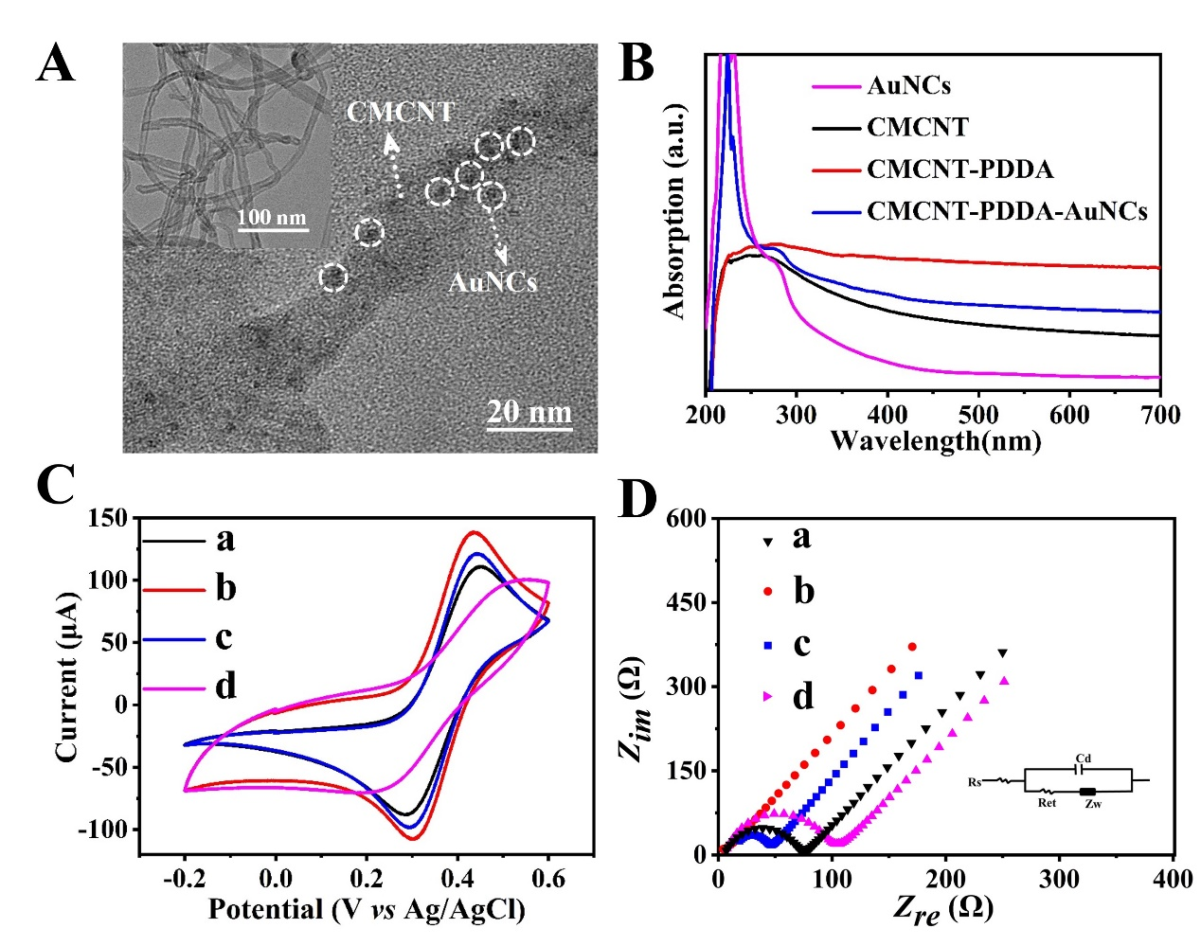
Fig. S1 (A) The TEM image of CMCNT-PDDA-AuNCs. The inset displays the TEM image of CMCNT-PDDA. (B) UV-vis absorption spectra of AuNCs, CMCNT, CMCNT-PDDA, and CMCNT-PDDA-AuNCs. (C) CVs (within -0.2 to 0.6 V at a scan rate of 25 mV/s) and (D) corresponding EIS results of bare GCE (a), CMCNT-PDDA/GCE (b), CMCNT-PDDA-AuNCs/GCE (c) and OA-CMCNT-PDDA-AuNCs/GCE (d) in a 5.0 mmol L⁻¹ [Fe(CN)₆]^{3-/4-} solution containing 1.0 mol L⁻¹ KCl.

2.2 Optimization of experimental conditions
To obtain the best analytical performance of the immunosensor, we optimized the pH of the PBS buffer, the incubation temperature and time of the modified electrode with the RuSiNPs@N,S-GQDs-Ab probe solution, the quantity of CMCNT-PDDA-AuNCs, and dilution with anti-OA-MAb and RuSiNPs@N,S-GQDs-Ab.
As shown in Fig. S2A, the increase in the ECL intensity was not significant when the incubation temperature of the modified electrode with the RuSiNPs@N,S-GQDs-Ab solution exceeded 37 °C; therefore, 37 °C was designated as the optimal incubation temperature. As shown in Fig. S2B reveals that when the quantity of CMCNT-PDDA-AuNCs at the modified electrode surpassed 10 µL, the ECL intensity increased insignificantly; therefore, 10 µL was designated as the optimal quantity. As shown in Fig. S2C, the ECL intensity increased with the increase in the pH of the test system, reaching a maximum at pH 8.0 as a result of the combined effect of pH on RuSiNPs consumption and N,S-GQDs protonation [6, 7]. As shown in Eqs. S(4), alkaline conditions favor the deprotonation of N,S-GQDs, and, thus, enhance the ECL intensity of the RuSiNPs@N,S-GQDs system. However, excessively high pH can lead to instability and inactivation of the antibodies, resulting in a reduced ECL signal and instability of the immune system. Therefore, the optimal pH for PBS was 8.0. As shown in Fig. S2D, the increase in the ECL intensity was not significant when the incubation time of the modified electrode with the RuSiNPs@N,S-GQDs-Ab solution exceeded 50 min; therefore, 50 min was designated as the optimal incubation time.
The sensor's sensitivity and signal intensity were directly influenced by the concentration of RuSiNPs@N,S-GQD-Ab probe. Fig. S2E show the standard curves obtained at different dilution rates of anti-OA-MAb and RuSiNPs@N,S-GQDs-Ab, respectively, and the calculated IC₅₀ values of anti-OA-MAb at dilution rates of 1:1000, 1:1500, and 1:2000 were 0.83, 0.57, and 0.14 ng mL⁻¹, respectively. Thus, the corresponding IC₅₀ decreases with the increase in the degree of dilution because antibodies are proteins, and an increase in antibody concentration (within certain limits) results in the capture of more RuSiNPs@N,S-GQDs on the electrode surface and, thus, a better ECL intensity. However, excess antibodies wrapping RuSiNPs@N,S-GQDs hinders the luminescence of RuSiNPs@N,S-GQDs and reduces the rate of electron diffusion at the electrode surface, which is not beneficial to improving the sensitivity for OA immunosensing. Therefore, 1:2000 was chosen as the optimal dilution for the anti-OA-mAb.
Table S1 shows the correlation curve parameters from Fig. S2F. The IC₅₀ values of RuSiNPs@N,S-GQDs-Ab at dilutions of 1:2, 1:5, and 1:10 were 1.31, 0.59, and 0.14 ng mL⁻¹, respectively. Assuming a 5% error, the limits of detection (LODs, corresponding to 85% antibody binding) were 0.023, 0.007, and 0.001 ng mL⁻¹, respectively. Thus, the optimal dilution ratio for RuSiNPs@N,S-GQDs-Ab was 1:10.

Fig. S2
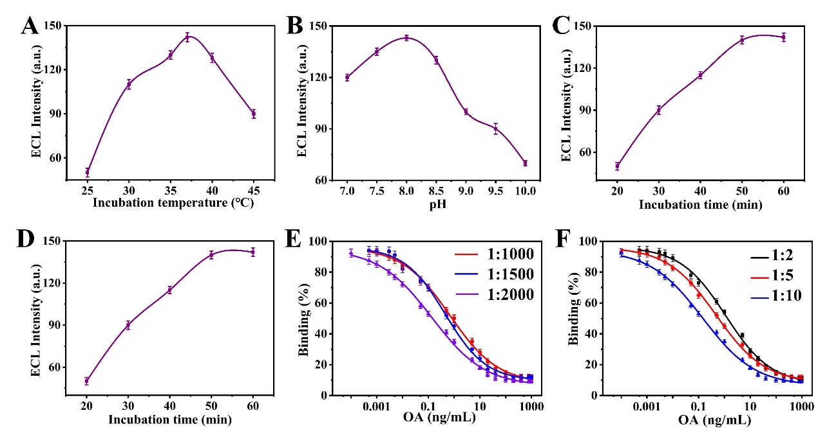
Fig. S2 (A) Effects of incubation temperature, (B)the quantity of CMCNT-PDDA-AuNCs, (C) pH value, and (D) incubation time on the ECL peak intensity of the immunosensor; (E) Effects of the dilution ratio of anti-OA-MAb and (F) RuSiNPS@N,S-GQDs-Ab on the sensing performance.

Table S1
Table S1 Curve parameters derived from the non-linear four-parameter logistic regression fitting with ECL immunosensor.
Dilution ratios of RuSiNPs@N,S-GQDs-Ab | LOD (ng mL⁻¹) | IC₅₀ (ng mL⁻¹) | Sigmoidal logistic equation
1:2 | 0.023 | 1.31 | 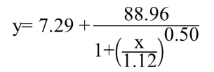
1:5 | 0.007 | 0.59 | 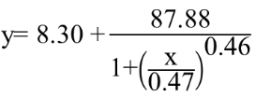
1:10 | 0.001 | 0.14 | 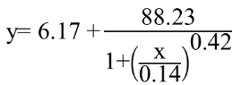
2.3 Determination of OA in CRM-DSP-Mus-c samples
In order to assess the viability of the ECL immunosensor in identifying OA within authentic shellfish samples, the identical immunocompetitive reaction was iplemented on CRM-DSP-Mus-c shellfish samples. The IC₅₀ for CRM-DSP-Mus-c was calculated as 0.09 ng mL⁻¹, and the LOD (corresponding to 85% antibody binding rate) was 0.001 ng mL⁻¹ based on the standard curve (red) in Fig. 5B. Therefore, the LOD of both methods were the same as the standard working curve parameters obtained in PBS standard solution, indicating that the sensor sensitivity did not change in the actual sample assay. This may be because the more accurate steps and specific binding between antigen and antibody effectively reduced the effects of the shellfish sample matrix. This suggests that the proposed ECL immunosensor has good resistance to matrix interference. Meanwhile, CRM-DSP-Mus-c had a lower IC₅₀, which is probably due to the cross-reaction of the immunosensor with DTX-1 and DTX-2 in the CRM-DSP-Mus-c sample. DTX-1 and DTX-2 are both DSP toxins with OA and have similar chemical structures to OA. Although the detection level of OA in CRM-DSP-Mus-c was higher than that expected in PBS, the developed ECL immunosensor had a wider linear range and lower detection limit than existing methods and was able to detect low concentrations of OA in real samples, as shown in Table S2.
Table S2
Table S2 Curve parameters derived from the non-linear four-parameter logistic regression fitting with ECL immunosensor.
Method | Range (ng mL⁻¹) | LOD (ng mL⁻¹) | Reference
DPV | 0.35-3.90 | 0.18 | [8]
DPV | 1.00-300.00 | 0.55 | [9]
Impedance | 0.195-12.50 | 0.30 | [10]
Amperometry | 0.10-60.00 | 0.07 | [11]
Dc-ELISA | 0-2500.00 | 5.41 | [12]
Fluorescence | 2.50-128.00 | 1.80 | [13]
Fluorescence | 0.10-1.77 | 0.025 | [14]
ECL | 0.01-20.00 | 0.005 | This work

2.3 Chemical structures of (A) OA, (B) DTX-1, (C) STX, and (D) SPX-1
Fig. S3
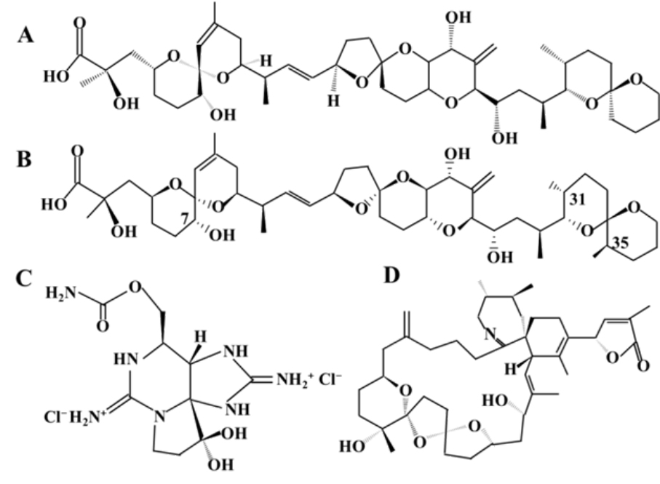
Fig. S3 Chemical structures of (A) OA, (B) DTX-1, (C) STX, and (D) SPX-1.
References:
- Feng X, Gan N, Zhou J, Li T, Cao Y, Hu F, Yu H, & Jiang Q (2014) A novel dual-template molecularly imprinted electrochemiluminescence immunosensor array using Ru(bpy)₃²⁺-Silica@Poly-L-lysine-Au composite nanoparticles as labels for near-simultaneous detection of tumor markers. Electrochim Acta 139: 127-136. https://doi.org/10.1016/j.electacta.2014.07.008.
- Amatatongchai M, Sroysee W, Chairam S, & Nacapricha D (2015) Simple flow injection for determination of sulfite by amperometric detection using glassy carbon electrode modified with carbon nanotubes–PDDA–gold nanoparticles. Talanta 133: 134-141. https://doi.org/10.1016/j.talanta.2014.07.055.
- Zhang Z, Zhu N, Zou Y, Wu X, Qu G, & Shi J (2018) A novel, enzyme-linked immunosorbent assay based on the catalysis of AuNCs@BSA-induced signal amplification for the detection of dibutyl phthalate. Talanta 179: 64-69. https://doi.org/10.1016/j.talanta.2017.10.051.
- Hayat A, Barthelmebs L, Sassolas A, & Marty J (2011) An electrochemical immunosensor based on covalent immobilization of okadaic acid onto screen printed carbon electrode via diazotization-coupling reaction. Talanta 85(1): 513-518. https://doi.org/10.1016/j.talanta.2011.04.034.
- Sassolas A, Catanante G, Hayat A, Stewart LD, Elliott CT, & Marty JL (2013) Improvement of the efficiency and simplification of ELISA tests for rapid and ultrasensitive detection of okadaic acid in shellfish. Food Control 30(1): 144-149. https://doi.org/10.1016/j.foodcont.2012.05.028.
- Luo L, Li L, Xu X, Liu D, Li J, Wang K, & You T (2017) Determination of pentachlorophenol by anodic electrochemiluminescence of Ru(bpy)₃²⁺ based on nitrogen-doped graphene quantum dots as co-reactant. RSC Advances 7(80): 50634-50642. https://doi.org/10.1039/C7RA10247J.
- Li L, Yu B, Zhang X, & You T (2015) A novel electrochemiluminescence sensor based on Ru(bpy)₃²⁺/N-doped carbon nanodots system for the detection of bisphenol. Anal Chim Acta 895: 104-111. https://doi.org/10.1016/j.aca.2015.08.055.
- Nelis JLD, Migliorelli D, Mühlebach L, Generelli S, Stewart L, Elliott CT, & Campbell K (2021) Highly sensitive electrochemical detection of the marine toxins okadaic acid and domoic acid with carbon black modified screen printed electrodes. Talanta 228: 122215. https://doi.org/10.1016/j.talanta.2021.122215.
- Zhou J, Qiu X, Su K, Xu G, & Wang P (2016) Disposable poly (o-aminophenol)-carbon nanotubes modified screen print electrode-based enzyme sensor for electrochemical detection of marine toxin okadaic acid. Sensors Actuators B Chem 235: 170-178. https://doi.org/10.1016/j.snb.2016.05.067.
- Kumar S, Panwar S, Kumar S, Augustine S, & Malhotra BD (2019) Biofunctionalized Nanostructured Yttria Modified Non-Invasive Impedometric Biosensor for Efficient Detection of Oral Cancer. Nanomaterials 9(9). https://doi.org/10.3390/nano9091190.
- Eissa S, Ng A, Siaj M, Tavares AC, & Zourob M (2013) Selection and Identification of DNA Aptamers against Okadaic Acid for Biosensing Application. Anal Chem 85(24): 11794-11801. https://doi.org/10.1021/ac402220k.
- Cho CH, Park CY, Chun HS, Park TJ, & Park JP (2023) Antibody-free and selective detection of okadaic acid using an affinity peptide-based indirect assay. Food Chem 422: 136243. https://doi.org/10.1016/j.foodchem.2023.136243.
- Yin M, Wang W, Wei J, Chen X, Chen Q, Chen X, & Oyama M (2022) Novel dual-emissive fluorescent immunoassay for synchronous monitoring of okadaic acid and saxitoxin in shellfish. Food Chem 368: 130856. https://doi.org/10.1016/j.foodchem.2021.130856.
- Lian Z, Zhao M, Wang J, & Yu R (2021) Dual-emission ratiometric fluorescent sensor based molecularly imprinted nanoparticles for visual detection of okadaic acid in seawater and sediment. Sensors Actuators B Chem 346: 130465. https://doi.org/10.1016/j.snb.2021.130465.

∗Corresponding author. Fax: 86 592 6180470; Tel: 86 592 6181487 E-mail address: xmchen@jmu.edu.cn

