Catalytic modulation of the tumor microenvironment using cascade enzymes for synergistic boron neutron capture therapy in the treatment of gliomas

Supplementary Material

Supplementary Figures 1 A. The standard curve of BSA; B. The BCA result of the nanoparticles.

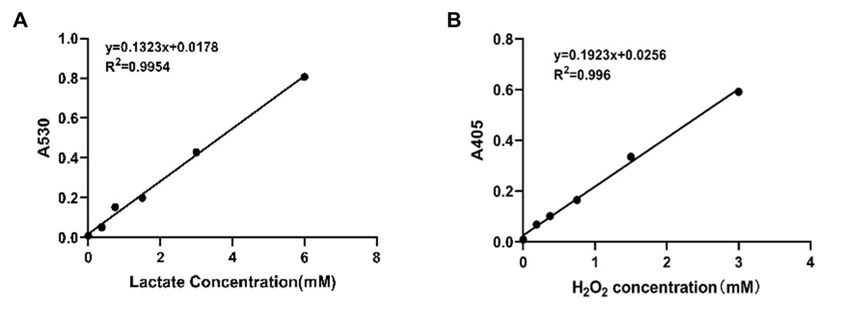
Supplementary Figures 2 A. The standard curve of lactate; B. The standard curve of H₂O₂.

Supplementary Figures 3 The O₂ levels in tumor cell culture medium detected by the portable dissolved oxygen detector assay.

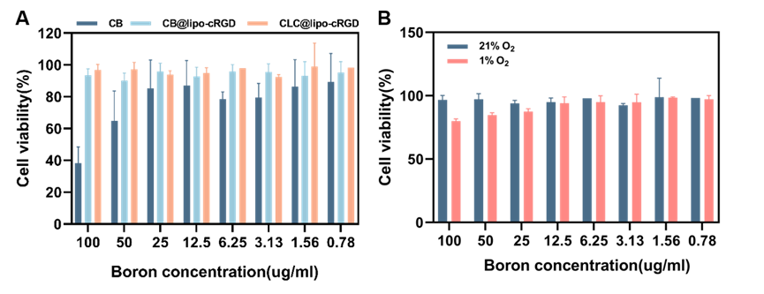
Supplementary Figures 4 A. The cytotoxic effects of drug carriers (CB、CB@lipo-cRGD and CLC@lipo-cRGD) on GL261 cell; B. The cytotoxic effects of CLC@lipo-cRGD under normal oxygen conditions (21% O₂) and low oxygen conditions (1% O₂).

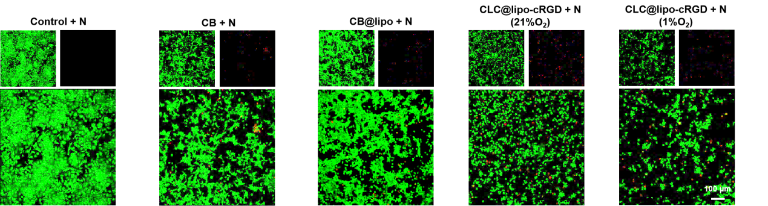
Supplementary Figures 5 The percentage of dead or alive cells under normal oxygen conditions (21% O₂) and low oxygen conditions(1% O₂) was investigated by Calcein AM/PI staining after BNCT treatment, scale bar: 100 μm.

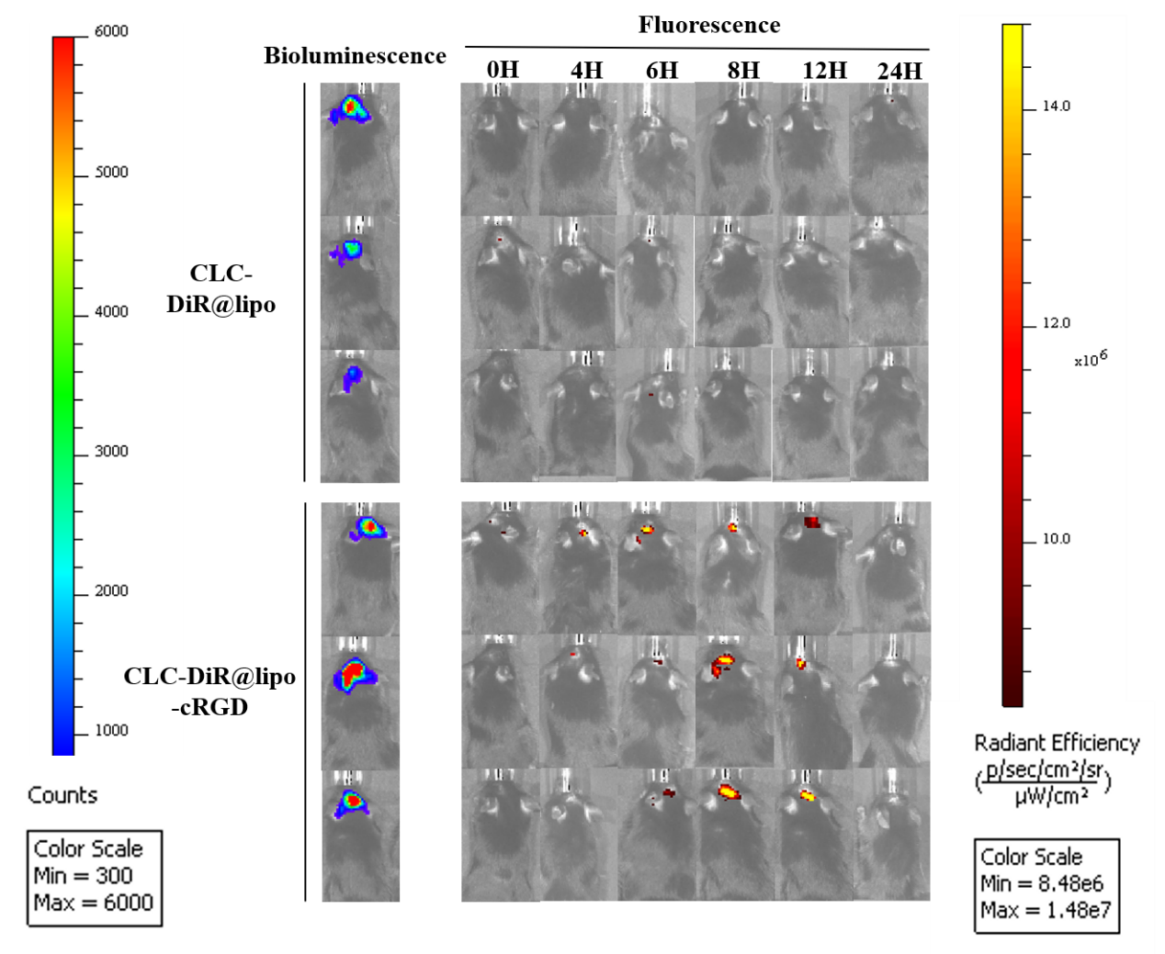
Supplementary Figures 6 The in vivo biodistribution of DiR-loaded nanoparticles of in situ GL261 tumor bearing GL261 mice investigated by IVIS Spectrum.

Supplementary Figures 7 A. The in vivo biodistribution of DiR-loaded nanoparticles in the scarified organs of in situ GL261 tumor bearing GL261 mice by IVIS Spectrum. Luminescence Bioluminescence Image (Top) and DiR fluorescence Image (Bottom); B. Semi-quantification was gained from the DiR in Figure 7 A by Image J.

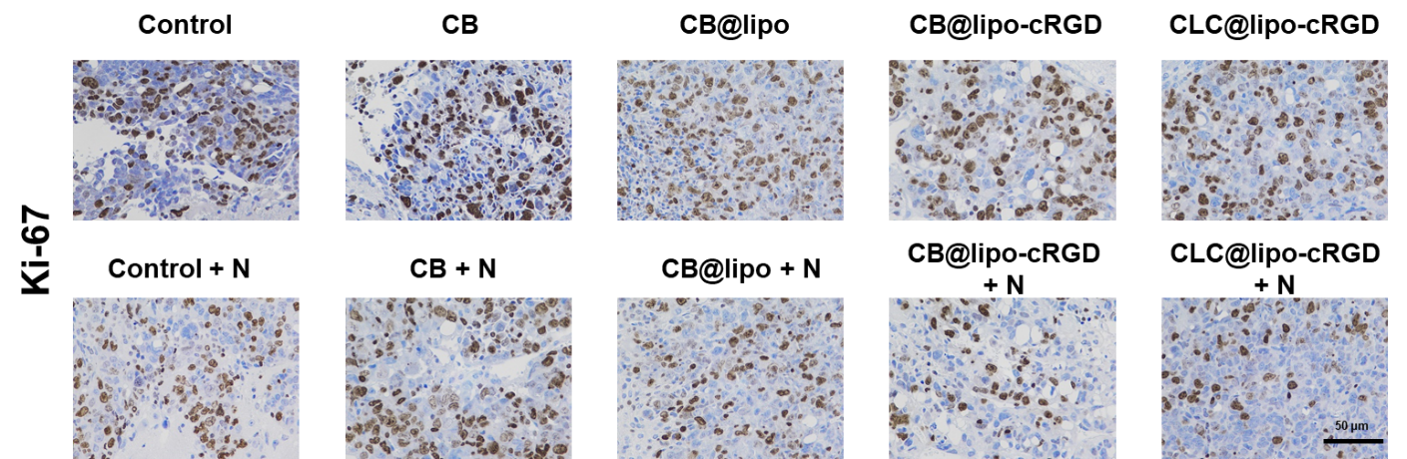
Supplementary Figures 8 The Ki67 immunohistochemical evaluation of tumor tissue.

Supplementary Figures 9 The CD133(A) and SOX2(B) immunofluorescence staining of tumor tissue.

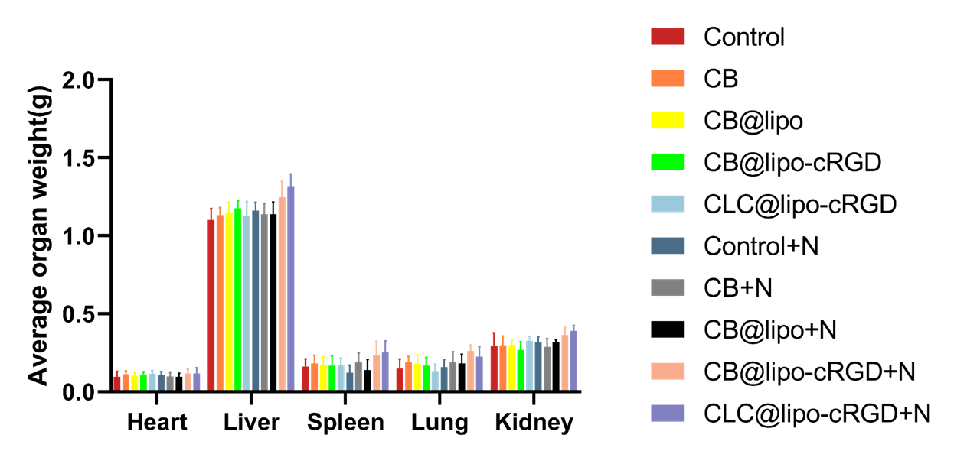
Supplementary Figures 10 The major organs qualities of each treatment group.

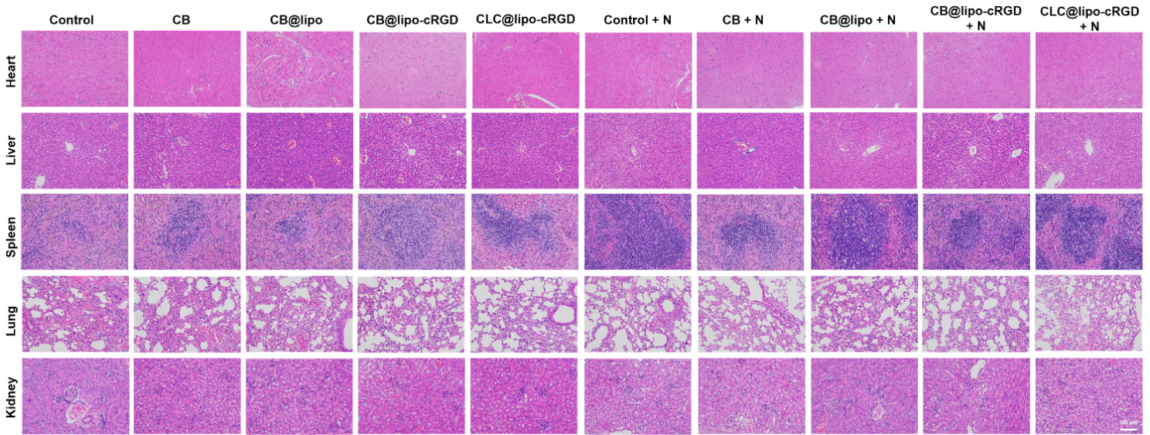
Supplementary Figures 11 The toxicity of organs was evaluated by H&E staining, scale bar: 100 μm.

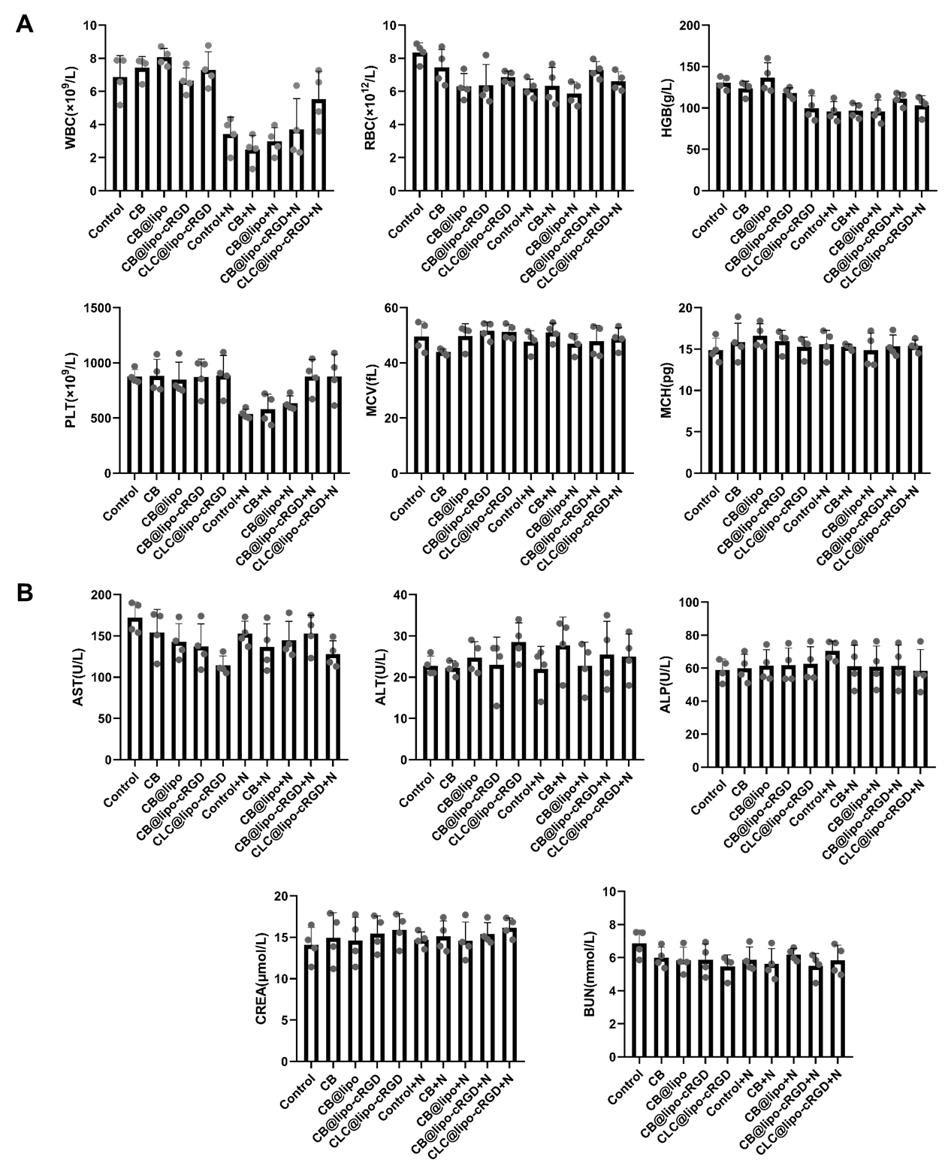
Supplementary Figures 12 A. The routine blood evaluation; B. The blood biochemical assessment of liver function and renal function

