Supplementary information

Title: Shrub encroachment modifies soil properties through plant resource economic traits
Authors: Lucía Laorden-Camacho¹, Karl Grigulis², Elena Tello-Garcia¹, Blandine Lyonnard², Marie-Pascale Colace², Christiane Gallet², Ulrike Tappeiner¹, Georg Leitinger¹ and Sandra Lavorel²
Affiliation:
1 Universität Innsbruck, Department of Ecology, Sternwartestr. 15, 6020 Innsbruck, Austria
2 Laboratoire d’Écologie Alpine, UMR 5553, Université Grenoble Alpes, Université Savoie Mont Blanc, CNRS, CS 40700, 38058 Grenoble Cedex 09, France 3 University of Innsbruck, Department of Microbiology, 6020 Innsbruck, Austria
Journal name: Plant and Soil

Supplementary information
Supplementary information: Tables
Table S1. Statistical analysis of differences between herbaceous traits at the Stubai site between sampling 2021 and 2022. Linear models with mixed effects were used for all regressions. Dependent variables are measured herbaceous traits: herbaceous carbon (Herb C), herbaceous nitrogen (Herb N), herbaceous phosphorus (Herb P) and herbaceous leaf dry matter content (Herb LDMC). Independent variables are : Shrub Biomass (quantitative) and Year (categorical with two 2 levels 2021, 2022). Total number of observations (N) is 30
Linear model | Estimate coefficients |  |  |  | Significance of interaction  (Shrub Biomass*Year)
Linear model | Intercept | Shrub Biomass | Year | Shrub Biomass*Year | Significance of interaction  (Shrub Biomass*Year)
Herb C ~ Shrub Biomass * Year | 43.2924 | -0.0018 | 0.4908 | 0.0001 | n.s
Herb N ~ Shrub Biomass * Year | 1.8712*** | -0.0049*** | 0.1026 | -0.0006 | n.s
Herb P ~ Shrub Biomass * Year | 1.7552 | -0.0034 | 0.0139 | 0.0008 | n.s
Herb LDMC ~ Shrub Biomass * Year | 256.20 | -1.529 | -35.163 | 5.354 | n.s
Significance: not significant (n.s.), < 0.1 (.), < 0.05 (*), < 0.01 (**), < 0.001 (***). N = 30

Supplementary information: Figures
Fig S1. Shrub species composition of the plots along the encroachment gradient. Each bar represents one plot from 0 percent of encroachment (Total shrub cover per plot = 0%) to the highest encroachment (Total shrub cover per plot = 90%). In each plot the cover % of the herbaceous community (light yellow) and the cover % for each shrub species is represented in a stacked form. Shrub species: C. vulgaris (grey), R. ferrugineum (green), V. vitis-idaea (dark blue), V. myrtillus (middle blue), V. uliginosum (light blue), J. communis (orange), Rosa sp. (dark red)
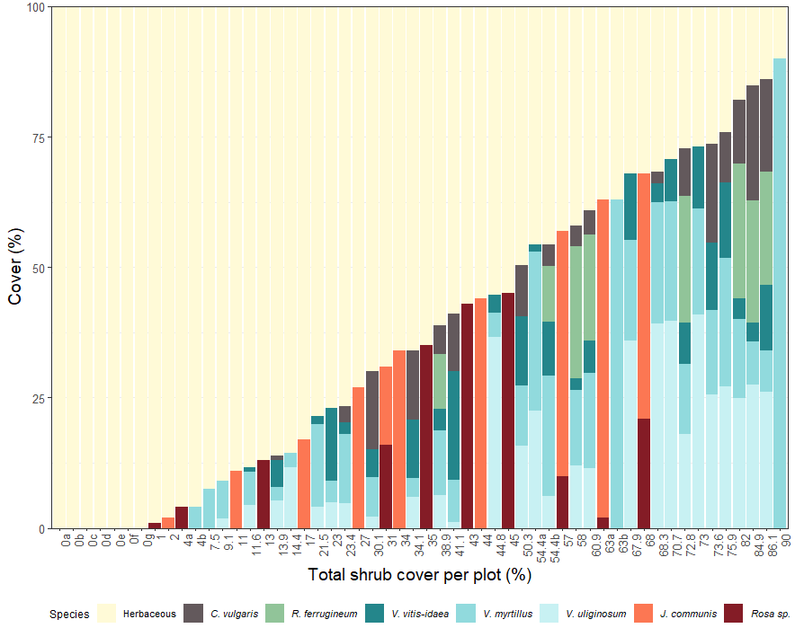

Fig S2. Principal component analysis for Vaccinium dominated plots at Lautaret (“VACC”) and Stubai (“DECIDUOUS”, “EVERGREEN”). Included contributing variables: (a) CWM traits and soil properties, (b) Only CWM; (c) Only soil properties and available nutrients. Points represent sampled plots and numbers next to each point represent the shrub biomass percetange of each plot. Plots with the same shrub biomass percetange are differenciated by a letter (i.e. “9a”, “9b”). Overlap of deciduous dominated plots at Lautaret (“VACC”) and deciduous dominated plots in Stubai (“DECIDUOUS”) confirms the similarity of Vaccinium dominated plots and plant communities between sites. Confidence level 0.95. Total number of observations is 54
(a)  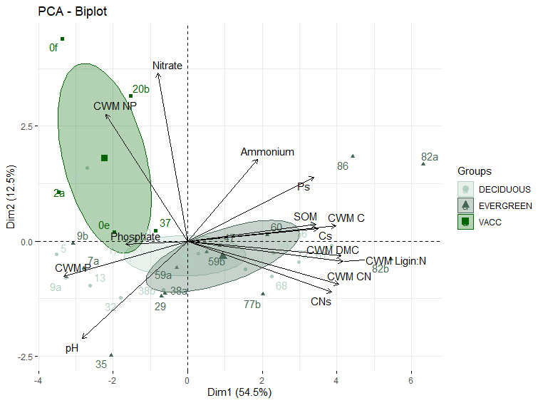  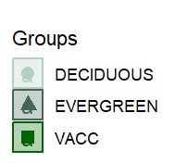 | (b)  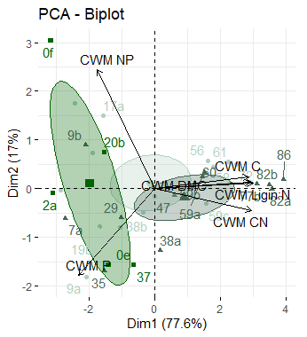
(c)
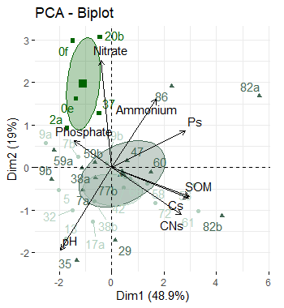

Fig S3. Linear regression model graphs. (a) Effects of shrub encroachment on measured community weighted means and calculated ratios. (b) Effects of Shrub encroachment on measured soil properties and calculated ratios. Total number of observations is 54
(a)
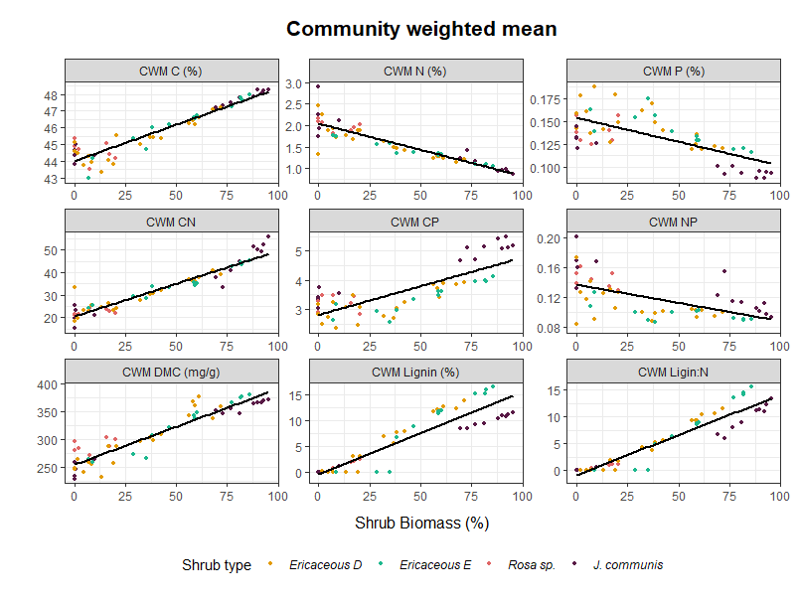
(b)
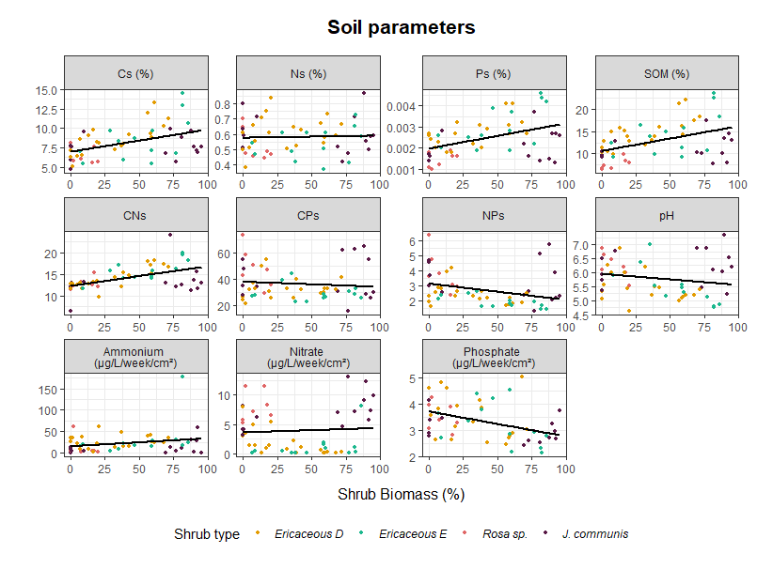

Fig S4. PCA analysis for all plots (n=54) including CWM and soil related variables. A) Contribution of variables to Dimension 1. B) Contribution of variables to Dimension 2.
(a) 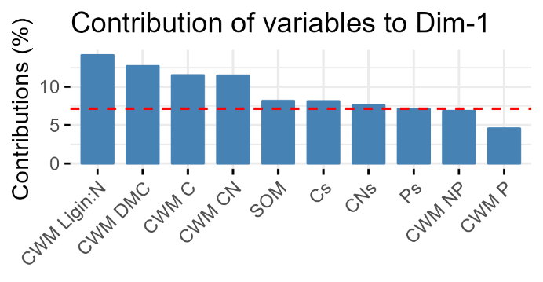 | (b) 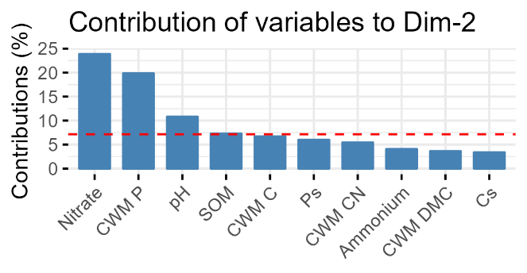

Fig S5. Structural equation model (SEM) including community weighted mean of lignin:nitrogen ratio (CWM Lignin:N) as an explanatory variable for pH, soil organic matter (SOM) and soil C:N ratio (CNs). Total number of observations is 54
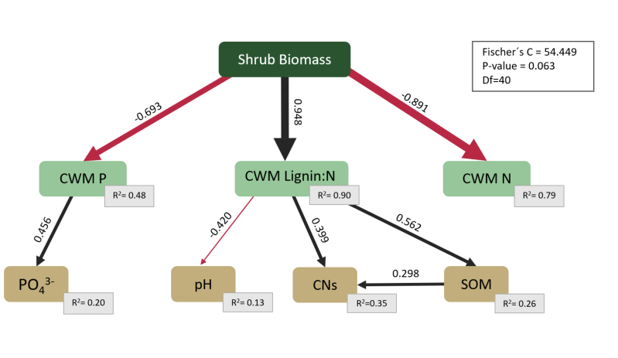

Fig S6. Changes in total aboveground stocks of carbon (C), nitrogen (N) and phosphorus(P) along the increasing gradient of shrub biomass. (a-b) Total C stocks; (c-d) Total N stocks, (e-f) Total P stocks. Left side figures (a,c,e) include the total stock of each nutrient by plant community (herbaceous in yellow, shrub in green) as well as the allocation to plant organs for the shrub community (shrub leaves in dark green, shrub twigs in light green), where each plot is represented by a bar. Right side figures (b,d,f) indicate the change of total stocks of C, N, P along the gradient of shrub biomass, where each plot is represented by a point and lines are linear models. Total number of observations is 54
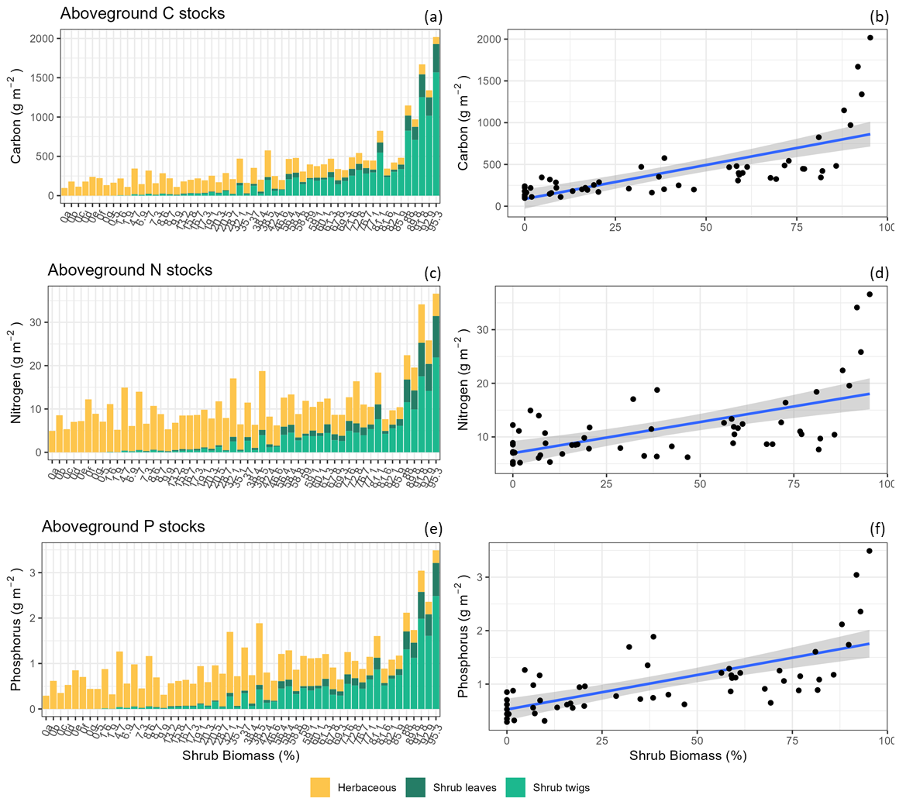

Supplementary information: Biomass estimation
Shrub biomass estimations using allometric methods
Biomass in dry kg per hectare of leaf and twig biomass was estimated for each of the principal shrub species at each site using allometric methods – namely the estimation of a number of easily measured field parameters, and the development of predictive equations relating these parameters to measures of actual leaf and twig biomass. For each shrub species we chose between 20 and 30 mature, well developed individuals of a wide range of sizes and measured their length (greatest horizontal extent of the shrub canopy), width (greatest horizontal extent of the canopy perpendicular to the length), mean and maximum canopy height as well as the number and diameter of stems (greater than 2cm in diameter) at 10cm above the ground. After this, we harvested the individuals, returned them to the lab where their biomass was sorted to leaves and twigs, and dried until no further moisture loss occurred in an oven at 60°C. The dry leaf and twig biomass of each individual was then weighed. In some cases, where shrub individuals were very large, a 1-meter by 1-meter sample was taken of the shrub (i.e. canopy height, stem number and diameter was measured in the 1-meter square) and then this square was harvested for actual measures of shrub biomass. For Calluna vulgaris at Stubai, due to the difficulty in separating leaf and twig biomass, we only estimated total biomass
For each shrub species we then used a stepwise multiple regression procedure to test for the best fitting model (based on the Aikake criterion) using our explanatory variables (field measured shrub areas in m2 (length by width), volumes in m3 (length by width by mean plot canopy height), canopy heights in cm, stem numbers and diameters in mm) to estimate our response variables of actual shrub leaf and twig biomass in dry kg. For all of our shrub species the best explanatory variables for estimating leaf and twig biomass were shrub volume in m3, or shrub area in m2. Shrub canopy height, stem number and stem diameter provided lower levels of explanatory power and did not increase the explanatory power of models using volume or area. All final allometric models were highly significant (p<0.05) and explained between 75 and 99 % of variation in shrub biomass, allowing us to confidently use them for the estimation of shrub biomass in the experimental plots from non-destructive measures of shrub species volume or area. The below table summarises for each shrub species retained allometric equation for leaf and stem biomass, the significance level (p) for these equations and the degree of variation in leaf and twig biomass explained by the equation (R2).

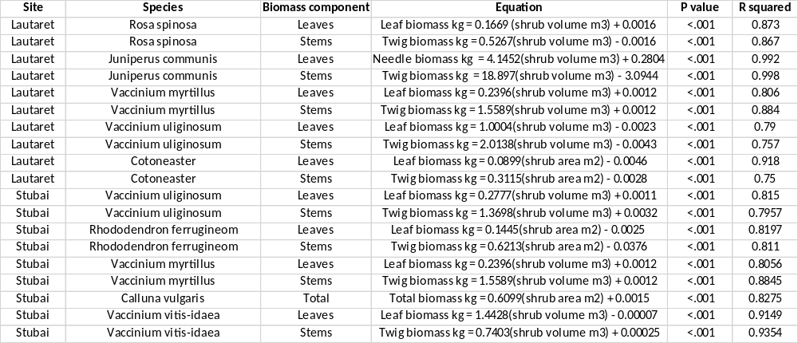

For illustrative purposes, an example is provided below of the form of these allometric equations, in this case that for leaves and twigs of Rosa spinosa at Lautaret
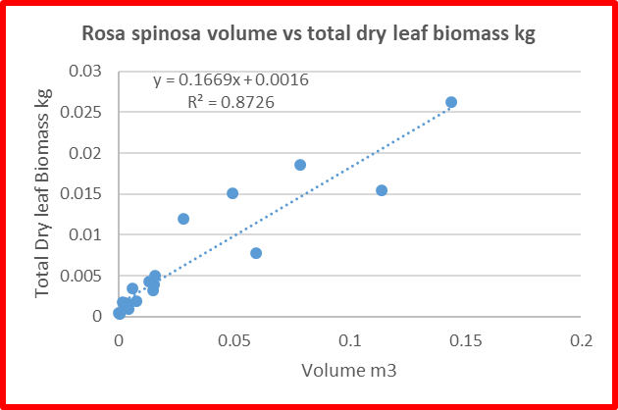 | 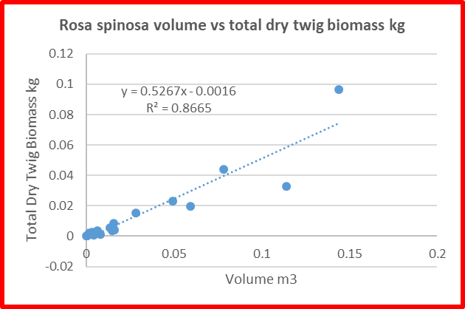

Shrub volumes and areas were estimated in each experimental plot using data from the percentage cover and mean canopy height measurements. These volumes and areas were then converted on a shrub species basis to estimates of dry kg of leaf and twig biomass using the allometric equations defined above.

Herbaceous Vegetation Biomass Estimates
We estimated the total standing dry biomass of the herbaceous component of the vegetation using sward height as an indicator as described in Grigulis and Lavorel (2020). We estimated the mean sward height in the experimental plots using the 100 points in each experimental plot measured for shrub and herbaceous vegetation cover and height. At Lautaret a previously determined equation relating sward height to total standing biomass in t/ha, as described in Grigulis and Lavorel 2020, was used for biomass estimation (Total Biomass (t DM/ha) = (0.0938 * sward height (cm)) + 1.2616). At Stubai a site specific reference equation was developed by measuring sward height in 25 additional 0.5 meter by 0.5 meter plots representative of herbaceous vegetation at the LUCSES experimental plots, harvesting these plots and drying them in the laboratory at 60°C, and developing a linear regression relating sward height to total standing biomass in t/ha. The final form of this equation was Total Biomass (t DM/ha) = (0.2291 * sward height (cm)) + 1.2166 with a p value < 0.001 and an R2 of 0.619. Biomass estimates in t/ha for each experimental plot were converted to biomass estimates in kg for the area of the experimental plots (10 meters by 10 meters).

Supplementary information: Results from SEM

Model 1:
my.mod1<- psem(
lme(ResinsP2O4_log ~ CWM_P, random = ~ 1 | JUNIPER, data = Path_no_extreme),
lm(CWM_P ~ ShrubBiomass, data = Path_no_extreme),
lme(SOM ~ CWM_LDMC, random = ~ 1 | JUNIPER, data = Path_no_extreme),
lme(pH ~ CWM_LDMC, random = ~ 1 | JUNIPER, data = Path_no_extreme),
lme(CNs ~ CWM_LDMC, random = ~ 1 | JUNIPER, data = Path_no_extreme),
lm(CWM_LDMC ~ ShrubBiomass, data = Path_no_extreme),
lme(ResinsN03 ~ CWM_N, random = ~ 1 | JUNIPER, data = Path_no_extreme),
lme(ResinsNH4 ~ CWM_N, random = ~ 1 | JUNIPER, data = Path_no_extreme),
lm(CWM_N ~ ShrubBiomass, data = Path_no_extreme)
)
Tests of directed separation:
Independ.Claim | Test.Type | DF | Crit.Value | P.Value
ResinsP2O4_log ~ ShrubBiomass + CWM_P | coef | 50 | -1.0988 | 0.2771
SOM ~ ShrubBiomass + CWM_LDMC | coef | 50 | 2.1694 | 0.0348 | *
pH ~ ShrubBiomass + CWM_LDMC | coef | 50 | -0.2191 | 0.8275
CNs ~ ShrubBiomass + CWM_LDMC | coef | 50 | 1.4986 | 0.1403
ResinsN03 ~ ShrubBiomass + CWM_N | coef | 50 | 0.8555 | 0.3963
ResinsNH4 ~ ShrubBiomass + CWM_N | coef | 50 | 1.2695 | 0.2101
CWM_LDMC ~ CWM_P + ShrubBiomass | coef | 51 | -0.5579 | 0.5793
CWM_N ~ CWM_P + ShrubBiomass | coef | 51 | -1.1355 | 0.2615
SOM ~ CWM_P + ShrubBiomass + CWM_LDMC | coef | 49 | 0.4807 | 0.6329
pH ~ CWM_P + ShrubBiomass + CWM_LDMC | coef | 49 | -1.2882 | 0.2037
CNs ~ CWM_P + ShrubBiomass + CWM_LDMC | coef | 49 | -0.9058 | 0.3695
ResinsN03 ~ CWM_P + ShrubBiomass + CWM_N | coef | 49 | -3.128 | 0.003 | **
ResinsNH4 ~ CWM_P + ShrubBiomass + CWM_N | coef | 49 | 0.7201 | 0.4749
CWM_N ~ CWM_LDMC + ShrubBiomass | coef | 51 | 0.486 | 0.6291
ResinsP2O4_log ~ CWM_LDMC + ShrubBiomass + CWM_P | coef | 49 | -1.5478 | 0.1281
ResinsN03 ~ CWM_LDMC + ShrubBiomass + CWM_N | coef | 49 | 2.4828 | 0.0165 | *
ResinsNH4 ~ CWM_LDMC + ShrubBiomass + CWM_N | coef | 49 | 0.3722 | 0.7114
ResinsP2O4_log ~ CWM_N + ShrubBiomass + CWM_P | coef | 49 | -0.069 | 0.9453
SOM ~ CWM_N + ShrubBiomass + CWM_LDMC | coef | 49 | 0.3164 | 0.7531
pH ~ CWM_N + ShrubBiomass + CWM_LDMC | coef | 49 | -0.9143 | 0.365
CNs ~ CWM_N + ShrubBiomass + CWM_LDMC | coef | 49 | -0.5198 | 0.6056
SOM ~ ResinsP2O4_log + CWM_P + CWM_LDMC | coef | 49 | -0.897 | 0.3741
pH ~ ResinsP2O4_log + CWM_P + CWM_LDMC | coef | 49 | 0.5691 | 0.5719
CNs ~ ResinsP2O4_log + CWM_P + CWM_LDMC | coef | 49 | -1.3747 | 0.1755
ResinsN03 ~ ResinsP2O4_log + CWM_P + CWM_N | coef | 49 | 1.485 | 0.1439
ResinsNH4 ~ ResinsP2O4_log + CWM_P + CWM_N | coef | 49 | -0.5018 | 0.6181
pH ~ SOM + CWM_LDMC | coef | 50 | -1.3607 | 0.1797
CNs ~ SOM + CWM_LDMC | coef | 50 | 2.6893 | 0.0097 | **
ResinsN03 ~ SOM + CWM_LDMC + CWM_N | coef | 49 | -2.5408 | 0.0143 | *
ResinsNH4 ~ SOM + CWM_LDMC + CWM_N | coef | 49 | 1.9491 | 0.057
CNs ~ pH + CWM_LDMC | coef | 50 | -1.2104 | 0.2318
ResinsN03 ~ pH + CWM_LDMC + CWM_N | coef | 49 | 3.4607 | 0.0011 | **
ResinsNH4 ~ pH + CWM_LDMC + CWM_N | coef | 49 | -3.0725 | 0.0035 | **
ResinsN03 ~ CNs + CWM_LDMC + CWM_N | coef | 49 | -2.4927 | 0.0161 | *
ResinsNH4 ~ CNs + CWM_LDMC + CWM_N | coef | 49 | 0.346 | 0.7308
ResinsNH4 ~ ResinsN03 + CWM_N | coef | 50 | -0.6403 | 0.5249

Global goodness-of-fit:
Fisher.C | df | P.Value
119.3 | 70 | 0

Coefficients:
Response | Predictor | Estimate | Std.Error | DF | Crit.Value | P.Value | Std.Estimate
ResinsP2O4_log | CWM_P | 1.395 | 0.378 | 51 | 3.694 | 0.0005 | 0.456 | ***
CWM_P | ShrubBiomass | -0.01 | 0.0008 | 52 | -6.93 | 0 | -0.69 | ***
SOM | CWM_LDMC | 0.04 | 0.01 | 51 | 3.862 | 0.0003 | 0.465 | ***
pH | CWM_LDMC | -0 | 0.002 | 51 | -2.59 | 0.013 | -0.32 | *
CNs | CWM_LDMC | 0.025 | 0.007 | 50 | 3.482 | 0.001 | 0.419 | **
CNs | SOM | 0.225 | 0.084 | 50 | 2.689 | 0.01 | 0.328 | **
CWM_LDMC | ShrubBiomass | 1.373 | 0.073 | 52 | 18.82 | 0 | 0.934 | ***
ResinsN03 | CWM_N | 1.246 | 1.003 | 51 | 1.242 | 0.22 | 0.146
ResinsNH4 | CWM_N | -14 | 7.948 | 51 | -1.77 | 0.083 | -0.24
CWM_N | ShrubBiomass | -0.01 | 0.0009 | 52 | -14.1 | 0 | -0.89 | ***

Model 2:

my.mod2 <- psem(
lme(ResinsP2O4_log ~ CWM_P, random = ~ 1 | JUNIPER, data = Path_no_extreme),
lm(CWM_P ~ ShrubBiomass, data = Path_no_extreme),
lme(pH ~ CWM_LDMC, random = ~ 1 | JUNIPER, data = Path_no_extreme),
lme(SOM ~ CWM_LDMC, random = ~ 1 | JUNIPER, data = Path_no_extreme),
lme(CNs ~ CWM_LDMC + SOM, random = list(JUNIPER = ~ 1), data = Path_no_extreme),
lm(CWM_LDMC ~ ShrubBiomass, data = Path_no_extreme),
lm(CWM_N ~ ShrubBiomass, data = Path_no_extreme))
---
Tests of directed separation:
Independ.Claim | Test.Type | DF | Crit.Value | P.Value
CNs ~ ShrubBiomass + CWM_LDMC + SOM | coef | 49 | 0.7394 | 0.4632
ResinsP2O4_log ~ ShrubBiomass + CWM_P | coef | 50 | -1.0988 | 0.2771
pH ~ ShrubBiomass + CWM_LDMC | coef | 50 | -0.2191 | 0.8275
SOM ~ ShrubBiomass + CWM_LDMC | coef | 50 | 2.1694 | 0.0348 | *
CWM_LDMC ~ CWM_P + ShrubBiomass | coef | 51 | -0.5579 | 0.5793
CNs ~ CWM_P + ShrubBiomass + CWM_LDMC + SOM | coef | 48 | -0.9419 | 0.3509
CWM_N ~ CWM_P + ShrubBiomass | coef | 51 | -1.1355 | 0.2615
pH ~ CWM_P + ShrubBiomass + CWM_LDMC | coef | 49 | -1.2882 | 0.2037
SOM ~ CWM_P + ShrubBiomass + CWM_LDMC | coef | 49 | 0.4807 | 0.6329
CWM_N ~ CWM_LDMC + ShrubBiomass | coef | 51 | 0.486 | 0.6291
ResinsP2O4_log ~ CWM_LDMC + ShrubBiomass + CWM_P | coef | 49 | -1.5478 | 0.1281
CWM_N ~ CNs + CWM_LDMC + SOM + ShrubBiomass | coef | 49 | -1.0752 | 0.2876
ResinsP2O4_log ~ CNs + CWM_LDMC + SOM + CWM_P | coef | 48 | -0.9617 | 0.341
pH ~ CNs + CWM_LDMC + SOM | coef | 49 | -0.6668 | 0.508
ResinsP2O4_log ~ CWM_N + ShrubBiomass + CWM_P | coef | 49 | -0.069 | 0.9453
pH ~ CWM_N + ShrubBiomass + CWM_LDMC | coef | 49 | -0.9143 | 0.365
SOM ~ CWM_N + ShrubBiomass + CWM_LDMC | coef | 49 | 0.3164 | 0.7531
pH ~ ResinsP2O4_log + CWM_P + CWM_LDMC | coef | 49 | 0.5691 | 0.5719
SOM ~ ResinsP2O4_log + CWM_P + CWM_LDMC | coef | 49 | -0.897 | 0.3741
SOM ~ pH + CWM_LDMC | coef | 50 | -1.5319 | 0.1319
--
Global goodness-of-fit:
Fisher.C | df | P.Value
42.032 | 40 | 0.383

---
Coefficients:
Response | Predictor | Estimate | Std.Error | DF | Crit.Value | P.Value | Std.Estimate
ResinsP2O4_log | CWM_P | 1.3954 | 0.3778 | 51 | 3.6938 | 5.00E-04 | 0.4559 | ***
CWM_P | ShrubBiomass | -0.0052 | 8.00E-04 | 52 | -6.9308 | 0 | -0.693 | ***
pH | CWM_LDMC | -0.0044 | 0.0017 | 51 | -2.5909 | 0.0125 | -0.3189 | *
SOM | CWM_LDMC | 0.0403 | 0.0104 | 51 | 3.8623 | 3.00E-04 | 0.4649 | ***
CNs | CWM_LDMC | 0.0249 | 0.0072 | 50 | 3.4817 | 0.001 | 0.419 | **
CNs | SOM | 0.2249 | 0.0836 | 50 | 2.6893 | 0.0097 | 0.3276 | **
CWM_LDMC | ShrubBiomass | 1.3732 | 0.073 | 52 | 18.8169 | 0 | 0.9338 | ***
CWM_N | ShrubBiomass | -0.0121 | 9.00E-04 | 52 | -14.1353 | 0 | -0.8908 | ***

