Supporting Information

Adsorption study of toxic metal ions using functionalized 3D mesostructured silica
Nagy L. Torad,ª Ahmed Abu El-Nasr,ª Nehal A. Salahuddin,ª Mohamad M. Ayad^{*a,b}

ª Department of Chemistry, Faculty of Science, Tanta University, Tanta 31527, Egypt
^{b}School of Basic and Applied Sciences, Egypt-Japan University of Science and Technology (E-JUST), New Borg El-Arab City, Alexandria 21934, Egypt
*Corresponding Email: Mohamad.ayad@ejust.edu.eg

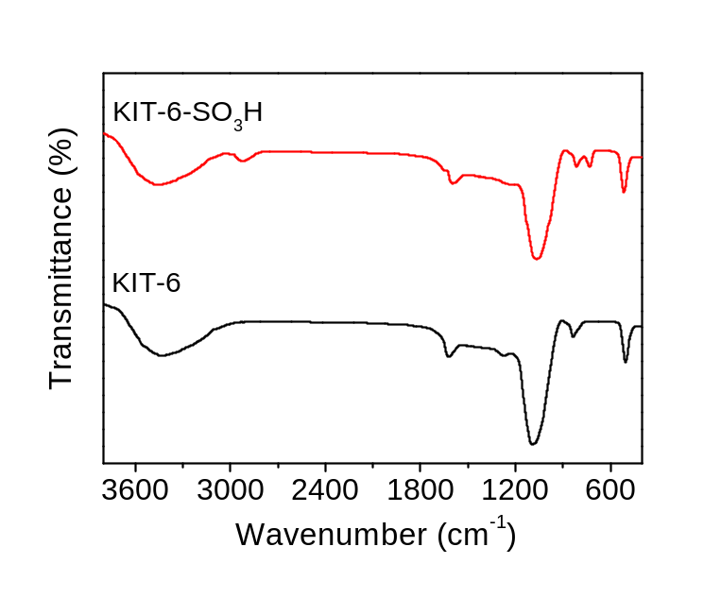

Figure S1. FT-IR spectra of pristin mesoporous silica KIT-6 (black line) and functionalized KIT-6-SO₃H (red line).

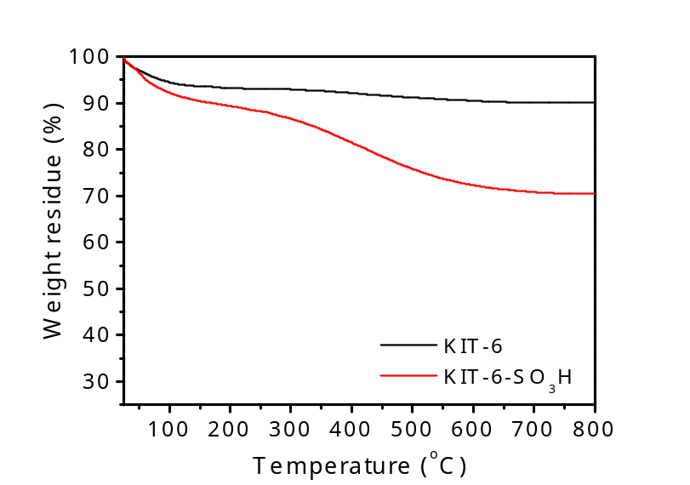

Figure S2. TG analysis curves of pristin mesoporous silica KIT-6 and functionalized KIT-6-SO₃H.

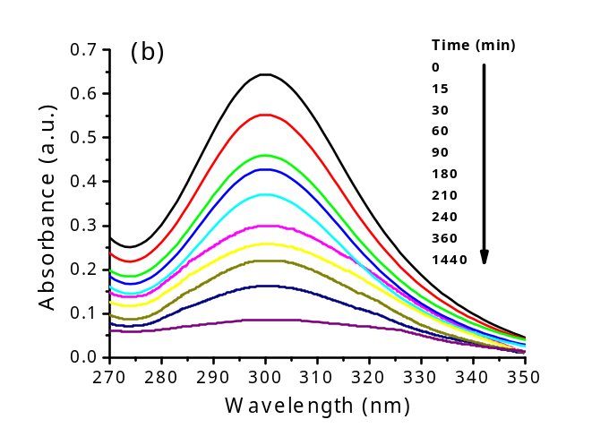
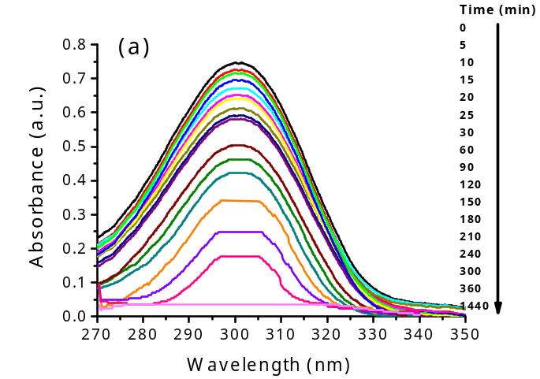
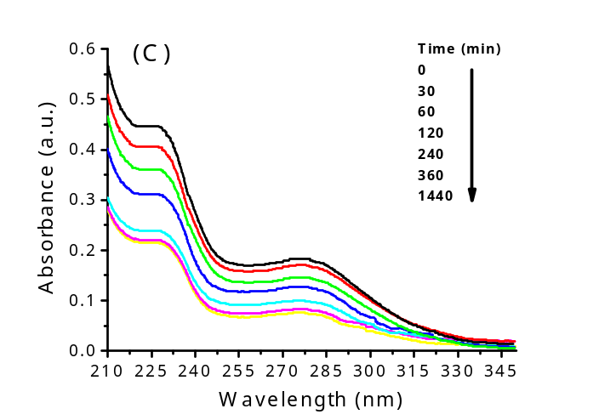
Figure S3. UV-Vis absorption spectra of (a) Pb(II), (b) Cd(II) and (c) Cs(I) ions adsorbed into KIT-6-SO₃H.

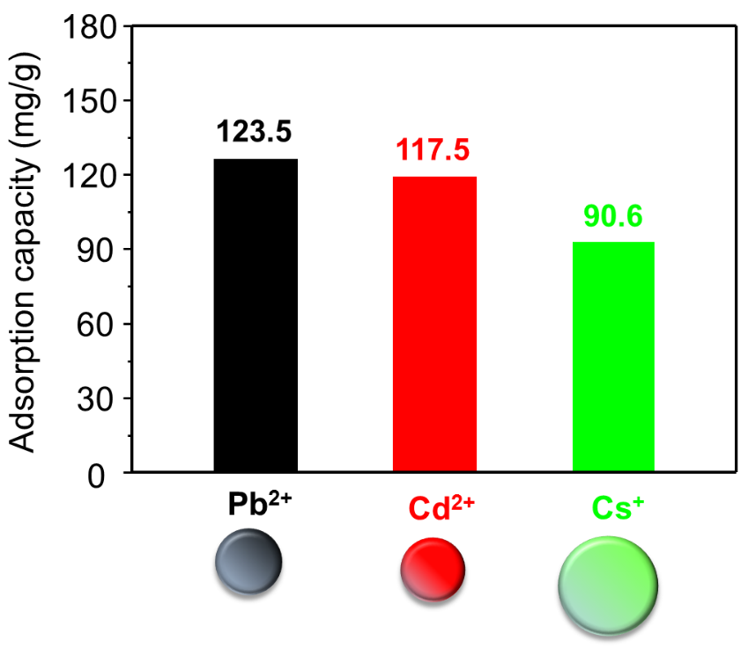
Figure S4. Effect of metal ion sizes on the adsorption efficacy of KIT-6-SO₃H toward of Pb(II), Cd(II) and Cs(I).

Table S1. Maximum adsorption capacities for Pb(II), Cd(II) and Cs(I) ions obtained by UV-visible absorption spectroscopy reported in the representative literatures using different modified adsorbents.
Adsorbent material | Surface area (m²·g^{–1}) | Pore volume  (cm³·g^{–1}) | Pore diameter  (nm) | Adsorption capacity  (mg·g^{–1}) |  |  | Ref.
 |  |  |  | Pb(II) | Cd(II) | Cs(I) | Ref.
KIT-6-SO₃H | 860 | 0.743 | 8.4 | 123.5 | 117.7 | 90.6 | This work
SBA-15-SH | 637 | 0.840 | 7.6 | 25.9 | -- | -- | [S1]
KIT-6-COOH | 525 | 0.810 | 6.9 | 75 | -- | -- | [S2]
SBA-15-COOH | 440 | 0.960 | 8.2 | -- | 97.5 | -- | [S3]
H₂N-MCM-41 | 1387 | 0.422 | 4.8 | 57.7 | 18.3 | -- | [S4]
H₂N-MCM-41 | 750 | 0.56 | 2.9 | -- | 79.8 | -- | [S5]
MDA-SBA-15 | 293 | 0.93 | 4.7 | 94.8 | 71.1 | -- | [S6]
TAC-SBA-15 | 336 | 0.48 | 0.7-0.8 | -- | 23.6 | -- | [S7]
MPY-SBA-15 | 330 | 0.38 | 5.47 | -- | 111.4 | -- | [S8]
PAO/SiO₂ | -- | -- | -- | 120 | 42.2 | -- | [S9]
DEAMTPP@Fe₃O₄ MNP | 1125 | 0.066 | 13.6 | -- | 49.1 | -- | [S10]
Polyaniline grafted chitosan | -- | -- | -- | -- | 14.3 | -- | [S11]
Chitosan modified- sulfoxine chelate agent | -- | -- | -- | -- | 32.9 | -- | [S12]
Fe₃O₄-cyclodextrin | -- | -- | -- | -- | 22.7 | -- | [S13]
Thiocyanato-functionalized silica gel | -- | -- | -- | -- | 49.3 |  | [S14]
Ion-imprinted polymer | -- | -- | -- | 75.4 | -- | -- | [S15]
MWCNT | -- | -- | -- | 10.3 | -- | -- | [S16]
PAN-MWCNT | -- | -- | -- | 9.3 | -- | -- | [S17]
4-Aminoazo-benzene-MWCNT | -- | -- | -- | 46.8 | -- | -- | [S18]

References
[S1] J. M. Arsuaga, J. Aguado, A. Arencibia, M. S. López-Gutiérrez, Aqueous mercury adsorption in a fixed bed column of thiol functionalized mesoporous silica, Adsorption 20 (2014) 311–319.
[S2] M. C. Bruzzoniti, A. Prelle, C. Sarzanini, B. Onida, S. Fiorilli, E. Garrone, Retention of heavy metal ions on SBA-15 mesoporous silica functionalized with carboxylic groups, J. Sep. Sci. 30 (2007) 2414–2420.
[S3] N. Bensacia, I. Fechete, S. Moulay, O. Hulea, A. Boos, F. Garin, Kinetic and equilibrium studies of lead(II) adsorption from aqueous media by KIT-6 mesoporous silica functionalized with –COOH, C. R. Chimie 17 (2014) 869–880.
[S4] A. Heidari, H. Younesi, Z. Mehraban, Removal of Ni(II) Cd(II) and Pb(II) from a ternary aqueous solution by amino functionalized mesoporous and nano mesoporous silica, Chem. Eng. J. 153 (2009) 70–79.
[S5] K.F. Lam, K.L. Yeung, G. McKay, Efficient approach for Cd²⁺ and Ni²⁺ removal and recovery using mesoporous adsorbent with tunable selectivity, Environ. Sci. Technol. 41 (2007) 3329–3334.
[S6] A. Shahbazi, H. Younesi, A. Badiei, Functionalized SBA-15 mesoporous silica by melamine-based dendrimer amines for adsorptive characteristics of Pb(II) Cu(II) and Cd(II) heavy metal ions in batch and fixed bed column, Chem. Eng. J. 168 (2011) 505–518.
[S7] I. Georgescu, M. Mureşeanu G. C. V. Hulea, Adsorptive removal of cadmium and copper from water by mesoporous silica functionalized with N-(aminothioxomethyl)-2-thiophen carboxamide, J. Environ. Eng. 139 (2013) 1285–1296.
[S8] D. Pérez-Quintanilla, I. D. Hierro, M. Fajardo, I. Sierra, Adsorption of cadmium(II) from aqueous media onto a mesoporous silica chemically modified with 2-mercaptopyrimidine, J. Mater. Chem. 16 (2006) 1757–1764.
[S9] B. Gao, Y. Gao, Y. Li, Preparation and chelation adsorption property of composite chelating material poly(amidoxime)/SiO2 towards heavy metal ions, Chem. Eng. J. 158 (2010) 542–549.
[S10] S. Venkateswarlu, M. Yoon, Rapid removal of cadmium ions using green-synthesized Fe₃O₄ nanoparticles capped with diethyl-4-(4 amino-5-mercapto-4H-124-triazol-3-yl)phenyl phosphonate, RSC Adv. 5 (2015) 65444–65453.
[S11] R. Karthik, S. Meenakshi, Removal of Pb(II) and Cd(II) ions from aqueous solution using polyaniline grafted chitosan, Chem. Eng. J. 263 (2015) 168–177.
[S12] R. Hua, Z. Li, Sulfhydryl functionalized hydrogel with magnetism: Synthesis characterization and adsorption behavior study for heavy metal removal, Chem. Eng. J. 249 (2014) 189–200.
[S13] L. Vitali, M. C. M. Laranjeira, N. S. Goncalves, V. T. Favere, Spray-dried chitosan microspheres containing 8-hydroxyquinoline -5 sulphonic acid as a new adsorbent for Cd(II) and Zn(II) ions, Int. J. Biol. Macromol. 42 (2008) 152–157.
[S14] Z. Li, H. Fan, Y. Zhang, M. Chen, Z. Yu, X. Cao, T. Sun, Cd(II)-imprinted polymer sorbents prepared by combination of surface imprinting technique with hydrothermal assisted sol-gel process for selective removal of cadmium(II) from aqueous solution, Chem. Eng. J. 171 (2011) 703–710.
[S15] M. Behbahania, A. Bagheri, M. Taghizadeh, M. Salarian, O. Sadeghi, L. Adlnasab, K. Jalali, Synthesis and characterisation of nano structure lead (II) ion-imprinted polymer as a new sorbent for selective extraction and preconcentration of ultra-trace amounts of lead ions from vegetables rice and fish samples, Food Chem. 138 (2013) 2050–2056.
[S16] M. Tuzen, K. O. Saygi, M. Soylak, Solid phase extraction of heavy metal ions in environmental samples on multiwalled carbon nanotubes, J. Hazard. Mater. 152 (2008) 632–639.
[S17] S. Z. Mohammadi, D. Afzali, D. Pourtalebi, Flame atomic absorption spectrometric determination of trace amounts of lead cadmium and nickel in different matrixes after solid phase extraction on modified multiwalled carbon nanotubes, Cent. Eur. J. Chem. 3 (2010) 662–668.
[S18] Z. Li, L. Wu, Synthesis characterization and application of 4-aminoazobenzene functionalized multiwalled carbon nanotubes as a novel and uniquely selective solid-phase extraction for determination of lead(II) in water samples, Int. J. Environ. Anal. Chem. 94 (2014) 291–303.

