Supplementary Figures:
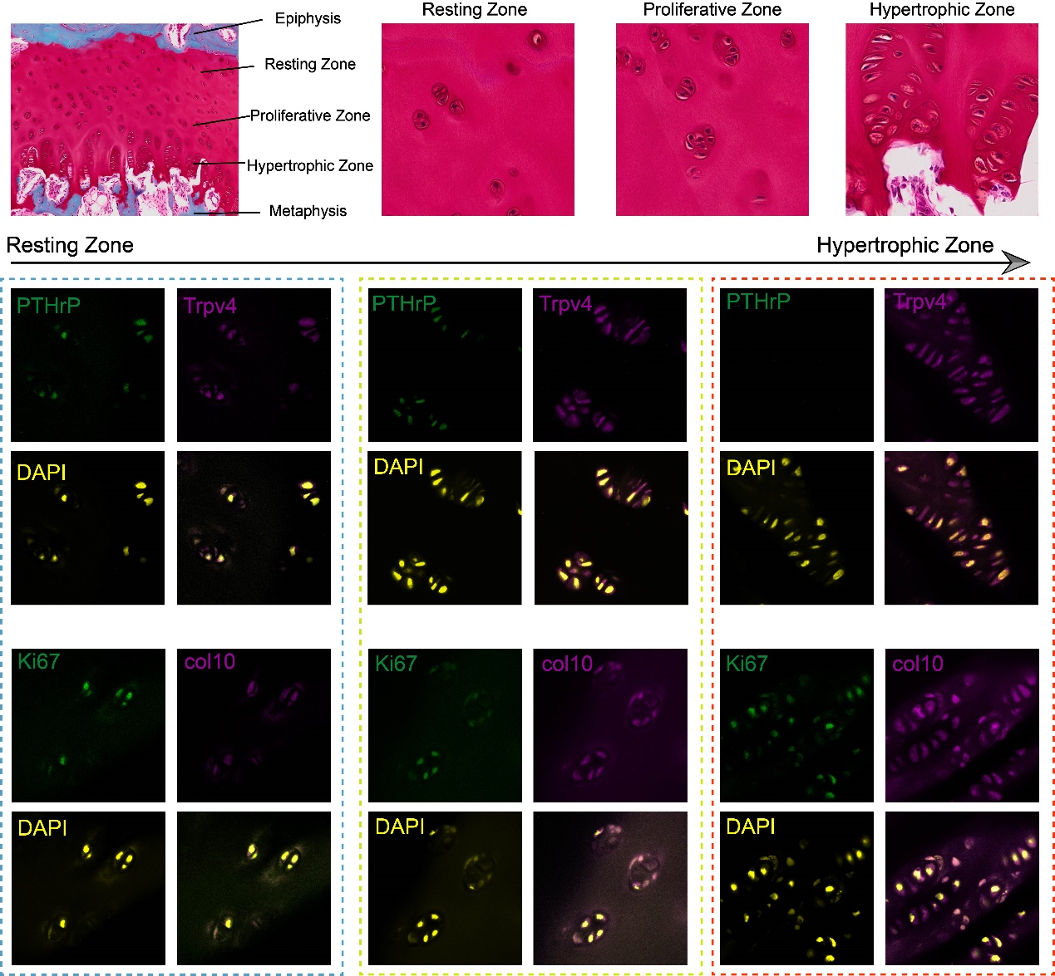
Figure S1: The immunofluorescent staining of PTHrP, Trpv4, Ki67 and col 10 from resting zone to hypertrophic zone, showing the highly ordered structure and different physiological states of zones within GP.
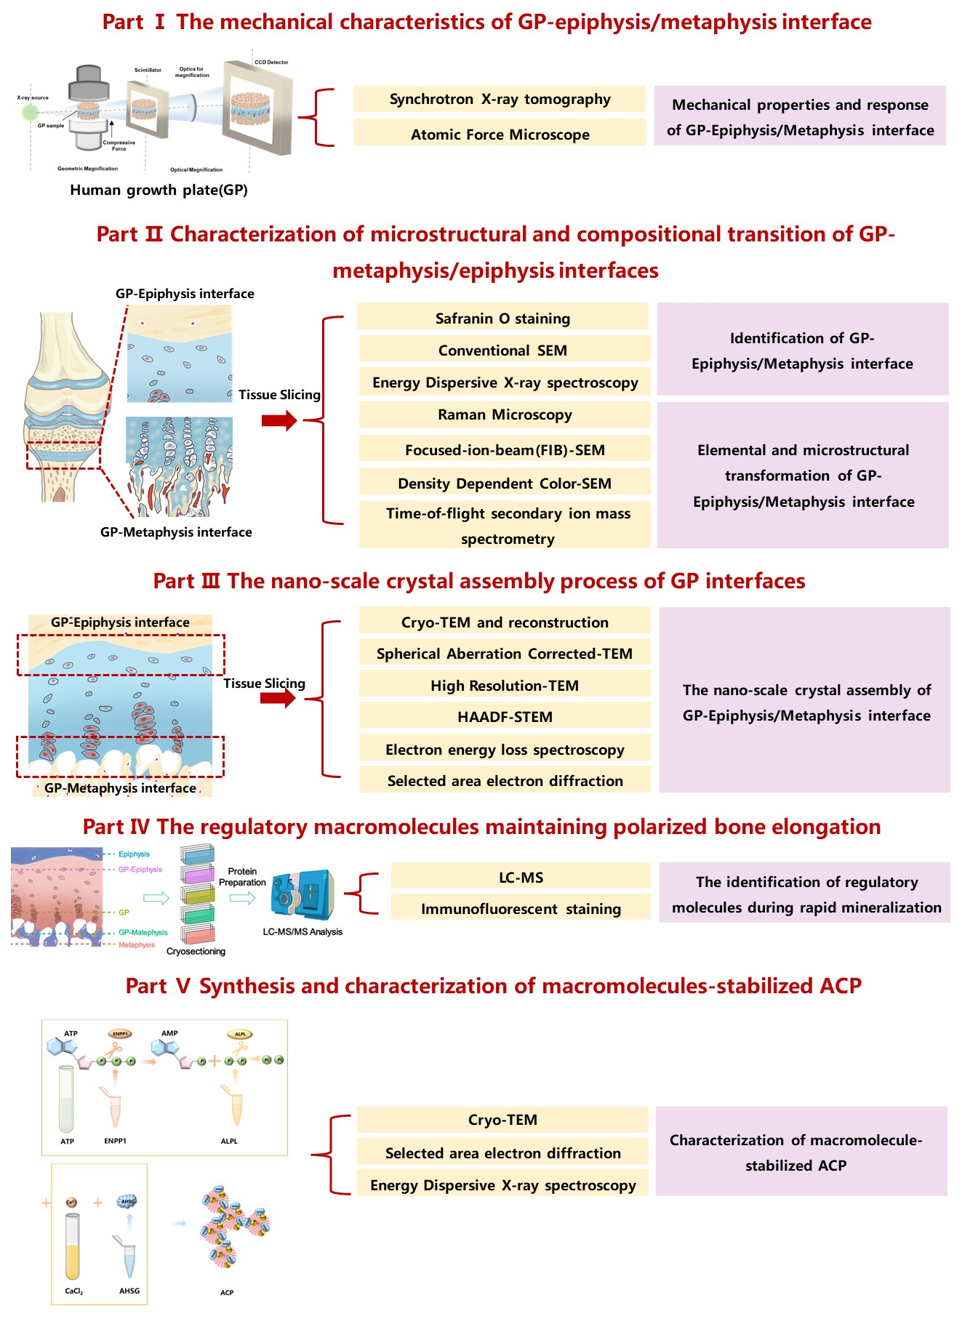
Figure S2: The workflow of the research.
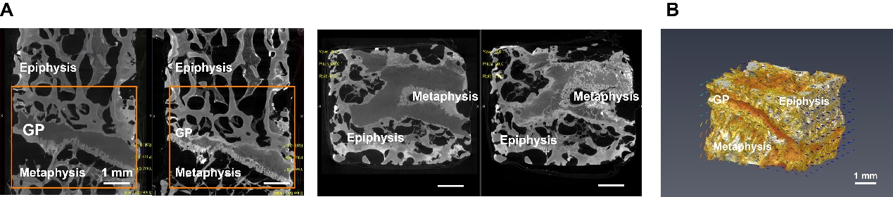
Figure S3: A) Selected CT images of GP tissue before and after compression via synchrotron XRM, scale bar = 1mm; B) The reconstructed CT image of GP after compression, the arrows represent the displacement direction, scale bar = 1mm.
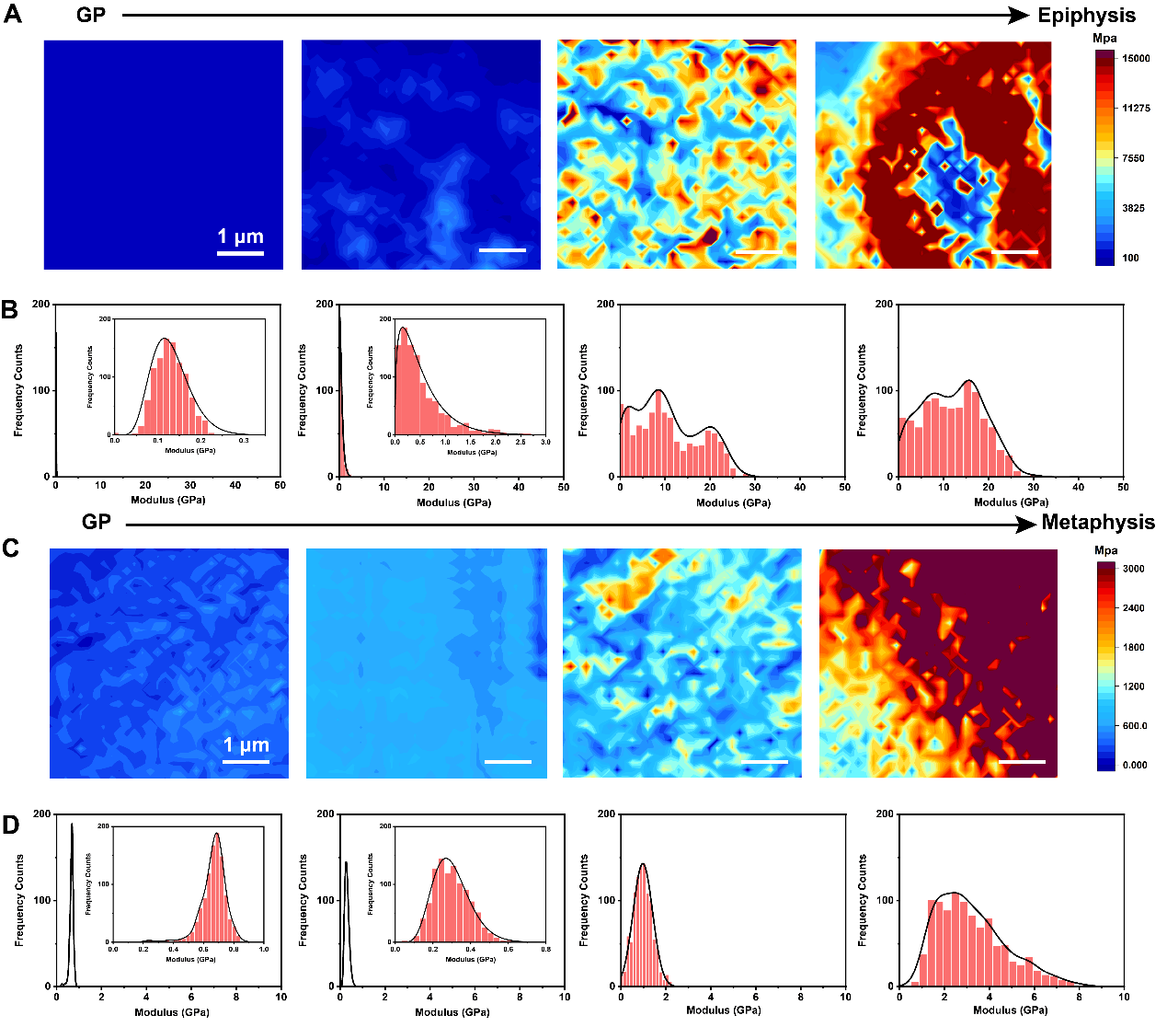
Figure S4: A-B) AFM stiffness maps and corresponding stiffness distribution of selected regions from GP to epiphysis, scale bar = 1μm; C-D) AFM stiffness maps and corresponding stiffness distribution of selected regions from GP to metaphysis, scale bar = 1μm.
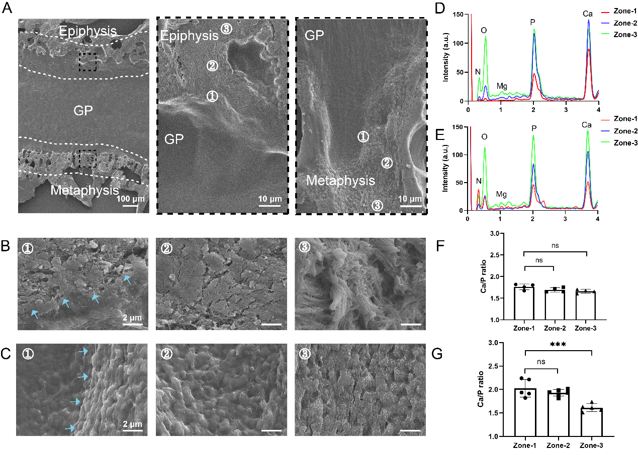
Figure S5: A) Representative SEM images of GP and enlarged images of GP-epiphysis interface and GP-epiphysis interface, scale bar = 100 μm; B) The enlarged SEM images of zone 1-3 in GP-epiphysis interface; C) The enlarged SEM images of zone 1-3 in GP-metaphysis interface, blue arrows pointing to the soft-hard interface in B-C), scale bar = 2 μm; C-D) Chemical composition of C) GP-epiphysis and D) GP-metaphysis interface in zone 1-3; E-F) The corresponding Ca/P ratios of minerals within each zone from GP to E) epiphysis and F) metaphysis.
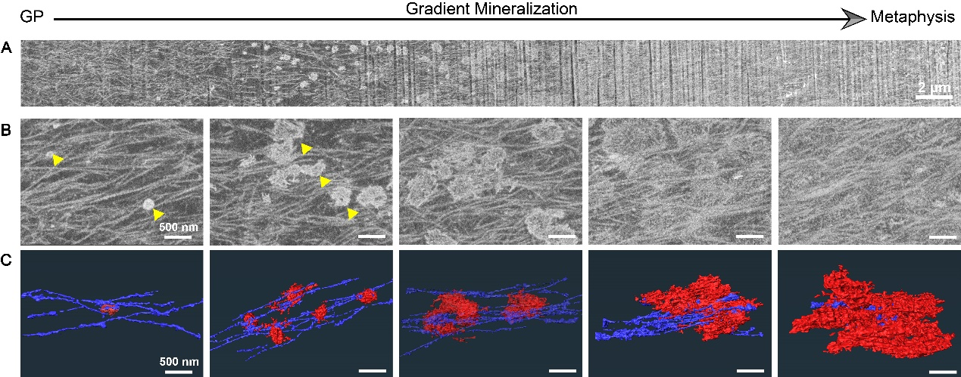
Figure S6: A-B) FIB-SEM (backscatter electron mode) images of GP-metaphysis interface from GP cartilage to mineralized metaphysis region, scale bar = 2 μm in A) and 500 nm in B), triangles pointing minerals; 3D reconstruction images showing the collagen fibers (violet) and minerals (red) across GP-metaphysis interface, scale bar = 500 nm.
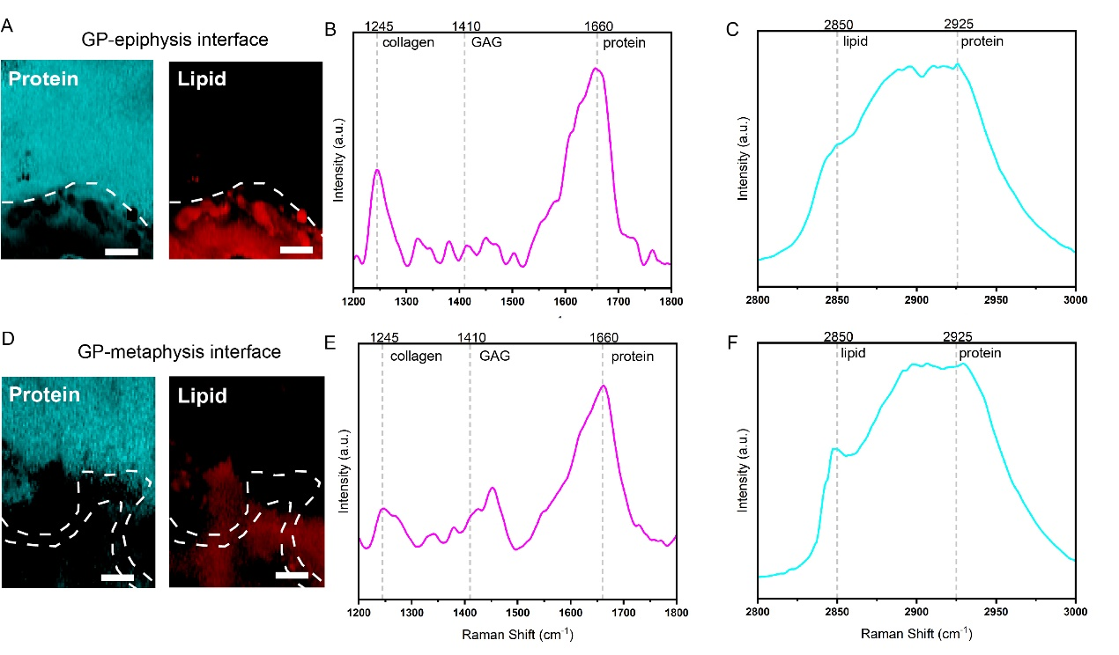
Figure S7: SRS imaging of GP-epiphysis interface A) and GP-metaphysis interface D) showing the band intensity associated with protein (1660 cm⁻¹) and lipid (2850 cm⁻¹), scale bar = 10 μm; Representative Raman spectra of GP-epiphysis interface B, C) and GP-metaphysis interface E, F) from SRS imaging with mark signatures for collagen (1245 cm⁻¹), GAG (1410 cm⁻¹), protein (1660 cm⁻¹ and 2925 cm⁻¹) and lipid (2850 cm⁻¹).
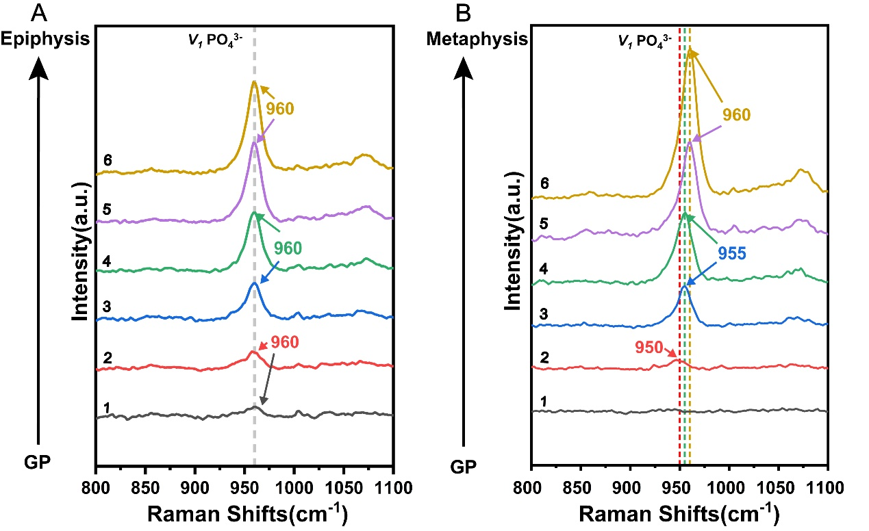
Figure S8: Enlarged images of Raman spectra collected in 800 ~1100 cm⁻¹ from GP to A) epiphysis/ B) metaphysis at different area (zone 1-6) in Figure 3A and 3B.

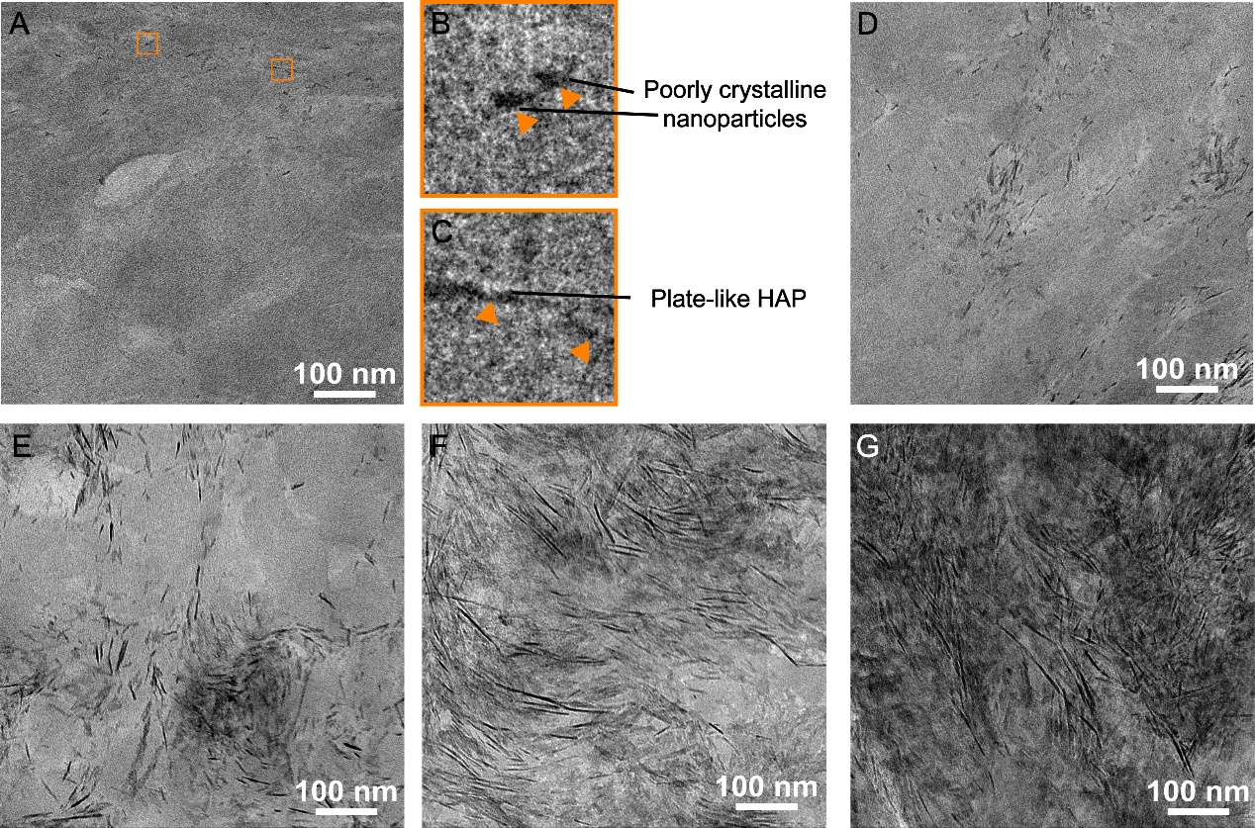
Figure S9: Representative cryo-TEM images in GP-epiphysis interface of tibia sample, from poorly crystalline HAp nanoparticles and plate-like HAp to fully mineralized epiphysis region, scale bar = 100 nm.
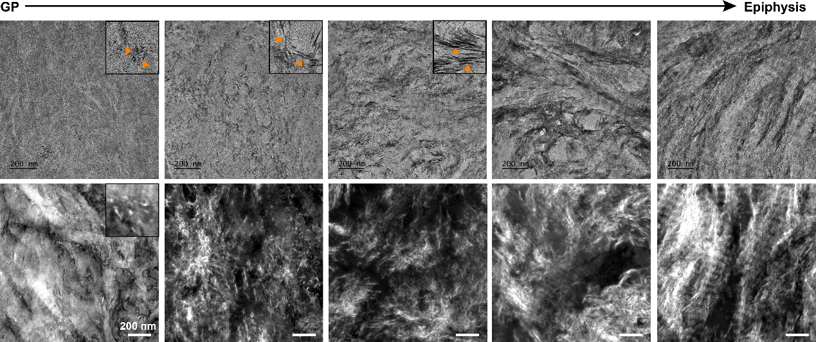
Figure S10: Representative TEM and STEM images of tibia GP sample showing the mineralization process of GP-epiphysis interface from poorly crystalline nanoparticles to fully mineralized metaphysis tissue, scale bar = 200 nm.
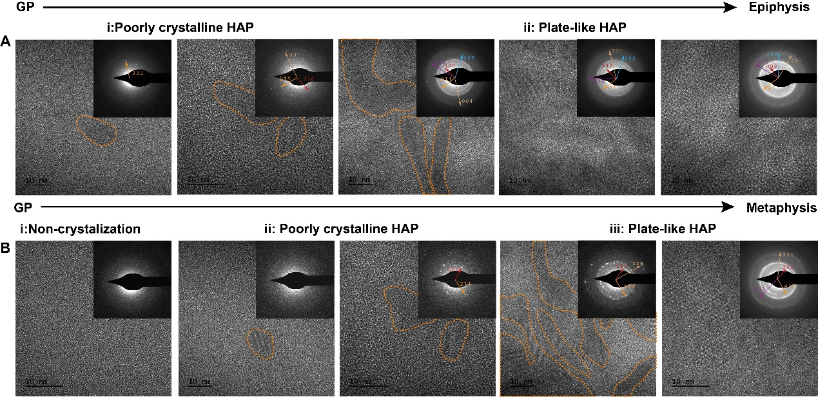
Figure S11: HR-TEM and SAED images in tibia A) GP-epiphysis interface, from poorly crystalline HAP into plate-like HAp, scale bar = 10 nm; and B) GP-metaphysis interface, from ACP-like structures to poorly crystalline HAp and plate-like HAp, scale bar = 10 nm.
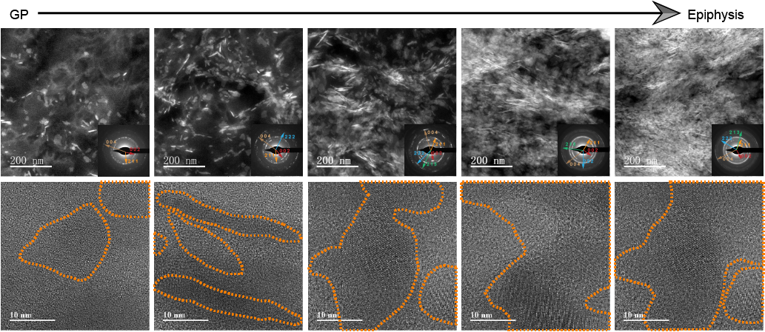
Figure S12: STEM, SAED and HR-TEM images in GP-epiphysis interface region of human phalange tissue, starting from nanocrystals to lacy-like HAp, scale bar = 200 nm in STEM images and 10 nm in HR-TEM images.
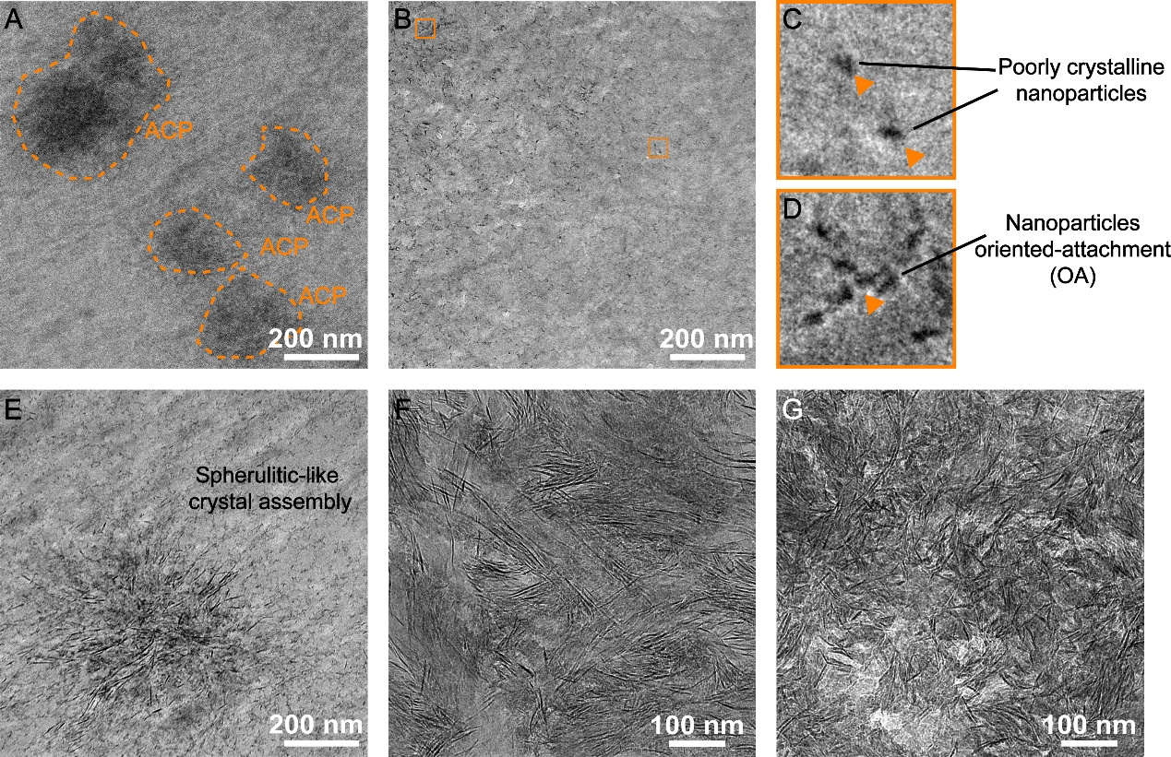
Figure S13: Representative TEM images of tibia GP sample showing the ACP-like structures A), poorly crystalline nanoparticles B, C), nanoparticle oriented-attachment (OA) D), spherulitic-like crystal assembly E) and mineralized region F, G) during GP-metaphysis mineralization process, scale bar = 200 nm in A-E) and 100 nm in F, G).
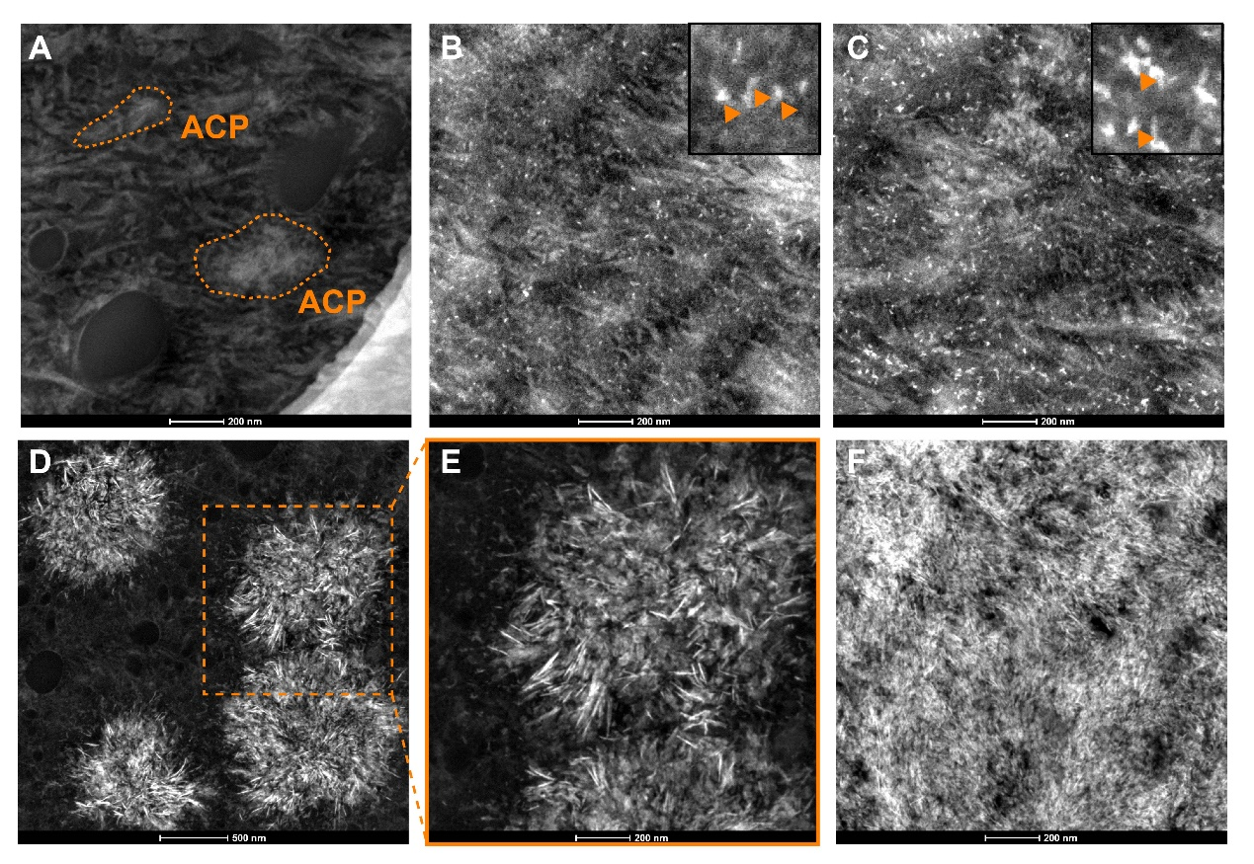
Figure S14: Representative STEM images of tibia GP sample showing the mineralization process of GP-metaphysis interface from A) ACP-like structures to B-C) poorly crystalline nanoparticles, and forming D-E) spherulites and transforming into F) fully mineralized metaphysis tissue, scale bar = 500 nm in D) and 200 nm in A-C, E-F).
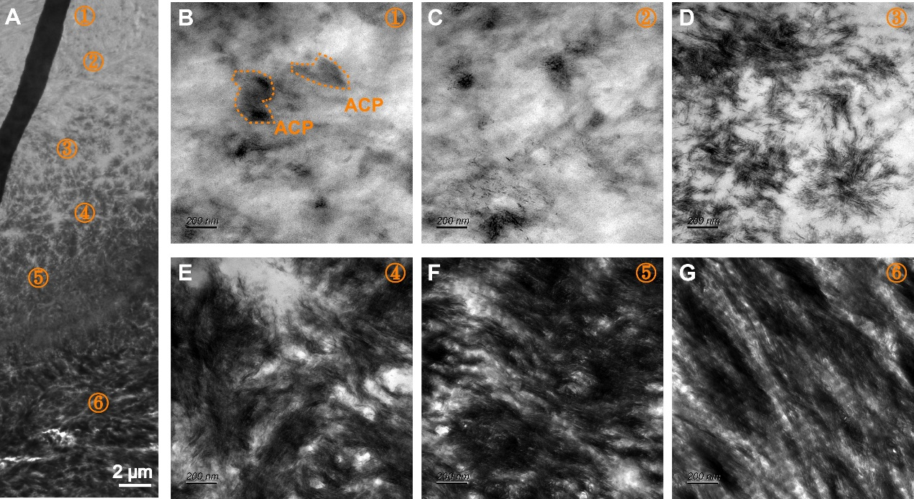
Figure S15: Representative TEM images of GP-metaphysis interface in phalange GP sample showing the gradual mineralization of GP and ACP-like structures B) and spherulitic-like structures D) during biomineralization, scale bar = 2 μm in A) and 200 nm in B-G.
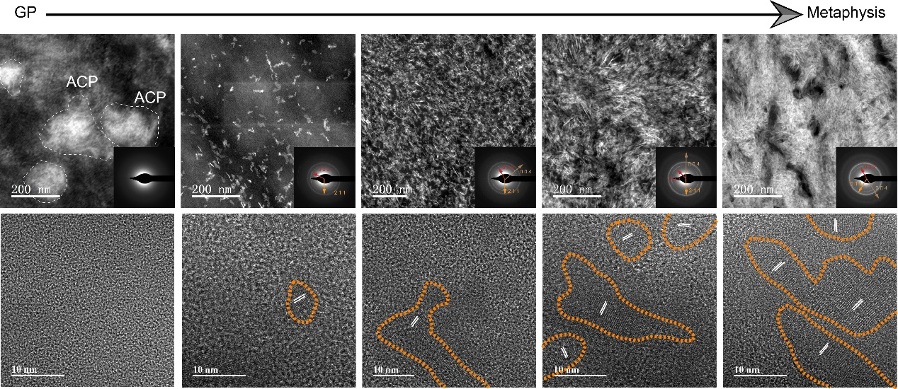
Figure S16: STEM, SAED and HR-TEM images in GP-metaphysis interface region of human phalange tissue, showing the transformation from ACP-like structures to lacy-like HAp, scale bar = 200 nm in STEM images and 10 nm in HR-TEM images.
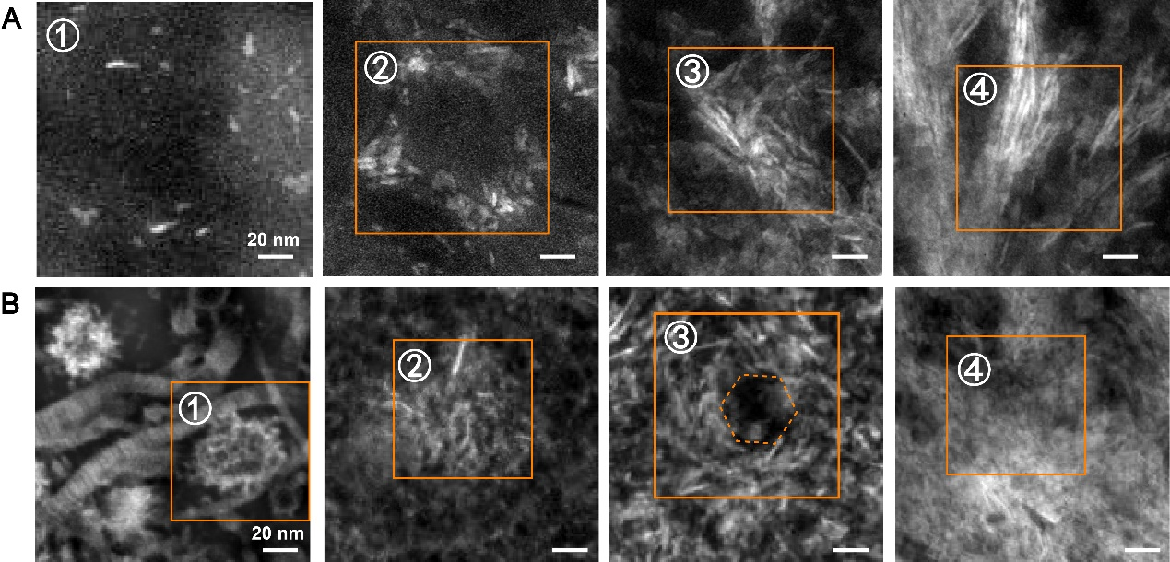
Figure S17: A-B) Representative HHADF-STEM images of minerals from GP-epiphysis A) and metaphysis B), scale bar = 20 nm.
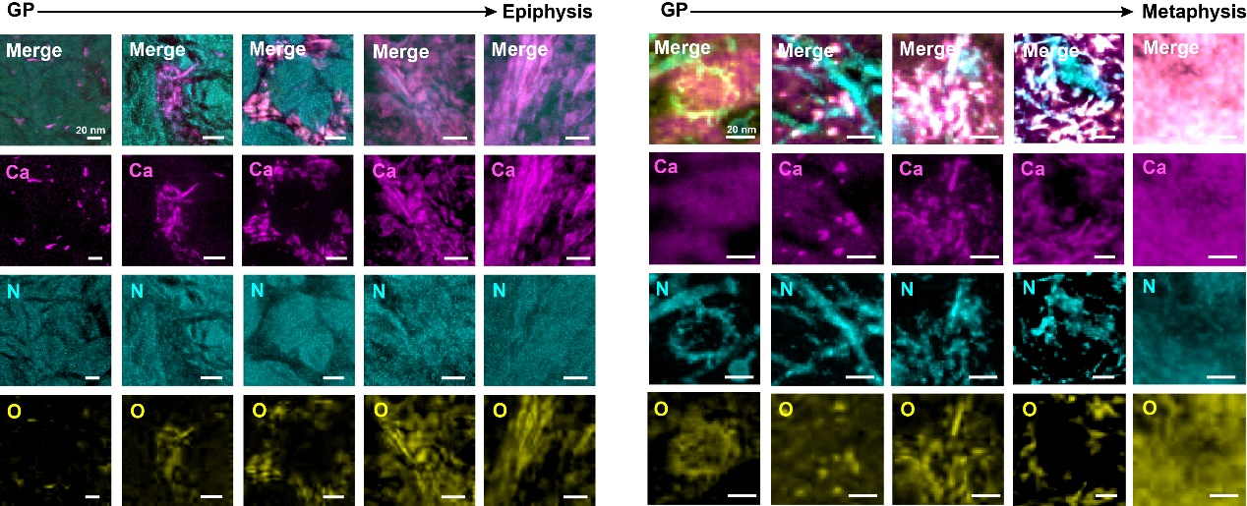
Figure S18: EELS maps corresponding to the spatial distribution of Ca in magenta (collected at Ca L23-edge), O in yellow (collected at O K-edge) and N in cyan (collected at N K-edge) in GP-epiphysis interface and GP-metaphysis interface region, scale bar = 20 nm.
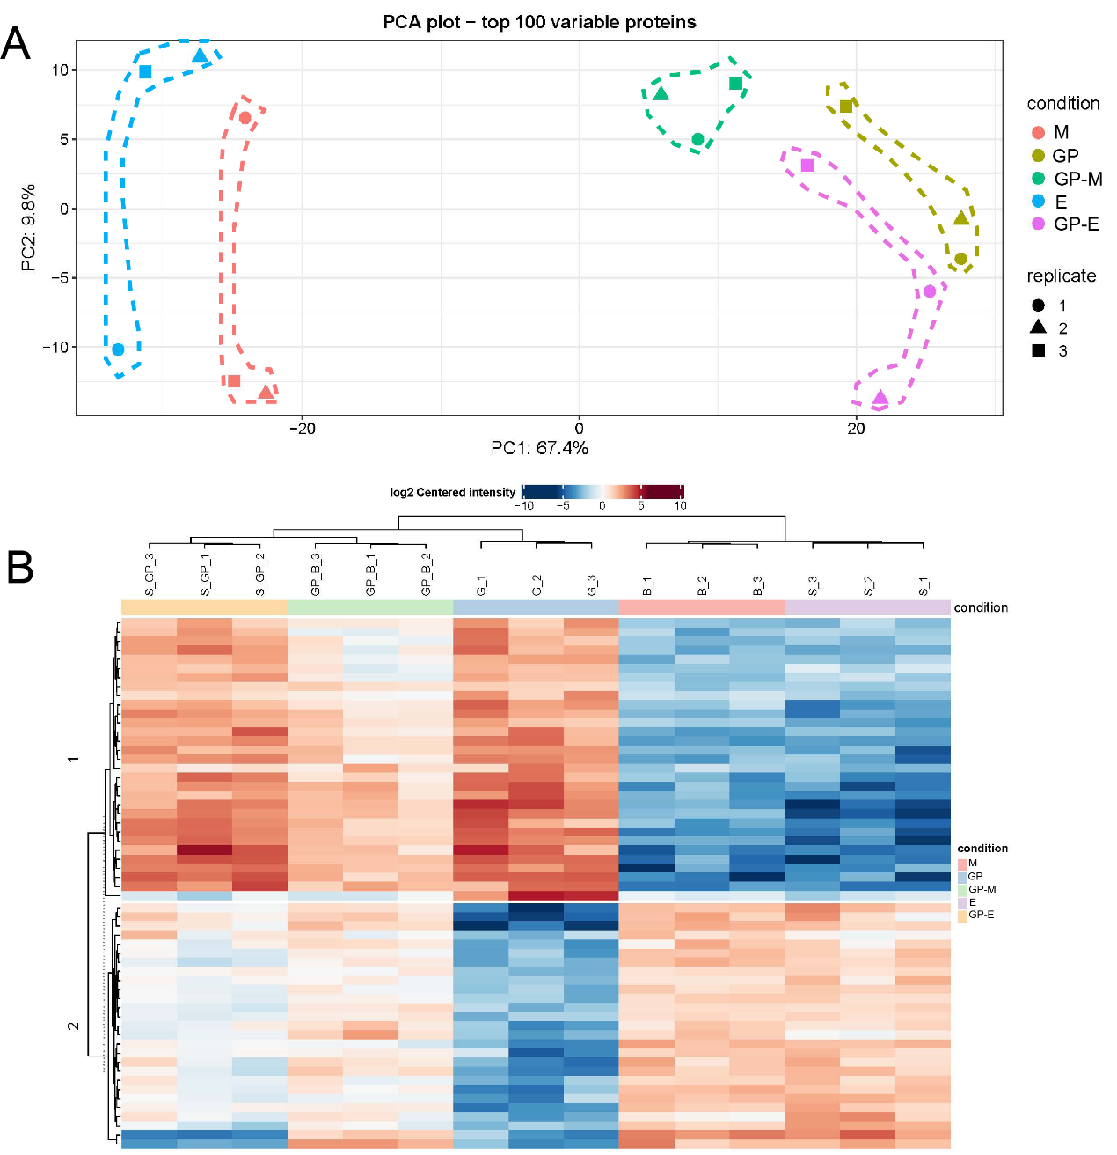
Figure S19: A) The principal component analysis (PCA) of proteomics data and B) heatmap view of proteins identified by proteomics in five groups: epiphysis (E), GP-epiphysis (GP-E), GP, GP-metaphysis (GP-M) and metaphysis (M) tissue.
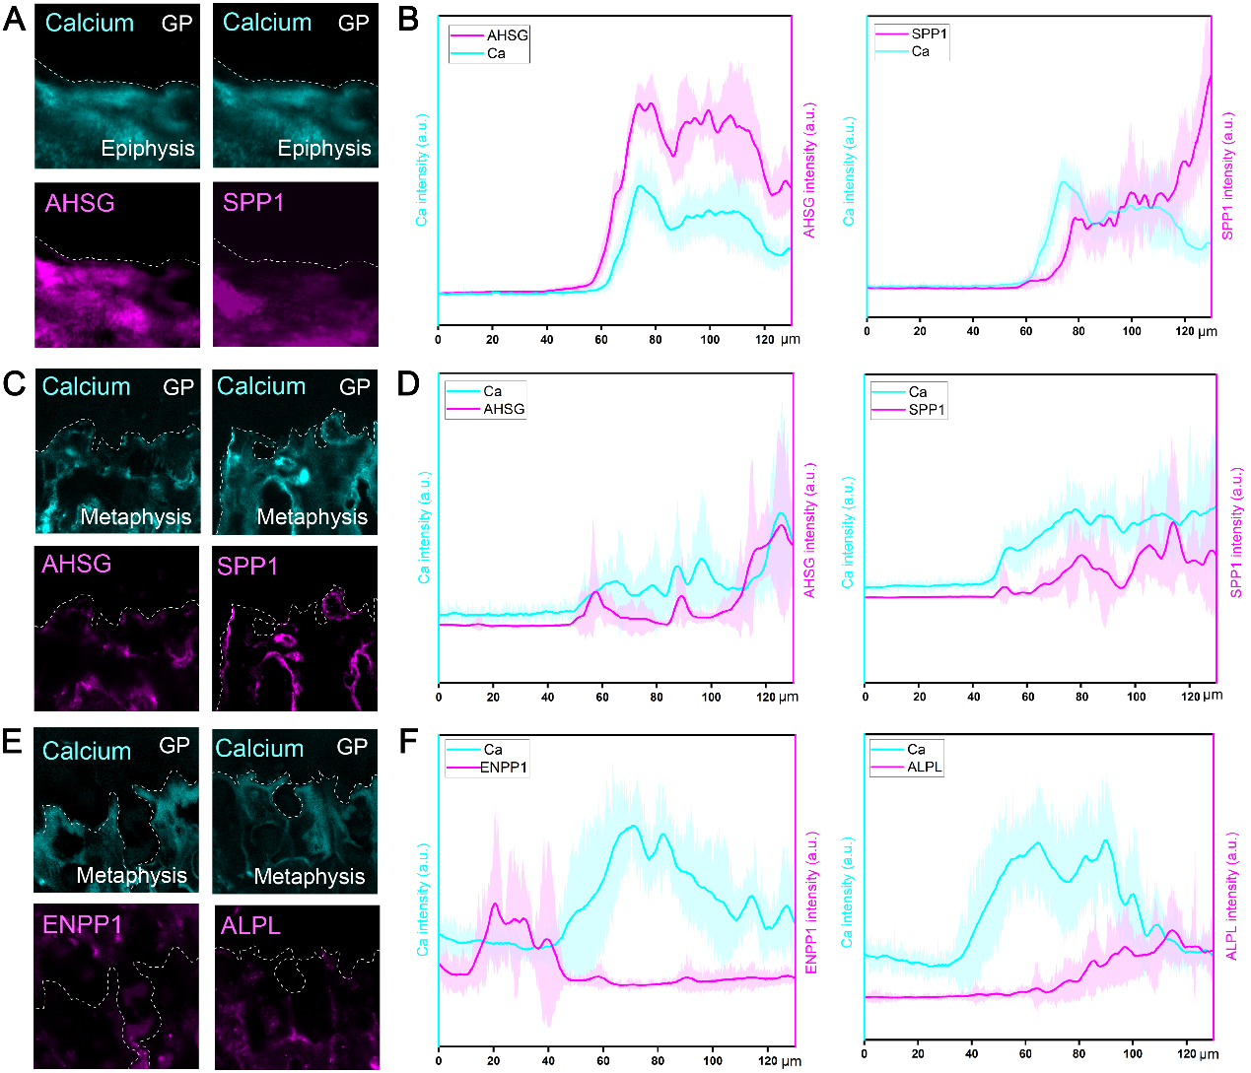
Figure S20: A-B) Representative images of GP-epiphysis interface samples immunostained for AHSG/calcium and SPP1/calcium and corresponding fluorescence intensities plotted over distance across the interface from GP to epiphysis; C-F) Representative images of GP-metaphysis interface samples immunostained for AHSG/calcium, SPP1/calcium, ENPP1/calcium and ALPL/calcium and corresponding fluorescence intensities plotted over distance across the interface from GP to metaphysis, scale bar = 20 μm.
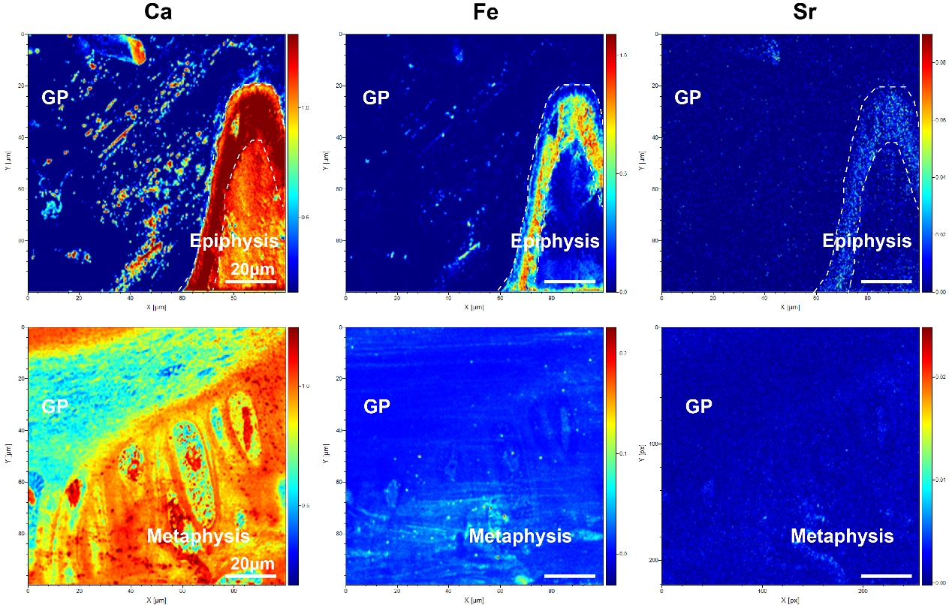
Figure S21: TOF-SIMS images of Ca, Fe and Sr in the region of GP-epiphysis and GP-metaphysis interface, scale bar = 20 μm.
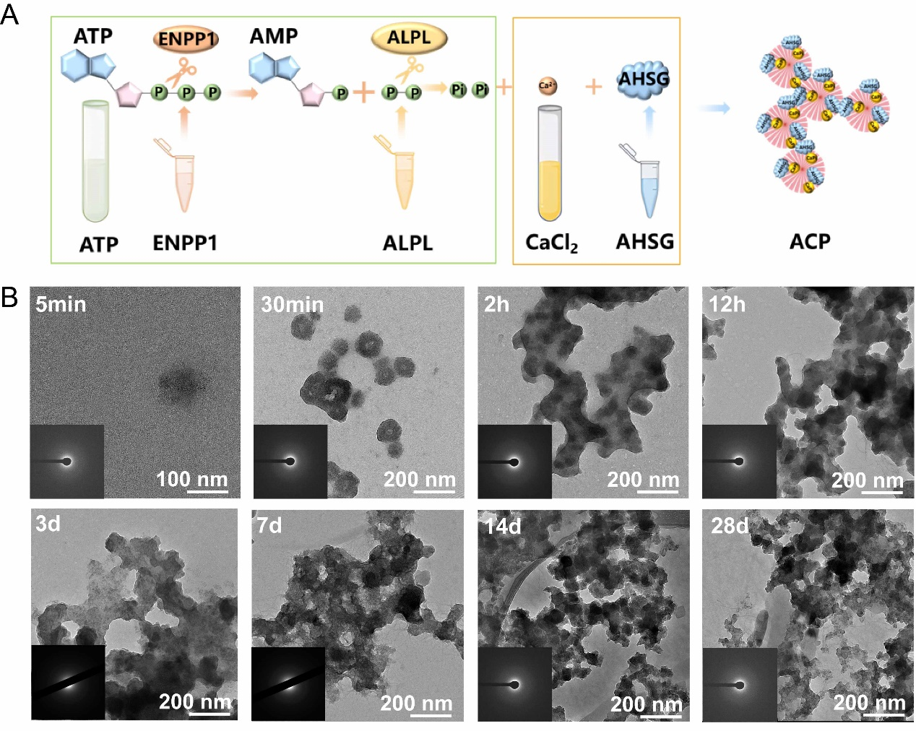
Figure S22: A) Schematic showing the preparation of protein-stabilized ACP; B) Representative cryo-TEM and SAED images of prepared ACP after 5min, 30min, 2h, 12h, 3d, 7d, 14d and 28d of reaction at 37 °C, scale bar = 100/200 nm
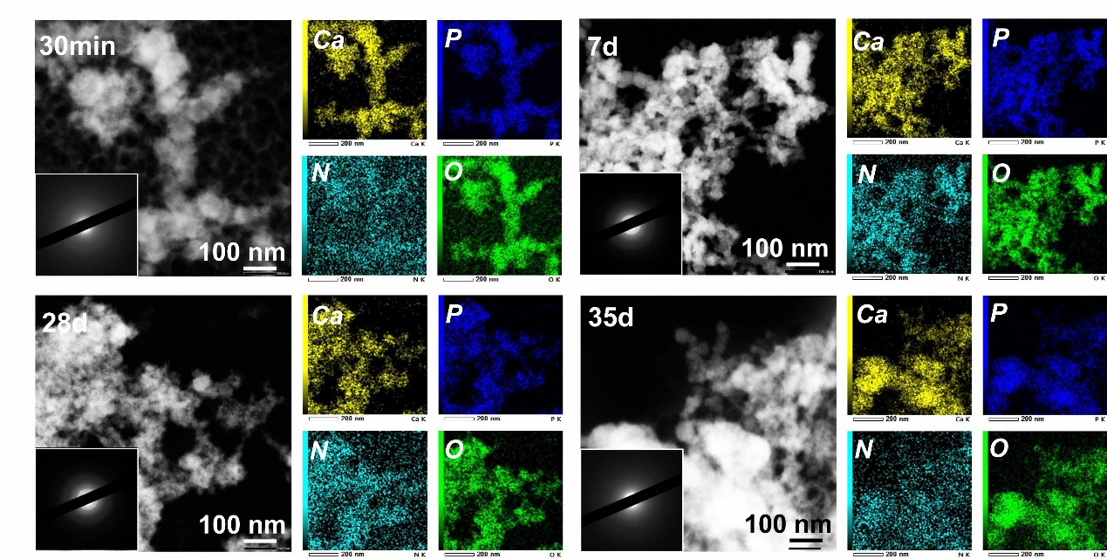
Figure S23: Representative images of STEM images, EDS mapping images of Ca, P, N, O and SAED pattern of the ACP particles after 30min, 7d, 28d and 35d of reaction at 37 °C, scale bar = 100 nm.

Table S1: Sample information
Sample source | Numbering scheme | Age | Gender
Phalange samples | Sample 1 | 8m | Male
Phalange samples | Sample 2 | 1y7m | Male
Phalange samples | Sample 3 | 2y3m | Female
Phalange samples | Sample 4 | 5y4m | Female
Tibia samples | Sample 1 | 6y | Female
Tibia samples | Sample 2 | 6y | Male
Tibia samples | Sample 3 | 10y | Male
Tibia samples | Sample 4 | 10y | Female
Tibia samples | Sample 5 | 13y | Male
Tibia samples | Sample 6 | 14y | Male

Table S2: EELS characteristic features for minerals, organic compounds and resin
Phosphorus | Edge | Approximate energy loss | Description
A | P L₂₃-edge | 138.0 eV | Transitions to p-like states
B | P L₂₃-edge | 141.0 eV | Transitions from 2p state to new state created from due to interactions with calcium 3d orbital function (Characteristic for calcium-containing minerals)
C | P L₂₃-edge | 146.0 eV | Transitions to d-like states
D | P L₂₃-edge | 160.0 eV | Multiple scattering and the maximum 2p state cross section
Carbon
A | C K edge | 284.5 eV | Transitions to vacant π*states in in the carbon-carbon bonding environment (Amorphous Carbon) possibly from the embedding resin
B | C K edge | 287.0 eV | Transitions to the vacant π*state of carbonyl groups possibly from amino acids.
C | C K edge | 290.2 eV | Transitions to the vacant π*-A states of CO₃ groups
D | C K edge | 297.0 eV | Transitions to vacant σ* states in the carbon-carbon bonding environment
Calcium
A | Ca L₂₃-edge | 348.0 eV | Transitions from L₃(2p3/2) to d-like states
B | Ca L₂₃-edge | 351.0 eV | Transitions from L₂(2p1/2) to d-like states
Nitrogen
A | N K edge | 400.0-401.0 eV | 1s-π* transitions
B | N K edge | 408.0 eV | 1s-σ* transitions in amino compounds
Oxygen
A | O K edge | 537.0 eV | Transitions to the vacant π* states of the Ca-O bonding environment
B | O K edge | 539.0 eV | Transitions to the vacant σ* states of the Ca-O bonding environment
C | O K edge | 545.0 eV | Transitions to 4s- and 4p-like states in Ca-O bonds

Movie S1: The displacement magnitude images via DVC processing of GP tissue under compression in XZ plane.
Movie S2: The displacement magnitude images via DVC processing of GP tissue under compression in YZ plane.
Movie S3: The displacement magnitude images via DVC processing of GP tissue under compression in XY plane.

