Maturation, conversion and metabolic profile of somatic embryos derived from Klussia odoratissima Mozaff as affected by light spectra
Khosravi F¹, Rafiei F^{1*}, Ebrahimi M² and Rabiei M¹.
¹Department of Plant Breeding and Biotechnology, College of Agriculture, Shahrekord University,
Shahrekord, Iran
²Department of Plant Tissue Culture, Agricultural Biotechnology Research Institute of Iran‑Isfahan Branch, Agricultural Research, Education and Extension Organization (AREEO), P.O. Box 85135-487, Isfahan, Iran
*Correspondence to: Fariba Rafiei

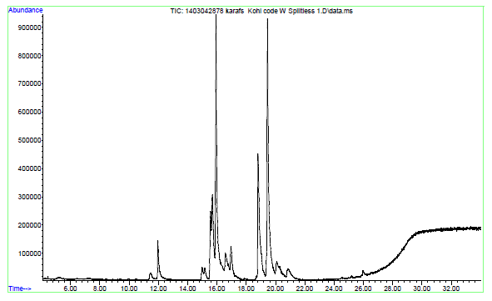
Supplementary Fig. S₁. Chromatogram of Klussia odoratissima culture grown under florescent light treatment

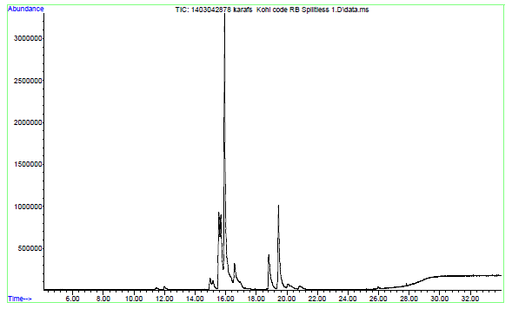
Supplementary Fig. S₃. Chromatogram of Klussia odoratissima culture grown under blue LED treatment

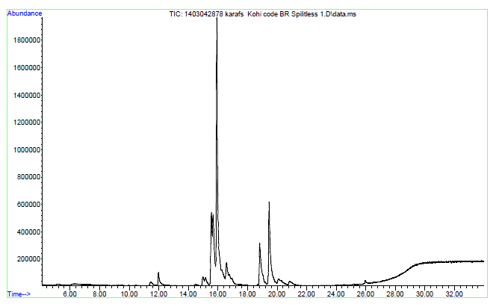
Supplementary Fig. S₄. Chromatogram of Klussia odoratissima culture grown in 3red:1blue LED treatment

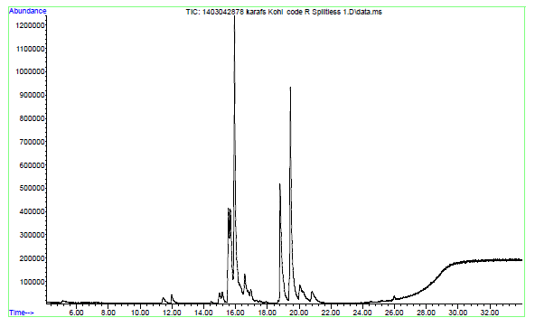
Supplementary Fig. S₅. Chromatogram of Klussia odoratissima culture grown in 3blue:1red LED treatment

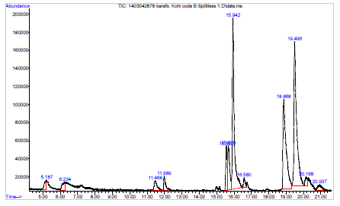
Supplementary Fig. S₂. Chromatogram of Klussia odoratissima culture grown under red LED treatment

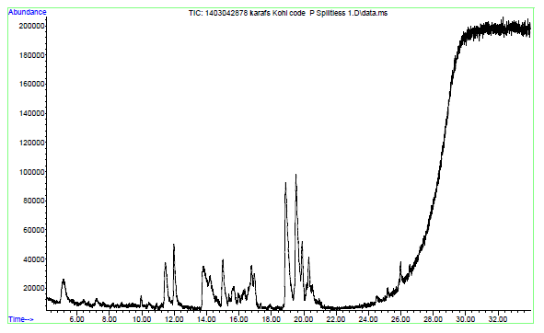
Supplementary Fig. S₆. Chromatogram of air-dry powder of Klussia odoratissima deived from in situ plant

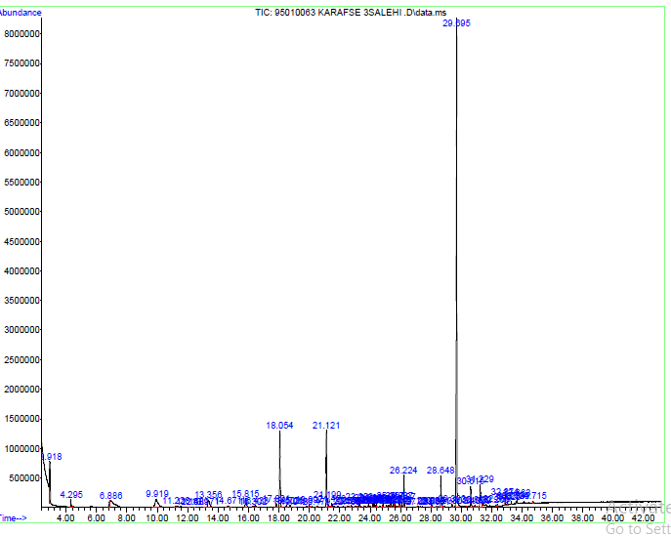
Supplementary Fig. S₇. Chromatogram two-old-month Klussia odoratissima deived from in situ

