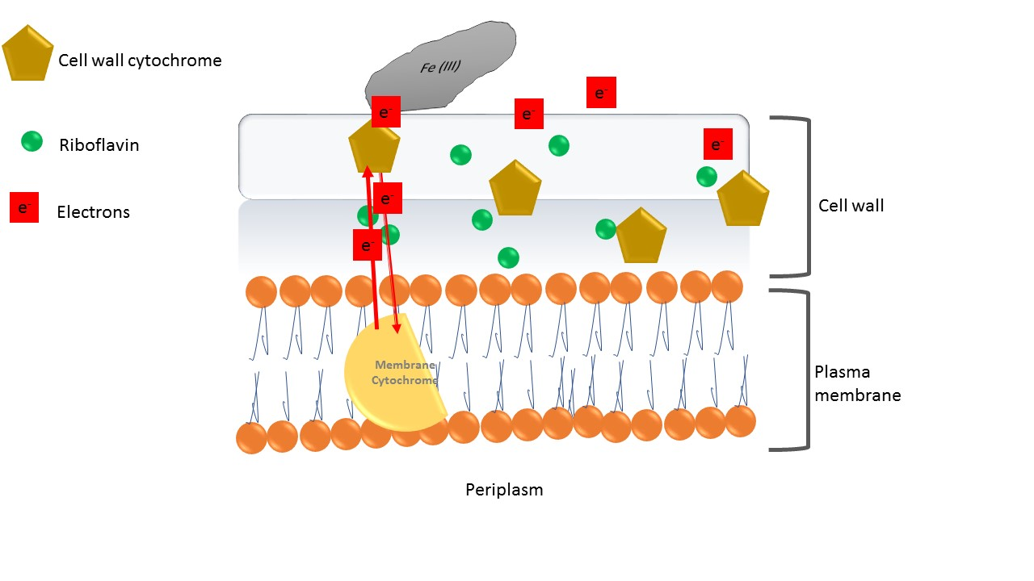
Supplementary information

Fig. S1. The Predicted pathway for electron transport in gram-positive Geobacillus sp. Iso5. The respiratory chain exhibit associated channels in which both riboflavin and cytochrome are directly involved in transfers of electrons extracellularly to the iron surface.

