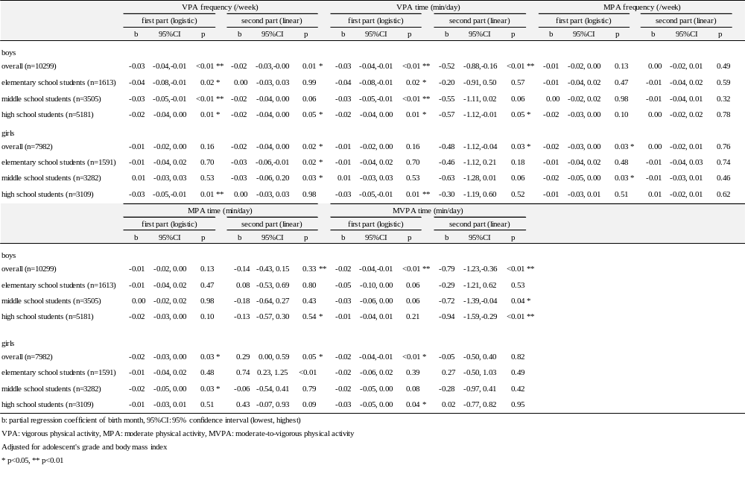Additional file 1. Results of two-part model (physical activity)

