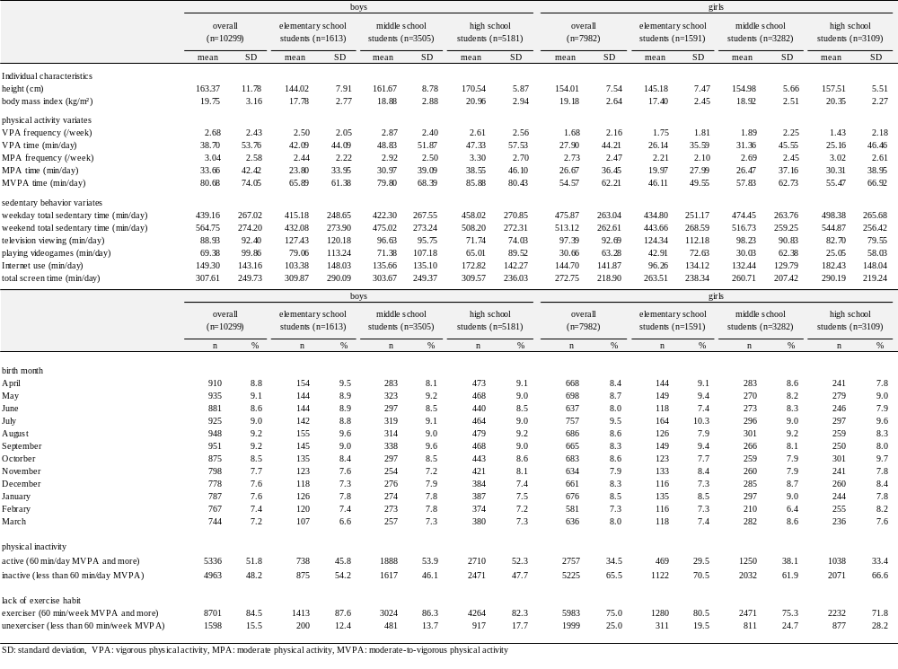Table 1. Characteristics of participants and distribution of the birth month of the participants
SD: standard deviation, VPA: vigorous activity, MPA: moderate physical activity, MVPA: moderate-to-vigorous activity

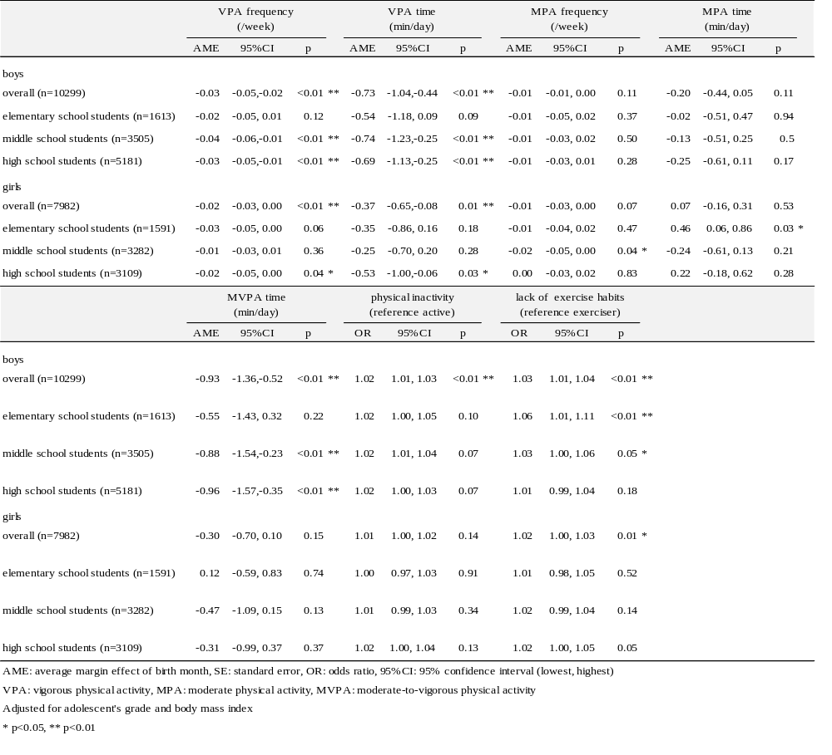Table 2. Existence of the relative age effect on the continuous and dichotomous physical activity of adolescents
AME: average margin effect of birth month, SE: standard error, OR: odds ratio, 95%CI: 95% confidence interval (lowest, highest)
VPA: vigorous physical activity, MPA: moderate physical activity, MVPA: moderate-to-vigorous physical activity
Adjusted for adolescent's grade and body mass index
* p<0.05, ** p<0.01

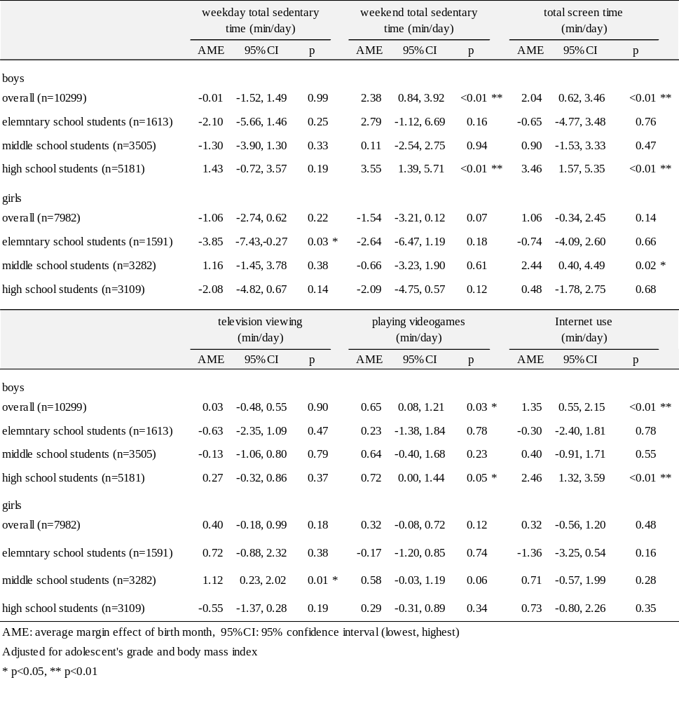Table 3. Existence of relative age effect on the sedentary behavior of adolescents
AME: average margin effect of birth month, 95%CI: 95% confidence interval (lowest, highest)
Adjusted for adolescent's grade and body mass index
* p<0.05, ** p<0.01

