Supplementary Information

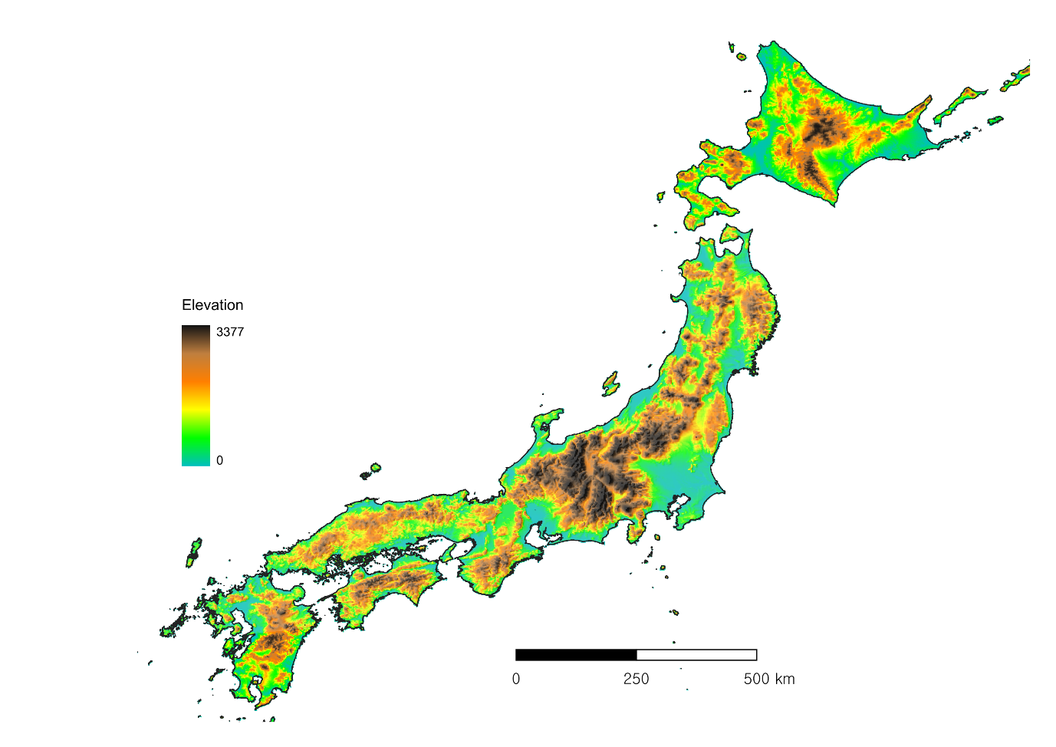
Figure 1. Elevation topographic map of Japan.

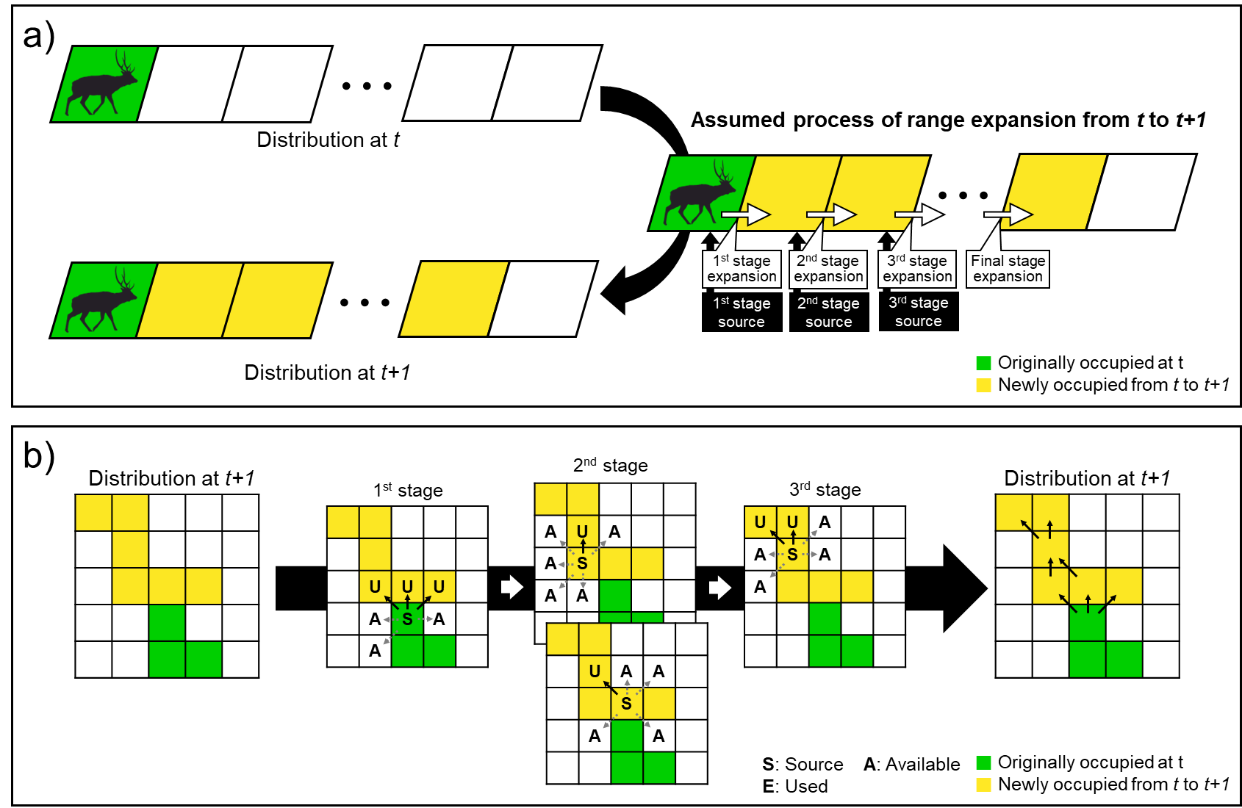
Figure 2. The assumptions for the process of range expansion (a) and the example of the process of range expansion estimated and the definition of each grid cell by applying assumptions (b).

