Supplementary Information for
Highly enhanced room-temperature single-atom catalysis of two-dimensional organic-inorganic multiferroics Cr(half-fluoropyrazine) for CO oxidation Feixiang Zhang^{1†}, Panshuo Wang^{1†}, Yandi Zhu¹, Jinlei Shi^{2,1}, Rui Pang¹, Xiaoyan Ren^{1*}, and Shunfang Li^{1,3*}
¹Key Laboratory of Material Physics, Ministry of Education, School of Physics, Zhengzhou University, Zhengzhou 450001, China
²College of Physics and Electronic Engineering, Zhengzhou Normal University, Zhengzhou 450044, China
³Institute of Quantum Materials and Physics, Henan Academy of Sciences, Zhengzhou 450046, China
*xiaoyren@zzu.edu.cn
*sflizzu@zzu.edu.cn
CONTENTS
I. Activation of O₂ on different Cr sites of Cr(h-fpyz)₂
II. Bader charge analysis of the pristine Cr(h-fpyz)₂ and O₂-Cr(h-fpyz)₂
III. CO oxidation on Cr_{III} reactive site of Cr(h-fpyz)₂
IV. The specific charge and magnetic moment transfer for each element during CO oxidation of Cr(h-fpyz)₂
V. CO oxidation on monoferroic Cr(pyz)₂
VI. Local geometric structures around the Cr reaction site
VII. Origin of the unexpected positive electric field based on the point-charge model
I. Activation of O₂ on different Cr sites of Cr(h-fpyz)₂
Supplementary Fig. 1 | O₂ molecule activation. Optimized local structures of O₂ adsorption on (a) Cr_{I}, (b) Cr_{II}, and (c) Cr_{III} sites of Cr(h-fpyz)₂. The activation O-O bond lengths are also shown. (d) The adsorption energies (black stars) are 1.10 eV, 0.68 eV and 0.36 eV for Cr_{I}, Cr_{II}, and Cr_{III} sites, respectively. The red stars illustrate the corresponding O-O bond lengths.

II. Bader charge analysis of the pristine Cr(h-fpyz)₂ and O₂-Cr(h-fpyz)₂
Supplementary Fig. 2 | Bader charge analysis of the pristine Cr(h-fpyz)₂. Bader charge analysis of the pristine Cr(h-fpyz)₂ (right panel), using their respective atomic charges as reference states. The corresponding atom numbers are shown in the left panel.
Supplementary Fig. 3 | Charge density and spin density of the initial state. a The differential charge density and b spin density map of O₂ and the substrate at a distance of 10 Å, with an iso-surface value of 0.0198 e/Å³. Negligible charge transfer is observed between O₂ and the substrate in the initial state.
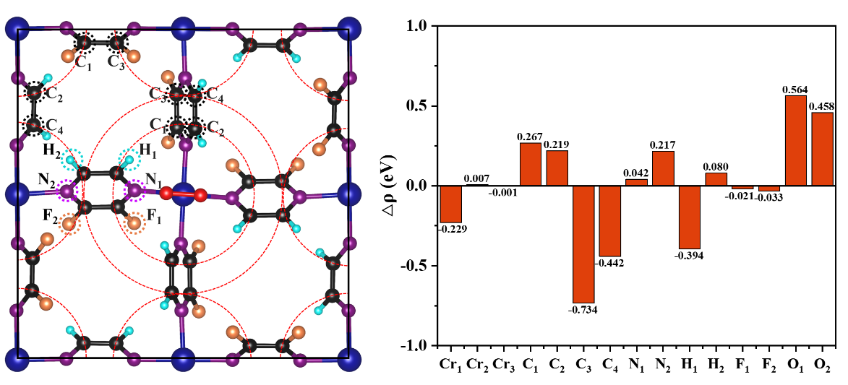
Supplementary Fig. 4 | Bader charge analysis of O₂-Cr(h-fpyz)₂. Specific charge transfer between the substrate and O₂ after O₂ adsorption on the Cr_{I} site. The corresponding atom numbers are shown in the left panel.

III. CO oxidation on Cr_{III} reactive site of Cr(h-fpyz)₂
Supplementary Fig. 5 | Catalytic pathway for CO oxidation on Cr_{III} site. Minimum energy pathway (MEP) for O₂ activation and CO oxidation via the Eley-Rideal (E-R) mechanism on Cr_{III} reactive site in Cr(h-fpyz)₂. The rate-limiting E_{bar} is about 1.0 eV resulting in a low reaction rate of about 1.59×10⁻⁵ s⁻¹ at room temperature.

IV. The specific charge and magnetic moment transfer for each element during CO oxidation of Cr(h-fpyz)₂
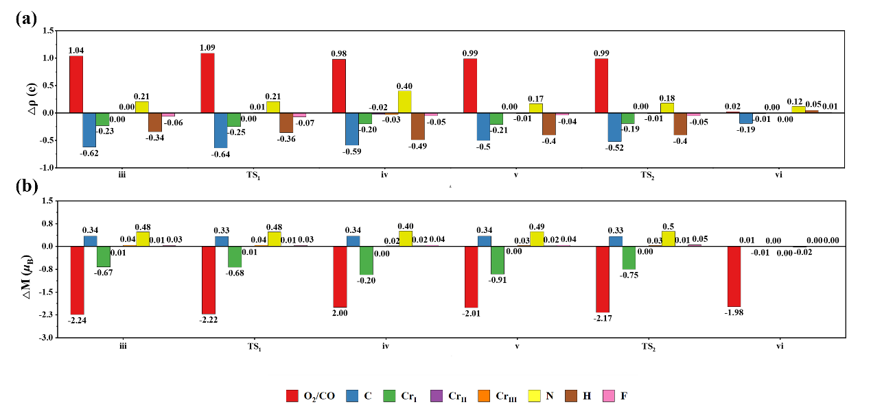
Supplementary Fig. 6 | Changes in charge and magnetic moment for each element. a Charge transfer and b magnetic moment changes for each element of the key steps during catalytic CO oxidation.

Throughout catalytic CO oxidation, O₂ molecules acquire charge from the substrate, facilitating full activation of O₂ crucial for the reaction. Interestingly, it is observed that the primary source of charge is not the Cr atoms at the active site but rather the C atoms (Supplementary Fig. 6a). Regarding changes in magnetic moments, both O₂ molecules and Cr atoms at the active sites experience a reduction in their magnetic moments, which are mainly accommodated by C and N atoms in the substrate (Supplementary Fig. 6b).

V. CO oxidation on monoferroic Cr(pyz)₂
Supplementary Fig. 7 | Optimized geometric structure of the 2D Cr(pyz)₂. a Top view of Cr(pyz)₂. The red arrow indicates the tilted orientation of the pyz ligands. b Side view of Cr(pyz)₂. c Side view of the optimal structure of O₂ adsorption on Cr(pyz)₂, with the O-O bond lengths marked.

Supplementary Fig. 8 | Catalytic pathway for CO oxidation of Cr(pyz)₂. Minimum energy pathway (MEP) for O₂ activation and CO oxidation via the E-R mechanism on Cr reactive site in Cr(pyz)₂.

VI. Local geometric structures around the Cr reaction site
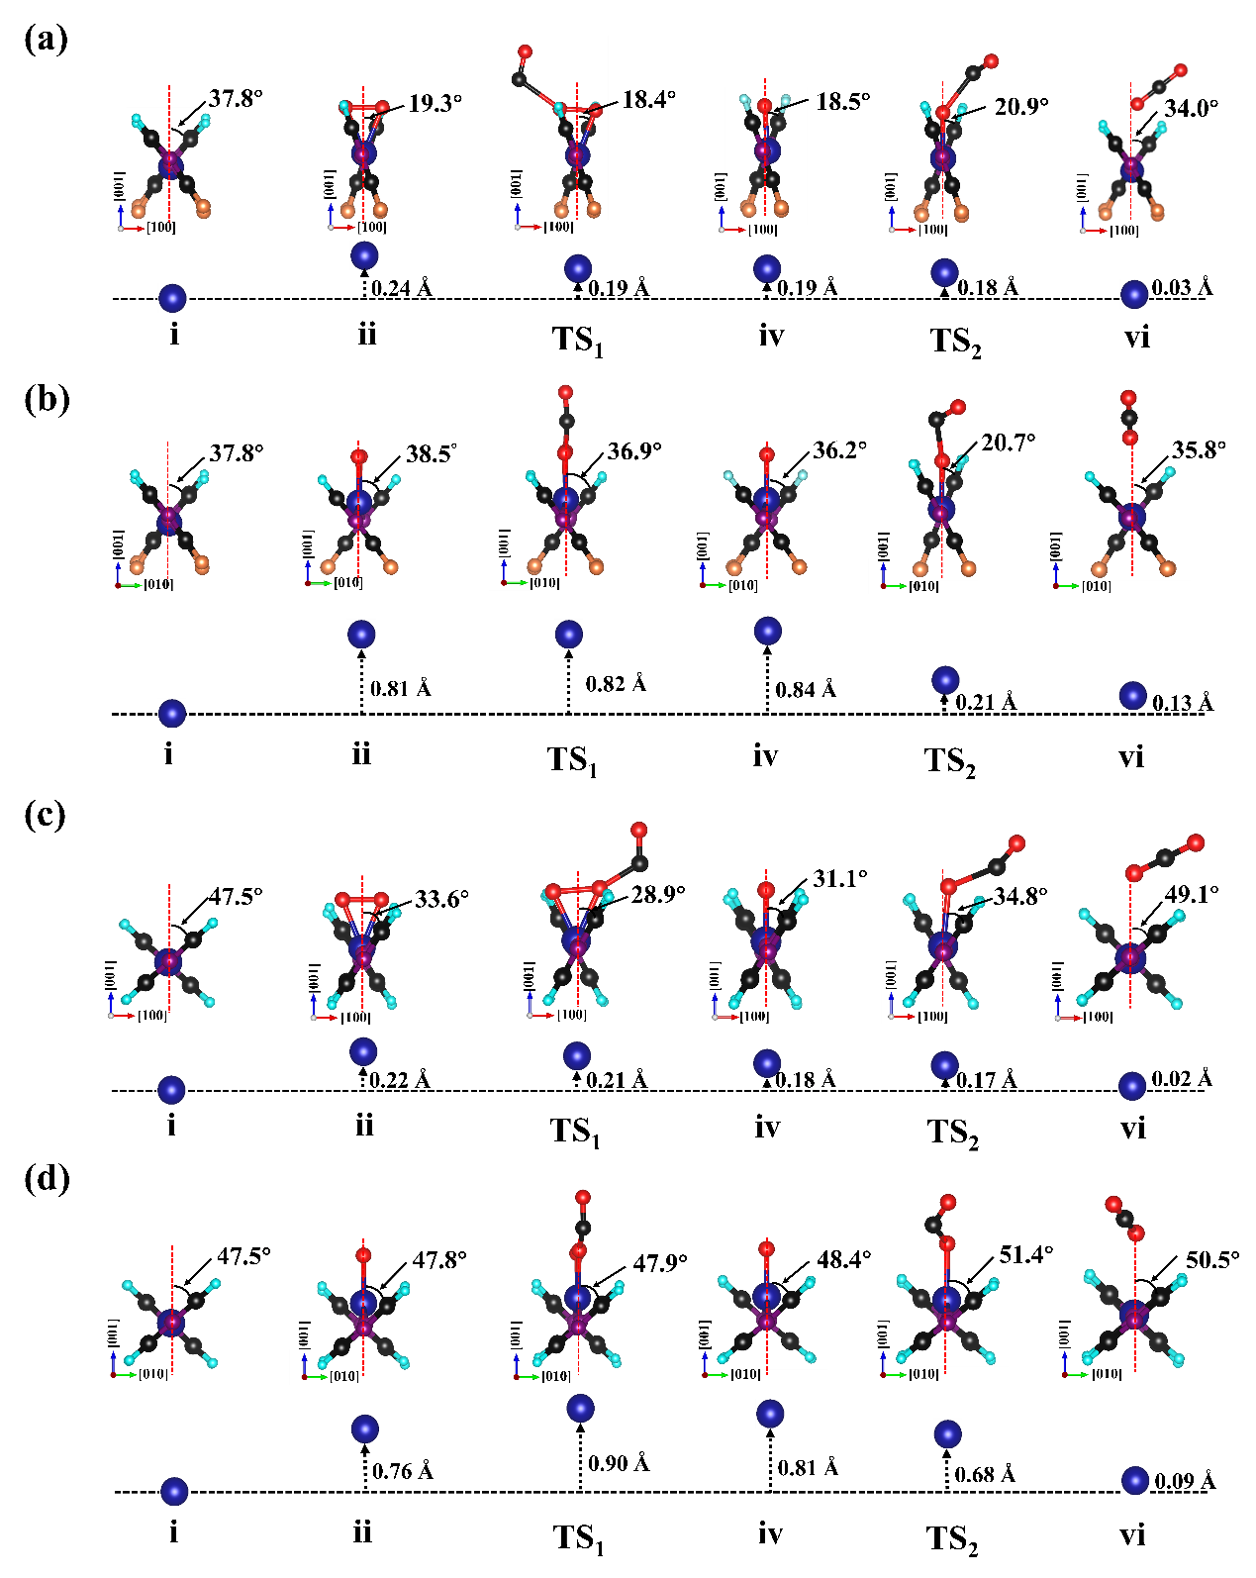
Supplementary Fig. 9 | Local structural changes around the active sites of Cr(h-fpyz)₂ and Cr(pyz)₂. Local geometric structures around the Cr reactive site of the (a-b) multiferroic Cr(h-fpyz)₂ and (c-d) monoferroic Cr(pyz)₂ of the key steps of CO oxidation viewed from the (a, c) [010] and (b, d) [100] directions, respectively. The lower panels illustrate the displacements of the Cr atoms along the [001] direction relative to the distinct mass centers of the N atoms along the (a, c) [010] and (b, d) [100] directions, respectively.
Supplementary Fig. 10 | Local structures without the rotations of ligands around the active sites of Cr(h-fpyz)₂ and Cr(pyz)₂. Local geometric structures around the Cr reactive site of the (a) multiferroic Cr(h-fpyz)₂ and (b) monoferroic Cr(pyz)₂ of the step i, ii, and TS₁ of CO oxidation, where the angles of the organic ligands and the positions of Cr atoms are fixed to that in the pristine Cr(h-fpyz)₂ and Cr(pyz)₂.

VII. Origin of the unexpected positive electric field based on the point-charge model
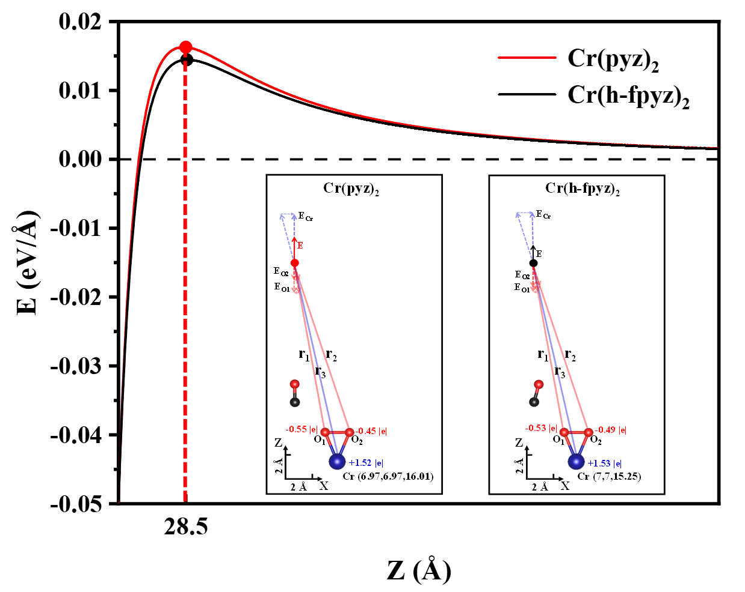
Supplementary Fig. 11 | Local electrical field profiles based on the point-charge model. Local electrical field profiles along the z direction of multiferroic Cr(h-fpyz)₂ (black line) and monoferroic Cr(pyz)₂ (red line) based on the point-charge model. The insets illustrate the relative positions and charge quantities of Cr, O₁ and O₂ atoms. The positions with maximum positive electric fields are indicated by black and red dots for Cr(h-fpyz)₂ and Cr(pyz)₂, respectively.

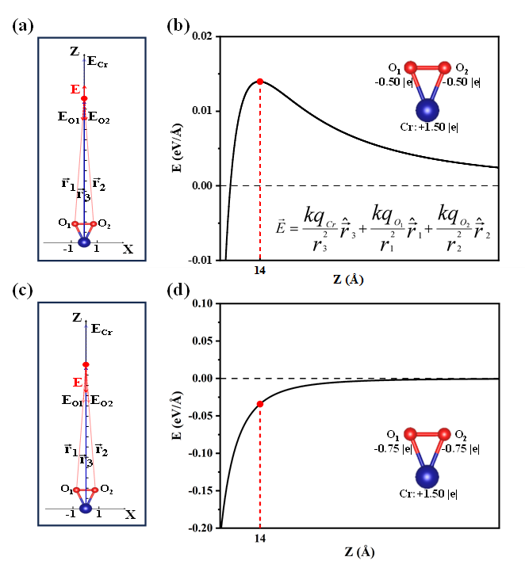
Supplementary Fig. 12 | Origin of the unexpected positive electric field. Comparison of the local electric field profiles of the (a-b) asymmetric and (c-d) symmetric charge distributions. The asymmetric charge distribution leads to an unexpected positive electric field along the z direction based on the point-charge model.

To investigate why the local electric field generated by monoferroic Cr(pyz)₂ is greater than that of multiferroic Cr(h-fpyz)₂, we conducted simulations based on a point-charge model using the charge quantities obtained from Bader charge analysis of Cr_{I} and O₂. The relative positions and charge quantities of Cr, O₁ and O₂ atoms are illustrated in the inset of Supplementary Fig. 11. We selected points along the line where CO is in its transition state during the rate-determining step of CO oxidation as test locations to fully simulate the actual scenario. The local electrical field profiles along the z direction of multiferroic Cr(h-fpyz)₂ (black line) and monoferroic Cr(pyz)₂ (red line) (Supplementary Fig. 11). We found that at a position of 28.5 Å, both materials exhibited a positive electric field, with the simulated electric field of O₂/Cr(pyz)₂ being greater than that of O₂/Cr(h-fpyz)₂. This difference is attributed to the additional negative charge carried by O₂ on Cr(h-fpyz)₂ compared to Cr(pyz)₂. This result is consistent with our DFT calculations. However, the positions where the maximum positive electric field appears of the point-charge model are slightly different from those obtained from DFT calculations, likely due to the screening effect and ligand atoms.
Furthermore, to elucidate the origin of the unexpected positive electric field above O₂, we compared the electric field distributions of two artificially designed charge distributions. Surprisingly, for the asymmetric charge distribution (i.e., 1.50 |e| for Cr, -0.50 |e| for O₁ and O₂), a positive electric field appears when the distance between the observation point and O₂ exceeds a critical distance, reaching its maximum value at 14 Å (Supplementary Fig. 12). However, with symmetric charge distributions, the positive electric field never appears (Supplementary Fig. 12).

