Supplementary information:

Increasing sensitivity of winter wheat yield to snow drought
Huijiao Chen¹, Shuo Wang^{1,}*, Peng Zhu², Amir AghaKouchak^{3,4,5}
- Research Institute for Sustainable Urban Development, The Hong Kong Polytechnic University, Hong Kong SAR, China
- Department of Geography, The University of Hong Kong, Hong Kong SAR, China
- Department of Civil and Environmental Engineering, University of California, Irvine, CA, USA
- Department of Earth System Science, University of California, Irvine, CA, USA
- United Nations University, Institute for Water, Environment and Health, United Nations University, Hamilton, ON, Canada
*Corresponding author: Shuo Wang (shuo.s.wang@polyu.edu.hk)

Contents
Supplementary Figures. 1−19
Supplementary Tables 1−3
Supplementary References

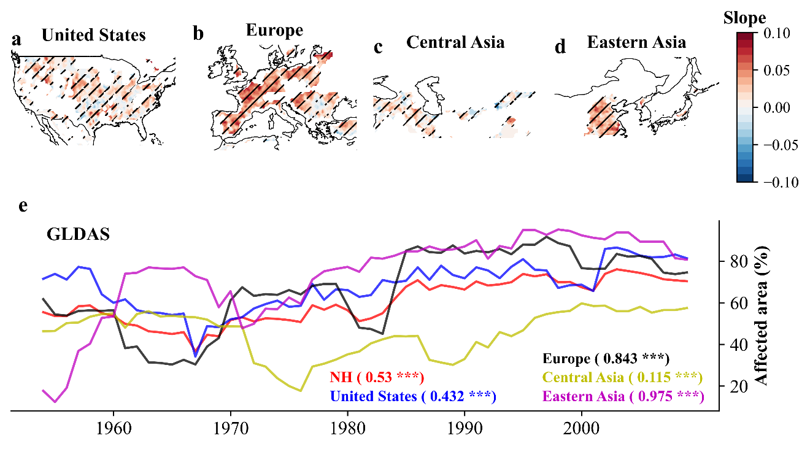

Supplementary Fig. S1. Same as Fig. 1, but for the GLDAS dataset.

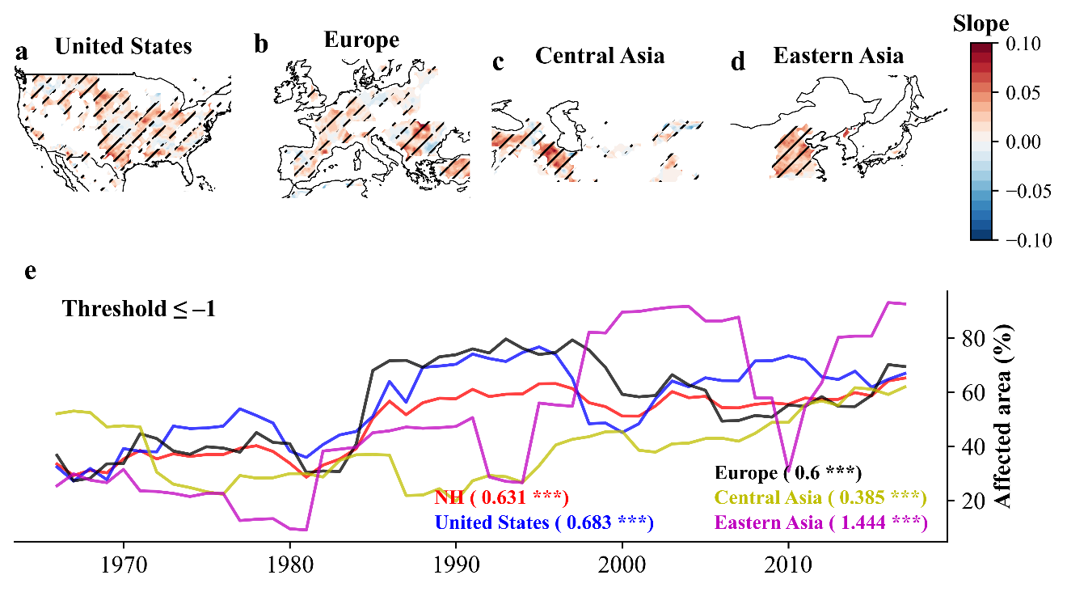

Supplementary Fig. S2. Same as Fig. 1, but snow drought is defined as the SWEI values below −1.

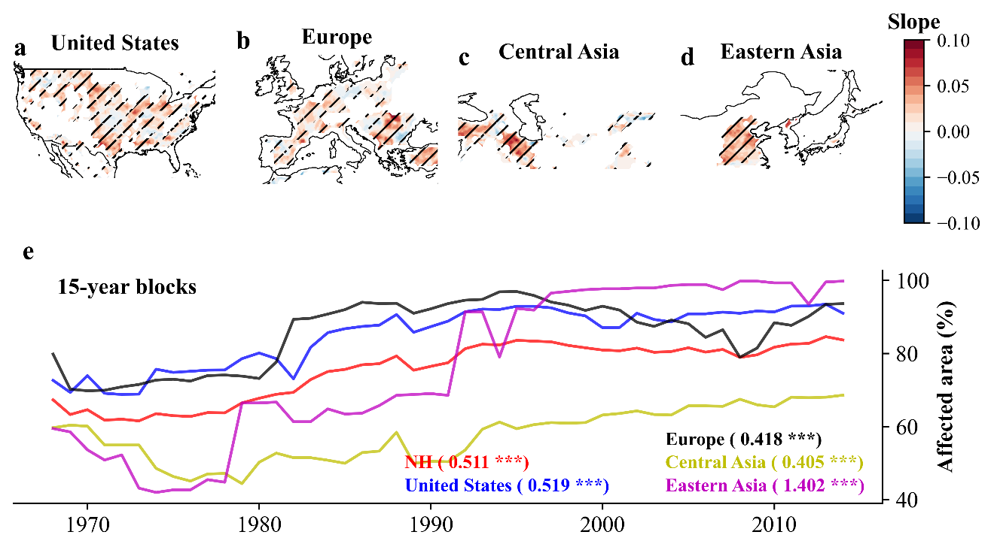

Supplementary Fig. S3. Same as Fig. 1, but temporal evolution of the snow drought-affected area of croplands (%) using 15-year blocks.

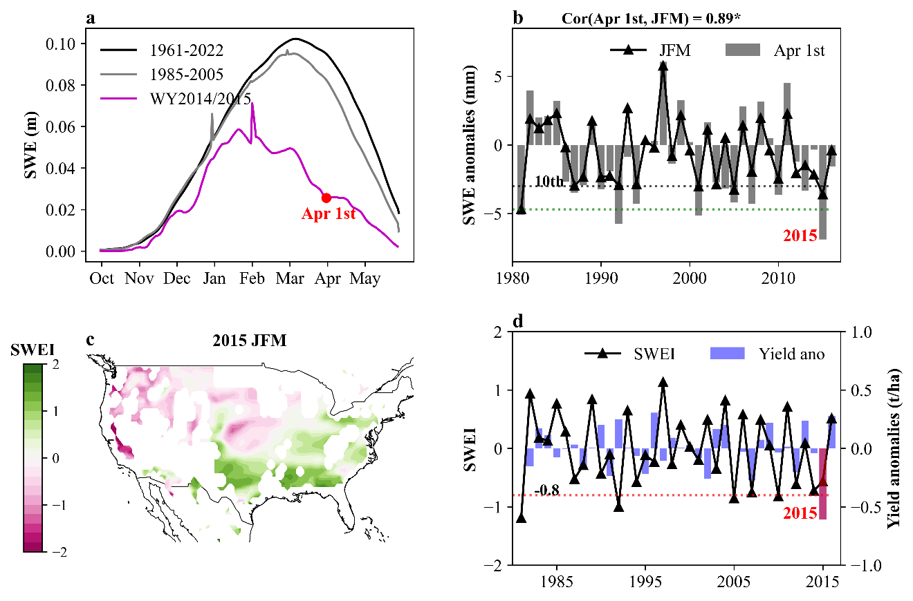

Supplementary Fig. S4. The case of snow drought events in water year (WY) 2014/15 across western United States. Common definitions of snow drought from literatures across western United States. The black line indicates daily climatological median SWE while the pink line indicates the daily SWE in 2014/15. This example illustrates different ways to assess that year’s snow drought. a dot highlights the magnitude of 1 April SWE¹. b line indicates the 3-month sum of daily SWE for the months of January, February, and March (JFM). The number indicates that significantly close relationship between SWE in 1 April and 3-month sum of daily SWE (JFM). “*” indicates the correlation is statistically significant at the level of 0.05. c Standardized SWE index (SWEI) is based on 3-month (JFM) sum of daily SWE². d temporal evolution of SWEI and winter wheat yield anomalies during 1982‒2016 across the western United States. Yield anomalies is estimated by subtracting the trends by the LOESS regression. The red bar highlights the severe yield loss in 2015 across western United States.

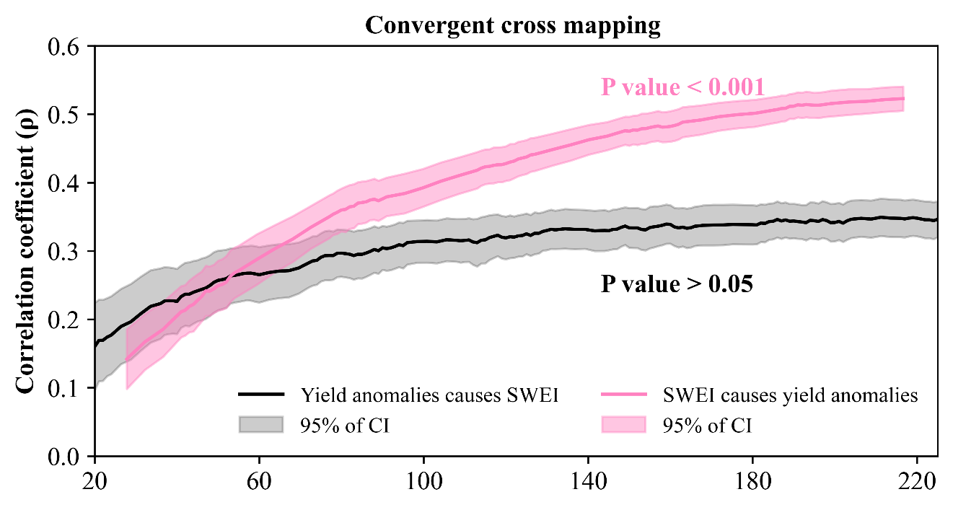

Supplementary Fig. S5 Detection of climate-crop causal mechanisms using convergent cross mapping (CCM). Causal relationships of snow anomalies (SWEI) and yield anomalies. The x axis represents the time-series length. The shaded regions show mean ± SD from bootstrapped iterations.

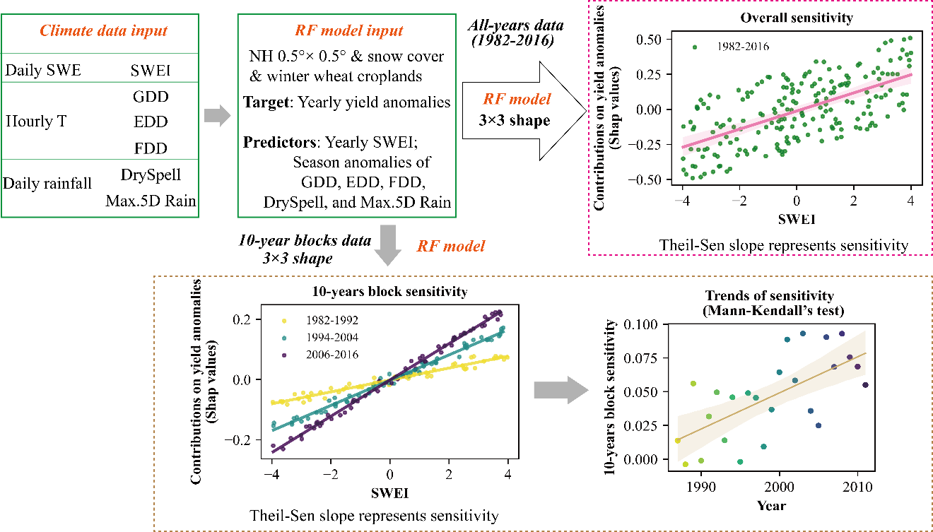

Supplementary Fig. S6. The flow chat of data-processing and sensitivity of winter wheat yield to SWEI. Details can be found in Methods, including Climate data, Identification of snow drought, Data pre-processing, Overall sensitivity of winter wheat yield to SWEI, and Trends of sensitivity of winter wheat yield to SWEI, respectively. Season climate extreme indices anomalies and SWEI are the predictor variables and winter wheat yield anomaly is as the target variable. Random forest model (RF model) and SHAP values are used to isolated contributions of SWEI to yield for each 3×3 grid shape, and the Theil-sen regression is used to estimate the linear sensitivity of winter wheat yield to SWEI from all-years data and 10-year-block data, respectively. To note that the values of x and y axes do not have any real meaning. SWE (mm) denotes snow water equivalent. T (°C) denotes temperature. GDD (℃d) denotes growing degree days between the base and optimum growth temperature thresholds. EDD (℃d) denotes extreme growing degree days above the optimum growing temperature thresholds. FDD (℃d) denotes freezing growing degree days below the freezing growing temperature thresholds. Rainfall (mm) is partitioned from precipitation using the empirical model (Eq. 4). DrySpell (days) denotes the maximum number of consecutive days with no rainfall. Max.5D Rain (mm) represents the maximum accumulative rainfall in a five-day period.

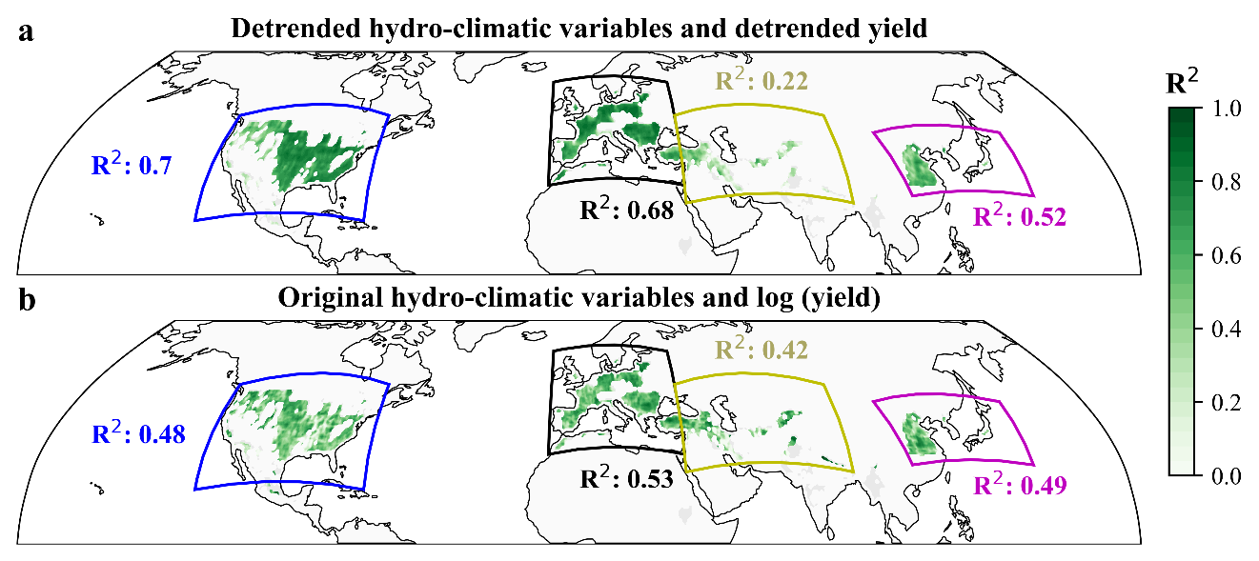

Supplementary Fig. S7. Spatial distribution of the performance (out-of-bag R²) of random forest models predicting winter wheat yield based on a de-trended hydro-climatic variables and b original hydro-climatic variables.

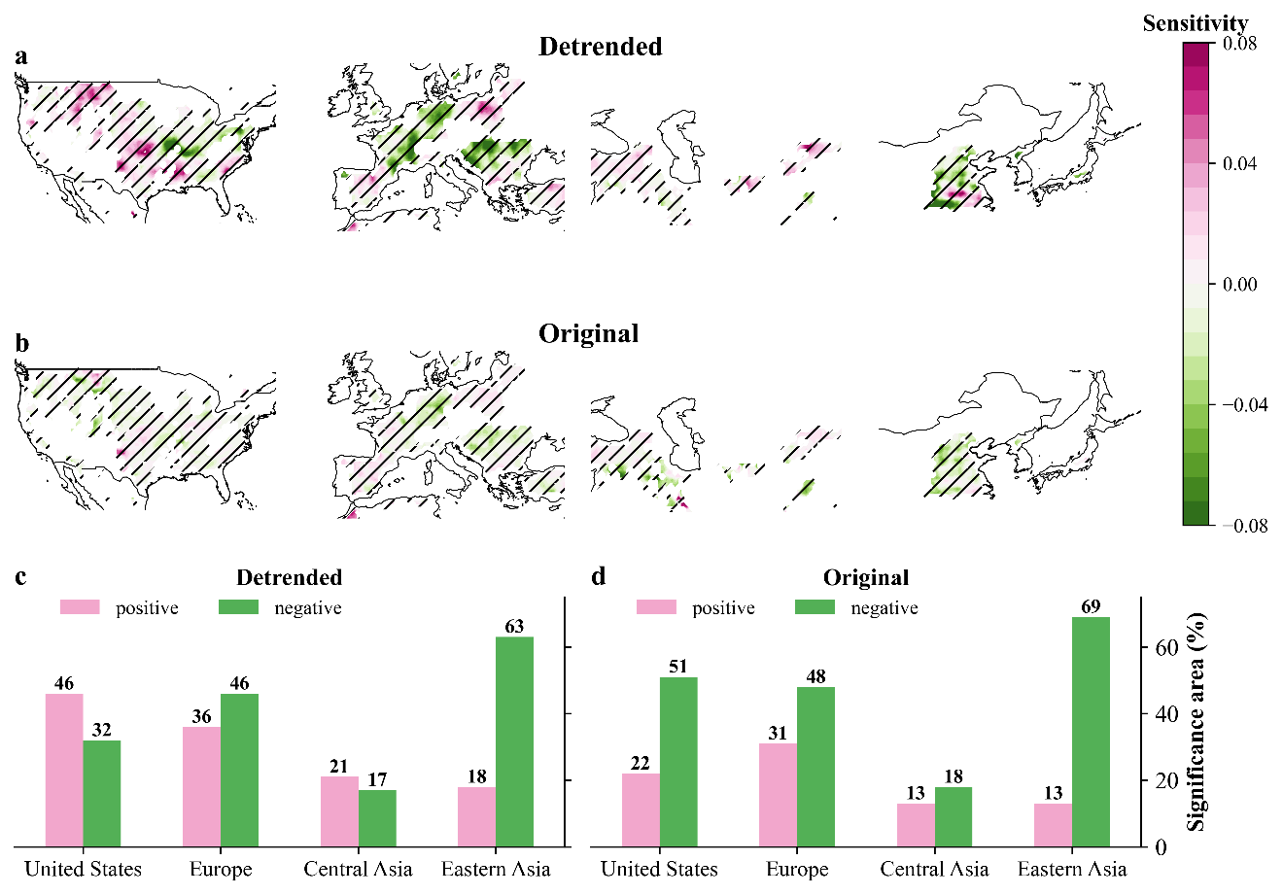

Supplementary Fig. S8. Same as Fig. 2, But for comparison between detrended climate extreme indices and original climate extreme indices.

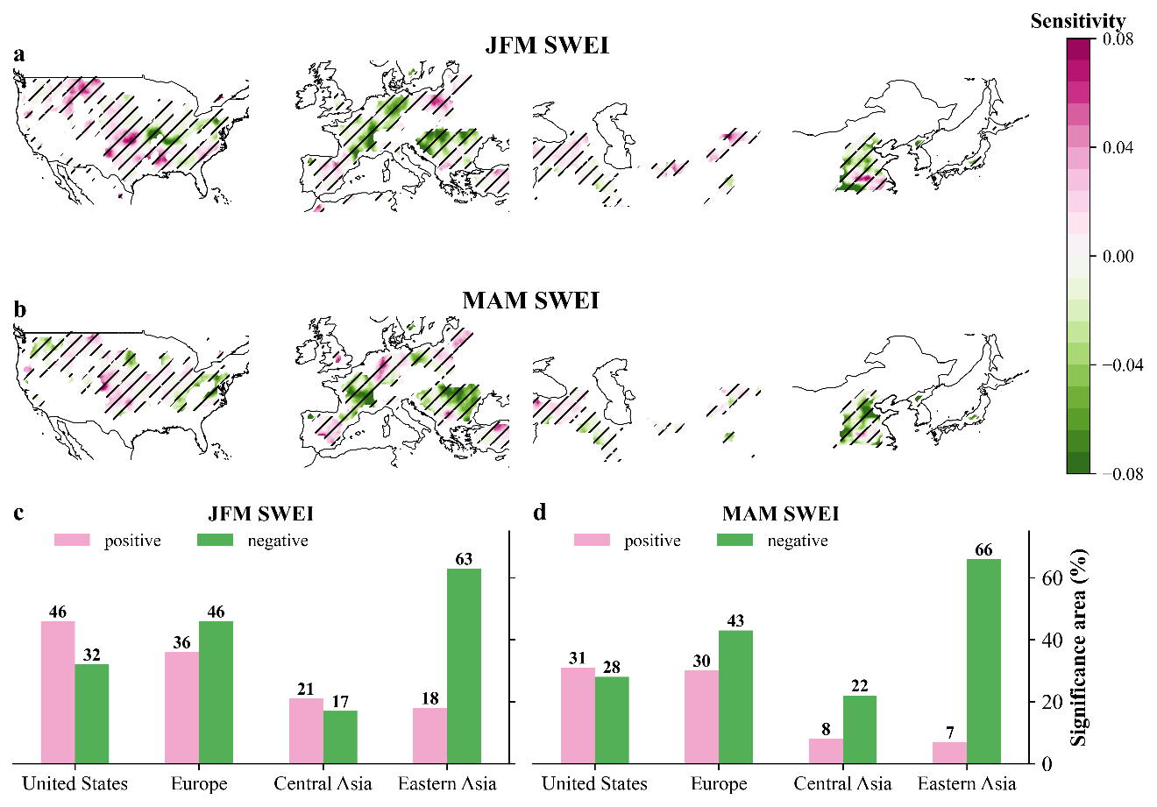

Supplementary Fig. S9. Same as Fig. 2, But for comparison between January-February-March (JFM) SWEI and March-April-May (MAM) SWEI.

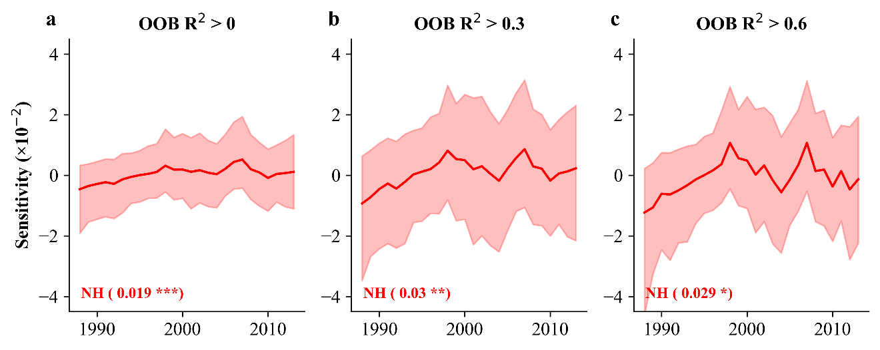

Supplementary Fig. S10. Same as Fig. 3a, but for different thresholds of out-of-bag (OOB) R² selected, including OOB R² > 0, OOB R²> 0.3, and OOB R²> 0.6.

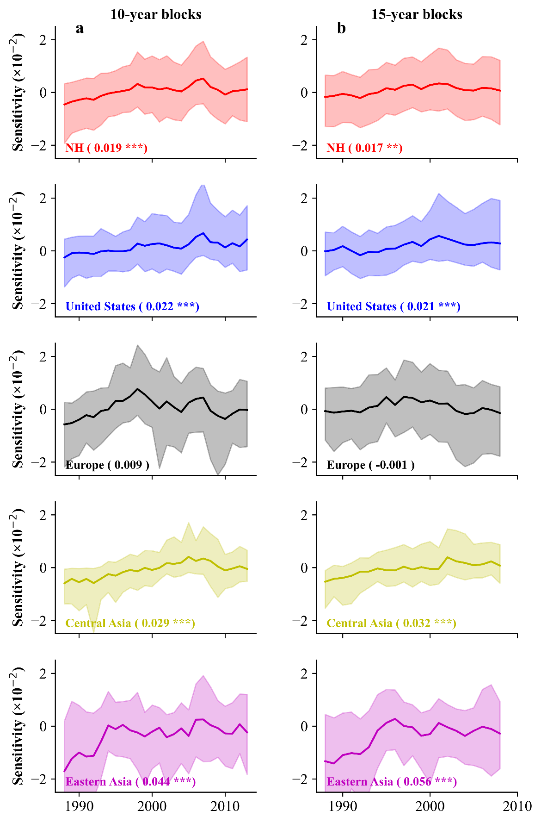

Supplementary Fig. S11. Same as Fig. 3a, But for the comparison between 10-year blocks and 15-year blocks.

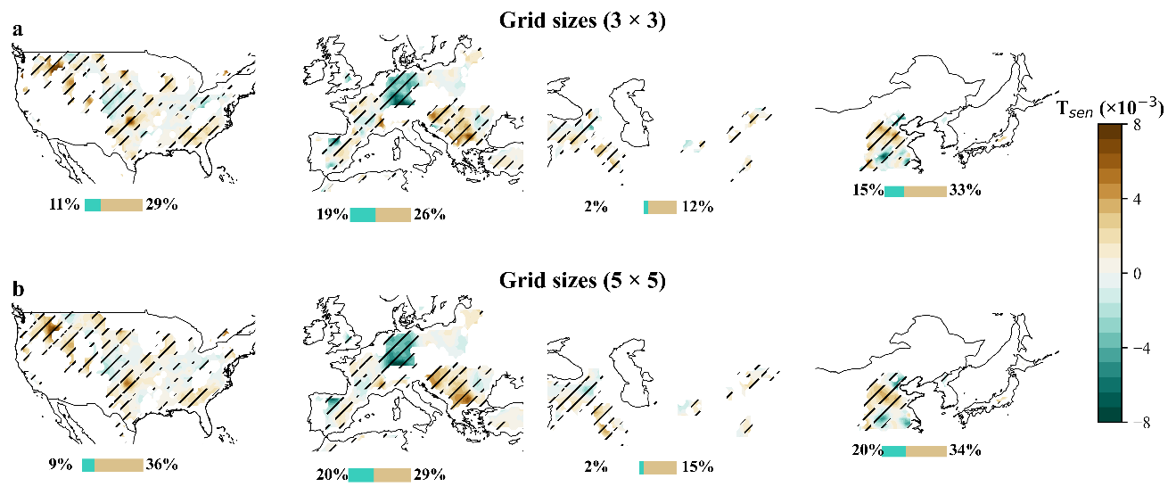

Supplementary Fig. S12 Same as Fig. 3, But for comparison between different grid sizes of 3×3 and of 5×5.

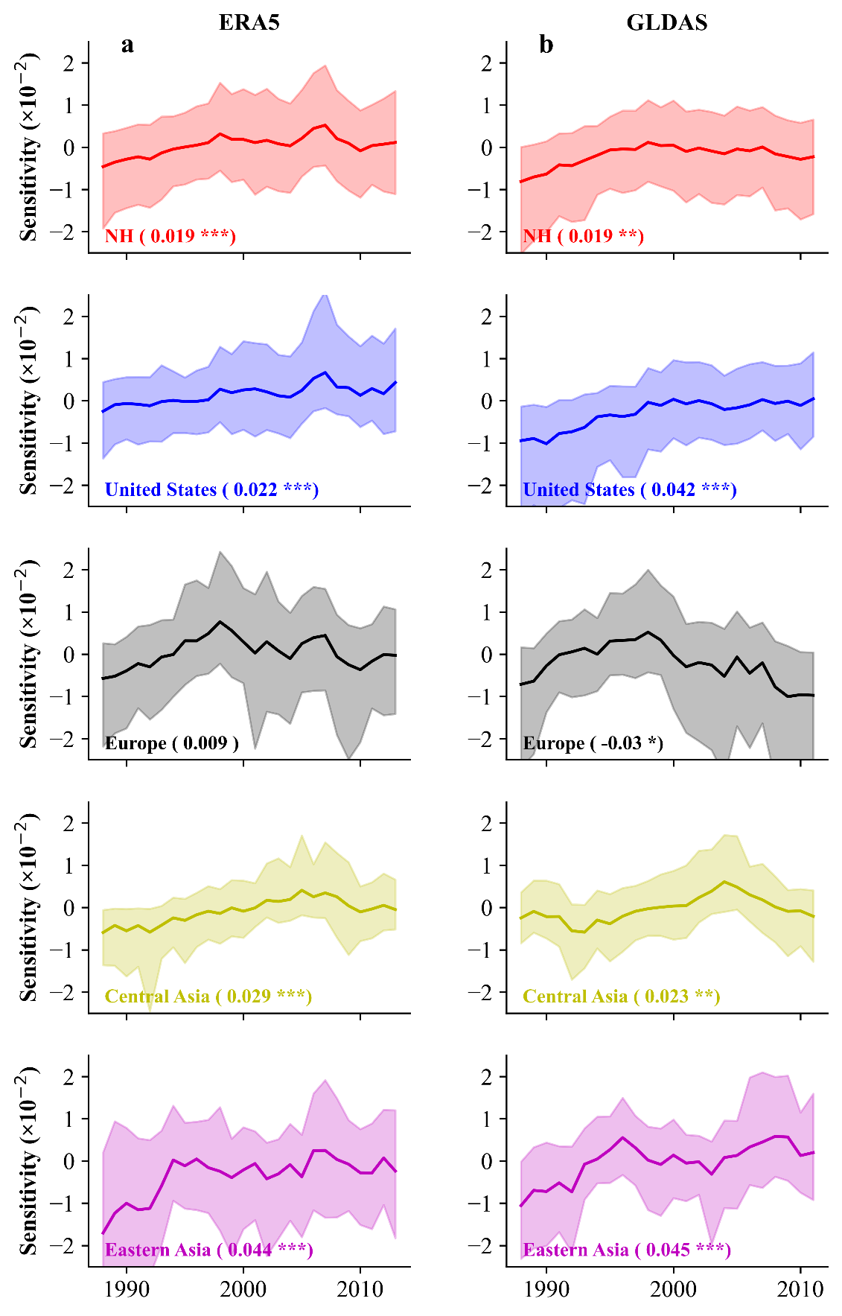

Supplementary Fig. S13 Same as Fig. 3a, but for comparison between ERA5-Land and GLDAS datasets.

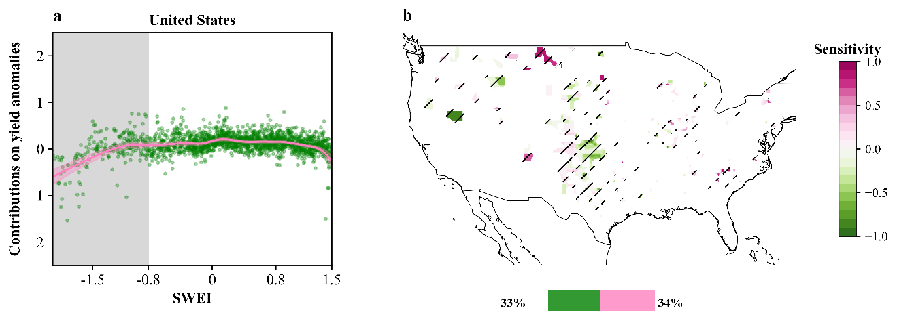

Supplementary Fig. S14 Same as Fig. 2, but for county-level winter wheat yield over United States. The climate extreme index is up-scaled to county resolution by spatially averaging grid cells falling within each county-season pair. County-season climate extreme indices anomalies and SWEI are the predictor variables and county-level winter wheat yield anomaly are the target variable to train random forest. Then we employed explainable machine learning (SHapley Additive exPlanations; SHAP) to isolate the contribution of SWEI to yield anomalies from the influence of other climate extremes stress. Climate extreme indices includes GDD, EDD, FDD, DrySpell, Max.5D Rain, and SWEI (details can be found in Supplementary Table S3). The numbers represent the proportions of counties with (pink) positive sensitivity and (green) negative sensitivity, respectively.

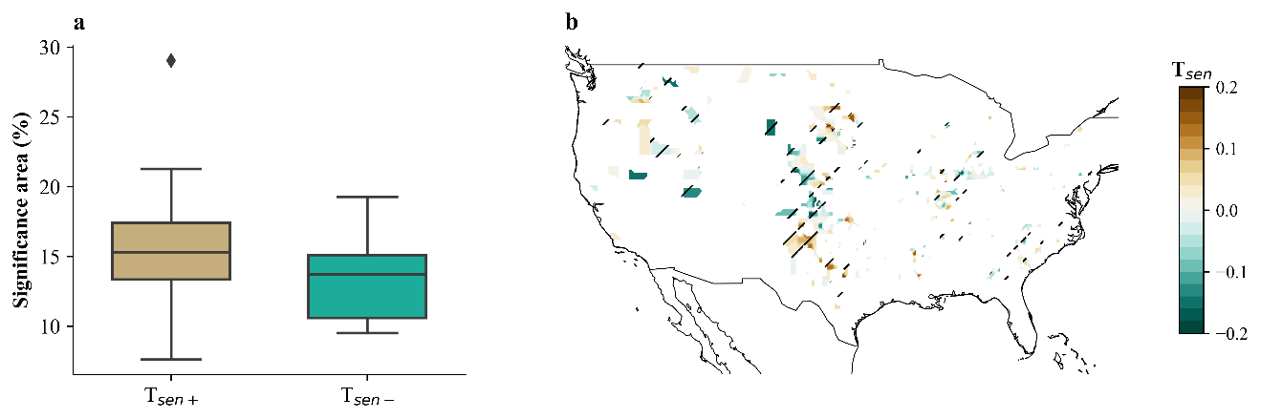

Supplementary Fig. S15 Same as Fig. 3, but for county-level winter wheat yield dataset over the United States during 1980‒2018. a The proportions of counties with (brown) increasing sensitivity ($T_{sen+}$) and (cyan) decreasing sensitivity ($T_{sen-}$) with statistical significance at the level of 0.1. b Spatial distributions of trends of sensitivity for county resolution.

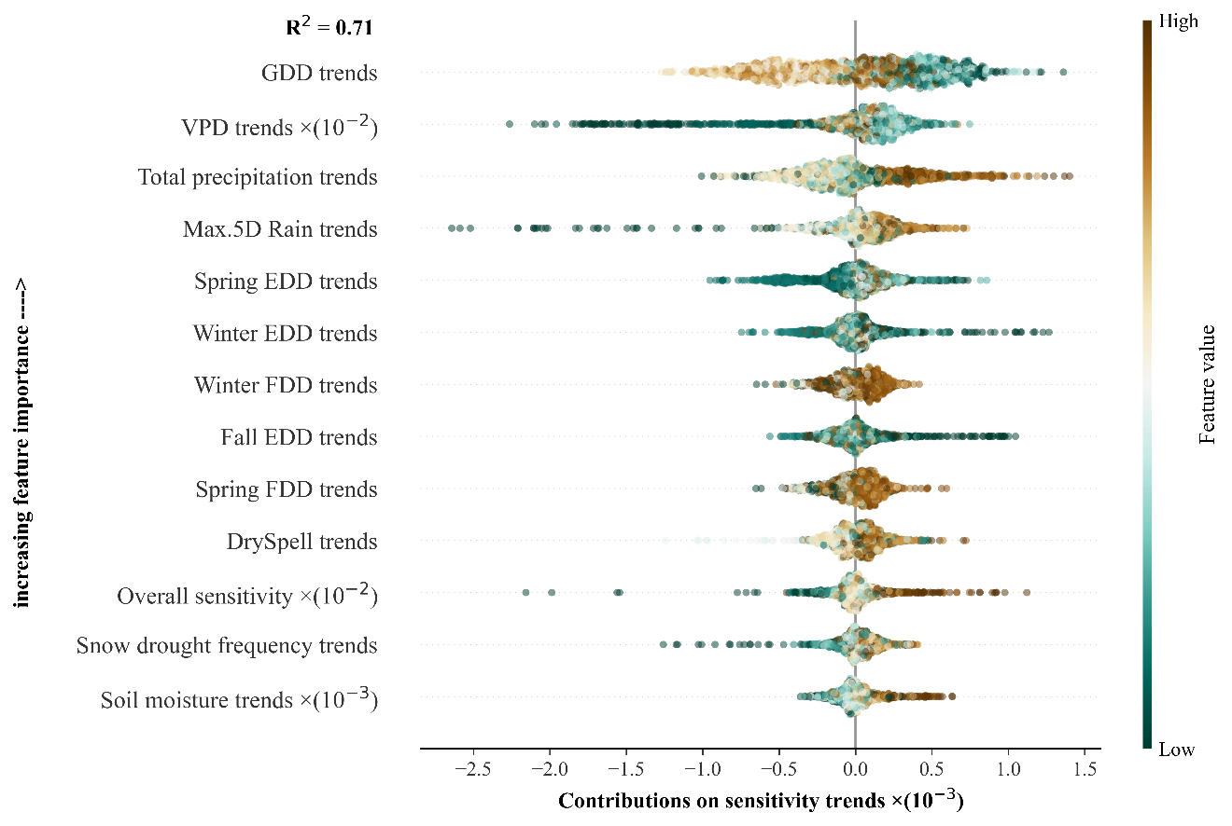

Supplementary Fig. S16. Relative importance and marginal contributions (SHAP values) of multiple hydro-climatic variables to trends in yield sensitivity to SWEI across Northern Hemisphere croplands. VPD denotes vapor pressure deficit. GDD denotes growing degree days between the base and optimum growth temperature thresholds (Eq. (1)). EDD denotes extreme growing degree days above the optimum growing temperature thresholds (Eq. (2)). FDD denotes freezing growing degree days below the freezing growing temperature thresholds (Eq. (3)). DrySpell denotes the maximum number of consecutive days with no rainfall. The Max.5D Rain (mm) denotes the maximum accumulative rainfall in a five-day period.

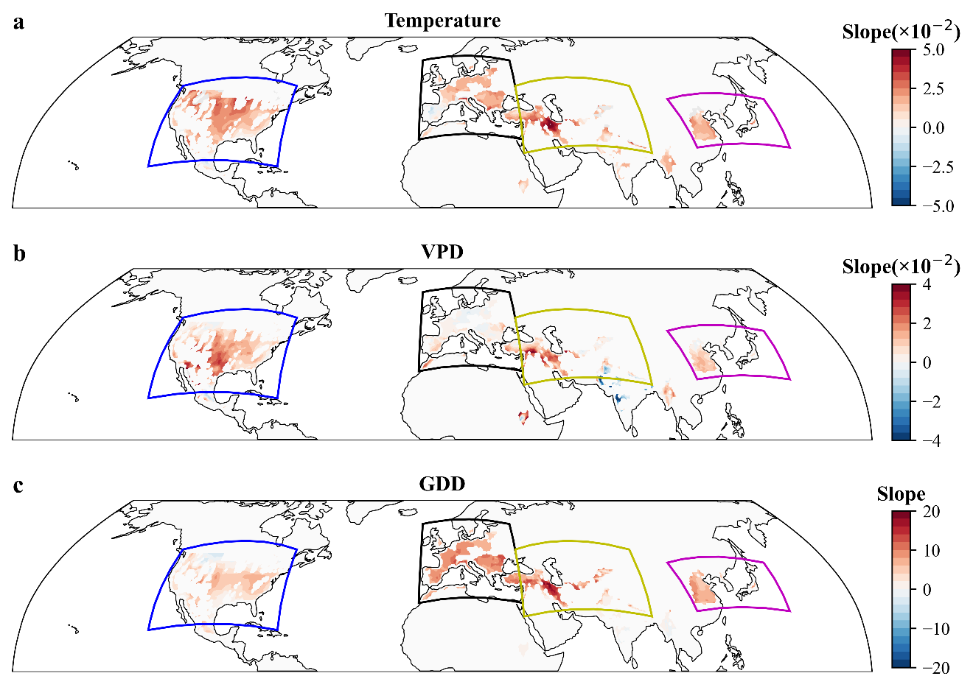

Supplementary Fig. S17. Spatial distributions of slope of trends of average growing-season a temperature, b VPD, and c GDD for the period of 1982‒2016.

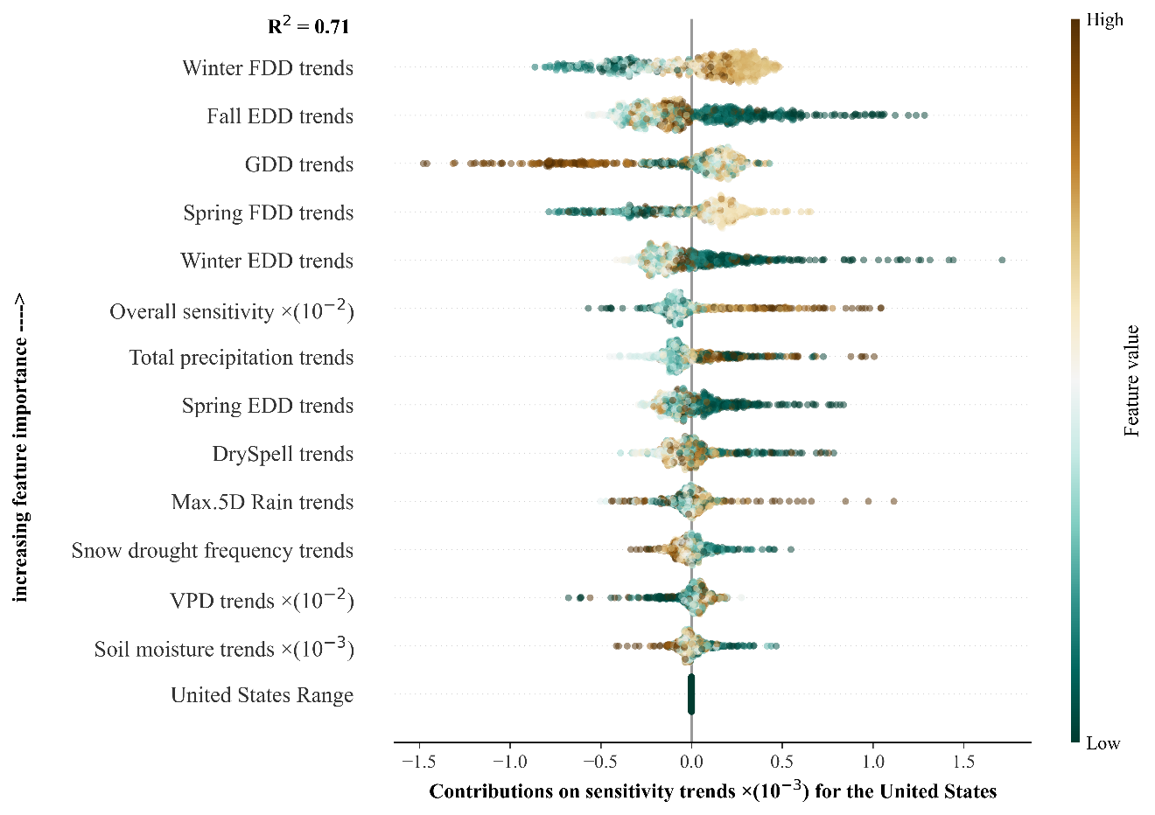

Supplementary Fig. S18. Relative importance and marginal contributions (SHAP values) of multiple hydro-climatic variables to trends in yield sensitivity to SWEI across the United States. VPD denotes vapor pressure deficit. GDD denotes growing degree days between the base and optimum growth temperature thresholds (Eq. (1)). EDD denotes extreme growing degree days above the optimum growing temperature thresholds (Eq. (2)). FDD denotes freezing growing degree days below the freezing growing temperature thresholds (Eq. (3)). DrySpell denotes the maximum number of consecutive days with no rainfall. The Max.5D Rain (mm) denotes the maximum accumulative rainfall in a five-day period.

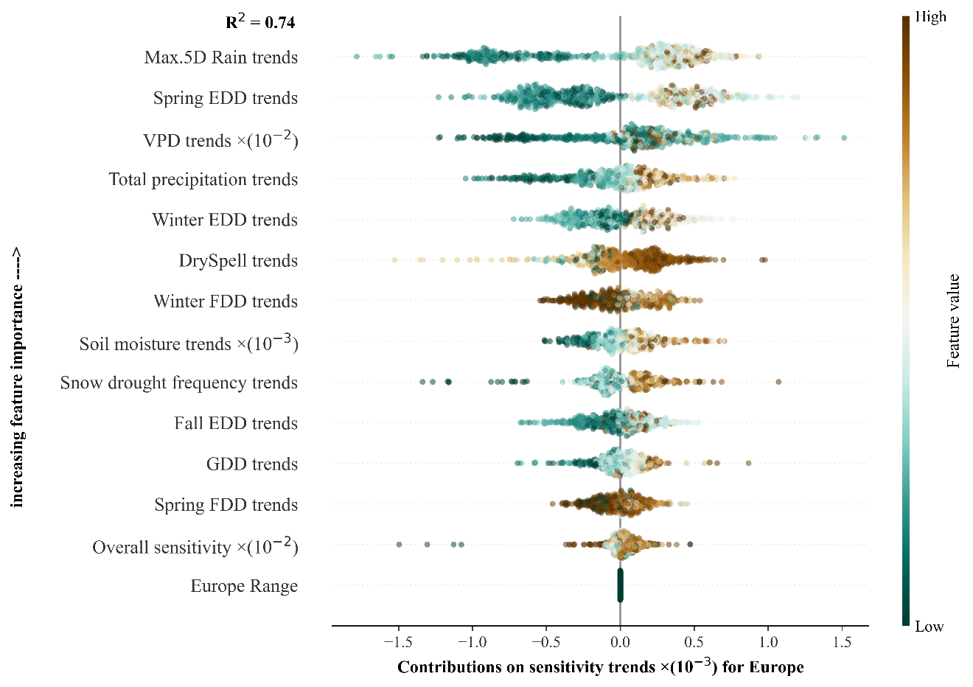

Supplementary Fig. S19. Relative importance and marginal contributions (SHAP values) of multiple hydro-climatic variables to trends in yield sensitivity to SWEI over Europe’s croplands. VPD denotes vapor pressure deficit. GDD denotes growing degree days between the base and optimum growth temperature thresholds (Eq. (1)). EDD denotes extreme growing degree days above the optimum growing temperature thresholds (Eq. (2)). FDD denotes freezing growing degree days below the freezing growing temperature thresholds (Eq. (3)). DrySpell denotes the maximum number of consecutive days with no rainfall. The Max.5D Rain (mm) denotes the maximum accumulative rainfall in a five-day period.

Supplementary Table S1. Relevant hydro-climate variables and yield data.
Abbreviate | Long name | Unit | Aggregate method | Data set
SWE | Snow depth water equivalent | m | Sums for JFM and standardized | ERA5-Land³
SWE | Snow depth water equivalent | kg/m² | Sums for JFM and standardized | GLDAS⁴
VPD | vapor pressure deficit | hPa | Averages for winter wheat growing season | ERA5-Land³
T | 2-m air temperature | °C | Averages for winter wheat growing-season | ERA5-Land³
Pre | Total precipitation | mm | Sums for winter wheat growing-season | ERA5-Land³
SM | Root–zone soil moisture | m³/m³ | Sums for winter wheat growing-season | GLEAM⁵

Supplementary Table S2. The freezing, base, and optimum growing temperature (℃) in each phenological phases for winter wheat. The threshold is based on Zhang et al 2022⁶, Tack et al⁷, and Saiyed et al⁸.
Season | Month | Growing phases | $T_{frez}$ (℃) | $T_{base}$ (℃) | $T_{opt}$ (℃)
Fall | Sep | Planting | 0.0 | 3.0 | 7.5
Fall | Oct | Vegetative | 0.0 | 3.0 | 7.5
Fall | Nov | Hardening | ‒5.0 | 3.0 | 7.5
Winter | Dec | Dormant | ‒11.0 | 0.0 | 5.0
Winter | Jan | Dormant | ‒11.0 | 0.0 | 5.0
Winter | Feb | Dormant | ‒11.0 | 0.0 | 5.0
Spring | Mar | Vegetative | ‒4.0 | 1.5 | 10.6
Spring | Apr | Jointing | ‒4.0 | 5.0 | 18.5
Spring | May | Heading | ‒1.0 | 5.0 | 20.0

Supplementary Table S3. The climate extremes indices in each phenological phases (fall, winter, and spring) for winter wheat. The definition of climate extreme indices is based on Zhang et al 2022⁶ and Troy et al 2015⁹. These climate extreme indices in three seasons and SWEI are the predictors in the random forest model.

Indices | Unit | Variable explanation
GDD | ℃d | Cumulative exposures to growing degree days with between the base and optimum temperature thresholds
EDD | ℃d | Cumulative exposures to extreme growing degree days with above the optimum temperature thresholds
FDD | ℃d | Cumulative exposures to freezing growing degree days with below the freezing temperature thresholds
DrySpell | days | Maximum number of consecutive days with no rainfall
Max.5D Rain | mm | Maximum rainfall in a five-day period

Supplementary References
1. Hatchett, B. J. & McEvoy, D. J. Exploring the origins of snow drought in the northern sierra nevada, california. Earth Interact 22, 1–13 (2018).
2. Huning, L. S. & AghaKouchak, A. Global snow drought hot spots and characteristics. Proc Natl Acad Sci U S A 117, 19753–19759 (2020).
3. Hersbach, H. et al. The ERA5 global reanalysis. Q J R Meteorol Soc 146, 1999–2049 (2020).
4. Rodell, M. et al. The global land data assimilation system. Bull Am Meteorol Soc 85, 381–394 (2004).
5. Martens, B. et al. GLEAM v3: Satellite-based land evaporation and root-zone soil moisture. Geosci Model Dev 10, 1903–1925 (2017).
6. Zhang, T. et al. Climate change may outpace current wheat breeding yield improvements in North America. Nat Commun 13, (2022).
7. Tack, J., Barkley, A. & Nalley, L. L. Effect of warming temperatures on US wheat yields. Proc Natl Acad Sci U S A 112, 6931–6936 (2015).
8. Saiyed, I. M., Bullock, P. R., Sapirstein, H. D., Finlay, G. J. & Jarvis, C. K. Thermal time models for estimating wheat phenological development and weather-based relationships to wheat quality. Can J Plant Sci 89, 429–439 (2009).
9. Troy, T. J., Kipgen, C. & Pal, I. The impact of climate extremes and irrigation on US crop yields. Environ Res Lett 10, (2015).

