Supplementary data
Four Supplemental Figures and One Supplemental Tables
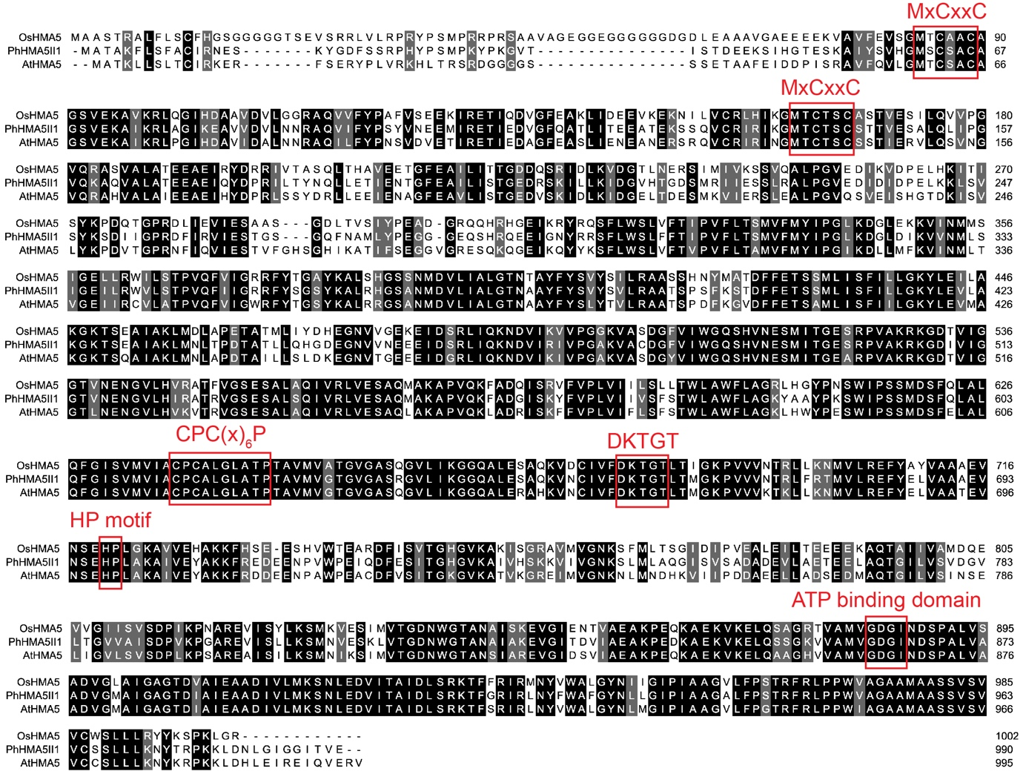
Fig. S1 Multiple sequence alignment of PhHMA5II1, OsHMA5 and AtHMA5. The red squares indicate the position and name of the conserved domains P_{1B}-type ATPases (Andrés-Colás et al., 2006), including two MxCxxC Cu-binding motif, a CPC(x)₆P transduction motif, an aspartyl kinase domain (DKTGT), and HP motif and an ATP binding domain.

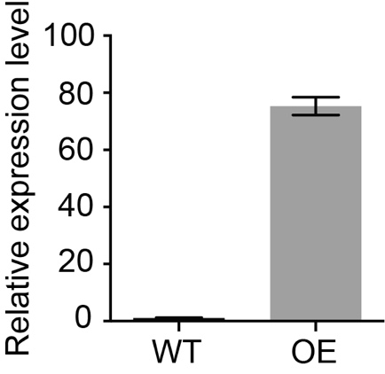
Fig. S2 Detection of PhHMA5II1 overexpression plants. The expression level of PhHMA5II1 in the leaf of wild-type petunia and overexpressing plants. EF1α was used as the reference gene.

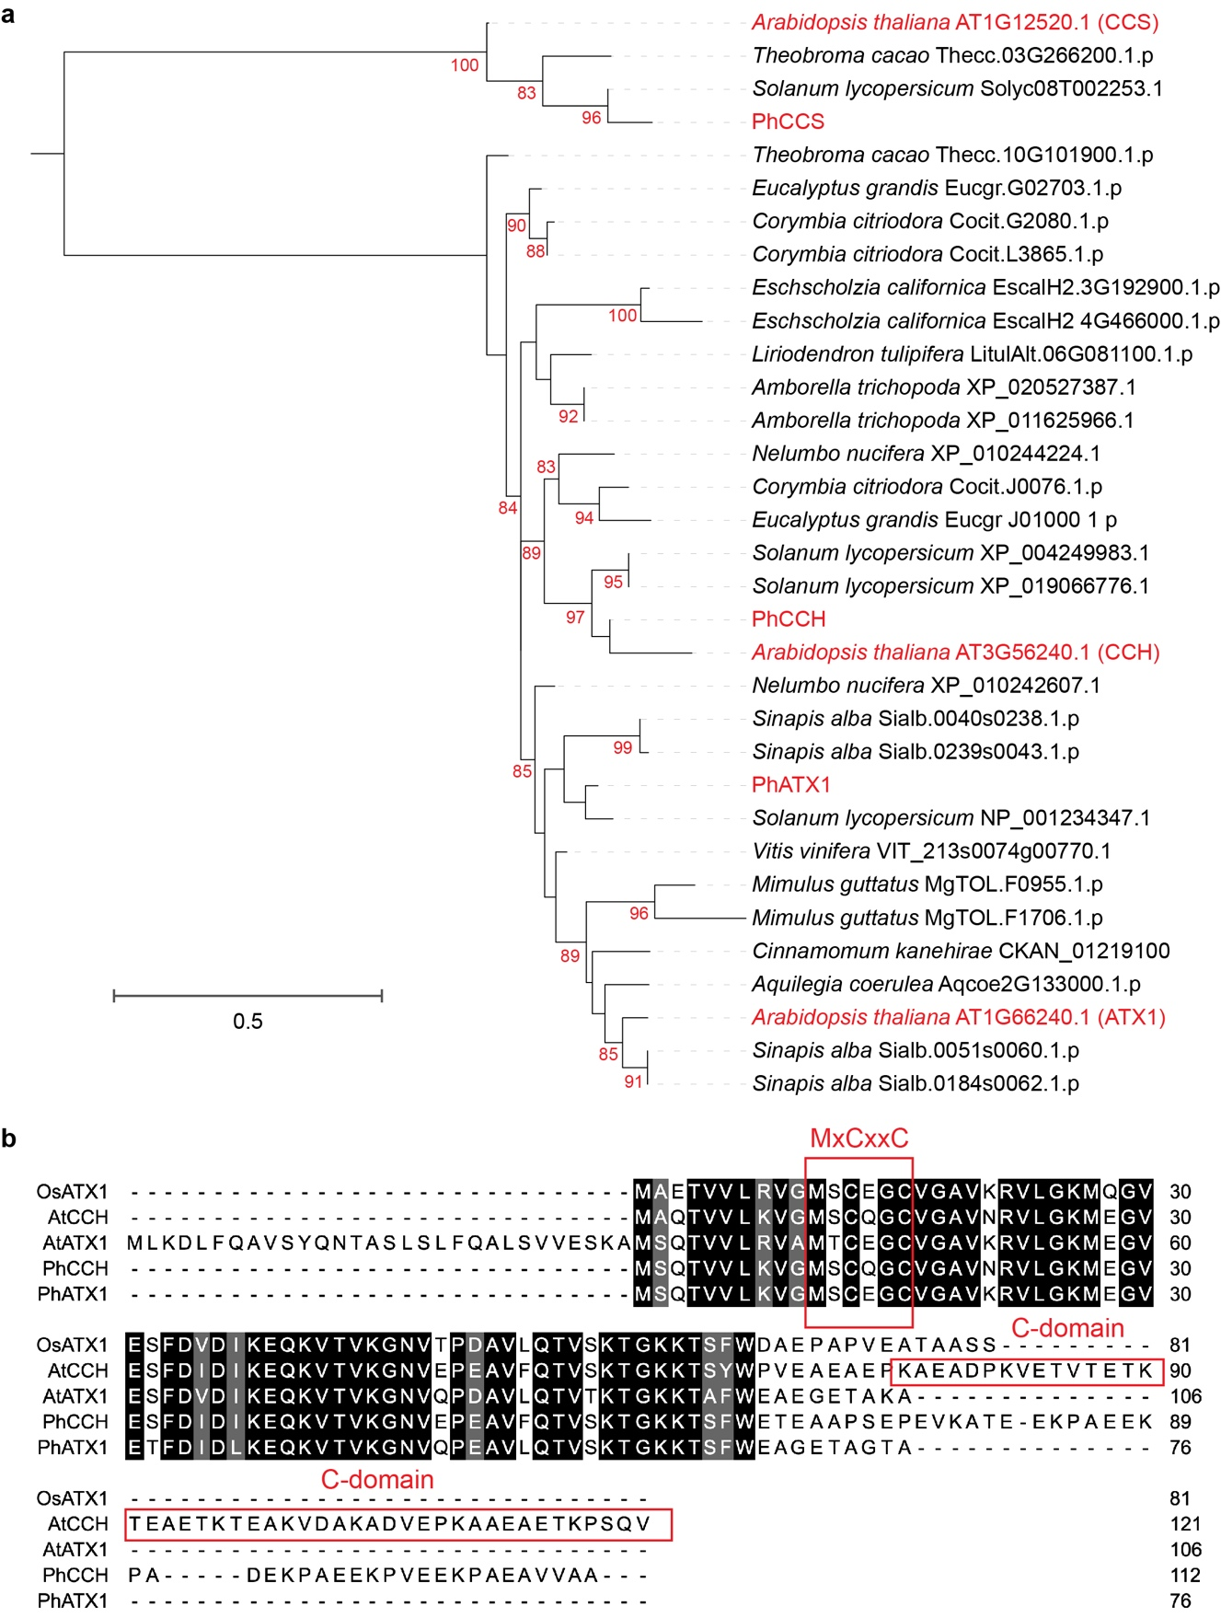
Fig. S3 Phylogenetic analysis and multiple sequence alignment of ATX1 homologs from different species. a, Maximum likelihood phylogenies were inferred using IQ-TREE under the WAG+G4 model. Branch support is indicated on the tree branches as percentage of 1000 bootstraps if ≥80%. For each species, the protein(s) with most similarity to AtATX1 and AtCCH is shown. Petunia and Arabidopsis copper chaperones are marked in red color. CCSs served as an outgroup. b, multiple sequence alignment of ATX1 homologs from Arabidopsis, rice and petunia.
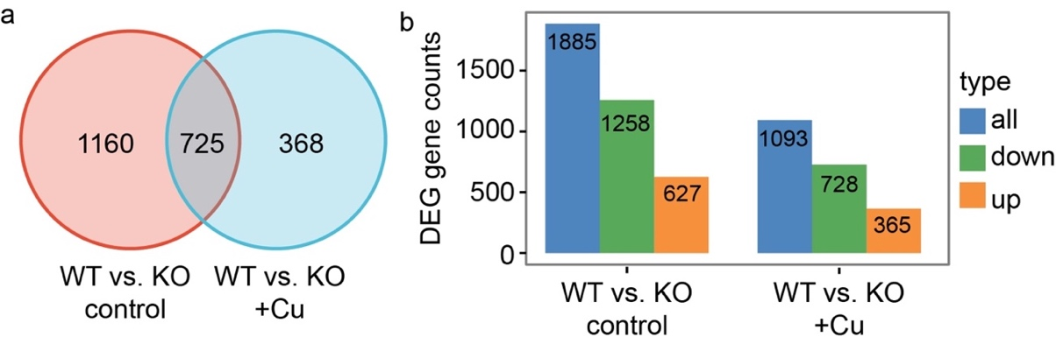
Fig. S4 Differentially expressed genes (DEGs) in roots under control and excess Cu conditions. a, Venn diagram showing the number of DEGs, fold change ≥ 2 and FDR < 0.05. b, Numbers of downregulated and upregulated DEGs under control and excess Cu treatment.

Table S1. List of primers used in this study.
Primers | Sequences (5’-3’)
0895 | CCCTCTAGATGCATGCTCGAGTCACTCAACAGTTATGCCTCCAATC
0903 | GCCGCCAGTGTGCTGGAATTCATGGCAACTGCAAAGTTTCTTTC
0995 | GCCGCCAGTGTGCTGGAATTCATGGAACTGCAAAGTTTCTTTC
062K | ATCCTGGTCAAATTGGAAACGG
063K | CAGATCGCCTGTCAATCTTGG
0256 | CGCCATGGCCAGTTATTGAC
0191 | CAAGGCAATTGTCGAATATGCC
0052 | GGGGACAAGTTTGTACAAAAAAGCAGGCTCAATGGCAACTGCAAAGTTTCTTTC
0268 | GGGGACCACTTTGTACAAGAAAGCTGGGTGCTCAACAGTTATGCCTCCAATC
0267 | GGGGACCACTTTGTACAAGAAAGCTGGGTTCACTCAACAGTTATGCCTCCAATC
1099 | caaatacacacactaatctagaATGGCAACTGCAAAGTTTCTTTC
1072 | gtcgacggtatcgataagctCTCAACAGTTATGCCTCCAATC
1075 | gttccagattacgctggatccATGTCTCAGACTGTCGTTCTC
1076 | gataagcttgatatcgaattctcaAGCTGTACCAGCCGTTTCTCCT
1077 | gttccagattacgctggatccATGTCTCAGACAGTTGTTCTC
1078 | gataagcttgatatcgaattcttaAGCTGCAACAACAGCTTCTG
1011 | gtacccggggatcctctagaATGGCAACTGCAAAGTTTCTTTC
1087 | GCCACCGCCGTCGACTCTAGACTCAACAGTTATGcCTCCAATC
1088 | ATCGAGGACGCCGGCGGATCCATGTCTCAGACTGTCGTTCTC
1102 | caggtcgactctagaggatccTCAAGCTGTACCAGCCGTTTCTC
1090 | atcgaggacgccggcggatccATGTCTCAGACAGTTGTTCTC
1103 | caggtcgactctagaggatccTTAAGCTGCAACAACAGCTTCTG

