BiVO₄ photoanode synergistically with persulfate to degrade antibiotics: degradation mechanism and pathway
Yun Chenª, Jinquan Wan^{a,b,*}, Yongwen Ma^{a,b}, Yan Wangª, Zhicheng Yanª, Shou Yang
ª College of Environment and Energy, South China University of Technology, Guangzhou 510006, Guangdong, China
^{b} Sino-Singapore International Joint Reasearch Institute, Guangzhou 510640, Guangdong, China

*Corresponding author: Tel: -86 13660539751
E-mail: jquan_wan@163.com (Jinquan Wan)
(b)
(a)
Fig.S1. (a) SEM image of BiVO₄ photoanode;(b) XRD patterns of BiVO₄ photoanode;

FigS2 UV-Vis spectra of BiVO₄ photoanode.
Text 1
The band gap energy of prepared electrodes can be calculated by:
$$({αhν)}^{n}=A(hν-E_{g})$$
Where α is the absorption coefficient, h is the Planck constant，ν is the light frequency, A is a constant and Eg is band gap. The index n depends on the type of optical transition in the semiconductor, n=2 or 1/2 indicating the type of semiconductor is direct-gap or indirect-gap, respectively.

Fig. S3 the degradation efficiency of SMX with different initial pH
Fig. S4 Changes of pH during degradation process

Fig.S5 The kinetic rate constant of TC in DI water and natural water
Fig.S6 Degradation efficiency of SMX after 4 cycles

Fig S7 XRD patterns of BiVO₄ photoanode before and after reaction.

Table S1. The detective methods of three organic contaminants by HPLC.
Organic Contaminants | Mobile Phase | Flow Rate | λ_{max}/nm
SMX | acetonitrile : 0.2% Formic acid =30:70 | 1 mL/min | 278
CIP | methanol : 5% Glacial acetic acid =68:32 | 1 mL/min | 278
TC | 0.01M oxalic acid: acetonitrile =75:25 | 1 mL/min | 365

Table S2 the kinetic rate constants of different degradation systems
Rate constant | PEC | PC/PS | EC/PS | PEC/PS
k` min⁻¹ | 0.0058 | 0.0069 | 0.0012 | 0.00948
R² | 0.9938 | 0.9996 | 0.9351 | 0.9990

Table S3 the kinetic rate constants of different degradation systems
 | R1 | CPE1-T | CPE2-P | R2 | Error%
BVO | 23.38 | 8.69E-05 | 0.80827 | 483.9 | 0.9051
BVO/PS | 13.11 | 4.33 E-04 | 0.79621 | 167.9 | 0.61858
BVO/SMX | 14.28 | 3.28 E-04 | 0.81068 | 221.2 | 0.33753
BVO/PS/SMX | 12.45 | 3.76 E-04 | 0.78076 | 126 | 0.30164

Table S3 The molecular formulae, molecular masses, and proposed structures of the TPs of SMX
Products | m/z | Molecular formula | Structural formula
SMX | 254 | C₁₀H₁₁N₃O₃ | 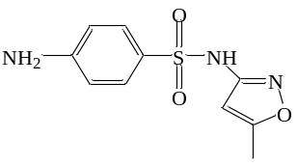
TP1 | 190 | C₁₀H₁₁N₃O | 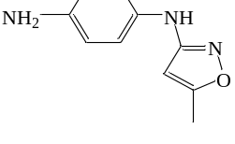
TP2 | 99 | C₄H₆N₂O | 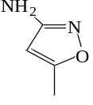
TP3 | 209 | C₈H₈N₄O₃ | 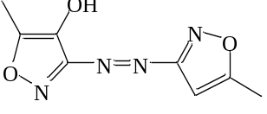
TP4-1 | 284 | C₁₀H₉N₃O₅S | 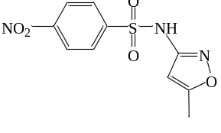
TP4-2 | 284 | C₁₀H₉N₃O₅S | 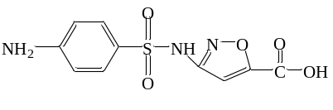
TP5 | 254 | C₁₀H₁₁N₃O₃S | 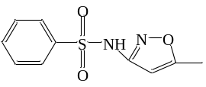
TP6 | 299 | C₁₀H₉N₃O₆S | 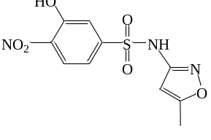
TP7 | 219 | C₆H₅NO₆S | 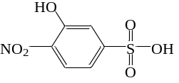
TP8 | 504 | C₂₀H₂₀N₆O₆S₂ | 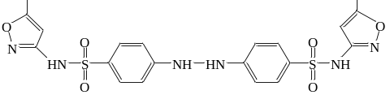

Table S5 The molecular formulae, molecular masses, and proposed structures of the TPs of SMX
Products | m/z | Molecular formula | Structural formula
CIP | 332 | C₁₇ H₁₈ F N₃ O₃ | 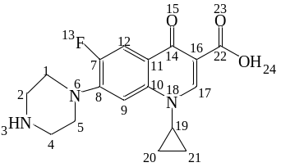
TP1 | 347 | C₁₇ H₁₈ F N₃ O₄ | 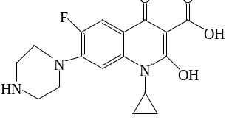
TP2 | 345 | C₁₇H₁₉N₃O₅ | 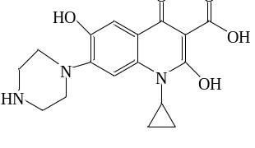
TP3 | 317 | C₁₆H₁₉N₃O₄ | 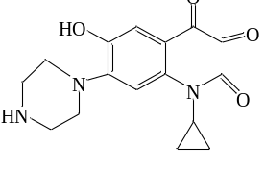
TP4 | 301 | C₁₆H₁₉N₃O₃ | 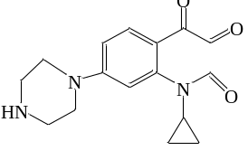
TP5 | 362 | C₁₇H₁₆FN₃O₅ | 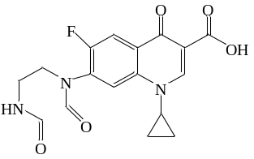
TP6-1 | 334 | C₁₆H₁₆FN₃O₄ | 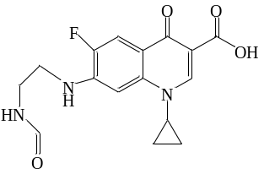
TP6-2 | 334 | C₁₆H₁₆FN₃O₄ | 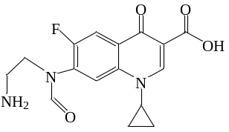
TP7 | 306 | C₁₅H₁₆FN₃O₃ | 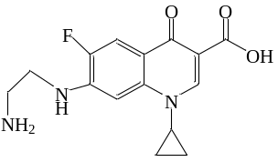
TP8 | 290 | C₁₅H₁₆FN₃O₂ | 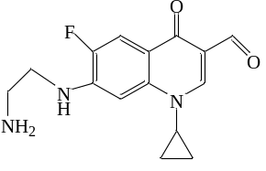
TP9 | 263 | C₁₃H₁₁FN₂O₃ | 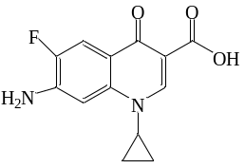
TP10 | 280 | C₁₃H₁₃FN₂O₄ | 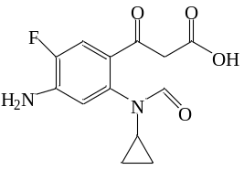
TP11 | 207 | C₁₁H₁₂FN₂O | 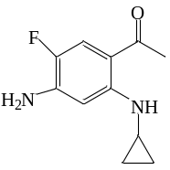

Table S6 The molecular formulae, molecular masses, and proposed structures of the TPs of SMX
Products | m/z | Molecular formula | Structural formula
TC | 445 | C₂₂H₂₄N₂O₈ | 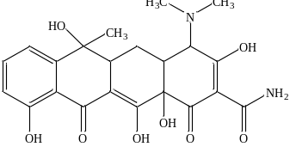
TP1 | 461 | C₂₂H₂₄N₂O₉ | 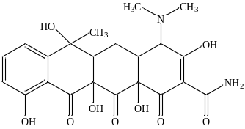
TP2 | 474 | C₂₂H₂₂N2O₁₀ | 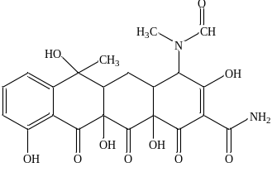
TP3 | 477 | C₂₂H₂₄N2O₁₀ | 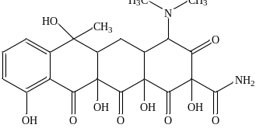
TP4 | 459 | C₂₂H₂₂N2O₉ | 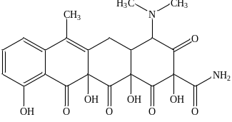
TP5 | 432 | C₂₀H₂₀N₂O₉ | 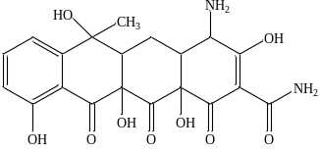
TP6 | 427 | C₂₂H₂₂N₂O₇ | 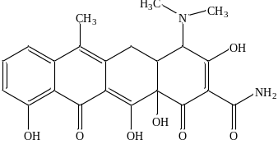
TP7 | 383 | C₂₁H₂₁NO₆ | 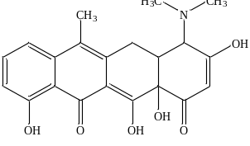
TP8 | 431 | C₂₁H₂₂N₂O₈ | 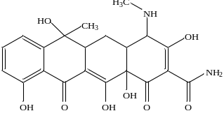
TP9 | 413 | C₂₁H₂₀N₂O₇ | 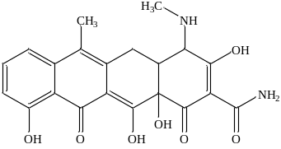
TP10 | 416 | C₂₁H₂₁NO₈ | 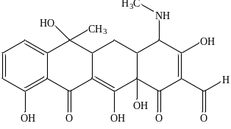
TP11 | 363 | C₁₈H₂₁NO₇ | 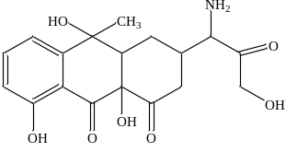
TP12 | 376 | C₁₈H₁₇NO₈ | 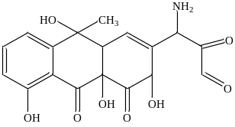
TP13 | 338 | C₁₆H₁₉NO₇ | 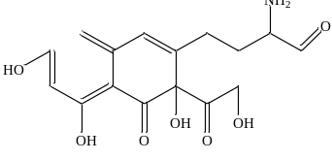
TP14 | 241 | C₁₂H₁₉NO₄ | 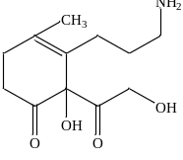
TP15 | 403 | C₂₁H₂₅NO₇ | 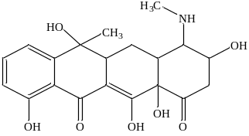
TP16 | 360 | C₁₉H₂₀O₇ | 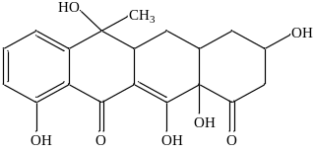
TP17 | 317 | C₁₇H₁₇O₆ | 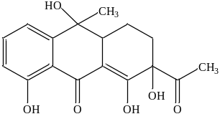
TP18 | 279 | C₁₅H₁₈O₅ | 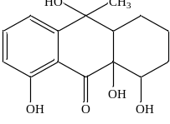
TP19 | 273 | C₁₅H₁₂O₅ | 