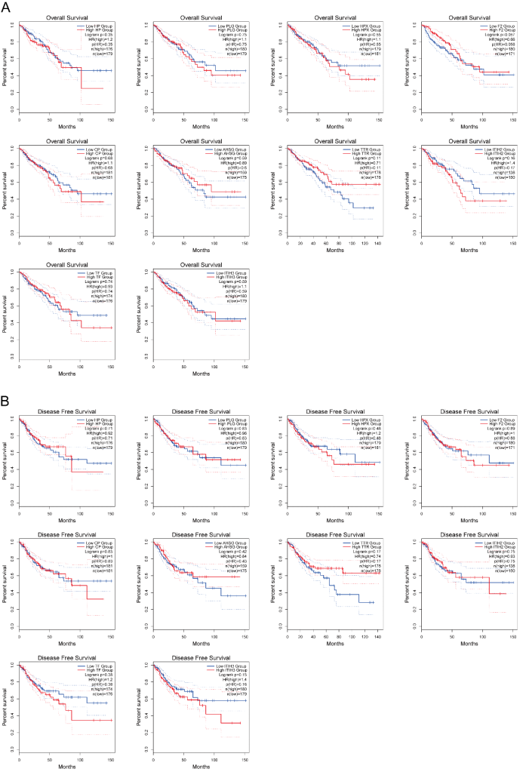
Fig. S1. OS and DFS survival analysis of the remaining hub genes based on GEPIA2. (A) OS analysis of HP, PLG, HPX, F2, CP, AHSG, TTR, ITIH2, TF, ITIH3 genes. (B) DFS analysis of HP, PLG, HPX, F2, CP, AHSG, TTR, ITIH2, TF, and ITIH3 genes. OS and DFS analyses of GC and CRP genes were not obtained.

