Supplementary Information
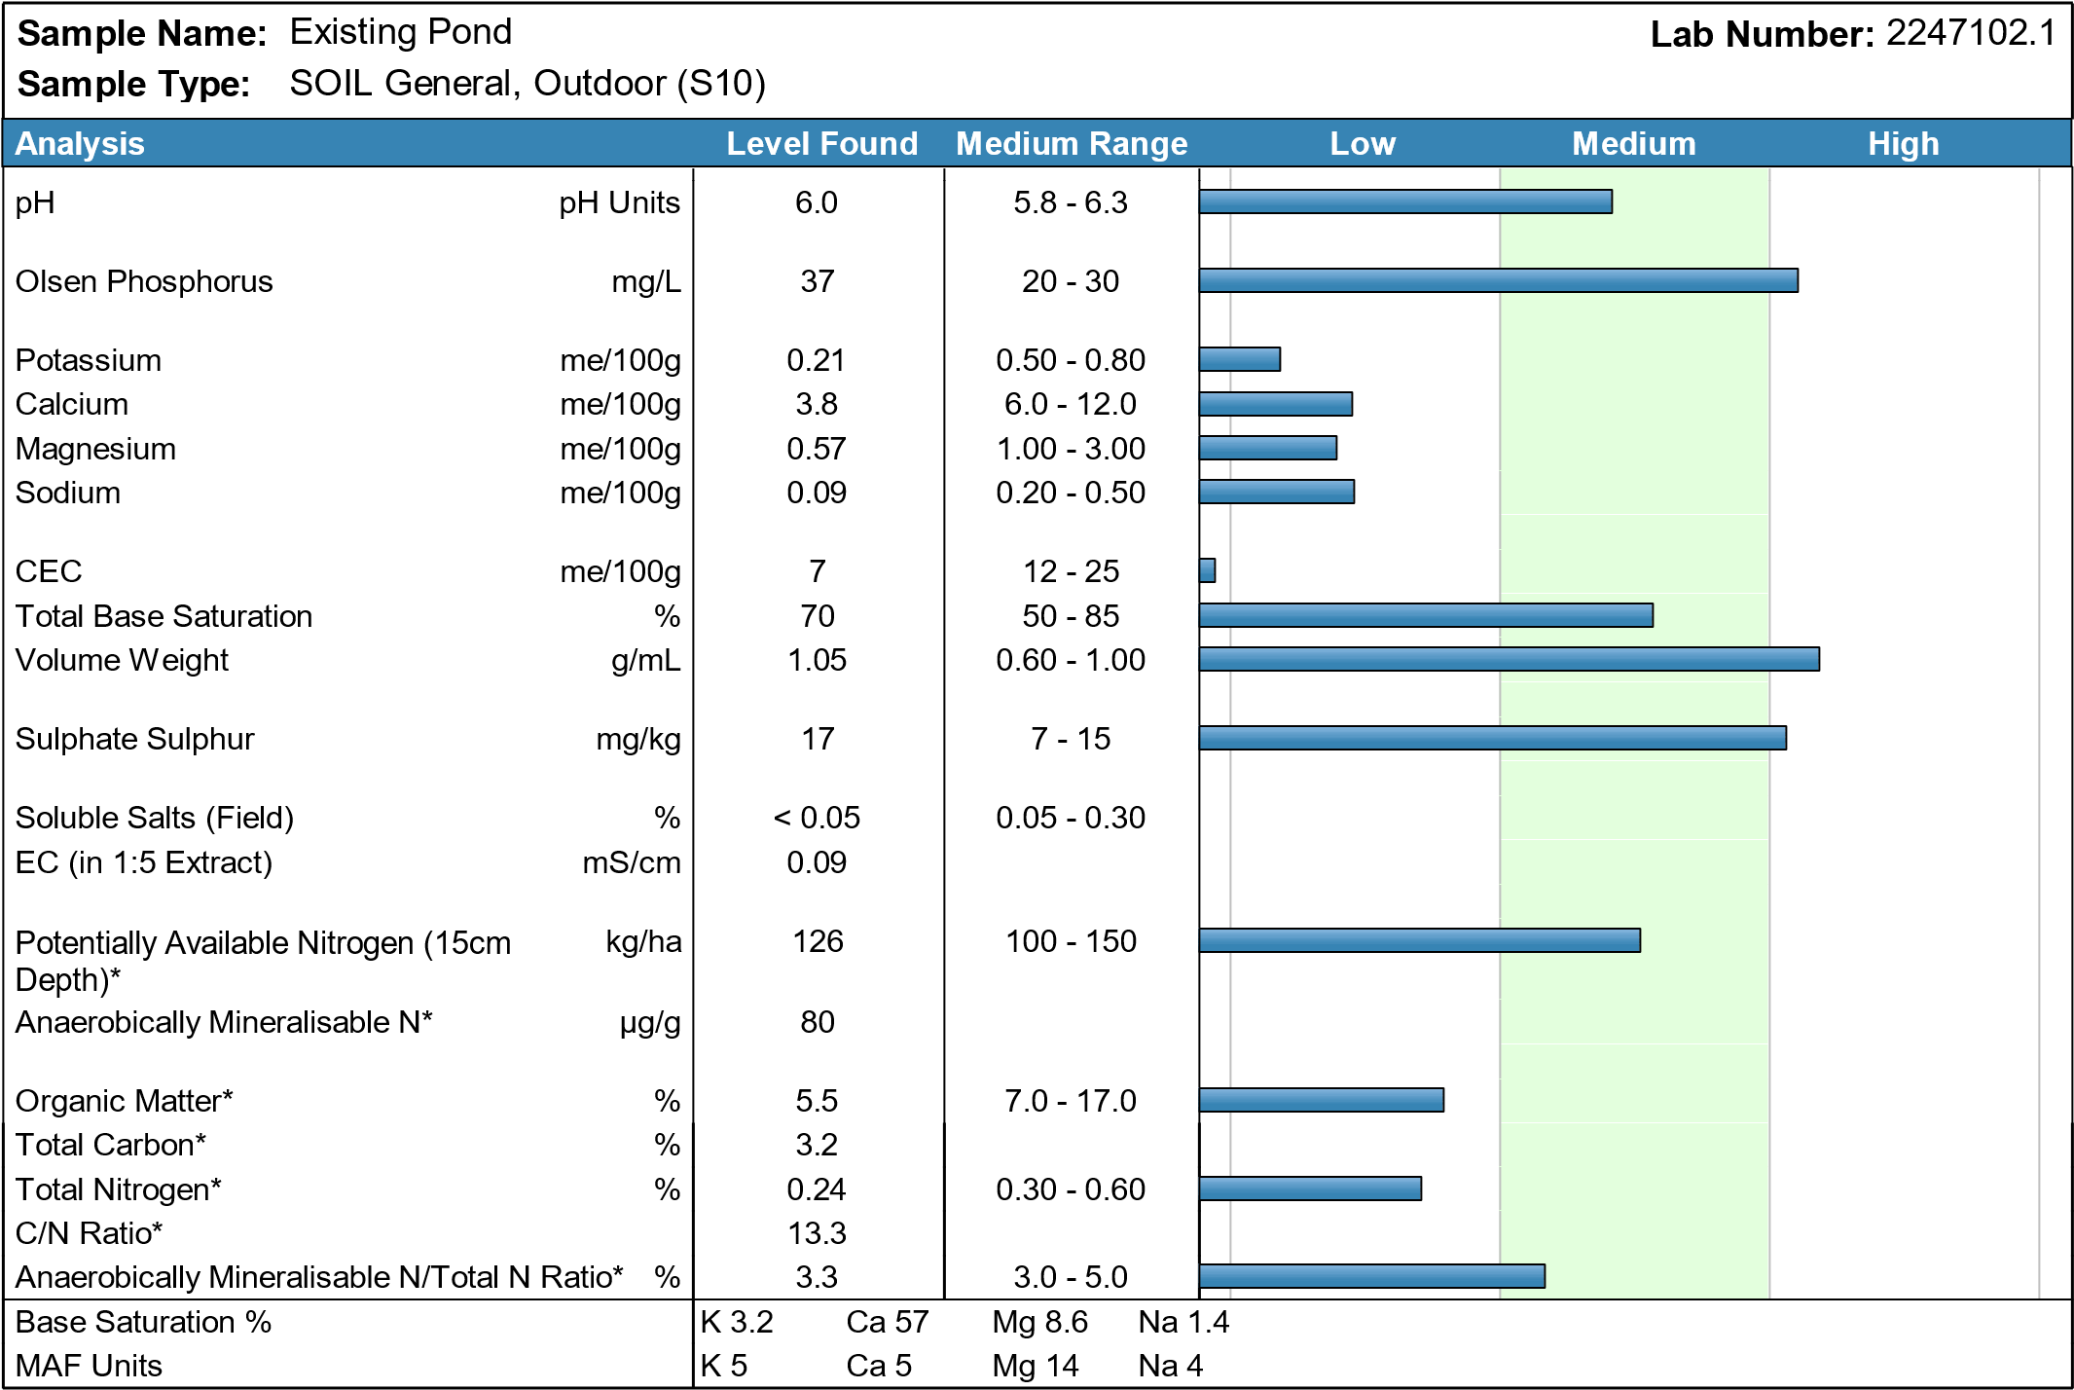
Figure A1. Wigram Basin summary of soil analysis

Soil Analysis Results
pH | pH Units |  | 6.0
Olsen Phosphorus | mg/L |  | 37
Potassium | me/100g |  | 0.21
Potassium | %BS |  | 3.2
Potassium | MAF units |  | 5
Calcium | me/100g |  | 3.8
Calcium | %BS |  | 57
Calcium | MAF units |  | 5
Magnesium | me/100g |  | 0.57
Magnesium | %BS |  | 8.6
Magnesium | MAF units |  | 14
Sodium | me/100g |  | 0.09
Sodium | %BS |  | 1.4
Sodium | MAF units |  | 4
CEC | me/100g |  | 7
Total Base Saturation | % |  | 70
Volume Weight | g/mL |  | 1.05
Sulphate Sulphur | mg/kg |  | 17
Soluble Salts (Field) | % |  | < 0.05
EC (in 1:5 Extract) | mS/cm |  | 0.09
Potentially Available Nitrogen kg/ha (15cm Depth) |  |  | 126
Anaerobically Mineralisable N* µg/g |  |  | 80
Organic Matter* |  | % | 5.5
Total Carbon* |  | % | 3.2
Total Nitrogen* |  | % | 0.24
C/N Ratio* |  |  | 13.3
Anaerobically Mineralisable N/Total% N Ratio* |  |  | 3.3
Table A1. Detailed soil chemical analysis results for Wigram Basin
Summary of Methods
Test | Method Description | Default Detection Limit
Soil Prep (Dry & Grind)* | Air dried at 35 - 40°C overnight (residual moisture typically 4%) and crushed to pass through a 2mm screen. | -
pH | 1:2 (v/v) soil:water slurry followed by potentiometric determination of pH. In-house. | 0.1 pH Units
Olsen Phosphorus | Olsen extraction followed by Molybdenum Blue colorimetry. Inhouse method. | 1 mg/L
Sulphate Sulphur | 0.02M Potassium phosphate extraction followed by Ion Chromatography. In-house. | 1 mg/kg
Potentially Available Nitrogen* | Determined by NIR, calibration based on Available N by Anaerobic incubation followed by extraction using 2M KCl followed by Berthelot colorimetry. (Calculation based on 15cm depth sample). Note that any Mineral N present is included in the AN/AMN result reported. | 1 mg/L
Anaerobically Mineralisable N* | As for Potentially Available Nitrogen but reported as µg/g. | 5 µg/g
Organic Matter* | Organic Matter is 1.72 x Total Carbon. | 0.2 %
Soluble Salts (Field) | 1:5 soil:water extraction followed by potentiometric determination of conductivity. Calculated by EC (mS/cm) x 0.35. In-house. | 0.05 %
Electrical Conductivity (EC) | Electrical Conductivity measured in 1:5 Soil:Water extract. | 0.01 mS/cm
Total Carbon* | Determined by NIR, calibration based on Total Carbon by Dumas combustion. | 0.1 %
Total Nitrogen* | Determined by NIR, calibration based on Total N by Dumas combustion. | 0.04 %
Potassium | 1M Neutral ammonium acetate extraction followed by ICP-OES. In-house. | 0.01 me/100g
Calcium | 1M Neutral ammonium acetate extraction followed by ICP-OES. In-house. | 0.5 me/100g
Magnesium | 1M Neutral ammonium acetate extraction followed by ICP-OES. In-house. | 0.04 me/100g
Sodium | 1M Neutral ammonium acetate extraction followed by ICP-OES. In-house. | 0.05 me/100g
CEC | Summation of extractable cations (K, Ca, Mg, Na) and extractable acidity. May be overestimated if soil contains high levels of soluble salts or carbonates. In-house. | 2 me/100g
Total Base Saturation | Calculated from Extractable Cations and Cation Exchange Capacity. | 5 %
Volume Weight | The weight/volume ratio of dried, ground soil. In-house. | 0.01 g/mL
Table A2. Soil analysis methods.
Compound | F-  (ppm) | Cl-  (ppm) | SO₄²⁻  (ppm) | NO₃-N  (ppm) | NH₄-N  (ppm) | DRP  (ppm) | Na  (ppb) | Mg  (ppb) | Al  (ppb) | K  (ppb) | Ca  (ppb) | Cr (ppb) | Fe (ppb) | Mn (ppb) | Ni (ppb) | Cu (ppb) | Zn (ppb) | Pb (ppb)
Average concentration | <1.0 | 5.1 | 4.4 | 0.39 | 0.18 | 0.20 | 5373.7 | 1455.1 | 103.9 | 1062.6 | 11909.0 | 9.3 | 5.7 | 0.4 | 36.6 | 2.4 | 205.5 | 0.7
Maximum concentration | <1.0 | 5.9 | 8.5 | 0.36 | 0.26 | 0.22 | 7234.5 | 1880.3 | 4741.7 | 1336.3 | 23276.7 | 226.5 | 184.7 | 4.7 | 963.4 | 3.8 | 257.9 | 19.8
Minimum concentration | <1.0 | 1.8 | 1.3 | 0.42 | 0.13 | 0.18 | 4134.1 | 1106.0 | 21.5 | 897.4 | 8214.4 | 0.5 | 0.0 | 0.0 | 0.1 | 1.8 | 157.4 | 0.1
Table A3: Composition analysis of SSW inlet concentration.

Table A4: Results of hydraulic conductivity test between soil mix and soil depth. Red shows very relevant and green shows relative statistically difference.
Criteria | Condition | Number of samples | Mean hydraulic conductivity (cm/s) | Variance | P-value
Soil mix | 50% WRB sediment / 50% sand | 18 | 3.2E-02 | 2.0E-04
Soil mix | 20% WRB sediment / 80% sand | 13 | 1.6E-01 | 2.9E-03 | 1.1E-06
Soil depth | 5 cm | 17 | 9.5E-02 | 5.9E-03
Soil depth | 4 cm | 14 | 7.6E-02 | 5.3E-03 | 4.7E-01
soil depth 50% WRB Sediment / 50% sand | 5 cm | 10 | 4.1E-02 | 1.5E-04
soil depth 50% WRB Sediment / 50% sand | 4 cm | 8 | 2.0E-02 | 2.1E-06 | 5.0E-04
soil depth 20% WRB Sediment / 80% sand | 5 cm | 7 | 1.7E-01 | 3.5E-03
soil depth 20% WRB Sediment / 80% sand | 4 cm | 6 | 1.5E-01 | 2.4E-03 | 4.6E-01

Table A5: Calculation of water flow through the media (L/min) given the area of the hydraulics conductivity test. This relates the hydraulic flow of the bench test (area 0.0079 m²) with the flume’s dimension (surface area 5.4 m²).
Sediment mix | Sediment depth | Water depth | Average flow (L/min) (for 0.0079 m2) | Flow (L/min) (5.4 m2) | Surface flow rate (L/m².min)
50% WRB sediment and 50% sand | 5 | 2 | 5.96E-02 | 40.73 | 7.83
50% WRB sediment and 50% sand | 5 | 1 | 5.24E-02 | 35.78 | 6.88
50% WRB sediment and 50% sand | 4 | 2 | 5.01E-02 | 34.21 | 6.58
50% WRB sediment and 50% sand | 4 | 1 | 2.18E-02 | 14.88 | 2.86
20% WRB sediment / 80% sand | 5 | 2 | 2.37E-01 | 161.73 | 31.10
20% WRB sediment / 80% sand | 5 | 1 | 2.22E-01 | 151.97 | 29.23
20% WRB sediment / 80% sand | 4 | 2 | 2.48E-01 | 169.25 | 32.55
20% WRB sediment / 80% sand | 4 | 1 | 2.29E-01 | 156.39 | 30.08

Table A6: Water residence time in the bed sediment
Description | Calculation | Result
Volume of Sediment | 18.1 m×0.3 m×0.05 m | 0.2715 m3
Flow Rate of Water (7.2 L/min) | 7.2 L/min×0.001 m3/L | 0.0072 m3/min
Flow Rate of Water (21.8 L/min) | 21.8 L/min×0.001 m3/L | 0.0218 m3/min
Residence Time of Water in Sediment (7.2 L/min) | 0.2715 m3÷0.0072 m3/min | 37.71 minutes
Residence Time of Water in Sediment (21.8 L/min) | 0.2715 m3÷0.0218 m3/min | 12.44 minutes

Table A7: Results of benchtop seepage test.
Date | 12-Jun
Water | Deionised water |  |  |  |  |  | Synthetic Stormwater
Experiment | Exp A |  |  | Exp B |  |  | Exp A |  |  | Exp B
Collection Time/ Compound | _{NO3-N} (mg/L) | DRP (mg/L) | Mass (g) | _{NO3-N} (mg/L) | DRP (mg/L) | Mass (g) | _{NO3-N} (mg/L) | DRP (mg/L) | Mass (g) | _{NO3-N} (mg/L) | DRP (mg/L) | Mass (g)
Wash Off |  |  |  |  |  |  | 0.371 | 0.122 | 380 | 0.310 | 0.152 | 320
T0-T15 | 4.458 | 0.117 | 325 | 3.200 | 0.100 | 564 | 0.438 | 0.158 | 218 | 0.352 | 0.185 | 234
T15-T30 | 1.165 | 0.114 | 275 | 0.562 | 0.105 | 224 | 0.441 | 0.188 | 193 | 0.349 | 0.200 | 187
T30-T45 | 0.650 | 0.113 | 212 | 0.455 | 0.130 | 232 | 0.423 | 0.186 | 194 | 0.348 | 0.213 | 196
T45-T60 | 0.372 | 0.115 | 234 | 0.241 | 0.141 | 198 | 0.413 | 0.206 | 209 | 0.266 | 0.213 | 212
Blank | 0.008 | n.d. | n.a. | n.a. | n.a. | n.a. | 0.407 | 0.227 | n.a. | n.a. | n.a. | n.a.
Date | 14-Jun
Wash Off | 0.273 | 0.195 | 850 | 0.055 | 0.144 | 875 | 0.256 | 0.171 | Not measured | 0.222 | 0.196 | Not measured
T0-T15 | 0.129 | 0.213 | 218 | 0.027 | 0.194 | 276 | 0.315 | 0.202 | Not measured | 0.259 | 0.231 | Not measured
T15-T30 | 0.089 | 0.211 | 146 | 0.015 | 0.245 | 197 | 0.337 | 0.236 | Not measured | 0.331 | 0.250 | Not measured
T30-T45 | 0.064 | 0.228 | 146 | 0.009 | 0.288 | 192 | 0.359 | 0.233 | Not measured | 0.352 | 0.254 | Not measured
T45-T60 | 0.045 | 0.251 | 130 | 0.008 | 0.301 | 163 | 0.372 | 0.239 | Not measured | 0.366 | 0.251 | Not measured
Blank | n.a. | n.a. | n.a. | 0.009 | n.d. | n.a. | n.a. | n.a. | Not measured | 0.406 | 0.215 | Not measured
Date | 15-Jun
Wash Off | 0.106 | 0.179 | 760 | 0.088 | 0.151 | 820 | 0.281 | 0.202 | 475 | 0.294 | 0.210 | 627
T0-T15 | 0.033 | 0.244 | 217 | 0.028 | 0.159 | 358 | 0.319 | 0.248 | 170 | 0.311 | 0.245 | 139
T15-T30 | 0.027 | 0.304 | 139 | 0.018 | 0.200 | 148 | 0.384 | 0.187 | 140 | 0.349 | 0.211 | 131
T30-T45 | 0.021 | 0.335 | 117 | 0.017 | 0.227 | 128 | 0.393 | 0.198 | 131 | 0.355 | 0.227 | 117
T45-T60 | 0.014 | 0.234 | 143 | 0.016 | 0.348 | 126 | 0.396 | 0.202 | 132 | 0.369 | 0.217 | 137
Blank | 0.009 | n.d. | n.a. | n.a. | n.a. | n.a. | 0.406 | 0.213 | n.a. | n.a. | n.a. | n.a.
Note: values of NO₃-N lower than 0.045 mg/L are highlighted in red and it is considered below detection limits due to analysis method; n.d. = not detected or below detection limits; mass of experiment A and B containing SSW performed on 12-Jun did not have the mass measured; wash off of experiments A and B performed on 12-Jun containing deionised water were not analysed due to large amount of bed sediment washed off.

