SUPPLEMENTARY DATA
Transcriptome analysis of Oral Squamous Cell Carcinoma Utilizing Expression Datasets of Middle-aged Indian Males

Anuraj Nayarisseri^{1, 2, *}, Niyati Bisht¹, Srinivas Bandaru³, Srushti Kunsavalikar¹, Durvi Bhati¹, Abhishek Kumar¹, Rinku chaudhary¹, Arshiya Khan¹, Khushboo Sharma¹, Sanjeev Kumar Singh^{4,*}

1. In silico Research Laboratory, Eminent Biosciences, 91-A, Sector-A, Mahalakshmi Nagar, Indore-452010, Madhya Pradesh, India
2. Bioinformatics Research Laboratory, LeGene Biosciences Pvt Ltd, 91-A, Sector-A, Mahalakshmi Nagar, Indore-452010, Madhya Pradesh, India
3 Department of Biotechnology, Koneru Lakshmiah Educational Foundation (KLEF), 11 Green Fields, Vaddeswaram, Andhra Pradesh 522302.
4. Computer Aided Drug Design and Molecular Modelling Lab, Department of Bioinformatics, Alagappa University, Karaikudi - 630003, Tamil Nadu, India.

*Authors for communication email: anuraj@eminentbio.com, skysanjeev@gmail.com

Corresponding authors

1. Dr. Anuraj Nayarisseri
Affiliation 1: In silico Research Laboratory, Eminent Biosciences, Indore – 452 010, Madhya Pradesh, India.
Affiliation 2: Computer Aided Drug Design and Molecular Modelling Lab, Department of Bioinformatics, Alagappa University, Karaikudi - 630003, Tamil Nadu, India.
Email: anuraj@eminentbio.com
Tel: +91 9752295342
ORCID: http://orcid.org/0000-0003-2567-9630

2. Dr. Sanjeev Kumar Singh
Designation: Professor
Affiliation: Computer Aided Drug Design and Molecular Modelling Lab, Department of Bioinformatics, Alagappa University, Karaikudi - 630003, Tamil Nadu, India.
Tel: +91-9894429800
E-mail: skysanjeev@gmail.com
ORCID: http://orcid.org/0000-0003-4153-6437

Table S1. Details about Sequence Archive Run (SRR) according to the accession numbers with sequencing data (The tumor samples are highlighted)
Run | Age | Average  spot length | Bases-giga  basepairs | Isolate | Tissue | Date  Published | Access  type
SRR19894447 | 45 | 269 | 1.55Gbp | ZTX45_2020 | Normal | 2022-06-29 | Public
SRR19894448 | 45 | 281 | 1.19Gbp | ZNT45_2020 | Normal | 2022-06-29 | Public
SRR19894449 | 39 | 280 | 1.77Gbp | ZTX43_2020 | Tumor | 2022-06-29 | Public
SRR19894450 | 39 | 284 | 1.45Gbp | ZNT43_2020 | Normal | 2022-06-29 | Public
SRR19894451 | 48 | 283 | 1.25Gbp | ZTX58_2021 | Tumor | 2022-06-29 | Public
SRR19894452 | 48 | 279 | 1.72Gbp | ZNT58_2021 | Normal | 2022-06-29 | Public
SRR19894453 | 37 | 285 | 1.73Gbp | ZTX40_2020 | Tumor | 2022-06-29 | Public
SRR19894454 | 37 | 280 | 1.93Gbp | ZNT40_2020 | Normal | 2022-06-29 | Public

Quality check
For quality check, the FastQC format provided a rapid assessment of the read quality, encompassing various features such as sequence quality, N content, GC content, adapter contamination, duplication levels, and statistical information. An overview of the FastQC results is shown in Table II.

Table S2. Overview of the FastQC results. The table summarizes the total sequences, per base sequence quality, sequence GC content, and per base N-content (The highlighted ones are the tumor samples)

Run | Basic statistics  (Total sequence) | Per-base-sequence quality | Sequence-GC content (%) | Per-base-N content
SRR19894447 | 5743048 | 28-40 | 55 | Nil
SRR19894448 | 4213119 | 28-40 | 54 | Nil
SRR19894449 | 6318879 | 30-40 | 54 | Nil
SRR19894450 | 511476 5 | 30-40 | 52 | Nil
SRR19894451 | 4389821 | 32-40 | 53-54 | Nil
SRR19894452 | 6161269 | 32-40 | 54 | Nil
SRR19894453 | 6064421 | 32-40 | 54-55 | Nil
SRR19894454 | 6876009 | 32-40 | 53-54 | Nil

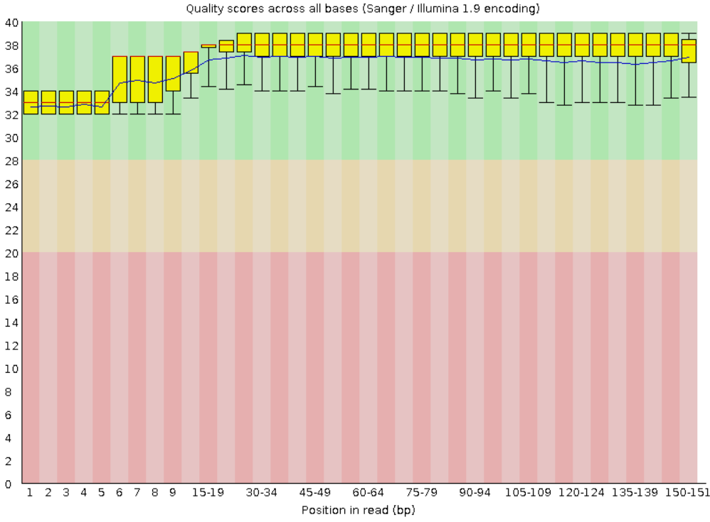
Figure S1. Post-trimming FastQC report. The trimming of the read was performed by TrimGaloresoftware, and the quality check can be done post-trimming. All the reads have a quality score of more than 30 and the reads less than 30 were trimmed.

Read the Alignment and Assembly of Transcripts
For read alignment in transcriptome reconstruction, the HISAT2 software was used. The alignment of reads to the reference genome is a critical step in the protocol, as it establishes the correspondence between the reads and the genomic regions. The read alignment to the human genome resulted in the generation of SAM (Sequence Alignment Map) files, with an alignment rate of more than 80%. The SAM files were converted to BAM (Binary Alignment Map) format to facilitate further analysis. Subsequently, the BAM files were indexed using samtools. Transcriptome reconstruction was performed using StringTie, which generated annotation files containing the expression levels of all the genes and transcripts of interest. These annotation files provide valuable insights into the gene expression profiles for the samples.

Table S3. Biologically significant genes related to oral squamous cell carcinoma
Gene names | Gene IDs | fc | pval | qval
P3H4 | MSTRG.13675 | 3.29144 | 7.76E-09 | 0.000139
PROS1 | MSTRG.22024 | 0.151577 | 3.48E-07 | 0.002907
DECR1 | MSTRG.30065 | 3.564668 | 4.86E-07 | 0.002907
PGLYRP4 | MSTRG.2025 | 5.074722 | 7.88E-06 | 0.024339
KIFAP3 | MSTRG.2374 | 5.255649 | 8.59E-06 | 0.024339
CTBP1 | MSTRG.23131 | 0.294249 | 9.49E-06 | 0.024339
GUCY1B1 | MSTRG.24230 | 2.764809 | 1.56E-05 | 0.031184
MARK3 | MSTRG.9875 | 5.907903 | 2.24E-05 | 0.036597
MMD | MSTRG.14033 | 2.982113 | 2.70E-05 | 0.040373
PSPHP1 | MSTRG.28276 | 3.132662 | 3.05E-05 | 0.041878
RPF2 | MSTRG.27234 | 4.631748 | 3.34E-05 | 0.041878
CERS4 | MSTRG.15538 | 4.570087 | 3.50E-05 | 0.041878
CDK16 | MSTRG.32218 | 0.199631 | 4.35E-05 | 0.04879
STAT3 | MSTRG.13697 | 4.449902 | 4.85E-05 | 0.051165
RGS20 | MSTRG.29804 | 3.167032 | 5.88E-05 | 0.058585
TWF1 | MSTRG.6883 | 9.066633 | 6.46E-05 | 0.061021
FDPS | MSTRG.2116 | 6.716559 | 6.94E-05 | 0.062288
KXD1 | MSTRG.15895 | 2.796901 | 7.90E-05 | 0.067467
NFIC | MSTRG.15379 | 0.329525 | 0.000111 | 0.090839
PNN | MSTRG.9105 | 0.449388 | 0.000138 | 0.104414
NEFL | MSTRG.29582 | 4.283213 | 0.00014 | 0.104414
RPSA | MSTRG.21533 | 20.25831 | 0.000159 | 0.109822
GDI2 | MSTRG.3264 | 3.812806 | 0.000194 | 0.128601
CLEC7A | MSTRG.6561 | 5.92354 | 0.000206 | 0.132312
STAT3 | MSTRG.13697 | 3.099627 | 0.000218 | 0.13496
NT5C3A | MSTRG.28110 | 0.245257 | 0.000236 | 0.138953
MAP3K13 | MSTRG.22906 | 2.175861 | 0.000242 | 0.138953
TRMT112 | MSTRG.5355 | 5.380821 | 0.000257 | 0.138953
CCDC167 | MSTRG.26719 | 2.567327 | 0.000261 | 0.138953
SUMF2 | MSTRG.28281 | 3.066449 | 0.000273 | 0.138953
PGAM5 | MSTRG.8076 | 3.48366 | 0.000279 | 0.138953
CHN1 | MSTRG.18529 | 2.834919 | 0.000287 | 0.139324
FAP | MSTRG.18412 | 2.786988 | 0.000303 | 0.143157
CASP1 | MSTRG.5948 | 3.349881 | 0.000328 | 0.150204
PPP1R14B-AS1 | MSTRG.5350 | 3.077709 | 0.000335 | 0.150204
NYNRIN | MSTRG.8946 | 0.391297 | 0.00035 | 0.15159
ERCC5 | MSTRG.8649 | 0.236914 | 0.000355 | 0.15159
RPS16 | MSTRG.16239 | 1.816302 | 0.000392 | 0.16006
KATNBL1 | MSTRG.10154 | 4.64907 | 0.000439 | 0.162799
TMEM40 | MSTRG.21280 | 4.540367 | 0.00044 | 0.162799
RPS21 | MSTRG.19961 | 2.37126 | 0.000451 | 0.162799
RIC8A | MSTRG.4548 | 1.637453 | 0.000454 | 0.162799
RPL39P3 | MSTRG.27000 | 2.317107 | 0.000544 | 0.181436
ENTR1 | MSTRG.31777 | 2.740155 | 0.000548 | 0.181436
HMGN4 | MSTRG.26336 | 1.808148 | 0.000552 | 0.181436
RPA3 | MSTRG.27908 | 2.047178 | 0.00056 | 0.181436
GAS5 | MSTRG.2426 | 0.398619 | 0.000566 | 0.181436
KLK12 | MSTRG.16640 | 3.03424 | 0.000587 | 0.183303
EIF4EBP1 | MSTRG.29695 | 2.039047 | 0.000592 | 0.183303
DDIT4 | MSTRG.3850 | 3.747658 | 0.00063 | 0.18869
PCDHB14 | MSTRG.25587 | 2.267529 | 0.000636 | 0.18869
SCNN1D | MSTRG.46 | 3.554325 | 0.000699 | 0.197098
EEF1E1 | MSTRG.26157 | 1.784998 | 0.000703 | 0.197098
ITGA1 | MSTRG.24736 | 2.166516 | 0.000764 | 0.210964
CXCL6 | MSTRG.23638 | 4.531233 | 0.000813 | 0.221047
DHRS9 | MSTRG.18461 | 9.183768 | 0.000896 | 0.229795
PTHLH | MSTRG.6773 | 2.668392 | 0.000964 | 0.236663

