Table S1. Baseline characteristics of participants based on training group and validation group
Variables a | Overall  (n=2364) | Validation group (n=473) | Training group (n=1891) | P b
Age, year | 70.98 (5.14) | 71.08 (5.01) | 70.95 (5.17) | 0.631
Gender, %
Male | 1240 (52.5) | 248 (52.4) | 992 (52.5) | >0.999
Female | 1124 (47.5) | 225 (47.6) | 899 (47.5)
Harmonized education levels, %
Less than lower secondary | 2167 (91.7) | 439 (92.8) | 1728 (91.4) | 0.466
Upper secondary & vocational training | 134 (5.7) | 25 (5.3) | 109 (5.8) | 0.466
Tertiary | 63 (2.7) | 9 (1.9) | 54 (2.9) | 0.466
Marital status, %
Married | 1724 (72.9) | 329 (69.6) | 1395 (73.8) | 0.325
Partnered | 640 (27.07) | 144 (30.44) | 496 (26.23) | 0.325
Currently working, %
No | 1311 (55.5) | 255 (53.9) | 1056 (55.8) | 0.708
Yes | 1005 (42.5) | 209 (44.2) | 796 (42.1) | 0.708
Missing | 48 (2.0) | 9 (1.9) | 39 (2.1) | 0.708
Ever drinks before, %
No | 1455 (61.5) | 295 (62.4) | 1160 (61.3) | 0.816
Yes | 908 (38.4) | 178 (37.6) | 730 (38.6) | 0.816
Missing | 1 (0.0) | 0 (0.0) | 1 (0.1) | 0.816
Smoke ever, %
No | 1367 (57.8) | 261 (55.2) | 1106 (58.5) | 0.211
Yes | 997 (42.2) | 212 (44.8) | 785 (41.5) | 0.211
Smoke now, %
No | 1618 (68.4) | 316 (66.8) | 1302 (68.9) | 0.491
Yes | 708 (29.9) | 151 (31.9) | 557 (29.5) | 0.491
Missing | 38 (1.6) | 6 (1.3) | 32 (1.7) | 0.491
Social activities, %
No | 1198 (50.7) | 267 (56.4) | 931 (49.2) | 0.019
Yes | 1084 (45.9) | 191 (40.4) | 893 (47.2) | 0.019
Missing | 82 (3.5) | 15 (3.2) | 67 (3.5) | 0.019
Any med for hypertention, %
No | 1768 (74.8) | 360 (76.1) | 1408 (74.5) | 0.68
Yes | 595 (25.2) | 113 (23.9) | 482 (25.5) | 0.68
Missing | 1 (0.0) | 0 (0.0) | 1 (0.1) | 0.68
Any meds for lung condition, %
No | 2179 (92.2) | 434 (91.8) | 1745 (92.3) | 0.809
Yes | 184 (7.8) | 39 (8.2) | 145 (7.7) | 0.809
Missing | 1 (0.0) | 0 (0.0) | 1 (0.1) | 0.809
Any meds for heart problems, %
No | 2121 (89.7) | 430 (90.9) | 1691 (89.4) | 0.576
Yes | 242 (10.2) | 43 (9.1) | 199 (10.5) | 0.576
Missing | 1 (0.0) | 0 (0.0) | 1 (0.1) | 0.576
Any meds for arthritis, %
No | 2062 (87.2) | 419 (88.6) | 1643 (86.9) | 0.074
Yes | 301 (12.7) | 53 (11.2) | 248 (13.1) | 0.074
Missing | 1 (0.0) | 1 (0.2) | 0 (0.0) | 0.074
Any meds for digestive disease, %
No | 2098 (88.7) | 431 (91.1) | 1667 (88.2) | 0.175
Yes | 265 (11.2) | 42 (8.9) | 223 (11.8) | 0.175
Missing | 1 (0.0) | 0 (0.0) | 1 (0.1) | 0.175
BMI, %
≤18.5 | 236 (10.0) | 46 (9.7) | 190 (10.0) | 0.994
18.5-23.9 | 939 (39.7) | 188 (39.7) | 751 (39.7) | 0.994
≥24 | 830 (35.1) | 168 (35.5) | 662 (35.0) | 0.994
Missing | 359 (15.2) | 71 (15.0) | 288 (15.2) | 0.994
Balance test summary score, %
No semi/yes s-b-s | 32 (1.4) | 11 (2.3) | 21 (1.1) | 0.133
Yes semi/no full | 484 (20.5) | 88 (18.6) | 396 (20.9) | 0.133
Yes semi/yes full | 1380 (58.4) | 284 (60.0) | 1096 (58.0) | 0.133
Missing | 468 (19.8) | 90 (19.0) | 378 (20.0) | 0.133
Walking speed test, sec | 4.68 (2.33) | 4.80 (2.40) | 4.65 (2.31) | 0.267
Grip strength, kg | 28.24 (9.74) | 27.36 (10.08) | 28.47 (9.65) | 0.042
CESD | 7.70 (5.90) | 8.35 (6.32) | 7.53 (5.78) | 0.008
Trajectory of multimorbidity, %
No multimorbidity | 580 (24.5) | 111 (23.5) | 469 (24.8) | 0.868
Newly-developing-decline | 1059 (44.8) | 211 (44.6) | 848 (44.8) | 0.868
Moderate-developing | 578 (24.5) | 122 (25.8) | 456 (24.1) | 0.868
Severe-developing | 147 (6.2) | 29 (6.1) | 118 (6.2) | 0.868
a Mean values (SD) for continuous variables and n (%) for categorical variables.
b Categorical data were compared using the Pearson’s chi-squared test. Continuous variables were compared using the t-test.
BMI, body mass index; semi, semi-tandem test; full, full-tandem test, s-b-s: side-by-side test; CES-D, Center for Epidemiological Studies Depression

Table S2. Fitting statistics for multimorbidity trajectories
 | Number of trajectory
 | wave 2 |  |  | wave 3 |  |  | wave 4 |  |  | wave 5
BICa | -15114.9 |  |  | -14117.44 |  |  | -13801.13 |  |  | -13647.16
Class1(n/%/APPb) | 1444 | 60.82 | 0.95 | 660 | 27.89 | 0.94 | 580 | 24.53 | 0.93 | 453 | 19.23 | 0.92
Class2(n/%/APPb) | 920 | 39.18 | 0.93 | 1267 | 53.25 | 0.94 | 1059 | 44.52 | 0.91 | 320 | 13.74 | 0.9
Class3(n/%/APPb) | / | / | / | 437 | 18.86 | 0.94 | 578 | 24.62 | 0.89 | 666 | 28.1 | 0.85
Class4(n/%/APPb) | / | / | / | / | / | / | 147 | 6.34 | 0.93 | 861 | 36.12 | 0.87
Class5(n/%/APPb) | / | / | / | / | / | / | / | / | / | 64 | 2.8 | 0.95
BIC: Bayesian information criteria
APP: average posterior probabilities
a: The lower absolute value shows a better model fit
b: The higher value is better (> 0.7 in a class)

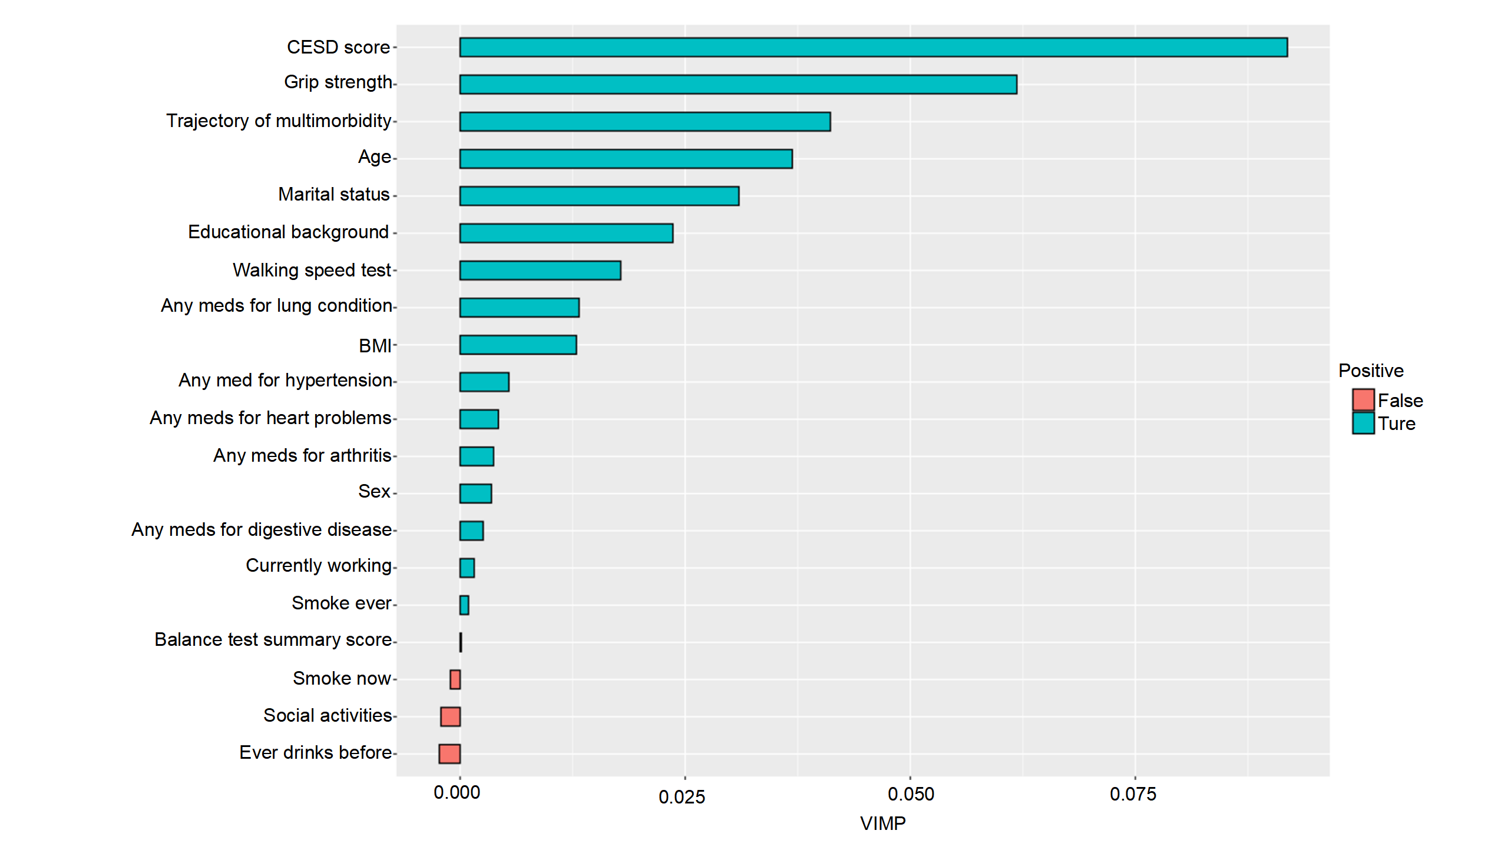
Figure S1. The ranked variables importance by the VIMP from the random survival forest method
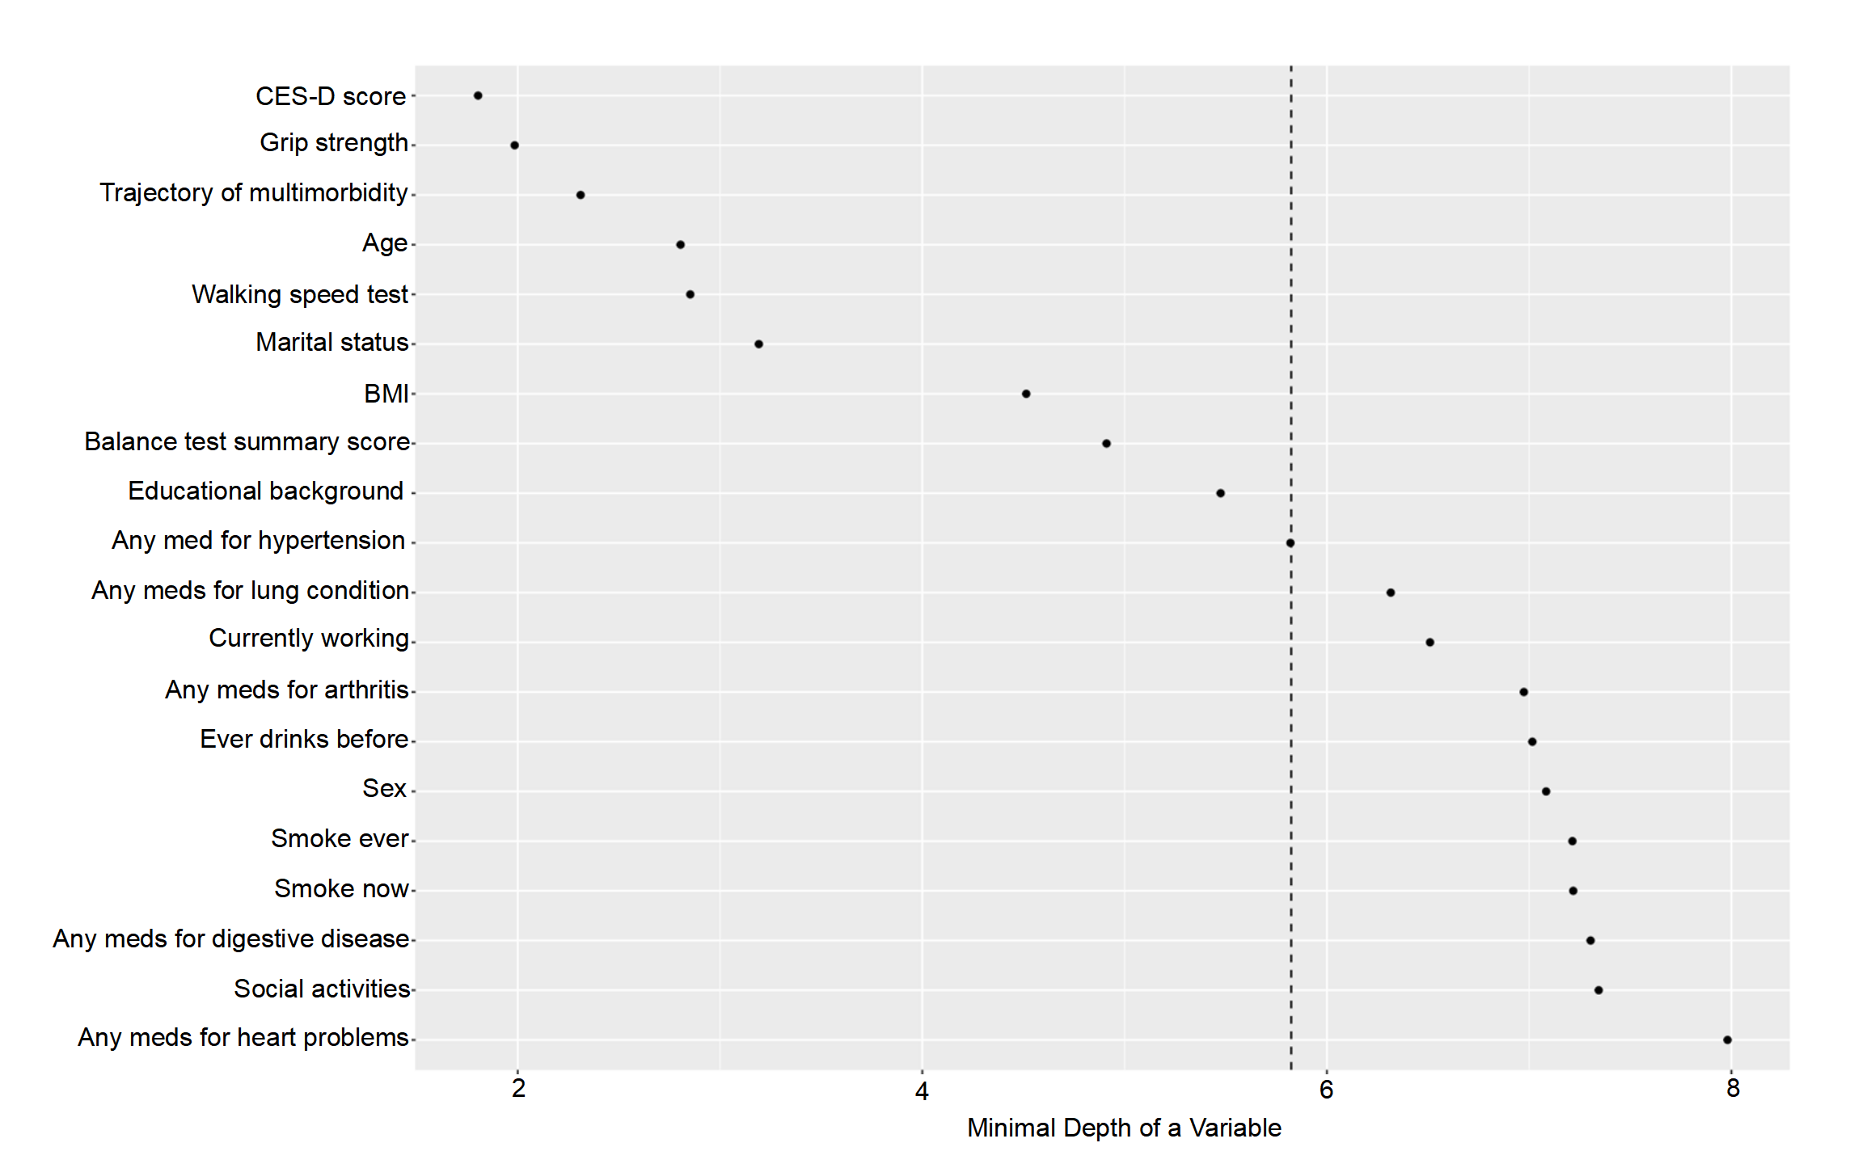
Figure S2. The ranked variables importance by the minimal depth from the random survival forest method 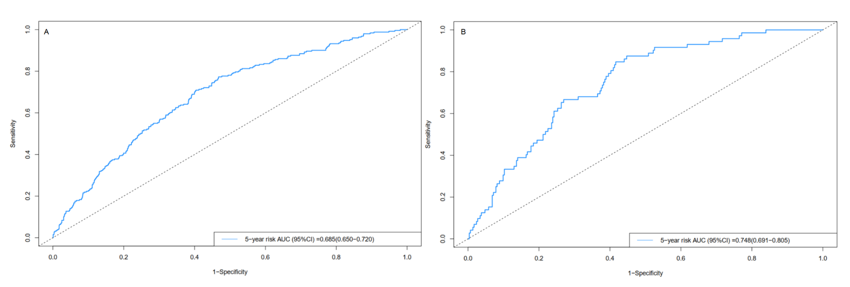
Figure S3. The multivariate Cox model ROC curves at 5-year risk in the training group (A) and in the validation group (B)
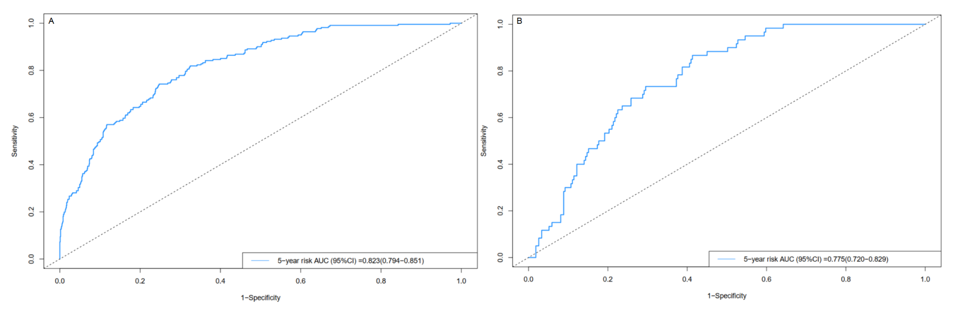
Figure S4. The random survival forests model ROC curves at 5-year risk in the training group (A) and in the validation group (B)

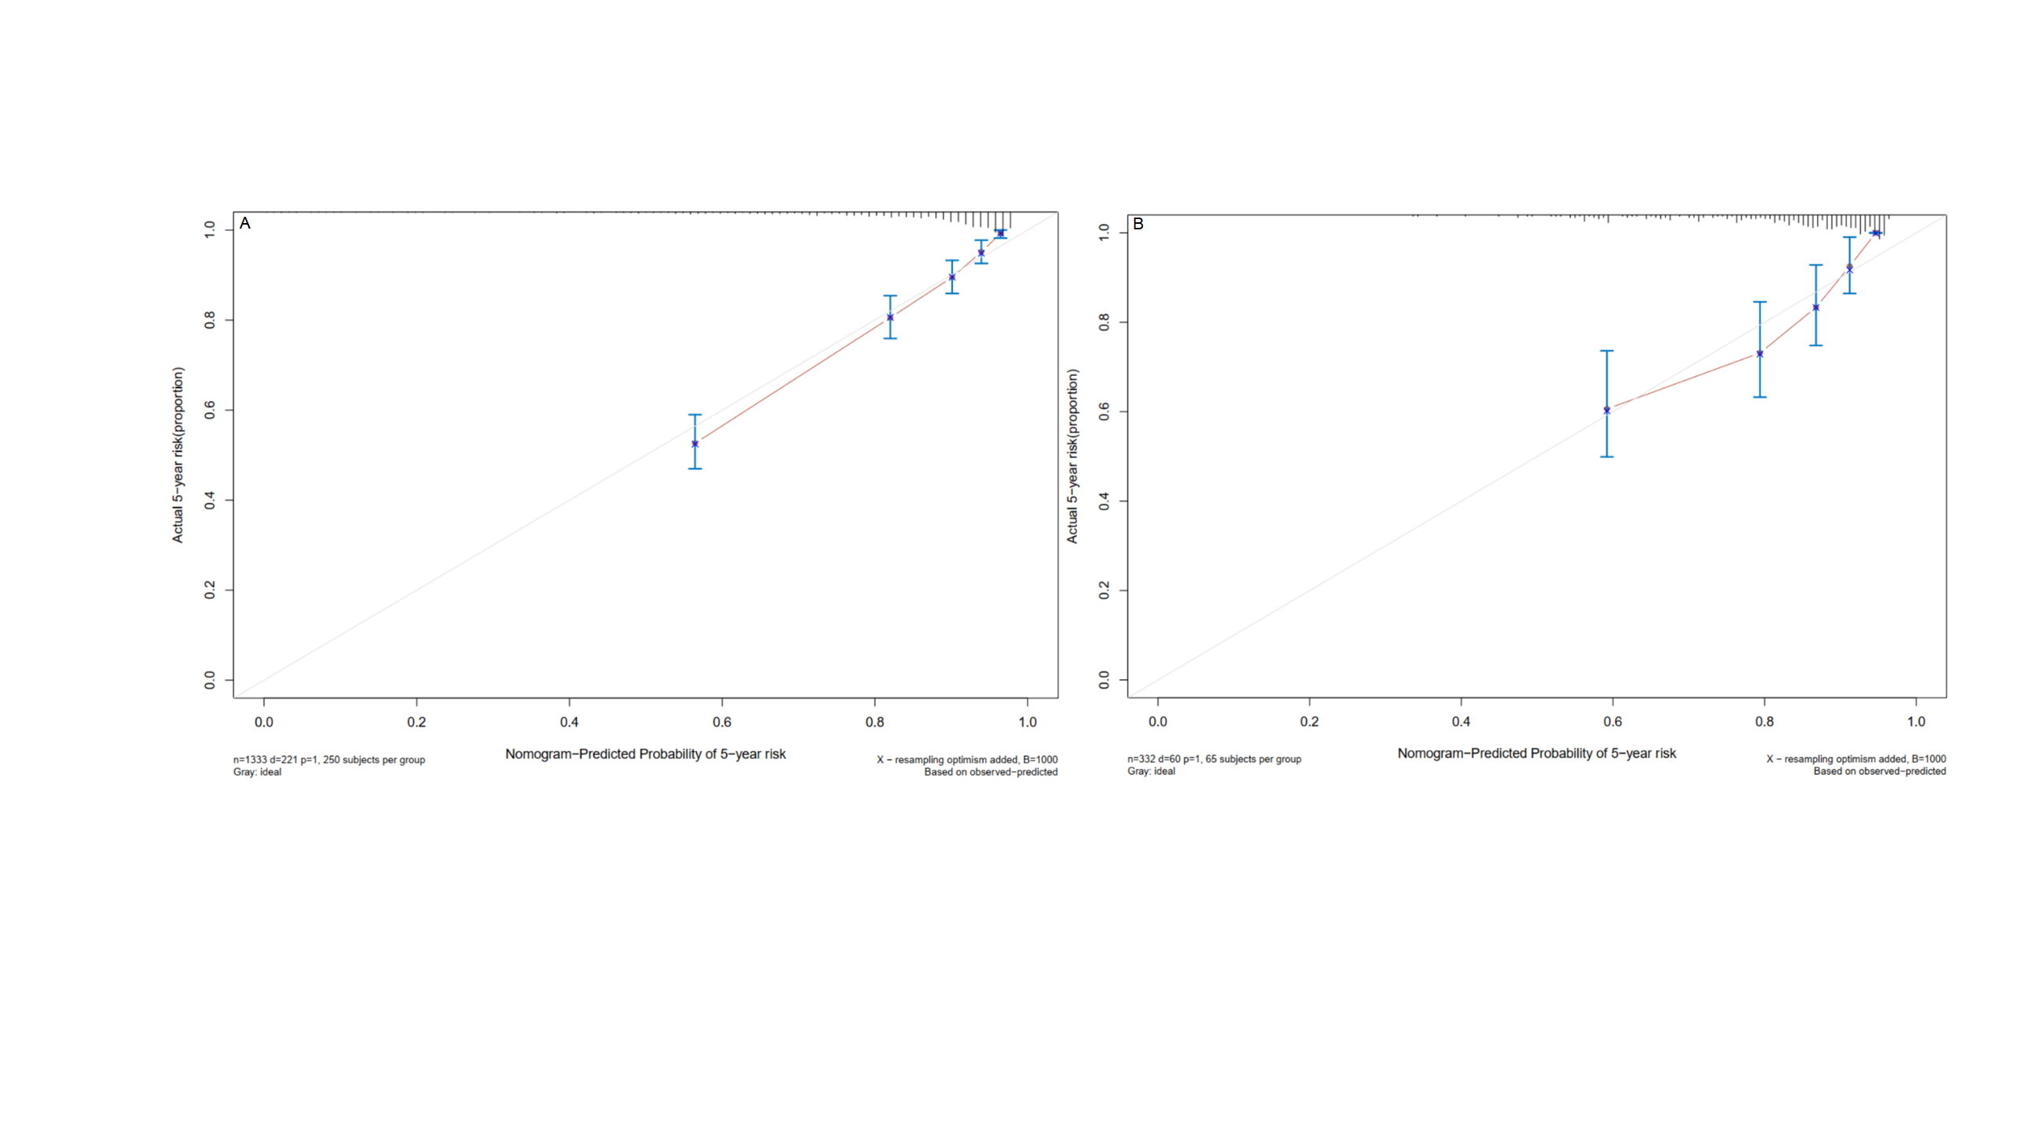
Figure S5. The multivariate Cox model calibration curves of 5-years risk in the training group (A) and in the validation group (B). The dashed line represents an excellent match between nomogram prediction (X-axis) and actual survival outcome (Y-axis). The cohort was divided into five groups with equal sample size for internal validation. Closer distances from the points to the dashed line indicate higher prediction accuracy.

Figure S6. The random survival forests model calibration curves of 5-years risk in the training group (A) and in the validation group (B). The dashed line represents an excellent match between nomogram prediction (X-axis) and actual survival outcome (Y-axis). The cohort was divided into five groups with equal sample size for internal validation. Closer distances from the points to the dashed line indicate higher prediction accuracy.

