Supplementary Material
Supplementary Fig. 1: Mutation map of key GRGs.
Supplementary Fig. 2: Box plot illustrating the expression of ten key GRGs across four classes.
Supplementary Fig. 3: (A) PCA distribution plot of expression levels across 33 cancer types. (B) t-SNE distribution plot of expression levels across 33 cancer types. (C) Survival curves for the four classes.
Supplementary Fig. 4: (A) Spearman correlation coefficient of key glycolytic genes with immune cell abundance. (B) Heatmap illustrating enrichment scores for significant feature sets.
Supplementary Fig. 5: Spearman correlation coefficient between key glycolytic genes and PDCD1.

Supplementary Fig. 1: Mutation map of key GRGs.
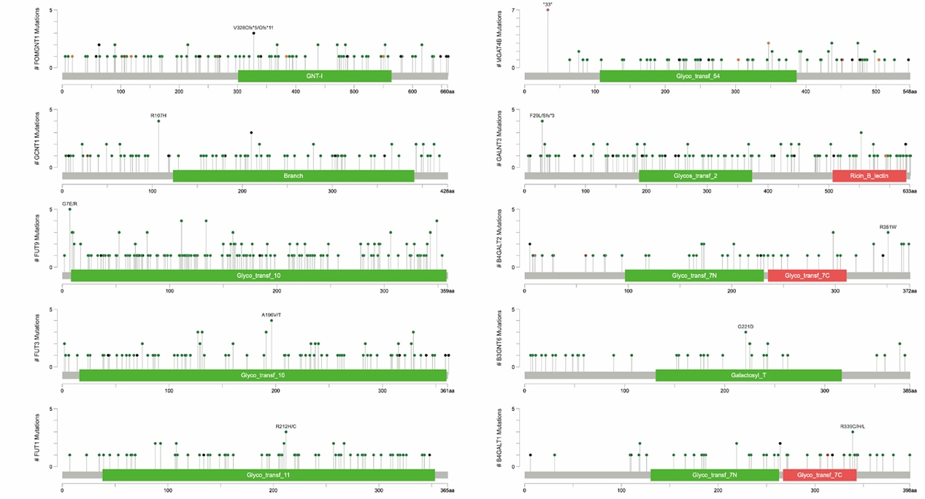

Supplementary Fig. 2: Box plot illustrating the expression of ten key GRGs across four classes.
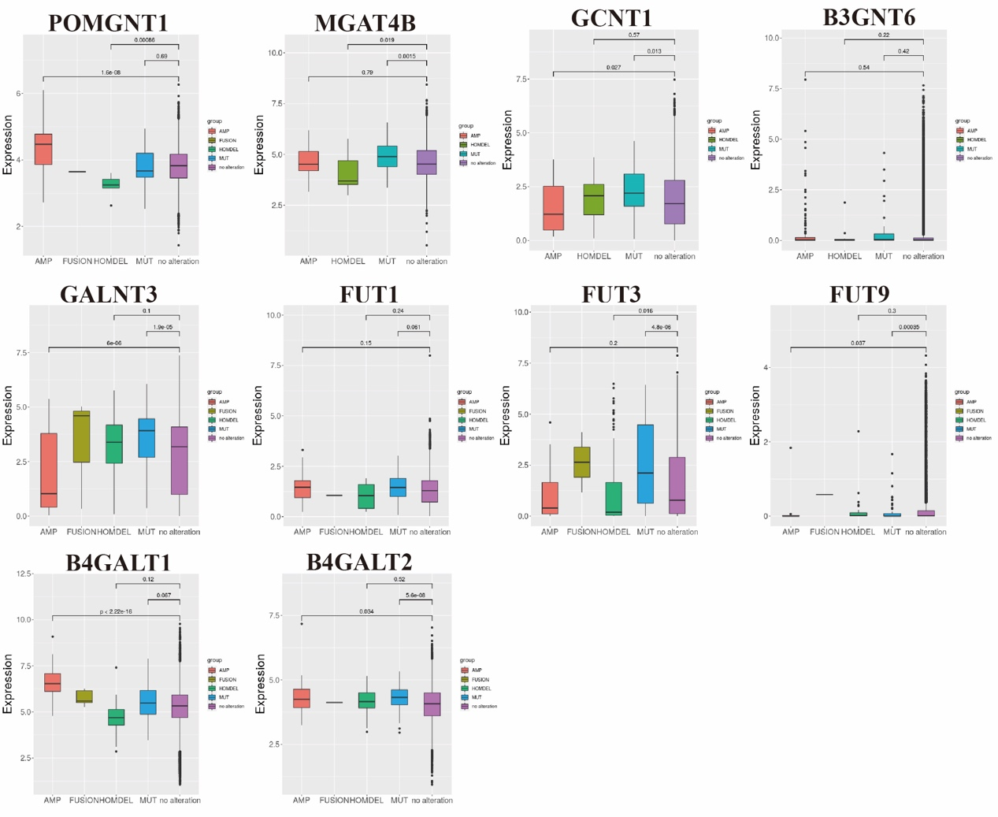

Supplementary Fig. 3: (A) PCA distribution plot of expression levels across 33 cancer types. (B) t-SNE distribution plot of expression levels across 33 cancer types. (C) Survival curves for the four classes.
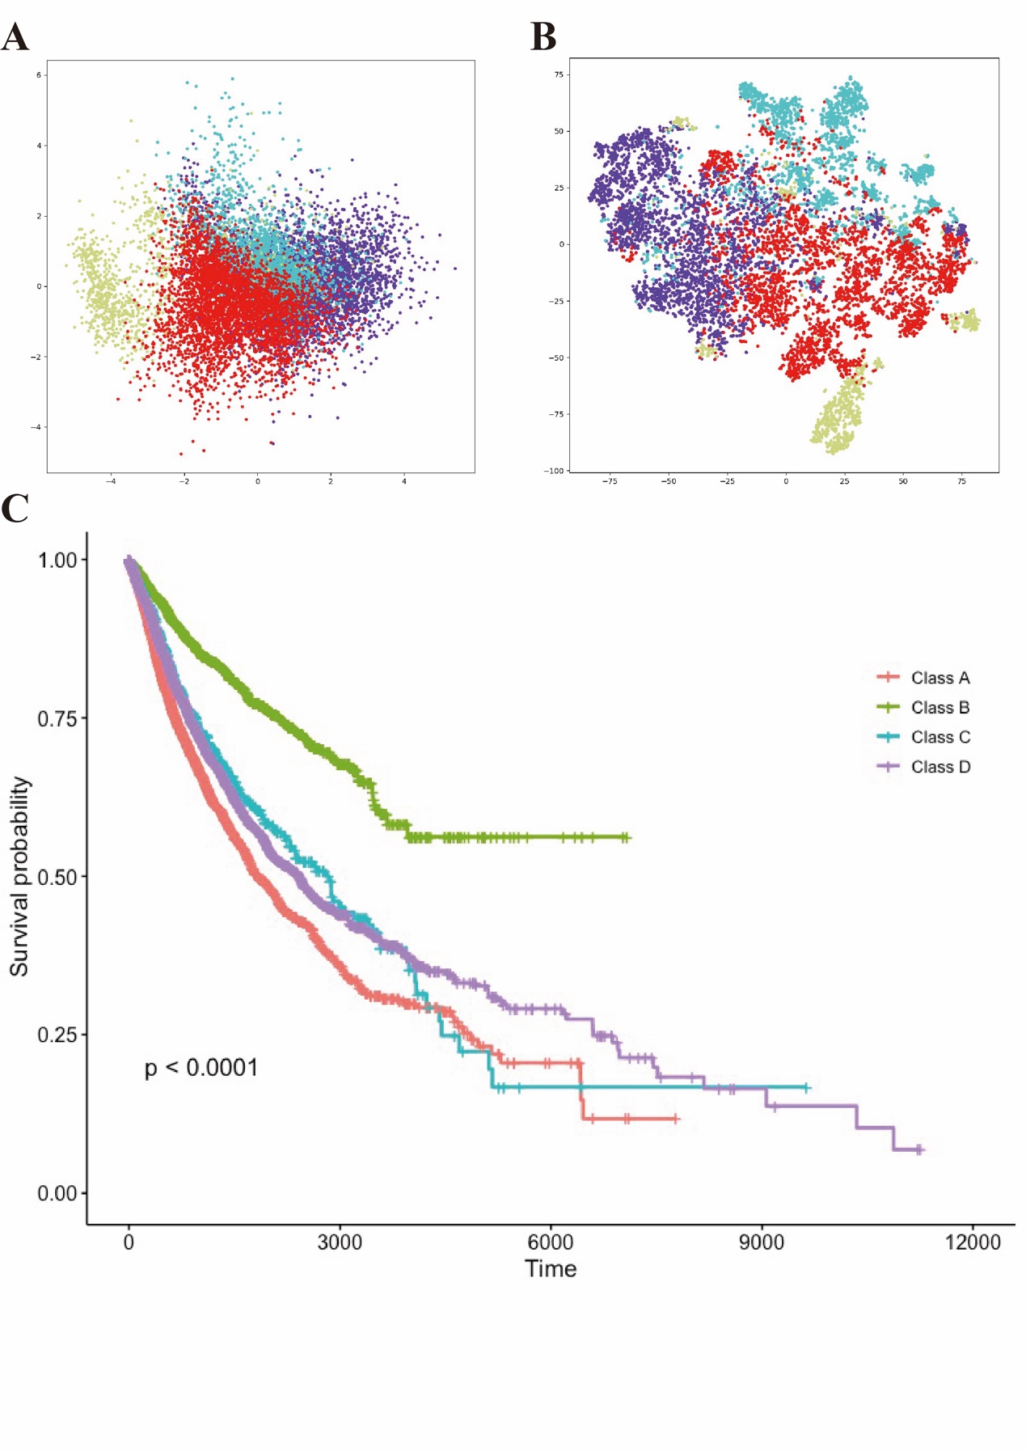

Supplementary Fig. 4: (A) Spearman correlation coefficient of key glycolytic genes with immune cell abundance. (B) Heatmap illustrating enrichment scores for significant feature sets.
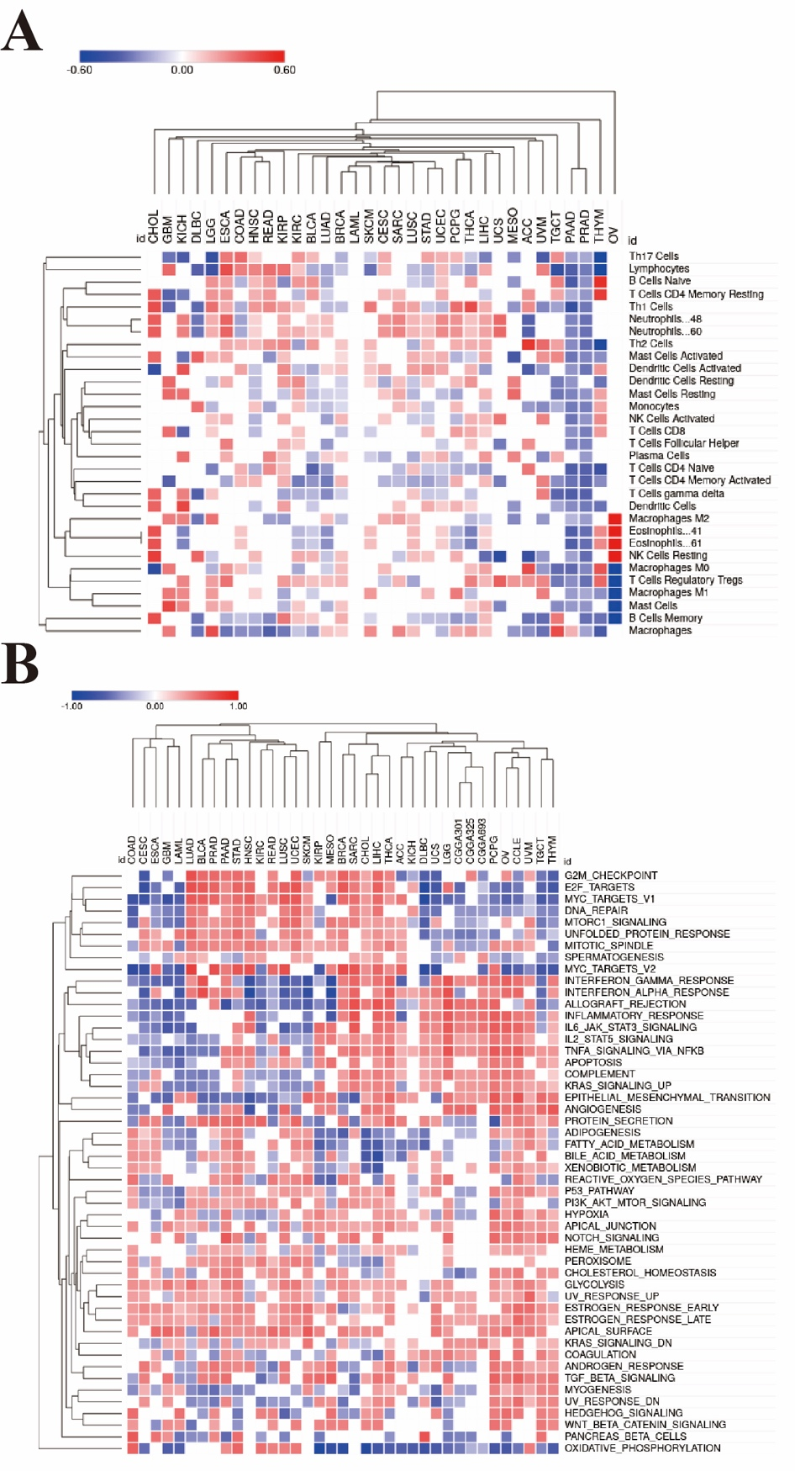

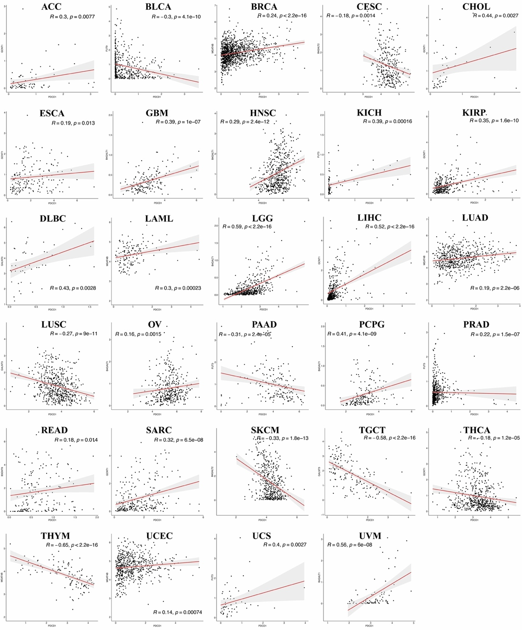
Supplementary Fig. 5: Spearman correlation coefficient between key glycolytic genes and PDCD1.

