vi. Supporting Information
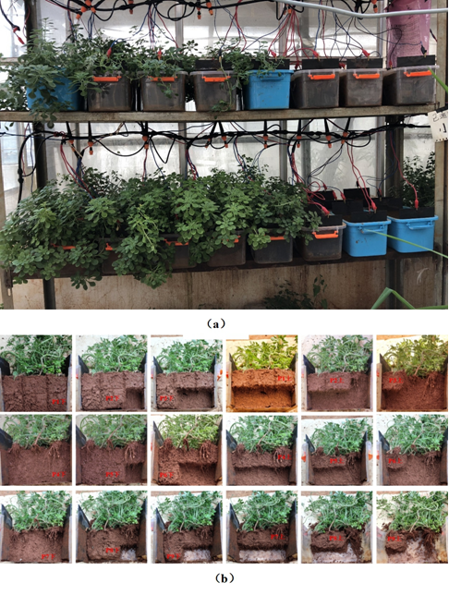
Fig. S1 EKPR pot experiment and partition sampling site situation
Table S1 Basic chemical characteristics of the soil.
pH | Organic matter  (g kg⁻¹) | Alkeline–N  (mg kg⁻¹) | Olsen–P  (mg kg⁻¹) | Available–K (mg kg⁻¹) | Pb  (mg kg⁻¹) | Cd  (mg kg⁻¹)
5.45 | 19.1 | 65.3 | 23.6 | 317 | 366 | 9.36
Table S2 EKPR experiment layout plan.
Voltage  (V) | Layout scheme |  |  |  |  |  |  |  |  | Amount
Voltage  (V) |  |  | No plants (EK) |  |  |  | With plants (EKPR)
 | CK | EK1 |  | EK2 | EK3 | EKPR1 |  | EKPR2 | EKPR3
0 | CK | / |  | / | / | / |  | / | / |  | 3
5 | / | EK1–5 |  | EK2–5 | EK3–5 | EKPR1–5 |  | EKPR2–5 | EKPR3–5 |  | 18
10 | / | EK1-10 |  | EK2-10 | EK3-10 | EKPR1-10 |  | EKPR2-10 | EKPR3-10 |  | 18
20 | / | EK1–20 |  | EK2–20 | EK3–20 | EKPR1–20 |  | EKPR2–20 | EKPR3–20 |  | 18
Amount | 3 | 9 |  | 9 | 9 | 9 |  | 9 | 9 |  | 57
Table S3 Soil pH in the surface and bottom layers of the cathode and anode regions under three electric field with 5 V.
Electrical fields | level | EK |  |  |  |  | EKPR
Electrical fields | level | Cathode | Middle |  | Anode |  | Cathode |  |  | Middle |  | Anode
1D | Surface | 5.90 ± 0.02 |  | 5.91 ± 0.13 |  | 5.63 ± 0.07 |  | 6.07 ± 0.04 | 5.93 ± 0.06 |  | 5.59 ± 0.13
1D | Bottom | 5.76 ± 0.13 |  | 5.77 ± 0.17 |  | 5.41 ± 0.19 |  | 6.02 ± 0.15 | 5.83 ± 0.14 |  | 5.54 ± 0.13
2D | Surface | 6.20 ± 0.03 |  | 5.81 ± 0.04 |  | 5.56 ± 0.34 |  | 5.9 ± 0.13 | 5.79 ± 0.05 |  | 5.52 ± 0.21
2D | Bottom | 4.87 ± 0.02 |  | 4.82 ± 0.04 |  | 4.62 ± 0.35 |  | 4.73 ± 0.05 | 4.60 ± 0.04 |  | 4.43 ± 0.20
3D | Surface | 5.51 ± 0.03 |  | 5.64 ± 0.04 |  | 5.75 ± 0.31 |  | 5.78 ± 0.01 | 5.78 ± 0.04 |  | 5.43 ± 0.19
3D | Bottom | 4.47 ± 0.06 |  | 5.53 ± 0.04 |  | 5.85 ± 0.28 |  | 4.46 ± 0.05 | 5.44 ± 0.04 |  | 5.93 ± 0.17

Table S4 Soil Cd in the Surface and Bottom layers of the cathode and anode regions under three electric field with 5 V.
Electrical fields |  | level | EK |  |  |  | EKPR
 |  | level | Cathode | Middle | Anode | Cathode |  | Middle | Anode
1D | Surface |  | 6.98 ± 0.86 | 7.35 ± 0.75 | 6.64 ± 1.66 | 6.22 ± 0.52 |  | 5.72 ± 0.78 | 4.57 ± 0.42
1D | Bottom |  | 7.77 ± 0.68 | 8.43 ± 0.18 | 8.01 ± 1.29 | 6.60 ± 0.58 |  | 6.26 ± 0.71 | 5.16 ± 0.70
2D | Surface |  | 2.42 ± 0.05 | 8.31 ± 0.87 | 8.98 ± 0.82 | 3.94 ± 0.32 |  | 4.38 ± 0.37 | 4.94 ± 1.62
2D | Bottom |  | 2.63 ± 0.32 | 9.12 ± 0.59 | 9.26 ± 0.81 | 3.02 ± 0.15 |  | 5.52 ± 0.68 | 4.93 ± 0.59
3D | Surface |  | 5.18 ± 0.12 | 8.93 ± 1.36 | 9.43 ± 1.11 | 3.72 ± 0.31 |  | 5.65 ± 1.61 | 4.49 ± 1.04
3D | Bottom |  | 4.2 ± 0.96 | 7.40 ± 0.08 | 8.95 ± 0.78 | 2.24 ± 0.10 |  | 4.43 ± 0.51 | 4.98 ± 0.60
Table S5 Translocation factor and bioconcentration factor of Sedum plumbizincicola
Electric field layout | TF (Translocation factor) |  |  | BCF (Bioconcentration factor)
Electric field layout | Cathode | Middle | Anode |  | Cathode | Middle | Anode
CK |  | 2.37 |  |  |  | 103.03
EKPR1–5 V | 2.48 | 2.47 | 2.67 |  | 136.55 | 179.45 | 175.13
EKPR1-10 V | 2.34 | 2.34 | 2.34 |  | 144.83 | 135.81 | 134.25
EKPR1–20 V | 2.04 | 1.89 | 1.92 |  | 97.35 | 107.08 | 108.01
EKPR2–5 V | 2.93 | 2.98 | 3.02 |  | 214.80 | 182.22 | 182.24
EKPR2-10 V | 2.05 | 2.23 | 2.06 |  | 137.19 | 162.36 | 155.85
EKPR2–20 V | 1.99 | 2.06 | 1.92 |  | 108.98 | 149.21 | 145.54
EKPR3–5 V | 2.48 | 2.81 | 2.73 |  | 166.91 | 204.05 | 192.19
EKPR3-10 V | 2.36 | 2.52 | 2.32 |  | 160.48 | 194.19 | 187.18
EKPR3–20 V | 2.82 | 3.06 | 3.04 |  | 148.60 | 135.77 | 129.74

