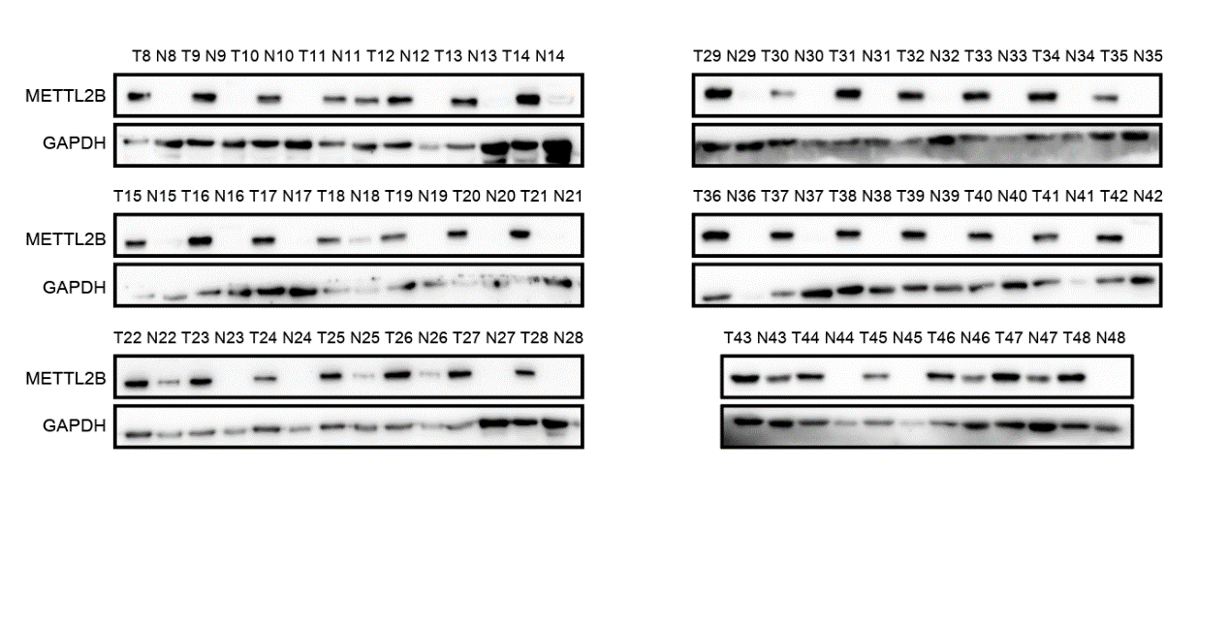
Figure S1. Relative expression of METTL2B protein in ovarian tissue samples obtained from patients with OC (n = 48) or normal controls (n = 48)

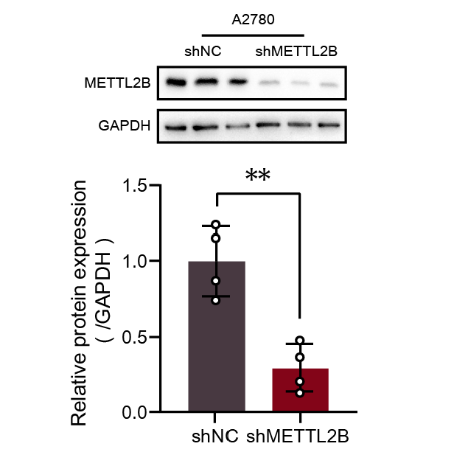
Figure S2. Validation of METTL2B silencing in A2780-shMETTL2B cells by western blotting

