Title: Identification, characterization, and expression of Oryza sativa betaine aldehyde dehydrogenase genes associated with the metabolism of oxyfluorfen
Authors: Zhao Jie Chenª*, Yi Zhuo Wangª, Jun Jin Luª, Xu Zhen Shiª, Ya Nan Quª, Gan Ai^{b}, Li Qing Zengª, Xiao Lu Wangª, Xi Ran Chengª, Yan Hui Wang^{c}*
Institute: ªGuangxi Key Laboratory of Agric-Environment and Agric-Products Safety, Guangxi University, Nanning, Guangxi, 530004, China; ^{b}The Key Laboratory of Plant Immunity, College of Plant Protection, Nanjing Agricultural University, Nanjing, 210095 China; ^{c}Guangxi Key Laboratory of Biology for Crop Diseases and Insect Pests, Plant Protection Research Institute, Guangxi Academy of Agricultural Sciences, Nanning 530007, China
Mailing address: Da Xue East Road No.100, College of agriculture, Guangxi University, Nanning 530004, China
*Corresponding author: Zhao Jie Chen; Yan Hui Wang
Email: zhaojie-chen@gxu.edu.cn; wangyh1984@163.com

Table S1. Primers for genes used for validating gene expression in rice tissues.
Genes | Sense-primer | Antisense-primer | Cycles
Os04g0464200 | GCCCGACCACAACACCTCAAA | TCTACTGCTTCACGCTCTGTCCTA | 40
Os07g0688800 | CGAAGACGCCAACCAGAACAAG | CGCAACATGCTCCTTAACCTCATC | 40
Os08g0424500 | TTATGGTCTGGCTGGTGCTGTG | CTTGCTTGACGCTTAGGTAGTTGT | 40

Table S2. The expression of genes coding for BADHs from roots and shoots of rice (Oryza sativa) in the presence of glycine betaine (+GB) under oxyfluorfen (OFF) stress and absence of glycine betaine (-GB) under oxyfluorfen (OFF) stress. The "Up" means expression of the genes that changed more than two-fold compared with controls, respectively, with false-discovery rates < 0.001.
Gene ID | ROOT-OFF/ ROOT+OFF+GB  (log2fold change) | Regulation | SHOOT-OFF/SHOOT+OFF+GB  (log2fold change) | Regulation | Description
Os04g0464200 | -0.550088809 | down | 0.088899613 | up | Betaine aldehyde dehydrogenase 1
Os07g0688800 | -0.022015478 | down | -0.018464182 | down | Aldehyde dehydrogenase 22A1
Os08g0424500 | -0.28711694 | down | -0.208842298 | down | Betaine aldehyde dehydrogenase 2

Table S3. List of the BADH genes identified in this study.
Gene ID | Chromosome | Nucleotide length | CDS Coordinates (5'-3')
Os04g0464200 | Chr4 | 1518 | 23176369 - 23171426
Os07g0688800 | Chr7 | 1794 | 29277745 - 29271520
Os08g0424500 | Chr8 | 1512 | 20379794 - 20386061

Table S4. Collinearity analysis results of rice BADH genes (interspecific).
Gene_1 | Gene_2 | E-value
Os04g0464200 | TraesCS2A02G336000 | 1E-311
Os04g0464200 | TraesCS2B02G346000 | 2E-187
Os04g0464200 | TraesCS2D02G326900 | 0
Os07g0688800 | TraesCS2A02G096000 | 0
Os07g0688800 | TraesCS2B02G111400 | 0
Os07g0688800 | TraesCS2D02G094400 | 0
Os08g0424500 | TraesCS2A02G336000 | 2E-269
Os08g0424500 | TraesCS2B02G346000 | 1E-155
Os08g0424500 | TraesCS2D02G326900 | 8E-278
Os04g0464200 | Zm00001eb041930 | 6E-286
Os08g0424500 | Zm00001eb041930 | 0
Os08g0424500 | Zm00001eb179190 | 0
Os07g0688800 | Zm00001eb331300 | 0
Os04g0464200 | Zm00001eb424410 | 0
Os04g0464200 | HORVU.MOREX.r3.2HG0173750 | 0
Os07g0688800 | HORVU.MOREX.r3.2HG0110060 | 0
Os07g0688800 | SORBI_3002G426100 | 0
Os04g0464200 | SORBI_3006G109500 | 0
Os08g0424500 | SORBI_3007G130800 | 0

Table S5. Mapping of rice BADH genes to those of monocotyledon and dicotyledon plants.
Rice BADH genes | BADH genes from monocotyledon and dicotyledon plants | Description | Identity
Os04g0464200 | SORBI_3006G109500 | Betaine aldehyde dehydrogenase 1 | 88.54%
Os04g0464200 | Zm00001d025626 | Betaine aldehyde dehydrogenase | 88.54%
Os04g0464200 | TaBADH-like | Betaine aldehyde dehydrogenase-like | 84.58%
Os04g0464200 | HvBADH | Betaine aldehyde dehydrogenase | 82.41%
Os04g0464200 | AT3G48170 | Betaine aldehyde dehydrogenase | 75.75%
Os04g0464200 | GLYMA_06G186300v4 | Betaine aldehyde dehydrogenase | 73.40%
Os04g0464200 | GLYMA_05G033500v4 | Betaine aldehyde dehydrogenase | 73.35%
Os07g0688800 | TaALDH22A1-like | Aldehyde dehydrogenase 22A1-like | 92.80%
Os07g0688800 | Zm00001d022554 | Uncharacterized protein | 89.32%
Os08g0424500 | AT3G48170 | Betaine aldehyde dehydrogenase | 74.95%
Os08g0424500 | Zm00001d050339 | Aminoaldehyde dehydrogenase 1a | 89.98%
Os08g0424500 | SORBI_3007G130800 | Betaine aldehyde dehydrogenase 2 | 89.31%
Os08g0424500 | TaBADH | Betaine-aldehyde dehydrogenase | 88.18%
Os08g0424500 | TaBADH2-like | Betaine aldehyde dehydrogenase 2-like | 87.48%
Os08g0424500 | HvBADH | Betaine aldehyde dehydrogenase | 87.95%
Os08g0424500 | Zm00001d032257 | Aminoaldehyde dehydrogenase 1b | 89.38%
Os08g0424500 | GLYMA_06G186300v4 | Betaine aldehyde dehydrogenase | 74.16%
Os08g0424500 | GLYMA_05G033500v4 | Betaine aldehyde dehydrogenase | 75.35%

Table S6 Prediction of cis-regulatory elements in promoter regions of BADHs
Gene ID | Element Name | Starting Point | Element Length | Function Description
Os08t0424500 | 4cl-CMA2b | 1958 | 13 | light responsive element
Os04t0464200 | A-box | 1284 | 6 | cis-acting regulatory element
Os07t0688800 | A-box | 1139 | 6 | cis-acting regulatory element
Os07t0688800 | A-box | 1150 | 6 | cis-acting regulatory element
Os04t0464200 | ABRE | 1659 | 5 | cis-acting element involved in the abscisic acid responsiveness
Os04t0464200 | ABRE | 1667 | 5 | cis-acting element involved in the abscisic acid responsiveness
Os07t0688800 | ABRE | 856 | 5 | cis-acting element involved in the abscisic acid responsiveness
Os07t0688800 | ABRE | 1025 | 6 | cis-acting element involved in the abscisic acid responsiveness
Os07t0688800 | ABRE | 1026 | 5 | cis-acting element involved in the abscisic acid responsiveness
Os08t0424500 | ABRE | 1772 | 5 | cis-acting element involved in the abscisic acid responsiveness
Os08t0424500 | ACE | 531 | 9 | cis-acting element involved in light responsiveness
Os04t0464200 | AE-box | 758 | 8 | part of a module for light response
Os04t0464200 | ARE | 363 | 6 | cis-acting regulatory element essential for the anaerobic induction
Os04t0464200 | ARE | 1643 | 6 | cis-acting regulatory element essential for the anaerobic induction
Os07t0688800 | ARE | 200 | 6 | cis-acting regulatory element essential for the anaerobic induction
Os07t0688800 | ARE | 207 | 6 | cis-acting regulatory element essential for the anaerobic induction
Os07t0688800 | ARE | 733 | 6 | cis-acting regulatory element essential for the anaerobic induction
Os07t0688800 | AT-rich element | 468 | 10 | binding site of AT-rich DNA binding protein (ATBP-1)
Os04t0464200 | Box 4 | 464 | 6 | part of a conserved DNA module involved in light responsiveness
Os07t0688800 | Box 4 | 150 | 6 | part of a conserved DNA module involved in light responsiveness
Os07t0688800 | Box 4 | 538 | 6 | part of a conserved DNA module involved in light responsiveness
Os08t0424500 | Box 4 | 735 | 6 | part of a conserved DNA module involved in light responsiveness
Os08t0424500 | Box 4 | 1063 | 6 | part of a conserved DNA module involved in light responsiveness
Os08t0424500 | Box 4 | 1146 | 6 | part of a conserved DNA module involved in light responsiveness
Os08t0424500 | Box 4 | 1395 | 6 | part of a conserved DNA module involved in light responsiveness
Os08t0424500 | Box 4 | 1645 | 6 | part of a conserved DNA module involved in light responsiveness
Os07t0688800 | Box III | 1420 | 11 | protein binding site
Os04t0464200 | CAT-box | 1791 | 6 | cis-acting regulatory element related to meristem expression
Os04t0464200 | CAT-box | 1870 | 6 | cis-acting regulatory element related to meristem expression
Os07t0688800 | CAT-box | 1052 | 6 | cis-acting regulatory element related to meristem expression
Os07t0688800 | CAT-box | 1293 | 6 | cis-acting regulatory element related to meristem expression
Os08t0424500 | CCAAT-box | 1705 | 6 | MYBHv1 binding site
Os08t0424500 | CCAAT-box | 1525 | 6 | MYBHv1 binding site
Os04t0464200 | CGTCA-motif | 744 | 5 | cis-acting regulatory element involved in the MeJA-responsiveness
Os04t0464200 | CGTCA-motif | 1065 | 5 | cis-acting regulatory element involved in the MeJA-responsiveness
Os07t0688800 | CGTCA-motif | 137 | 5 | cis-acting regulatory element involved in the MeJA-responsiveness
Os07t0688800 | CGTCA-motif | 1131 | 5 | cis-acting regulatory element involved in the MeJA-responsiveness
Os08t0424500 | CGTCA-motif | 846 | 5 | cis-acting regulatory element involved in the MeJA-responsiveness
Os08t0424500 | CGTCA-motif | 1116 | 5 | cis-acting regulatory element involved in the MeJA-responsiveness
Os08t0424500 | CGTCA-motif | 1520 | 5 | cis-acting regulatory element involved in the MeJA-responsiveness
Os08t0424500 | CGTCA-motif | 1935 | 5 | cis-acting regulatory element involved in the MeJA-responsiveness
Os08t0424500 | chs-CMA1a | 728 | 8 | part of a light responsive element
Os08t0424500 | chs-CMA1a | 1653 | 8 | part of a light responsive element
Os07t0688800 | GARE-motif | 34 | 7 | gibberellin-responsive element
Os07t0688800 | GARE-motif | 128 | 7 | gibberellin-responsive element
Os07t0688800 | GARE-motif | 627 | 7 | gibberellin-responsive element
Os08t0424500 | GATA-motif | 1041 | 7 | part of a light responsive element
Os04t0464200 | GATA-motif | 684 | 7 | part of a light responsive element
Os04t0464200 | G-box | 1667 | 6 | cis-acting regulatory element involved in light responsiveness
Os07t0688800 | G-box | 856 | 6 | cis-acting regulatory element involved in light responsiveness
Os07t0688800 | G-box | 1025 | 6 | cis-acting regulatory element involved in light responsiveness
Os04t0464200 | G-box | 1659 | 8 | cis-acting regulatory element involved in light responsiveness
Os04t0464200 | G-Box | 1659 | 6 | cis-acting regulatory element involved in light responsiveness
Os07t0688800 | G-Box | 1025 | 6 | cis-acting regulatory element involved in light responsiveness
Os08t0424500 | G-Box | 1771 | 6 | cis-acting regulatory element involved in light responsiveness
Os07t0688800 | G-box | 1074 | 6 | cis-acting regulatory element involved in light responsiveness
Os07t0688800 | GC-motif | 1859 | 6 | enhancer-like element involved in anoxic specific inducibility
Os04t0464200 | GT1-motif | 569 | 6 | light responsive element
Os07t0688800 | GT1-motif | 1373 | 6 | light responsive element
Os07t0688800 | GT1-motif | 1648 | 6 | light responsive element
Os08t0424500 | GT1-motif | 821 | 6 | light responsive element
Os08t0424500 | GT1-motif | 823 | 6 | light responsive element
Os07t0688800 | GT1-motif | 1647 | 7 | light responsive element
Os07t0688800 | GTGGC-motif | 836 | 10 | part of a light responsive element
Os07t0688800 | I-box | 679 | 8 | part of a light responsive element
Os07t0688800 | MBS | 884 | 6 | MYB binding site involved in drought-inducibility
Os07t0688800 | MBS | 1791 | 6 | MYB binding site involved in drought-inducibility
Os08t0424500 | MBS | 969 | 6 | MYB binding site involved in drought-inducibility
Os08t0424500 | MBS | 1748 | 6 | MYB binding site involved in drought-inducibility
Os04t0464200 | O2-site | 1827 | 9 | cis-acting regulatory element involved in zein metabolism regulation
Os04t0464200 | P-box | 1954 | 7 | gibberellin-responsive element
Os04t0464200 | Sp1 | 821 | 6 | light responsive element
Os04t0464200 | Sp1 | 1999 | 6 | light responsive element
Os04t0464200 | TCCC-motif | 991 | 7 | part of a light responsive element
Os04t0464200 | TC-rich repeats | 1125 | 9 | cis-acting element involved in defense and stress responsiveness
Os07t0688800 | TC-rich repeats | 597 | 9 | cis-acting element involved in defense and stress responsiveness
Os07t0688800 | TC-rich repeats | 1354 | 9 | cis-acting element involved in defense and stress responsiveness
Os04t0464200 | TCT-motif | 1186 | 6 | part of a light responsive element
Os04t0464200 | TGACG-motif | 744 | 5 | cis-acting regulatory element involved in the MeJA-responsiveness
Os04t0464200 | TGACG-motif | 1065 | 5 | cis-acting regulatory element involved in the MeJA-responsiveness
Os07t0688800 | TGACG-motif | 137 | 5 | cis-acting regulatory element involved in the MeJA-responsiveness
Os07t0688800 | TGACG-motif | 1131 | 5 | cis-acting regulatory element involved in the MeJA-responsiveness
Os08t0424500 | TGACG-motif | 846 | 5 | cis-acting regulatory element involved in the MeJA-responsiveness
Os08t0424500 | TGACG-motif | 1116 | 5 | cis-acting regulatory element involved in the MeJA-responsiveness
Os08t0424500 | TGACG-motif | 1520 | 5 | cis-acting regulatory element involved in the MeJA-responsiveness
Os08t0424500 | TGACG-motif | 1935 | 5 | cis-acting regulatory element involved in the MeJA-responsiveness

Table S7. Prediction of domain of BADHs
Gene ID | PSSM-ID | From | To | E-Value | Bitscore | Accession | Superfamily
Os04g0464200 | 215260 | 3 | 505 | 0 | 1068.97 | PLN02467 | ALDH-SF
Os07g0688800 | 143416 | 69 | 531 | 0 | 788.804 | cd07098 | ALDH-SF
Os08g0424500 | 215260 | 1 | 503 | 0 | 1056.26 | PLN02467 | ALDH-SF

Table S8. Prediction biophysical properties of BADHs
Gene ID | The number of amino acids | Molecular weight (KDa) | Theoretical isoelectric point | Instability index | Grand average of hydropathicity of protein
Os04g0464200 | 505 | 54.64802 | 6.63 | 33.42 | -0.020
Os07g0688800 | 597 | 66.01946 | 7.50 | 35.69 | 0.031
Os08g0424500 | 503 | 54.68271 | 5.36 | 35.87 | -0.124

Table S9. Prediction of secondary structures of BADH proteins.
Gene ID | Alpha helix (Hh) | Extended strand (Ee) | Beta turn (Tt) | Random coil (Cc)
Os04g0464200 | 43.96% | 15.64% | 7.52% | 32.87%
Os07g0688800 | 45.06% | 12.23% | 5.19% | 37.52%
Os08g0424500 | 43.74% | 15.11% | 7.75% | 33.40%

Table S10. Analysis of protein-protein interactions among rice BADH family genes.
Node1 | Node2 | Experimentally determined interaction | Database annotated | Automated textmining | Combined score
A0A0N7KGH1 | Q6ZFI6_ORYSJ | 0 | 0.679 | 0 | 0.704
A0A0N7KGH1 | Q8H5F0_ORYSJ | 0 | 0.629 | 0.119 | 0.705
A0A0N7KGH1 | Q7XTZ0_ORYSJ | 0 | 0.841 | 0 | 0.849
A0A0N7KGH1 | BADH2 | 0 | 0.806 | 0.143 | 0.85
A0A0N7KGH1 | Q652S1_ORYSJ | 0 | 0.848 | 0.054 | 0.85
A0A0N7KGH1 | BADH1 | 0 | 0.806 | 0.143 | 0.85
A0A0N7KGH1 | A0A0P0X0M6 | 0 | 0.847 | 0.148 | 0.864
A0A0N7KGH1 | Q69P84_ORYSJ | 0 | 0.847 | 0.149 | 0.882
A0A0P0UYD8 | Q6ZFI6_ORYSJ | 0 | 0.738 | 0.064 | 0.777
A0A0P0UYD8 | BADH1 | 0.187 | 0.638 | 0.122 | 0.801
A0A0P0UYD8 | Q8H5F0_ORYSJ | 0.187 | 0.638 | 0.122 | 0.801
A0A0P0UYD8 | BADH2 | 0.187 | 0.638 | 0.122 | 0.801
A0A0P0UYD8 | Q69P84_ORYSJ | 0.284 | 0.638 | 0.122 | 0.825
A0A0P0WIK5 | Q6ZFI6_ORYSJ | 0 | 0.738 | 0.064 | 0.777
A0A0P0WIK5 | BADH1 | 0.187 | 0.638 | 0.122 | 0.801
A0A0P0WIK5 | Q8H5F0_ORYSJ | 0.187 | 0.638 | 0.122 | 0.801
A0A0P0WIK5 | BADH2 | 0.187 | 0.638 | 0.122 | 0.801
A0A0P0WIK5 | Q69P84_ORYSJ | 0.284 | 0.638 | 0.122 | 0.825
A0A0P0X0M6 | A0A0N7KGH1 | 0 | 0.847 | 0.148 | 0.864
A0A0P0X0M6 | Q6ZFI6_ORYSJ | 0 | 0.656 | 0.254 | 0.787
A0A0P0X0M6 | Q69P84_ORYSJ | 0 | 0.868 | 0.119 | 0.89
A0A0P0X0M6 | Q7XTZ0_ORYSJ | 0 | 0.868 | 0.257 | 0.897
A0A0P0X0M6 | BADH1 | 0 | 0.859 | 0.454 | 0.927
A0A0P0X0M6 | BADH2 | 0 | 0.868 | 0.454 | 0.932
BADH1 | A0A0N7KGH1 | 0 | 0.806 | 0.143 | 0.85
BADH1 | A0A0P0UYD8 | 0.187 | 0.638 | 0.122 | 0.801
BADH1 | A0A0P0WIK5 | 0.187 | 0.638 | 0.122 | 0.801
BADH1 | A0A0P0X0M6 | 0 | 0.859 | 0.454 | 0.927
BADH1 | P5CS1 | 0 | 0.872 | 0.571 | 0.947
BADH1 | Q5JMW7_ORYSJ | 0.084 | 0.647 | 0.189 | 0.811
BADH1 | OJ1065_B06.20 | 0.084 | 0.647 | 0.189 | 0.811
BADH1 | Q6ZFI6_ORYSJ | 0.185 | 0.681 | 0.253 | 0.818
BADH1 | Q336U3_ORYSJ | 0.091 | 0.644 | 0.347 | 0.851
BADH1 | Q2QMH0_ORYSJ | 0.266 | 0.796 | 0.19 | 0.875
BADH1 | Q7XTZ0_ORYSJ | 0 | 0.847 | 0.143 | 0.881
BADH1 | P5CS2 | 0 | 0.872 | 0.475 | 0.935
BADH1 | BADH2 | 0 | 0.94 | 0.053 | 0.941
BADH1 | Q652S1_ORYSJ | 0.176 | 0.878 | 0.382 | 0.942
BADH1 | Q69P84_ORYSJ | 0.22 | 0.94 | 0.08 | 0.958
BADH2 | A0A0N7KGH1 | 0 | 0.806 | 0.143 | 0.85
BADH2 | A0A0P0UYD8 | 0.187 | 0.638 | 0.122 | 0.801
BADH2 | A0A0P0WIK5 | 0.187 | 0.638 | 0.122 | 0.801
BADH2 | A0A0P0X0M6 | 0 | 0.868 | 0.454 | 0.932
BADH2 | P5CS1 | 0 | 0.872 | 0.626 | 0.953
BADH2 | BADH1 | 0 | 0.94 | 0.053 | 0.941
BADH2 | Q2QMH0_ORYSJ | 0.266 | 0.796 | 0.19 | 0.875
BADH2 | Q336U3_ORYSJ | 0.091 | 0.644 | 0.504 | 0.887
BADH2 | Q5JMW7_ORYSJ | 0.084 | 0.647 | 0.189 | 0.811
BADH2 | Q652S1_ORYSJ | 0.176 | 0.878 | 0.382 | 0.942
BADH2 | Q69P84_ORYSJ | 0.22 | 0.94 | 0.08 | 0.958
BADH2 | Q6ZFI6_ORYSJ | 0.185 | 0.681 | 0.253 | 0.818
BADH2 | OJ1065_B06.20 | 0.084 | 0.647 | 0.189 | 0.811
BADH2 | Q7XTZ0_ORYSJ | 0 | 0.847 | 0.143 | 0.881
BADH2 | P5CS2 | 0 | 0.872 | 0.632 | 0.954
OJ1065_B06.20 | BADH1 | 0.084 | 0.647 | 0.189 | 0.811
OJ1065_B06.20 | Q69P84_ORYSJ | 0.096 | 0.647 | 0.189 | 0.814
OJ1065_B06.20 | Q8H5F0_ORYSJ | 0.084 | 0.647 | 0.189 | 0.811
OJ1065_B06.20 | BADH2 | 0.084 | 0.647 | 0.189 | 0.811
P5CS1 | Q8H5F0_ORYSJ | 0 | 0.872 | 0.445 | 0.931
P5CS1 | BADH1 | 0 | 0.872 | 0.571 | 0.947
P5CS1 | Q69P84_ORYSJ | 0 | 0.872 | 0.582 | 0.953
P5CS1 | BADH2 | 0 | 0.872 | 0.626 | 0.953
P5CS1 | Q336U3_ORYSJ | 0.151 | 0.953 | 0.805 | 0.992
P5CS1 | P5CS2 | 0 | 0.94 | 0.566 | 0.999
P5CS2 | P5CS1 | 0 | 0.94 | 0.566 | 0.999
P5CS2 | BADH1 | 0 | 0.872 | 0.475 | 0.935
P5CS2 | Q336U3_ORYSJ | 0.151 | 0.953 | 0.795 | 0.992
P5CS2 | Q69P84_ORYSJ | 0 | 0.872 | 0.582 | 0.953
P5CS2 | BADH2 | 0 | 0.872 | 0.632 | 0.954
P5CS2 | Q8H5F0_ORYSJ | 0 | 0.872 | 0.445 | 0.931
Q2QMH0_ORYSJ | BADH1 | 0.266 | 0.796 | 0.19 | 0.875
Q2QMH0_ORYSJ | Q8H5F0_ORYSJ | 0.266 | 0.796 | 0.19 | 0.875
Q2QMH0_ORYSJ | BADH2 | 0.266 | 0.796 | 0.19 | 0.875
Q2QMH0_ORYSJ | Q69P84_ORYSJ | 0.266 | 0.847 | 0.19 | 0.906
Q2QMH0_ORYSJ | Q652S1_ORYSJ | 0.2 | 0.917 | 0.483 | 0.974
Q336U3_ORYSJ | P5CS1 | 0.151 | 0.953 | 0.805 | 0.992
Q336U3_ORYSJ | BADH1 | 0.091 | 0.644 | 0.347 | 0.851
Q336U3_ORYSJ | Q69P84_ORYSJ | 0.091 | 0.644 | 0.254 | 0.83
Q336U3_ORYSJ | Q8H5F0_ORYSJ | 0.091 | 0.644 | 0.254 | 0.83
Q336U3_ORYSJ | BADH2 | 0.091 | 0.644 | 0.504 | 0.887
Q336U3_ORYSJ | P5CS2 | 0.151 | 0.953 | 0.795 | 0.992
Q5JMW7_ORYSJ | BADH1 | 0.084 | 0.647 | 0.189 | 0.811
Q5JMW7_ORYSJ | Q8H5F0_ORYSJ | 0.084 | 0.647 | 0.189 | 0.811
Q5JMW7_ORYSJ | BADH2 | 0.084 | 0.647 | 0.189 | 0.811
Q5JMW7_ORYSJ | Q69P84_ORYSJ | 0.096 | 0.647 | 0.189 | 0.814
Q652S1_ORYSJ | A0A0N7KGH1 | 0 | 0.848 | 0.054 | 0.85
Q652S1_ORYSJ | BADH1 | 0.176 | 0.878 | 0.382 | 0.942
Q652S1_ORYSJ | Q2QMH0_ORYSJ | 0.2 | 0.917 | 0.483 | 0.974
Q652S1_ORYSJ | Q6ZFI6_ORYSJ | 0 | 0.471 | 0.497 | 0.722
Q652S1_ORYSJ | Q7XTZ0_ORYSJ | 0 | 0.848 | 0.054 | 0.85
Q652S1_ORYSJ | Q69P84_ORYSJ | 0.138 | 0.854 | 0.372 | 0.926
Q652S1_ORYSJ | Q8H5F0_ORYSJ | 0.138 | 0.854 | 0.372 | 0.926
Q652S1_ORYSJ | BADH2 | 0.176 | 0.878 | 0.382 | 0.942
Q69P84_ORYSJ | A0A0N7KGH1 | 0 | 0.847 | 0.149 | 0.882
Q69P84_ORYSJ | A0A0P0UYD8 | 0.284 | 0.638 | 0.122 | 0.825
Q69P84_ORYSJ | A0A0P0WIK5 | 0.284 | 0.638 | 0.122 | 0.825
Q69P84_ORYSJ | A0A0P0X0M6 | 0 | 0.868 | 0.119 | 0.89
Q69P84_ORYSJ | P5CS1 | 0 | 0.872 | 0.582 | 0.953
Q69P84_ORYSJ | BADH1 | 0.22 | 0.94 | 0.08 | 0.958
Q69P84_ORYSJ | Q2QMH0_ORYSJ | 0.266 | 0.847 | 0.19 | 0.906
Q69P84_ORYSJ | Q336U3_ORYSJ | 0.091 | 0.644 | 0.254 | 0.83
Q69P84_ORYSJ | Q5JMW7_ORYSJ | 0.096 | 0.647 | 0.189 | 0.814
Q69P84_ORYSJ | Q652S1_ORYSJ | 0.138 | 0.854 | 0.372 | 0.926
Q69P84_ORYSJ | OJ1065_B06.20 | 0.096 | 0.647 | 0.189 | 0.814
Q69P84_ORYSJ | Q6ZFI6_ORYSJ | 0.217 | 0.681 | 0.367 | 0.845
Q69P84_ORYSJ | Q7XTZ0_ORYSJ | 0 | 0.868 | 0.149 | 0.898
Q69P84_ORYSJ | P5CS2 | 0 | 0.872 | 0.582 | 0.953
Q69P84_ORYSJ | BADH2 | 0.22 | 0.94 | 0.08 | 0.958
Q6ZFI6_ORYSJ | A0A0N7KGH1 | 0 | 0.679 | 0 | 0.704
Q6ZFI6_ORYSJ | A0A0P0UYD8 | 0 | 0.738 | 0.064 | 0.777
Q6ZFI6_ORYSJ | A0A0P0WIK5 | 0 | 0.738 | 0.064 | 0.777
Q6ZFI6_ORYSJ | A0A0P0X0M6 | 0 | 0.656 | 0.254 | 0.787
Q6ZFI6_ORYSJ | BADH1 | 0.185 | 0.681 | 0.253 | 0.818
Q6ZFI6_ORYSJ | Q652S1_ORYSJ | 0 | 0.471 | 0.497 | 0.722
Q6ZFI6_ORYSJ | Q69P84_ORYSJ | 0.217 | 0.681 | 0.367 | 0.845
Q6ZFI6_ORYSJ | Q7XTZ0_ORYSJ | 0 | 0.679 | 0 | 0.704
Q6ZFI6_ORYSJ | Q8H5F0_ORYSJ | 0.172 | 0.681 | 0.253 | 0.807
Q6ZFI6_ORYSJ | BADH2 | 0.185 | 0.681 | 0.253 | 0.818
Q7XTZ0_ORYSJ | A0A0N7KGH1 | 0 | 0.841 | 0 | 0.849
Q7XTZ0_ORYSJ | A0A0P0X0M6 | 0 | 0.868 | 0.257 | 0.897
Q7XTZ0_ORYSJ | BADH1 | 0 | 0.847 | 0.143 | 0.881
Q7XTZ0_ORYSJ | Q652S1_ORYSJ | 0 | 0.848 | 0.054 | 0.85
Q7XTZ0_ORYSJ | Q69P84_ORYSJ | 0 | 0.868 | 0.149 | 0.898
Q7XTZ0_ORYSJ | Q6ZFI6_ORYSJ | 0 | 0.679 | 0 | 0.704
Q7XTZ0_ORYSJ | Q8H5F0_ORYSJ | 0 | 0.629 | 0.119 | 0.705
Q7XTZ0_ORYSJ | BADH2 | 0 | 0.847 | 0.143 | 0.881
Q8H5F0_ORYSJ | A0A0N7KGH1 | 0 | 0.629 | 0.119 | 0.705
Q8H5F0_ORYSJ | A0A0P0UYD8 | 0.187 | 0.638 | 0.122 | 0.801
Q8H5F0_ORYSJ | A0A0P0WIK5 | 0.187 | 0.638 | 0.122 | 0.801
Q8H5F0_ORYSJ | P5CS1 | 0 | 0.872 | 0.445 | 0.931
Q8H5F0_ORYSJ | Q2QMH0_ORYSJ | 0.266 | 0.796 | 0.19 | 0.875
Q8H5F0_ORYSJ | Q336U3_ORYSJ | 0.091 | 0.644 | 0.254 | 0.83
Q8H5F0_ORYSJ | Q5JMW7_ORYSJ | 0.084 | 0.647 | 0.189 | 0.811
Q8H5F0_ORYSJ | Q652S1_ORYSJ | 0.138 | 0.854 | 0.372 | 0.926
Q8H5F0_ORYSJ | Q6ZFI6_ORYSJ | 0.172 | 0.681 | 0.253 | 0.807
Q8H5F0_ORYSJ | OJ1065_B06.20 | 0.084 | 0.647 | 0.189 | 0.811
Q8H5F0_ORYSJ | Q7XTZ0_ORYSJ | 0 | 0.629 | 0.119 | 0.705
Q8H5F0_ORYSJ | P5CS2 | 0 | 0.872 | 0.445 | 0.931

Table S11. Molecular docking analysis of BADH proteins and OFF.
Gene name | Number of favorable interactions | Binding energy (Kcal mol⁻¹)
Os04g0464200 | 13 | -7.7
Os07g0688800 | 12 | -7.5
Os08g0424500 | 14 | -7.8

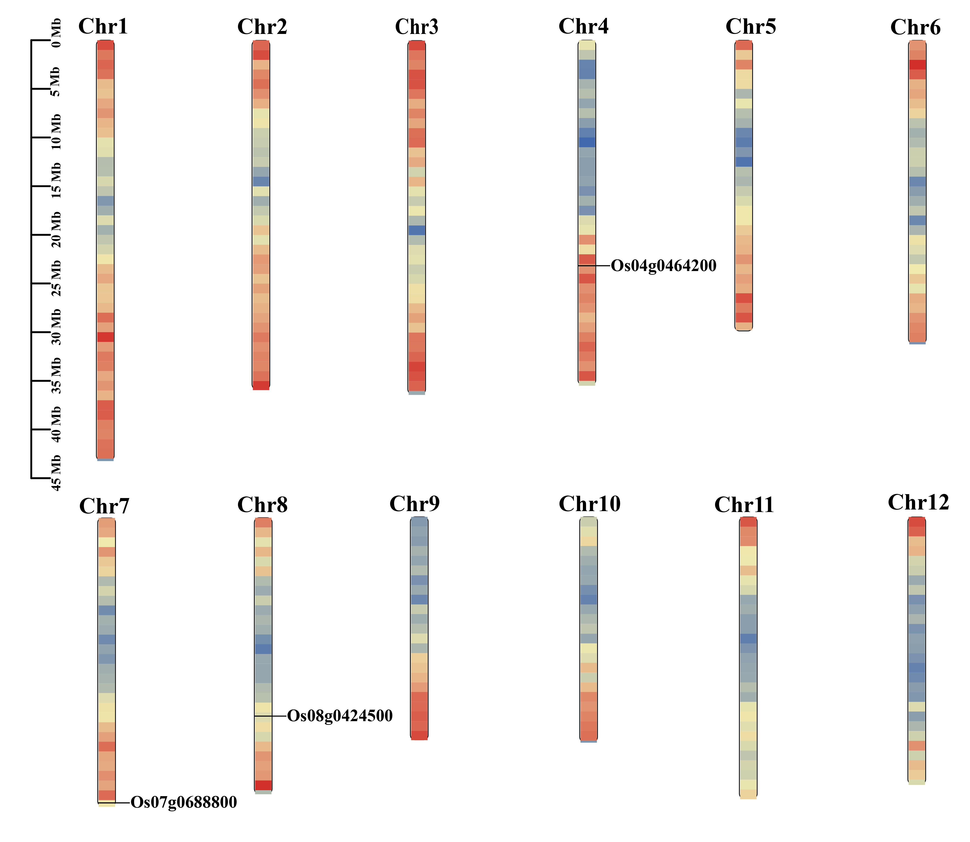
Fig. S1. Chromosomal location of 3 BADH genes from rice response to OFF+GB. The scale on the left is in mega bases (Mb). The different colors in chromosomes represent gene density, with red indicating the highest density and blue indicating the lowest density.
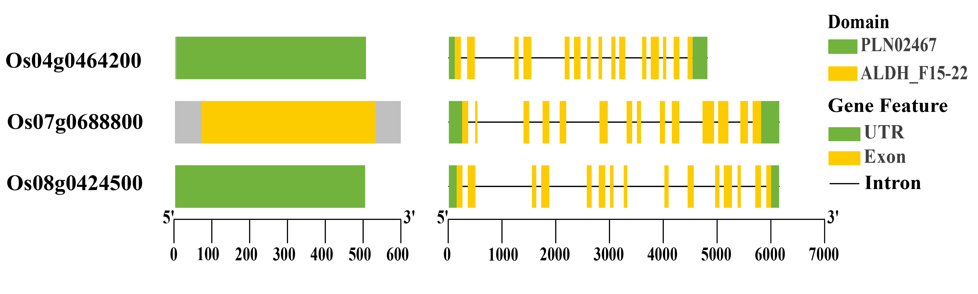
Fig. S2. Analysis of protein structure and gene structure of BADH genes in rice.

