Assessment of Atmospheric Concentrations, Gas/Particle Partitioning, Cancer Risks, Sources, and Atmospheric Transport of PCDD/Fs in a Suburban Area of Bursa, Türkiye

Berke Gülegen¹, Abdul Alim Noori¹, S. Sıddık Cindoruk¹, Aşkın Birgül², Elif Tümay Özer³, Yücel Tasdemir^{1*}

¹Department of Environmental Engineering, Faculty of Engineering, Bursa Uludag University 16059 Nilüfer/Bursa – Türkiye

²Department of Environmental Engineering, Faculty of Engineering and Natural Sciences, Bursa Technical University, 16310 Yıldırım/Bursa – Türkiye

³Department of Chemistry, Faculty of Arts and Science, Bursa Uludag University 16059 Nilüfer/Bursa – Türkiye
*Corresponding author: tasdemir@uludag.edu.tr

Supporting Information

Table of Contents

Table S1 LOD Values (pg) for Gas and Particle Phases (Güleğen 2024) 2
Table S2 RI Values Used for P_{L}⁰ and K_{OA} Calculation (Donnelly et al. 1987; Hale et al. 1985) 2
Table S3 Parameter Values Used for pp-LFER Model 3
Table S4 System Parameter Values for pp-LFER Model 3
Table S5 Parameter Values for mp-pp-LFER Model 3
Table S6 System Parameter Values for mp-pp-LFER Model 5
Table S7 Parameter Values for QSPR Model 5
Table S8 Parameters Used for ILCR Calculation (Li et al. 2018; Yu et al. 2023) 6
Fig. S1 Regression Analysis of Concentration and Meteorological Data 6
Fig. S2 72-Hour Backward Air Mass Trajectories 7

Table S1 LOD Values (pg) for Gas and Particle Phases (Güleğen 2024)
PCDD/F | Gas | Particle
2,3,7,8-TCDD | 0.749 | 0.192
1,2,3,7,8-PeCDD | 0.997 | 0.494
1,2,3,4,7,8-HxCDD | 0.839 | 0.454
1,2,3,6,7,8-HxCDD | 1.935 | 0.917
1,2,3,7,8,9-HxCDD | 2.413 | 0.615
1,2,3,4,6,7,8-HpCDD | 0.461 | 0.479
OCDD | 0.196 | 0.433
2,3,7,8-TCDF | 5.423 | 0.437
1,2,3,7,8-PeCDF | 0.649 | 0.623
2,3,4,7,8-PeCDF | 2.223 | 0.756
1,2,3,4,7,8-HxCDF | 2.810 | 0.707
1,2,3,6,7,8-HxCDF | 1.586 | 0.676
1,2,3,7,8,9-HxCDF | 2.014 | 1.187
2,3,4,6,7,8-HxCDF | 0.750 | 0.719
1,2,3,4,6,7,8-HpCDF | 1.515 | 0.777
1,2,3,4,7,8,9-HpCDF | 0.339 | 0.574
OCDF | 0.212 | 0.403

Table S2 RI Values Used for P_{L}⁰ and K_{OA} Calculation (Donnelly et al. 1987; Hale et al. 1985)
PCDD/F | Group | RI
2,3,7,8-TCDD | 2 | 2386
1,2,3,7,8-PeCDD | 2 | 2587
1,2,3,4,7,8-HxCDD | 2 | 2781
1,2,3,6,7,8-HxCDD | 2 | 2788
1,2,3,7,8,9-HxCDD | 2 | 2802
1,2,3,4,6,7,8-HpCDD | 1 | 2994
OCDD | 1 | 3197
2,3,7,8-TCDF | 2 | 2338
1,2,3,7,8-PeCDF | 2 | 2507
2,3,4,7,8-PeCDF | 2 | 2551
1,2,3,4,7,8-HxCDF | 2 | 2708
1,2,3,6,7,8-HxCDF | 2 | 2714
1,2,3,7,8,9-HxCDF | 2 | 2772
2,3,4,6,7,8-HxCDF | 2 | 2748
1,2,3,4,6,7,8-HpCDF | 1 | 2898
1,2,3,4,7,8,9-HpCDF | 1 | 2986
OCDF | 1 | 3147

Table S3 Parameter Values Used for pp-LFER Model (Ulrich et al. 2017)
PCDD/F | S | A | B | V | L
2,3,7,8-TCDF | 2.03 | 0 | -0.06 | 1.7639 | 9.674
1,2,3,7,8-PeCDF | 2.11 | 0 | -0.07 | 1.8863 | 10.544
2,3,4,7,8-PeCDF | 2.11 | 0 | -0.07 | 1.8863 | 10.544
1,2,3,4,7,8-HxCDF | 2.19 | 0 | -0.08 | 2.0087 | 11.415
1,2,3,6,7,8-HxCDF | 2.19 | 0 | -0.08 | 2.0087 | 11.415
1,2,3,7,8,9-HxCDF | 2.19 | 0 | -0.08 | 2.0087 | 11.415
2,3,4,6,7,8-HxCDF | 2.19 | 0 | -0.08 | 2.0087 | 11.415
1,2,3,4,6,7,8-HpCDF | 2.27 | 0 | -0.1 | 2.1311 | 12.285
1,2,3,4,7,8,9-HpCDF | 2.27 | 0 | -0.1 | 2.1311 | 12.285
OCDF | 2.35 | 0 | -0.11 | 2.2535 | 13.155
2,3,7,8-TCDD | 1.69 | 0 | 0 | 1.8226 | 9.755
1,2,3,7,8-PeCDD | 1.39 | 0 | 0.08 | 1.945 | 10.533
1,2,3,4,7,8-HxCDD | 1.59 | 0 | 0.21 | 2.0674 | 11.324
1,2,3,6,7,8-HxCDD | 1.34 | 0 | 0.15 | 2.0674 | 11.324
1,2,3,7,8,9-HxCDD | 1.34 | 0 | 0.15 | 2.0674 | 11.324
1,2,3,4,6,7,8-HpCDD | 1.55 | 0 | 0.28 | 2.1898 | 12.116
OCDD | 1.75 | 0 | 0.4 | 2.3122 | 12.907

Table S4 System Parameter Values for pp-LFER Model (Arp et al. 2008)
Unit | s | a | b | v | l | c | T(K)
m³/g | 1.19 | 3.37 | 0.03 | 0.73 | 0.66 | -7.08 | 288.15

Table S5 Parameter Values for mp-pp-LFER Model
Parameter | aEC | a(NH₄)₂SO₄ | aNH₄Cl | 𝜌_{DMSO} | Reference
Unit | m²/g | m²/g | m²/g | g/m³ | (Shahpoury et al., 2016)
Value | 18.21 | 0.13 | 0.083 | 1100000 | (Shahpoury et al., 2016)

Parameter | f(NH₄)₂SO₄ | fNH₄Cl | 𝑓_{OM,A}=0.6*f_{OM} | 𝑓_{OM,B}=0.4*f_{OM} | Reference
Value | 0.15 | 0.002 | 0.12 | 0.08 | (Shahpoury et al., 2016)

Table S6 System Parameter Values for mp-pp-LFER Model
System | Unit | s | a | b | v | l | c | T(K) | ºC | Reference
NIST diesel soot-air | m³ _{air}/m² _{surface} | - | 2.7 | 2.45 | - | 1.09 | -8.47 | 288.15 | 15 | (Roth et al., 2005)
(NH₄)₂SO₄ | m³ _{air}/m² _{surface} | - | 2.13 | 5.34 | - | 0.88 | -8.47 | 288.15 | 15 | (Goss et al., 2003)
NH₄Cl | m³ _{air}/m² _{surface} | - | 2.28 | 4.72 | - | 0.92 | -8.47 | 288.15 | 15 | (Goss et al., 2003)
Dry dimethyl sulfoxide-air | L _{air}/L _{solvent} | 2.9 | 5.04 | 0 | - | 0.72 | -0.56 | 298.15 | 25 | (Abraham et al., 2010)
Polyurethane ether (PU)-air | L _{air}/kg _{PU} | 1.69 | 3.66 | 0 | 0.36 | 0.71 | -0.15 | 288.15 | 15 | (Kamprad and Goss, 2007)

Table S7 Parameter Values for QSPR Model
PCDD/F | V | qH+ | qC- | Reference
2,3,7,8-TCDD | 196 | 0.138 | -0.136 | (Jiao and Li, 2010; Kim et al., 2016)
1,2,3,7,8-PeCDD | 207.9 | 0.139 | -0.151 | (Chen et al., 2001; Kim et al., 2016)
1,2,3,4,7,8-HxCDD | 219.9 | 0.139 | -0.14 | (Jiao and Li, 2010; Kim et al., 2016)
1,2,3,6,7,8-HxCDD | 219.9 | 0.14 | -0.151 | (Chen et al., 2001; Kim et al., 2016)
1,2,3,7,8,9-HxCDD | 219.9 | 0.14 | -0.152 | (Chen et al., 2001; Kim et al., 2016)
1,2,3,4,6,7,8-HpCDD | 231.8 | 0.14 | -0.151 | (Jiao and Li, 2010; Kim et al., 2016)
OCDD | 243.8 | 0 | -0.14 | (Jiao and Li, 2010; Kim et al., 2016)

Table S8 Parameters Used for ILCR Calculation (Li et al. 2018; Yu et al. 2023)
Parameter / Age Group | Nursery Children | Primary School Children | Adults
IR (m³/day) | 7.6 | 7.6 | 20
ET (h/day) | 24 | 24 | 24
ED (year) | 3 | 6 | 30
EF (days/year) | 230 | 190 | 350
BW (kg) | 18 | 35 | 70
AT (days) | 25550 | 25550 | 25550

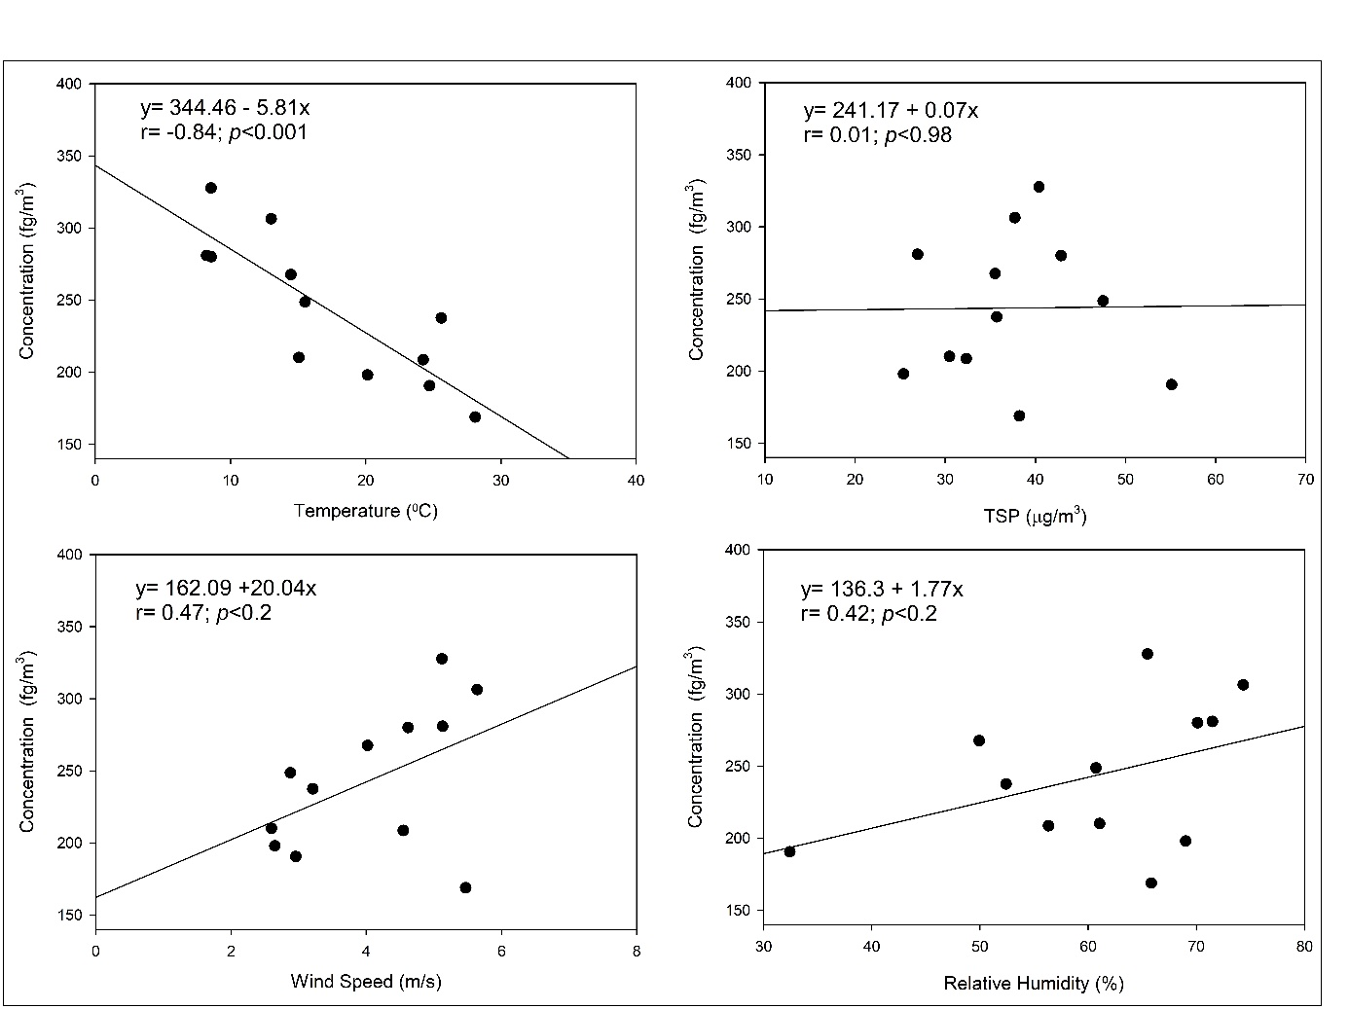

Fig. S1 Regression Analysis of Concentration and Meteorological Data

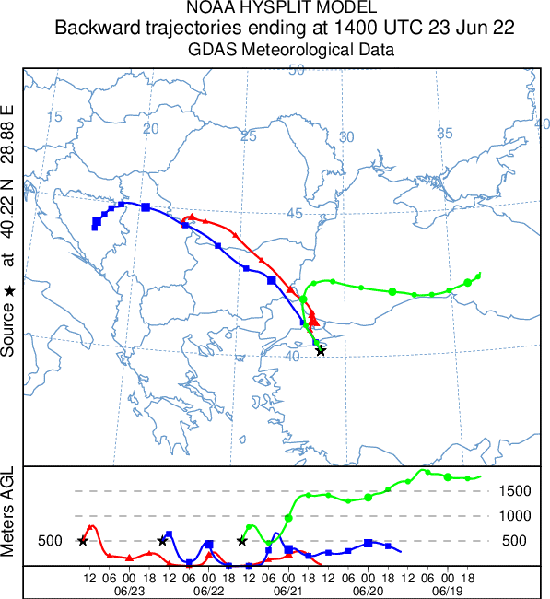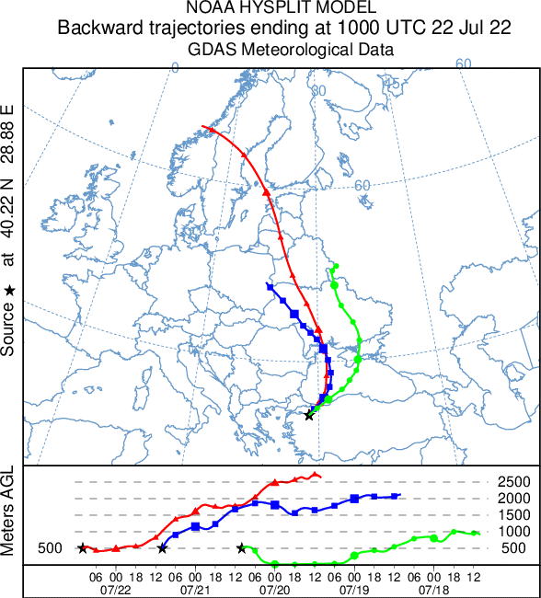
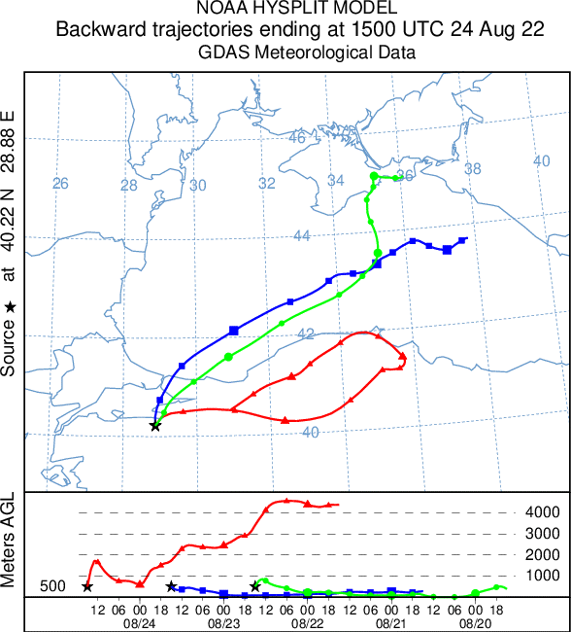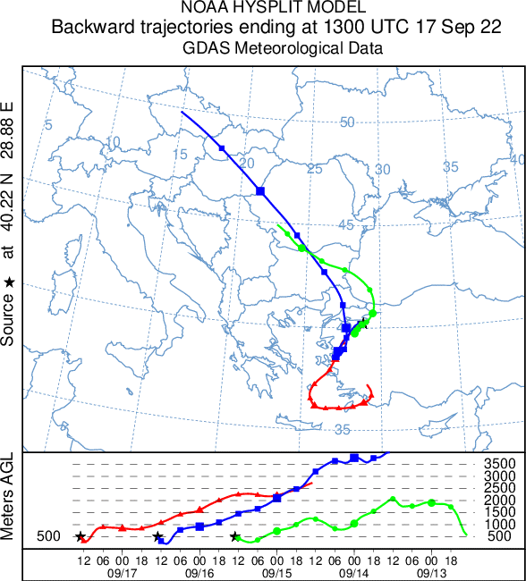

Fig. S2 72-Hour Backward Air Mass Trajectories
Note: The red, blue, and green lines represent the trajectories of the 3 main air masses transported to the sampling area on different sampling days.
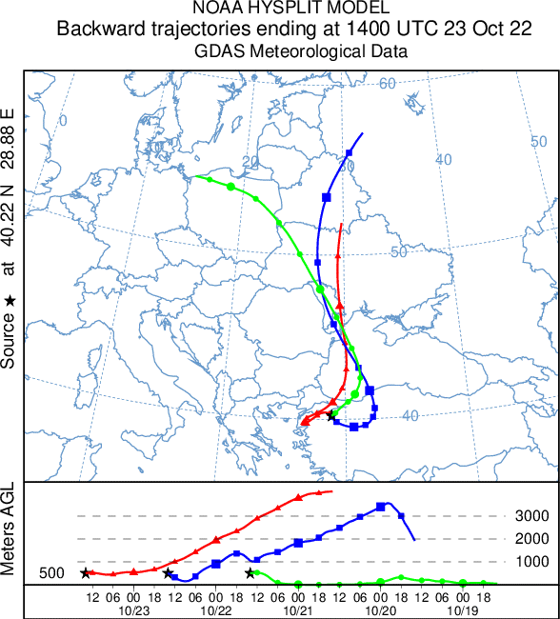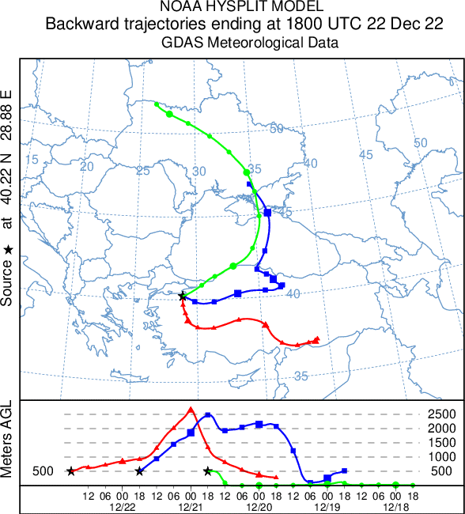
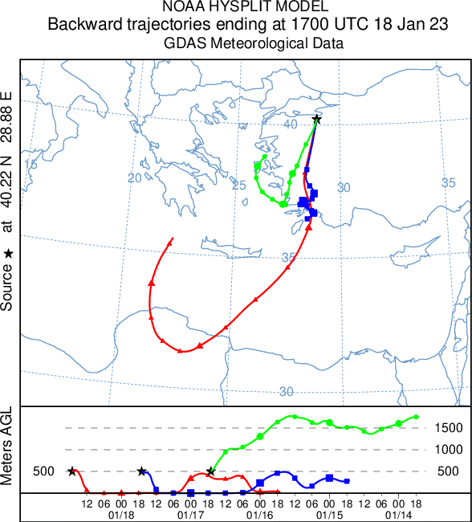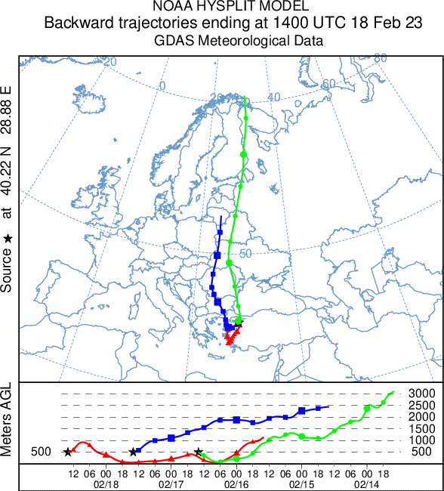
Fig. S2 72-Hour Backward Air Mass Trajectories

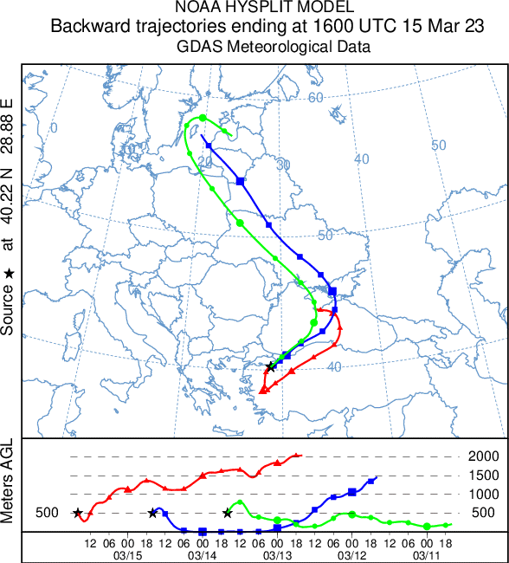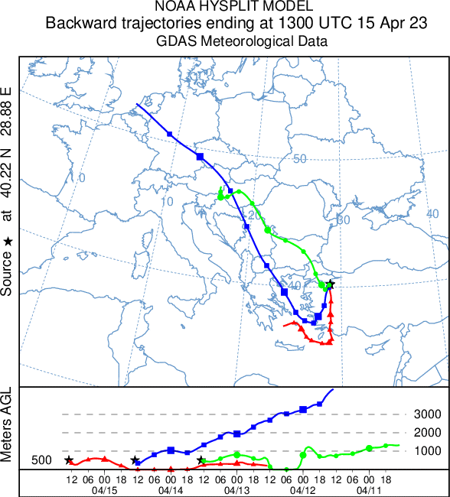
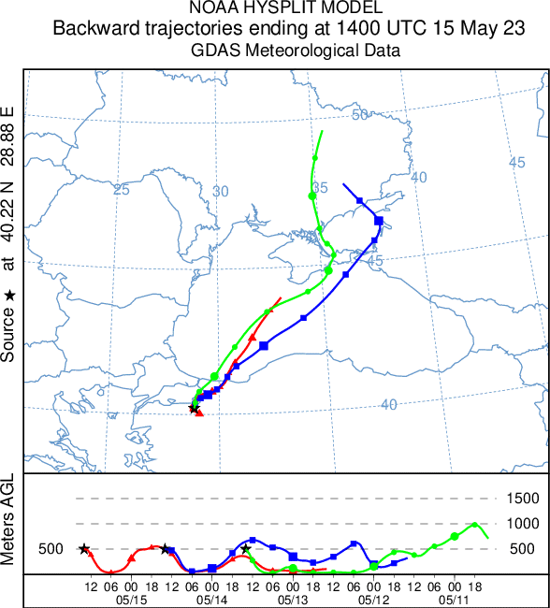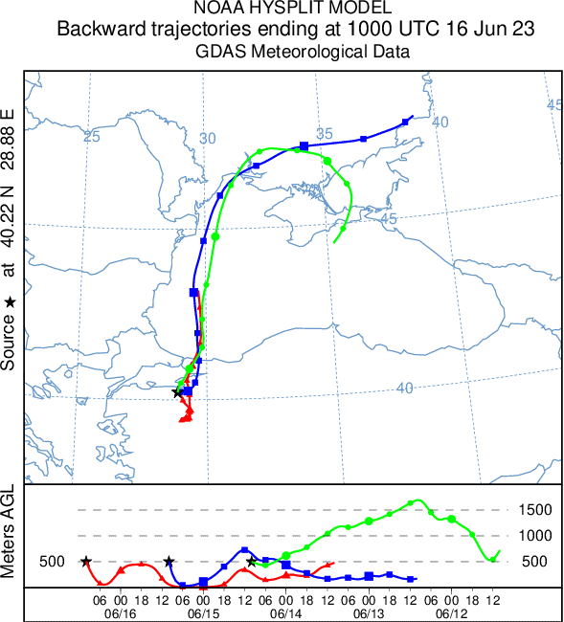
Fig. S2 72-Hour Backward Air Mass Trajectories

References
Abraham MH, Smith RE, Luchtefeld R, et al (2010) Prediction of Solubility of Drugs and Other Compounds in Organic Solvents. J Pharm Sci 99:1500–1515. https://doi.org/10.1002/jps.21922
Arp HPH, Schwarzenbach RP, Goss K-U (2008) Ambient Gas/Particle Partitioning. 2: The Influence of Particle Source and Temperature on Sorption to Dry Terrestrial Aerosols. Environ Sci Technol 42:5951–5957. https://doi.org/10.1021/es703096p
Chen J, Quan X, Schramm K-W, et al (2001) Quantitative structure–property relationships (QSPRs) on direct photolysis of PCDDs. Chemosphere 45:151–159. https://doi.org/10.1016/S0045-6535(00)00554-3
Donnelly JR, Munslow WD, Mitchum RK, Sovocool GW (1987) Correlation of structure with retention index for chlorinated dibenzo-p-dioxins. J Chromatogr A 392:51–63. https://doi.org/10.1016/S0021-9673(01)94253-0
Goss K, Buschmann J, Schwarzenbach RP (2003) Determination of the surface sorption properties of talc, different salts, and clay minerals at various relative humidities using adsorption data of a diverse set of organic vapors. Environ Toxicol Chem 22:2667–2672. https://doi.org/10.1897/03-56
Güleğen B (2024) Investigation of Atmospheric Concentrations and Particulate-Gas Partitionings of Polychlorinated dibenzo-p-dioxins and Polychlorinated dibenzo-furans. MSc Thesis of Bursa Uludag Universitesi
Hale MD, Hileman FD, Mazer Thomas, et al (1985) Mathematical modeling of temperature programmed capillary gas chromatographic retention indexes for polychlorinated dibenzofurans. Anal Chem 57:640–648. https://doi.org/10.1021/ac00280a017
Harner T, Green NJL, Jones KC (2000) Measurements of Octanol−Air Partition Coefficients for PCDD/Fs: A Tool in Assessing Air−Soil Equilibrium Status. Environ Sci Technol 34:3109–3114. https://doi.org/10.1021/es000970m
Jiao L, Li H (2010) QSPR studies on the aqueous solubility of PCDD/Fs by using artificial neural network combined with stepwise regression. Chemometrics and Intelligent Laboratory Systems 103:90–95. https://doi.org/10.1016/j.chemolab.2010.05.019
Kamprad I, Goss K-U (2007) Systematic Investigation of the Sorption Properties of Polyurethane Foams for Organic Vapors. Anal Chem 79:4222–4227. https://doi.org/10.1021/ac070265x
Kim M, Li LY, Grace JR (2016) Predictability of physicochemical properties of polychlorinated dibenzo-p-dioxins (PCDDs) based on single-molecular descriptor models. Environmental Pollution 213:99–111. https://doi.org/10.1016/j.envpol.2016.02.007
Li J, Zhang Y, Sun T, et al (2018) The health risk levels of different age groups of residents living in the vicinity of municipal solid waste incinerator posed by PCDD/Fs in atmosphere and soil. Science of The Total Environment 631–632:81–91. https://doi.org/10.1016/j.scitotenv.2018.03.009
Roth CM, Goss K-U, Schwarzenbach RP (2005) Sorption of a Diverse Set of Organic Vapors To Diesel Soot and Road Tunnel Aerosols. Environ Sci Technol 39:6632–6637. https://doi.org/10.1021/es049204w
Shahpoury P, Lammel G, Albinet A, et al (2016) Evaluation of a Conceptual Model for Gas-Particle Partitioning of Polycyclic Aromatic Hydrocarbons Using Polyparameter Linear Free Energy Relationships. Environ Sci Technol 50:12312–12319. https://doi.org/10.1021/acs.est.6b02158

Yu J, Li H, Liu Y, Wang C (2023) PCDD/Fs in indoor environments of residential communities around a municipal solid waste incineration plant in East China: Occurrence, sources, and cancer risks. Environ Int 174:107902. https://doi.org/10.1016/j.envint.2023.107902

