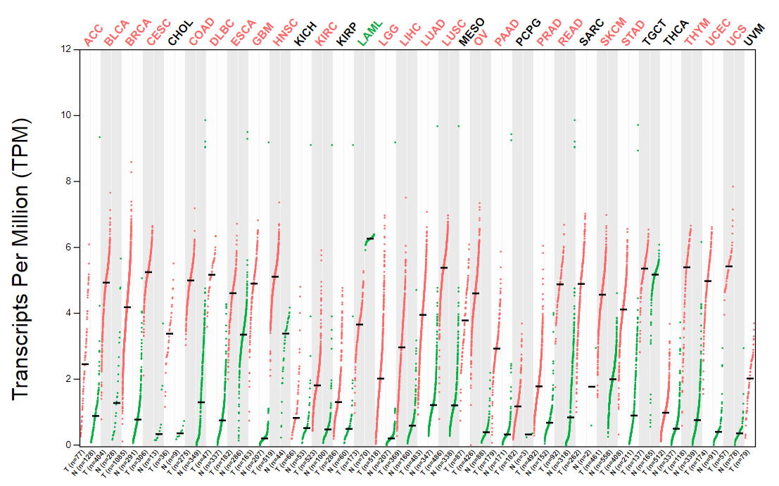
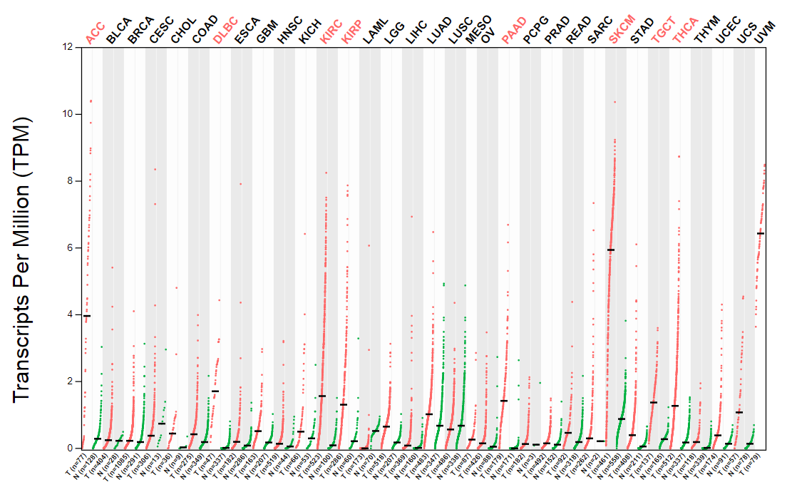
Fig.S2 Differential expression analysis of BIRC5/BIRC7 genes between tumor tissue and normal tissue in TCGA. A: BIRC5; B: BIRC7

