Appendix
TABLE S1
Descriptive statistics of Scientific Writing Workshop
Competencies of the Resource Person |  | N |  | Mean |  | Std. Deviation |  | Std. Error Mean
Resource persons demonstrated extensive knowledge in the subject area discussed during the workshop. |  | 440 |  | 4.47 |  | .543 |  | .026
I found resource persons to be highly knowledgeable and experienced in the field. |  | 440 |  | 4.37 |  | .619 |  | .029
The resource persons effectively communicated complex research concepts. |  | 440 |  | 4.38 |  | .633 |  | .030
I felt confident in the resource persons' ability to provide valuable insights into research practices and techniques. |  | 440 |  | 4.30 |  | .613 |  | .029
Resource persons demonstrated a strong ability to provide practical examples and real-world applications of research concepts. |  | 440 |  | 4.33 |  | .659 |  | .031
Resource persons effectively encouraged critical thinking and problem-solving skills. |  | 440 |  | 4.31 |  | .630 |  | .030
Resource persons had an in-depth understanding of current research trends, which they shared with participants. |  | 440 |  | 4.35 |  | .614 |  | .029
 | Quality and Organization of Workshop |  | N |  | Mean |  | Std. Deviation |  | Std. Error Mean
 | The workshop's quality was evident in its well-structured agenda and clear learning objectives. |  | 440 |  | 4.32 |  | .535 |  | .026
 | I perceived the workshop materials and presentations to be of exceptional quality. |  | 440 |  | 4.25 |  | .607 |  | .029
 | The workshops I have attended met the standards of a high-quality learning experience. |  | 440 |  | 4.34 |  | .693 |  | .033
 | The workshop consistently maintained a high level of quality in terms of content delivery. |  | 440 |  | 4.24 |  | .684 |  | .033
 | The workshops ensured that participants remained engaged and actively involved. |  | 440 |  | 4.25 |  | .681 |  | .032
 | I appreciate the workshop's attention to practical exercises and hands-on learning. |  | 440 |  | 4.26 |  | .650 |  | .031
Content Relevance |  | N |  | Mean |  | Std. Deviation |  | Std. Error Mean
I found the topics covered in the workshops to be directly applicable to my research interests. |  | 440 |  | 4.32 |  | .598 |  | .029
The content delivered in the workshops was highly relevant to current research trends in the field. |  | 440 |  | 4.26 |  | .626 |  | .030
The workshop's content provided practical knowledge and skills that were beneficial for research endeavors. |  | 440 |  | 4.37 |  | .631 |  | .030
The workshop's content was engaging and instrumental in advancing my research. |  | 440 |  | 4.29 |  | .627 |  | .030
The content delivered in the workshop addressed both theoretical and practical aspects of the research field. |  | 440 |  | 4.30 |  | .672 |  | .032
The workshop content deepened my understanding of specific research areas. |  | 440 |  | 4.30 |  | .610 |  | .029
The workshop enhanced their ability to evaluate the feasibility of research topics. |  | 440 |  | 4.30 |  | .616 |  | .029

TABLE S2
Analytical Skills and Personal Efforts
Analytical Skills | N | Mean | Std. Deviation | Std. Error Mean
Critical thinking in research has helped me develop my ability to analyze complex issues. | 440 | 4.31 | .620 | .030
Analyzing a large pool of data in research has significantly contributed to my analytical skills. | 440 | 4.25 | .622 | .030
After taking up research, I make decisions based on facts and figures, prioritizing evidence-based approaches. | 440 | 4.33 | .680 | .032
Research has increased my trust in information only when supported by statistical evidence. | 440 | 4.33 | .696 | .033
Research has equipped me with the skills to effectively identify, define, collect, analyze, and communicate information about complex problems. | 440 | 4.28 | .642 | .031
I have learned to communicate research results with clarity and precision, which has improved my analytical and presentation skills significantly. | 440 | 4.28 | .660 | .031
Research activities have encouraged me to apply theoretical concepts in practical settings, leading to a greater understanding of the subject matter. | 440 | 4.28 | .629 | .030
Engaging in research has sparked my curiosity to learn new things and explore the causes behind recent issues in my field. | 440 | 4.35 | .607 | .029
I've become more curious and eager to solve issues in my area through research adoption. | 440 | 4.33 | .626 | .030
Research has helped me become a critical thinker, demanding supportive evidence for my research results. | 440 | 4.34 | .660 | .031
My knowledge level has seen an upward trend as a result of taking up research. | 440 | 4.33 | .616 | .029
Research activities have contributed to my overall academic development, making me more productive and encouraging me to spend quality time accumulating new information. | 440 | 4.33 | .629 | .030
Personal Efforts | N | Mean | Std. Deviation | Std. Error Mean
I have increased the number of research publications since participating in research workshops. | 440 | 4.09 | .734 | .035
The research workshops have positively influenced my publishing frequency. | 440 | 4.13 | .743 | .035
My research publications have seen a boost in quality and impact after attending research workshops. | 440 | 4.28 | .739 | .035
I am more confident in submitting my research findings for publication. | 440 | 4.22 | .686 | .033
The workshops have improved my ability to effectively communicate research findings in publications. | 440 | 4.22 | .721 | .034

TABLE S3
Academic Writeups
Publications | N | Mean | Std. Deviation | Std. Error Mean
I have increased the number of research publications since participating in research workshops. | 440 | 4.09 | .734 | .035
The research workshops have positively influenced my publishing frequency. | 440 | 4.13 | .743 | .035
My research publications have seen a boost in quality and impact after attending research workshops. | 440 | 4.28 | .739 | .035
I am more confident in submitting my research findings for publication. | 440 | 4.22 | .686 | .033
The workshops have improved my ability to effectively communicate research findings in publications. | 440 | 4.22 | .721 | .034
Journal Selection | N | Mean | Std. Deviation | Std. Error Mean
I feel more confident in selecting suitable journals for my research publications. | 440 | 4.18 | .667 | .032
The workshops have taught me to consider the relevance and reputation of journals. | 440 | 4.19 | .673 | .032
I now pay greater attention to the impact factor when choosing journals for publication. | 440 | 4.27 | .680 | .032
I understand the importance of aligning my research with the target audience of selected journals. | 440 | 4.26 | .703 | .034
My journal selection process has improved due to insights gained in the research workshops. | 440 | 4.21 | .727 | .035
Topic Selection | N | Mean | Std. Deviation | Std. Error Mean
I am more skilled at choosing research topics that align with my academic interests and career goals. | 440 | 4.20 | .611 | .029
The workshops have broadened my perspective on potential research areas and topics. | 440 | 4.18 | .638 | .030
I am better at assessing the feasibility and relevance of research topics. | 440 | 4.28 | .694 | .033
The workshops have enhanced my ability to justify the importance of my chosen research topics. | 440 | 4.23 | .667 | .032
I have a clear vision of my research objectives and research questions after attending the workshops. | 440 | 4.20 | .661 | .031
Collaboration | N | Mean | Std. Deviation | Std. Error Mean
I have initiated more collaborative research projects since attending the research workshops. | 440 | 4.13 | .747 | .036
The collaborative opportunities I've explored have enriched the content and scope of my research write-ups. | 440 | 4.12 | .756 | .036
I value the input and contributions of my research collaborators more since the workshops. | 440 | 4.24 | .736 | .035
Research Ethics | N | Mean | Std. Deviation | Std. Error Mean
I am more conscious of ethical considerations in all stages of my research, from data collection to publication. | 440 | 4.33 | .647 | .031
The workshops have reinforced the importance of transparency, honesty, and research integrity. | 440 | 4.26 | .643 | .031
The workshops have heightened my awareness of ethical standards and responsibilities. | 440 | 4.34 | .675 | .032
My research write-ups reflect a stronger commitment to ethical research practices. | 440 | 4.29 | .673 | .032
Content Knowledge | N | Mean | Std. Deviation | Std. Error Mean
I have gained a deeper understanding of the subject matter relevant to my research. | 440 | 4.32 | .618 | .029
The workshops have improved my knowledge of both theoretical and practical concepts. | 440 | 4.25 | .625 | .030
I can now critically evaluate and synthesize research literature more effectively. | 440 | 4.32 | .681 | .032
The workshops have increased my content knowledge in specific research areas. | 440 | 4.30 | .680 | .032
Research Aspiration | N | Mean | Std. Deviation | Std. Error Mean
The workshops have inspired me to set higher academic and research goals. | 440 | 4.25 | .589 | .028
I am more motivated to pursue a career in research and publish more impactful write-ups. | 440 | 4.22 | .621 | .030
I have a clear vision of my research aspirations and long-term objectives. | 440 | 4.30 | .676 | .032
The workshops encouraged me to aim for excellence in my academic write-ups. | 440 | 4.28 | .675 | .032

TABLE S4
Age
ANOVA
 |  | Sum of Squares | df | Mean Square | F | Sig.
Scientific Research Workshop | Between Groups | .911 | 3 | .304 | 1.500 | .214
Scientific Research Workshop | Within Groups | 88.297 | 436 | .203
Scientific Research Workshop | Total | 89.209 | 439
Analytical Skills and Personal Efforts | Between Groups | .403 | 3 | .134 | .584 | .626
Analytical Skills and Personal Efforts | Within Groups | 100.228 | 436 | .230
Analytical Skills and Personal Efforts | Total | 100.630 | 439
Academic Writeups | Between Groups | .042 | 3 | .014 | .077 | .972
Academic Writeups | Within Groups | 79.900 | 436 | .183
Academic Writeups | Total | 79.943 | 439

TABLE S5
Designation
ANOVA
 |  | Sum of Squares | df | Mean Square | F | Sig.
Scientific Research Workshop | Between Groups | 1.848 | 3 | .616 | 3.074 | .028
Scientific Research Workshop | Within Groups | 87.361 | 436 | .200
Scientific Research Workshop | Total | 89.209 | 439
Analytical Skills and Personal Efforts | Between Groups | 3.983 | 3 | 1.328 | 5.990 | .001
Analytical Skills and Personal Efforts | Within Groups | 96.647 | 436 | .222
Analytical Skills and Personal Efforts | Total | 100.630 | 439
Academic Writeups | Between Groups | 5.099 | 3 | 1.700 | 9.902 | .000
Academic Writeups | Within Groups | 74.843 | 436 | .172
Academic Writeups | Total | 79.943 | 439

TABLE S6
Discipline
ANOVA
 |  | Sum of Squares | df | Mean Square | F | Sig.
Scientific Research Workshop | Between Groups | .310 | 2 | .155 | .762 | .467
Scientific Research Workshop | Within Groups | 88.898 | 437 | .203
Scientific Research Workshop | Total | 89.209 | 439
Analytical Skills and Personal Efforts | Between Groups | .549 | 2 | .275 | 1.199 | .303
Analytical Skills and Personal Efforts | Within Groups | 100.081 | 437 | .229
Analytical Skills and Personal Efforts | Total | 100.630 | 439
Academic Writeups | Between Groups | .056 | 2 | .028 | .153 | .858
Academic Writeups | Within Groups | 79.887 | 437 | .183
Academic Writeups | Total | 79.943 | 439

TABLE S7
Academic Year/Stages of Ph.D.
ANOVA
 |  | Sum of Squares | df | Mean Square | F | Sig.
Scientific Research Workshop | Between Groups | 1.009 | 5 | .202 | .993 | .421
Scientific Research Workshop | Within Groups | 88.199 | 434 | .203
Scientific Research Workshop | Total | 89.209 | 439
Analytical Skills and Personal Efforts | Between Groups | 3.483 | 5 | .697 | 3.112 | .009
Analytical Skills and Personal Efforts | Within Groups | 97.147 | 434 | .224
Analytical Skills and Personal Efforts | Total | 100.630 | 439
Academic Writeups | Between Groups | 3.141 | 5 | .628 | 3.550 | .004
Academic Writeups | Within Groups | 76.802 | 434 | .177
Academic Writeups | Total | 79.943 | 439

TABLE S8
Type of Workshop
ANOVA
 |  | Sum of Squares | df | Mean Square | F | Sig.
Scientific Research Workshop | Between Groups | 3.318 | 2 | 1.659 | 3.907 | .021
Scientific Research Workshop | Within Groups | 149.471 | 352 | .425
Scientific Research Workshop | Total | 152.789 | 354
Analytical Skills and Personal Efforts | Between Groups | 1.506 | 2 | .753 | 2.557 | .049
Analytical Skills and Personal Efforts | Within Groups | 103.660 | 352 | .294
Analytical Skills and Personal Efforts | Total | 105.166 | 354
Academic Writeups | Between Groups | 2.053 | 2 | 1.026 | 2.778 | .044
Academic Writeups | Within Groups | 130.043 | 352 | .369
Academic Writeups | Total | 132.096 | 354

TABLE S9
Duration
ANOVA
 |  | Sum of Squares | df | Mean Square | F | Sig.
Scientific Research Workshop | Between Groups | 15.169 | 3 | 5.056 | 5.284 | .001
Scientific Research Workshop | Within Groups | 334.922 | 350 | .957
Scientific Research Workshop | Total | 350.090 | 353
Analytical Skills and Personal Efforts | Between Groups | 9.788 | 3 | 3.263 | 2.850 | .037
Analytical Skills and Personal Efforts | Within Groups | 400.678 | 350 | 1.145
Analytical Skills and Personal Efforts | Total | 410.466 | 353
Academic Writeups | Between Groups | 9.259 | 3 | 3.086 | 3.308 | .020
Academic Writeups | Within Groups | 326.504 | 350 | .933
Academic Writeups | Total | 335.763 | 353

FIGURE S1
Independent Variable (Scientific Writing Workshop)
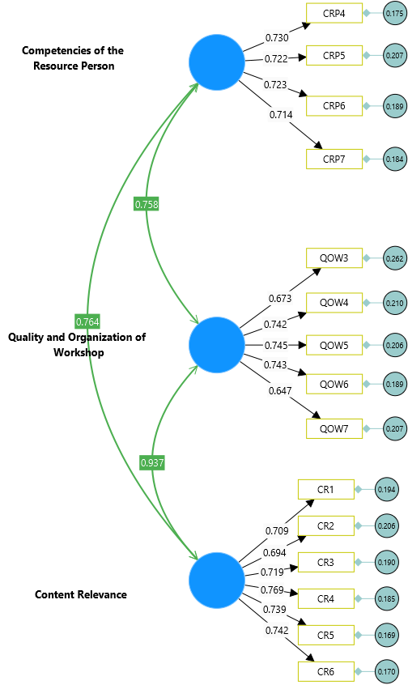

FIGURE S2
Dependent Variable (Academic Write-ups)
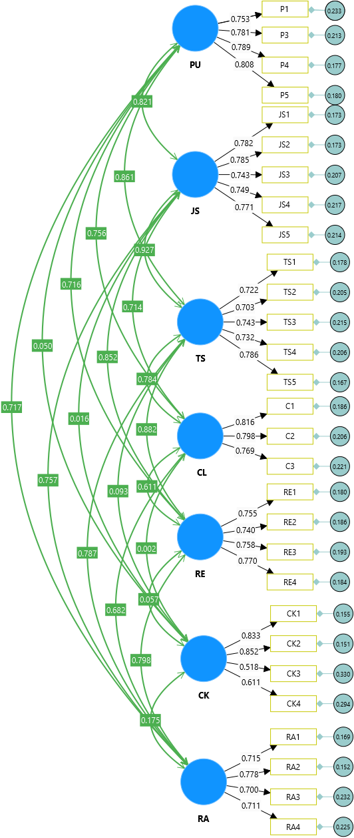

FIGURE S3
Mediating Variable (Analytical Skills and Personal Efforts)
