Supplementary material:
Title:

In-depth comparison of sorghum straw composting process inoculated with mature compost or commercial microbial agent

Author:
Xiao-Xing Li, Xiu-Lin Chu, Wen-Shuai Zhang, Zhao-Yong Sun*, Yue-Qin Tang
Affiliation:
College of Architecture and Environment, Sichuan University, No. 24 South Section 1 First Ring Road, Chengdu 610065, Sichuan, China

*Corresponding author:
Zhao-Yong Sun E-mail: szy@scu.edu.cn
College of Architecture and Environment, Sichuan University, No. 24 South Section 1 First Ring Road, Chengdu 610065, Sichuan, China
Telephone: +86(28)85990936, Fax: +86(28)85990936

Table S1 Diversity and richness indices of bacterial community during sorghum straw composting.
 |  | Shannon | Simpson | Ace | Chao 1
M1 | 1 | 2.76 | 0.18 | 428.54 | 447.16
M1 | 2 | 2.80 | 0.10 | 218.07 | 184.32
M1 | 3 | 3.38 | 0.06 | 245.42 | 241.00
M1 | 4 | 3.16 | 0.08 | 270.36 | 252.50
M1 | 5 | 2.64 | 0.16 | 250.96 | 231.00
M1 | 6 | 3.02 | 0.10 | 287.57 | 292.10
M1 | 7 | 3.69 | 0.05 | 347.66 | 352.42
M1 | 8 | 3.90 | 0.04 | 487.76 | 465.88
M2 | 1 | 4.26 | 0.06 | 722.33 | 744.47
M2 | 2 | 3.40 | 0.06 | 435.78 | 394.20
M2 | 3 | 3.26 | 0.08 | 326.44 | 265.31
M2 | 4 | 3.56 | 0.06 | 332.32 | 316.12
M2 | 5 | 3.62 | 0.04 | 316.10 | 355.13
M2 | 6 | 3.76 | 0.04 | 367.50 | 358.16
M2 | 7 | 3.92 | 0.04 | 367.55 | 353.88
M2 | 8 | 3.90 | 0.04 | 370.34 | 354.38
M3 | 1 | 2.96 | 0.16 | 615.08 | 543.20
M3 | 2 | 2.82 | 0.12 | 234.42 | 206.10
M3 | 3 | 3.31 | 0.06 | 252.58 | 241.03
M3 | 4 | 3.10 | 0.12 | 337.56 | 349.06
M3 | 5 | 3.50 | 0.06 | 286.04 | 283.10
M3 | 6 | 3.75 | 0.04 | 387.42 | 380.38
M3 | 7 | 3.92 | 0.04 | 370.35 | 407.50
M3 | 8 | 3.82 | 0.04 | 327.46 | 335.20

Table S2 Key topological features of co-occurrence network analysis of bacterial communities during composting process.
Network indices | M1 | M2 | M3
Total nodes | 281 | 348 | 287
Total links | 4162 | 9276 | 5549
Modularity index | 0.587 | 0.313 | 0.523
Graph density | 0.104 | 0.152 | 0.134
Average degree | 14.707 | 26.503 | 19.267
Average path distance | 2.992 | 2.959 | 2.573
Average clustering coefficient | 0.783 | 0.801 | 0.770
Weighted mean | 0.104 | 0.152 | 0.134
Positive links/negative links | 3754 /408 | 8794/482 | 4849/700

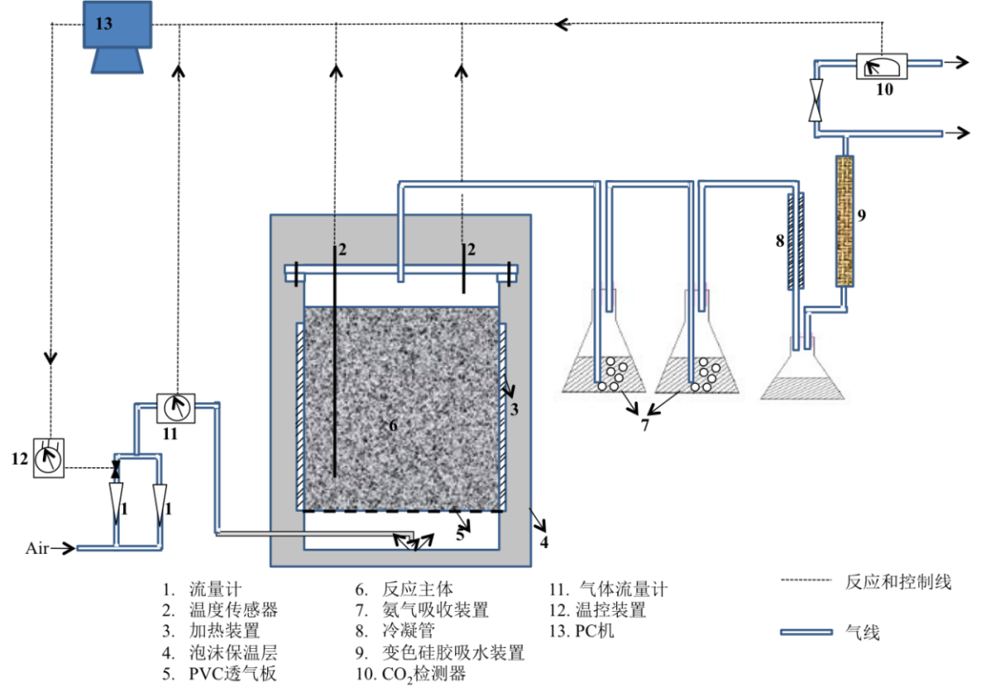
1. Flow meter 2. Thermometer 3. Ribbon heater 4. Styrofoam insulator 5. Perforated plate 6. Reactor
7. Ammonia trap 8. Cooling pipe 9. Silicagel absorber 10. CO₂ detector 11. Gas meter 12. Temperature controller 13. Micro-computer
Fig. S1 Schematic diagram of the lab-scale composting device.

Fig. S2. Evolution of cumulative CO₂ emission during the sorghum straw composting.

