Species | Isotype | Wormbase ParaSite Gene ID | Nucleotide Sequence Length | UniProt ID | Amino Acid Sequence Length
Ancylostoma ceylanicum | Isotype 1 | maker-ANCCEYDFT_Contig37-pred_gff_fgenesh-gene-6.3-mRNA-1 | 1644 bp | A0A0D6MC88 | 448
Ancylostoma ceylanicum | Isotype 2 | Acey_s0432.g1351.t2 | 1407 bp | A0A016X062 | 468
Ancylostoma ceylanicum | Isotype 3 | Acey_s0209.g2091.t2 | 1326 bp | A0A016SLE6 | 441
Ancylostoma ceylanicum | Isotype 4 | Acey_s0032.g2448.t1 | 1338 bp | A0A8I3B3I9 | 445
Ancylostoma caninum | Isotype 1 | ANCCAN_08153 | 1347 bp | Q2QJK8 | 448
Ancylostoma caninum | Isotype 2 | ANCCAN_23405 | 1347 bp | A0A368FF85 | 448
Ancylostoma caninum | Isotype 3 | ANCCAN_15393 | 1083 bp | A0A368G4Q6 | 360
Ancylostoma caninum | Isotype 4 | ANCCAN_15408 | 1338 bp | A0A368G2I7 | 445
Ancylostoma duodenale | Isotype 1 | ANCDUO_05511 | 1347 bp | A3FKG1 | 448
Ancylostoma duodenale | Isotype 3 | ANCDUO_27569 | 709 bp | A0A0C2FBM8 | 263
Ancylostoma duodenale | Isotype 4 | ANCDUO_18393 | 606 bp | A0A0C2G375 | 201
Necator americanus | Isotype 1 | NAME_02123 | 2438 bp | W2TBE1 | 470
Necator americanus | Isotype 2 | NAME_08726 | 2131 bp | N/A | 649
Necator americanus | Isotype 3 | NAME_01126 | 1598 bp | W2TTI9 | 433
Necator americanus | Isotype 4 | NAME_01137 | 1816 bp | W2TVB3 | 461
Supplementary Table 1. The sources and sizes of the β-tubulin coding nucleotide and amino acid sequences that were used in this study.

Supplementary Table 2. Single nucleotide polymorphisms (SNPS) have been reported to occur in hookworms of One Health concern.
Position and SNPs | Species | Location | References
134 (CAA/Glutamine/Q/GLU CAT/Histidine/H/HIS) | Ancylostoma caninum | United States | (Venkatesan et al. 2023)
167 (TTC, TTT/Phenylalanine/F/PHE TAC, TAT/Tyrosine/Y/TYR) | Ancylostoma caninum | United States | (Jimenez Castro et al. 2019; Kitchen et al. 2019; Leutenegger et al. 2023; Venkatesan et al. 2023; Evason et al. 2023)
167 (TTC, TTT/Phenylalanine/F/PHE TAC, TAT/Tyrosine/Y/TYR) | Ancylostoma caninum | Canada | (Evason et al. 2023)
167 (TTC, TTT/Phenylalanine/F/PHE TAC, TAT/Tyrosine/Y/TYR) | Necator americanus | Ghana, Brazil, Mozambique | (Ng’etich et al. 2023)
198 (GAG, GAA/glutamic acid/E/GLU GCG, GCA/alanine/A/ALA) | Ancylostoma ceylanicum* | Brazil | (Medeiros et al. 2022)
198 (GAG, GAA/glutamic acid/E/GLU GCG, GCA/alanine/A/ALA) | Necator americanus | Ghana, Mozambique | (Ng’etich et al. 2023)
198 (GAG, GAA/Glutamic acid/E/GLU AAG/lysine/K/LYS) | Ancylostoma caninum | Australia | (Stocker, Scott, and Šlapeta 2023)
198 (GAG, GAA/Glutamic acid/E.GLU GTA /Valine/V/VAL) | Uncinaria stenocephala | New Zealand | (Stocker, Scott, and Šlapeta 2023)
200 (TTC/ Phenylalanine/F/PHE TAC/Tyrosine/Y/TYR) | Ancylostoma caninum | Brazil | (Furtado et al. 2014)
200 (TTC/ Phenylalanine/F/PHE TAC/Tyrosine/Y/TYR) | Necator americanus | Ghana, Mozambique | (Ng’etich et al. 2023)
200 (TTC/ Phenylalanine/F/PHE TTA/Leucine/L/LEU) | Ancylostoma ceylanicum* | Brazil | (Medeiros et al. 2022)
* - Results from studies that utilized laboratory induced resistance

Supplementary Table 3. Results of quality assurance checks of modeled hookworm β-tubulin proteins. Quality assurance checks included Ramachandran plots from Swiss-Model (https://swissmodel.expasy.org/) and PROCHECK from UCLA-DOE LAB — SAVES v6.0 (https://saves.mbi.ucla.edu/). Also, 3D verification of the modeled protein was done using Verify3D (https://saves.mbi.ucla.edu/), where a score of 80% indicates a modeled protein pass.
Species | Size (No. of Amino Acids) | Wormbase Parasite ID | UNIPROT | Template | Seq Identity | GMQE | Ramachandran Favored (SwissModel) | Verify 3D | Prechecks Most Favorable Regions | ProCheck Additional Allowed Region | ProCheck Generously Allowed Region | ProCheck Disallowable Regions
Ancylostoma ceylanicum  Isotype 1 | 448 | maker-ANCCEYDFT_Contig37-pred_gff_fgenesh-gene-6.3-mRNA-1 | A0A0D6MC88 | 6fkj | 91.73% | 0.81 | 97.65% | 85.95%  (Pass) | 94.9% | 5.1% | 0 | 0
Ancylostoma caninum  Isotype 1 | 448 | ANCCAN_08153 | Q2QJK8 | 6fkj | 91.49% | 0.81 | 97.65% | 85.95%  (Pass) | 94.9% | 5.1% | 0 | 0
Ancylostoma duodenale  Isotype 1 | 448 | ANCDUO_05511 | A3FKG1 | 6fkj | 91.49% | 0.81 | 97.65% | 85.95%  (Pass) | 94.9% | 5.1% | 0 | 0
Necator americanus  Isotype 1 | 470 | NAME_02123 | W2TBE1 | 6fkj | 91.49% | 0.79 | 93.51% | 84.19%  (Pass) | 90.1% | 8.4% | 1.3% | 0.3%
Ancylostoma ceylanicum  Isotype 2 | 468 | Acey_s0432.g1351.t2 | A0A016X062 | 6fkj | 91.73% | 0.79 | 97.65% | 85.95%  (Pass) | 94.9% | 5.1% | 0 | 0
Ancylostoma caninum  Isotype 2 | 448 | ANCCAN_23405 | A0A368FF85 | 6fkj | 91.73% | 0.81 | 97.65% | 85.95%  (Pass) | 94.9% | 5.1% | 0 | 0
Ancylostoma duodenale  Isotype 2 | - | - | - | - | - | - | - | - | - | - | - | -
Necator americanus  Isotype 2 | 694 | NAME_08726 | N/A | 6fkj | 88.42% | 0.51 | 97.41% | 84.19%  (Pass) | 94.9% | 5.1% | 0 | 0
Ancylostoma ceylanicum  Isotype 3 | 441 | Acey_s0209.g2091.t2 | A0A016SLE6 | 6fkj | 94.56% | 0.82 | 97.41% | 81.73%  (Pass) | 94.6% | 5.1% | 0.3% | 0
Ancylostoma caninum  Isotype 3 | 360 | ANCCAN_15393 | A0A368G4Q6 | 6fkj | 88.99% | 0.78 | 94.29% | 60.80%  (Fail) | 92.9% | 6.8% | 0.3% | 0
Ancylostoma duodenale  Isotype 3 | 263 | ANCDUO_27569 | A0A0C2FBM8 | 6fkj | 95.26% | 0.78 | 96.58% | 45.34%  (Fail) | 94.6% | 5.4% | 0 | 0
Necator americanus  Isotype 3 | 433 | NAME_01126 | W2TTI9 | 6fkj | 93.81% | 0.80 | 94.96% | 81.15%  (Pass) | 91.5% | 7.7% | 0.5% | 0.3%
Ancylostoma ceylanicum  Isotype 4 | 445 | Acey_s0032.g2448.t1 | A0A8I3B3I9 | 6fkj | 95.04% | 0.82 | 97.88% | 85.01%  (Pass) | 95.4% | 4.6% | 0 | 0
Ancylostoma caninum  Isotype 4 | 445 | ANCCAN_15408 | A0A368G2I7 | 6fkj | 95.04% | 0.82 | 97.88% | 85.01%  (Pass) | 95.4% | 4.6% | 0 | 0
Ancylostoma duodenale  Isotype 4 | 201 | ANCDUO_18393 | A0A0C2G375 | 6fkj | 93.72% | 0.72 | 97.41% | 40.0%  (Fail) | 95.2% | 4.8% | 0 | 0
Necator americanus  Isotype 4 | 461 | NAME_01137 | W2TVB3 | 6fkj | 95.05% | 0.80 | 95.25% | 79.5%  (Fail) | 92.2% | 7.0% | 0.5% | 0.3%

Supplementary Table 4. Results of quality assurance checks of hookworm β-tubulin proteins with reported Single Nucleotide Polymorphisms (SNPs) that is related to benzimidazole resistance. Quality assurance checks included Ramachandran plot from PROCHECK from UCLA-DOE LAB — SAVES v6.0 (https://saves.mbi.ucla.edu/). Also, 3D verification of the modeled protein was done using Verify3D (https://saves.mbi.ucla.edu/), where a score of 80% indicates a modeled protein pass.
Species | Size (No. of Amino Acids) | Verify3D | PROCHECK  Most Favorable Regions | PROCHECK  Additional Allowed Region | PROCHECK  Generously Allowed Region | PROCHECK  Disallowable Regions
Ancylostoma ceylanicum
Isotype 1
Q134H | 448 | 86.42%  (PASS) | 94.9% | 5.1% | 0 | 0
F167Y | 448 | 87.12%  (PASS) | 94.9% | 5.1% | 0 | 0
E198A | 448 | 86.42%  (PASS) | 94.9% | 5.1% | 0 | 0
E198K | 448 | 85.95%  (PASS) | 94.9% | 5.1% | 0 | 0
E198V | 448 | 85.71%  (PASS) | 94.9% | 5.1% | 0 | 0
F200L | 448 | 84.78%  (PASS) | 94.9% | 5.1% | 0 | 0
F200Y | 448 | 85.95%  (PASS) | 94.9% | 5.1% | 0 | 0
Ancylostoma caninum
Isotype 1
Q134H | 448 | 86.42%  (PASS) | 94.9% | 5.1% | 0 | 0
F167Y | 448 | 87.12%  (PASS) | 94.9% | 5.1% | 0 | 0
E198A | 448 | 86.42%  (PASS) | 94.9% | 5.1% | 0 | 0
E198K | 448 | 85.95%  (PASS) | 94.9% | 5.1% | 0 | 0
E198V | 448 | 85.71%  (PASS) | 94.9% | 5.1% | 0 | 0
F200L | 448 | 85.68%  (PASS) | 94.9% | 5.1% | 0 | 0
F200T | 448 | 85.95%  (PASS) | 94.9% | 5.1% | 0 | 0
Ancylostoma duodenale
Isotype 1
Q134H | 448 | 86.42%  (PASS) | 94.9% | 5.1% | 0 | 0
F167Y | 448 | 87.12%  (PASS) | 94.9% | 5.1% | 0 | 0
E198A | 448 | 86.42%  (PASS) | 94.9% | 5.1% | 0 | 0
E198K | 448 | 85.95%  (PASS) | 94.9% | 5.1% | 0 | 0
E198V | 448 | 85.71%  (PASS) | 94.9% | 5.1% | 0 | 0
F200L | 448 | 84.78%  (PASS) | 94.9% | 5.1% | 0 | 0
F200T | 448 | 85.95%  (PASS) | 94.9% | 5.1% | 0 | 0
Necator americanus
Isotype 1
Q134H | 470 | 85.52%  (PASS) | 91.6% | 7.7% | 0.3% | 0.5%
F167Y | 470 | 86.64%  (PASS) | 91.6% | 7.7% | 0.3% | 0.5%
E198A | 470 | 85.97%  (PASS) | 91.6% | 7.7% | 0.3% | 0.5%
E198K | 470 | 85.97%  (PASS) | 91.6% | 7.7% | 0.3% | 0.5%
E198V | 470 | 84.63%  (PASS) | 91.6% | 7.7% | 0.3% | 0.5%
F200L | 470 | 84.63%  (PASS) | 91.6% | 7.7% | 0.3% | 0.5%
F200T | 470 | 86.41%  (PASS) | 90.6% | 9.2% | 0.3% | 0

Supplementary Table 5. Complete frequency table of amino acids that formed bonds with the benzimidazole ligands in the docking experiments with the wild type protein.
Amino Acid Position | Frequency | Percent
253 | 14 | 12.96%
257 | 11 | 10.19%
246 | 9 | 8.33%
165 | 8 | 7.41%
198 | 8 | 7.41%
314 | 7 | 6.48%
50 | 6 | 5.56%
368 | 6 | 5.56%
134 | 5 | 4.63%
279 | 5 | 4.63%
275 | 4 | 3.70%
336 | 4 | 3.70%
248 | 3 | 2.78%
258 | 3 | 2.78%
268 | 3 | 2.78%
270 | 2 | 1.85%
350 | 2 | 1.85%
390 | 2 | 1.85%
200 | 1 | 0.93%
240 | 1 | 0.93%
250 | 1 | 0.93%
252 | 1 | 0.93%
256 | 1 | 0.93%
274 | 1 | 0.93%
4 | 0 | 0.00%
164 | 0 | 0.00%
167 | 0 | 0.00%
199 | 0 | 0.00%
236 | 0 | 0.00%
245 | 0 | 0.00%
247 | 0 | 0.00%
249 | 0 | 0.00%
254 | 0 | 0.00%
262 | 0 | 0.00%
265 | 0 | 0.00%
271 | 0 | 0.00%
272 | 0 | 0.00%
276 | 0 | 0.00%
278 | 0 | 0.00%
313 | 0 | 0.00%
316 | 0 | 0.00%
338 | 0 | 0.00%
351 | 0 | 0.00%
367 | 0 | 0.00%
372 | 0 | 0.00%
373 | 0 | 0.00%
TOTAL | 108 | 100.00%

Supplementary Table 6. Complete frequency table of amino acids that formed bonds with the benzimidazole ligands in the docking experiments with the mutated type protein.
Amino Acid Position | Frequency | Percent
253 | 143 | 14.30%
198 | 89 | 8.90%
257 | 85 | 8.50%
314 | 73 | 7.30%
246 | 53 | 5.30%
165 | 46 | 4.60%
134 | 45 | 4.50%
200 | 41 | 4.10%
368 | 39 | 3.90%
275 | 37 | 3.70%
279 | 34 | 3.40%
50 | 31 | 3.10%
250 | 31 | 3.10%
336 | 29 | 2.90%
258 | 21 | 2.10%
248 | 20 | 2.00%
252 | 20 | 2.00%
268 | 20 | 2.00%
256 | 13 | 1.30%
390 | 13 | 1.30%
240 | 10 | 1.00%
254 | 10 | 1.00%
350 | 10 | 1.00%
351 | 10 | 1.00%
272 | 9 | 0.90%
270 | 8 | 0.80%
274 | 7 | 0.70%
167 | 6 | 0.60%
278 | 6 | 0.60%
372 | 6 | 0.60%
4 | 5 | 0.50%
236 | 4 | 0.40%
276 | 3 | 0.30%
313 | 3 | 0.30%
338 | 3 | 0.30%
367 | 3 | 0.30%
262 | 2 | 0.20%
265 | 2 | 0.20%
316 | 2 | 0.20%
373 | 2 | 0.20%
164 | 1 | 0.10%
199 | 1 | 0.10%
245 | 1 | 0.10%
247 | 1 | 0.10%
249 | 1 | 0.10%
271 | 1 | 0.10%
TOTAL | 1000 | 100.00%

Supplementary Table 7. MM-PBSA binding free energy values calculate from the molecular dynamics simulations.
β-tubulin Docking | VdW | Electrostatic | Polar Solvation | Nonpolar | Total Binding Free Energy
Wildtype+ABZ | -36.61±2.24 | -13.42±3.83 | 20.4±2.23 | -3.7±0.11 | -33.33±3.69
E198K+ABZ | -36.21±2.71 | -10.59±2.34 | 22.1±2.97 | -3.71±0.09 | -28.42±2.79
Q134H+ABZ | -28.92±2.6 | -7.78±3.96 | 15.45±3.8 | -3.31±0.15 | -24.57±2.49
Wildtype+FBZ | -40.13±3.13 | -10.66±1.5 | 18.94±1.59 | -3.92±0.09 | -35.76±3.28
E198K+FBZ | -36.16±2.69 | -2.16±2.13 | 14.59±2.76 | -3.82±0.14 | -27.55±2.6
Q134H+FBZ | -37.15±2.44 | -14.4±1.93 | 28.68±3.16 | -4.03±0.1 | -26.91±1.05

Supplementary Table 8. MM-GBSA binding free energy values calculate from the molecular dynamics simulations.
β-tubulin Docking | VdW | Electrostatic | Polar Solvation | Nonpolar | Total Binding Free Energy
Wildtype + ABZ | -36.61 ± 2.24 | -13.42 ±3.83 | 18.56 ±2.13 | -5.3 ±0.28 | -36.78 ±3.09
E198K+ABZ | -36.21±2.71 | -10.59±2.34 | 17.66±1.49 | -5.36±0.32 | -34.5±2.81
Q134H+ABZ | -28.92±2.6 | -7.78±3.96 | 14.37±3.45 | -3.99±0.34 | -26.32±2.67
Wildtype+FBZ | -40.13±3.13 | -10.66±1.5 | 16.81±0.97 | -5.56±0.28 | -39.53±3.31
E198K+FBZ | -36.16±2.69 | -2.16±2.13 | 11.13±2.28 | -4.9±0.4 | -32.09±2.72
Q134H+FBZ | -37.15±2.44 | -14.4±1.93 | 23.13±0.45 | -5.22±0.28 | -33.65±2.42

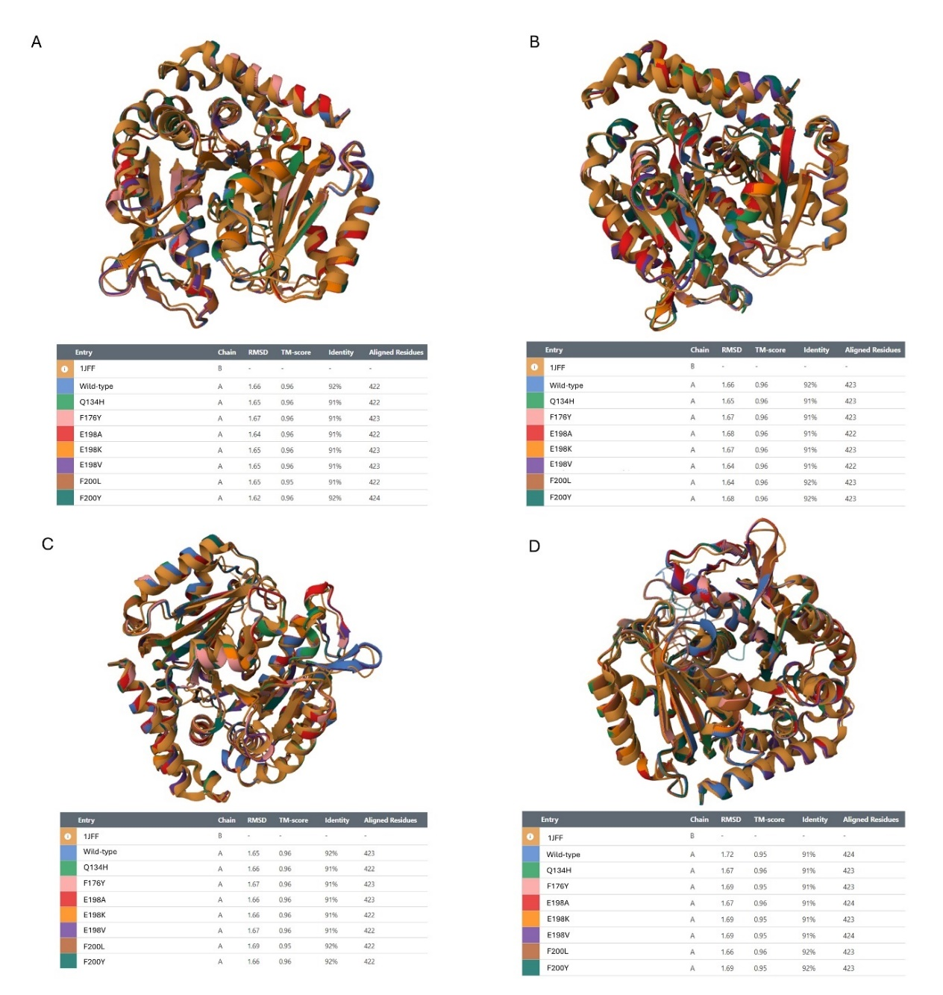
Supplementary Figure 1. Pairwise alignment of A. caninum (A), A. ceylanicum (B), A. duodenale (C) and N. americanus (D) modeled β-tubulins against the template protein from PDB ID No. 1jff. All predicted mutated proteins were of high structural similarity to the described crystal structure of the mammalian β-tubulin protein. The analysis was done using the PDB Pairwise Structure Alignment (https://www.rcsb.org/alignment).

