Supplementary
Microwave-assisted extraction of Camellia oleifera shell lignin via dual-acidic deep eutectic solvent and its mechanism
Liu He, ^{a, b} Conghao Ku, ^{a, b} Huiqin Guo, ^{* a, b} Yangyang Peng, ^{a, b} Yue Chen, ^{a, b} Liushui Yan ^{* a, b}
ª Key Laboratory of Jiangxi Province for Persistent Pollutants Control and Resources Recycle, Nanchang Hangkong University, Nanchang 330063, China.
^{b} Jiangxi Provincial Experimental Teaching Demonstration Center of Environmental Science and Engineering, Nanchang Hangkong University, Nanchang 330063, China.

Contents
1. Preparation and recovery of DES 2
2. DES recycling 5
3. characterization of Camellia oleifera shell lignin 7
4. Characterization of ZnCl₂-LA/GG system 11
5. DFT Calculation 13
6. Analysis of solid residues and water-soluble products 16

- Preparation and recovery of DES
Table S1 DADESs with molar ratios of HBAs and HBDs.
Hydrogen bond  acceptor (HBA) | Hydrogen bond  donor (HBD) | Respective molar ratio  (HBA:HBD)
ZnCl₂ | LA | 1:2
ZnCl₂ | LA | 1:4
ZnCl₂ | LA | 1:6
ZnCl₂ | LA | 1:8
ZnCl₂ | LA | 1:10
MgCl₂ | LA | 1:8
CuCl₂ | LA | 1:8
AlCl₃ | LA | 1:8
FeCl₃ | LA | 1:8
ZnCl₂ | FA | 1:8
ZnCl₂ | AA | 1:8
ZnCl₂ | PA | 1:8

Table S2 DES pretreatment conditions and lignin extraction rates
DES | Molar ratio | DES pretreatment condition |  |  | Extraction rate(%)
DES | Molar ratio | Microwave power(W) | Reaction time(min) | Solid-liquid ratio | Extraction rate(%)
ZnCl₂-LA | 1:4 | 70 | 10 | 1:20 | 19.9
ZnCl₂-LA | 1:6 | 70 | 10 | 1:20 | 25.8
ZnCl₂-LA | 1:8 | 70 | 10 | 1:20 | 97.1
ZnCl₂-LA | 1:10 | 70 | 10 | 1:20 | 86.2
ZnCl₂-LA | 1:12 | 70 | 10 | 1:20 | 82.6
ZnCl₂-LA | 1:8 | 30 | 8 | 1:20 | 47.7
ZnCl₂-LA | 1:8 | 50 | 8 | 1:20 | 61.9
ZnCl₂-LA | 1:8 | 70 | 8 | 1:20 | 78.5
ZnCl₂-LA | 1:8 | 90 | 8 | 1:20 | 71.5
ZnCl₂-LA | 1:8 | 110 | 8 | 1:20 | 69.5
ZnCl₂-LA | 1:8 | 70 | 4 | 1:20 | 50.9
ZnCl₂-LA | 1:8 | 70 | 6 | 1:20 | 73.9
ZnCl₂-LA | 1:8 | 70 | 8 | 1:20 | 84.7
ZnCl₂-LA | 1:8 | 70 | 10 | 1:20 | 96.9
ZnCl₂-LA | 1:8 | 70 | 12 | 1:20 | 80.7
ZnCl₂-LA | 1:8 | 70 | 10 | 1:10 | 83.2
 |  |  |  | 1:15 | 89.0
 |  |  |  | 1:20 | 96.0
 |  |  |  | 1:25 | 87.3
MgCl₂-LA | 1:8 | 70 | 10 | 1:20 | 70.6
CuCl₂-LA |  |  |  |  | 10.6
AlCl₃-LA |  |  |  |  | 42.4
FeCl₃-LA |  |  |  |  | 7.9
ZnCl₂-FA |  |  |  |  | 50.2
ZnCl₂-AA |  |  |  |  | 60.0
ZnCl₂-PA |  |  |  |  | 46.9

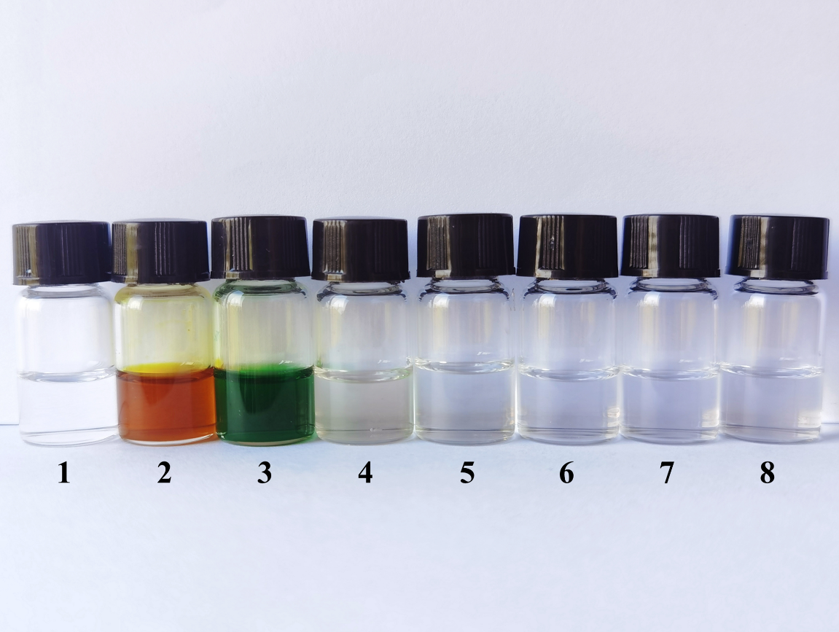 Fig. S1 Different types of DADES. 1: MgCl₂-LA; 2: FeCl₃-LA; 3: CuCl₂-LA; 4: AlCl₃-LA; 5: ZnCl₂-LA; 6: ZnCl₂-FA; 7: ZnCl₂-AA; 8: ZnCl₂-PA.

2. DES recycling
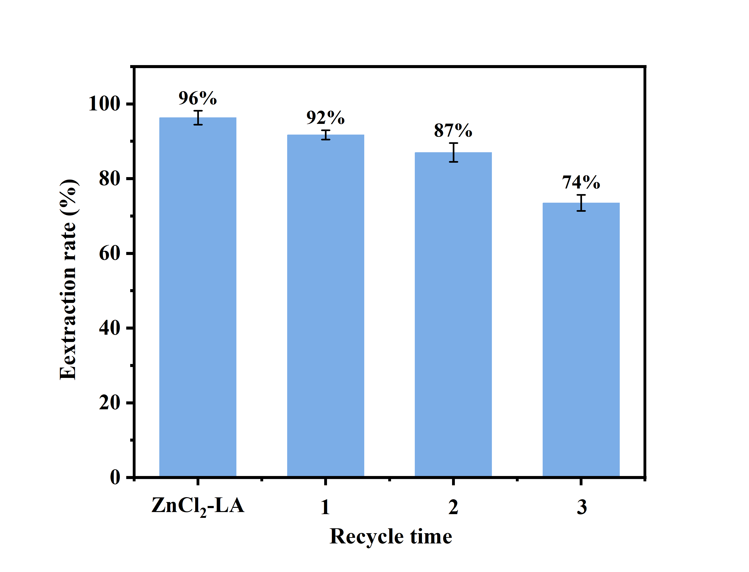
Fig. S2 Effects of DES recovery on lignin extraction. Optimal separation and extraction process conditions: DES is ZnCl₂-LA (1:8, n/n), the solid-liquid ratio is 1:20, microwave time is 10 min and microwave power is 70 W.

- characterization of Camellia oleifera shell lignin
Table S3 Assignments of FTIR bands of WCOS and MW-DESL.
Frequency/cm⁻¹ | Functional group
3405 | O-H stretching
2935 | C-H stretching
1732 | C=O stretching of hemicellulose xylan
1700 | C-O stretching
1600 | Aromatic backbone stretching of lignin
1510 | Aromatic backbone stretching of lignin
1459 | Aromatic backbone stretching of lignin
1367 | C-H stretching or phenolic hydroxyl group stretching in CH₃
1332 | Aromatic ring with S-type structural unit
1275 | C-C,C-O,C=O stretching
1206 | G-type structural unit C=O expansion and contraction
1113 | G-type structural unit C-H in-plane bending
1030 | Bending and stretching of ether bonds on benzene ring
895 | Glycosidic bond between sugar unit
821 | Benzene ring C-H surface bending outward

Table S4 Assignments of major signals in the 2D HSQC spectra of the lignin.
Labels | δC/δH (ppm) | Assignments
B_{β} | 53.8/3.06 | C_{β}-H_{β} in resinol substructures (B)
OCH₃ | 56.2/3.73 | C-H in methoxyls
A_{γ} | 58.6-61.4/3.17-3.88 | C_{γ}-H_{γ} in β-O-4 substructures (A)
C_{γ} | 63.0/3.66 | C_{γ}-H_{γ} in phenylcoumaran substructures (C)
A'_{γ} | 63.7/4.36 | C_{γ}-H_{γ} in γ-acylated β-O-4 substructures (A')
A_{α} | 70.1/4.95 | C_{α}-H_{α} in β-O-4 substructures linked to a S unit (A)
B_{γ} | 71.3/4.54 | C_{γ}-H_{γ} in resinol substructures (B)
B_{α} | 84.9/4.69 | C_{α}-H_{α} in resinol substructures (B)
C_{α} | 86.8/5.49 | C_{α}-H_{α} in phenylcoumaran substructures (C)
S_{2,6} | 104.1/6.72 | C_{2,6}-H_{2,6} in etherified syringyl units (S)
S'_{2,6} | 106.7/7.24 | C_{2,6}-H_{2,6} in oxidized (Cα=O) phenolic syringyl units (S')
G₂ | 111.1/6.98 | C₂-H₂ in guaiacyl units (G)
G₅ | 114.4/6.74 | C₅-H₅ in guaiacyl units (G)
G₆ | 118.8/6.82 | C₆-H₆ in guaiacyl units (G)

Table S5 Relative molecular weight and polydispersity index of lignin.
Sample | M_{w} (g/mol) | M_{n} (g/mol) | PDI
MW-DESL | 1597 | 1070 | 1.49
EL¹ | 3007 | 1249 | 2.41

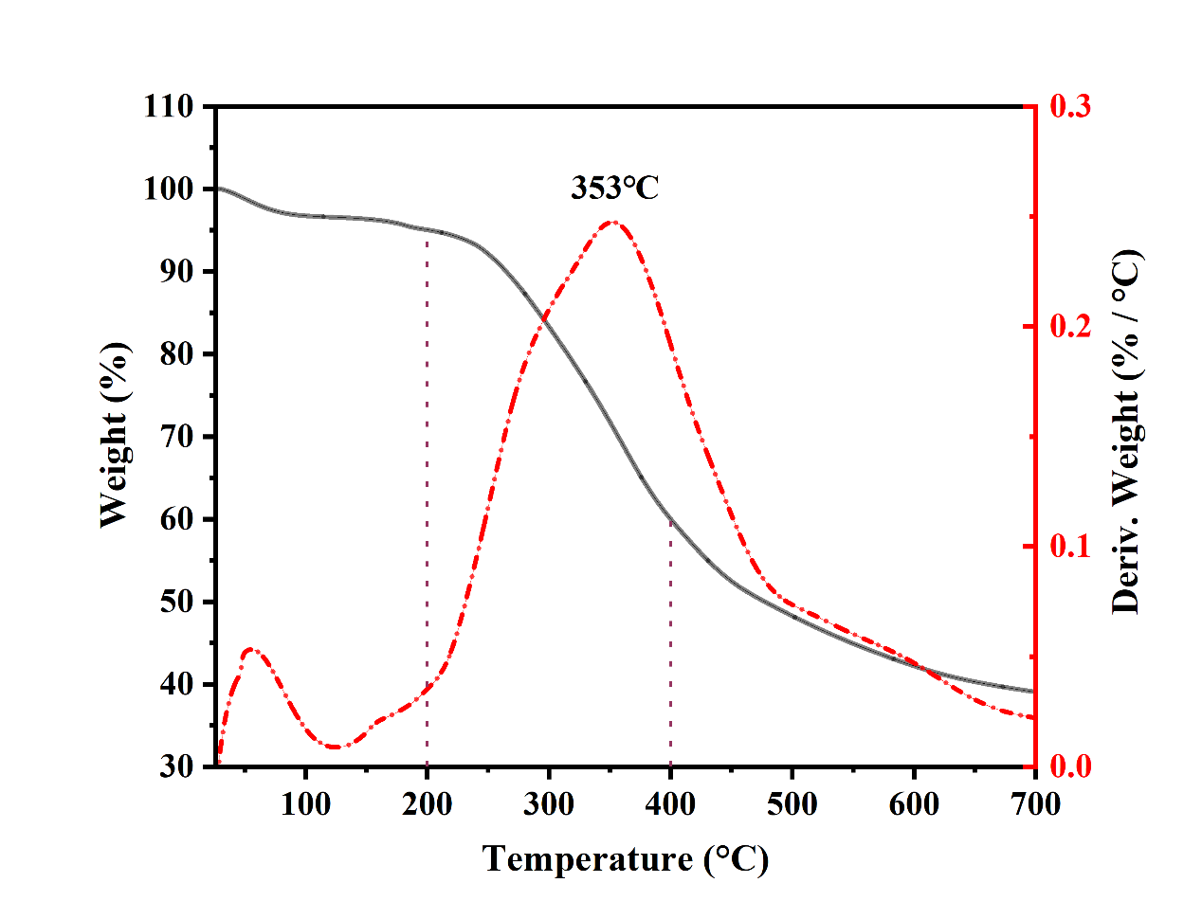
Fig. S3 MW-DESL thermogravimetric and differential thermogravimetric plot.

- Characterization of ZnCl₂-LA/GG system
Ji et al. have demonstrated through density functional theory (DFT) calculations that C-H⋯π and O⋯H interactions significantly contribute to the solubility of lignin in DES.² Based on this findings, we conducted a detailed analysis of the ZnCl₂-LA/GG system using FT-IR spectroscopy and ¹H NMR spectroscopy. As depicted in Fig. S4, the FT-IR spectrum of the ZnCl₂-LA/GG system closely resembles that of ZnCl₂-LA, a similarity attributable to the presence of shared functional groups in both the DES and lignin as well as the high content of DES within the system. This observation aligns with the findings of Hladnik et al.³ Upon dissolution of GG, notable shifts in the FTIR absorption bands were observed. The O-H stretching vibration of ZnCl₂-LA exhibited a redshift from 3460 cm⁻¹ to 3443 cm⁻¹, and the C=O stretching vibration shifted from 1732 cm⁻¹ to 1719 cm⁻¹. These spectral changes indicate the formation of new hydrogen bonds between the carbonyl and hydroxyl groups in ZnCl₂-LA and GG, which is consistent with the DFT computational results.
Fig. S4 FTIR spectra of ZnCl₂-LA and ZnCl₂-LA/GG.

The proton nuclear magnetic resonance (¹H NMR) spectra of ZnCl₂-LA/GG, GG alone, and ZnCl₂-LA are presented in Fig. S5. Notably, the chemical shifts of specific hydrogen atoms in ZnCl₂-LA exhibit a shift from higher to lower magnetic field strength, suggesting the formation of robust hydrogen bonding interactions between ZnCl₂-LA with GG at various interaction sites. This indicates a multifaceted and simultaneous engagement of ZnCl₂-LA with GG, leading to a strong intermolecular complexation. Similarly, the chemical shifts of certain hydrogen atoms in GG also show a movement towards lower field strength, while the signals from some hydrogen atoms are no longer detectable. These changes imply that ZnCl₂-LA and GG engage in extensive hydrogen bondings, resulting in a combined effect that enhances the extraction efficiency of lignin from Camellia oleifera shells. This observation aligns with the outcomes of the DFT calculations, reinforcing the molecular-level understanding of the solvation extraction mechanisms at play.
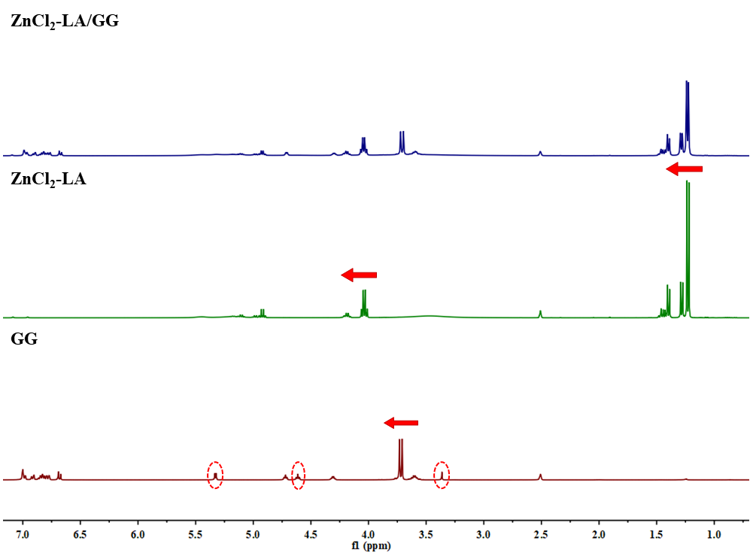
Fig. S5 ¹H NMR spectra of ZnCl₂-LA/GG, GG and ZnCl₂-LA.

- DFT Calculation
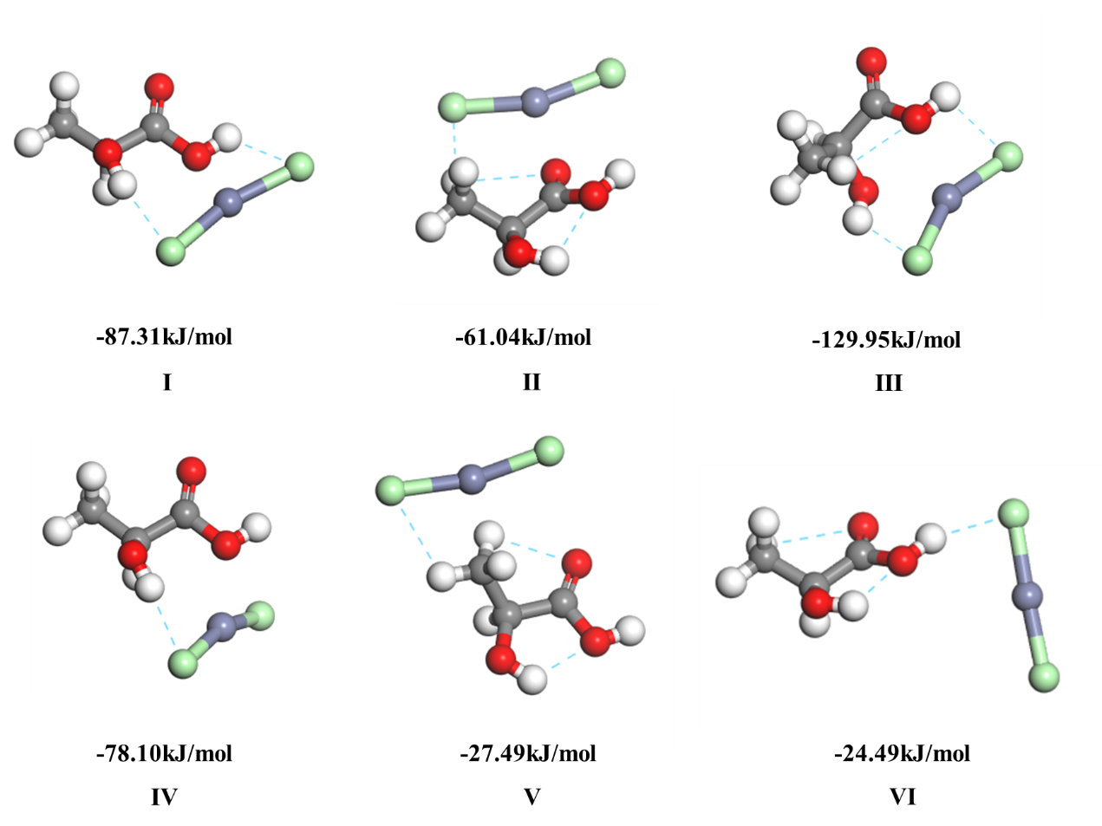
Fig. S6 Optimized interaction structures of ZnCl₂-LA and the relative energies of the structures.

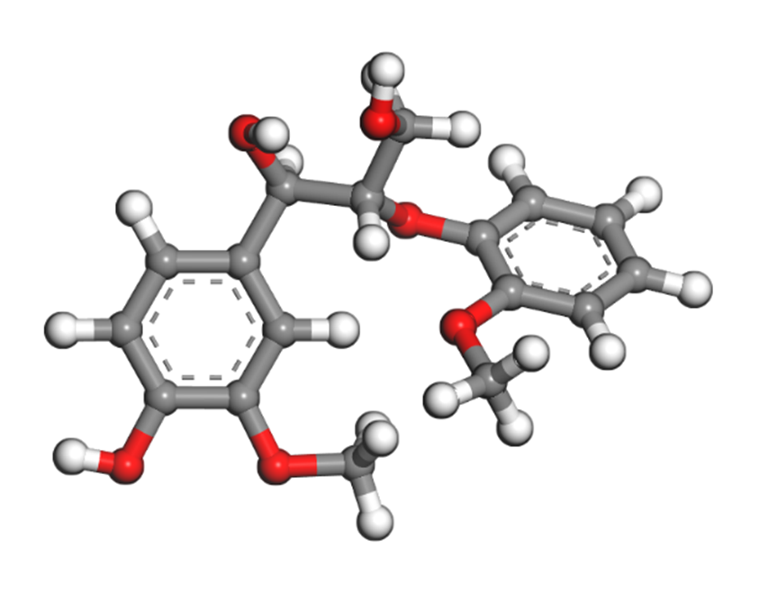
Fig. S7 Structure of GG optimized by DFT-m-GGA/M06-L.

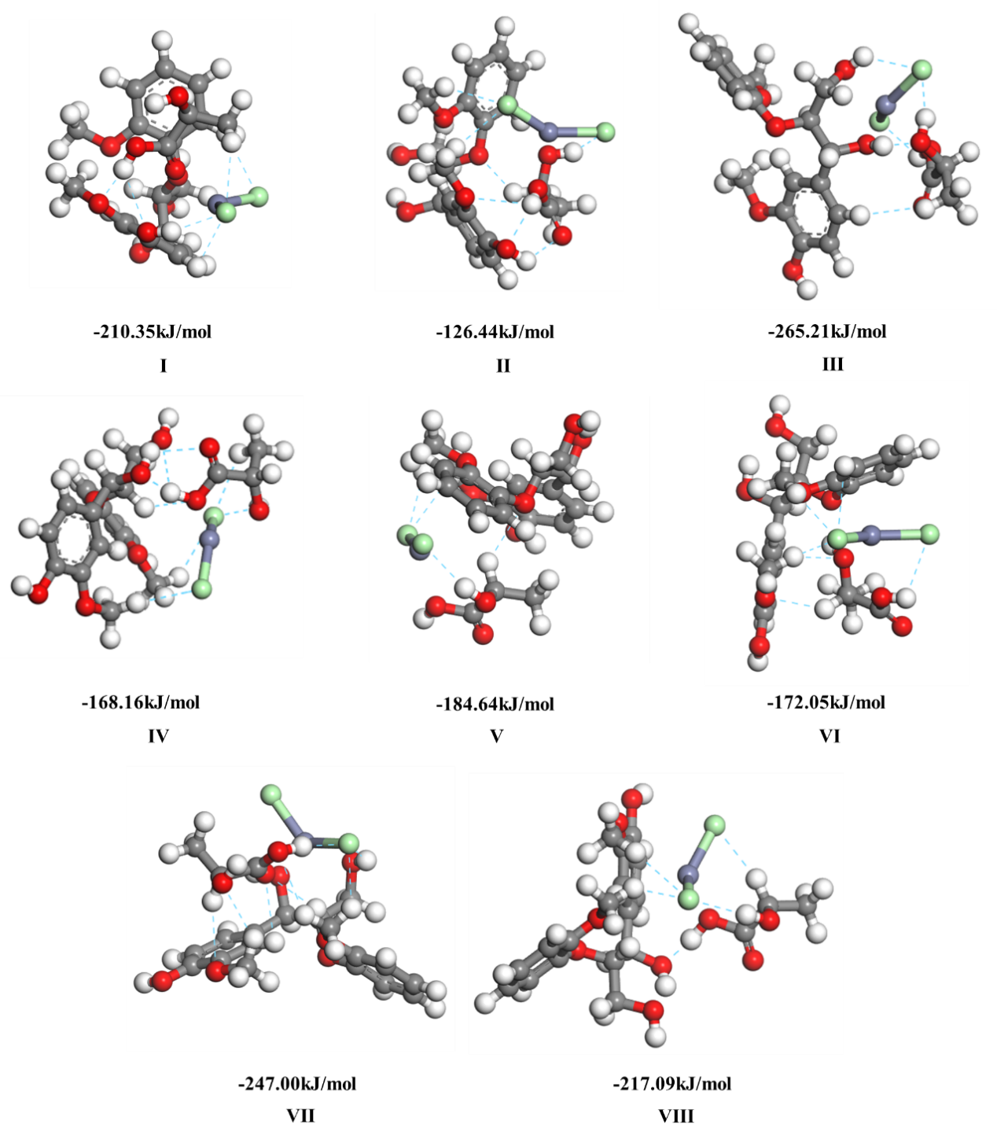
Fig. S8 Optimized interaction structures of ZnCl₂-LA and GG and their relative energies.

- Analysis of solid residues and water-soluble products
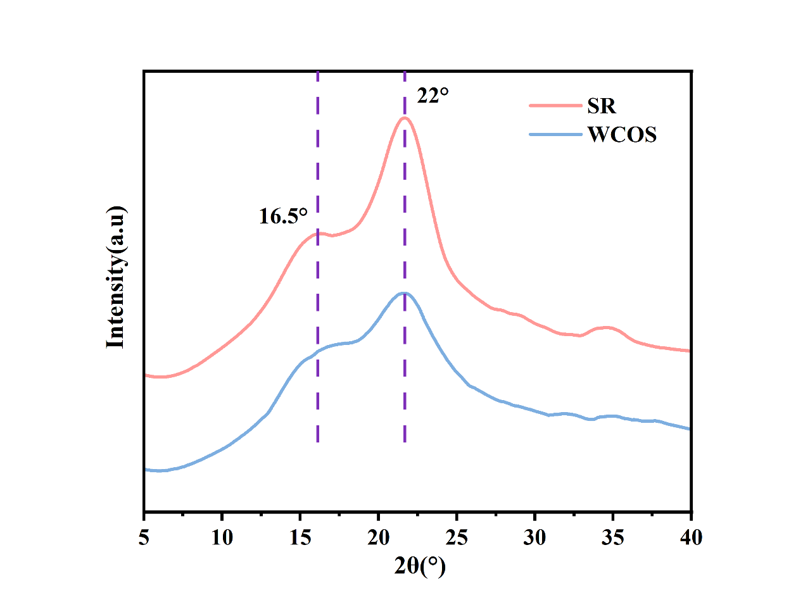
Fig. S9 X-ray diffraction patterns of WCOS and SR.

Water-soluble products were analyzed by high-performance liquid chromatography (HPLC). Detection conditions: Welch Ultimate XB-C18 column (30 cm×4.6 mm×250 mm), column temperature 25°C, detection wavelength 280 nm, injection volume 10 μL, mobile phase flow rate 1.0 mL/min, mobile phase (water phase: Acetonitrile phase=70%:30%), isocratic elution.
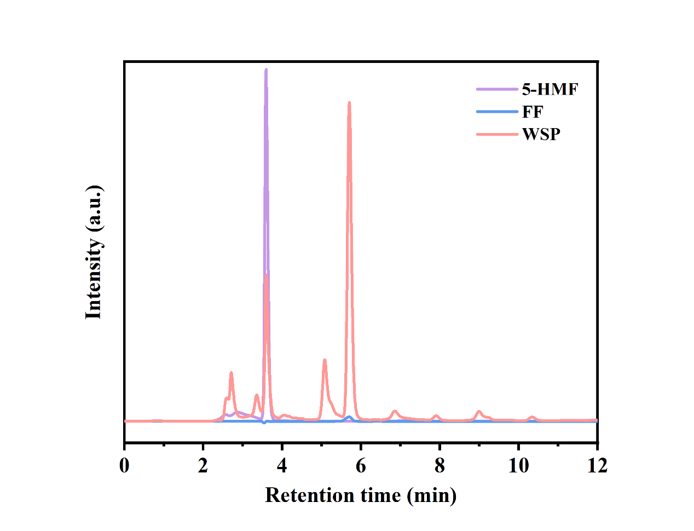
Fig. S10 HPLC chromatograms of WSP, FF and 5-HMF.

References
1 C. Ku, K. Li, H. Guo, Q. Wu and L. Yan, Applied Surface Science, 2022, 592, 153266.
2 H. Ji and P. Lv, Green Chem., 2020, 22, 1378–1387.
3 L. Hladnik, F. A. Vicente, U. Novak, M. Grilc and B. Likozar, Industrial Crops and Products, 2021, 164, 113359.

