Supplementary Material

Table 1. Causal effects of cognitive performance on meniscus derangement using MR analysis
Exposure | MR method | OR(95%CI) | P
cognitive performance:  136 SNPs | MR Egger | 0.95(0.47,1.91) | 0.89
cognitive performance:  136 SNPs | Weighted median | 0.81(0.67,0.98) | 3*10-2
cognitive performance:  136 SNPs | Inverse variance weighted | 0.76(0.66,0.88) | 2*10-4
cognitive performance:  136 SNPs | Simple mode | 0.86(0.48,1.52) | 0.61
cognitive performance:  136 SNPs | Weighted mode | 0.88(0.53,1.48) | 0.65

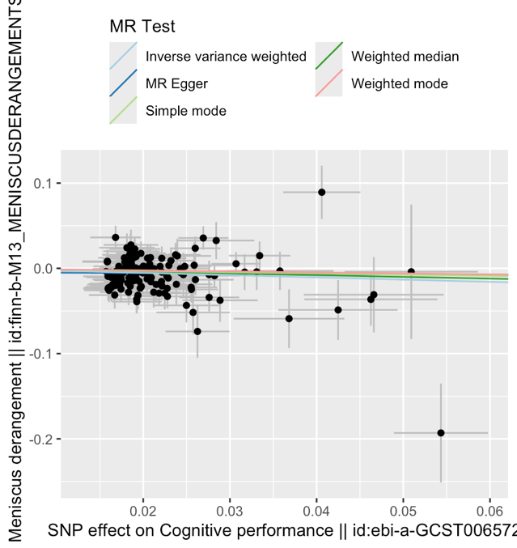
Figure 1. Scatter plots showing the effects of cognitive performance on the risk of meniscus derangement. Each point represents the per allele association with exposure plotted against per allele association with meniscus derangement.
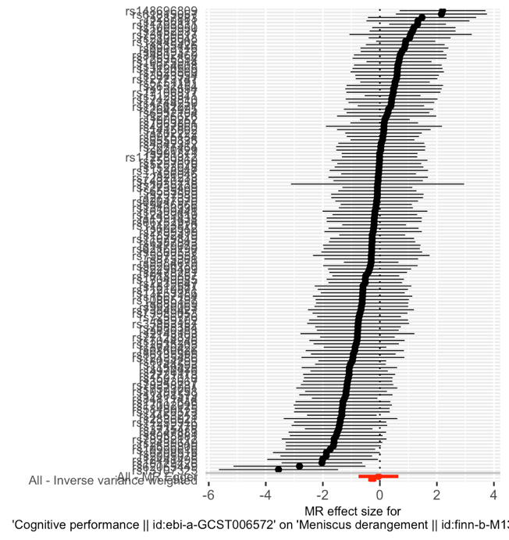
Figure 2. Forest plots of Mendelian randomization effect sizes for causal associations. cognitive performance on the risk of meniscus derangement.

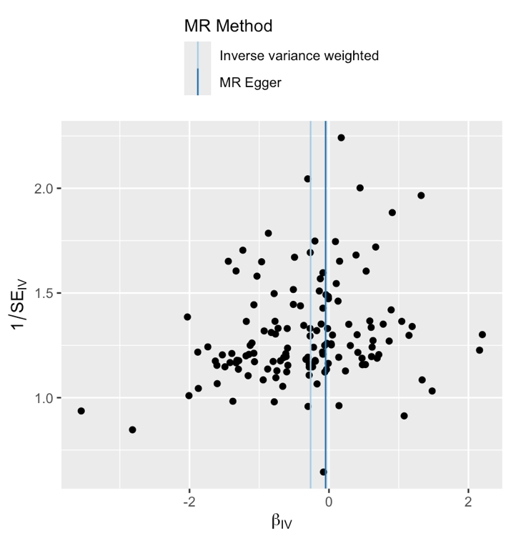

Figure 3. Funnel plots of Mendelian randomization effect sizes for causal associations. cognitive performance on the risk of meniscus derangement.

