Supplementary Information

Table of Contents
Supplementary Tables 1
Supplementary Table 1. Detailed information of BGCs included in the phylogenetic analysis 1
Supplementary Table 2. Annotation of genes containing mgp BGC via BLASTp analysis 2
Supplementary Table 3. Annotation of genes containing chp BGC via BLASTp analysis 3
Supplementary Table 4. Annotation of genes containing ctp BGC via BLASTp analysis 4
Supplementary Table 5. ¹H (600 MHz) and ¹³C (150 MHz) NMR Data of 1 in DMSO-d₆ 6
Supplementary Table 6. ¹H (500 MHz) and ¹³C (125 MHz) NMR Data of 2 in DMSO-d₆ 8
Supplementary Table 7. ¹H (600 MHz) and ¹³C (150 MHz) NMR Data of 3 in DMSO-d₆ 10
Supplementary Table 8. ¹H (500 MHz) and ¹³C (125 MHz) NMR Data of 4, 5 in DMSO-d₆ 12
Supplementary Table 9. ¹H (600 MHz) and ¹³C (150 MHz) NMR Data of 6, 7 in DMSO-d₆ 14
Supplementary Table 10. ¹H (600 MHz) and ¹³C (150 MHz) NMR Data of 8, 9 in DMSO-d₆ 16
Supplementary Table 11. ¹H (600 MHz) and ¹³C (150 MHz) NMR Data of 10, 11 in DMSO-d₆ 18
Supplementary Table 12. ¹H (600 MHz) and ¹³C (150 MHz) NMR Data of 12, 13 in DMSO-d₆ 20
Supplementary Table 13. Medium used for propagation and fermentation of strains in this study 22
Supplementary Table 14. Retention times of amino acids derivatized with Marfey’s reagent L-FDAA 23
Supplementary Figures 24
Supplementary Fig 1. BiG SCAPE-CORSON phylogenetic relationship of PUFAS and PUFAS-containing biosynthetic pathways on the basis of PfaA as reference. 24
Supplementary Fig 2. BiG SCAPE-CORSON phylogenetic relationship of PUFAS and PUFAS-containing biosynthetic pathways on the basis of PfaBC fusion as reference. 25
Supplementary Fig 3. HR-ESI-MS spectra of megapolipeptins Ia, Ib, Ic, Id, and Ⅱa (1-5) 26
Supplementary Fig 4. ¹H NMR (600 MHz) spectrum of megapolipeptin Ia (1) in DMSO-d₆ 27
Supplementary Fig 5. ¹³C NMR (150 MHz) spectrum of megapolipeptin Ia (1) in DMSO-d₆ 27
Supplementary Fig 6. DEPT 90 and DEPT 135 spectra of megapolipeptin Ia (1) in DMSO-d₆ 28
Supplementary Fig 7. HSQC spectrum of megapolipeptin Ia (1) in DMSO-d₆ 28
Supplementary Fig 8. ¹H-¹H COSY spectrum of megapolipeptin Ia (1) in DMSO-d₆ 29
Supplementary Fig 9. HMBC spectrum of megapolipeptin Ia (1) in DMSO-d₆ 29
Supplementary Fig 10. ¹H NMR (500 MHz) spectrum of megapolipeptin Ib (2) in DMSO-d₆ 30
Supplementary Fig 11. ¹³C NMR (125 MHz) spectrum of megapolipeptin Ib (2) in DMSO-d₆ 30
Supplementary Fig 12. DEPT 90 and DEPT 135 spectra of megapolipeptin Ib (2) in DMSO-d₆ 31
Supplementary Fig 13. HSQC spectrum of megapolipeptin Ib (2) in DMSO-d₆ 31
Supplementary Fig 14. ¹H-¹H COSY spectrum of megapolipeptin Ib (2) in DMSO-d₆ 32
Supplementary Fig 15. HMBC spectrum of megapolipeptin Ib (2) in DMSO-d₆ 32
Supplementary Fig 16. ¹H NMR (600 MHz) spectrum of megapolipeptin Ic (3) in DMSO-d₆ 33
Supplementary Fig 17. ¹³C NMR (150 MHz) spectrum of megapolipeptin Ic (3) in DMSO-d₆ 33
Supplementary Fig 18. DEPT 90 and DEPT 135 spectra of megapolipeptin Ic (3) in DMSO-d₆ 34
Supplementary Fig 19. HSQC spectrum of megapolipeptin Ic (3) in DMSO-d₆ 34
Supplementary Fig 20. ¹H-¹H COSY spectrum of megapolipeptin Ic (3) in DMSO-d₆ 35
Supplementary Fig 21. HMBC spectrum of megapolipeptin Ic (3) in DMSO-d₆ 35
Supplementary Fig 22. ¹H NMR (500 MHz) spectrum of megapolipeptin Id (4) in DMSO-d₆ 36
Supplementary Fig 23. ¹³C NMR (125 MHz) spectrum of megapolipeptin Id (4) in DMSO-d₆ 36
Supplementary Fig 24. DEPT 90 and DEPT 135 spectra of megapolipeptin Id (4) in DMSO-d₆ 37
Supplementary Fig 25. HSQC spectrum of megapolipeptin Id (4) in DMSO-d₆ 37
Supplementary Fig 26. ¹H-¹H COSY spectrum of megapolipeptin Id (4) in DMSO-d₆ 38
Supplementary Fig 27. HMBC spectrum of megapolipeptin Id (4) in DMSO-d₆ 38
Supplementary Fig 28. ¹H NMR (500 MHz) spectrum of megapolipeptin Ⅱa (5) in DMSO-d₆ 39
Supplementary Fig 29. ¹³C NMR (125 MHz) spectrum of megapolipeptin Ⅱa (5) in DMSO-d₆ 39
Supplementary Fig 30. DEPT 90 and DEPT 135 spectra of megapolipeptin Ⅱa (5) in DMSO-d₆ 40
Supplementary Fig 31. HSQC spectrum of megapolipeptin Ⅱa (5) in DMSO-d₆ 40
Supplementary Fig 32. ¹H-¹H COSY spectrum of megapolipeptin Ⅱa (5) in DMSO-d₆ 41
Supplementary Fig 33. HMBC spectrum of megapolipeptin Ⅱa (5) in DMSO-d₆ 41
Supplementary Fig 34. The truncated HR-ESI-MS spectra of Marfey’s hydrolysis reaction of megapolipeptins Ib (2), Ic (3), and L- /D-standard amino acids. 42
Supplementary Fig 35. Bioinformatic analysis of the ketoreductase domains 43
Supplementary Fig 36. HR-ESI-MS spectra of chromopeptins Ia, Ib, Ⅱa, Ⅱb, and Ⅱc (6-10) 44
Supplementary Fig 37. ¹H NMR (600 MHz) spectrum of chromopeptin Ia (6) in DMSO-d₆ 45
Supplementary Fig 38. ¹³C NMR (150 MHz) spectrum of chromopeptin Ia (6) in DMSO-d₆ 45
Supplementary Fig 39. DEPT 90 and DEPT 135 spectra of chromopeptin Ia (6) in DMSO-d₆ 46
Supplementary Fig 40. HSQC spectrum of chromopeptin Ia (6) in DMSO-d₆ 46
Supplementary Fig 41. ¹H-¹H COSY spectrum of chromopeptin Ia (6) in DMSO-d₆ 47
Supplementary Fig 42. HMBC spectrum of chromopeptin Ia (6) in DMSO-d₆ 47
Supplementary Fig 43. ¹H NMR (600 MHz) spectrum of chromopeptin Ib (7) in DMSO-d₆ 48
Supplementary Fig 44. ¹³C NMR (150 MHz) spectrum of chromopeptin Ib (7) in DMSO-d₆ 48
Supplementary Fig 45. DEPT 90 and DEPT 135 spectra of chromopeptin Ib (7) in DMSO-d₆ 49
Supplementary Fig 46. HSQC spectrum of chromopeptin Ib (7) in DMSO-d₆ 49
Supplementary Fig 47. ¹H-¹H COSY spectrum of chromopeptin Ib (7) in DMSO-d₆ 50
Supplementary Fig 48. HMBC spectrum of chromopeptin Ib (7) in DMSO-d₆ 50
Supplementary Fig 49. ¹H NMR (600 MHz) spectrum of chromopeptin Ⅱa (8) in DMSO-d₆ 51
Supplementary Fig 50. ¹³C NMR (150 MHz) spectrum of chromopeptin Ⅱa (8) in DMSO-d₆ 51
Supplementary Fig 51. DEPT 90 and DEPT 135 spectra of chromopeptin Ⅱa (8) in DMSO-d₆ 52
Supplementary Fig 52. HSQC spectrum of chromopeptin Ⅱa (8) in DMSO-d₆ 52
Supplementary Fig 53. ¹H-¹H COSY spectrum of chromopeptin Ⅱa (8) in DMSO-d₆ 53
Supplementary Fig 54. HMBC spectrum of chromopeptin Ⅱa (8) in DMSO-d₆ 53
Supplementary Fig 55. ¹H NMR (600 MHz) spectrum of chromopeptin Ⅱb (9) in DMSO-d₆ 54
Supplementary Fig 56. ¹³C NMR (150 MHz) spectrum of chromopeptin Ⅱb (9) in DMSO-d₆ 54
Supplementary Fig 57. DEPT 90 and DEPT 135 spectra of chromopeptin Ⅱb (9) in DMSO-d₆ 55
Supplementary Fig 58. HSQC spectrum of chromopeptin Ⅱb (9) in DMSO-d₆ 55
Supplementary Fig 59. ¹H-¹H COSY spectrum of chromopeptin Ⅱb (9) in DMSO-d₆ 56
Supplementary Fig 60. HMBC spectrum of chromopeptin Ⅱb (9) in DMSO-d₆ 56
Supplementary Fig 61. ¹H NMR (600 MHz) spectrum of chromopeptin Ⅱc (10) in DMSO-d₆ 57
Supplementary Fig 62. ¹³C NMR (150 MHz) spectrum of chromopeptin Ⅱc (10) in DMSO-d₆ 57
Supplementary Fig 63. DEPT 90 and DEPT 135 spectra of chromopeptin Ⅱc (10) in DMSO-d₆ 58
Supplementary Fig 64. HSQC spectrum of chromopeptin Ⅱc (10) in DMSO-d₆ 58
Supplementary Fig 65. ¹H-¹H COSY spectrum of chromopeptin Ⅱc (10) in DMSO-d₆ 59
Supplementary Fig 66. HMBC spectrum of chromopeptin Ⅱc (10) in DMSO-d₆ 59
Supplementary Fig 67. The truncated HR-ESI-MS spectra of Marfey’s hydrolysis reaction of chromopeptins Ib (7), Ⅱa (8), and L- /D-standard amino acids. 60
Supplementary Fig 68. HR-ESI-MS spectra of chitinimopeptins Ia, Ib, and Ic (11-13) 61
Supplementary Fig 69. ¹H NMR (600 MHz) spectrum of chitinimopeptin Ia (11) in DMSO-d₆ 62
Supplementary Fig 70. ¹³C NMR (150 MHz) spectrum of chitinimopeptin Ia (11) in DMSO-d₆ 62
Supplementary Fig 71. DEPT 90 and DEPT 135 spectra of chitinimopeptin Ia (11) in DMSO-d₆ 63
Supplementary Fig 72. HSQC spectrum of chitinimopeptin Ia (11) in DMSO-d₆ 63
Supplementary Fig 73. ¹H-¹H COSY spectrum of chitinimopeptin Ia (11) in DMSO-d₆ 64
Supplementary Fig 74. HMBC spectrum of chitinimopeptin Ia (11) in DMSO-d₆ 64
Supplementary Fig 75. ¹H NMR (600 MHz) spectrum of chitinimopeptins Ib/Ic (12-13) in DMSO-d₆ 65
Supplementary Fig 76. ¹³C NMR (150 MHz) spectrum of chitinimopeptins Ib/Ic (12-13) in DMSO-d₆ 65
Supplementary Fig 77. DEPT 90 and DEPT 135 spectra of chitinimopeptins Ib/Ic (12-13) in DMSO-d₆ 66
Supplementary Fig 78. HSQC spectrum of chitinimopeptins Ib/Ic (12-13) in DMSO-d₆ 66
Supplementary Fig 79. ¹H-¹H COSY spectrum of chitinimopeptins Ib/Ic (12-13) in DMSO-d₆ 67
Supplementary Fig 80. HMBC spectrum of chitinimopeptins Ib/Ic (12-13) in DMSO-d₆ 67
Supplementary Fig 81. The truncated HR-ESI-MS spectra of Marfey’s hydrolysis reaction of chitinimopeptins Ia/Ib (12/13) mixture, and L- /D-standard amino acids. 68

Supplementary Tables

Supplementary Table 1. Detailed information of BGCs included in the phylogenetic analysis
No. | Sample Name | Organism | Accession
1 | Aureispira marina | Aureispira marina | AB980240.1
2 | Shewanella sp. BR-2 | Shewanella sp. | EU719604.1
3 | Shewanella sp. YLB-08 | Shewanella sp. | NZ_VOQB01000001.1
4 | Psychromonas hadalis ATCCBAA-638 | Psychromonas hadalis | ATUO01000055.1
5 | Psychromonas sp. MB-3u-54 | Psychromonas sp. | NZ_PJBP01000183.1
6 | Moritella marina ATCC 15381 | Moritella marina | NZ_KB907150.1
7 | Shewanella pneumatophori | Shewanella pneumatophori | U73935.1
8 | Vibrio tasmaniensis 5F-79 | Vibrio tasmaniensis | NZ_AJZP01000053.1
9 | Flammeovirga pectinis L12 M1 | Flammeovirga pectinis | NZ_CP034562.1
10 | Shewanella morhuae | Shewanella morhuae | NZ_PYSG01000002.1
11 | Parashewanella curva | Parashewanella curva | NZ_ML014784.1
12 | Fischerella thermalis CCMEE5318 | Fischerella thermalis | NZ_NMQE01000539.1
13 | Vibrio splendidus 10N | Vibrio splendidus | NZ_MCVU01000320.1
14 | Aetherobacter fasciculatus | Aetherobacter fasciculatus | NZ_CAWUQY010000010.1
15 | Moritella sp. PE36 | Moritella sp. | NZ_NIBS01000014.1
16 | Pseudoalteromonas sp. DS12 | Pseudoalteromonas sp. | DQ469875.1
17 | Shewanella canadensis HAW-EB2 | Shewanella canadensis | NZ_RXNU01000004.1
18 | Xenorhabdus budapestensis | Xenorhabdus budapestensis | NZ_NIBS01000014.1
19 | Dickeya solani GBBC 2040 | Dickeya solani | NZ_CM001860.1
20 | Dickeya solani IFB 0099 | Dickeya solani | NZ_CP024711.1
21 | Dickeya sp. NCPPB 3274 | Dickeya sp. | NZ_CM001979.1
22 | Serratia plymuthica S13 | Serratia plymuthica | NC_021659.1
23 | Serratia plymuthica A30 | Serratia plymuthica | NZ_AMSV01000061.1
24 | Serratia plymuthica RVH1 | Serratia plymuthica | NZ_ARWD01000001.1
25 | Serratia plymuthica strain 3Re4-18 | Serratia plymuthica | NZ_CP012097.1
26 | Dickeya fangzhongdai strain ND14b | Dickeya fangzhongdai | NZ_CP009460.1
27 | Dickeya solani D s0432-1 | Dickeya solani | NZ_CP017453.1
28 | Paraburkholderia megapolitana DSM23488  (LMG23650) | Paraburkholderia megapolitana | NZ_CP041743.1
29 | Paraburkholderia acidicola ATCC31363 | Paraburkholderia acidicola | NZ_MTZV01000006.1
30 | Collimonas arenae Cal35 | Collimonas arenae | NZ_CP009962.1
31 | Chromobacterium subtsugae ATCC31532 | Chromobacterium subtsugae | PQ106806
32 | Chromobacterium sp. ATCC53434 | Chromobacterium sp. | NZ_CP025429.1
33 | Chitinimonas sp. BJB300 | Chitinimonas sp. | NZ_PDZH01000032.1
34 | Chitinimonas koreensis DSM17726 | Chitinimonas koreensis | PQ106805
35 | Minicystis rosea DSM24000 | Minicystis rosea | CP016211.1
36 | Sorangium cellulosum So0157-2 | Sorangium cellulosum | NC_021658.1
37 | Sorangium cellulosum strain So ce26 | Sorangium cellulosum | NZ_CP012673.1

Supplementary Table 2. Annotation of genes containing mgp BGC via BLASTp analysis
ORF | No. of amino acids | Function in mgp BGC | Top hit of homolog function | Homolog accession | Amino acid identity (%)
mgp-5 | 136 |  | Hypothetical protein FNZ07_07495 | QDQ81032.1 | 135/135(100%)
mgp-4 | 132 |  | Type Ⅱ toxin-antitoxin system VapC family toxin | WP_091015062.1 | 131/131(100%)
mgp-3 | 79 |  | Type Ⅱ toxin-antitoxin system Phd/YefM family antitoxin | WP_211367909.1 | 78/78(100%)
mgp-2 | 141 |  | MULTISPECIES: DoxX family protein | WP_091015058.1 | 140/140(100%)
mgp-1 | 233 |  | Pirin family protein | WP_091015056.1 | 232/232(100%)
mgpR | 306 |  | LysR substrate-binding domain-containing protein | WP_091015054.1 | 305/305(100%)
mgpO | 521 |  | DUF6351 family protein | WP_170275685.1 | 520/520(100%)
mgpA | 1281 | KS-KR-ACP | SDRm family NAD(P)-dependent oxidoreductase | WP_091015048.1 | 1280/1280(100%)
mgpB | 2665 | KS-AT-ACP-AmT-C-A-PCP | Hybrid non-ribosomal peptide synthetase/type I polyketide synthase | WP_091015046.1 | 2664/2664(100%)
mgpC | 3744 | C-C-A_{Thr}-PCP-C-A_{Thr}-PCP-KS-DHT-KR-ACP | Non-ribosomal peptide synthetase | WP_091015044.1 | 3743/3743(100%)
mgpD | 2374 | C-A-PCP-E-C-PCP-TE | Non-ribosomal peptide synthetase | WP_091015042.1 | 2373/2373(100%)
mgpE | 2333 | KS-AT-ACP-ACP-ACP-ACP-KR | Type I polyketide synthase | WP_091015040.1 | 2332/2332(100%)
mgpF | 1896 | KS-KS₀-AT-FabA | Beta-ketoacyl synthase N-terminal-like domain-containing protein | WP_091015038.1 | 1895/1895(100%)
mgpG | 313 | Hydroxylase | Cupin-like domain-containing protein | WP_170275684.1 | 312/312(100%)
mgpH | 570 | ER-ACP | PfaD family polyunsaturated fatty acid/polyketide biosynthesis protein | QDQ81018.1 | 569/569(100%)
mgpI | 271 | Thioesterase | MULTISPECIES: alpha/beta fold hydrolase | WP_091015031.1 | 270/270(100%)
mgpJ | 240 | PPTase | 4'-phosphopantetheinyl transferase superfamily protein | WP_091015029.1 | 239/239(100%)
mgpK | 483 |  | MULTISPECIES: polysaccharide pyruvyl transferase family protein | WP_170275682.1 | 482/482(100%)
mgpL | 587 |  | 2-succinyl-5-enolpyruvyl-6-hydroxy-3-cyclohexene-1-carboxylic-acid synthase | WP_091015023.1 | 586/586(100%)
mgpM | 270 |  | Predicted phosphoesterase | SFJ25572.1 | 269/269(100%)
mgpN | 550 |  | Acyl-CoA synthetase | WP_091015017.1 | 549/549(100%)
mgp+1 | 470 |  | MmgE/PrpD family protein | WP_091015014.1 | 469/469(100%)
mgp+2 | 102 |  | Antibiotic biosynthesis monooxygenase | WP_091015011.1 | 101/101(100%)
mgp+3 | 205 |  | MULTISPECIES: hypothetical protein | WP_091015848.1 | 204/204(100%)

Supplementary Table 3. Annotation of genes containing chp BGC via BLASTp analysis
ORF | No. of amino acids | Function in chp BGC | Top hit of homolog function | Homolog accession | Amino acid identity (%)
chp-4 | 251 |  | SDR family oxidoreductase | WP_043573403.1 | 250/250(100%)
chp-3 | 228 |  | Phosphoglycolate phosphatase | WP_043573401.1 | 227/227(100%)
chp-2 | 489 |  | Anthranilate synthase component I | WP_043573399.1 | 488/488(100%)
chp-1 | 559 |  | Hypothetical protein | WP_146008325.1 | 555/555(100%)
chpJ | 549 |  | Methyl-accepting chemotaxis protein | WP_043573394.1 | 548/548(100%)
chpK | 219 |  | class I SAM-dependent methyltransferase | WP_043573392.1 | 218/218(100%)
chpL | 950 |  | Ribonucleoside-diphosphate reductase subunit alpha | WP_043573390.1 | 949/949(100%)
chpA | 2794 | KS-AT-ACP-AmT-C-A_{Leu1}-PCP | Hybrid non-ribosomal peptide synthetase/type I polyketide synthase | WP_043573388.1 | 2793/2793(100%)
chpB | 3522 | C-A_{Gln}-PCP-C-A_{Ala}-PCP-KS-AT-KR-ACP | Hypothetical protein AWB61_02580 | KZE84882.1 | 3521/3521(100%)
chpC | 2351 | C-A_{Val/Ile}-PCP-E-C-PCP-TE | Non-ribosomal peptide synthetase | WP_043573382.1 | 2350/2350(100%)
chpD | 2142 | KS-AT-ACP-ACP-ACP-ACP-ACP-KR | Type I polyketide synthase | WP_193603929.1 | 2141/2141(100%)
chpE | 1823 | KS-KS₀-AT-FabA | Hypothetical protein AWB61_21400 | KZE84808.1 | 1822/1822(100%)
chpF | 571 | ER-ACP | PfaD family polyunsaturated fatty acid/polyketide biosynthesis protein | WP_052257951.1 | 570/570(100%)
chpG | 265 | Thioesterase | Alpha/beta fold hydrolase | WP_047249468.1 | 264/264(100%)
chpH | 237 | PPTase | 4'-phosphopantetheinyl transferase superfamily protein | WP_052257950.1 | 236/236(100%)
chpI | 478 |  | Polysaccharide pyruvyl transferase family protein | WP_043573373.1 | 477/477(100%)
chp+1 | 205 |  | Hypothetical protein | WP_052257949.1 | 204/204(100%)
chp+2 | 133 |  | Hypothetical protein | WP_043573370.1 | 132/132(100%)
chp+3 | 132 |  | Hypothetical protein | WP_043573366.1 | 131/131(100%)
chp+4 | 70 |  | Hypothetical protein | WP_043573363.1 | 69/69(100%)
chp+5 | 361 |  | Ribonucleoside-diphosphate reductase subunit beta | WP_043573358.1 | 360/360(100%)

Supplementary Table 4. Annotation of genes containing ctp BGC via BLASTp analysis
ORF | No. of amino acids | Function in ctp BGC | Top hit of homolog function | Homolog accession | Amino acid identity (%)
ctp-4 | 260 |  | TOBE domain-containing protein | WP_051319214.1 | 259/259(100%)
ctp-3 | 247 |  | Molybdate ABC transporter substrate-binding protein | WP_034607452.1 | 246/246(100%)
ctp-2 | 226 |  | Molybdate ABC transporter permease subunit | WP_028447091.1 | 225/225(100%)
ctp-1 | 358 |  | Molybdenum ABC transporter ATP-binding protein | WP_028447092.1 | 357/357(100%)
ctpI | 503 |  | AMP nucleosidase | WP_028447093.1 | 497/497(100%)
ctpJ | 255 |  | Transporter substrate-binding domain-containing protein | WP_028447094.1 | 254/254(100%)
ctpR | 296 |  | LysR family transcriptional regulator | QNM94661.1 | 295/295(100%)
ctpK | 252 |  | CTP synthase | WP_051319215.1 | 251/251(100%)
ctpL | 122 |  | Antibiotic biosynthesis monooxygenase | WP_028447097.1 | 121/121(100%)
ctpA | 2716 | KS-AT-ACP-AmT-C-A_{Leu1}-PCP | Hybrid non-ribosomal peptide synthetase/type I polyketide synthase | WP_034607454.1 | 2715/2715(100%)
ctpB | 3569 | C-A_{Gln}-PCP-C-A_{Ala}-PCP-KS-AT-KR-ACP | Hybrid non-ribosomal peptide synthetase/type I polyketide synthase | WP_028447098.1 | 3568/3568(100%)
ctpC | 2380 | C-A_{Val/Ile/Leu2}-PCP-E-C-PCP-TE | Non-ribosomal peptide synthetase | WP_028447099.1 | 2379/2379(100%)
ctpD | 1814 | KS-AT-ACP-ACP-ACP-ACP-KR | Type I polyketide synthase | WP_084300472.1 | 2152/2152(100%)
ctpE | 355 | KR | Type I polyketide synthase | WP_084300472.1 | 354/354(100%)
ctpE | 1838 | KS-KS₀-AT-FabA | Beta-ketoacyl synthase N-terminal-like domain-containing protein | WP_028447101.1 | 1837/1837(100%)
ctpF | 603 | ER-ACP | PfaD family polyunsaturated fatty acid/polyketide biosynthesis protein | WP_051319216.1 | 602/602(100%)
ctpG | 266 | Thioesterase | Alpha/beta fold hydrolase | WP_051319217.1 | 265/265(100%)
ctpH | 478 |  | Polysaccharide pyruvyl transferase family protein | WP_157462049.1 | 477/477(100%)
ctp+1 | 221 |  | Hypothetical protein | WP_051319218.1 | 220/220(100%)
ctp+2 | 1191 |  | EAL domain-containing protein | WP_034607623.1 | 1190/1190(100%)
ctp+3 | 292 |  | Hypothetical protein | WP_157462050.1 | 291/291(100%)
ctp+4 | 173 |  | HEPN domain-containing protein | WP_028447104.1 | 172/172(100%)
ctp+5 | 94 |  | Nucleotidyltransferase domain-containing protein | WP_028447105.1 | 93/93(100%)

Supplementary Table 5. ¹H (600 MHz) and ¹³C (150 MHz) NMR Data of 1 in DMSO-d₆

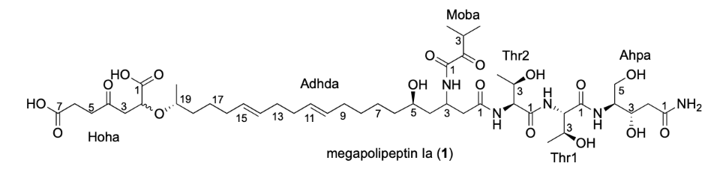
 | no | 1
 | no | δ_{C}, Type | δ_{H} (J in Hz) | △δ_{C}^{b} | △δ_{H}^{c}
Ahpa | 1  2a  2b  3  4  5  1-NH₂  4-NH | 173.5, C  39.8, CH₂  67.5, CH  55.1, CH  60.4, CH₂ | 2.26, dd (2.9, 14.8)  2.08, dd (9.7, 14.8)  3.85, mª  3.65, m  3.49, d (5.4)  7.20, s  6.75, s  7.60, d (8.9) | ﹢0.1  ﹢0.1  0  0  0 | 0  0  0  + 0.01  0  + 0.01  ﹣0.01  + 0.02
Thr1 | 1  2  3  4  2-NH | 169.9, C  58.6, CH  67.1, CH  19.7, CH₃ | 4.21, dd (6.5, 8.3)  3.85, mª  1.05, d (6.4)  7.91, d (8.3) | ﹢0.1  0  0  + 0.1 | 0  + 0.01  + 0.01  + 0.05
Thr2 | 1  2  3  4  2-NH | 169.9, C  57.7, CH  66.6, CH  19.2, CH₃ | 4.32, dd (4.0, 8.3)  3.94, m  0.96, d (6.4)  8.00, d (6.8) | 0  ﹢0.1  ﹣0.2  0 | 0  + 0.01  0  + 0.07
Adhda | 1  2a  2b  3  4  5  6a  6b  7  8a  8b  9  10  11  12  13  14  15  16  17  18a  18b  19  20  3-NH | 170.5, C  39.2, CH₂  44.4, CH  41.8, CH₂  66.9, CH  36.8, CH₂  29.2, CH₂  24.6, CH₂  32.1, CH₂  130.4, CH  129.6, CH  32.1, CH₂  32.1, CH₂  129.4, CH  130.3, CH  32.1, CH₂  24.6, CH₂  34.8, CH₂  74.7, CH  20.3, CH₃ | 2.57, dd (7.4, 14.3)  2.36, mª  4.21, mª  1.51, m  3.39, m  1.35, m  1.23, mª  1.25, mª  1.33, mª  1.23, mª  1.91, mª  5.36, mª  5.36, mª  1.99, mª  1.99, mª  5.36, mª  5.36, mª  1.90, mª  1.23, mª  1.42, mª  1.23, mª  3.45, m  1.04, d (6.2)  8.50, d (8.9) | 0  ﹣0.1  0  0  + 0.3  0  0  + 0.3  + 0.1  + 0.1  0  0  0  0  + 0.1  + 0.1  ﹣0.1  0  ﹣0.4  0 | + 0.01  0  0  0  0  ﹣0.02  0  0  0  0  0  0  0  0  0  0  0  0  0  0  0  0  ﹣0.03  + 0.01
Hoha | 1  2  3a  3b  4  5a  5b  6  7 | 174.5, C  73.6, CH  45.7, CH₂  206.3, C  37.6, CH₂  27.8, CH₂  173.8, C | 4.12, m  2.69, m  2.65, m  2.68, m  2.64, m  2.37, m | + 0.5  + 0.7  + 0.4  + 0.1  + 0.2  + 0.1  + 0.2 | ﹣0.04  ﹣0.03  ﹣0.07  ﹣0.03  ﹣0.02  ﹣0.01
Moba | 1  2  3  4  5 | 159.9, C  202.3, C  33.9, CH  17.5, CH₃  17.4, CH₃ | 3.39, mª  1.01, d (7.1)  1.00, d (7.1) | + 0.1  ﹣0.1  0  0  + 0.1 | 0  0  ﹣0.01
ª overlapped
^{b}△δ_{C} = δ_{C (1)}-δ_{C(megapolipeptin A}¹₎
^{c}△δ_{H} = δ_{H (1)}-δ_{H (megapolipeptin A}¹₎

Supplementary Table 6. ¹H (500 MHz) and ¹³C (125 MHz) NMR Data of 2 in DMSO-d₆

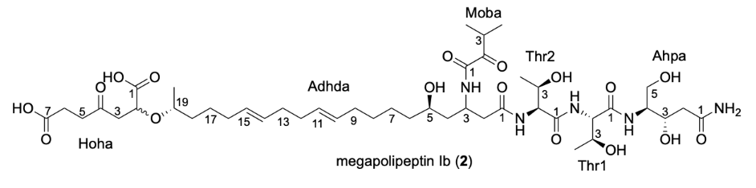
 | no | 2
 | no | δ_{C}, Type | δ_{H} (J in Hz) | △δ_{C}^{b} | △δ_{H}^{c}
Ahpa | 1  2a  2b  3  4  5  1-NH₂  4-NH | 173.4, C  39.9, CH₂  67.5, CH  55.1, CH  60.4, CH₂ | 2.26, dd (2.2, 14.6)  2.08, dd (9.8, 14.6)  3.85, mª  3.64, m  3.49, d (4.7)  7.18, s  6.76, s  7.55, d (9.1) | 0  0  0  0  0 | 0  0  0  0  0  ﹣0.01  0  ﹣0.03
Thr1 | 1  2  3  4  2-NH | 169.8, C  58.6, CH  67.1, CH  19.7, CH₃ | 4.21, mª  3.84, mª  1.05, d (6.4)  7.77, d (8.3) | 0  0  0  + 0.1 | 0  0  + 0.01  ﹣0.09
Thr2 | 1  2  3  4  2-NH | 169.8, C  57.6, CH  66.9, CH  19.2, CH₃ | 4.33, dd (4.3, 8.7)  3.93, m  0.95, d (6.1)  7.80, d (8.6) | ﹣0.1  0  + 0.1  0 | + 0.01  0  ﹣0.01  ﹣0.13
Adhda | 1  2a  2b  3  4  5  6a  6b  7  8a  8b  9  10  11  12  13  14  15  16  17  18a  18b  19  20  3-NH | 170.4, C  39.2, CH₂  44.4, CH  41.8, CH₂  66.6, CH  36.8, CH₂  29.2, CH₂  24.5, CH₂  32.1, CH₂  130.3, CH  129.7, CH  32.2, CH₂  32.2, CH₂  129.4, CH  130.2, CH  32.1, CH₂  24.7, CH₂  34.9, CH₂  75.2, CH  20.1, CH₃ | 2.55, dd (7.2, 13.9)  2.36, mª  4.21, mª  1.51, m  3.39, m  1.39, m  1.21, mª  1.25, mª  1.35, mª  1.25, mª  1.91, mª  5.37, mª  5.37, mª  1.99, mª  1.99, mª  5.37, mª  5.37, mª  1.91, mª  1.25, mª  1.41, mª  1.25, mª  3.45, m  1.04, d (6.4)  8.47, d (8.8) | ﹣0.1  ﹣0.1  0  0  0  0  0  + 0.2  0  0  + 0.1  + 0.1  + 0.1  0  0  + 0.1  0  + 0.1  + 0.1  ﹣0.2 | ﹣0.01  0  0  0  0  + 0.02  ﹣0.02  0  + 0.02  + 0.02  0  + 0.01  + 0.02  0  0  + 0.02  + 0.01  + 0.01  + 0.02  ﹣0.01  ﹣0.01  0  0  ﹣0.02
Hoha | 1  2  3  4  5a  5b  6  7  1/7-COOH | 173.7, C  72.6, CH  45.1, CH₂  205.9, C  37.5, CH₂  27.5, CH₂  173.6, C | 4.18, m  2.73, mª  2.71, m  2.64, m  2.38, m  12.27, brs | ﹣0.3  ﹣0.3  ﹣0.2  ﹣0.3  + 0.1  ﹣0.2 | + 0.03  + 0.01  0  ﹣0.02  0
Moba | 1  2  3  4  5 | 159.8  202.3, C  33.9, CH  17.5, CH₃  17.4, CH₃ | 3.39, mª  1.02, d (6.6)  1.00, d (6.7) | 0  ﹣0.1  0  0  + 0.1 | 0  + 0.01  ﹣0.01
ª overlapped
^{b}△δ_{C} = δ_{C (2)}-δ_{C(megapolipeptin A}¹₎
^{c}△δ_{H} = δ_{H (2)}-δ_{H (megapolipeptin A}¹₎

Supplementary Table 7. ¹H (600 MHz) and ¹³C (150 MHz) NMR Data of 3 in DMSO-d₆

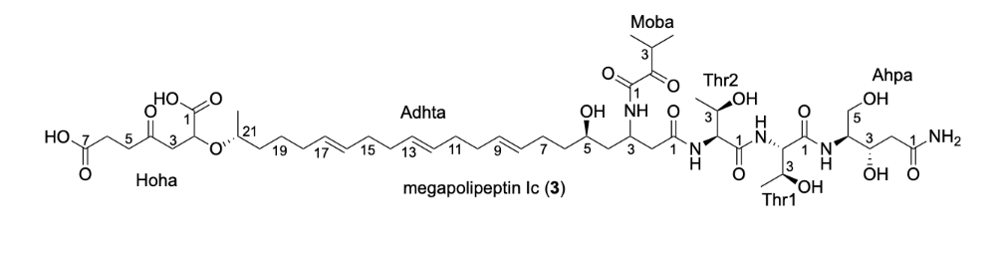
 | no | 3
 | no | δ_{C}, Type | δ_{H} (J in Hz) | △δ_{C}^{b} | △δ_{H}^{c}
Ahpa | 1  2a  2b  3  4  5  1-NH₂  3-OH  4-NH  5-OH | 173.5, C  39.9, CH₂  67.5, CH  55.1, CH  60.4, CH₂ | 2.27, dd (2.8, 14.8)  2.08, dd (9.7, 14.8)  3.86, m  3.65, m  3.49, d (4.7)  7.18, s  6.77, s  4.81, brs  7.55, d (9.0)  4.46, brs | ﹢0.1  0  0  0  0 | + 0.01  0  + 0.01  + 0.01  + 0.01  ﹣0.02  + 0.02  ﹣0.07
Thr1 | 1  2  3  4  2-NH  3-OH | 169.8, C  58.6, CH  67.1, CH  19.7, CH₃ | 4.22, dd (6.7, 8.4)  3.85, m  1.05, d (6.4)  7.77, d (8.4)  4.88, brs | 0  0  0  + 0.1 | + 0.01  + 0.01  0  ﹣0.08
Thr2 | 1  2  3  4  2-NH  3-OH | 169.9, C  57.6, CH  66.6, CH  19.2, CH₃ | 4.33, dd (4.0, 8.4)  3.93, m  0.95, d (6.3)  7.80, d (8.4)  4.98, brs | 0  ﹣0.2  ﹣0.2  0 | + 0.02  0  0  ﹣0.24
Adhta | 1  2a  2b  3  4  5  6a  6b  7a  7b  8  9  10  11  12  13  14  15  16  17  18  19  20a  20b  21  22  3-NH  5-OH | 170.5, C  39.4, CH₂  44.4, CH  41.7, CH₂  66.6, CH  36.8, CH₂  28.2, CH₂  130.4, CH  129.8, CH  32.2, CH₂  32.2, CH₂  129.7, CH  129.2, CH  32.2, CH₂  32.2, CH₂  129.7, CH  130.2, CH  32.0, CH₂  24.6, CH₂  34.9, CH₂  75.3, CH  20.2, CH₃ | 2.54, dd (7.4, 14.1)  2.36, dd (5.8, 14.1)  4.21, mª  1.52, m  3.39, m  1.42, m  1.30, m  2.03, m  1.91, m  5.36, mª  5.36, mª  1.99, mª  1.99, mª  5.36, mª  5.36, mª  1.99, mª  1.99, mª  5.36, mª  5.36, mª  1.90, mª  1.23, mª  1.42, mª  1.25, m  3.44, m  1.04, d (6.2)  8.46, d (9.0)  4.40, brs | 0  ﹢0.1  0  ﹣0.1  + 0.1  0  0  + 0.1  0  + 0.1  + 0.1  + 0.2  + 0.1  + 0.1  + 0.1  0  0  0  0  + 0.1  + 0.2  ﹣0.1 | ﹣0.02  0  0  0  0  0  0  0  ﹣0.01  0  0  0  0  0  0  0  0  0  0  ﹣0.01  0  0  0  ﹣0.02  0  ﹣0.03
Hoha | 1  2  3a  3b  4  5a  5b  6  7  1/7-COOH | 173.7, C  72.6, CH  45.1, CH₂  206.0, C  37.5, CH₂  27.6, CH₂  173.6, C | 4.19, m  2.78, dd (8.1, 16.5)  2.72, dd (4.3, 16.5)  2.69, m  2.63, m  2.38, m  12.32, brs | ﹣0.8  ﹣0.9  ﹣0.2  ﹣0.3  ﹣0.1  0  ﹣0.2 | + 0.06  + 0.06  0  ﹣0.02  ﹣0.03  + 0.01
Moba | 1  2  3  4  5 | 159.9, C  202.4, C  34.0, CH  17.5, CH₃  17.4, CH₃ | 3.39, mª  1.02, d (7.3)  1.00, d (7.2) | + 0.1  + 0.1  ﹣0.1  0  + 0.1 | 0  + 0.01  ﹣0.01
ª overlapped
^{b}△δ_{C} = δ_{C (3)}-δ_{C(megapolipeptin B}¹₎
^{c}△δ_{H} = δ_{H (3)}-δ_{H (megapolipeptin B}¹₎

Supplementary Table 8. ¹H (500 MHz) and ¹³C (125 MHz) NMR Data of 4, 5 in DMSO-d₆
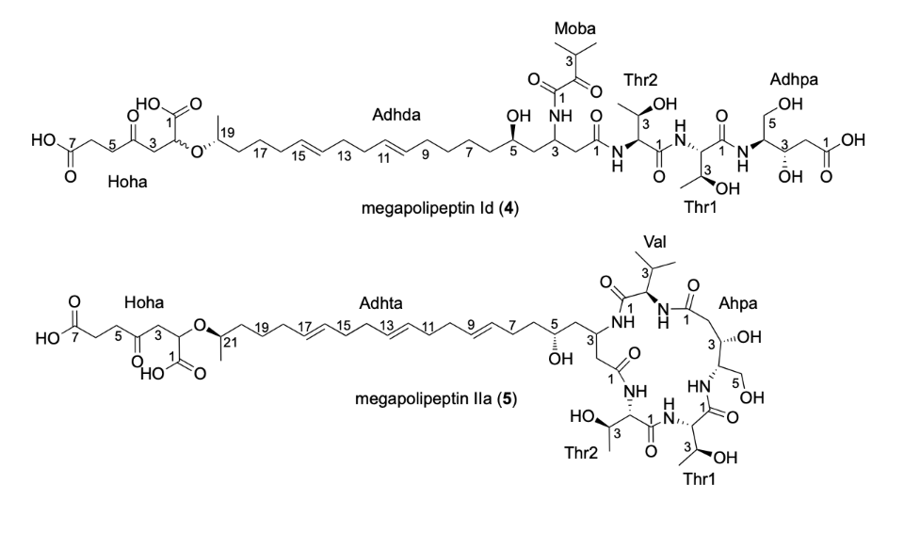
 | no | 4 |  | 5
 | no | δ_{C}, Type | δ_{H} (J in Hz) | δ_{C}, Type | δ_{H} (J in Hz)
Adhpa | 1  2a  2b  3  4  5  1-COOH  4-NH | 173.3, C  39.2, CH₂  67.3, CH  55.0, CH  60.3, CH₂ | 2.52, mª  2.11, dd (10.3, 15.5)  3.87, m  3.66, m  3.48, d (4.5)  12.21, brs  7.57, d (9.0) | 172.5, C  39.6, CH₂  65.2, CH  54.5, CH  60.5, CH₂ | 2.49, mª  2.17, dd (9.5, 16.2)  4.02, m  3.65, m  3.50, mª  7.37, d (9.1)
Thr1 | 1  2  3  4  2-NH | 169.7, C  58.5, CH  67.1, CH  19.7, CH₃ | 4.22, mª  3.81, m  1.05, d (6.5)  7.75, d (8.0) | 169.5, C  60.9, CH  66.5, CH  19.8, CH₃ | 4.09, mª  3.90, m  1.06, d (6.1)  7.79, d (8.1)
Thr2 | 1  2  3  4  2-NH | 169.9, C  57.5, CH  66.5, CH  19.1, CH₃ | 4.33, dd (4.1, 8.5)  3.91, m  0.95, d (6.3)  7.81, d (8.5) | 170.2, C  59.4, CH  66.2, CH  20.1, CH₃ | 4.04, dd (2.1, 6.6)  4.25, m  1.09, d (6.3)  7.67, d (6.6)
Adhda/  Adhta | 1  2a  2b  3  4  5  6a  6b  7a  7b  8a  8b  9  10  11  12  13  14  15  16  17  18a  18b  19  20a  20b  21  22  3-NH | 170.4, C  39.2, CH₂  44.4, CH  41.8, CH₂  66.9, CH  36.7, CH₂  29.2, CH₂  24.5, CH₂  32.0, CH₂  130.3, CH  129.7, CH  32.2, CH₂  32.2, CH₂  129.4, CH  130.1, CH  32.1, CH₂  24.7, CH₂  34.9, CH₂  75.2, CH  20.1, CH₃ | 2.55, dd (7.3, 14.1)  2.35, mª  4.21, mª  1.51, m  3.38, mª  1.37, mª  1.22, mª  1.27, mª  1.34, mª  1.25, mª  1.91, mª  5.37, mª  5.37, mª  1.99, mª  1.99, mª  5.37, mª  5.37, mª  1.91, mª  1.25, mª  1.41, mª  1.27, mª  3.44, m  1.04, d (6.5)  8.47, d (9.0) | 172.9, C  37.6, CH₂  43.5, CH  40.8, CH₂  66.8, CH  37.1, CH₂  28.4, CH₂  130.3, CH  129.1, CH  32.2, CH₂  32.2, CH₂  129.8, CH  129.7, CH  32.1, CH₂  32.1, CH₂  129.6, CH  130.2, CH  32.0, CH₂  24.5, CH₂  34.9, CH₂  75.2, CH  20.3, CH₃ | 2.61, dd (4.1, 15.0)  2.31, dd (3.6, 15.0)  4.09, mª  1.41, m  3.45, mª  1.38, mª  1.28, mª  1.98, mª  1.90, mª  5.36, mª  5.36, mª  1.98, mª  1.98, mª  5.36, mª  5.36, mª  1.98, mª  1.98, mª  5.36, mª  5.36, mª  1.90, mª  1.25, mª  1.41, mª  1.25, mª  3.46, mª  1.04, d (6.2)  7.85, d (9.0)
Hoha | 1  2  3a  3b  4  5a  5b  6  7  1/7-COOH | 173.7, C  72.5, CH  45.1, CH₂  205.9, C  37.5, CH₂  27.5, CH₂  173.6, C | 4.20, m  2.78, m  2.73, m  2.69, m  2.64, m  2.38, t (6.7) | 173.7, C  72.6, CH  45.1, CH₂  205.9, C  37.5, CH₂  27.5, CH₂  173.6, C | 4.20, dd (4.7, 7.9)  2.79, dd (7.9, 16.4)  2.73, dd (4.7, 16.4)  2.69, m  2.63, m  2.38, mª  12.26, brs
Moba/  Val | 1  2  3  4  5 | 159.8, C  202.3, C  33.9, CH  17.5, CH₃  17.3, CH₃ | 3.38, mª  1.02, d (6.7)  1.00, d (6.7) | 170.3, C  60.6, CH  28.8, CH  19.3, CH₃  18.4, CH₃ | 3.80, t (5.9)  1.98, mª  0.87, d (6.4)  0.89, d (6.3)
ª overlapped

Supplementary Table 9. ¹H (600 MHz) and ¹³C (150 MHz) NMR Data of 6, 7 in DMSO-d₆

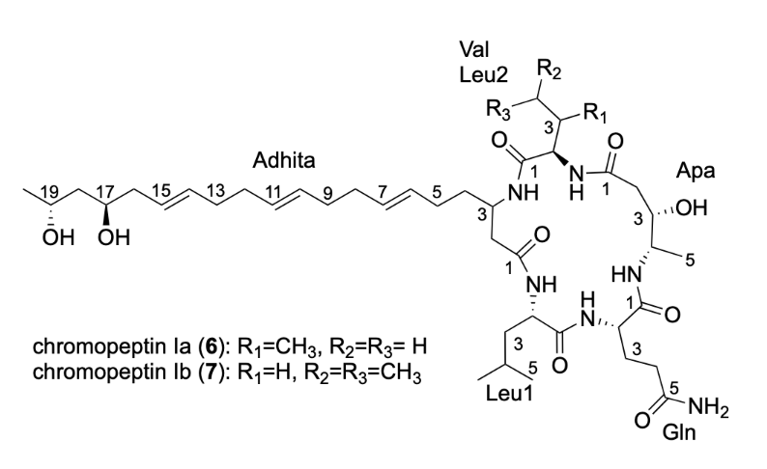
 | no | 6 |  | 7
 | no | δ_{C}, Type | δ_{H} (J in Hz) | δ_{C}, Type | δ_{H} (J in Hz)
Apa | 1  2a  2b  3  4  5  4-NH | 172.0, C  39.8, CH₂  69.4, CH  49.3, CH  17.4, CH₃ | 2.50, mª  2.12, dd (10.0, 16.0)  3.83, m  3.41, m  1.04, d (6.5)  7.42, d (8.0) | 171.7, C  39.9, CH₂  69.4, CH  49.4, CH  17.4, CH₃ | 2.50, mª  2.03, mª  3.82, m  3.40, m  1.03, d (6.4)  7.39, brs
Gln | 1  2  3  4  5  2-NH  5-NH₂ | 171.0, C  54.7, CH  27.3, CH₂  31.5, CH₂  173.4, C | 4.06, m  1.82, m  1.99, mª  7.83, d (8.8)  7.28, s  6.74, s | 171.0, C  54.7, CH  27.2, CH₂  31.5, CH₂  173.5, C | 4.04, m  1.83, m  1.99, mª  7.83, brs  7.28, s  6.74, s
Leu1 | 1  2  3  4  5  6  2-NH | 171.8, C  52.6, CH  39.4, CH₂  24.3, CH  23.1, CH₃  20.4, CH₃ | 3.97, m  1.52, m  1.71, m  0.91, d (6.5)  0.80, d (6.5)  8.19, d (5.9) | 171.9, C  52.6, CH  39.1, CH₂  24.3, CH  23.2, CH₃  20.3, CH₃ | 3.98, m  1.53, m  1.69, m  0.91, d (6.6)  0.79, d (6.6)  8.18, brs
Adhita | 1  2a  2b  3  4  5  6  7  8  9  10  11  12  13  14  15  16  17  18  19  20  3-NH | 173.1, C  37.4, CH₂  45.7, CH  33.3, CH₂  29.1, CH₂  129.6, CH  129.6, CH  32.1, CH₂  32.1, CH₂  129.8, CH  129.6, CH  32.2, CH₂  32.1, CH₂  127.2, CH  131.2, CH  40.9, CH₂  68.8, CH  45.4, CH₂  64.7, CH  23.7, CH₃ | 2.44, dd (3.3, 14.6)  2.29, dd (3.0, 14.6)  3.89, mª  1.31, m  1.91, m  5.37, mª  5.37, mª  1.99, mª  1.99, mª  5.37, mª  5.37, mª  1.99, mª  1.99, mª  5.42, dt (6.2, 15.4)  5.39, mª  2.04, t (5.9)  3.56, m  1.38, m  3.76, m  1.03, d (6.2)  8.08, d (8.2) | 173.1, C  37.4, CH₂  45.6, CH  33.2, CH₂  29.0, CH₂  129.7, CH  129.7, CH  32.1, CH₂  32.1, CH₂  129.8, CH  129.6, CH  32.2, CH₂  32.1, CH₂  127.2, CH  131.2, CH  40.9, CH₂  68.8, CH  45.4, CH₂  64.7, CH  23.7, CH₃ | 2.44, dd (2.8, 14.8)  2.30, dd (3.4, 14.8)  3.87, m  1.31, m  1.88, m  5.37, mª  5.37, mª  1.99, mª  1.99, mª  5.37, mª  5.37, mª  1.99, mª  1.99, mª  5.42, dt (6.2, 15.4)  5.39, mª  2.01, mª  3.55, m  1.37, m  3.76, m  1.02, d (6.1)  8.12, d (8.5)
Val/Leu2 | 1  2  3  4  5  6  2-NH | 170.4, C  60.7, CH  28.7, CH  19.3, CH₃  18.4, CH₃ | 3.78, t (6.1)  1.99, mª  0.89, d (6.4)  0.90, d (6.4)  8.07, d (6.1) | 171.9, C  53.3, CH  39.9, CH₂  24.4, CH  23.0, CH₃  21.3, CH₃ | 3.94, m  1.42, m  1.66, m  0.88, d (6.6)  0.82, d (6.6)  8.23, d (6.2)
ª overlapped

Supplementary Table 10. ¹H (600 MHz) and ¹³C (150 MHz) NMR Data of 8, 9 in DMSO-d₆

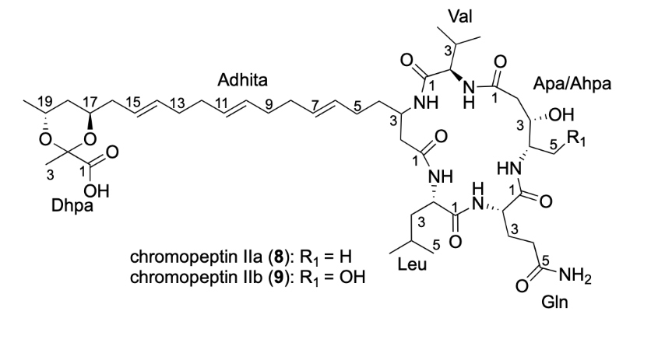
 | no | 8 |  | 9
 | no | δ_{C}, Type | δ_{H} (J in Hz) | δ_{C}, Type | δ_{H} (J in Hz)
Apa/Ahpa | 1  2a  2b  3  4  5a  5b  4-NH | 172.0, C  40.0, CH₂  69.4, CH  49.4, CH  17.4, CH₃ | 2.50, mª  2.11, dd (10.1, 15.8)  3.83, m  3.42, m  1.04, d (6.4)  7.49, brs | 172.6, C  39.7, CH₂  64.8, CH  55.0, CH  60.0, CH₂ | 2.50, mª  2.18, dd (9.7, 16.0)  4.11, m  3.43, m  3.61, m  3.39, m  7.46, d (7.0)
Gln | 1  2  3a  3b  4  5  2-NH  5-NH₂ | 171.0, C  54.7, CH  27.3, CH₂  31.6, CH₂  173.5, C | 4.07, m  1.83, m  2.01, mª  7.95, brs  7.32, s  6.73, s | 171.5, C  55.0, CH  27.6, CH₂  31.8, CH₂  174.2, C | 4.09, m  1.89, m  1.81, m  2.02, mª  8.05, d (8.5)  7.33, s  6.76, s
Leu | 1  2  3  4  5  6  2-NH | 171.9, C  52.6, CH  39.5, CH₂  24.3, CH  23.1, CH₃  20.4, CH₃ | 4.01, m  1.52, mª  1.71, m  0.90, d (6.6)  0.79, d (6.6)  8.24, d (5.0) | 172.4, C  52.7, CH  39.6, CH₂  24.5, CH  23.3, CH₃  20.5, CH₃ | 3.99, m  1.51, mª  1.70, m  0.89, d (6.4)  0.78, d (6.4)  8.16, brs
Adhita | 1  2a  2b  3  4  5  6  7  8  9  10  11  12  13  14  15  16a  16b  17  18a  18b  19  20  3-NH | 173.1, C  37.3, CH₂  45.7, CH  33.3, CH₂  29.2, CH₂  129.6, CH  129.7, CH  32.1, CH₂  32.1, CH₂  129.8, CH  129.6, CH  32.1, CH₂  31.9, CH₂  132.2, CH  125.6, CH  39.1, CH₂  68.6, CH  37.7, CH₂  64.9, CH  21.9, CH₃ | 2.45, dd (2.5, 14.8)  2.29, dd (2.8, 14.8)  3.89, mª  1.33, m  1.91, m  5.36, mª  5.36, mª  2.01, mª  2.01, mª  5.36, mª  5.36, mª  2.01, mª  2.01, mª  5.43, dt (5.3, 15.4)  5.36, mª  2.18, m  2.01, mª  3.89, mª  1.52, m  1.02, m  3.98, m  1.07, d (6.0)  8.07, d (8.5) | 173.3, C  37.8, CH₂  45.9, CH  33.5, CH₂  29.2, CH₂  129.8, CH  129.9, CH  32.3, CH₂  32.3, CH₂  129.9, CH  129.9, CH  32.1, CH₂  31.8, CH₂  132.5, CH  125.6, CH  39.0, CH₂  68.7, CH  37.8, CH₂  65.3, CH  22.0, CH₃ | 2.40, dd (3.0, 14.6)  2.24, dd (3.2, 14.6)  3.89, mª  1.31, m  1.90, m  5.35, mª  5.35, mª  1.97, mª  1.97, mª  5.35, mª  5.35, mª  1.97, mª  1.97, mª  5.42, dt (5.8, 15.4)  5.35, mª  2.16, mª  2.03, mª  3.89, mª  1.53, mª  1.03, m  4.02, m  1.07, d (6.0)  8.10, d (9.2)
Dhpa | 1  2  3 | 172.0, C  97.2, C  17.4, CH₃ | 1.49, s | 170.8, C  97.1, C  17.5, CH₃ | 1.50, s
Val | 1  2  3  4  5  2-NH | 170.4, C  60.7, CH  28.7, CH  19.3, CH₃  18.4, CH₃ | 3.78, t (6.1)  2.01, mª  0.89, d (6.7)  0.90, d (6.7)  8.10, d (6.2) | 170.8, C  60.9, CH  28.8, CH  19.5, CH₃  18.4, CH₃ | 3.79, t (5.9)  2.00, mª  0.88, d (6.8)  0.89, d (6.8)  8.09, d (6.7)
ª overlapped

Supplementary Table 11. ¹H (600 MHz) and ¹³C (150 MHz) NMR Data of 10, 11 in DMSO-d₆

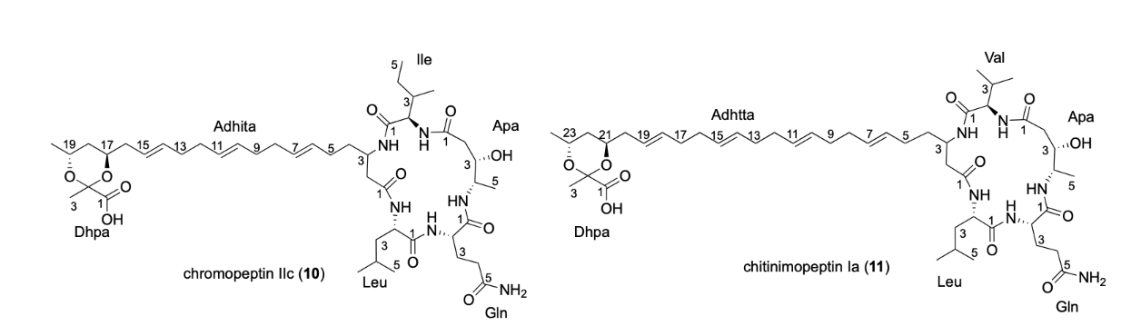
 | no | 10 |  | 11
 | no | δ_{C}, Type | δ_{H} (J in Hz) | δ_{C}, Type | δ_{H} (J in Hz)
Apa | 1  2a  2b  3  4  5  3-OH  4-NH | 172.1, C  40.0, CH₂  69.7, CH  49.5, CH  16.7, CH₃ | 2.50, mª  2.09, dd (10.1, 15.1)  3.86, mª  3.44, m  1.02, d (6.4)  7.70, brs | 172.1, C  40.0, CH₂  69.8, CH  49.6, CH  16.7, CH₃ | 2.47, mª  2.07, dd (10.8, 15.3)  3.88, m  3.41, m  1.02, d (6.3)  4.80, d (5.6)  7.75, d (7.6)
Gln | 1  2  3  4a  4b  5  2-NH  5-NH₂ | 171.2, C  54.7, CH  27.4, CH₂  31.8, CH₂  173.6, C | 4.05, m  1.83, m  2.00, mª  8.31, brs  7.44, s  6.69, s | 171.4, C  54.8, CH  27.7, CH₂  32.0, CH₂  173.9, C | 4.05, m  1.82, m2.11, m  1.94, mª  8.49, d (8.4)  7.59, s  6.65, s
Leu | 1  2  3a  3b  4  5  6  2-NH | 172.0, C  52.8, CH  39.3, CH₂  24.4, CH  23.1, CH₃  20.5, CH₃ | 3.99, mª  1.51, mª  1.70, m  0.90, d (6.5)  0.80, d (6.5)  8.30, d (6.0) | 172.4, C  52.9, CH  39.6, CH₂  24.4, CH  23.2, CH₃  20.6, CH₃ | 4.00, m  1.58, m  1.45, m  1.71, m  0.89, d (6.6)  0.78, d (6.6)  8.78, d (5.6)
Adhita/  Adhtta | 1  2a  2b  3  4a  4b  5  6  7  8  9  10  11  12  13  14  15  16a  16b  17  18a  18b  19  20a  20b  21  22a  22b  23  24  3-NH | 173.0, C  37.0, CH₂  45.9, CH  33.1, CH₂  29.3, CH₂  129.7, CH  129.8, CH  32.0, CH₂  32.0, CH₂  129.9, CH  129.8, CH  31.9, CH₂  31.8, CH₂  132.1, CH  125.7, CH  39.2, CH₂  68.4, CH  38.0, CH₂  64.6, CH  22.0, CH₃ | 2.48, mª  2.34, dd (2.5, 14.6)  3.86, mª  1.31, m  1.91, m  5.35, mª  5.35, mª  2.00, mª  2.00, mª  5.35, mª  5.35, mª  2.00, mª  2.00, mª  5.42, dt (5.5, 15.4)  5.38, dt (6.4, 15.4)  2.21, m  2.00, mª  3.86, mª  1.51, m  0.97, m  3.99, mª  1.07, d (5.9)  8.08, d (8.1) | 173.2, C  36.9, CH₂  45.8, CH  33.1, CH₂  29.2, CH₂  129.8, CH  129.7, CH  32.1, CH₂  32.1, CH₂  129.9, CH  129.8, CH  32.1, CH₂  32.1, CH₂  129.8, CH  129.7, CH  32.0, CH₂  31.9, CH₂  131.8, CH  126.2, CH  39.2, CH₂  68.4, CH  38.1, CH₂  64.6, CH  22.1, CH₃ | 2.47, mª  2.35, dd (2.9, 14.9)  3.82, m  1.39, m  1.29, m  1.91, m  5.36, mª  5.36, mª  1.99, mª  1.99, mª  5.36, mª  5.36, mª  1.99, mª  1.99, mª  5.36, mª  5.36, mª  1.99, mª  1.99, mª  5.42, dt (5.2, 15.5)  5.32, dt (5.0, 15.5)  2.17, m  1.96, mª  3.80, m  1.44, m  0.98, m  3.93, m  1.06, d (6.1)  8.10, d (8.3)
Dhpa | 1  2  3 | 172.7, C  97.8, C  17.5, CH₃ | 1.45, s | 172.7, C  98.1, C  17.6, CH₃ | 1.41, s
Ile/Val | 1  2  3  4a  4b  5  6  2-NH | 170.7, C  58.2, CH  35.0, CH  25.7, CH₂  11.5, CH₃  14.9, CH₃ | 3.99, mª  1.78, m  1.31, mª  1.17, m  0.82, t (7.3)  0.85, d (6.9)  8.07, d (6.5) | 170.6, C  60.9, CH  28.8, CH  19.4, CH₃  18.6, CH₃ | 3.75, t (6.5)  1.94, mª  0.88, d (6.8)  0.89, d (6.8)  8.18, d (6.5)
ª overlapped

Supplementary Table 12. ¹H (600 MHz) and ¹³C (150 MHz) NMR Data of 12, 13 in DMSO-d₆

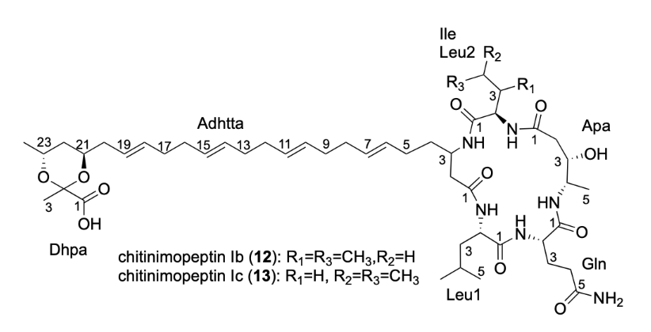
 | no | 12 |  | 13
 | no | δ_{C}, Type | δ_{H} (J in Hz) | δ_{C}, Type | δ_{H} (J in Hz)
Apa | 1  2a  2b  3  4  5  3-OH  4-NH | 172.1, C  40.0, CH₂  69.8, CH  49.6, CH  16.5, CH₃ | 2.47, mª  2.07, dd (9.8, 15.1)  3.89, mª  3.42, m  1.01, d (6.4)  4.81, d (4.1)  7.74, d (7.6) | 171.7, C  39.9, CH₂  69.8, CH  49.6, CH  16.6, CH₃ | 2.47, mª  2.12, dd (6.8, 14.5)  3.89, mª  3.42, m  1.01, d (6.4)  4.81, d (4.1)  7.73, d (7.72)
Gln | 1  2  3  4  5  2-NH  5-NH₂ | 171.3, C  54.8, CH  27.6, CH₂  31.9, CH₂  173.9, C | 4.04, m  1.84, m  1.99, mª  8.55, d (8.3)  7.60, s  6.64, s | 171.3, C  54.7, CH  27.6, CH₂  31.9, CH₂  173.9, C | 4.04, m  1.84, m  1.99, mª  8.52, d (8.3)  7.60, s  6.64, s
Leu1 | 1  2  3a  3b  4  5  6  2-NH | 172.4, C  52.9, CH  39.5, CH₂  24.4, CH  23.2, CH₃  20.6, CH₃ | 4.01, mª  1.59, mª  1.49, m  1.71, m  0.89, d (6.6)  0.79, d (6.5)  8.78, d (5.3) | 172.4, C  52.9, CH  39.5, CH₂  24.4, CH  23.2, CH₃  20.6, CH₃ | 4.01, m  1.59, mª  1.49, m  1.71, m  0.89, d (6.6)  0.79, d (6.5)  8.80, d (5.6)
Adhtta | 1  2a  2b  3  4a  4b  5  6  7  8  9  10  11  12  13  14  15  16  17  18  19  20a  20b  21  22a  22b  23  24  3-NH | 173.1, C  36.7, CH₂  45.9, CH  33.0, CH₂  29.1, CH₂  129.8, CH  129.7, CH  32.0, CH₂  32.1, CH₂  129.8, CH  129.8, CH  31.9, CH₂  31.9, CH₂  129.8, CH  1298, CH  31.9, CH₂  31.9, CH₂  131.8, CH  126.2, CH  39.2, CH₂  68.4, CH  38.1, CH₂  64.5, CH  22.1, CH₃ | 2.47, mª  2.37, mª  3.80, mª  1.37, mª  1.29, mª  1.91, m  5.37, mª  5.37, mª  2.00, mª  2.00, mª  5.37, mª  5.37, mª  2.00, mª  2.00, mª  5.37, mª  5.37, mª  2.00, mª  2.00, mª  5.42, dt (5.6, 15.4)  5.37, mª  2.17, m  2.00, mª  3.82, mª  1.46, mª  0.97, mª  3.93, mª  1.06, d (6.0)  8.16, d (7.3) | 173.1, C  36.9, CH₂  45.7, CH  33.0, CH₂  29.1, CH₂  129.8, CH  129.7, CH  32.0, CH₂  32.1, CH₂  129.8, CH  129.8, CH  31.9, CH₂  31.9, CH₂  129.8, CH  129.8, CH  31.9, CH₂  31.9, CH₂  131.8, CH  126.2, CH  39.2, CH₂  68.4, CH  38.1, CH₂  64.5, CH  22.1, CH₃ | 2.47, mª  2.37, mª  3.80, mª  1.37, mª  1.29, mª  1.91, m  5.37, mª  5., mª  2.00, mª  2.00, mª  5.37, mª  5.37, mª  2.00, mª  2.00, mª  5.37, mª  5.37, mª  2.00, mª  2.00, mª  5.42 dt (5.6, 15.4)  5.37, mª  2.17, m  2.00, mª  3.82, mª  1.46, mª  0.97, mª  3.93, mª  1.06, d (6.0)  8.15, d (8.0)
Dhpa | 1  2  3 | 172.5, C  98.1, C  17.6, CH₃ | 1.42, s | 172.5, C  98.1, C  17.6, CH₃ | 1.42, s
Ile/Leu2 | 1  2  3a  3b  4a  4b  5  6  2-NH | 170.7, C  58.2, CH  35.1, CH  25.8, CH₂  11.6, CH₃  14.9, CH₃ | 3.99, mª  1.78, mª  1.32, mª  1.16, m  0.85, t (6.7)  0.85, d (6.9)  8.12, d (7.0) | 172.0, C  53.5, CH  40.0, CH₂  24.5, CH  23.0, CH₃  21.4, CH₃ | 3.93, m  1.64, m  1.46, mª  1.72, m  0.87, d (6.6)  0.81, d (6.5)  8.34, d (6.4)
ªoverlapped

Supplementary Table 13. Medium used for propagation and fermentation of strains in this study
LB Medium
Tryptone | 10 g L⁻¹
Yeast extract | 5 g L⁻¹
NaCl | 1 g L⁻¹
pH | 7.0
M9 Medium
Glucose | 10 g L⁻¹
K₂HPO₄ | 7 g L⁻¹
KH₂PO₄ | 2 g L⁻¹
(NH₄)₂SO₄ | 1 g L⁻¹
Sodium citrate | 0.5 g L⁻¹
MgSO₄·7H₂O | 0.1 g L⁻¹
CYMG Medium
Casitone | 8 g L⁻¹
Yeast extract | 4 g L⁻¹
MgCl₂·6H₂O | 8.66 g L⁻¹
Glycerol | 5 g L⁻¹
Landy1 Medium
Glucose | 20 g L⁻¹
L-glutamic acid | 5 g L⁻¹
Yeast extract | 1 g L⁻¹
K₂HPO₄ | 1 g L⁻¹
MgSO₄·7H₂O | 1.02 g L⁻¹
KCl | 0.5 g L⁻¹
pH | 7.0
TSB Medium
Casitone | 17 g L⁻¹
NaCl | 5 g L⁻¹
Enzymatic digest of soybean meal | 3 g L⁻¹
K₂HPO₄ | 2.5 g L⁻¹
Glucose | 2.5 g L⁻¹
pH | 7.3
PDB Medium
Potato extract | 6 g L⁻¹
Glucose | 20 g L⁻¹
pH | 7.0

Supplementary Table 14. Retention times of amino acids derivatized with Marfey’s reagent L-FDAA
Aminoacid | Configuration |  | Retention times of hydrolyzed compounds (min)
Aminoacid | Configuration | standard  amino acid | megapolipeptin Ia | megapolipeptin Ib | chromopeptin Ib | chromopeptin Ⅱa | chitinimopeptin Ib/Ic
Leu1 | L | 31.65 |  |  | 31.69 | 31.68 | 31.70
Leu1 | D | 35.10
Gln | L (25 min) | 10.01 |  |  |  |  | 9.98
Gln | D (25 min) | 10.26
Gln | L (45 min) | 21.34 |  |  | 21.37 | 21.34
Gln | D (45 min) | 22.67
Val | L  D | 27.98  31.48 |  |  |  | 31.47
Ile | L | 30.93
Ile | D | 34.60
Ile | L-allo | 31.05
Ile | D-allo | 34.75 |  |  |  |  | 34.78
Leu2 | L | 31.65
Leu2 | D | 35.10 |  |  | 35.05 |  | 35.20
Thr2 | L | 17.90 | 17.89 | 17.91
Thr2 | D | 21.09
Thr2 | L-allo | 18.15
Thr2 | D-allo | 19.49
Thr1 | L | 17.90
Thr1 | D | 21.09
Thr1 | L-allo | 18.15 | 18.15 | 18.15
Thr1 | D-allo | 19.49
* The corresponding MS spectra of above derivatized compounds and standard amino acids were listed in Supplementray Fig. 34, 67, and 81, respectively.

Supplementary Figures
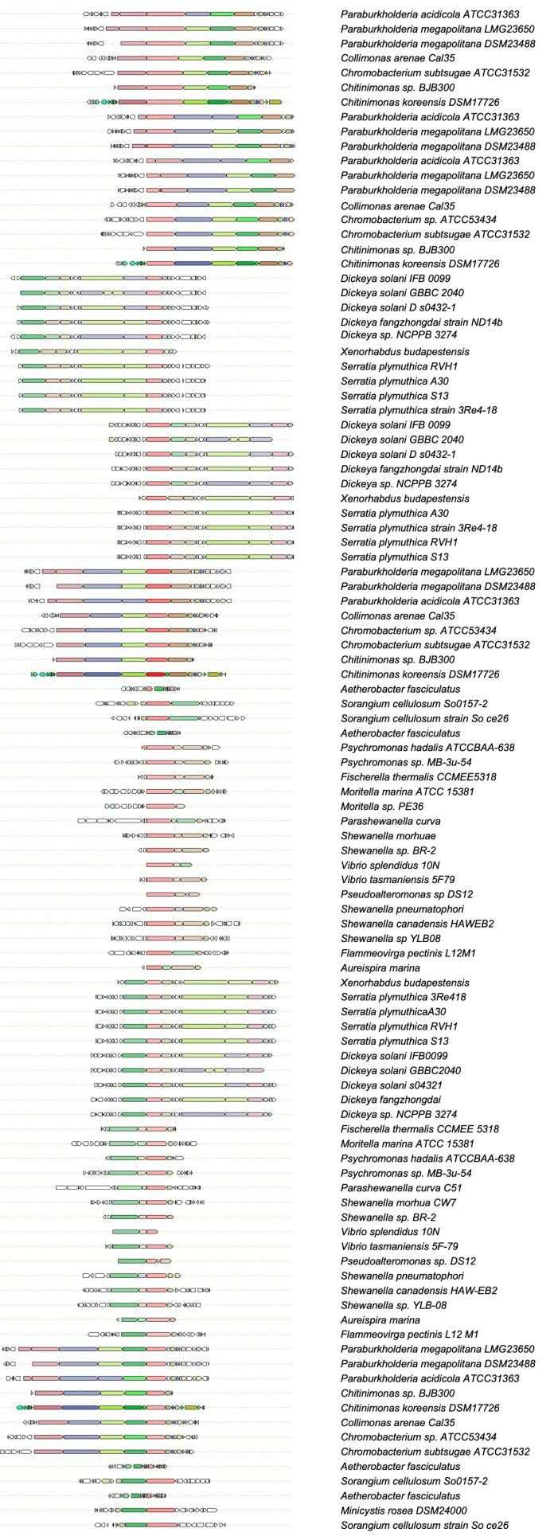

Supplementary Fig 1. BiG SCAPE-CORSON phylogenetic relationship of PUFAS and PUFAS-containing biosynthetic pathways on the basis of PfaA as reference.

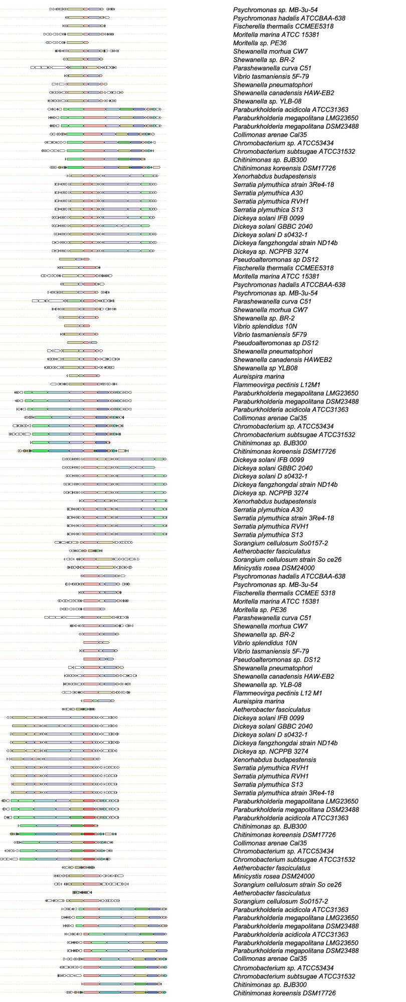
Supplementary Fig 2. BiG SCAPE-CORSON phylogenetic relationship of PUFAS and PUFAS-containing biosynthetic pathways on the basis of PfaBC fusion protein as reference.
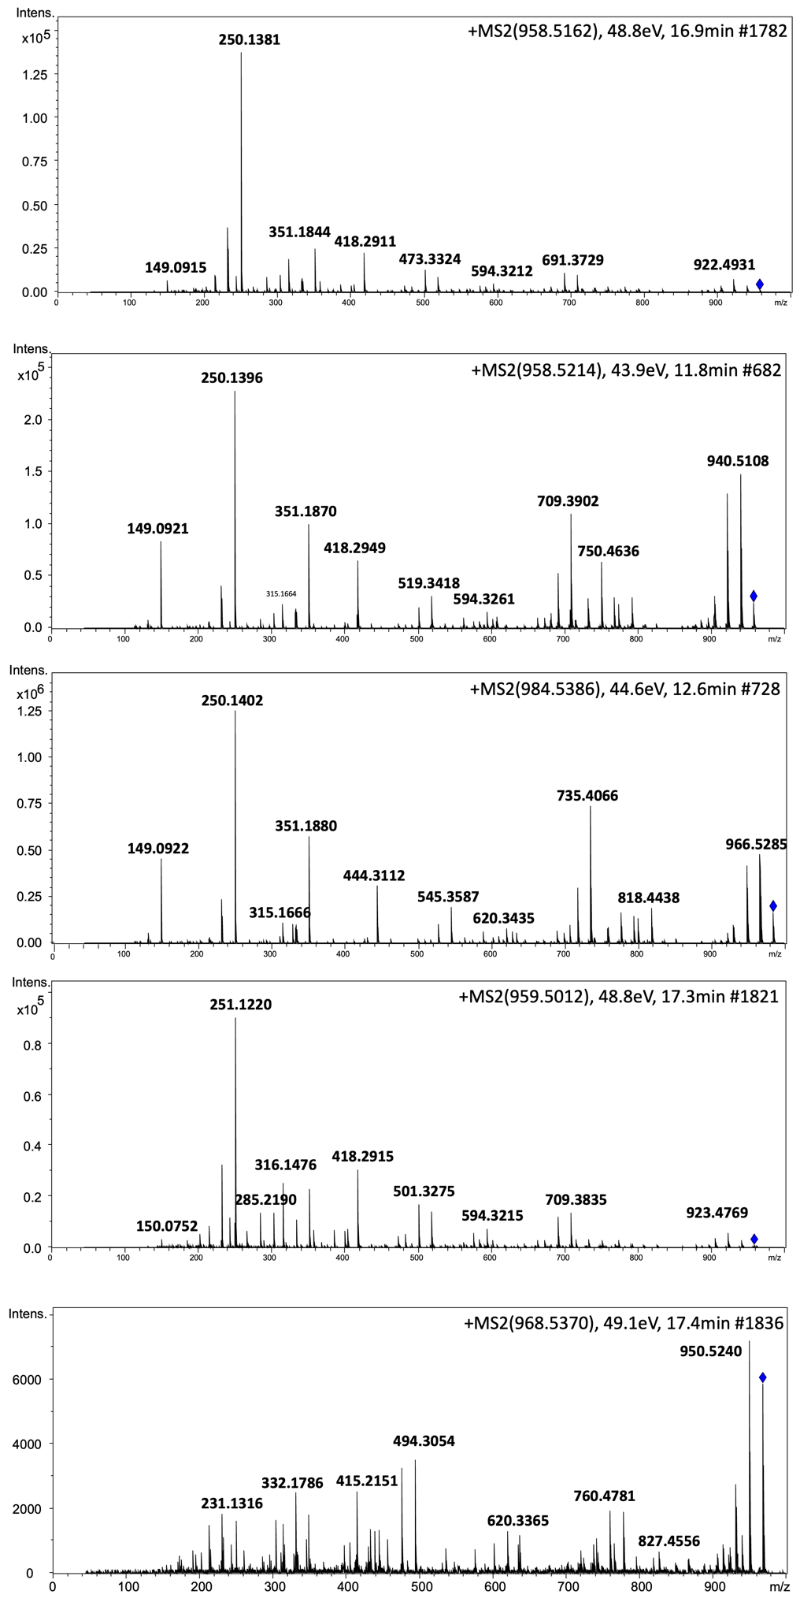
Supplementary Fig 3. HR-ESI-MS spectra of megapolipeptins Ia, Ib, Ic, Id, and Ⅱa (1-5)
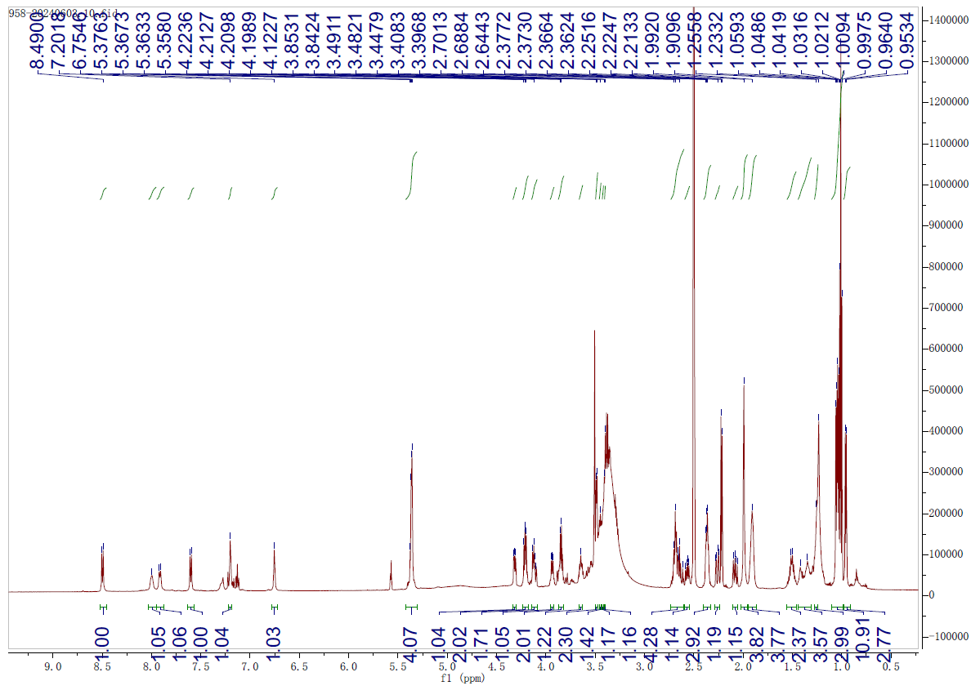

Supplementary Fig 4. ¹H NMR (600 MHz) spectrum of megapolipeptin Ia (1) in DMSO-d₆
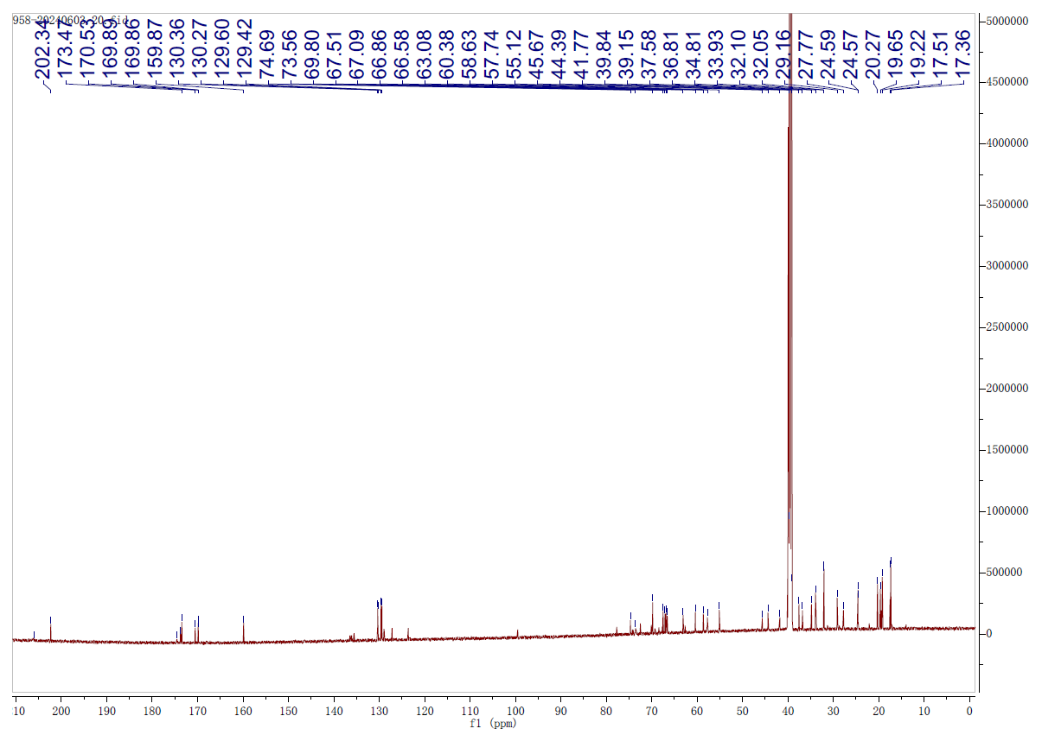

Supplementary Fig 5. ¹³C NMR (150 MHz) spectrum of megapolipeptin Ia (1) in DMSO-d₆

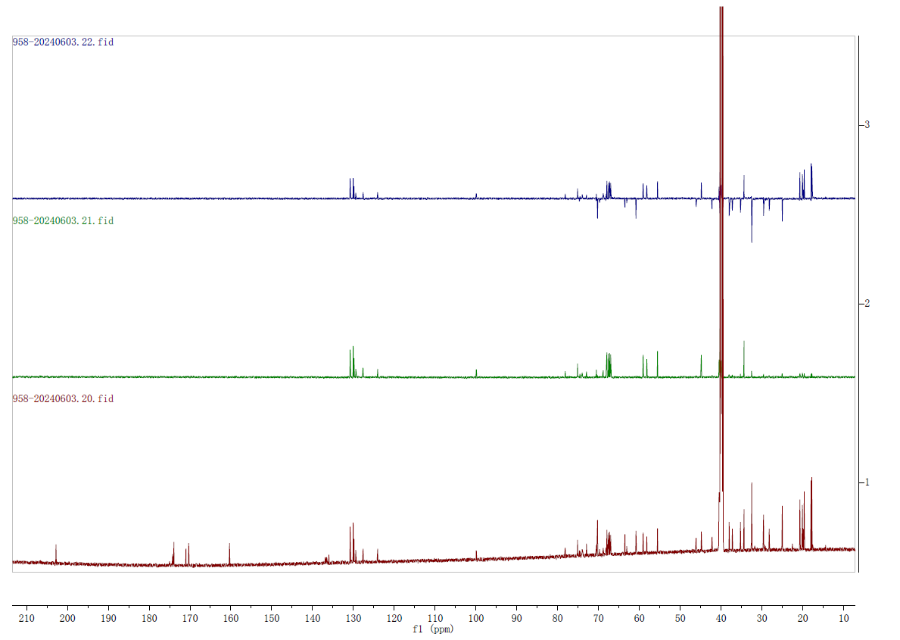
DEPT 90
DEPT 135
¹³C NMR

Supplementary Fig 6. DEPT 90 and DEPT 135 spectra of megapolipeptin Ia (1) in DMSO-d₆
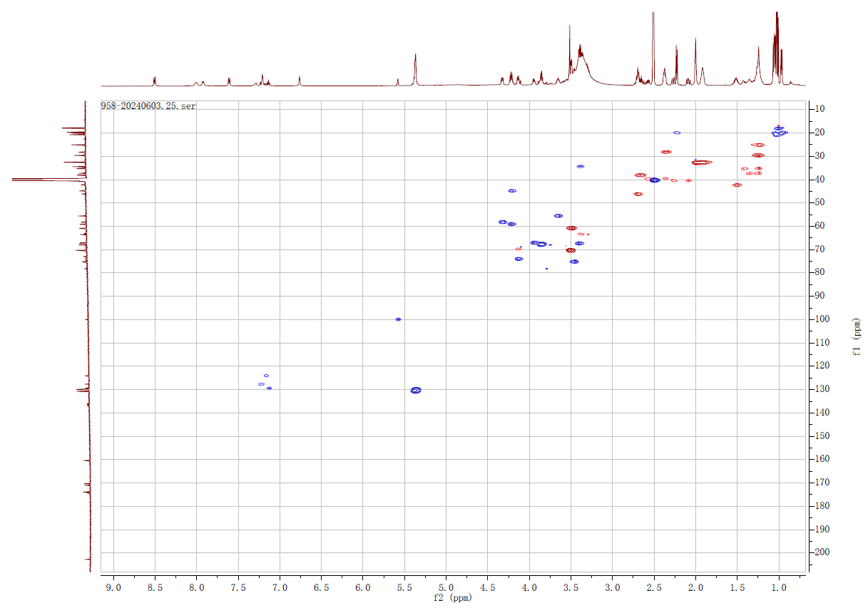

Supplementary Fig 7. HSQC spectrum of megapolipeptin Ia (1) in DMSO-d₆

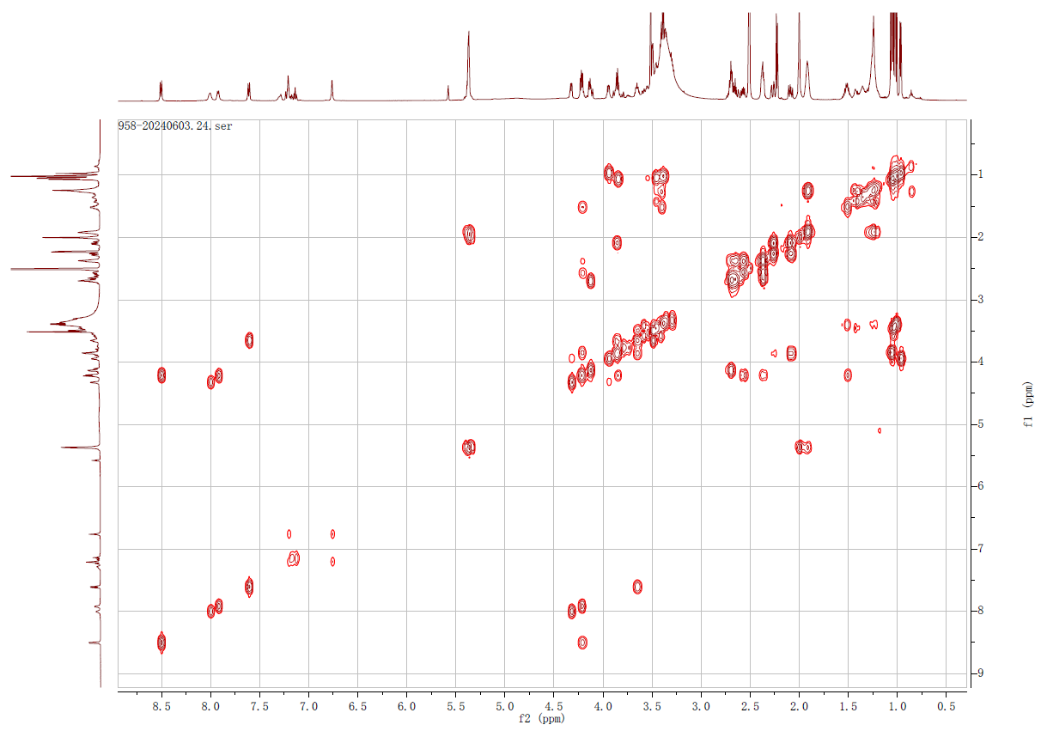

Supplementary Fig 8. ¹H-¹H COSY spectrum of megapolipeptin Ia (1) in DMSO-d₆
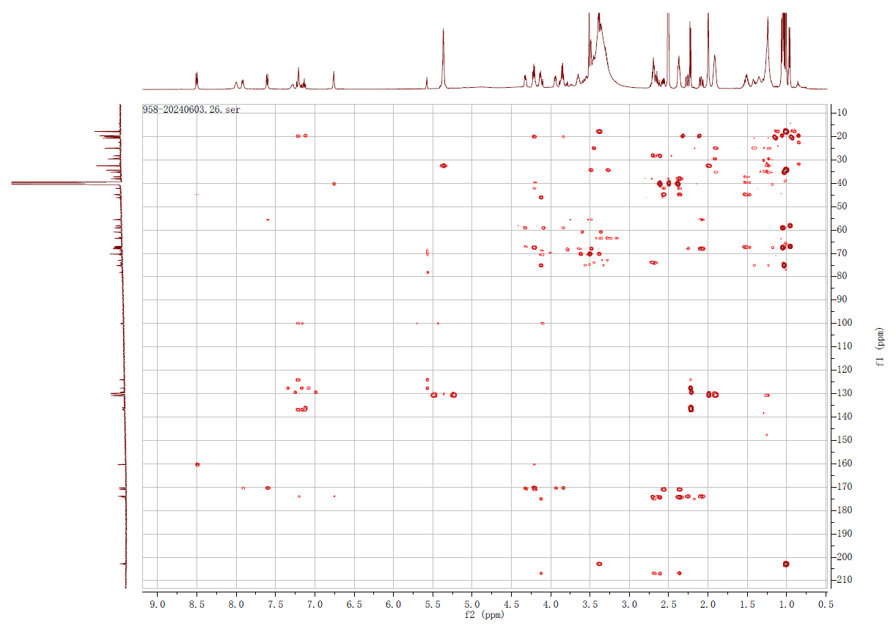

Supplementary Fig 9. HMBC spectrum of megapolipeptin Ia (1) in DMSO-d₆

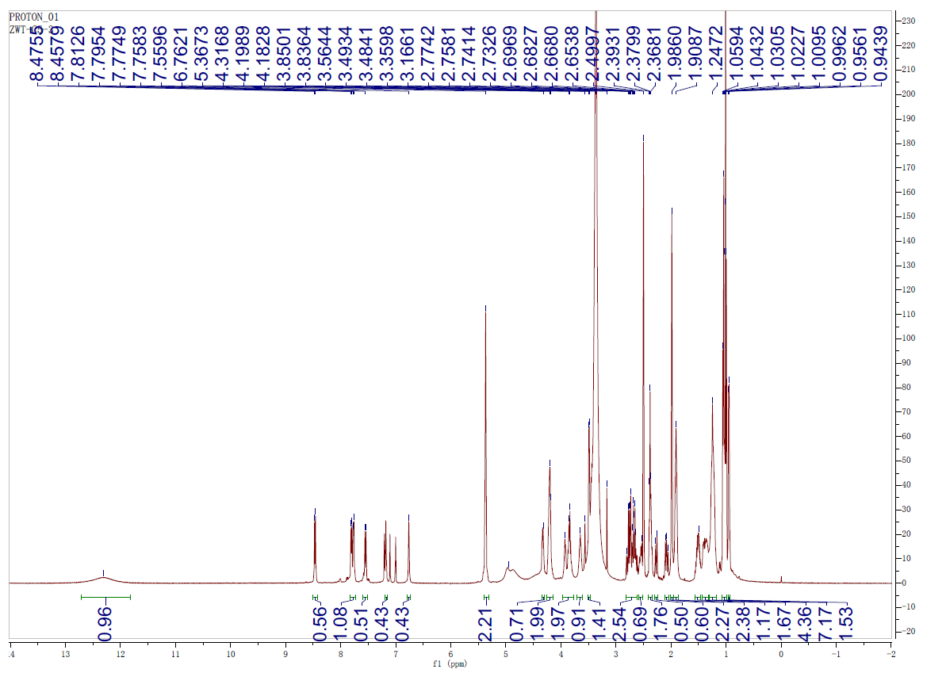

Supplementary Fig 10. ¹H NMR (500 MHz) spectrum of megapolipeptin Ib (2) in DMSO-d₆
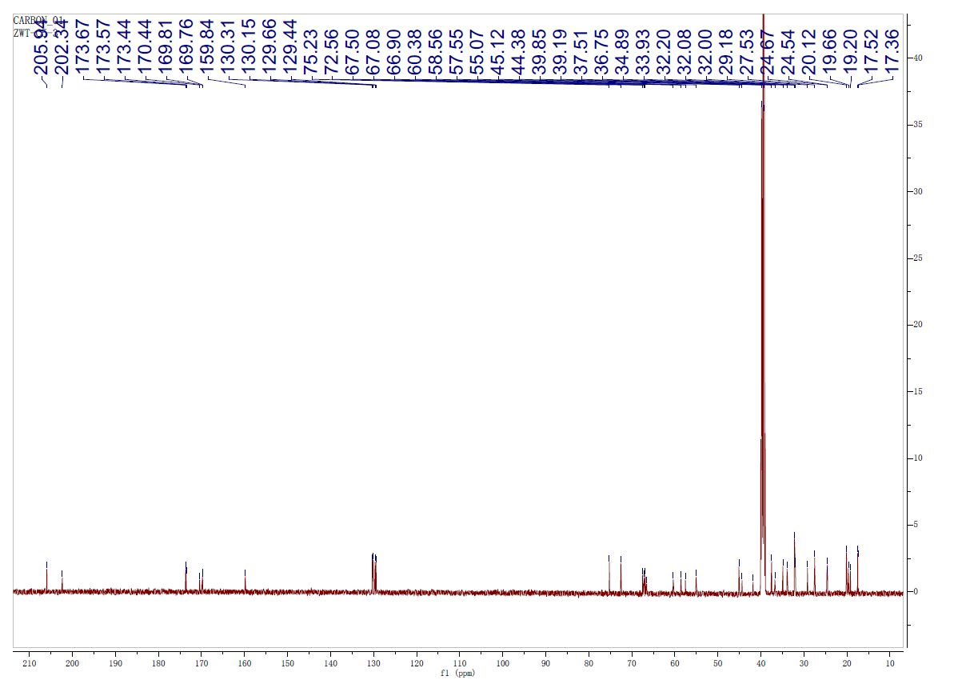

Supplementary Fig 11. ¹³C NMR (125 MHz) spectrum of megapolipeptin Ib (2) in DMSO-d₆

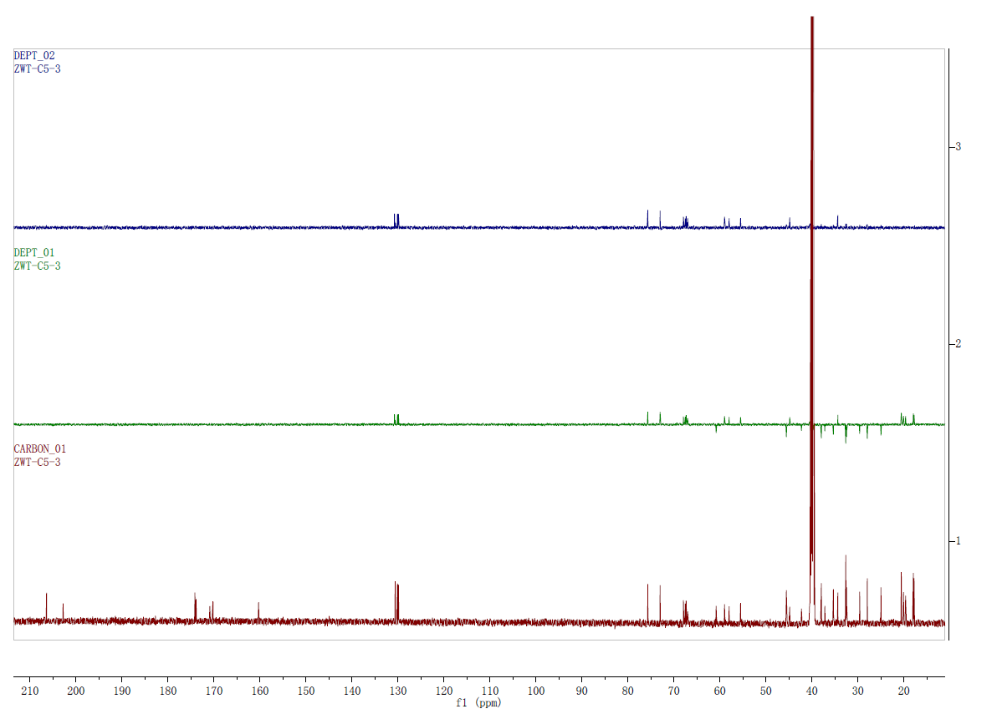
¹³C NMR
DEPT 135
DEPT 90

Supplementary Fig 12. DEPT 90 and DEPT 135 spectra of megapolipeptin Ib (2) in DMSO-d₆
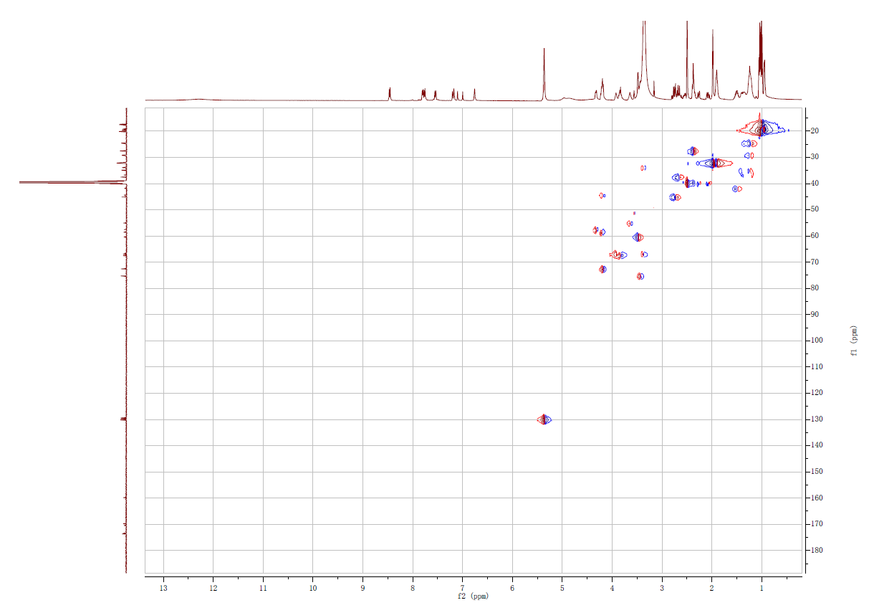

Supplementary Fig 13. HSQC spectrum of megapolipeptin Ib (2) in DMSO-d₆

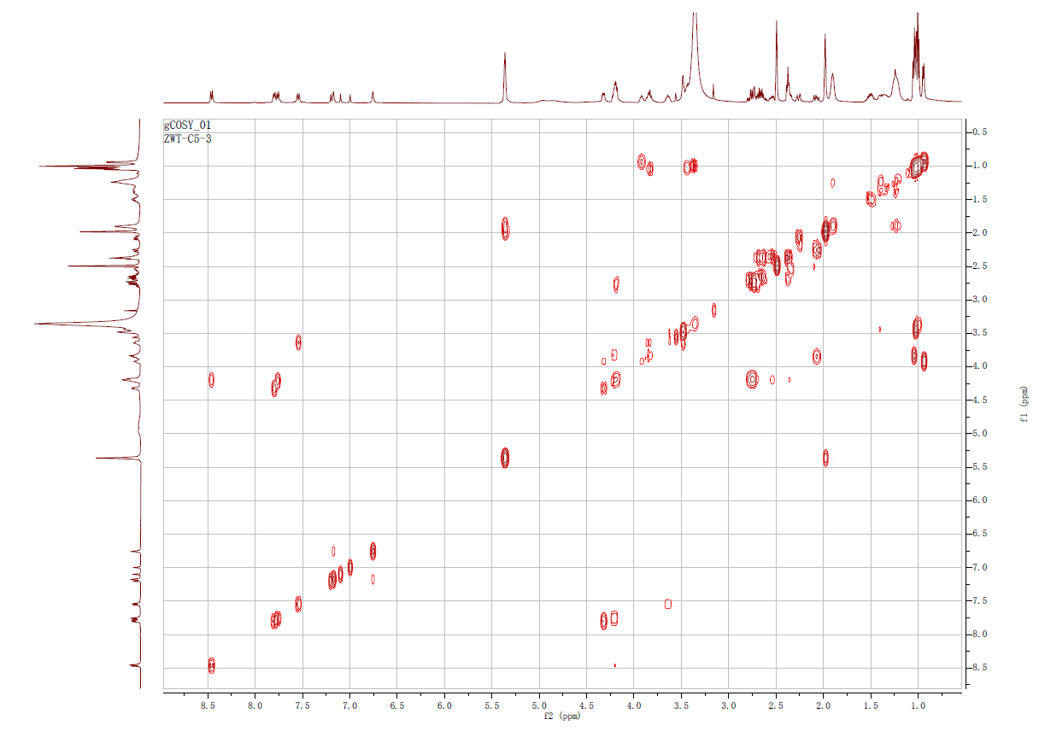

Supplementary Fig 14. ¹H-¹H COSY spectrum of megapolipeptin Ib (2) in DMSO-d₆
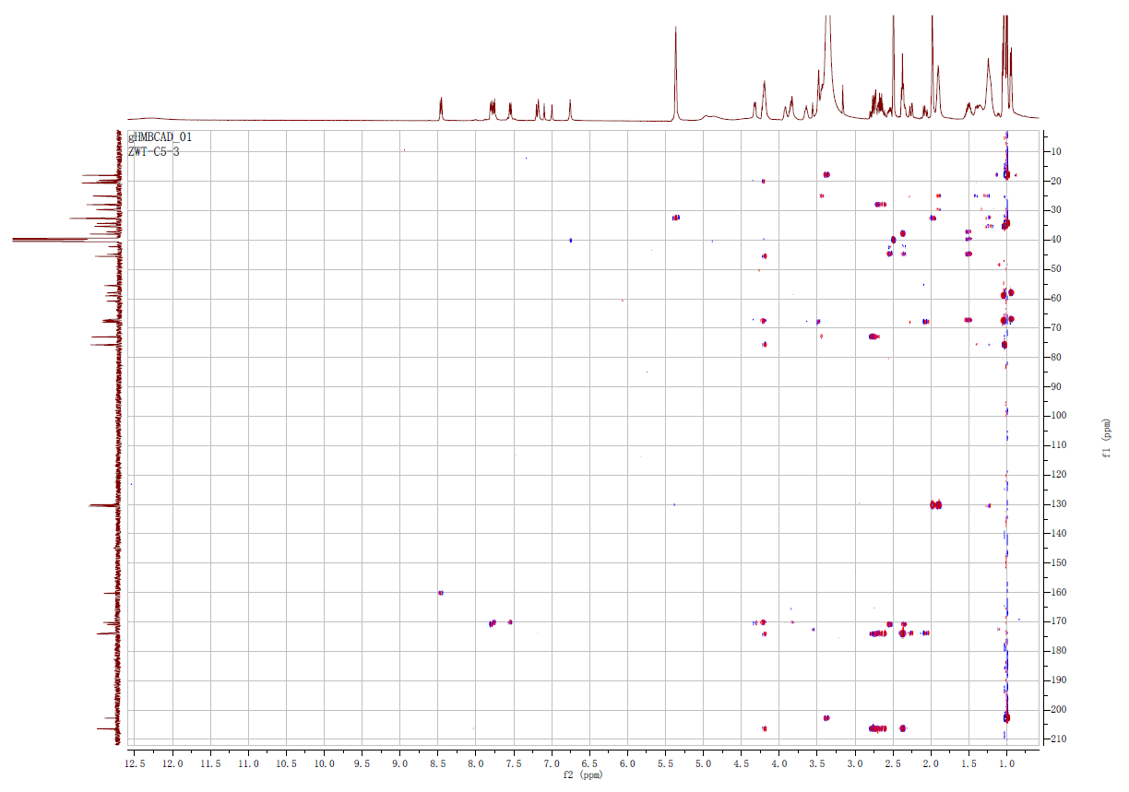

Supplementary Fig 15. HMBC spectrum of megapolipeptin Ib (2) in DMSO-d₆

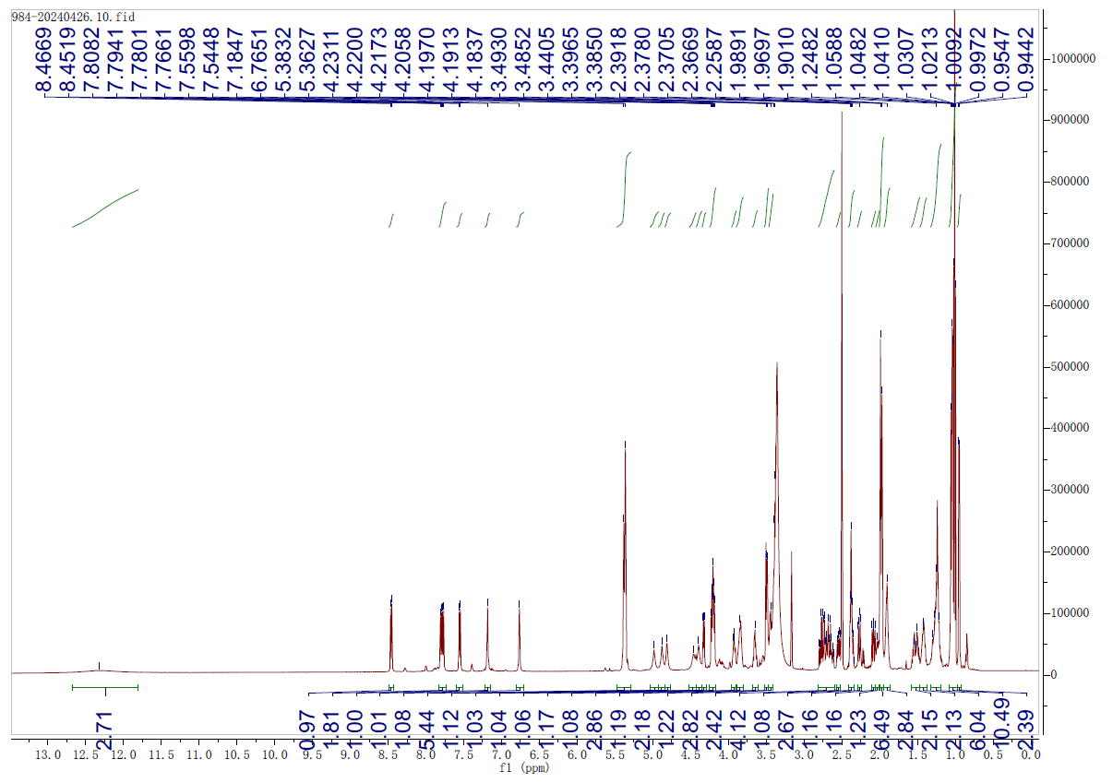

Supplementary Fig 16. ¹H NMR (600 MHz) spectrum of megapolipeptin Ic (3) in DMSO-d₆

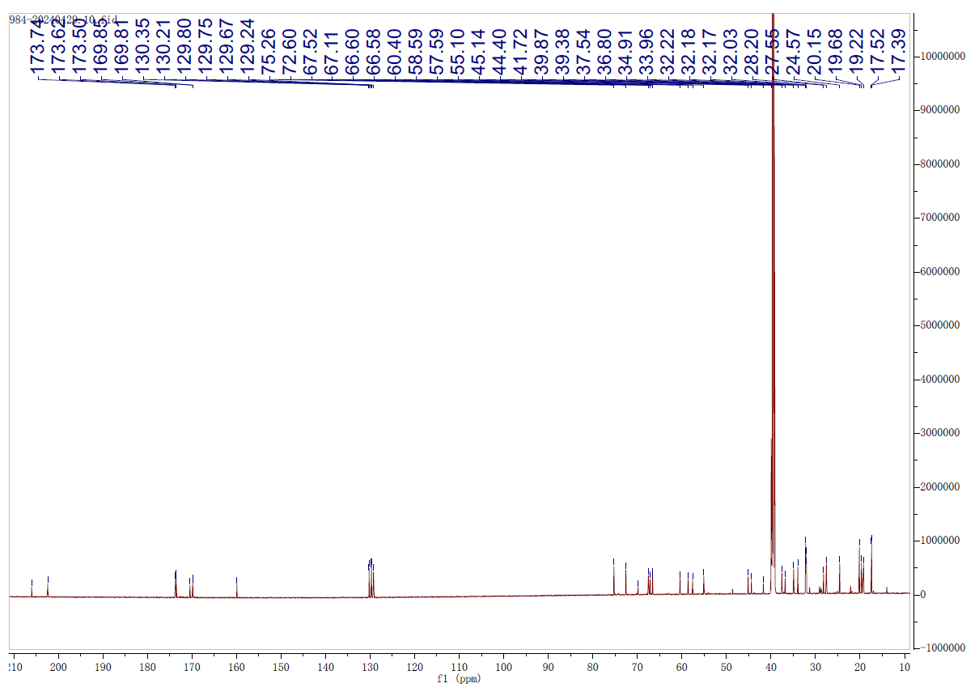

Supplementary Fig 17. ¹³C NMR (150 MHz) spectrum of megapolipeptin Ic (3) in DMSO-d₆

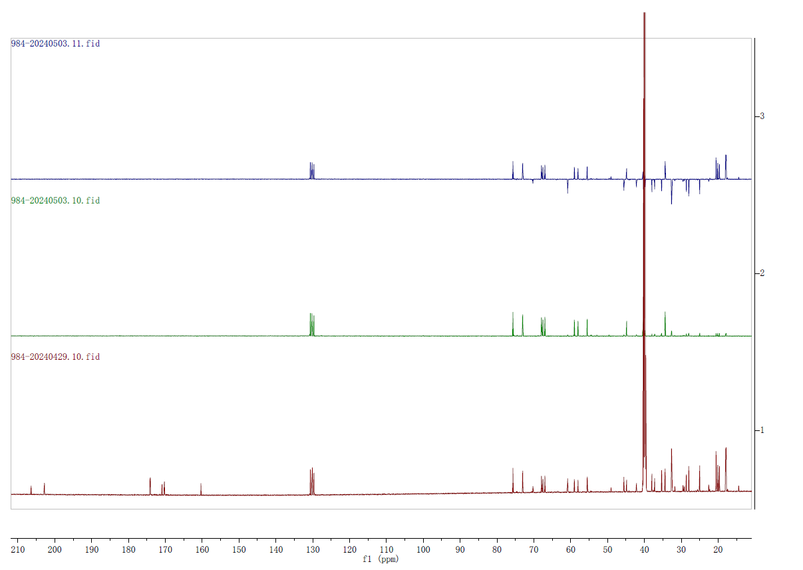
¹³C NMR
DEPT 90
DEPT 135

Supplementary Fig 18. DEPT 90 and DEPT 135 spectra of megapolipeptin Ic (3) in DMSO-d₆
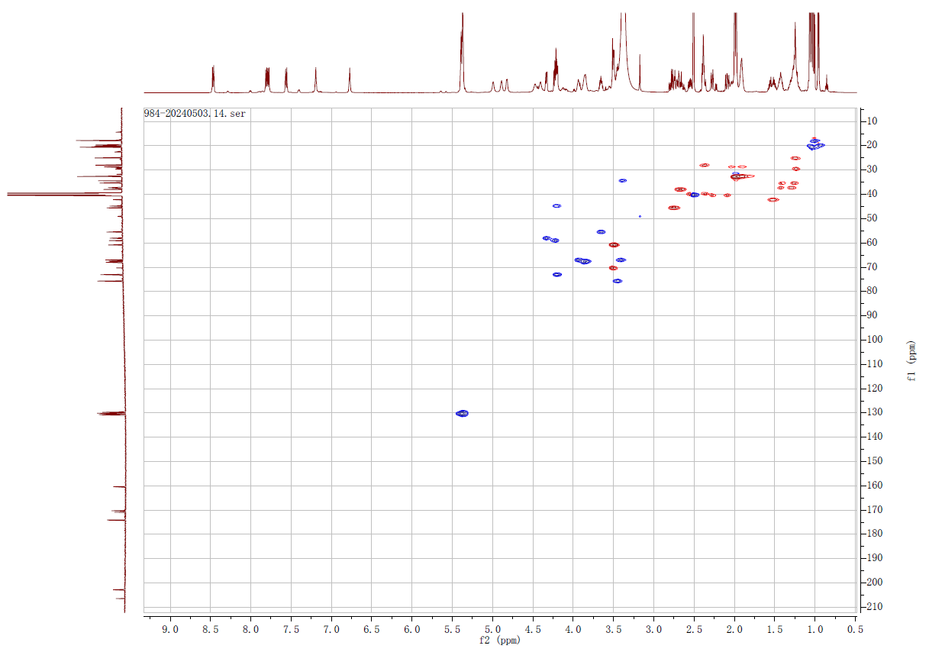

Supplementary Fig 19. HSQC spectrum of megapolipeptin Ic (3) in DMSO-d₆

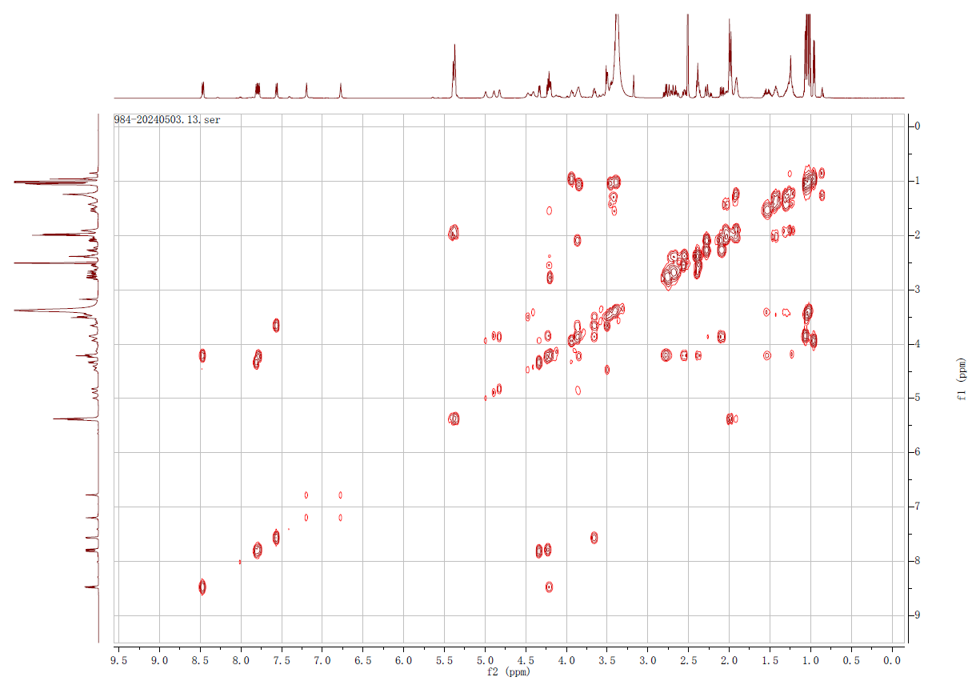

Supplementary Fig 20. ¹H-¹H COSY spectrum of megapolipeptin Ic (3) in DMSO-d₆
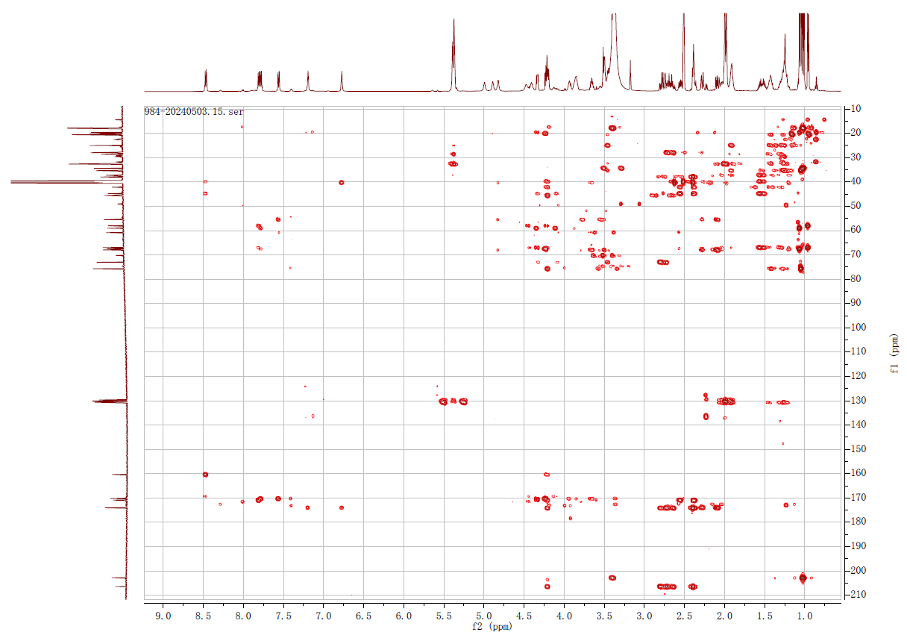

Supplementary Fig 21. HMBC spectrum of megapolipeptin Ic (3) in DMSO-d₆

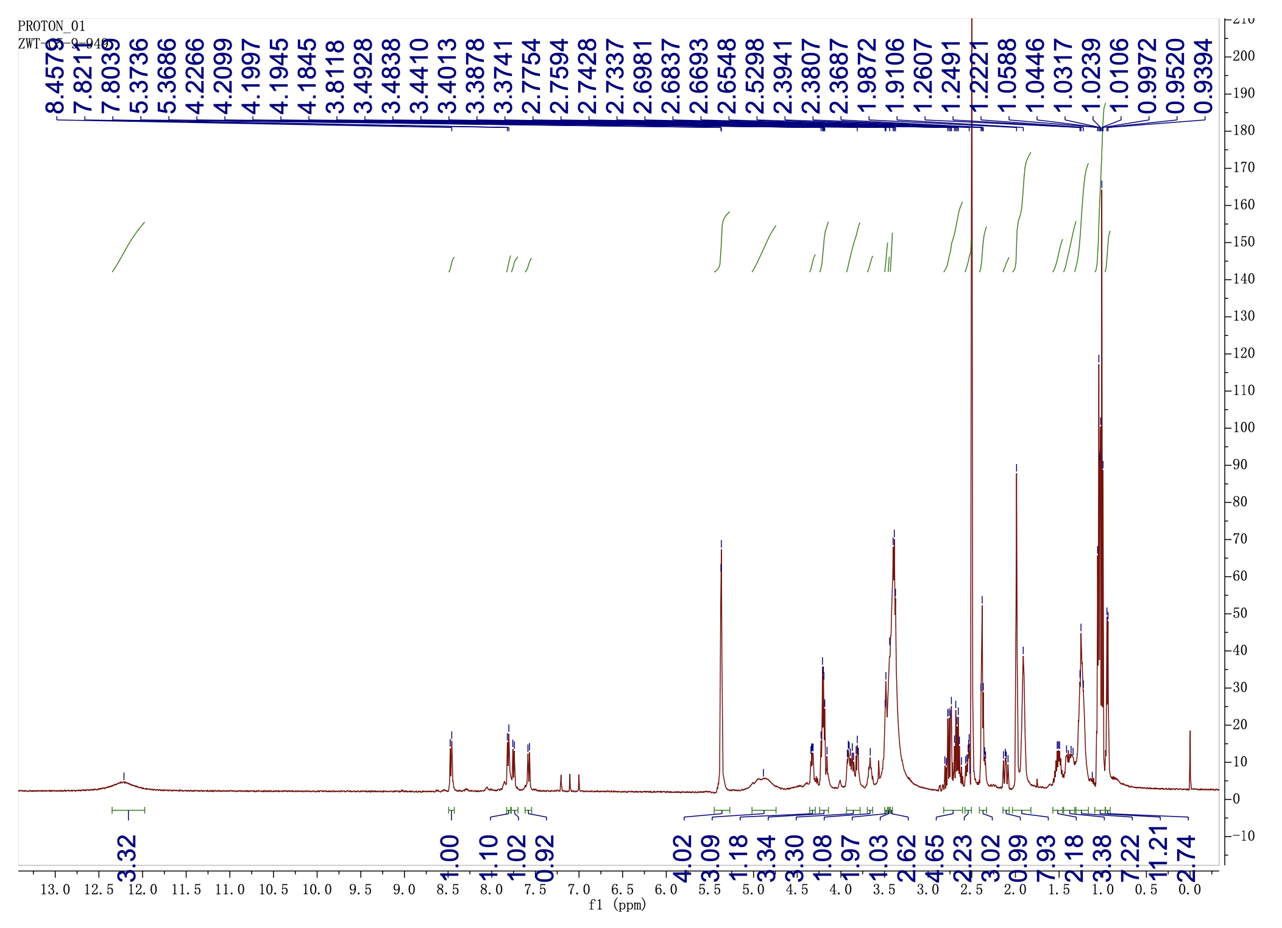

Supplementary Fig 22. ¹H NMR (500 MHz) spectrum of megapolipeptin Id (4) in DMSO-d₆
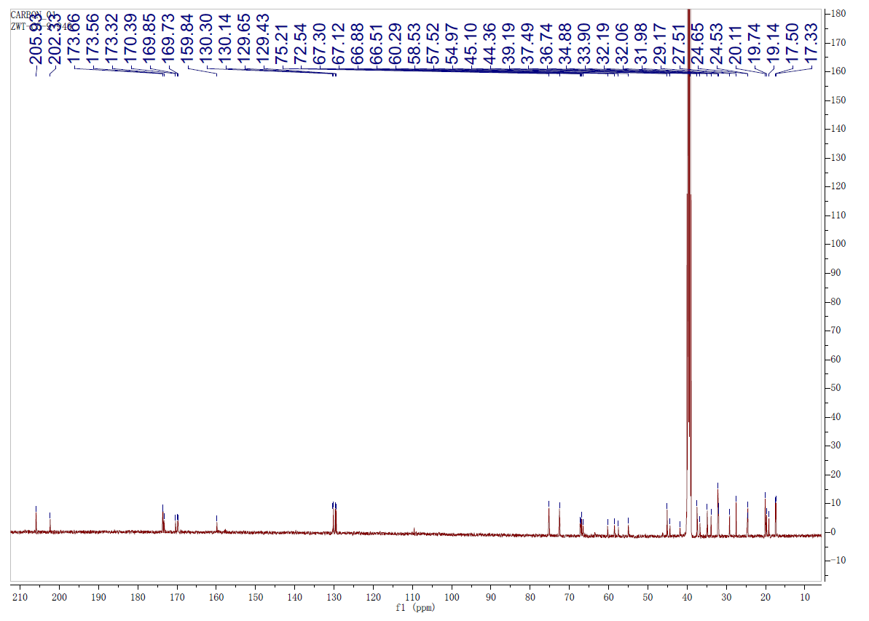

Supplementary Fig 23. ¹³C NMR (125 MHz) spectrum of megapolipeptin Id (4) in DMSO-d₆

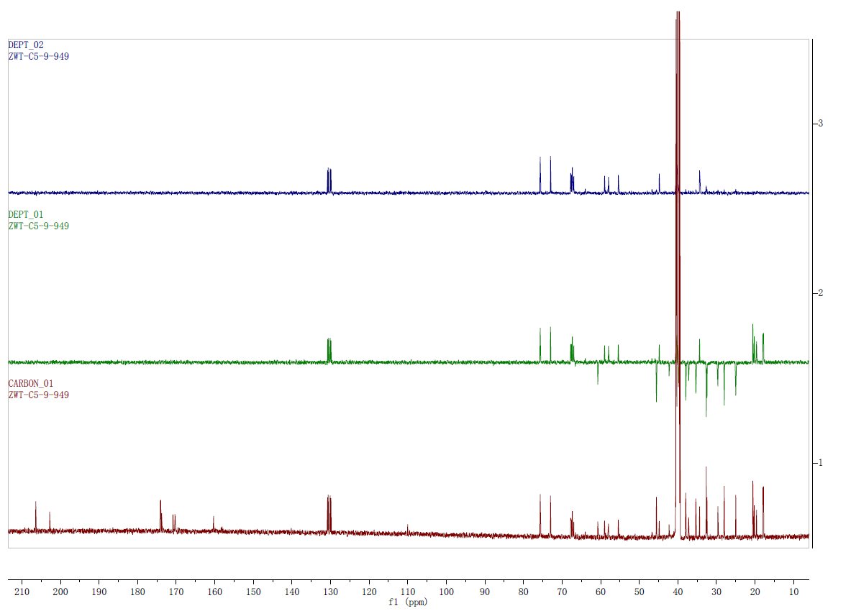
DEPT 135
DEPT 90
¹³C NMR

Supplementary Fig 24. DEPT 90 and DEPT 135 spectra of megapolipeptin Id (4) in DMSO-d₆
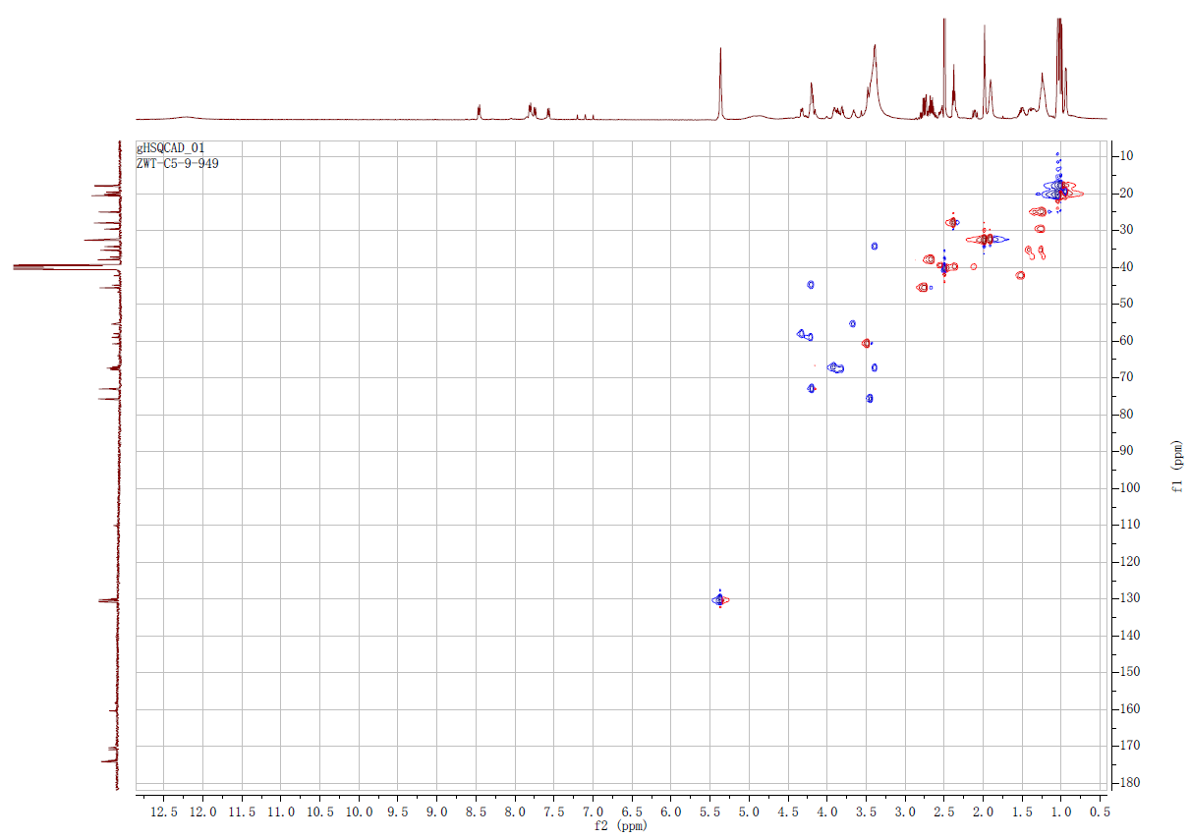

Supplementary Fig 25. HSQC spectrum of megapolipeptin Id (4) in DMSO-d₆

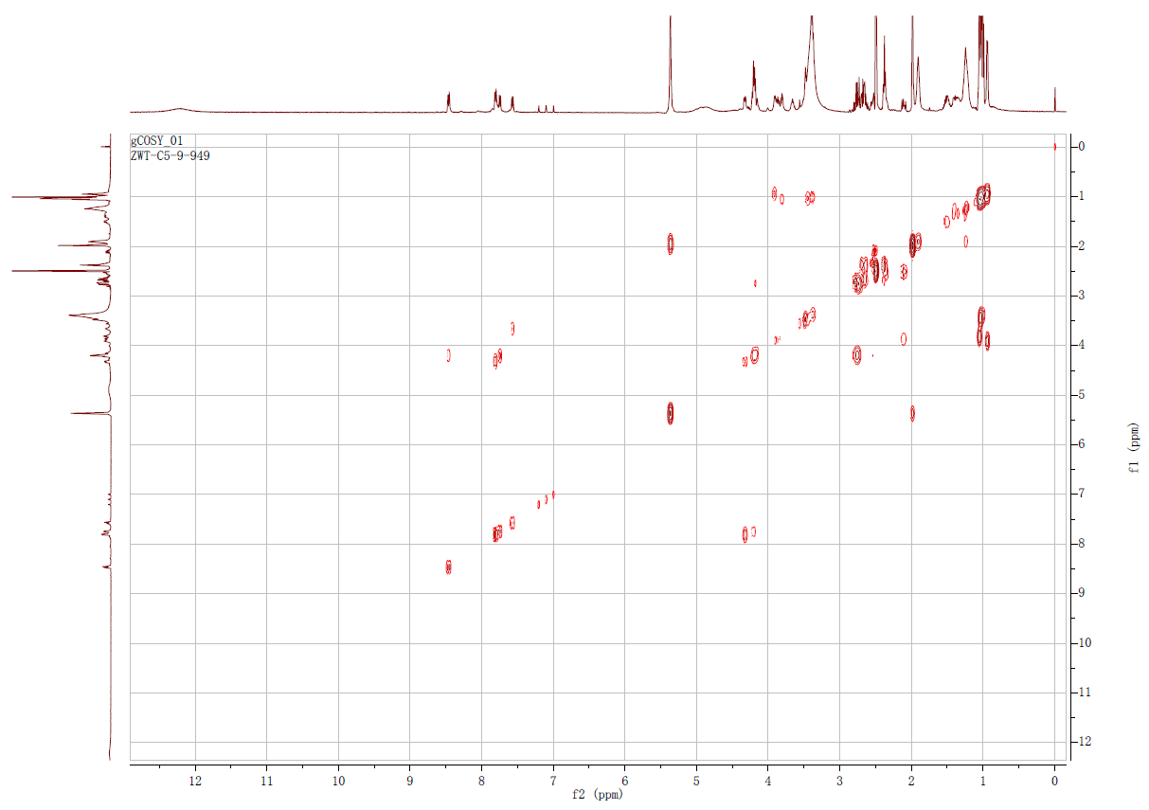

Supplementary Fig 26. ¹H-¹H COSY spectrum of megapolipeptin Id (4) in DMSO-d₆
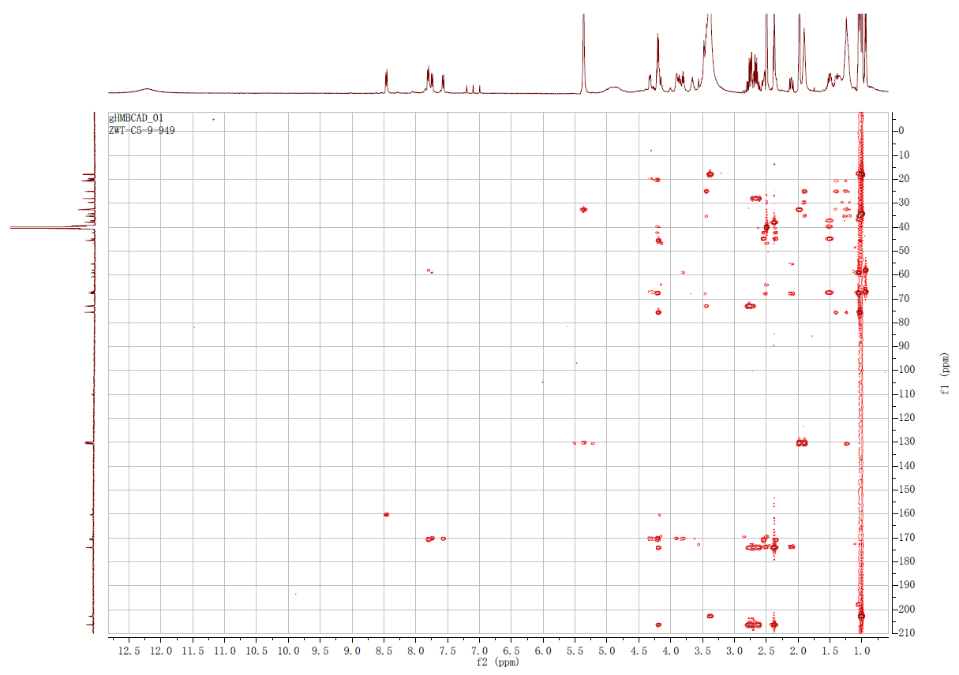

Supplementary Fig 27. HMBC spectrum of megapolipeptin Id (4) in DMSO-d₆

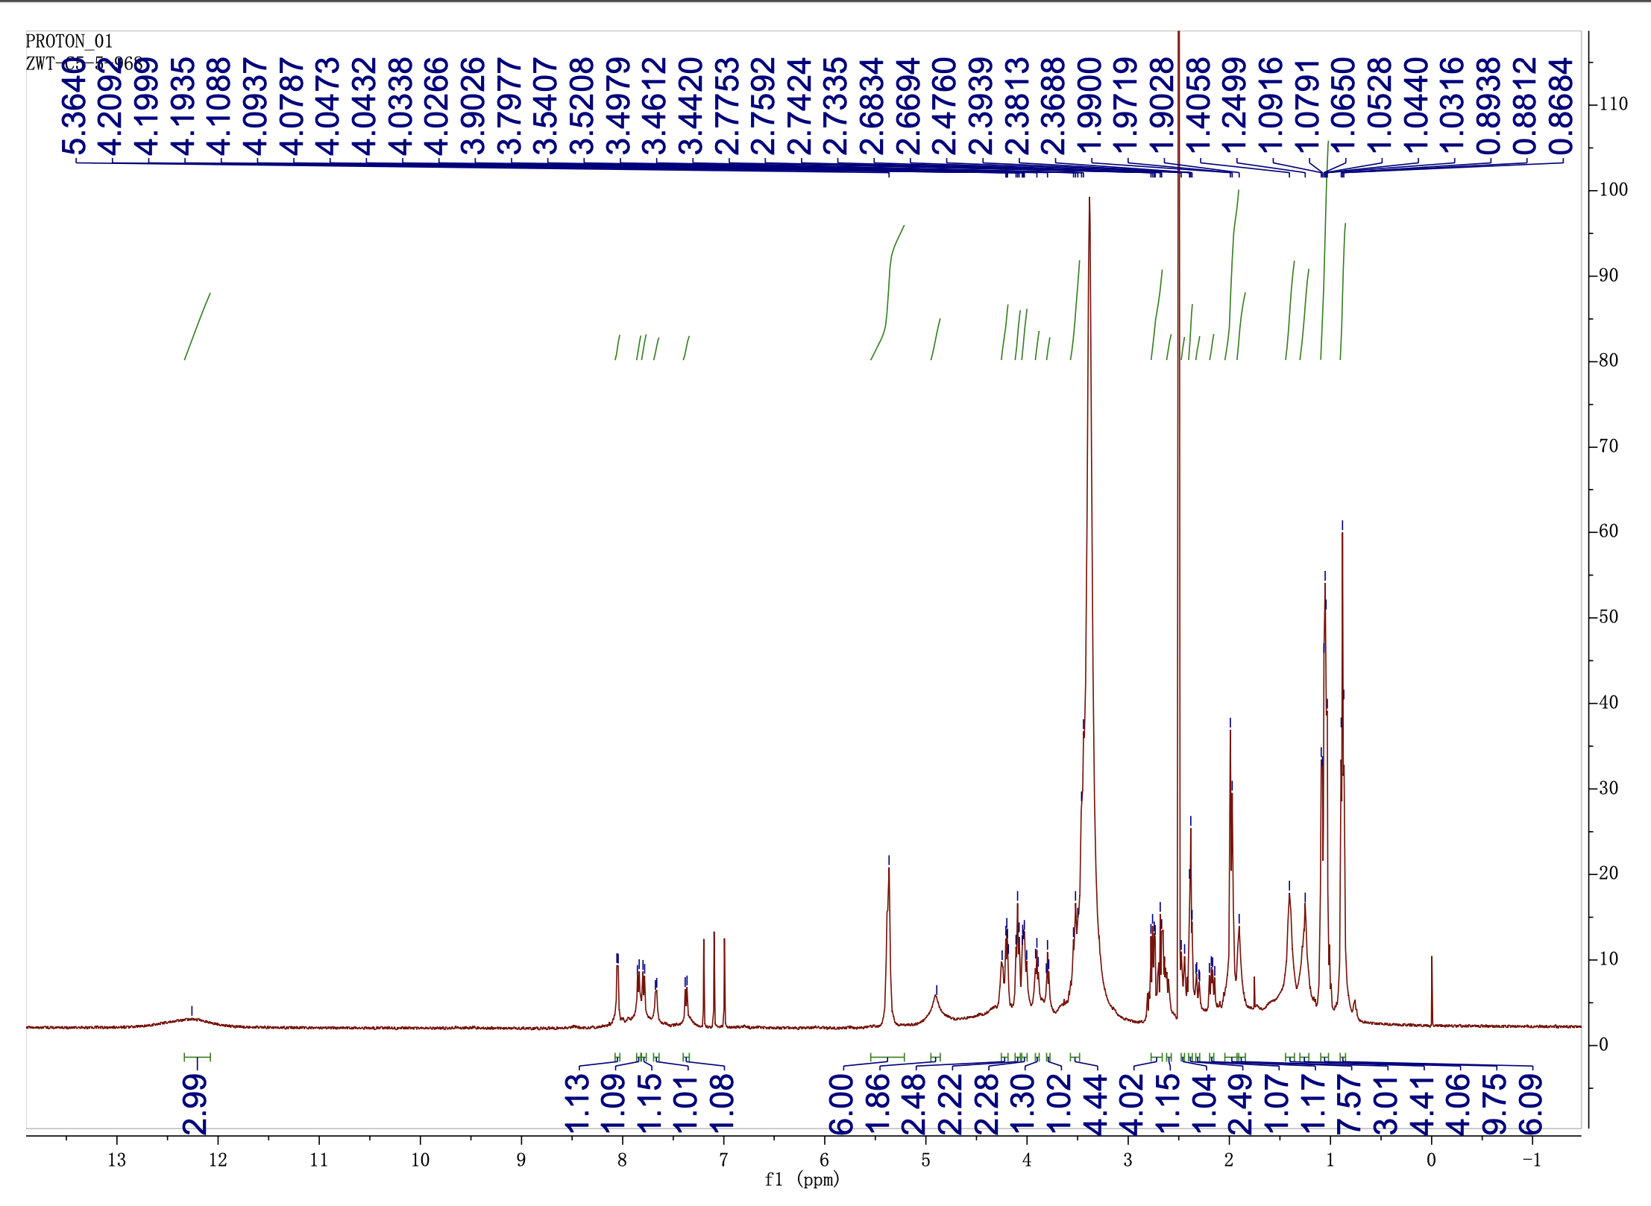

Supplementary Fig 28. ¹H NMR (500 MHz) spectrum of megapolipeptin Ⅱa (5) in DMSO-d₆
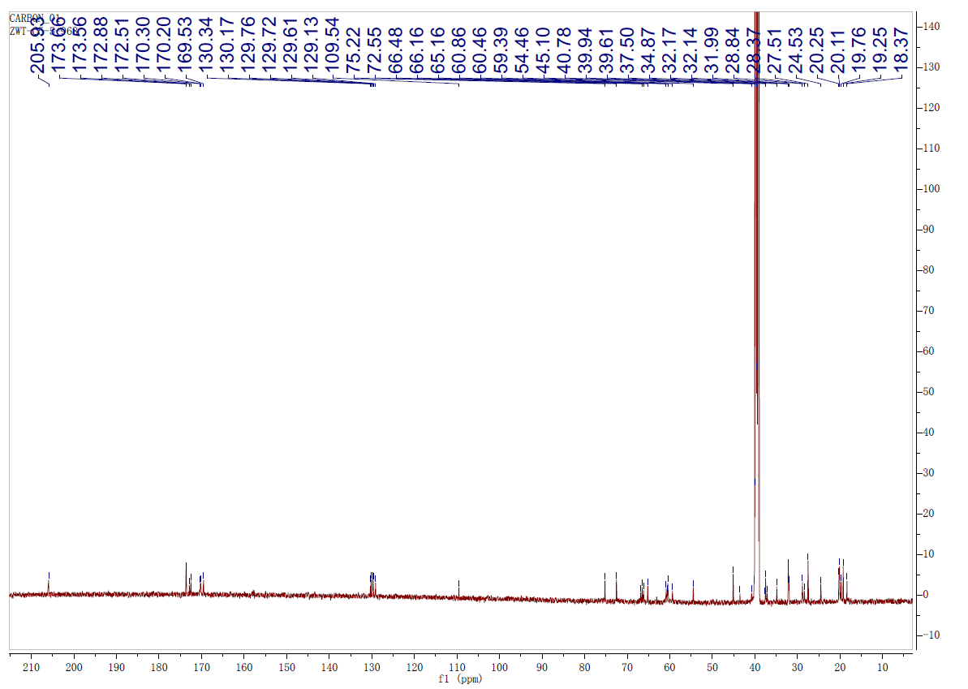

Supplementary Fig 29. ¹³C NMR (125 MHz) spectrum of megapolipeptin Ⅱa (5) in DMSO-d₆

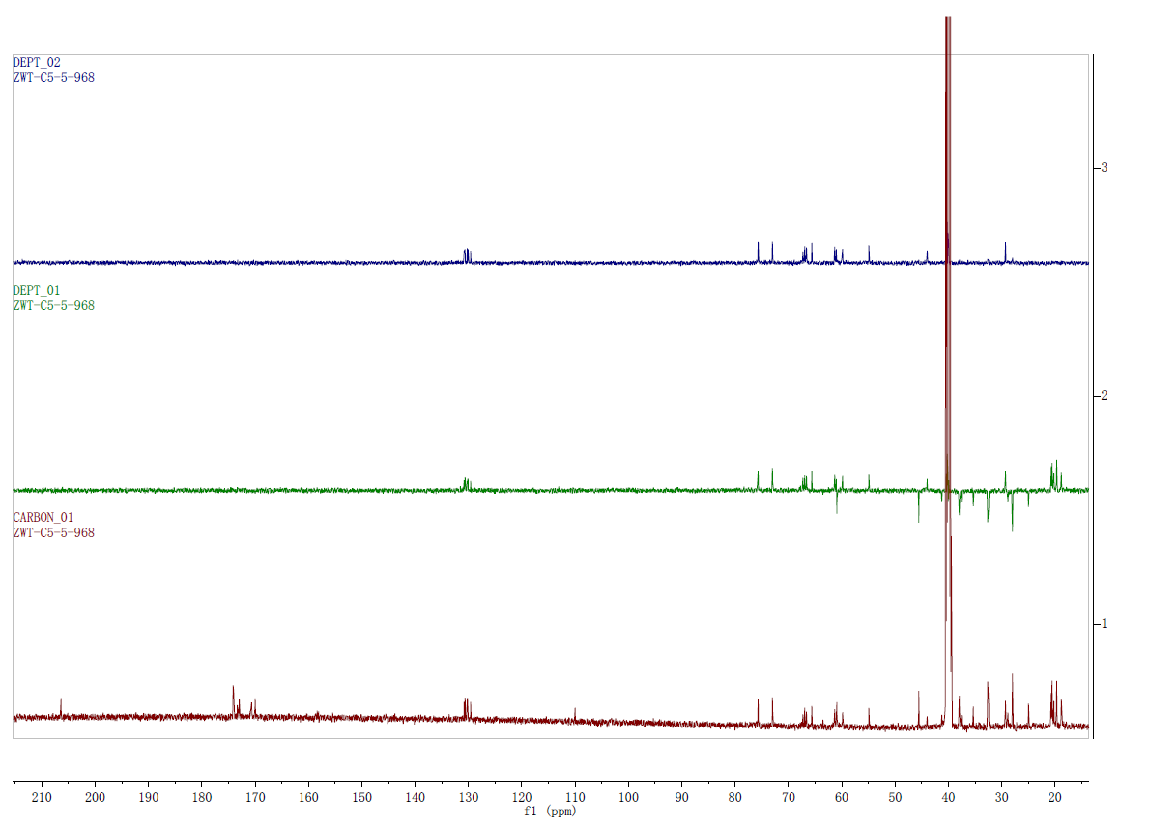
DEPT 135
DEPT 90
¹³C NMR

Supplementary Fig 30. DEPT 90 and DEPT 135 spectra of megapolipeptin Ⅱa (5) in DMSO-d₆

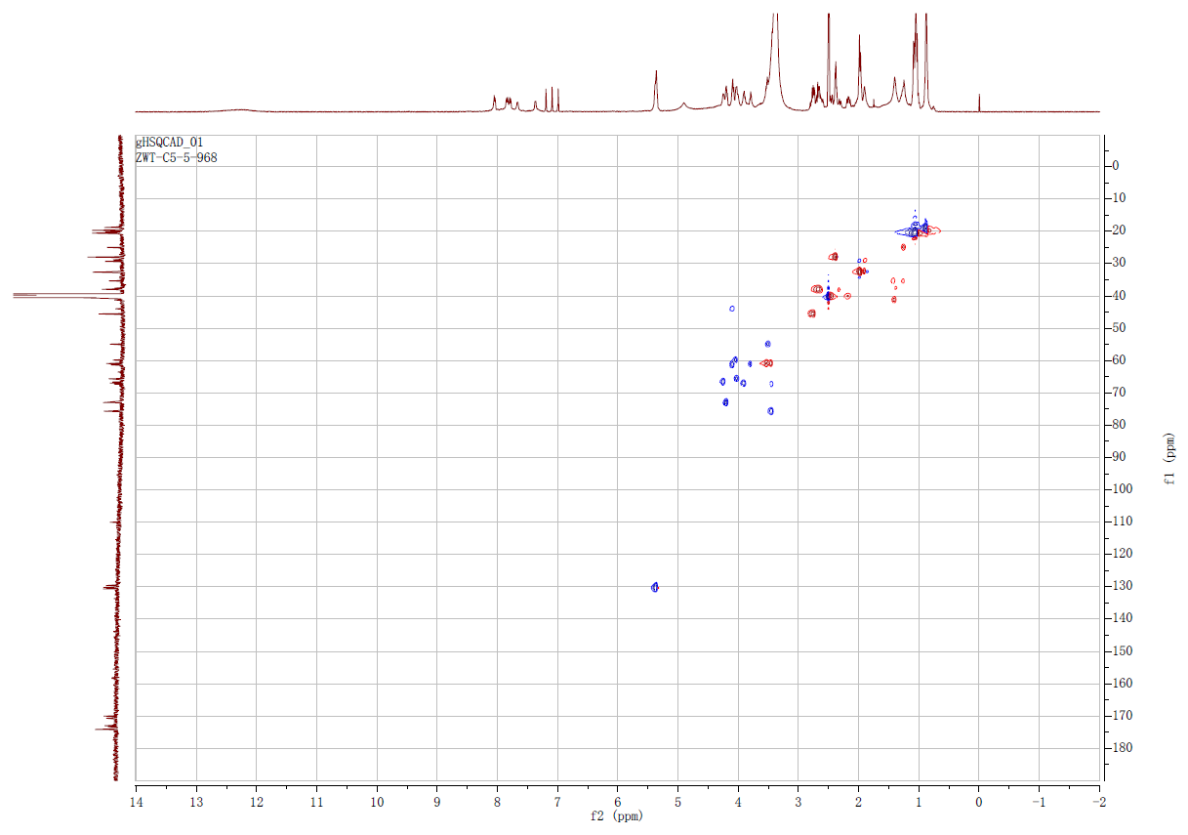

Supplementary Fig 31. HSQC spectrum of megapolipeptin Ⅱa (5) in DMSO-d₆

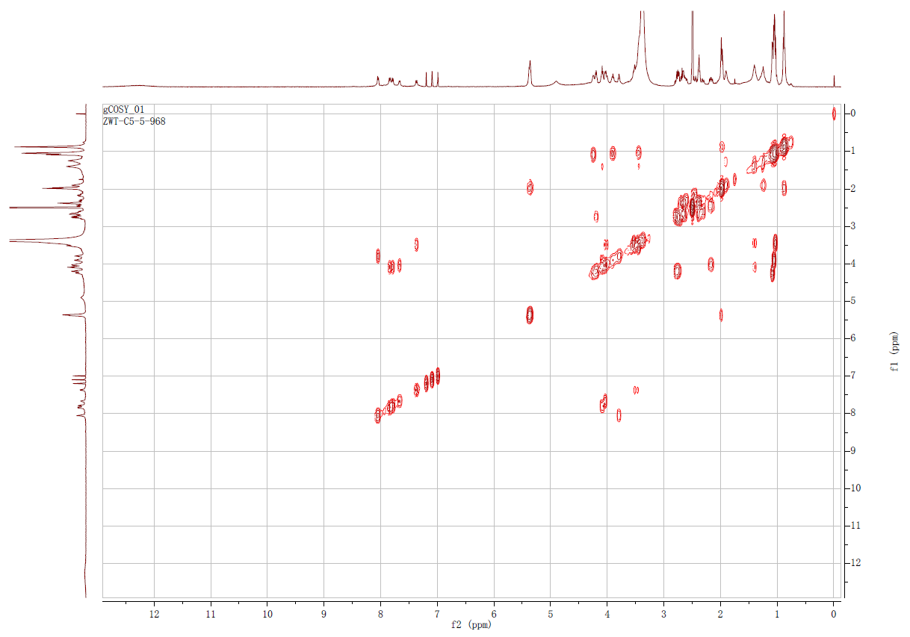

Supplementary Fig 32. ¹H-¹H COSY spectrum of megapolipeptin Ⅱa (5) in DMSO-d₆
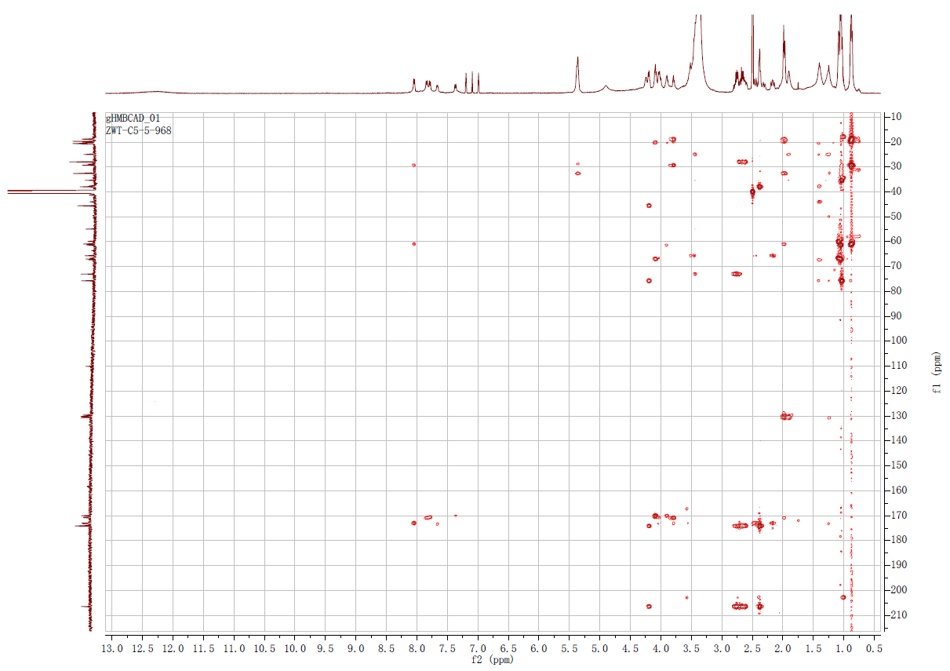

Supplementary Fig 33. HMBC spectrum of megapolipeptin Ⅱa (5) in DMSO-d₆

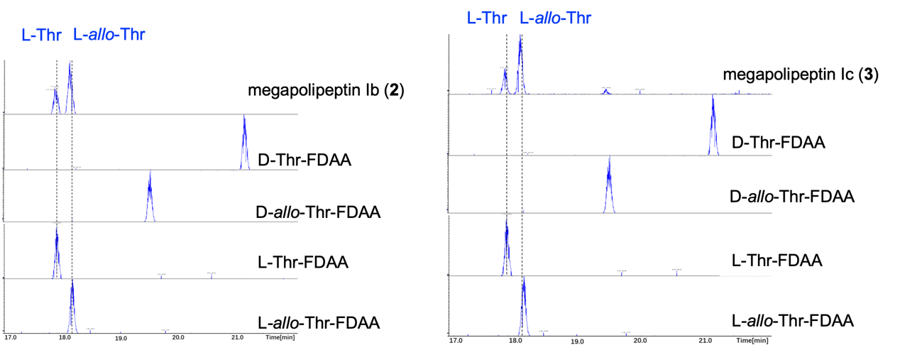
Supplementary Fig 34. The truncated HR-ESI-MS spectra of Marfey’s hydrolysis reaction of megapolipeptins Ib (2), Ic (3), and L- /D-standard amino acids. All hydrolysed chromopeptins and standard amino acids were derivatized by Marfey’s reagent (N2-(5-Fluoro-2,4-dinitrophenyl)-L-alaninamide, L-FDAA) for detection by LC-MS. The configurations of amino acids in compounds 2 and 3 are indicated by dashed lines and blue characters.

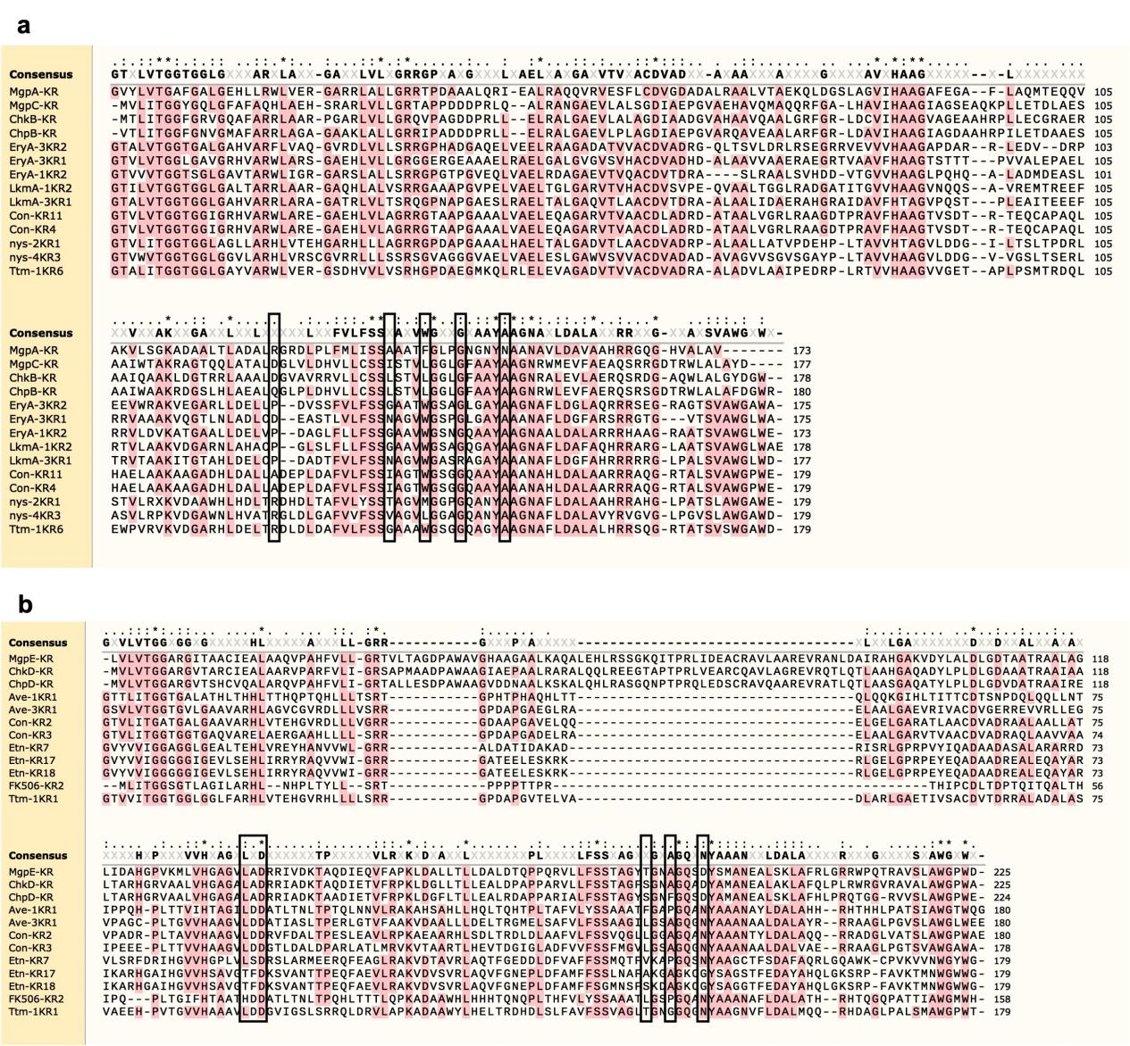

Supplementary Fig 35. Bioinformatic analysis of the ketoreductase domains for configurational assignments of secondary hydroxyl groups of megapolipeptins, chromopeptins, and chitinimopeptins. The sequence alignments of A type KR domain for L configuration of hydroxyl group installation (a) and B type KR domain for D configuration of hydroxyl group installation (b) were shown.

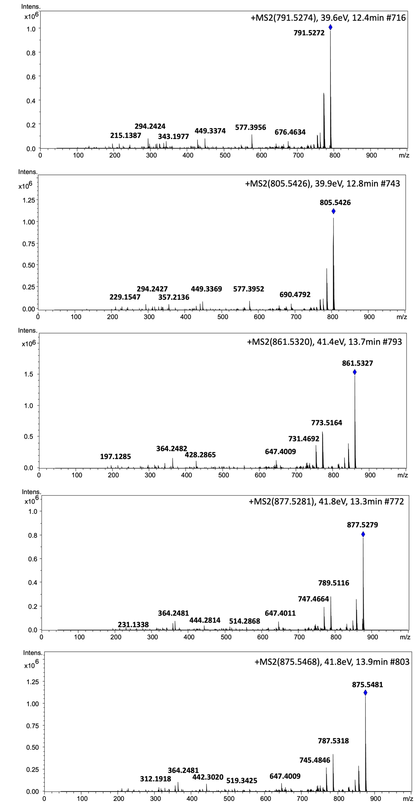

Supplementary Fig 36. HR-ESI-MS spectra of chromopeptins Ia, Ib, Ⅱa, Ⅱb, and Ⅱc (6-10)

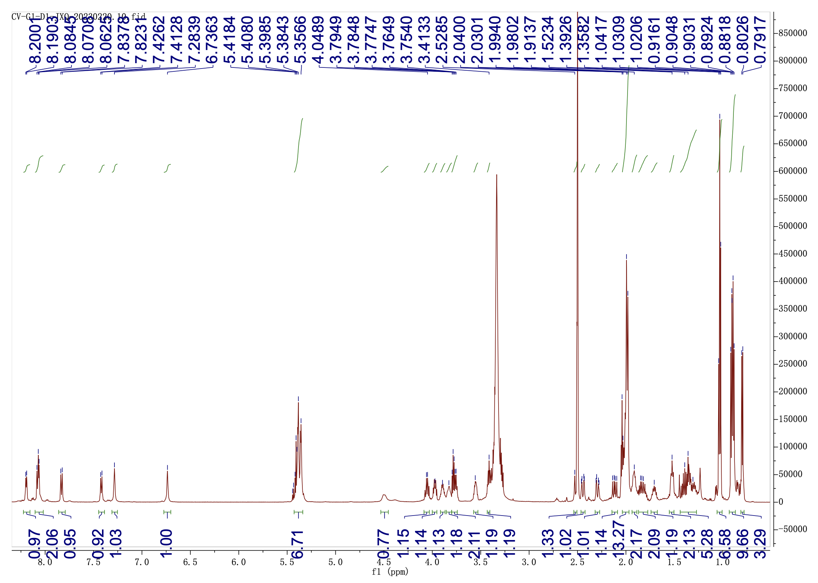

Supplementary Fig 37. ¹H NMR (600 MHz) spectrum of chromopeptin Ia (6) in DMSO-d₆

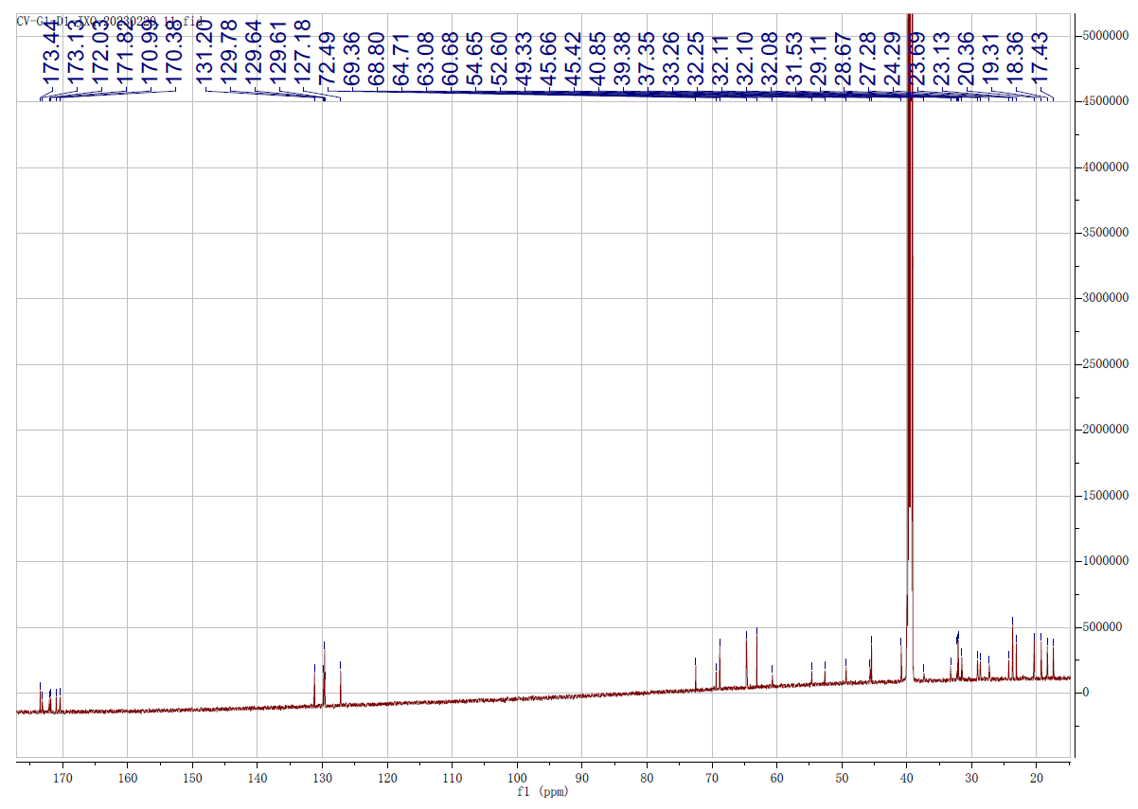

Supplementary Fig 38. ¹³C NMR (150 MHz) spectrum of chromopeptin Ia (6) in DMSO-d₆

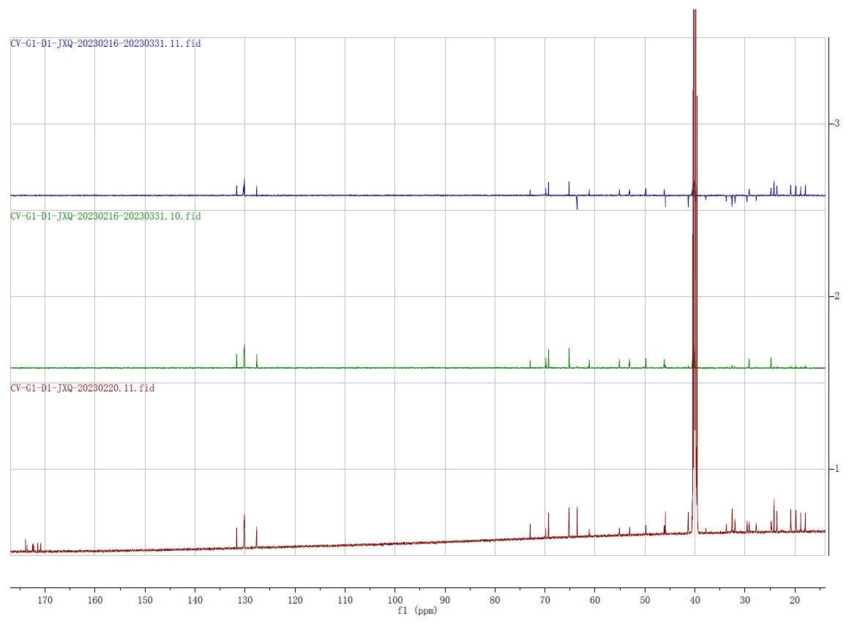
DEPT 90
DEPT 135
¹³C NMR

Supplementary Fig 39. DEPT 90 and DEPT 135 spectra of chromopeptin Ia (6) in DMSO-d₆

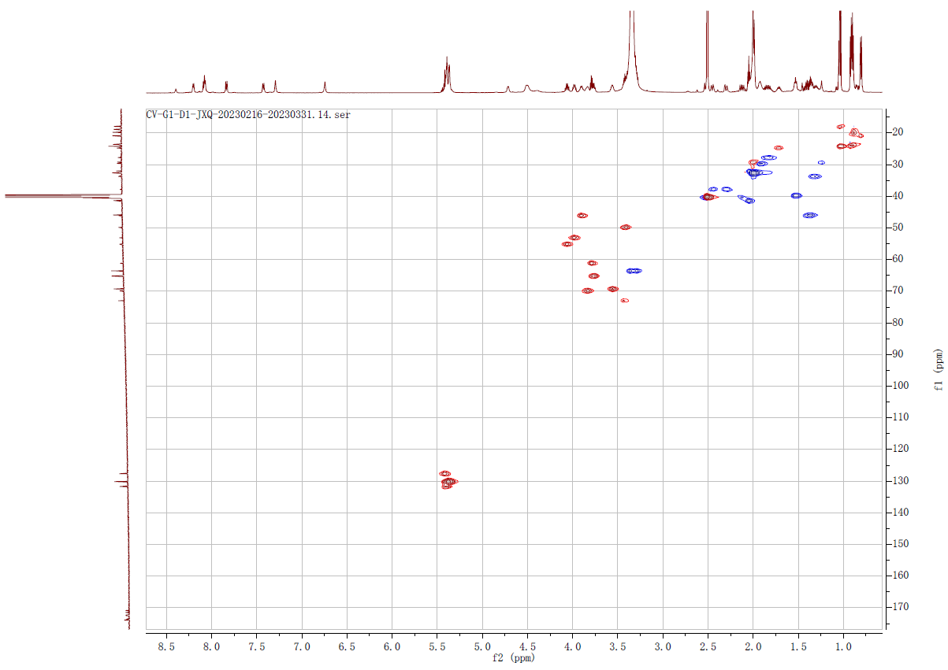

Supplementary Fig 40. HSQC spectrum of chromopeptin Ia (6) in DMSO-d₆

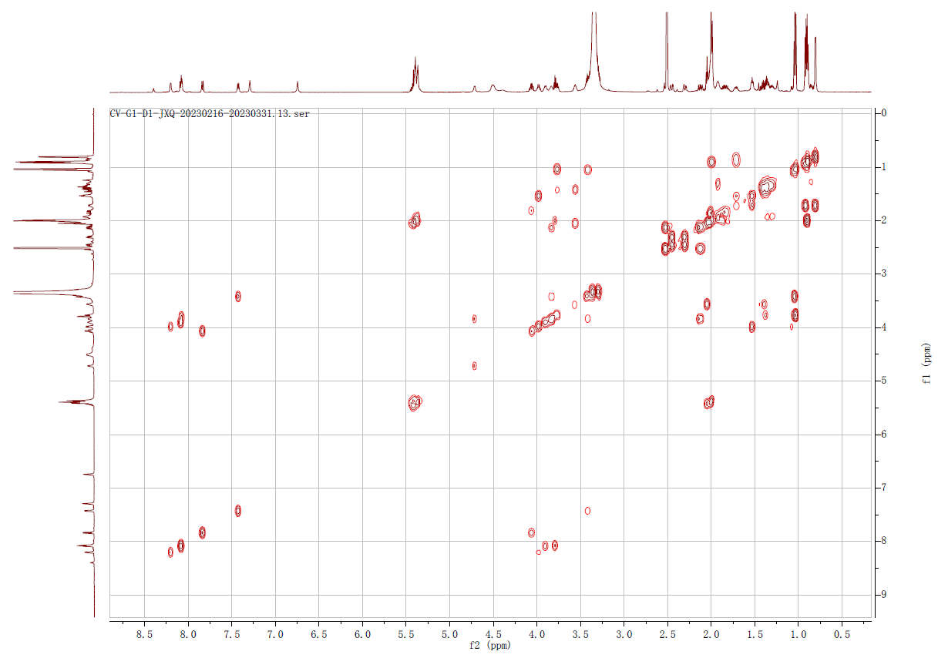

Supplementary Fig 41. ¹H-¹H COSY spectrum of chromopeptin Ia (6) in DMSO-d₆

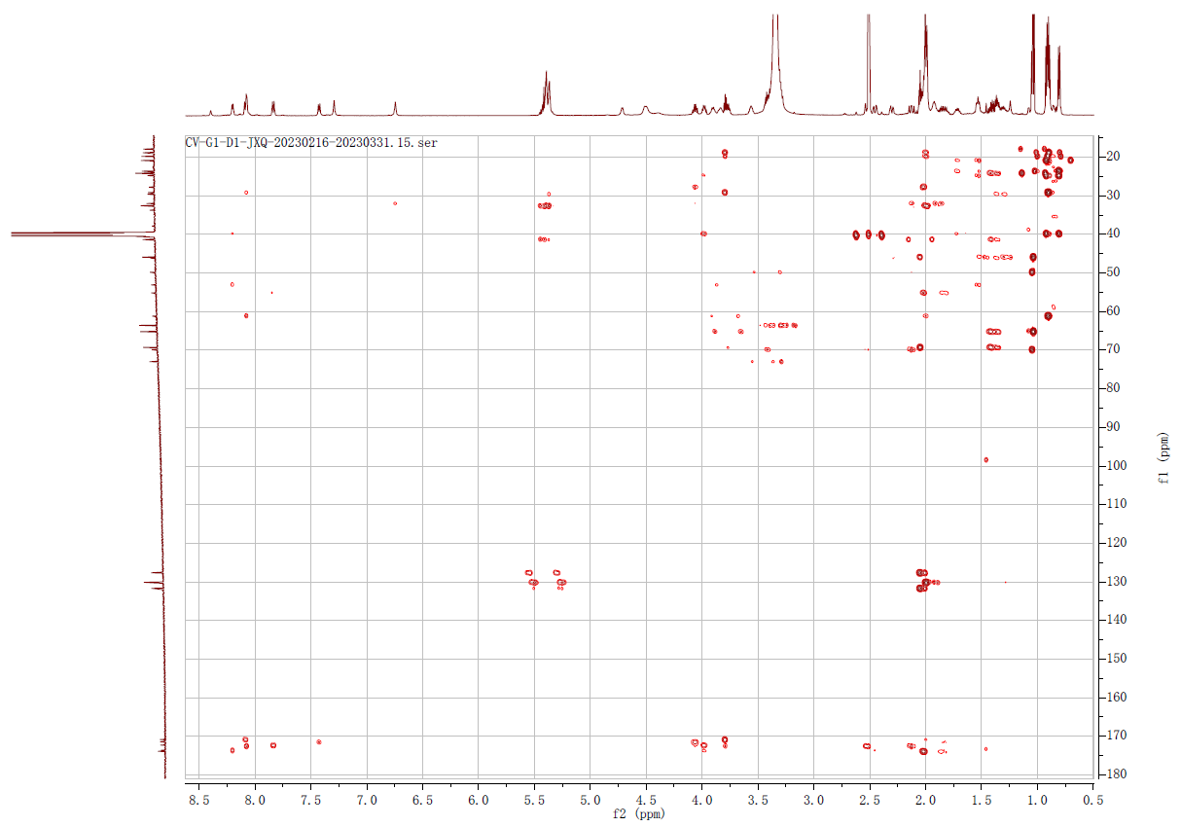

Supplementary Fig 42. HMBC spectrum of chromopeptin Ia (6) in DMSO-d₆

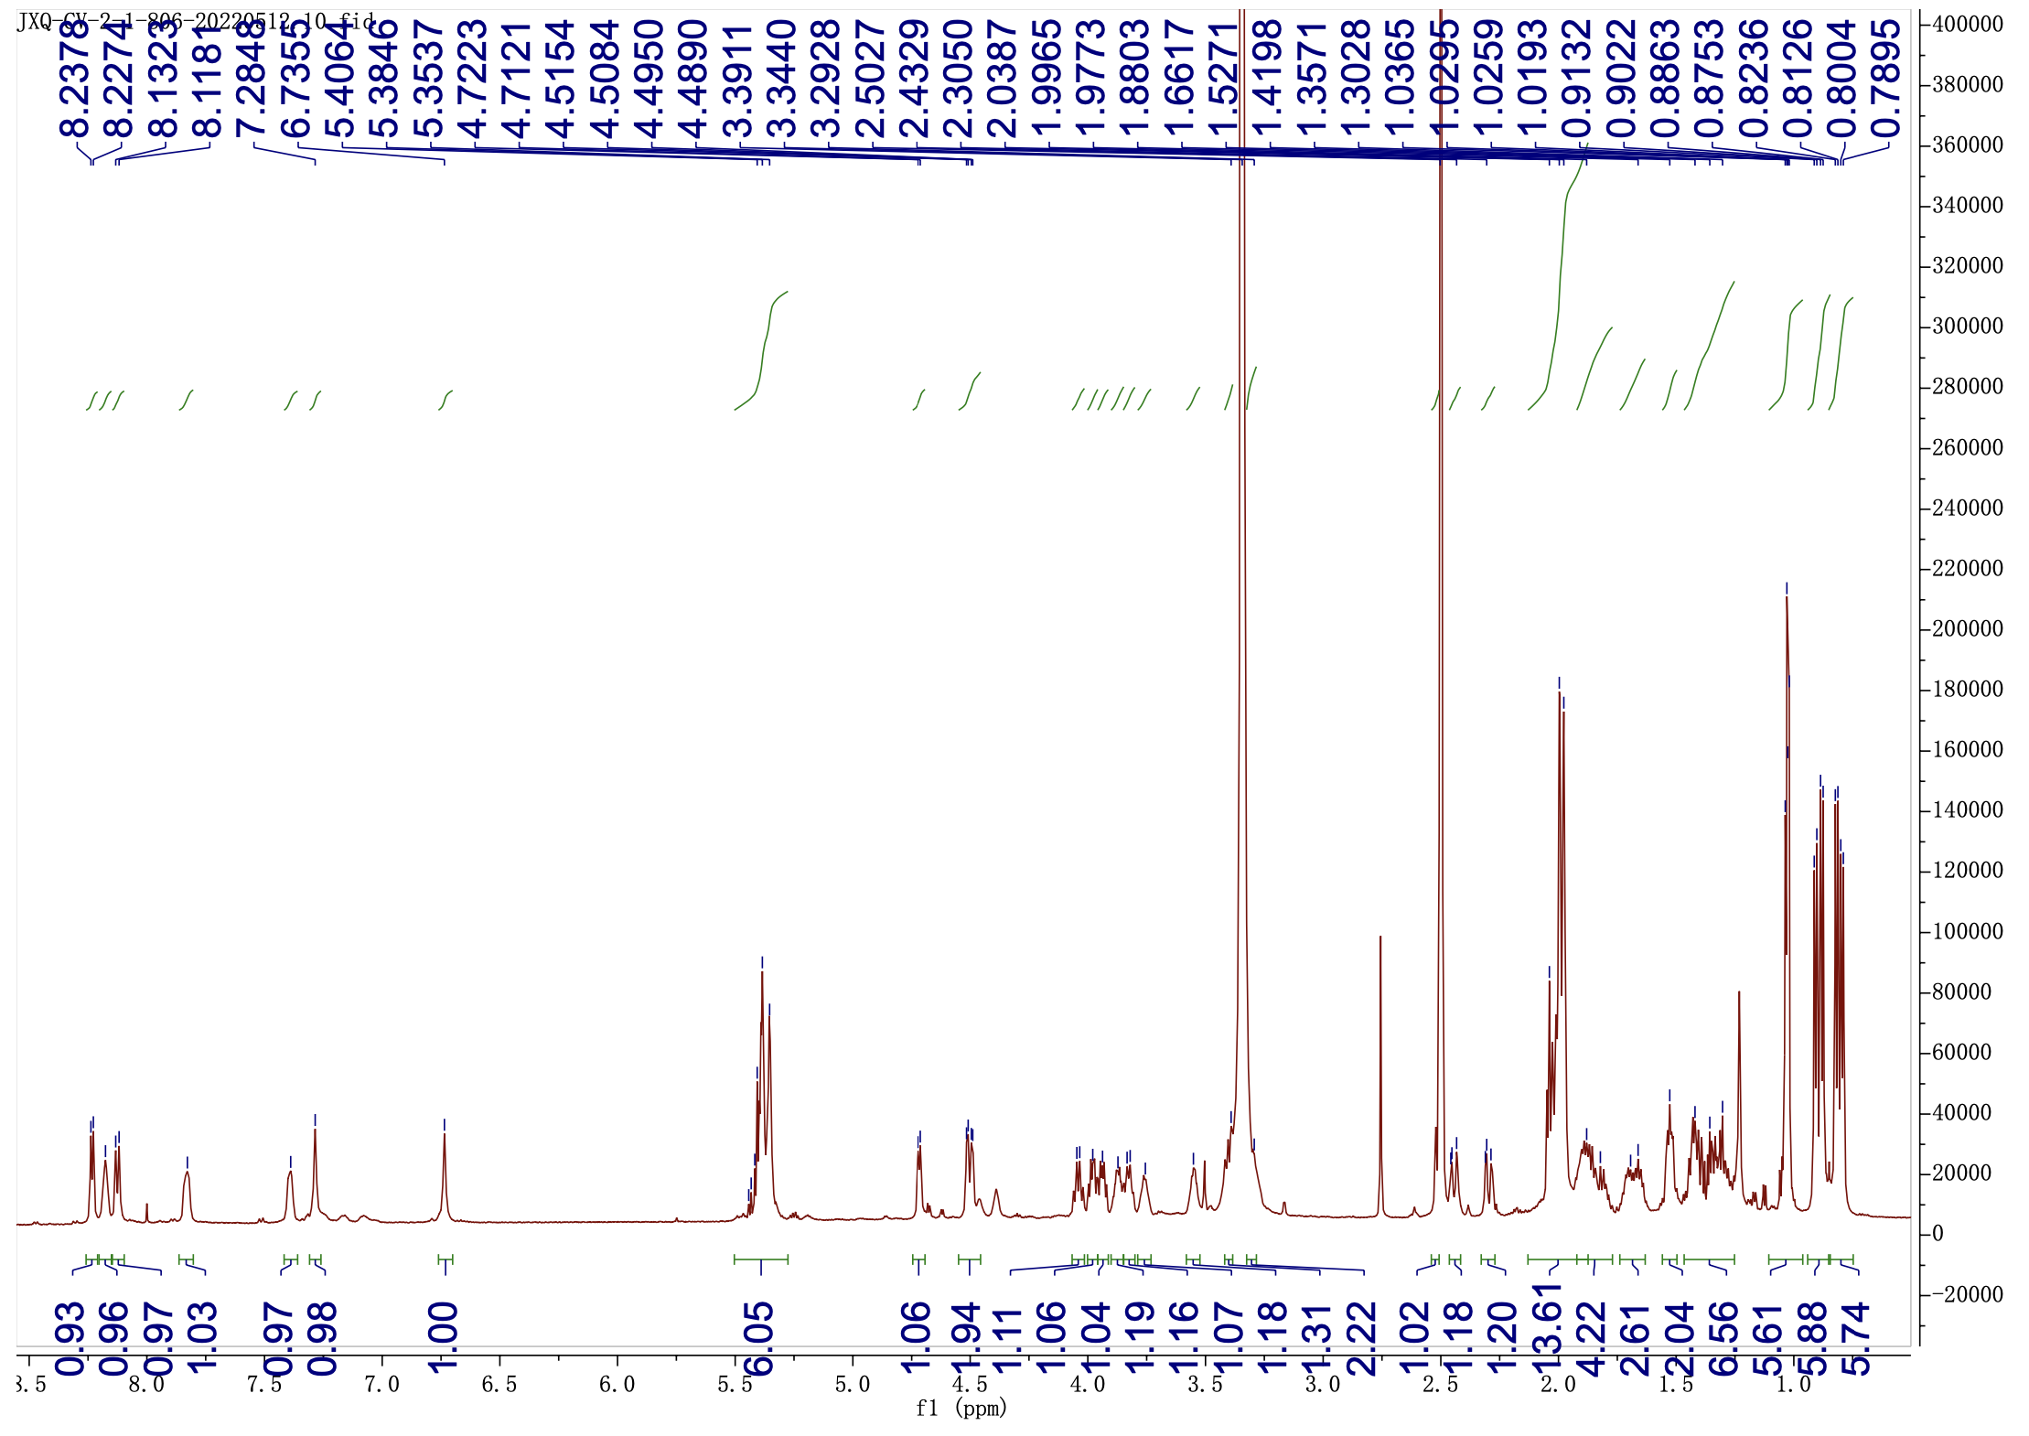

Supplementary Fig 43. ¹H NMR (600 MHz) spectrum of chromopeptin Ib (7) in DMSO-d₆

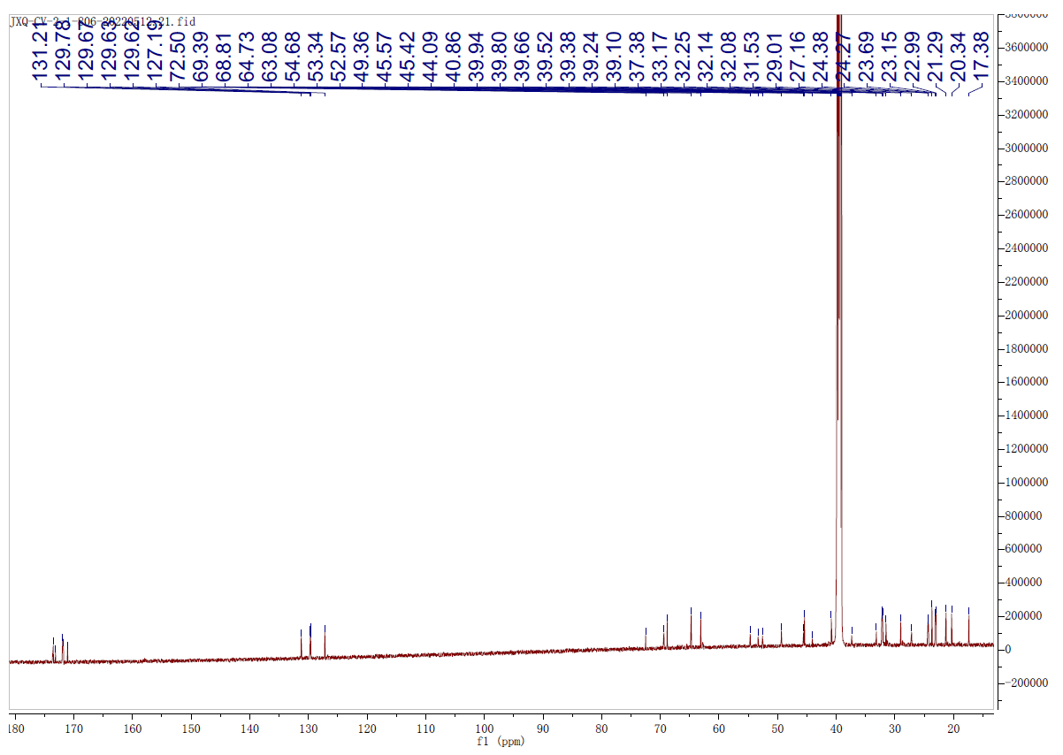

Supplementary Fig 44. ¹³C NMR (150 MHz) spectrum of chromopeptin Ib (7) in DMSO-d₆

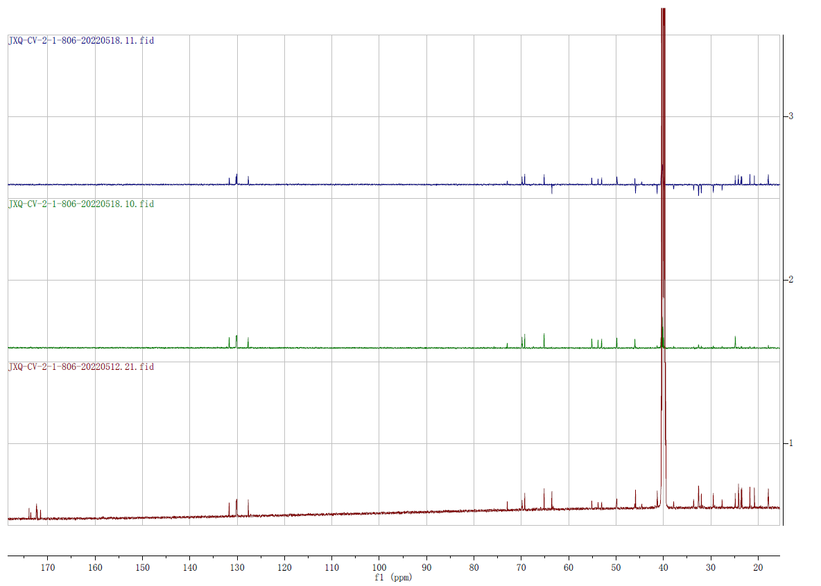
DEPT 90
DEPT 135
¹³C NMR

Supplementary Fig 45. DEPT 90 and DEPT 135 spectra of chromopeptin Ib (7) in DMSO-d₆

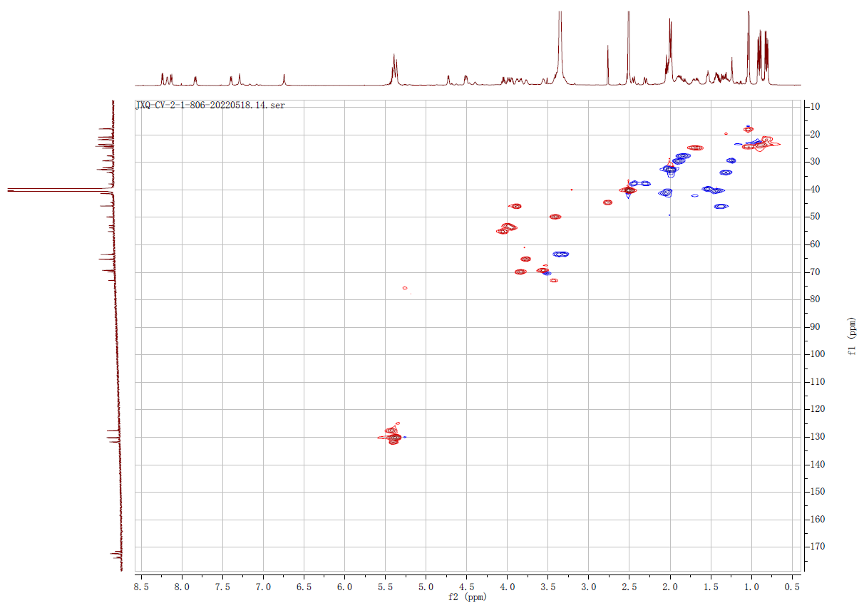

Supplementary Fig 46. HSQC spectrum of chromopeptin Ib (7) in DMSO-d₆

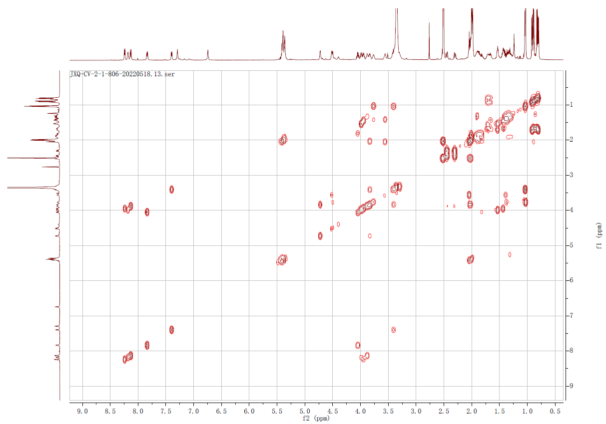

Supplementary Fig 47. ¹H-¹H COSY spectrum of chromopeptin Ib (7) in DMSO-d₆

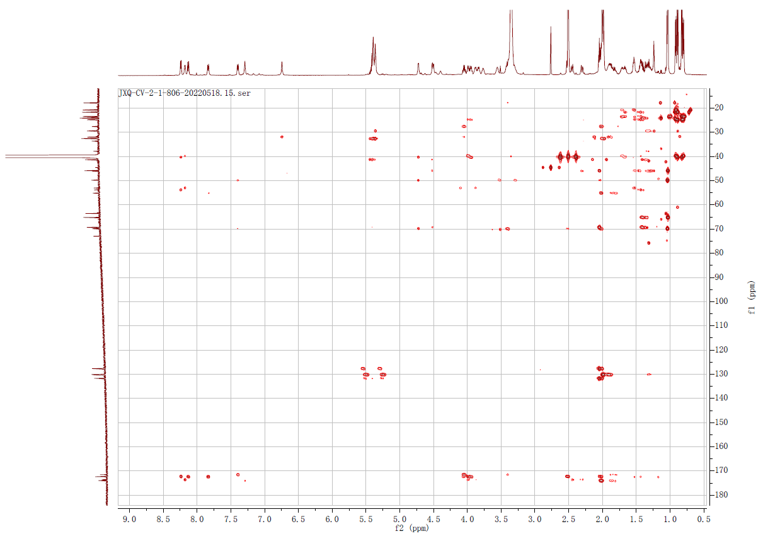

Supplementary Fig 48. HMBC spectrum of chromopeptin Ib (7) in DMSO-d₆

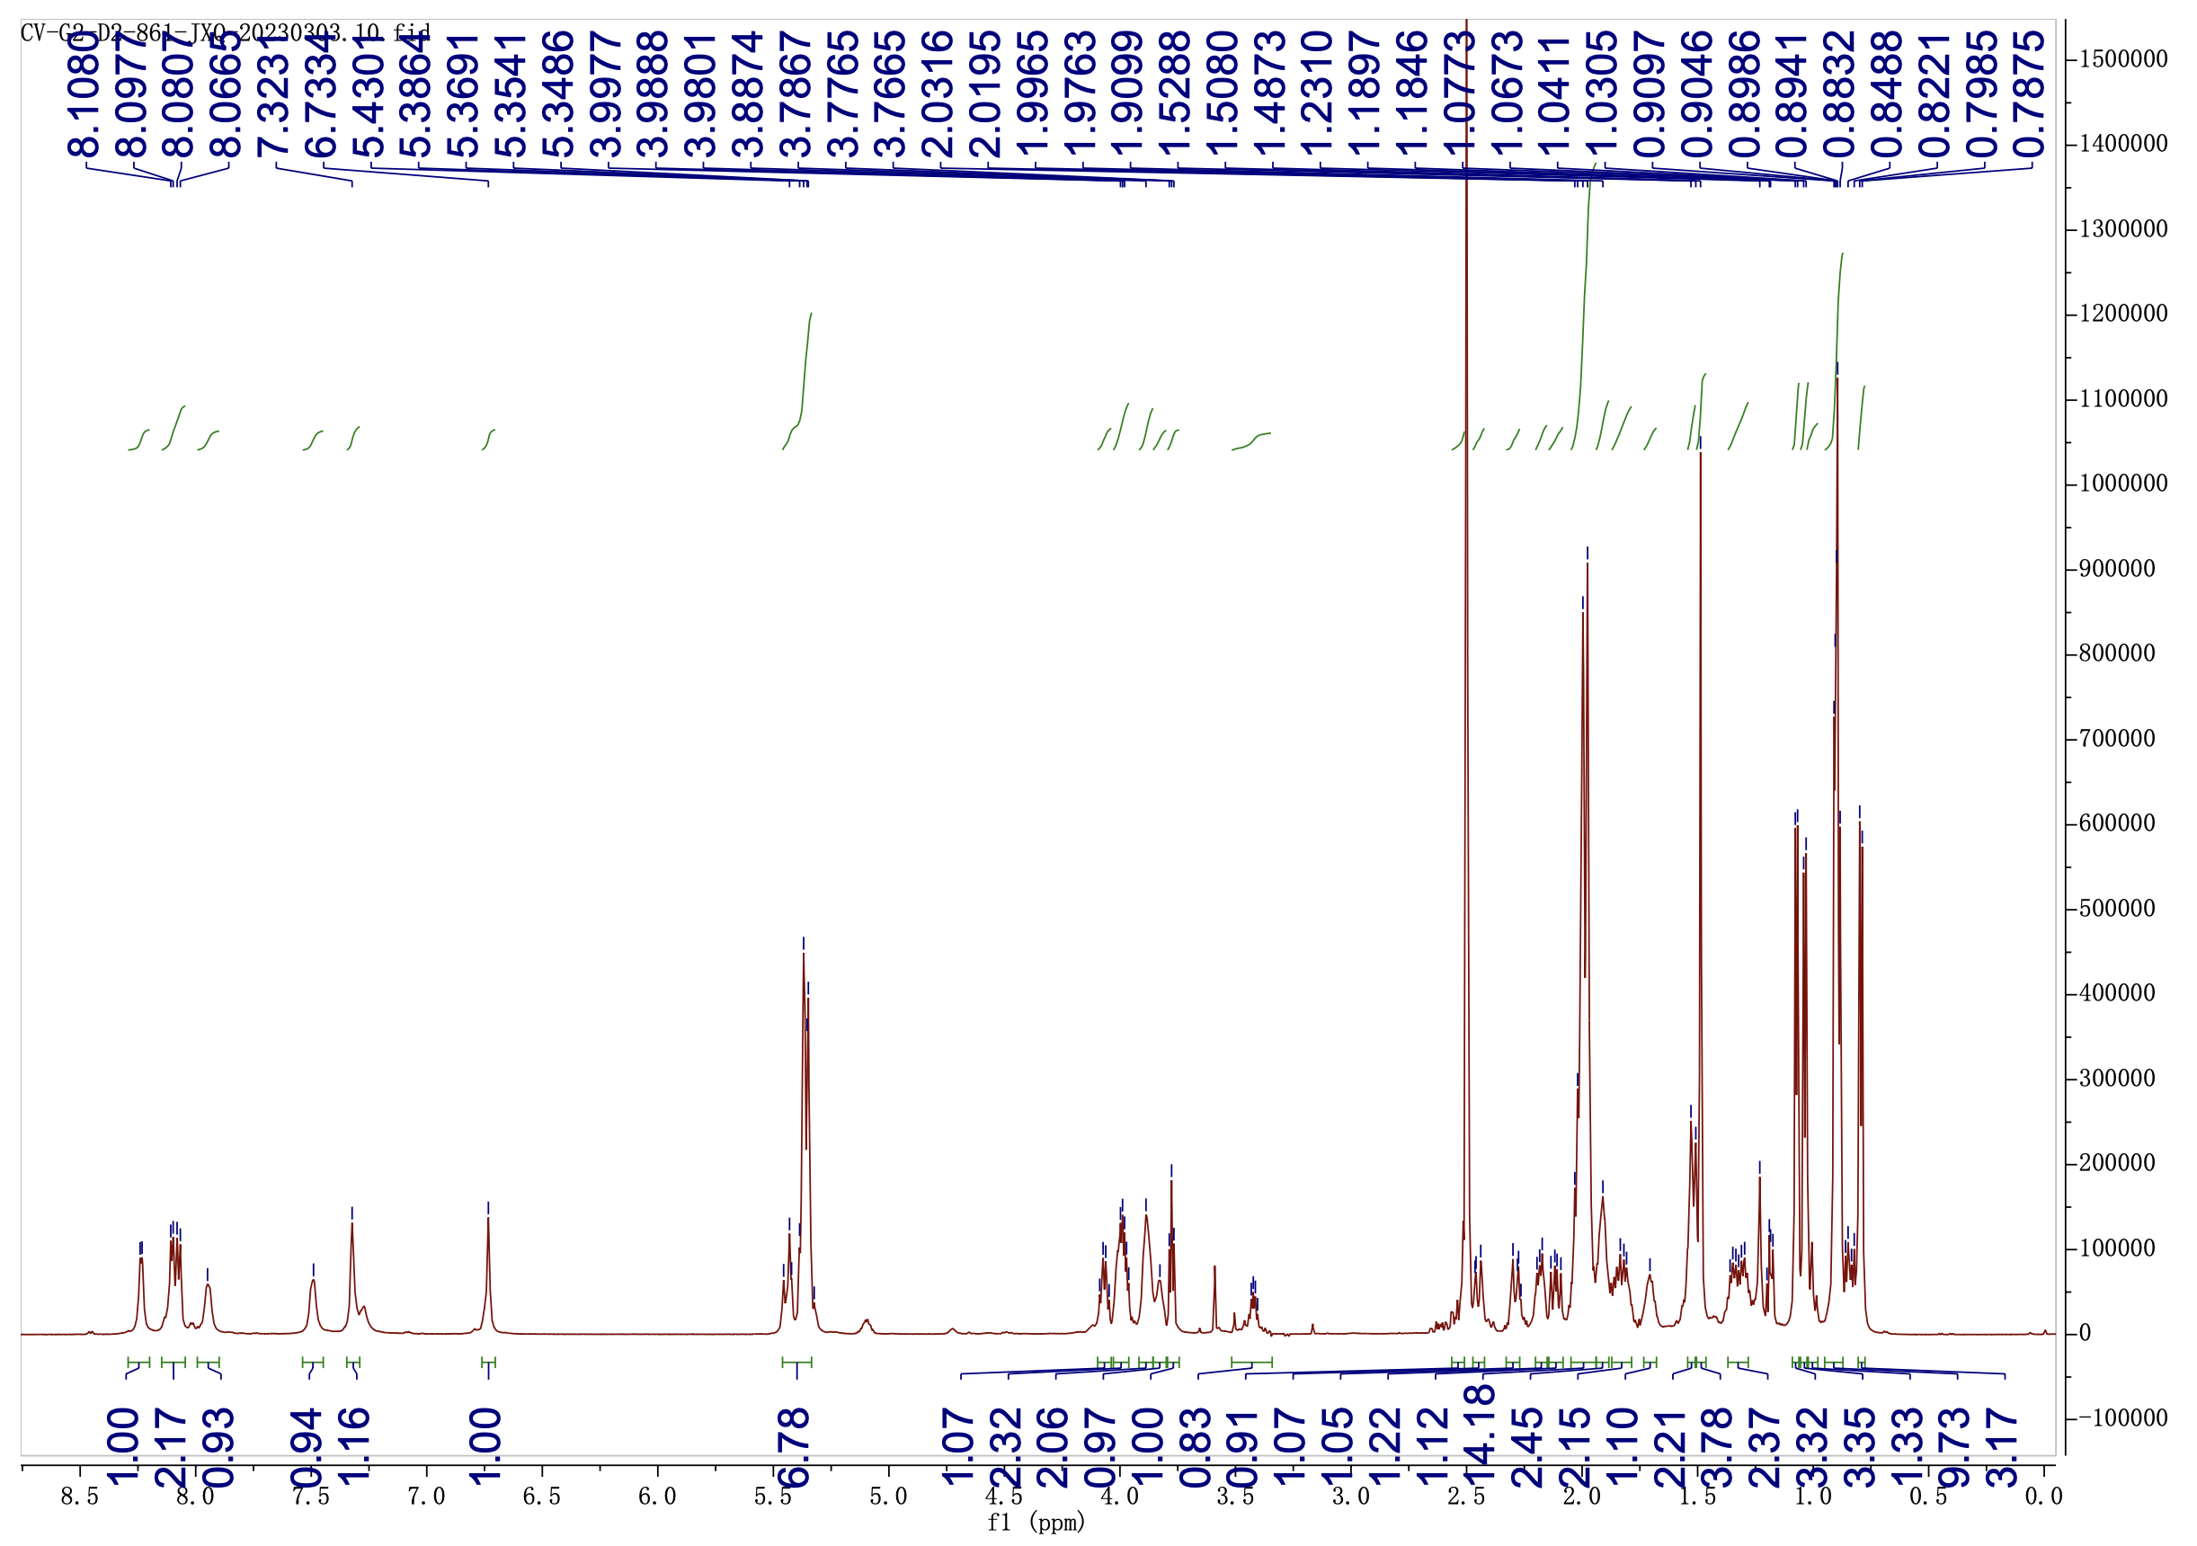

Supplementary Fig 49. ¹H NMR (600 MHz) spectrum of chromopeptin Ⅱa (8) in DMSO-d₆

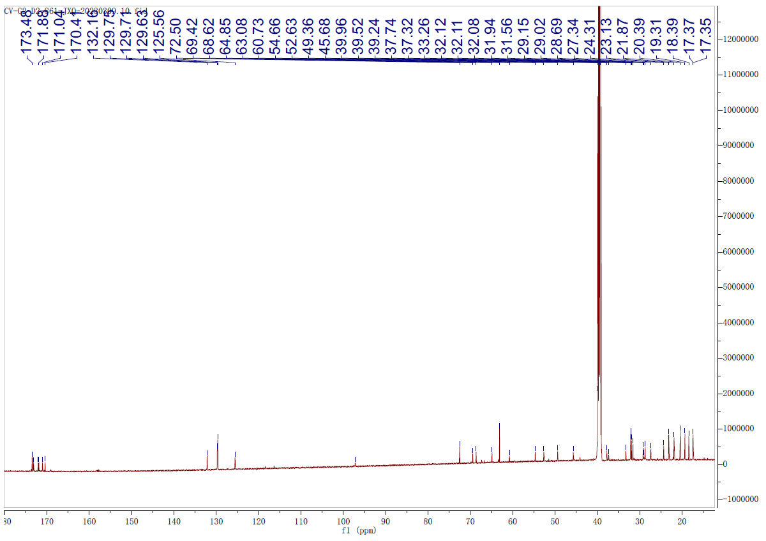

Supplementary Fig 50. ¹³C NMR (150 MHz) spectrum of chromopeptin Ⅱa (8) in DMSO-d₆

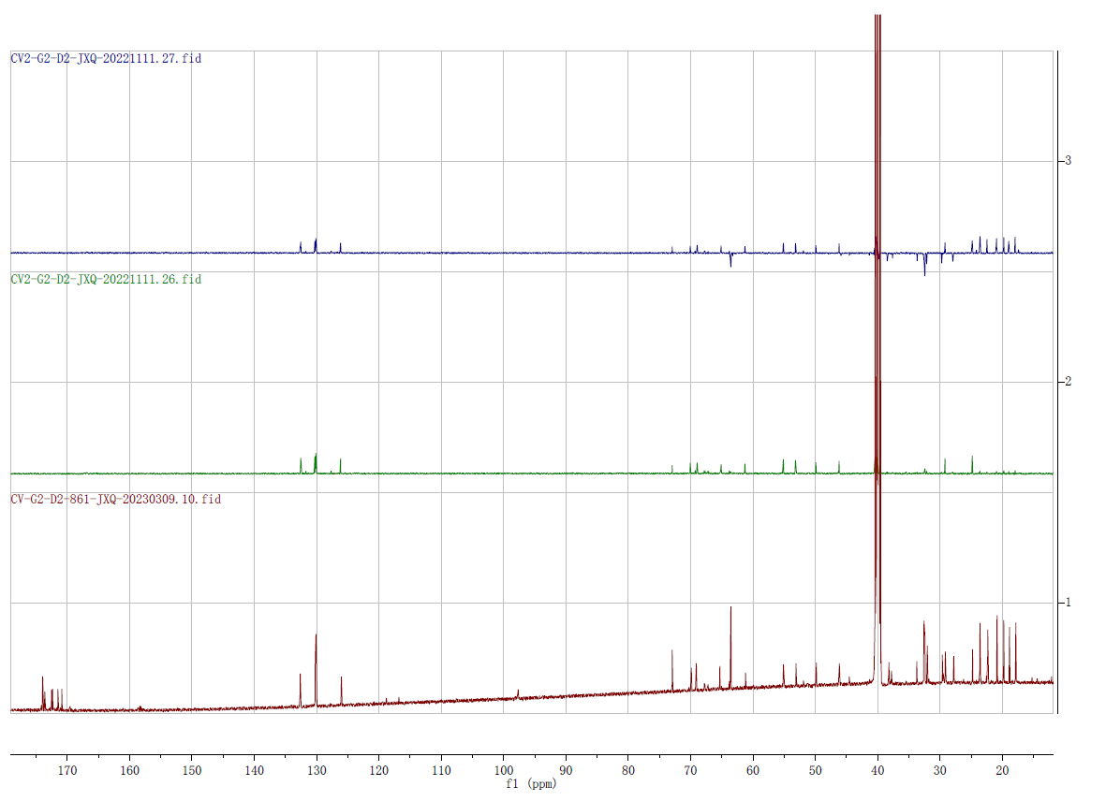
DEPT 90
DEPT 135
¹³C NMR

Supplementary Fig 51. DEPT 90 and DEPT 135 spectra of chromopeptin Ⅱa (8) in DMSO-d₆

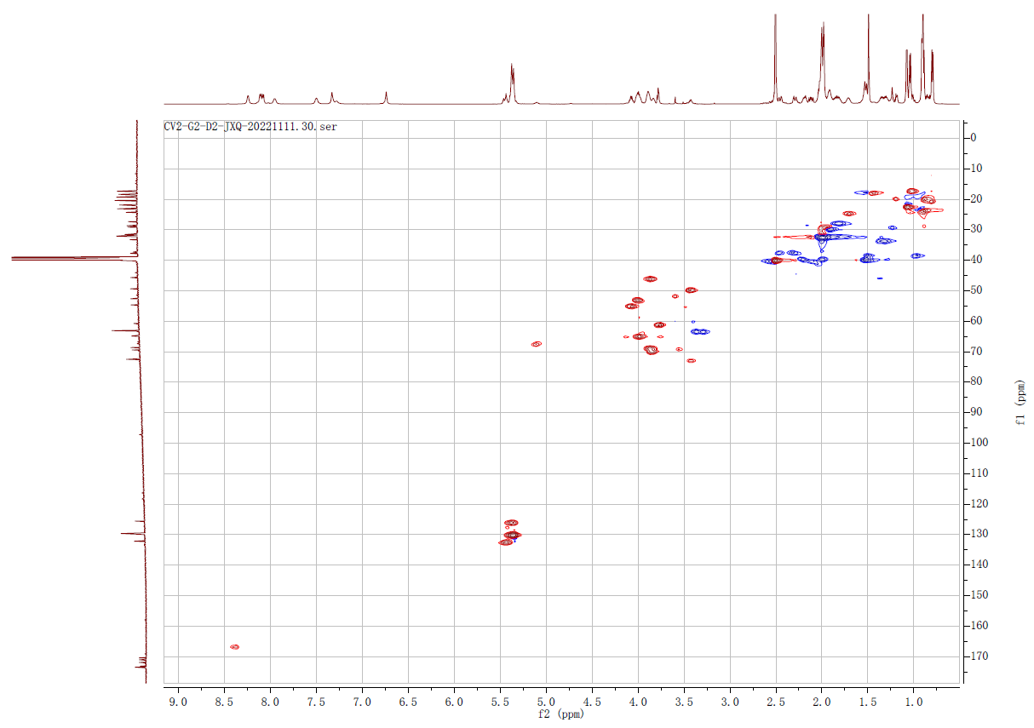

Supplementary Fig 52. HSQC spectrum of chromopeptin Ⅱa (8) in DMSO-d₆

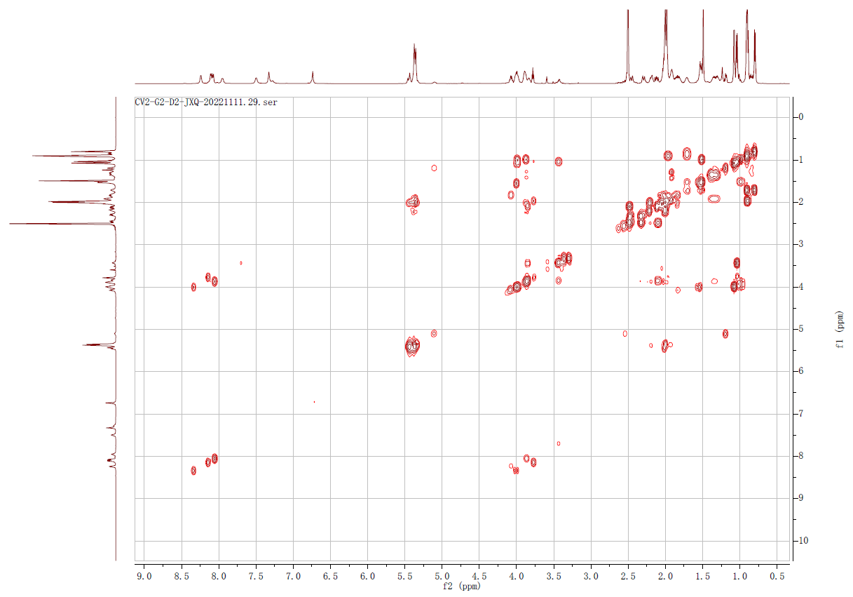

Supplementary Fig 53. ¹H-¹H COSY spectrum of chromopeptin Ⅱa (8) in DMSO-d₆

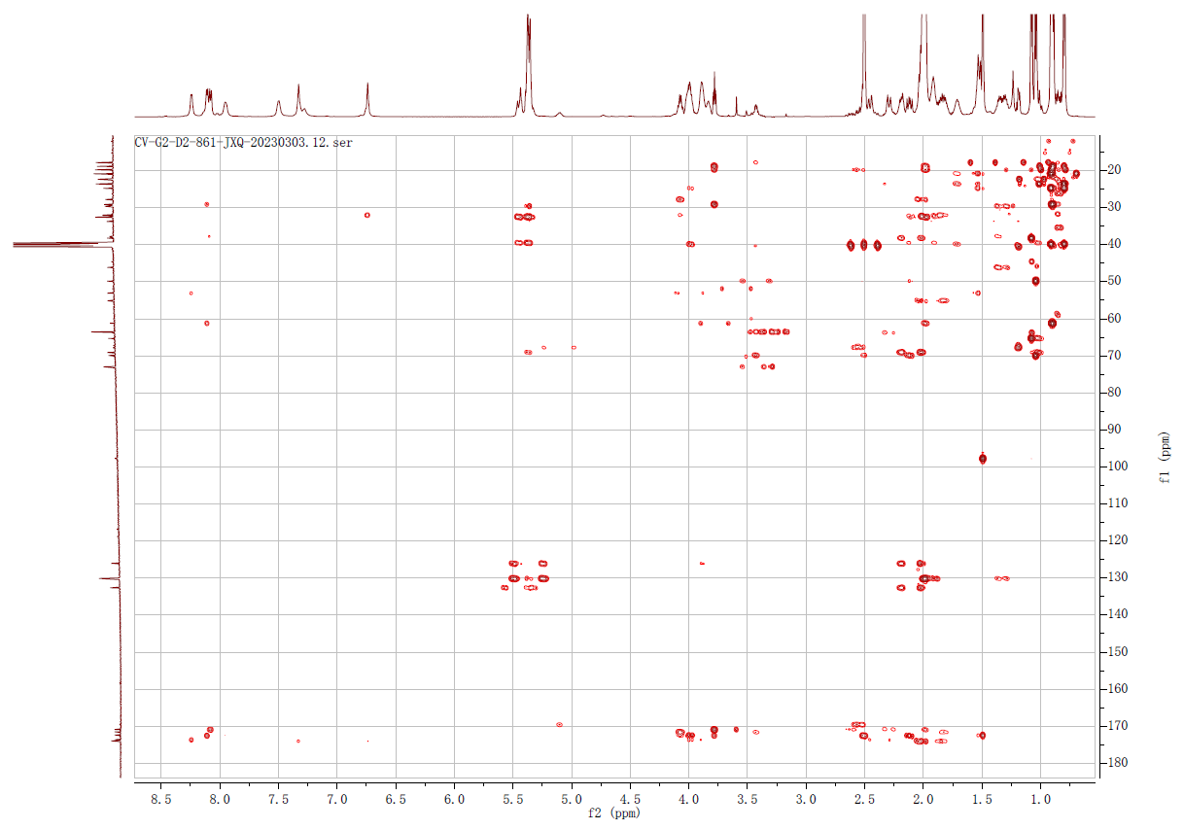

Supplementary Fig 54. HMBC spectrum of chromopeptin Ⅱa (8) in DMSO-d₆

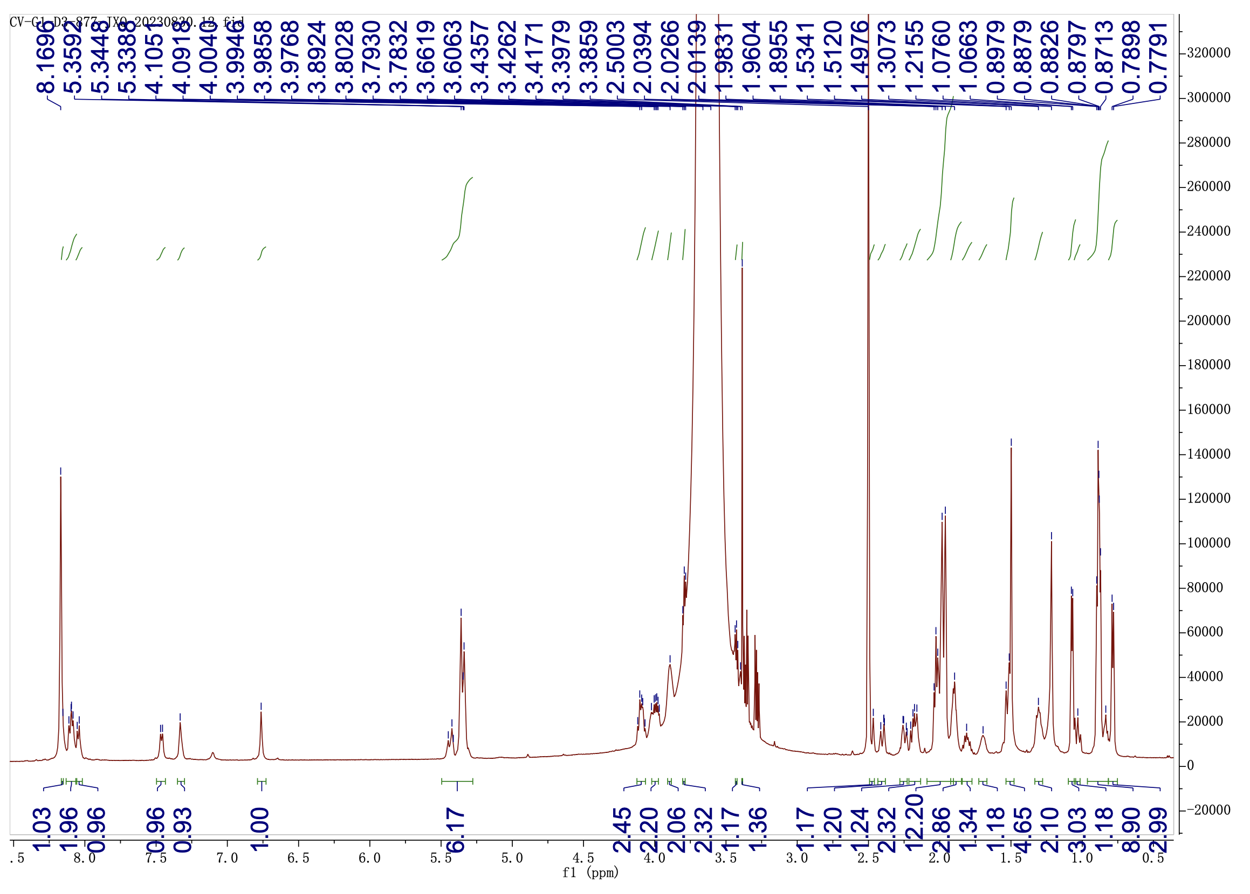

Supplementary Fig 55. ¹H NMR (600 MHz) spectrum of chromopeptin Ⅱb (9) in DMSO-d₆

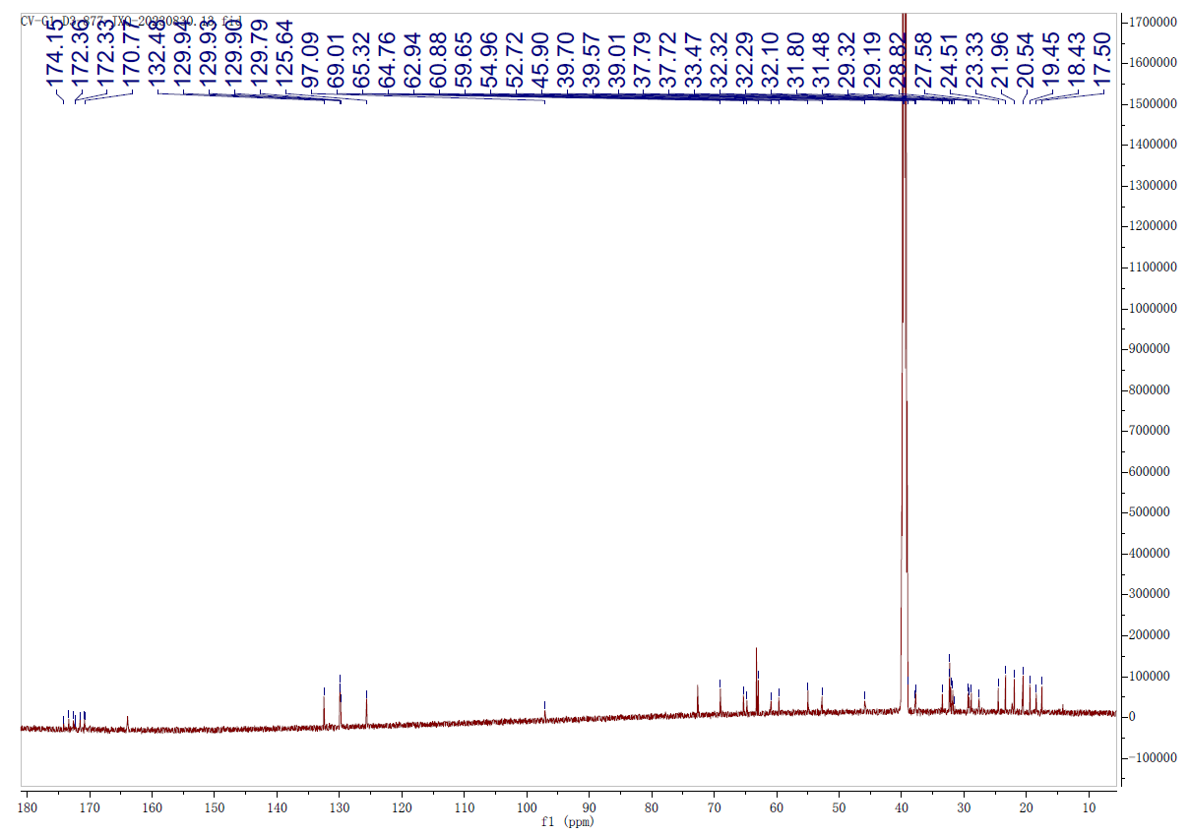

Supplementary Fig 56. ¹³C NMR (150 MHz) spectrum of chromopeptin Ⅱb (9) in DMSO-d₆

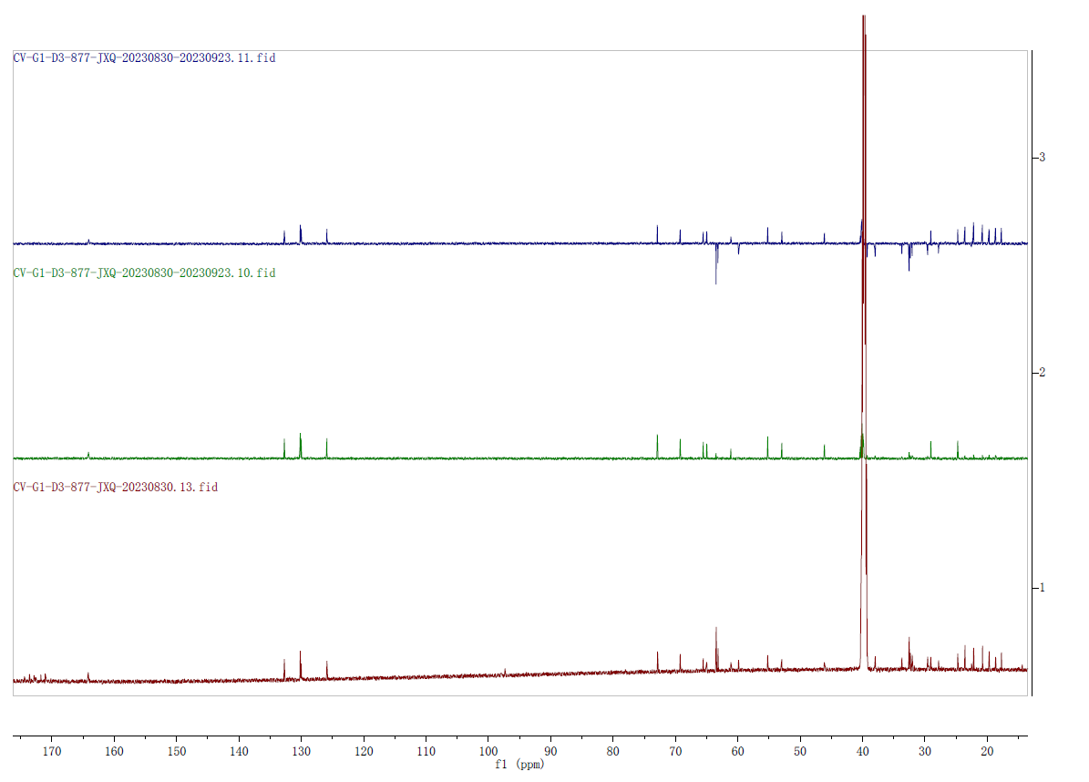
DEPT 135
DEPT 90
¹³C NMR

Supplementary Fig 57. DEPT 90 and DEPT 135 spectra of chromopeptin Ⅱb (9) in DMSO-d₆

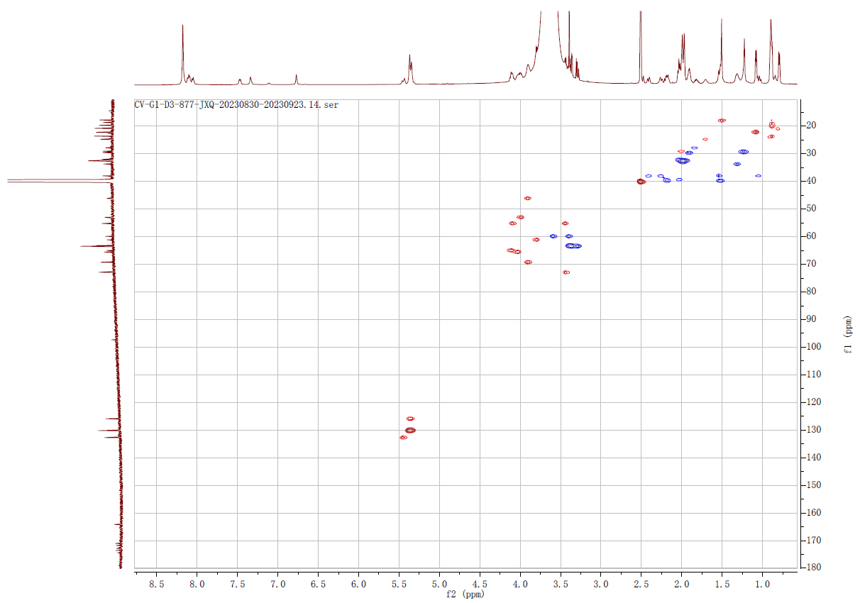

Supplementary Fig 58. HSQC spectrum of chromopeptin Ⅱb (9) in DMSO-d₆

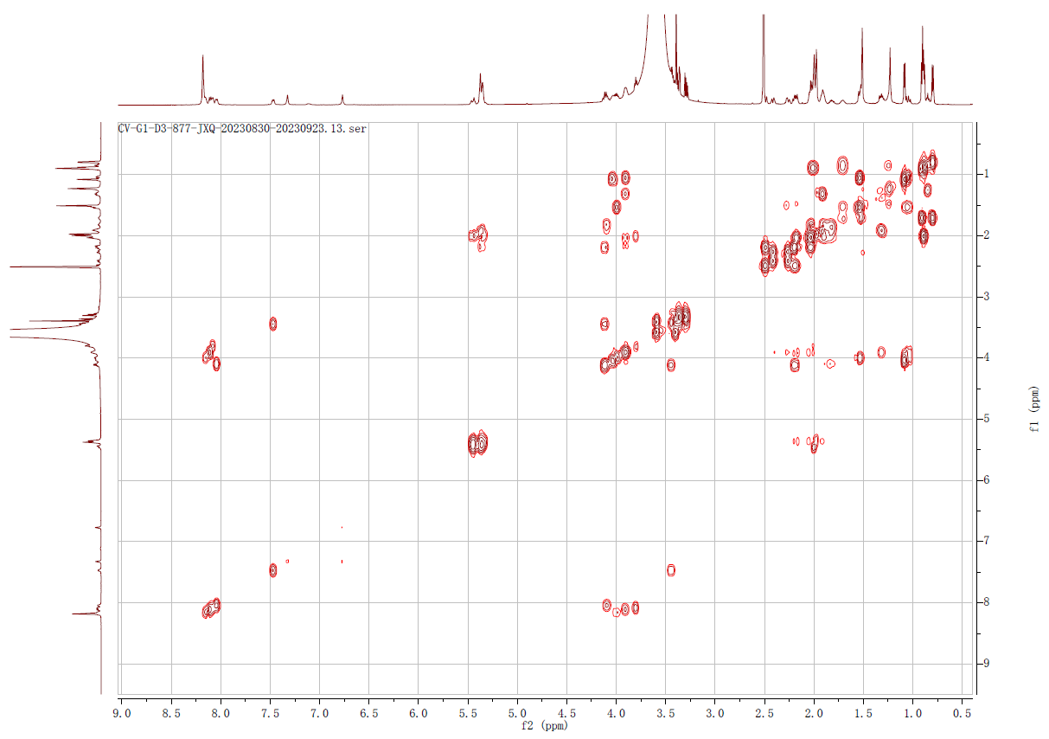

Supplementary Fig 59. ¹H-¹H COSY spectrum of chromopeptin Ⅱb (9) in DMSO-d₆

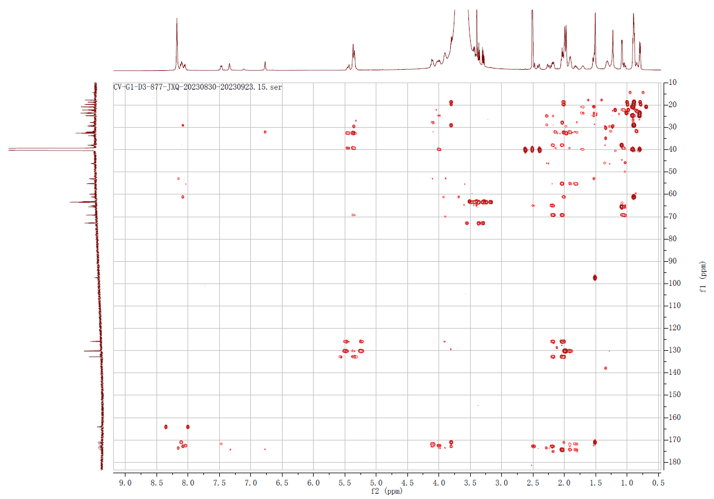

Supplementary Fig 60. HMBC spectrum of chromopeptin Ⅱb (9) in DMSO-d₆

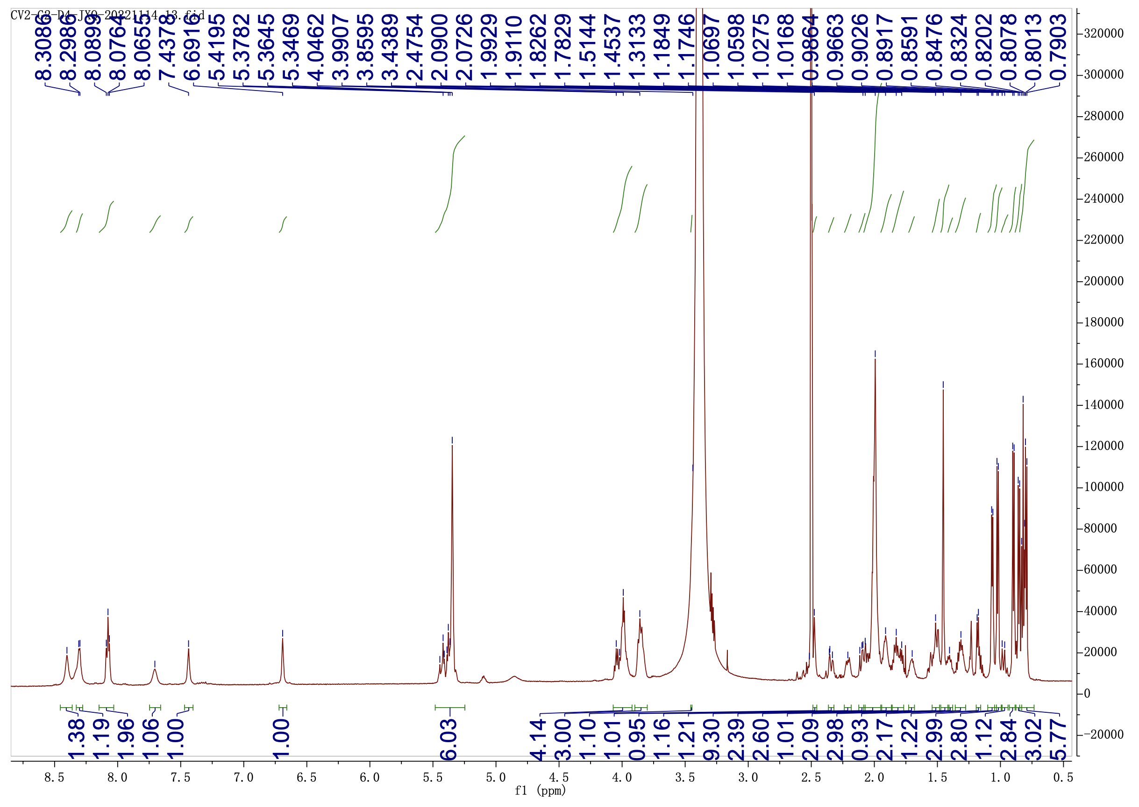

Supplementary Fig 61. ¹H NMR (600 MHz) spectrum of chromopeptin Ⅱc (10) in DMSO-d₆

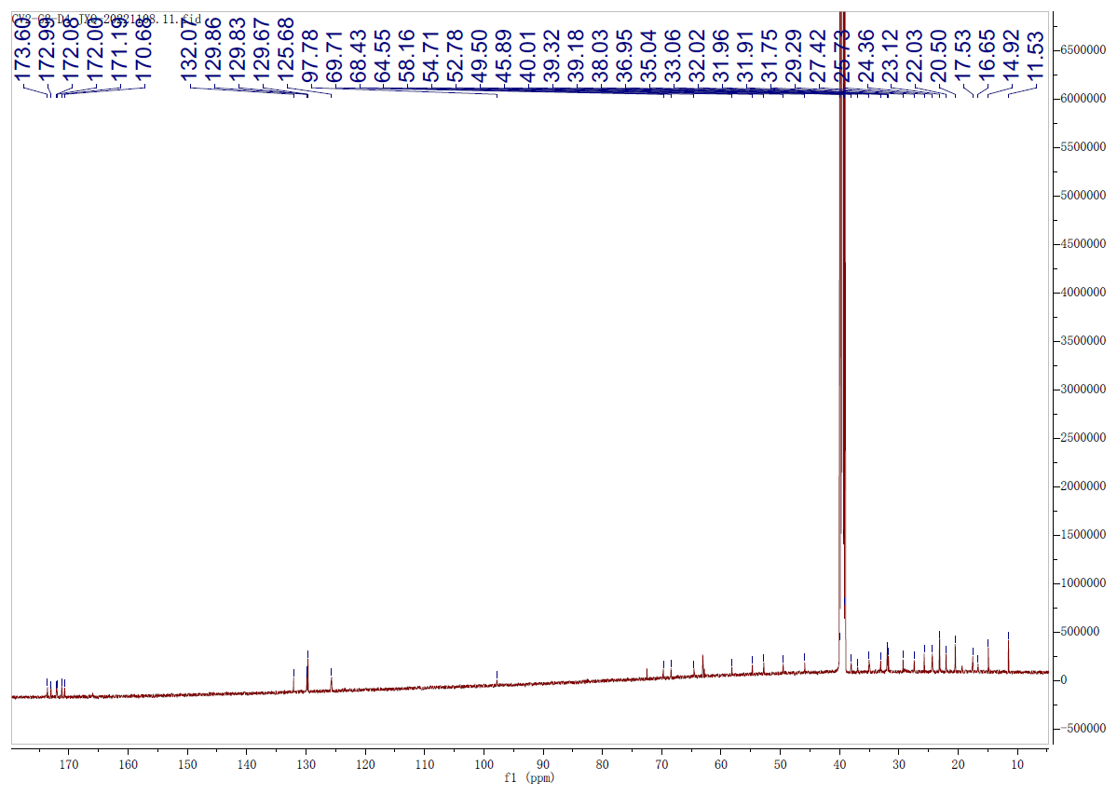

Supplementary Fig 62. ¹³C NMR (150 MHz) spectrum of chromopeptin Ⅱc (10) in DMSO-d₆

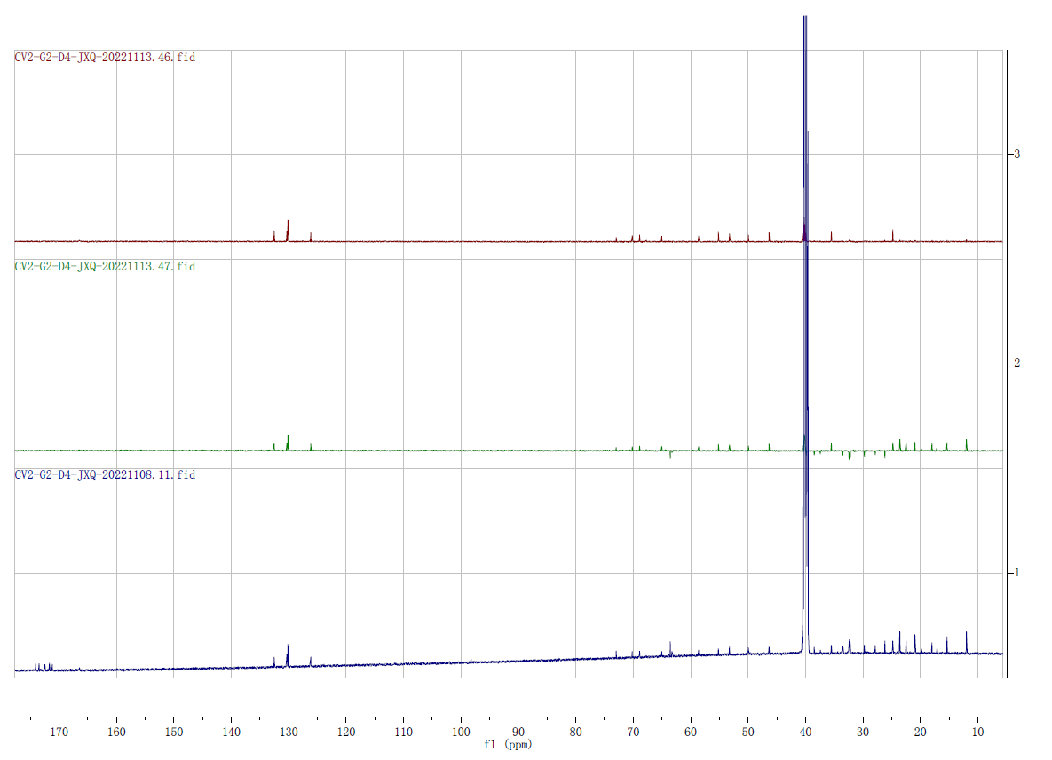
DEPT 135
DEPT 90
¹³C NMR

Supplementary Fig 63. DEPT 90 and DEPT 135 spectra of chromopeptin Ⅱc (10) in DMSO-d₆

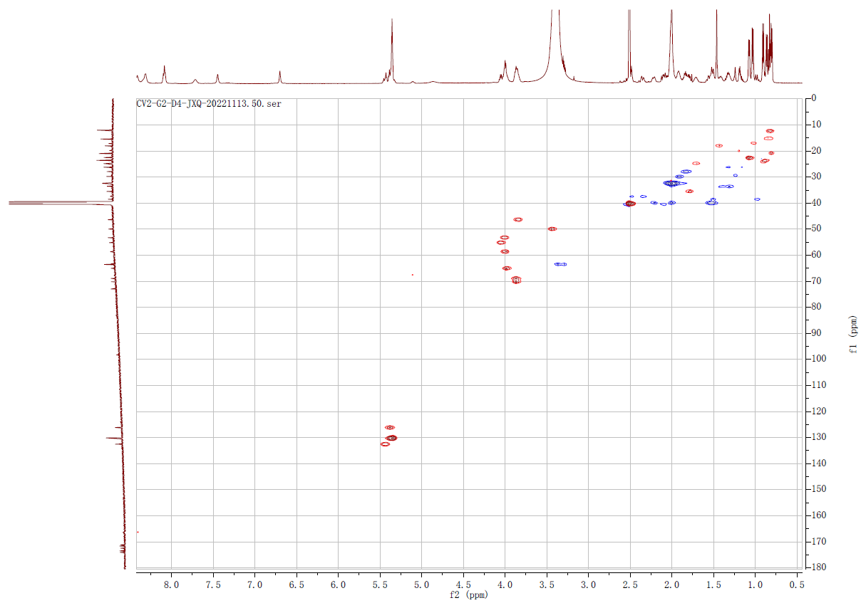

Supplementary Fig 64. HSQC spectrum of chromopeptin Ⅱc (10) in DMSO-d₆

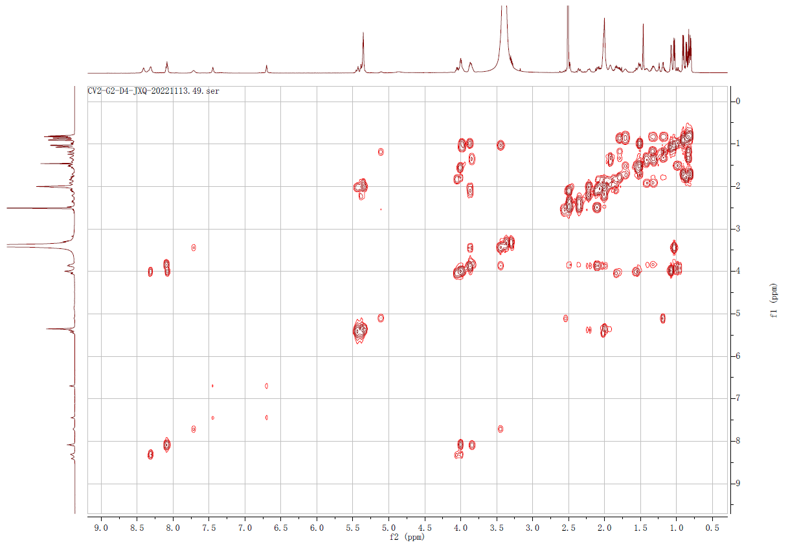

Supplementary Fig 65. ¹H-¹H COSY spectrum of chromopeptin Ⅱc (10) in DMSO-d₆

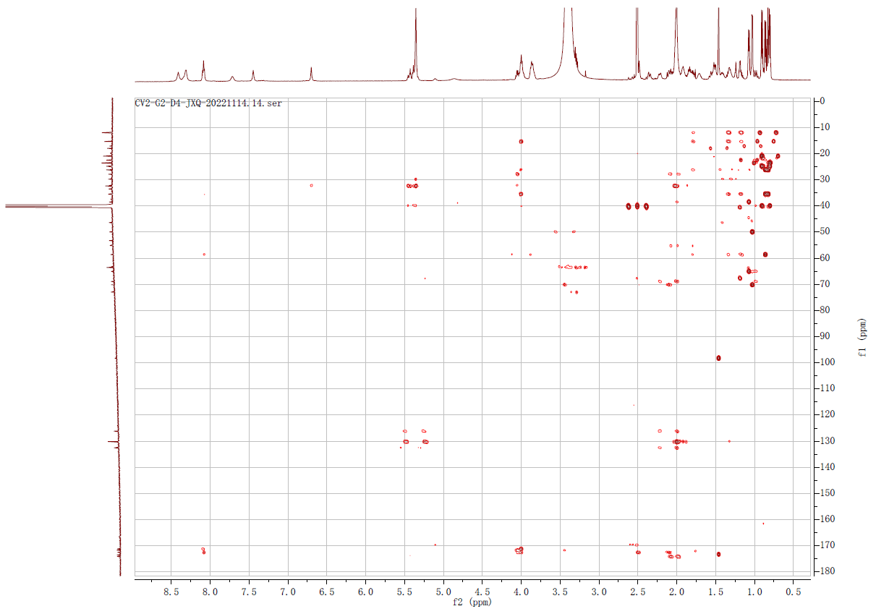

Supplementary Fig 66. HMBC spectrum of chromopeptin Ⅱc (10) in DMSO-d₆
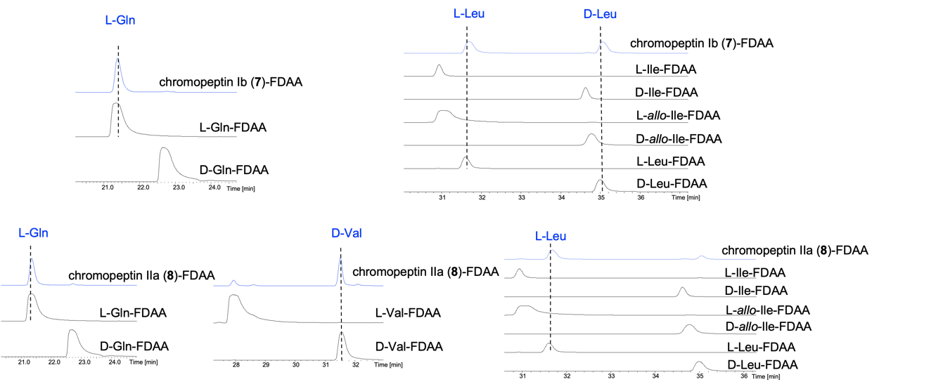
Supplementary Fig 67. The truncated HR-ESI-MS spectra of Marfey’s hydrolysis reaction of chromopeptins Ib (7), Ⅱa (8), and L- /D-standard amino acids. All hydrolysed chromopeptins and standard amino acids were derivatized by Marfey’s reagent (N2-(5-Fluoro-2,4-dinitrophenyl)-L-alaninamide, L-FDAA) for detection by LC-MS. The configurations of amino acids in compounds 7 and 8 are indicated by dashed lines and blue characters.

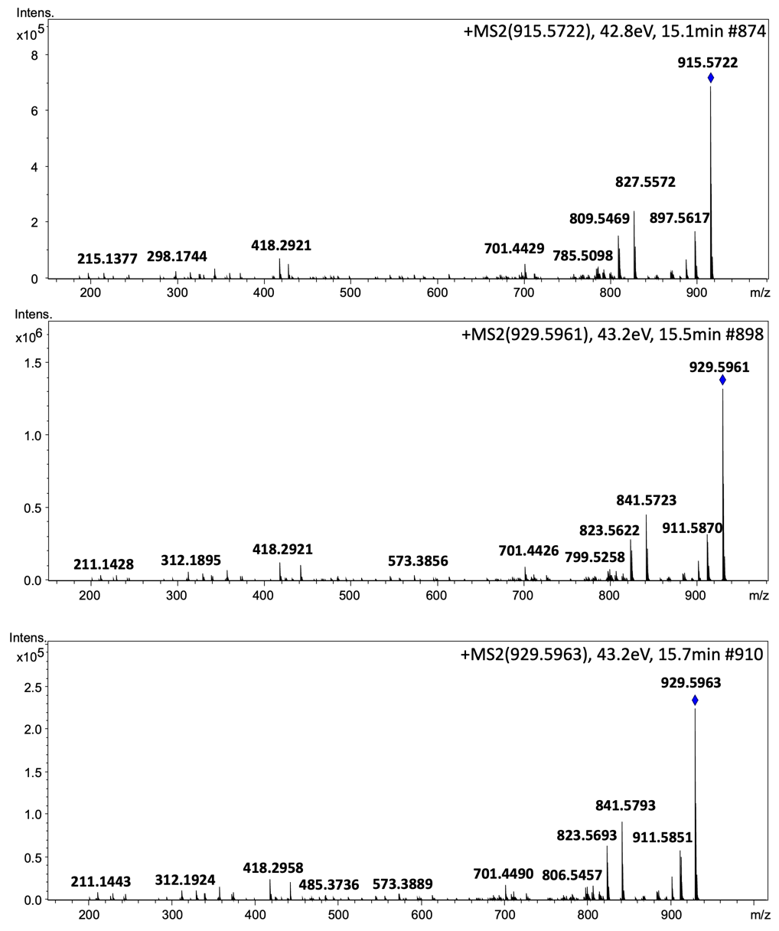

Supplementary Fig 68. HR-ESI-MS spectra of chitinimopeptins Ia, Ib, and Ic (11-13)

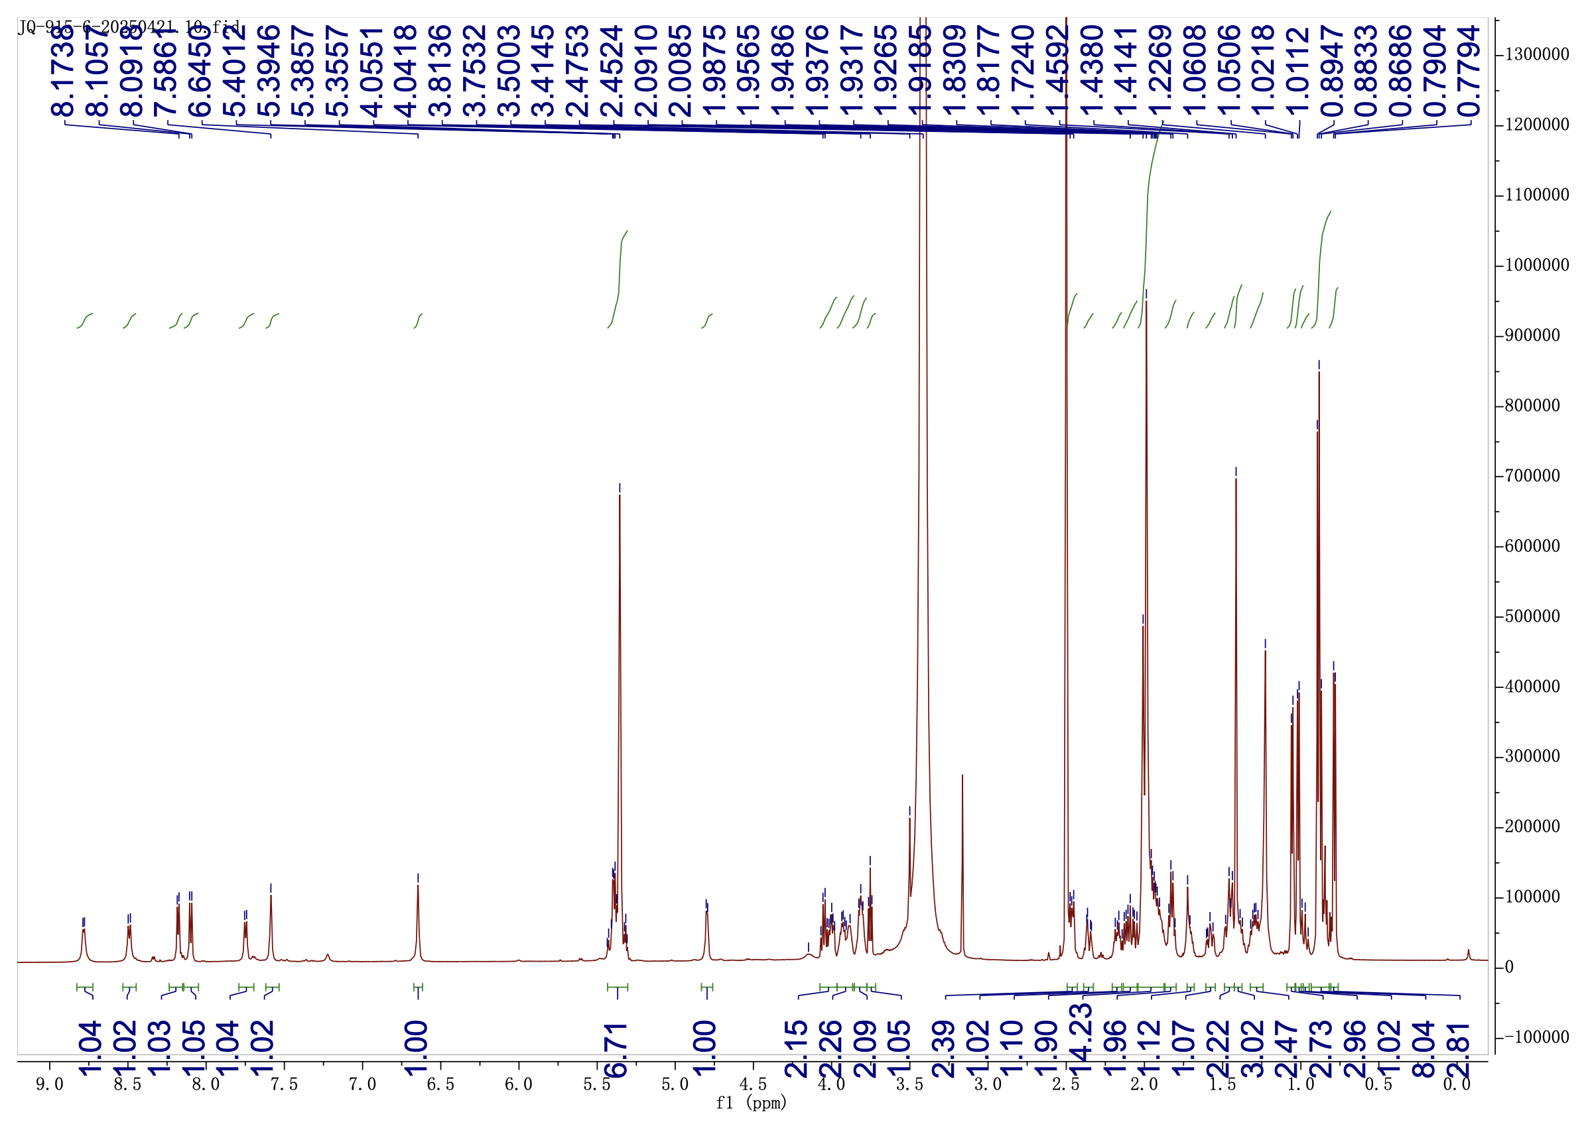

Supplementary Fig 69. ¹H NMR (600 MHz) spectrum of chitinimopeptin Ia (11) in DMSO-d₆

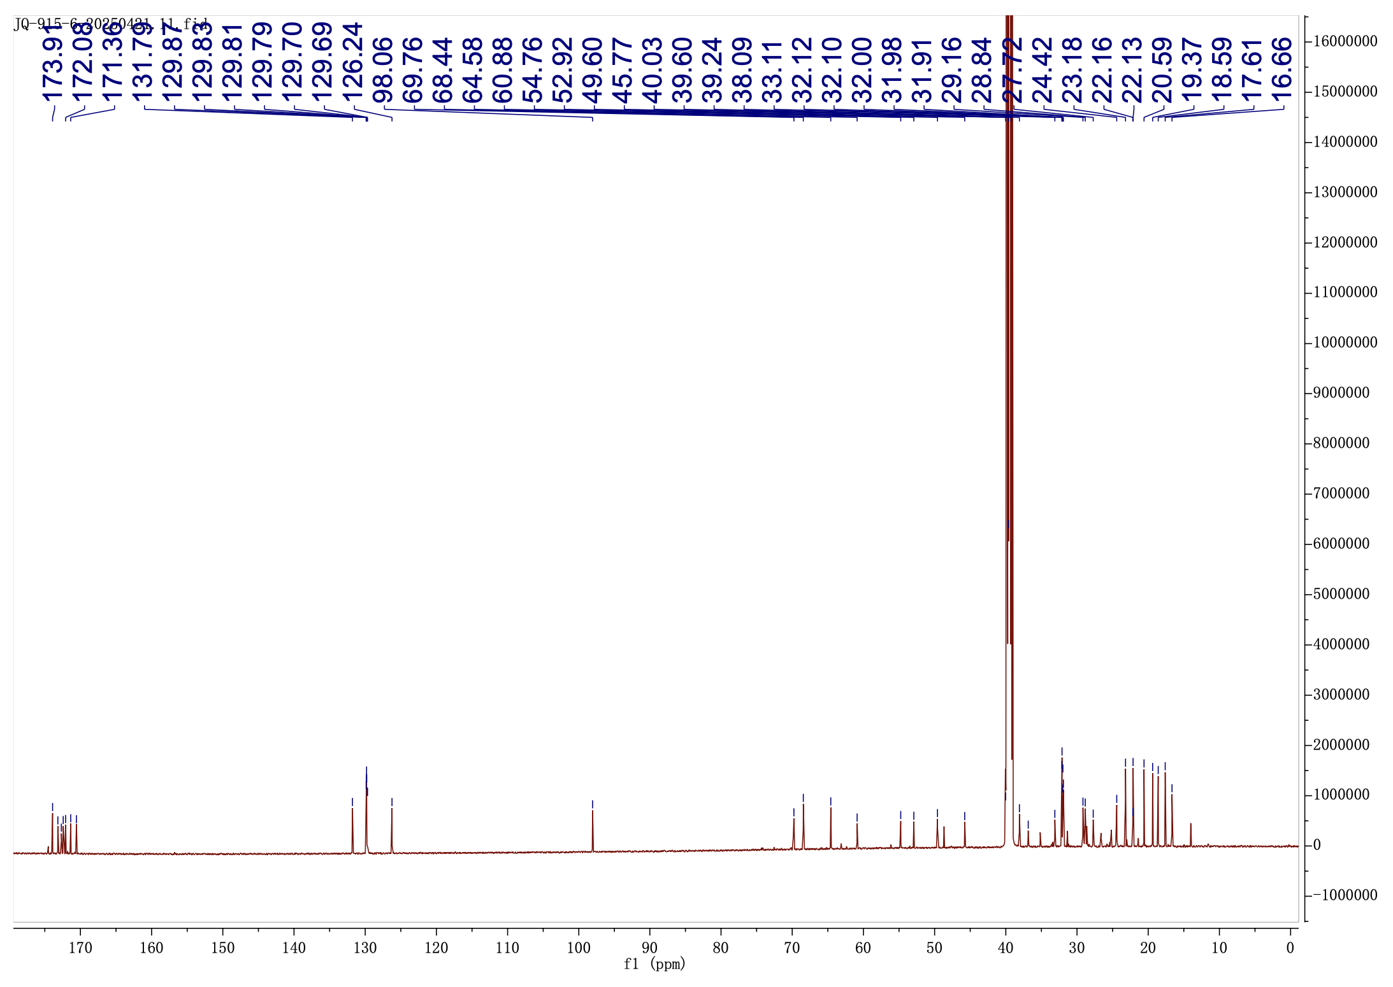

Supplementary Fig 70. ¹³C NMR (150 MHz) spectrum of chitinimopeptin Ia (11) in DMSO-d₆

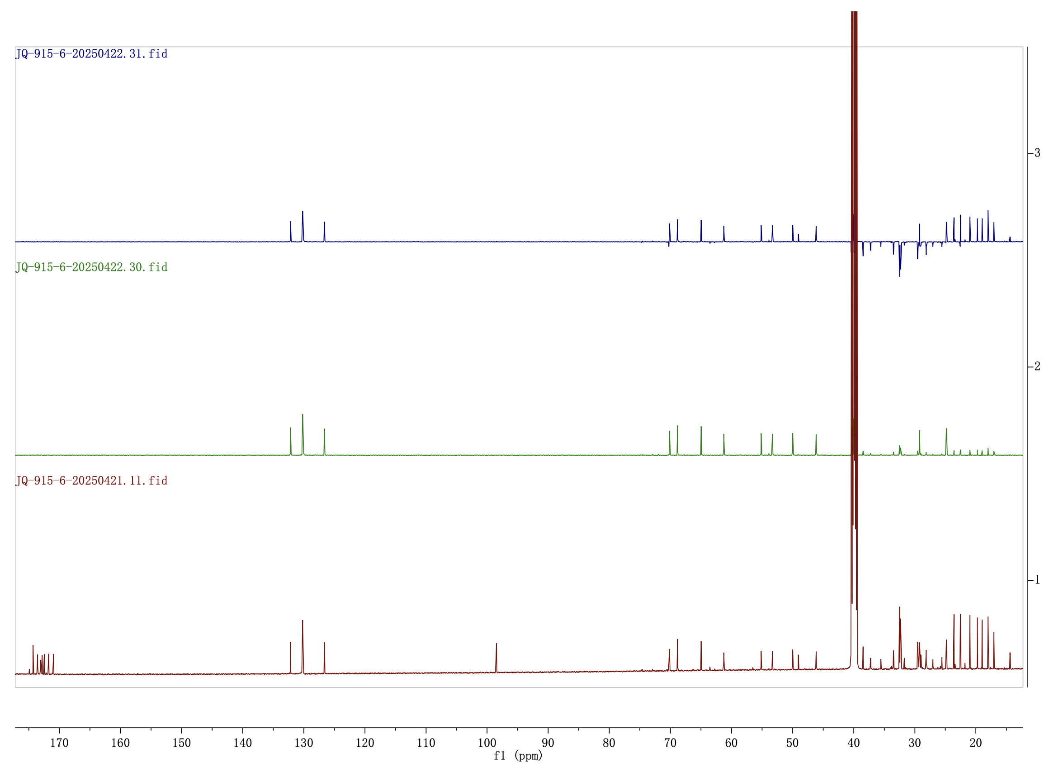
¹³C NMR
DEPT 90
DEPT 135

Supplementary Fig 71. DEPT 90 and DEPT 135 spectra of chitinimopeptin Ia (11) in DMSO-d₆

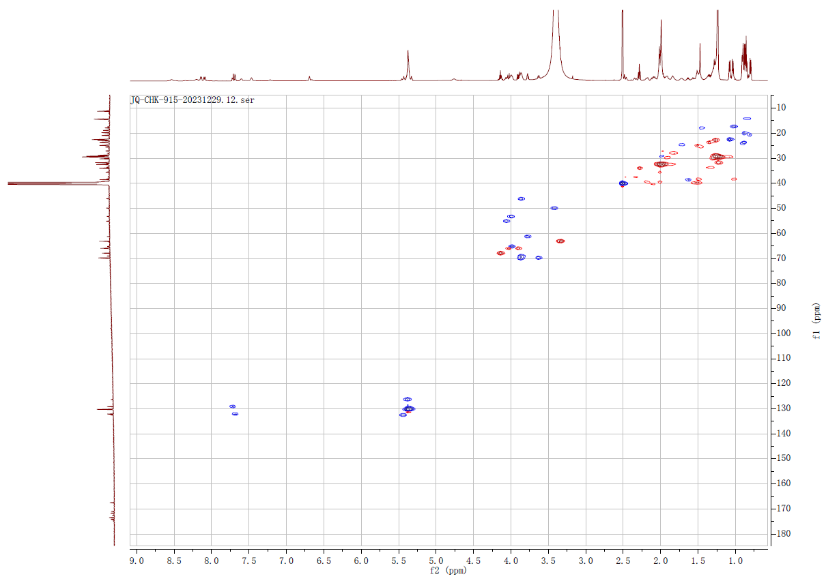

Supplementary Fig 72. HSQC spectrum of chitinimopeptin Ia (11) in DMSO-d₆

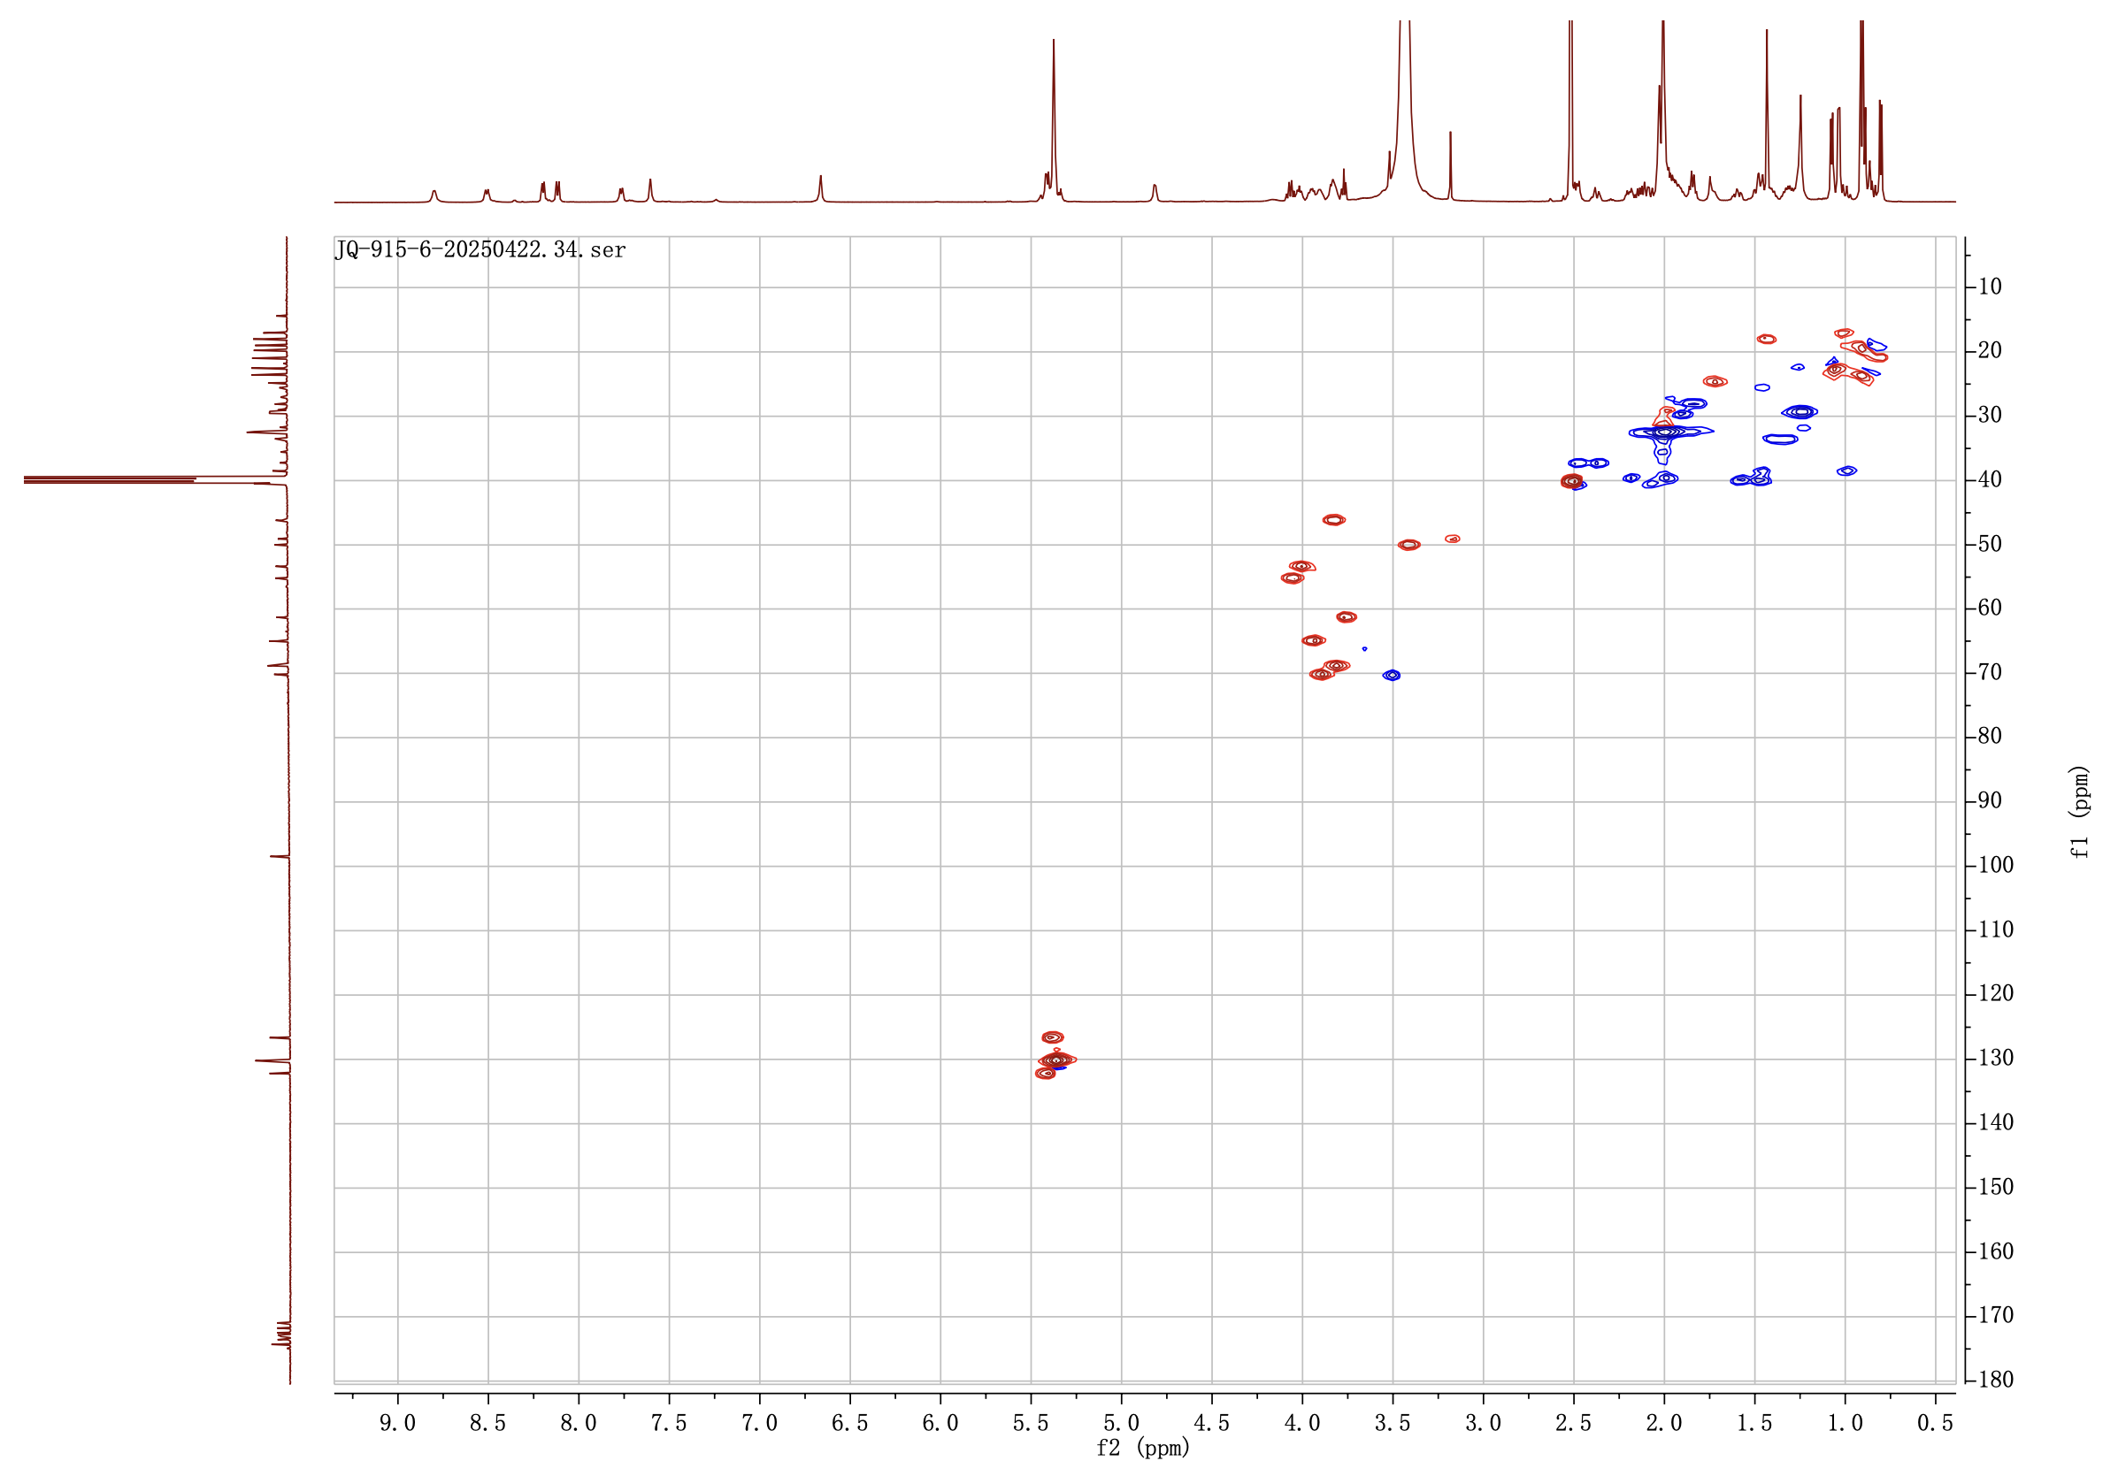

Supplementary Fig 73. ¹H-¹H COSY spectrum of chitinimopeptin Ia (11) in DMSO-d₆

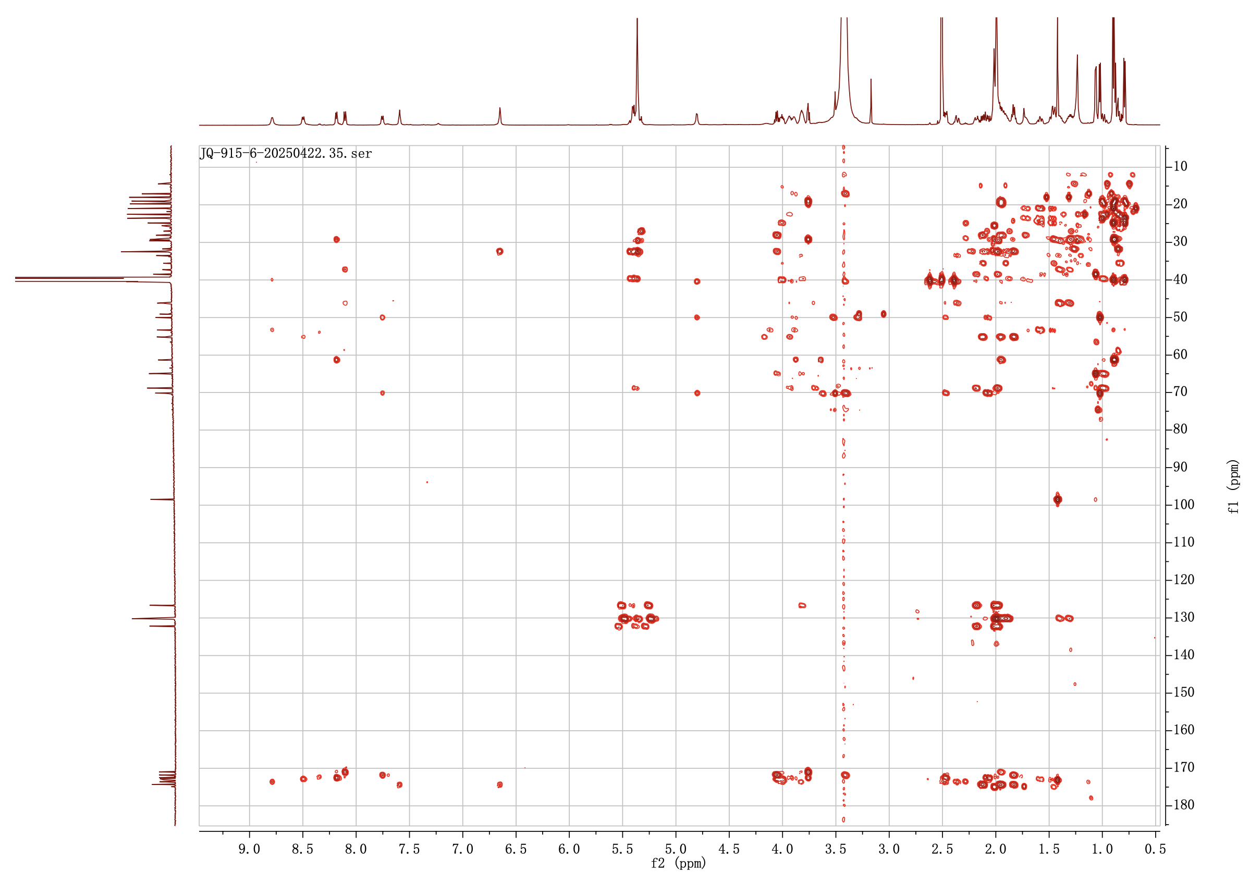

Supplementary Fig 74. HMBC spectrum of chitinimopeptin Ia (11) in DMSO-d₆

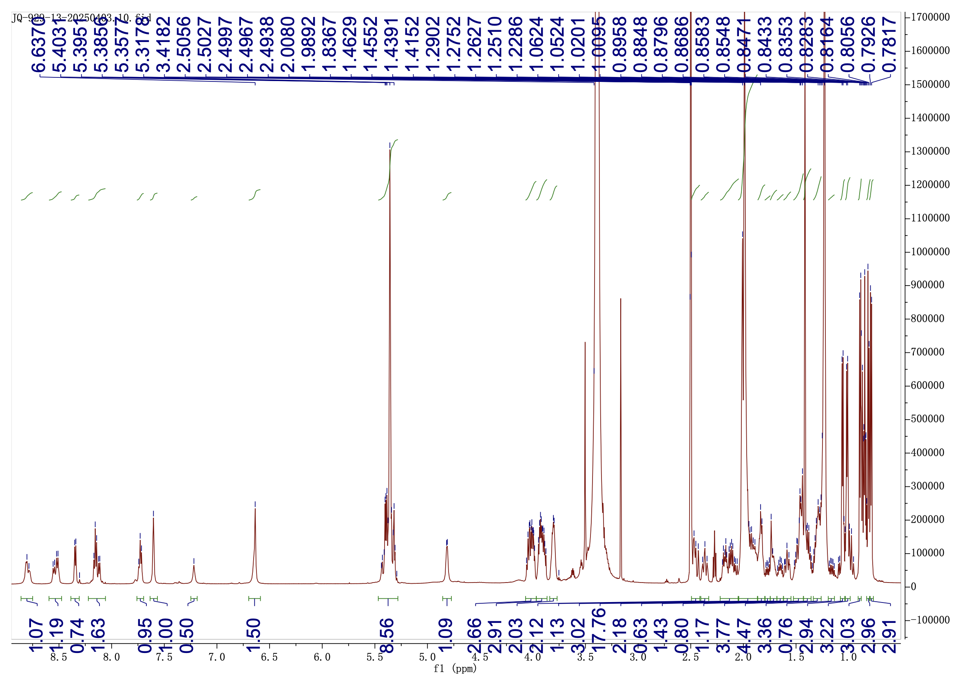

Supplementary Fig 75. ¹H NMR (600 MHz) spectrum of chitinimopeptins Ib/Ic (12-13) in DMSO-d₆

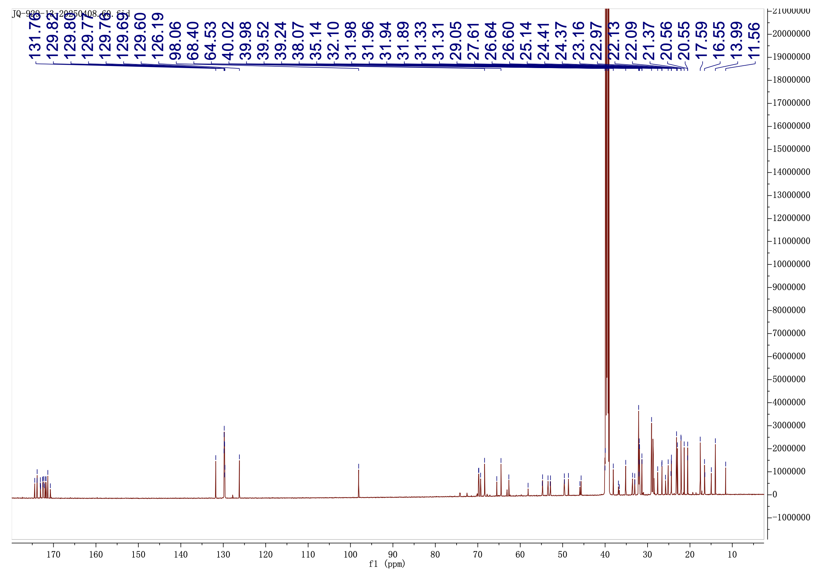

Supplementary Fig 76. ¹³C NMR (150 MHz) spectrum of chitinimopeptins Ib/Ic (12-13) in DMSO-d₆

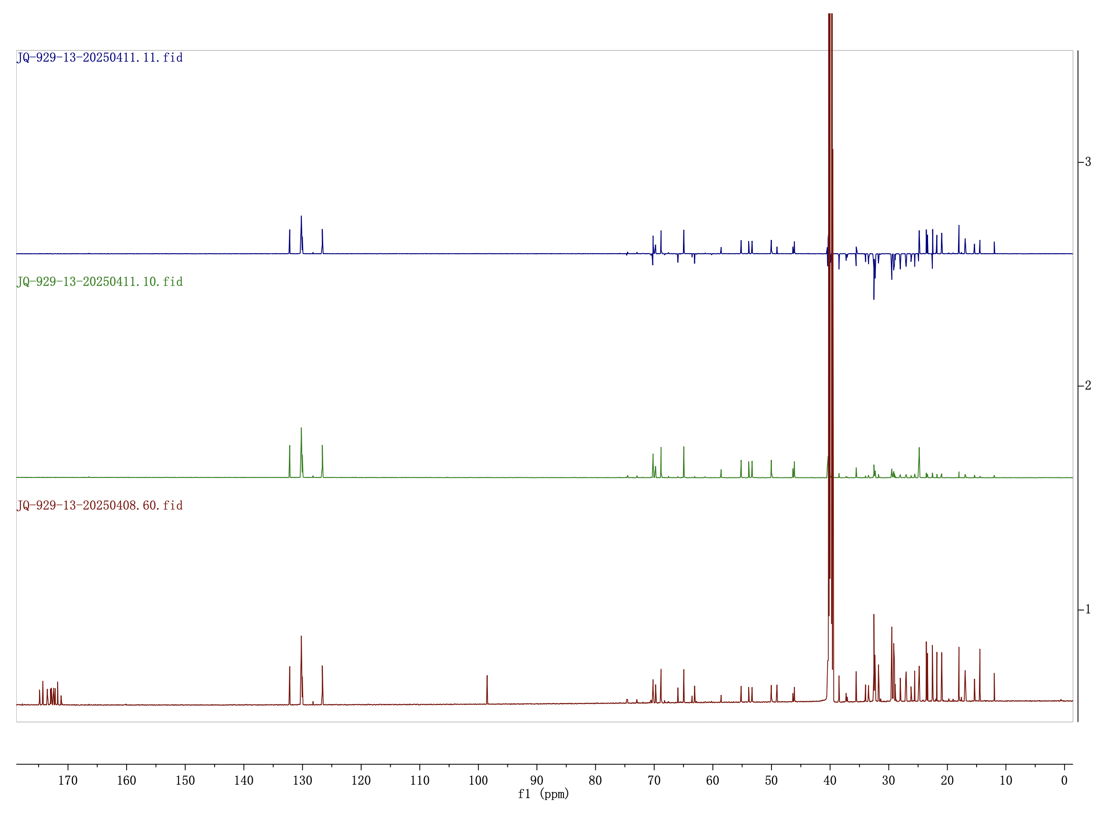
DEPT 90
¹³C NMR
DEPT 135

Supplementary Fig 77. DEPT 90 and DEPT 135 spectra of chitinimopeptins Ib/Ic (12-13) in DMSO-d₆

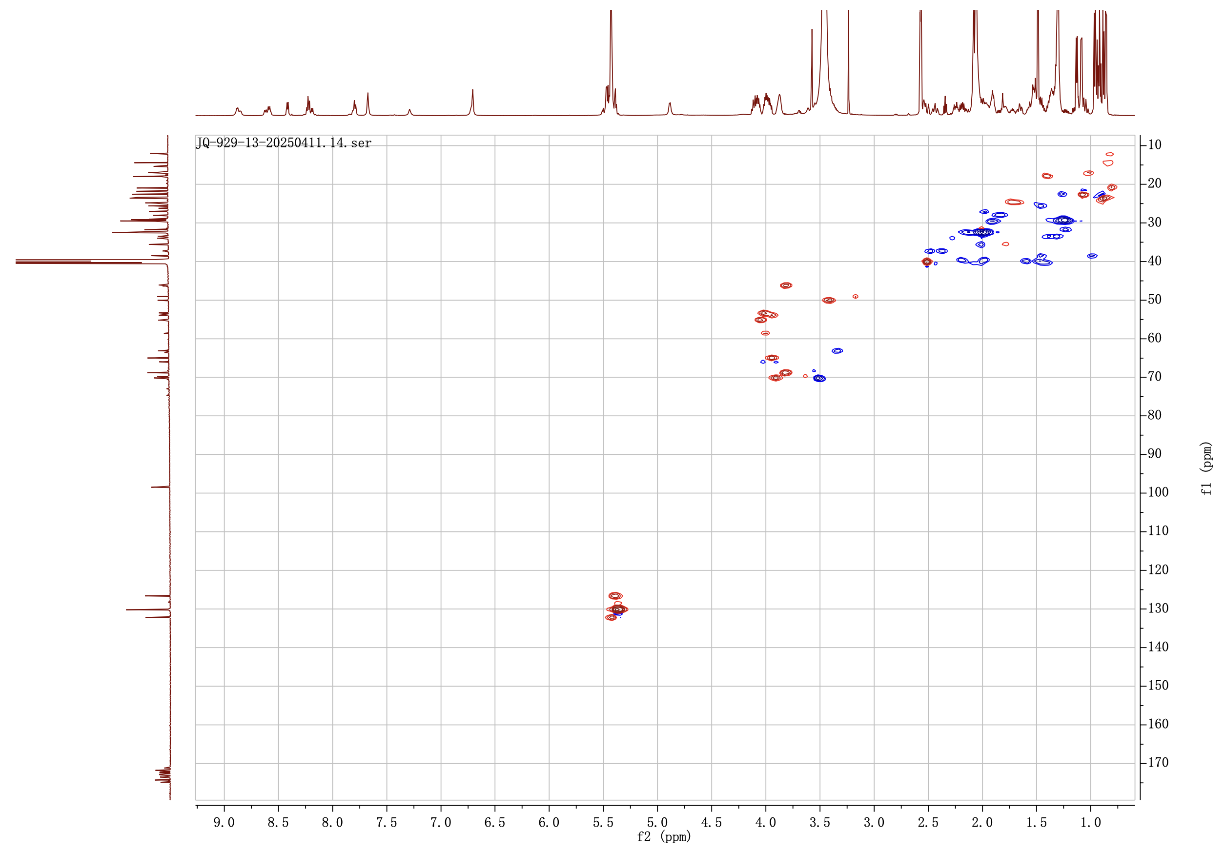

Supplementary Fig 78. HSQC spectrum of chitinimopeptins Ib/Ic (12-13) in DMSO-d₆

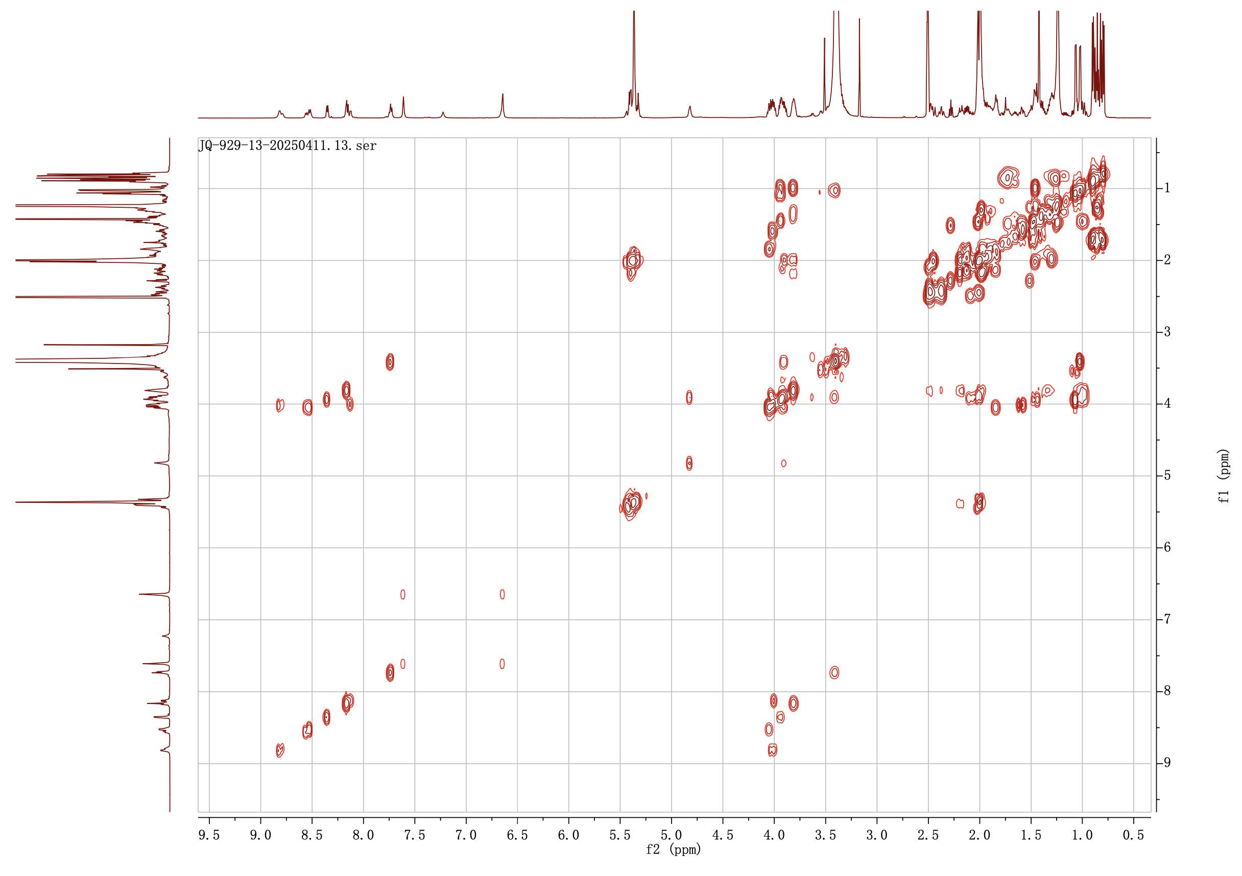

Supplementary Fig 79. ¹H-¹H COSY spectrum of chitinimopeptins Ib/Ic (12-13) in DMSO-d₆

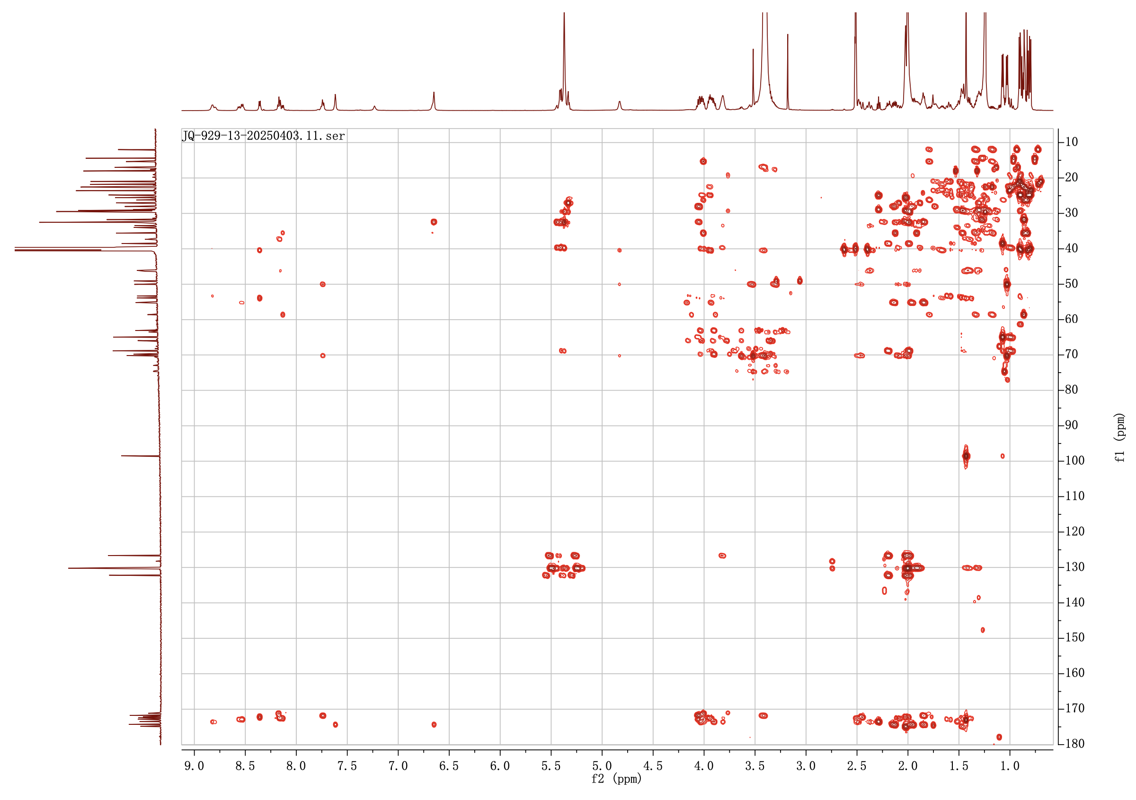

Supplementary Fig 80. HMBC spectrum of chitinimopeptins Ib/Ic (12-13) in DMSO-d₆

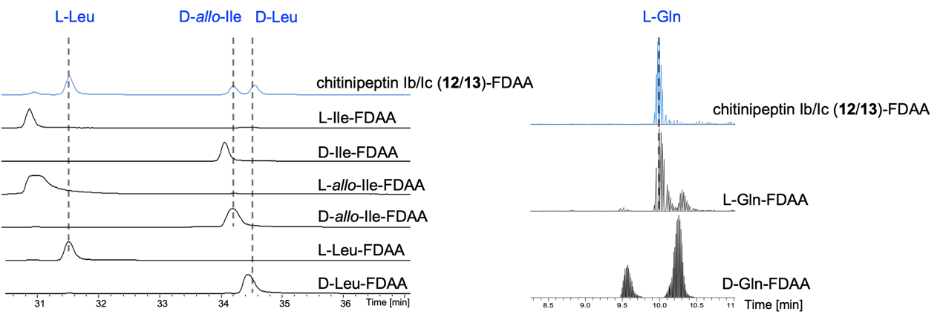
Supplementary Fig 81. The truncated HR-ESI-MS spectra of Marfey’s hydrolysis reaction of chitinimopeptins Ia/Ib (12/13) mixture, and L- /D-standard amino acids. All hydrolysed chromopeptins and standard amino acids were derivatized by Marfey’s reagent (N2-(5-Fluoro-2,4-dinitrophenyl)-L-alaninamide, L-FDAA) for detection by LC-MS. The configurations of amino acids in compounds 12/13 are indicated by dashed lines and blue characters.

References
1. Bruno S. Paulo, M.J.J.R., Sanghoon Lee, et al. Discovery of megapolipeptins by genome mining of a Burkholderiales bacteria collection. ChemRxiv (2024).

