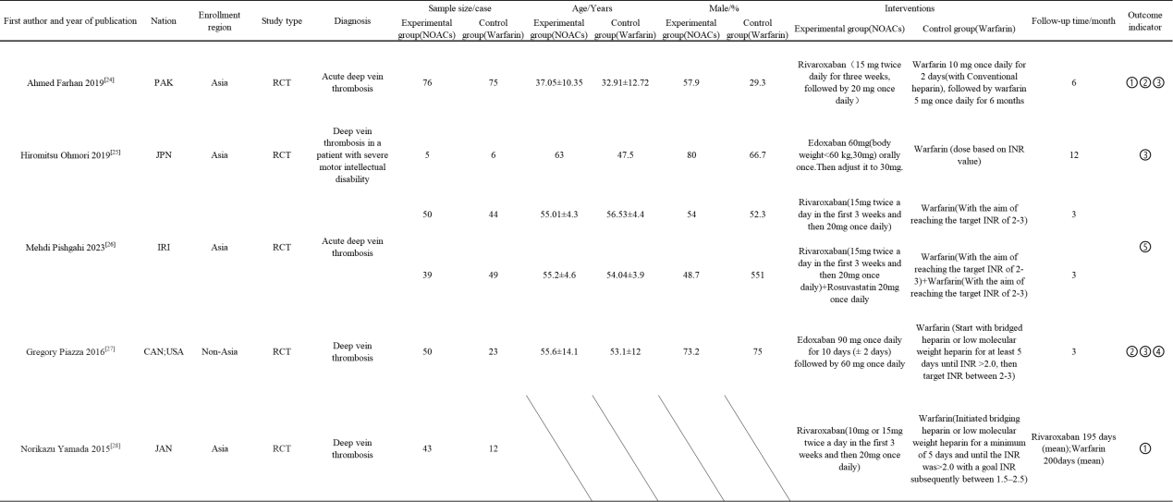
Continuation of table 1
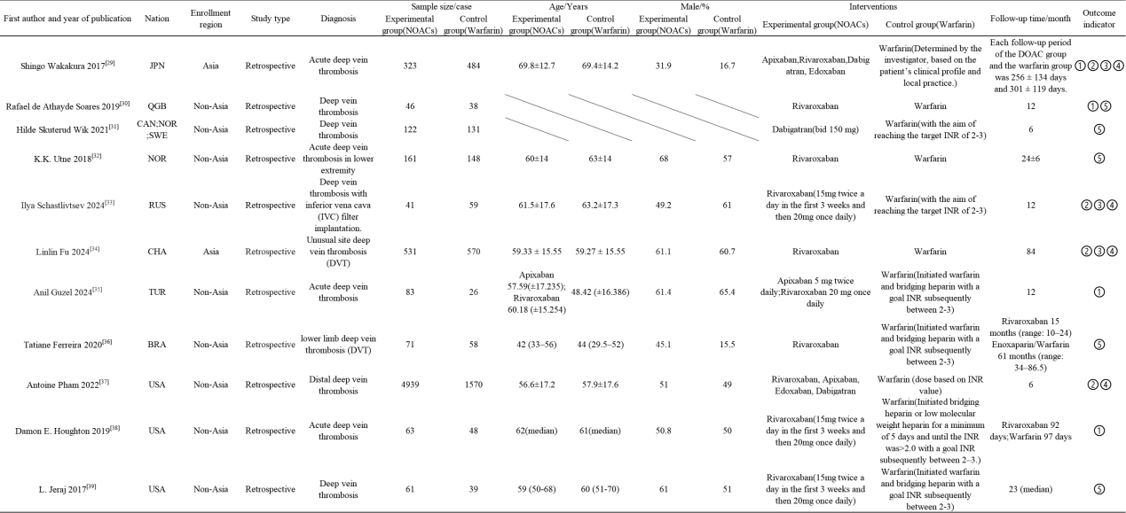
Note: ①The rate of vascular patency; ②The rate of major bleeding event; ③The rate of other bleeding events; ④The rate of other adverse events (pulmonary embolism, death, stroke or myocardial infarction);⑤PTS

