Supplementary Information

Table S1. The number of deaths cases and the age-standardized deaths rate of ovarian cancer attributable to occupational exposure to asbestos in 1990 and 2019, and its trends from 1990 to 2019 globally.
Table S2. The number of DALYs cases and the age-standardized DALYs rate of ovarian cancer attributable to occupational exposure to asbestos in 1990 and 2019, and its trends from 1990 to 2019 globally. Abbreviations: DALYs, disability-adjusted life years.
Table S3. The predicted results in the numbers and age-standardized rates of deaths and DALYs of ovarian cancer attributable to occupational exposure to asbestos by sex globally from 1990 to 2030 of the APC model. Abbreviations: DALYs, disability-adjusted-life-year; APC, age-period-cohort.
Table S4. The predicted results in the numbers and age-standardized rates of deaths and DALYs of ovarian cancer attributable to occupational exposure to asbestos by sex globally from 1990 to 2030 of the BAPC model. Abbreviations: DALYs, disability-adjusted-life-year; BAPC, Bayesian age-period-cohort.
Table S5. Changes in deaths numbers of ovarian cancer attributable to occupational exposure to asbestos based on the population-level determinants and causes between 1990 and 2019.
Table S6. Changes in DALYs numbers of ovarian cancer attributable to occupational exposure to asbestos based on the population-level determinants and causes between 1990 and 2019.
Figure S1. Numbers and age-standardized rates of ovarian cancer attributable to occupational exposure to asbestos deaths and DALYs for different age groups in 2019. Abbreviations: DALYs, disability-adjusted life years.
Figure S2. Numbers and age-standardized rates of ovarian cancer attributable to occupational exposure to asbestos deaths and DALYs for different SDI regions in 2019. Abbreviations: DALYs, disability-adjusted life years.
Figure S3. Numbers and age-standardized rates of ovarian cancer attributable to occupational exposure to asbestos deaths and DALYs for different GBD regions in 2019. Abbreviations: DALYs, disability-adjusted life years.
Figure S4. Trends in the numbers and age-standardized rates of ovarian cancer attributable to occupational exposure to asbestos deaths and DALYs globally by age groups from 1990 to 2019. Abbreviations: DALYs, disability-adjusted-life-years.
Figure S5. Trends in the numbers and age-standardized rates of ovarian cancer attributable to occupational exposure to asbestos deaths and DALYs globally by SDI regions from 1990 to 2019. Abbreviations: DALYs, disability-adjusted-life-years.
Figure S6. Results of cluster analysis based on the EAPC values of the age-standardized deaths and DALYs rates of ovarian cancer attributable to occupational exposure to asbestos from 1990 to 2019. Abbreviations: EAPC, estimated annual percentage change; DALYs, disability-adjusted-life-years.
Figure S7. The EAPC value for the age-standardized deaths and DALYs rates of ovarian cancer attributable to occupational exposure to asbestos from 1990 to 2019 (A and B). The relative change in the numbers of deaths and DALYs cases of ovarian cancer attributable to occupational exposure to asbestos between 1990 and 2019 (C and D). Abbreviations: EAPC, estimated annual percentage change; DALYs, disability-adjusted-life-years.

Table S1. The number of deaths cases and the age-standardized deaths rate of ovarian cancer attributable to occupational exposure to asbestos in 1990 and 2019, and its trends from 1990 to 2019 globally.
 | Number of deaths  cases (95% UI) in 1990 | The age-standardized deaths rate/100000 (95% UI) in 1990 | Number of deaths  cases (95% UI) in 2019 | The age-standardized deaths rate/100000 (95% UI) in 2019 | EAPC (95% CI)
Global | 4030 (1857-6541) | 0.12 (0.05-0.19) | 6557 (2951-10664) | 0.08 (0.04-0.14) | -1.12 (-1.16--1.07)
Age
<20 years | 0 (0-0) | 0 (0-0) | 0 (0-0) | 0 (0-0) | 0 (0-0)
20-24 years | 0 (0-1) | 0 (0-0) | 0 (0-1) | 0 (0-0) | -3.78 (-4.46--3.09)
25-29 years | 1 (0-3) | 0 (0-0) | 1 (0-2) | 0 (0-0) | -3.77 (-4.54--3)
30-34 years | 1 (0-3) | 0 (0-0) | 1 (0-2) | 0 (0-0) | -2.7 (-3.16--2.24)
35-39 years | 6 (1-18) | 0 (0-0.01) | 7 (2-18) | 0 (0-0) | -2.32 (-2.7--1.93)
40-44 years | 16 (6-38) | 0.01 (0-0.01) | 22 (7-42) | 0 (0-0.01) | -1.58 (-1.84--1.33)
45-49 years | 30 (13-57) | 0.01 (0.01-0.02) | 41 (17-75) | 0.01 (0-0.02) | -1.76 (-1.95--1.57)
50-54 years | 96 (40-169) | 0.05 (0.02-0.08) | 127 (53-228) | 0.03 (0.01-0.05) | -1.55 (-1.61--1.48)
55-59 years | 205 (88-355) | 0.11 (0.05-0.19) | 274 (117-467) | 0.07 (0.03-0.13) | -1.57 (-1.68--1.45)
60-64 years | 384 (168-641) | 0.24 (0.1-0.4) | 451 (197-767) | 0.14 (0.06-0.25) | -1.82 (-1.91--1.74)
65-69 years | 600 (266-985) | 0.49 (0.22-0.8) | 739 (314-1235) | 0.29 (0.12-0.48) | -1.76 (-1.88--1.65)
70-74 years | 670 (318-1090) | 0.79 (0.38-1.29) | 1062 (478-1761) | 0.57 (0.26-0.94) | -1.45 (-1.6--1.3)
75-79 years | 852 (389-1391) | 1.39 (0.63-2.27) | 1189 (524-1929) | 0.94 (0.41-1.52) | -1.42 (-1.54--1.31)
80-84 years | 677 (317-1090) | 1.92 (0.9-3.1) | 1216 (535-2019) | 1.44 (0.63-2.39) | -1.07 (-1.18--0.95)
85-89 years | 362 (165-597) | 2.4 (1.1-3.96) | 877 (381-1469) | 2.02 (0.88-3.38) | -0.44 (-0.69--0.19)
90-94 years | 105 (46-171) | 2.37 (1.04-3.88) | 405 (163-682) | 2.4 (0.97-4.04) | 0.39 (0.18-0.6)
95+ years | 25 (11-43) | 2.47 (1.07-4.13) | 146 (57-244) | 3.07 (1.2-5.1) | 1.19 (0.93-1.45)
SDI region
High SDI | 2619 (1183-4224) | 0.24 (0.11-0.39) | 3514 (1595-5854) | 0.16 (0.07-0.27) | -1.34 (-1.38--1.3)
High-middle SDI | 1059 (481-1700) | 0.1 (0.05-0.17) | 1721 (732-2822) | 0.09 (0.04-0.14) | -0.81 (-0.96--0.67)
Middle SDI | 180 (82-336) | 0.02 (0.01-0.04) | 634 (276-1087) | 0.03 (0.01-0.05) | 1.06 (0.99-1.12)
Low-middle SDI | 112 (43-241) | 0.02 (0.01-0.05) | 481 (197-892) | 0.04 (0.02-0.07) | 1.97 (1.9-2.05)
Low SDI | 58 (15-146) | 0.03 (0.01-0.07) | 203 (73-371) | 0.05 (0.02-0.08) | 1.72 (1.61-1.84)
GBD region
Africa | 78 (23-160) | 0.03 (0.01-0.06) | 239 (79-429) | 0.05 (0.02-0.08) | 1.16 (1.09-1.24)
African Region | 74 (21-152) | 0.04 (0.01-0.08) | 224 (71-406) | 0.06 (0.02-0.1) | 1.12 (1.04-1.21)
America | 865 (380-1400) | 0.14 (0.06-0.23) | 1513 (682-2536) | 0.12 (0.05-0.2) | -0.78 (-0.9--0.66)
Andean Latin America | 8 (3-15) | 0.04 (0.02-0.08) | 30 (11-60) | 0.06 (0.02-0.11) | 0.55 (0.33-0.76)
Asia | 455 (206-848) | 0.03 (0.01-0.05) | 1420 (635-2429) | 0.03 (0.01-0.06) | 0.6 (0.51-0.69)
Australasia | 83 (42-142) | 0.34 (0.17-0.59) | 160 (78-265) | 0.29 (0.15-0.48) | -0.34 (-0.52--0.15)
Caribbean | 2 (1-6) | 0.01 (0-0.02) | 12 (5-25) | 0.02 (0.01-0.05) | 2.83 (2.08-3.57)
Central Asia | 24 (7-60) | 0.05 (0.02-0.13) | 43 (14-85) | 0.07 (0.02-0.13) | 0.28 (0.05-0.52)
Central Europe | 121 (56-202) | 0.08 (0.04-0.14) | 214 (87-377) | 0.09 (0.04-0.17) | 0.89 (0.74-1.04)
Central Latin America | 27 (11-45) | 0.04 (0.02-0.06) | 102 (44-182) | 0.04 (0.02-0.08) | 0.94 (0.83-1.06)
Central Sub-Saharan Africa | 6 (1-15) | 0.03 (0.01-0.07) | 20 (5-43) | 0.05 (0.01-0.1) | 1.29 (1.13-1.45)
Commonwealth High Income | 701 (324-1121) | 0.44 (0.2-0.71) | 1012 (456-1632) | 0.36 (0.16-0.58) | -0.65 (-0.71--0.59)
Commonwealth Low Income | 25 (7-50) | 0.03 (0.01-0.07) | 96 (33-180) | 0.05 (0.02-0.09) | 1.48 (1.42-1.53)
Commonwealth Middle Income | 128 (44-272) | 0.03 (0.01-0.05) | 544 (213-1038) | 0.04 (0.02-0.08) | 1.27 (1.11-1.44)
East Asia | 114 (48-249) | 0.02 (0.01-0.03) | 411 (151-747) | 0.02 (0.01-0.04) | 1.38 (1.16-1.6)
East Asia & Pacific - WB | 319 (151-589) | 0.03 (0.01-0.05) | 874 (376-1497) | 0.03 (0.01-0.05) | 0.28 (0.15-0.4)
Eastern Europe | 325 (134-559) | 0.11 (0.05-0.2) | 406 (172-710) | 0.11 (0.05-0.2) | -0.32 (-0.6--0.04)
Eastern Mediterranean Region | 27 (8-68) | 0.02 (0.01-0.04) | 126 (40-316) | 0.03 (0.01-0.08) | 2.45 (2.36-2.55)
Eastern Sub-Saharan Africa | 36 (6-91) | 0.06 (0.01-0.13) | 111 (27-218) | 0.08 (0.02-0.16) | 1.48 (1.31-1.64)
Europe | 2629 (1181-4246) | 0.25 (0.11-0.4) | 3379 (1470-5576) | 0.2 (0.09-0.33) | -0.81 (-0.87--0.76)
Europe & Central Asia - WB | 2646 (1188-4264) | 0.24 (0.11-0.39) | 3405 (1476-5610) | 0.2 (0.09-0.32) | -0.79 (-0.84--0.74)
European Region | 2654 (1191-4275) | 0.24 (0.11-0.39) | 3418 (1485-5635) | 0.2 (0.09-0.32) | -0.8 (-0.85--0.75)
High-income Asia Pacific | 96 (44-166) | 0.05 (0.02-0.09) | 224 (91-396) | 0.04 (0.02-0.07) | -1.01 (-1.12--0.9)
High-income North America | 721 (316-1150) | 0.19 (0.08-0.31) | 1054 (468-1746) | 0.16 (0.07-0.26) | -0.81 (-0.97--0.64)
Latin America & Caribbean - WB | 144 (64-237) | 0.06 (0.03-0.1) | 461 (201-787) | 0.07 (0.03-0.12) | 0.68 (0.58-0.79)
Middle East & North Africa - WB | 14 (6-26) | 0.01 (0.01-0.03) | 36 (16-68) | 0.01 (0.01-0.02) | -0.47 (-0.6--0.34)
North Africa and Middle East | 71 (23-162) | 0.05 (0.02-0.1) | 156 (59-290) | 0.04 (0.02-0.08) | -0.24 (-0.72-0.24)
North America | 721 (316-1150) | 0.19 (0.08-0.31) | 1054 (468-1746) | 0.16 (0.07-0.26) | -0.81 (-0.97--0.64)
Oceania | 0 (0-1) | 0.01 (0-0.03) | 1 (0-2) | 0.01 (0-0.03) | 1.14 (0.93-1.34)
Region of the Americas | 865 (380-1400) | 0.14 (0.06-0.23) | 1513 (682-2536) | 0.12 (0.05-0.2) | -0.78 (-0.9--0.66)
South-East Asia Region | 106 (33-259) | 0.02 (0.01-0.04) | 451 (178-871) | 0.03 (0.01-0.06) | 1.4 (1.25-1.55)
South Asia | 106 (34-250) | 0.02 (0.01-0.05) | 488 (186-972) | 0.04 (0.01-0.08) | 1.57 (1.41-1.73)
South Asia - WB | 108 (35-255) | 0.02 (0.01-0.05) | 496 (189-984) | 0.04 (0.01-0.08) | 1.6 (1.44-1.75)
Southeast Asia | 27 (11-61) | 0.01 (0-0.03) | 85 (32-163) | 0.02 (0.01-0.03) | 0.89 (0.82-0.96)
Southern Latin America | 33 (15-60) | 0.07 (0.03-0.13) | 91 (38-161) | 0.11 (0.04-0.19) | 1.92 (1.65-2.19)
Southern Sub-Saharan Africa | 25 (10-42) | 0.11 (0.04-0.18) | 72 (29-122) | 0.15 (0.06-0.26) | 1.28 (0.98-1.58)
Sub-Saharan Africa - WB | 75 (21-155) | 0.04 (0.01-0.08) | 227 (71-409) | 0.06 (0.02-0.11) | 1.24 (1.16-1.32)
Tropical Latin America | 75 (32-121) | 0.1 (0.05-0.17) | 227 (103-374) | 0.1 (0.05-0.16) | -0.06 (-0.12-0.01)
Western Europe | 2122 (955-3437) | 0.34 (0.16-0.56) | 2628 (1161-4295) | 0.25 (0.11-0.41) | -1.13 (-1.21--1.06)
Western Pacific Region | 300 (143-547) | 0.03 (0.02-0.06) | 816 (351-1382) | 0.03 (0.01-0.05) | 0.2 (0.07-0.32)
Western Sub-Saharan Africa | 7 (2-16) | 0.01 (0-0.02) | 23 (7-46) | 0.01 (0-0.03) | 1.19 (1.01-1.36)
World Bank High Income | 3133 (1399-5065) | 0.23 (0.1-0.38) | 4266 (1931-7058) | 0.17 (0.07-0.28) | -1.22 (-1.26--1.18)
World Bank Low Income | 48 (12-121) | 0.04 (0.01-0.08) | 144 (46-271) | 0.05 (0.02-0.1) | 1.41 (1.29-1.54)
World Bank Lower Middle Income | 252 (92-512) | 0.03 (0.01-0.05) | 741 (306-1392) | 0.04 (0.01-0.07) | 0.51 (0.36-0.66)
World Bank Upper Middle Income | 595 (284-971) | 0.04 (0.02-0.07) | 1403 (588-2387) | 0.04 (0.02-0.07) | 0.04 (-0.07-0.15)
Countries
Afghanistan | 1 (0-6) | 0.01 (0-0.08) | 2 (0-10) | 0.02 (0-0.07) | 1.15 (1.02-1.29)
Albania | 0 (0-1) | 0.02 (0.01-0.04) | 1 (0-3) | 0.03 (0.01-0.06) | 2.16 (1.76-2.56)
Algeria | 1 (0-1) | 0.01 (0-0.01) | 2 (1-4) | 0.01 (0-0.02) | 0.22 (0.1-0.33)
American Samoa | 0 (0-0) | 0.06 (0.02-0.13) | 0 (0-0) | 0.09 (0.04-0.18) | 1.83 (0.48-3.19)
Andorra | 0 (0-0) | 0.18 (0.04-0.43) | 0 (0-0) | 0.14 (0.03-0.3) | -0.7 (-1.07--0.33)
Angola | 1 (0-2) | 0.02 (0.01-0.06) | 4 (1-9) | 0.05 (0.01-0.1) | 2.23 (2.13-2.34)
Antigua and Barbuda | 0 (0-0) | 0.01 (0-0.01) | 0 (0-0) | 0.02 (0.01-0.05) | 4.42 (3.38-5.48)
Argentina | 25 (11-46) | 0.08 (0.03-0.15) | 73 (30-133) | 0.13 (0.05-0.24) | 2.64 (2.32-2.96)
Armenia | 6 (2-12) | 0.23 (0.07-0.49) | 9 (3-20) | 0.22 (0.08-0.48) | -0.61 (-0.95--0.28)
Australia | 72 (36-126) | 0.36 (0.18-0.63) | 144 (71-239) | 0.31 (0.15-0.52) | -0.24 (-0.44--0.03)
Austria | 41 (18-71) | 0.32 (0.14-0.56) | 28 (13-51) | 0.14 (0.07-0.26) | -2.69 (-2.91--2.46)
Azerbaijan | 0 (0-1) | 0.01 (0-0.02) | 2 (1-4) | 0.02 (0.01-0.05) | 3.77 (3.35-4.18)
Bahamas | 0 (0-0) | 0.01 (0.01-0.03) | 0 (0-0) | 0.04 (0.01-0.07) | 3.46 (2.45-4.48)
Bahrain | 0 (0-0) | 0.03 (0.01-0.06) | 0 (0-0) | 0.03 (0.01-0.05) | -1.42 (-2.46--0.37)
Bangladesh | 7 (2-20) | 0.02 (0-0.04) | 28 (10-65) | 0.02 (0.01-0.06) | 1.21 (1.01-1.41)
Barbados | 0 (0-0) | 0.01 (0-0.02) | 0 (0-0) | 0.05 (0.02-0.09) | 5.71 (4.25-7.2)
Belarus | 18 (4-50) | 0.14 (0.03-0.4) | 20 (4-55) | 0.12 (0.02-0.34) | -0.69 (-1.02--0.37)
Belgium | 57 (27-96) | 0.35 (0.16-0.59) | 64 (28-112) | 0.24 (0.11-0.43) | -1.14 (-1.35--0.93)
Belize | 0 (0-0) | 0.01 (0-0.01) | 0 (0-0) | 0.02 (0.01-0.04) | 3.7 (2.47-4.95)
Benin | 0 (0-0) | 0.01 (0-0.02) | 0 (0-1) | 0.01 (0-0.03) | 0.74 (0.58-0.89)
Bermuda | 0 (0-0) | 0.2 (0.08-0.33) | 0 (0-0) | 0.09 (0.04-0.17) | -3.67 (-4.05--3.28)
Bhutan | 0 (0-0) | 0.02 (0.01-0.07) | 0 (0-1) | 0.05 (0.02-0.13) | 2.71 (2.64-2.78)
Bolivia (Plurinational State of) | 1 (0-4) | 0.05 (0.01-0.13) | 7 (2-16) | 0.09 (0.03-0.2) | 2.34 (2.19-2.5)
Bosnia and Herzegovina | 1 (0-2) | 0.02 (0.01-0.04) | 1 (0-3) | 0.02 (0.01-0.04) | -0.23 (-0.69-0.23)
Botswana | 0 (0-1) | 0.09 (0.03-0.2) | 2 (1-3) | 0.16 (0.06-0.34) | 1.76 (1.46-2.07)
Brazil | 75 (32-120) | 0.11 (0.05-0.17) | 225 (102-370) | 0.1 (0.05-0.17) | -0.11 (-0.17--0.05)
Brunei Darussalam | 0 (0-0) | 0.14 (0.06-0.28) | 0 (0-1) | 0.21 (0.09-0.39) | 1.49 (1.35-1.64)
Bulgaria | 2 (1-4) | 0.02 (0.01-0.03) | 5 (2-10) | 0.03 (0.01-0.06) | 2.19 (1.97-2.41)
Burkina Faso | 0 (0-1) | 0.01 (0-0.02) | 1 (0-2) | 0.01 (0-0.03) | 0.41 (0.02-0.79)
Burundi | 1 (0-4) | 0.06 (0.01-0.19) | 2 (0-5) | 0.06 (0.01-0.14) | -0.57 (-0.7--0.44)
Cabo Verde | 0 (0-0) | 0 (0-0) | 0 (0-0) | 0 (0-0.01) | 6.16 (5.6-6.73)
Cambodia | 1 (0-2) | 0.01 (0-0.05) | 3 (1-6) | 0.03 (0.01-0.06) | 2.55 (2.52-2.59)
Cameroon | 1 (0-1) | 0.01 (0-0.03) | 2 (0-5) | 0.02 (0-0.05) | 0.66 (0.44-0.88)
Canada | 65 (31-112) | 0.2 (0.09-0.34) | 122 (54-214) | 0.16 (0.07-0.29) | -0.51 (-0.63--0.4)
Central African Republic | 0 (0-1) | 0.04 (0.01-0.11) | 1 (0-2) | 0.04 (0.01-0.11) | 0.49 (0.43-0.56)
Chad | 0 (0-0) | 0.01 (0-0.02) | 0 (0-1) | 0.01 (0-0.02) | 0.19 (0.1-0.28)
Chile | 6 (3-11) | 0.07 (0.03-0.12) | 13 (6-25) | 0.05 (0.02-0.1) | -0.81 (-0.99--0.63)
China | 108 (45-244) | 0.02 (0.01-0.03) | 391 (142-708) | 0.02 (0.01-0.04) | 1.43 (1.19-1.68)
Colombia | 6 (3-11) | 0.04 (0.02-0.07) | 17 (7-36) | 0.03 (0.01-0.07) | -0.6 (-0.82--0.38)
Comoros | 0 (0-0) | 0.06 (0.01-0.13) | 1 (0-1) | 0.11 (0.02-0.26) | 2.41 (2.24-2.58)
Congo | 1 (0-1) | 0.06 (0.01-0.14) | 2 (0-3) | 0.07 (0.02-0.16) | 0.51 (0.34-0.68)
Cook Islands | 0 (0-0) | 0.01 (0-0.02) | 0 (0-0) | 0.01 (0-0.02) | 1.59 (1.29-1.9)
Costa Rica | 0 (0-0) | 0.01 (0-0.02) | 1 (0-2) | 0.02 (0.01-0.04) | 0.71 (0-1.41)
Croatia | 9 (4-14) | 0.14 (0.06-0.23) | 13 (5-25) | 0.13 (0.05-0.26) | 0.97 (0.34-1.6)
Cuba | 1 (0-1) | 0.01 (0-0.01) | 3 (1-6) | 0.02 (0.01-0.03) | 3.63 (2.44-4.83)
Cyprus | 2 (1-4) | 0.22 (0.08-0.5) | 3 (1-6) | 0.17 (0.05-0.31) | -1.02 (-1.3--0.74)
Czechia | 21 (10-37) | 0.15 (0.07-0.26) | 22 (9-41) | 0.1 (0.04-0.18) | -1.7 (-2.07--1.33)
Côte d'Ivoire | 0 (0-1) | 0.01 (0-0.02) | 1 (0-3) | 0.01 (0-0.03) | 0.9 (0.72-1.08)
Democratic People's Republic of Korea | 2 (1-6) | 0.02 (0.01-0.04) | 7 (2-15) | 0.02 (0.01-0.05) | 1.43 (1.21-1.66)
Democratic Republic of the Congo | 4 (1-10) | 0.03 (0.01-0.07) | 13 (3-29) | 0.04 (0.01-0.1) | 1.28 (1.06-1.49)
Denmark | 22 (11-38) | 0.26 (0.12-0.45) | 34 (15-60) | 0.27 (0.12-0.47) | -0.31 (-0.73-0.11)
Djibouti | 0 (0-0) | 0.05 (0.01-0.13) | 0 (0-1) | 0.1 (0.02-0.23) | 2.21 (2.1-2.31)
Dominica | 0 (0-0) | 0 (0-0) | 0 (0-0) | 0 (0-0.01) | 4.17 (3.43-4.93)
Dominican Republic | 0 (0-0) | 0 (0-0.01) | 0 (0-1) | 0.01 (0-0.01) | 3.38 (2.6-4.17)
Ecuador | 1 (0-2) | 0.01 (0-0.04) | 7 (2-14) | 0.05 (0.02-0.1) | 5.96 (5.38-6.55)
Egypt | 1 (0-4) | 0 (0-0.02) | 4 (1-12) | 0.01 (0-0.02) | 1.62 (1.33-1.92)
El Salvador | 0 (0-0) | 0 (0-0.01) | 0 (0-1) | 0.01 (0-0.02) | 5.41 (5.13-5.68)
Equatorial Guinea | 0 (0-0) | 0.02 (0-0.07) | 0 (0-1) | 0.08 (0.02-0.2) | 4.66 (4.45-4.87)
Eritrea | 0 (0-1) | 0.05 (0.01-0.15) | 2 (0-6) | 0.12 (0.02-0.29) | 3.1 (2.85-3.35)
Estonia | 2 (1-3) | 0.08 (0.04-0.14) | 2 (1-5) | 0.08 (0.03-0.16) | 0.01 (-0.32-0.34)
Eswatini | 0 (0-1) | 0.12 (0.04-0.29) | 1 (0-2) | 0.18 (0.05-0.4) | 1.48 (0.93-2.04)
Ethiopia | 10 (1-44) | 0.06 (0.01-0.23) | 22 (5-49) | 0.06 (0.01-0.14) | 0.04 (-0.25-0.33)
Fiji | 0 (0-0) | 0.01 (0-0.01) | 0 (0-0) | 0.01 (0-0.01) | -1.05 (-1.41--0.69)
Finland | 27 (12-46) | 0.36 (0.16-0.6) | 34 (15-58) | 0.24 (0.1-0.41) | -1.59 (-1.71--1.46)
France | 266 (118-441) | 0.3 (0.13-0.49) | 397 (150-707) | 0.24 (0.09-0.44) | -0.31 (-0.48--0.14)
Gabon | 0 (0-1) | 0.06 (0.01-0.13) | 1 (0-2) | 0.09 (0.02-0.19) | 1.32 (1.07-1.57)
Gambia | 0 (0-0) | 0.01 (0-0.02) | 0 (0-0) | 0.02 (0-0.05) | 2.23 (1.91-2.55)
Georgia | 0 (0-1) | 0.01 (0-0.01) | 2 (0-5) | 0.04 (0.01-0.08) | 8.67 (6.98-10.39)
Germany | 491 (210-831) | 0.36 (0.16-0.61) | 469 (195-794) | 0.21 (0.09-0.35) | -2.06 (-2.28--1.83)
Ghana | 1 (0-1) | 0.01 (0-0.02) | 2 (1-5) | 0.02 (0.01-0.04) | 1.16 (0.85-1.46)
Greece | 18 (4-49) | 0.11 (0.03-0.31) | 20 (6-48) | 0.08 (0.02-0.19) | -2.52 (-3.08--1.95)
Greenland | 0 (0-0) | 0.59 (0.23-1.19) | 0 (0-0) | 0.27 (0.11-0.5) | -3.8 (-4.33--3.28)
Grenada | 0 (0-0) | 0.03 (0.01-0.06) | 0 (0-0) | 0.11 (0.05-0.19) | 4.92 (3.78-6.08)
Guam | 0 (0-0) | 0 (0-0.01) | 0 (0-0) | 0 (0-0.01) | -3.28 (-4.16--2.4)
Guatemala | 0 (0-0) | 0 (0-0.01) | 1 (0-2) | 0.01 (0-0.02) | 5.51 (5.06-5.96)
Guinea | 0 (0-1) | 0.02 (0-0.04) | 1 (0-3) | 0.02 (0-0.05) | 0.81 (0.76-0.85)
Guinea-Bissau | 0 (0-0) | 0.01 (0-0.04) | 0 (0-0) | 0.02 (0-0.05) | 1.35 (1.27-1.42)
Guyana | 0 (0-0) | 0.04 (0.02-0.09) | 1 (0-2) | 0.14 (0.05-0.26) | 3.37 (2.19-4.57)
Haiti | 1 (0-4) | 0.03 (0.01-0.12) | 3 (1-12) | 0.05 (0.01-0.18) | 2.26 (1.99-2.53)
Honduras | 0 (0-1) | 0.02 (0.01-0.05) | 4 (1-9) | 0.07 (0.02-0.17) | 4.08 (3.65-4.5)
Hungary | 16 (7-28) | 0.11 (0.05-0.19) | 18 (7-34) | 0.09 (0.04-0.17) | -0.99 (-1.18--0.81)
Iceland | 1 (0-1) | 0.25 (0.11-0.42) | 1 (0-1) | 0.11 (0.05-0.19) | -3.58 (-3.88--3.28)
India | 78 (23-189) | 0.02 (0.01-0.05) | 351 (129-690) | 0.03 (0.01-0.07) | 1.25 (1.05-1.46)
Indonesia | 9 (2-26) | 0.01 (0-0.03) | 34 (11-77) | 0.02 (0.01-0.04) | 2.46 (2.34-2.58)
Iran (Islamic Republic of) | 1 (0-1) | 0 (0-0.01) | 2 (1-5) | 0 (0-0.01) | 0.5 (0.17-0.83)
Iraq | 1 (0-3) | 0.01 (0-0.04) | 4 (1-9) | 0.02 (0.01-0.04) | 1.1 (0.93-1.26)
Ireland | 11 (3-29) | 0.25 (0.06-0.66) | 9 (2-23) | 0.11 (0.03-0.3) | -3.88 (-4.29--3.47)
Israel | 7 (3-12) | 0.14 (0.06-0.25) | 11 (5-21) | 0.09 (0.04-0.17) | -2.01 (-2.23--1.78)
Italy | 355 (152-581) | 0.38 (0.16-0.62) | 473 (197-785) | 0.28 (0.12-0.47) | -1.1 (-1.19--1.01)
Jamaica | 0 (0-0) | 0.01 (0-0.01) | 1 (0-2) | 0.03 (0.01-0.05) | 2.7 (1.14-4.28)
Japan | 91 (42-158) | 0.06 (0.03-0.1) | 204 (81-363) | 0.04 (0.02-0.08) | -0.95 (-1.04--0.86)
Jordan | 0 (0-0) | 0.01 (0-0.03) | 0 (0-1) | 0.01 (0-0.02) | -2.59 (-3.28--1.89)
Kazakhstan | 16 (3-49) | 0.13 (0.02-0.39) | 21 (5-53) | 0.13 (0.03-0.31) | -1 (-1.42--0.57)
Kenya | 2 (0-5) | 0.03 (0.01-0.07) | 14 (4-28) | 0.08 (0.02-0.17) | 3.59 (3.41-3.78)
Kiribati | 0 (0-0) | 0.01 (0-0.03) | 0 (0-0) | 0.02 (0.01-0.05) | 2.32 (1.93-2.71)
Kuwait | 0 (0-0) | 0.01 (0-0.02) | 0 (0-0) | 0.01 (0-0.01) | 2 (1.25-2.76)
Kyrgyzstan | 0 (0-1) | 0.01 (0-0.02) | 1 (0-1) | 0.02 (0.01-0.03) | 3.62 (3.04-4.21)
Lao People's Democratic Republic | 0 (0-1) | 0.01 (0-0.06) | 1 (0-2) | 0.02 (0.01-0.04) | 0.68 (0.64-0.72)
Latvia | 3 (1-6) | 0.09 (0.04-0.16) | 4 (1-8) | 0.09 (0.03-0.18) | -0.5 (-0.85--0.15)
Lebanon | 0 (0-1) | 0.02 (0.01-0.04) | 1 (0-3) | 0.02 (0.01-0.06) | 0.69 (0.57-0.8)
Lesotho | 1 (0-1) | 0.07 (0.02-0.15) | 2 (1-5) | 0.2 (0.06-0.5) | 4.74 (4.3-5.19)
Liberia | 0 (0-0) | 0.01 (0-0.02) | 0 (0-1) | 0.01 (0-0.04) | 1.55 (1.24-1.87)
Libya | 0 (0-0) | 0.01 (0-0.02) | 1 (0-2) | 0.01 (0-0.03) | 1.94 (1.71-2.17)
Lithuania | 8 (3-14) | 0.18 (0.07-0.3) | 7 (3-12) | 0.11 (0.04-0.2) | -2.55 (-2.93--2.16)
Luxembourg | 1 (1-2) | 0.24 (0.11-0.42) | 1 (1-2) | 0.13 (0.05-0.23) | -2.11 (-2.24--1.97)
Madagascar | 2 (0-4) | 0.04 (0.01-0.08) | 5 (1-12) | 0.06 (0.01-0.13) | 1.18 (1.06-1.29)
Malawi | 2 (0-3) | 0.05 (0.01-0.1) | 4 (1-9) | 0.07 (0.02-0.15) | 1.58 (1.28-1.88)
Malaysia | 1 (0-1) | 0.01 (0-0.02) | 3 (1-7) | 0.02 (0-0.03) | 2.45 (2.2-2.7)
Maldives | 0 (0-0) | 0.02 (0-0.09) | 0 (0-0) | 0.02 (0.01-0.03) | -1.86 (-2.29--1.43)
Mali | 0 (0-1) | 0.01 (0-0.02) | 1 (0-2) | 0.01 (0-0.02) | 0.02 (-0.1-0.15)
Malta | 1 (0-2) | 0.22 (0.09-0.38) | 1 (1-3) | 0.14 (0.06-0.25) | -1.98 (-2.17--1.79)
Marshall Islands | 0 (0-0) | 0.02 (0.01-0.06) | 0 (0-0) | 0.03 (0.01-0.1) | 1.6 (1.24-1.96)
Mauritania | 0 (0-0) | 0.02 (0-0.04) | 0 (0-1) | 0.02 (0-0.04) | -0.2 (-0.31--0.08)
Mauritius | 0 (0-0) | 0.01 (0-0.01) | 0 (0-0) | 0.01 (0-0.02) | 0.88 (0.69-1.07)
Mexico | 19 (8-31) | 0.05 (0.02-0.08) | 71 (29-130) | 0.06 (0.03-0.12) | 1.14 (0.97-1.31)
Micronesia (Federated States of) | 0 (0-0) | 0.02 (0.01-0.07) | 0 (0-0) | 0.04 (0.01-0.11) | 2.19 (2.05-2.32)
Monaco | 0 (0-0) | 0.21 (0.08-0.45) | 0 (0-0) | 0.19 (0.06-0.39) | -0.28 (-0.43--0.13)
Mongolia | 0 (0-0) | 0.01 (0-0.03) | 1 (0-1) | 0.02 (0.01-0.05) | 0.89 (0.47-1.31)
Montenegro | 0 (0-1) | 0.05 (0.02-0.09) | 1 (0-1) | 0.06 (0.02-0.11) | 0.84 (0.51-1.18)
Morocco | 1 (0-3) | 0.01 (0-0.02) | 5 (1-11) | 0.02 (0-0.04) | 2.33 (2.2-2.47)
Mozambique | 3 (0-6) | 0.06 (0.01-0.12) | 9 (2-22) | 0.1 (0.02-0.24) | 2.15 (1.89-2.41)
Myanmar | 4 (1-12) | 0.02 (0-0.05) | 9 (3-20) | 0.02 (0.01-0.05) | 0.2 (-0.09-0.5)
Namibia | 0 (0-1) | 0.07 (0.03-0.13) | 1 (0-3) | 0.1 (0.04-0.22) | 1.07 (0.75-1.39)
Nauru | 0 (0-0) | 0.02 (0.01-0.08) | 0 (0-0) | 0.04 (0.01-0.1) | 1.62 (1.44-1.79)
Nepal | 2 (0-5) | 0.02 (0.01-0.06) | 11 (4-28) | 0.06 (0.02-0.15) | 3.71 (3.42-3.99)
Netherlands | 83 (39-134) | 0.4 (0.18-0.64) | 132 (60-228) | 0.35 (0.16-0.61) | -0.59 (-0.74--0.44)
New Zealand | 11 (5-18) | 0.26 (0.11-0.44) | 15 (6-27) | 0.18 (0.08-0.32) | -1.28 (-1.4--1.15)
Nicaragua | 0 (0-0) | 0 (0-0.01) | 1 (0-1) | 0.02 (0-0.03) | 6.77 (5.73-7.81)
Niger | 0 (0-0) | 0.01 (0-0.02) | 1 (0-1) | 0.01 (0-0.02) | 0.28 (0.1-0.46)
Nigeria | 3 (1-8) | 0.01 (0-0.02) | 11 (3-24) | 0.02 (0-0.03) | 1.61 (1.32-1.91)
Niue | 0 (0-0) | 0.02 (0.01-0.05) | 0 (0-0) | 0.03 (0.01-0.06) | 0.55 (0.44-0.67)
North Macedonia | 0 (0-1) | 0.02 (0.01-0.03) | 1 (0-2) | 0.03 (0.01-0.06) | 2.54 (2.27-2.81)
Northern Mariana Islands | 0 (0-0) | 0.01 (0-0.03) | 0 (0-0) | 0.01 (0-0.03) | 0.6 (-0.36-1.57)
Norway | 64 (31-93) | 0.91 (0.43-1.34) | 37 (17-76) | 0.36 (0.17-0.74) | -2.88 (-3.37--2.39)
Oman | 0 (0-0) | 0.01 (0-0.03) | 0 (0-0) | 0.02 (0-0.03) | 2.56 (2.3-2.82)
Pakistan | 20 (5-49) | 0.04 (0.01-0.09) | 98 (24-266) | 0.11 (0.03-0.29) | 3.7 (3.48-3.92)
Palau | 0 (0-0) | 0.01 (0-0.03) | 0 (0-0) | 0.01 (0-0.03) | 0.45 (0.41-0.5)
Palestine | 0 (0-0) | 0.01 (0-0.02) | 0 (0-0) | 0.01 (0-0.02) | 1.93 (1.5-2.36)
Panama | 0 (0-0) | 0.01 (0-0.02) | 1 (0-1) | 0.01 (0.01-0.03) | 0.3 (-0.39-0.99)
Papua New Guinea | 0 (0-0) | 0.01 (0-0.02) | 0 (0-1) | 0.01 (0-0.03) | 1.51 (1.39-1.63)
Paraguay | 0 (0-1) | 0.01 (0.01-0.03) | 2 (1-5) | 0.04 (0.01-0.09) | 4.13 (3.49-4.77)
Peru | 6 (2-11) | 0.05 (0.02-0.11) | 16 (5-35) | 0.05 (0.02-0.11) | -1.15 (-1.51--0.78)
Philippines | 4 (2-8) | 0.02 (0.01-0.03) | 9 (4-20) | 0.01 (0.01-0.03) | -0.96 (-1.49--0.43)
Poland | 39 (17-70) | 0.09 (0.04-0.16) | 102 (36-183) | 0.14 (0.05-0.25) | 2.42 (2.06-2.78)
Portugal | 5 (2-12) | 0.04 (0.01-0.08) | 9 (4-17) | 0.03 (0.01-0.06) | -0.27 (-0.68-0.14)
Puerto Rico | 0 (0-0) | 0.01 (0-0.01) | 1 (0-2) | 0.02 (0.01-0.03) | 2.25 (1.35-3.16)
Qatar | 0 (0-0) | 0.02 (0-0.04) | 0 (0-0) | 0.02 (0.01-0.05) | 2.11 (1.46-2.77)
Republic of Korea | 2 (1-10) | 0.01 (0-0.04) | 16 (5-29) | 0.02 (0.01-0.04) | 1.84 (1.52-2.16)
Republic of Moldova | 1 (0-2) | 0.02 (0.01-0.03) | 1 (0-2) | 0.02 (0.01-0.04) | 0.24 (-0.48-0.97)
Romania | 15 (7-29) | 0.05 (0.02-0.1) | 27 (11-51) | 0.07 (0.03-0.13) | 0.98 (0.81-1.16)
Russian Federation | 193 (87-331) | 0.11 (0.05-0.18) | 273 (119-493) | 0.11 (0.05-0.21) | 0.15 (-0.12-0.43)
Rwanda | 2 (0-6) | 0.08 (0.02-0.21) | 7 (2-16) | 0.14 (0.03-0.31) | 1.65 (1.45-1.85)
Saint Kitts and Nevis | 0 (0-0) | 0.03 (0.01-0.05) | 0 (0-0) | 0.06 (0.02-0.11) | 3.62 (2.4-4.86)
Saint Lucia | 0 (0-0) | 0.03 (0.01-0.05) | 0 (0-0) | 0.06 (0.02-0.1) | 0.68 (-0.22-1.6)
Saint Vincent and the Grenadines | 0 (0-0) | 0.01 (0.01-0.02) | 0 (0-0) | 0.03 (0.01-0.05) | 2.49 (1.92-3.05)
Samoa | 0 (0-0) | 0.04 (0.01-0.08) | 0 (0-0) | 0.05 (0.01-0.12) | 0.8 (0.67-0.94)
San Marino | 0 (0-0) | 0.19 (0.06-0.36) | 0 (0-0) | 0.15 (0.05-0.36) | -0.19 (-0.45-0.07)
Sao Tome and Principe | 0 (0-0) | 0.02 (0-0.03) | 0 (0-0) | 0.03 (0.01-0.07) | 1.96 (1.74-2.19)
Saudi Arabia | 0 (0-1) | 0.01 (0-0.01) | 1 (0-3) | 0.01 (0-0.02) | 1.38 (0.89-1.87)
Senegal | 0 (0-1) | 0.01 (0-0.02) | 1 (0-2) | 0.02 (0-0.03) | 1.65 (1.43-1.88)
Serbia | 6 (3-11) | 0.05 (0.02-0.1) | 11 (5-23) | 0.07 (0.03-0.14) | 1.01 (0.85-1.17)
Seychelles | 0 (0-0) | 0.02 (0.01-0.03) | 0 (0-0) | 0.03 (0.01-0.07) | 2.06 (1.74-2.38)
Sierra Leone | 0 (0-0) | 0.01 (0-0.02) | 0 (0-1) | 0.01 (0-0.03) | 2.02 (1.93-2.11)
Singapore | 2 (0-7) | 0.12 (0.02-0.32) | 4 (1-10) | 0.05 (0.01-0.12) | -3.75 (-4.26--3.23)
Slovakia | 4 (2-7) | 0.06 (0.03-0.11) | 5 (2-11) | 0.05 (0.02-0.11) | -0.66 (-0.91--0.41)
Slovenia | 7 (3-14) | 0.29 (0.12-0.55) | 8 (3-17) | 0.18 (0.06-0.36) | -1.25 (-1.64--0.86)
Solomon Islands | 0 (0-0) | 0.01 (0-0.07) | 0 (0-0) | 0.03 (0.01-0.14) | 2.85 (2.66-3.04)
Somalia | 1 (0-3) | 0.04 (0.01-0.12) | 3 (1-9) | 0.06 (0.01-0.16) | 1.62 (1.44-1.81)
South Africa | 20 (7-35) | 0.11 (0.04-0.19) | 56 (20-96) | 0.15 (0.05-0.25) | 0.97 (0.61-1.32)
South Sudan | 1 (0-2) | 0.04 (0.01-0.1) | 2 (0-4) | 0.05 (0.01-0.12) | 0.46 (0.21-0.7)
Spain | 67 (30-119) | 0.12 (0.05-0.21) | 104 (46-189) | 0.1 (0.04-0.17) | -0.7 (-0.8--0.6)
Sri Lanka | 2 (1-3) | 0.02 (0.01-0.03) | 6 (2-15) | 0.02 (0.01-0.06) | 1.81 (1.61-2)
Sudan | 0 (0-2) | 0 (0-0.02) | 1 (0-2) | 0.01 (0-0.01) | 1.74 (1.53-1.96)
Suriname | 0 (0-0) | 0.02 (0.01-0.04) | 0 (0-1) | 0.05 (0.02-0.11) | 3.96 (3.17-4.75)
Sweden | 37 (16-62) | 0.22 (0.1-0.38) | 40 (18-68) | 0.16 (0.07-0.28) | -1.22 (-1.41--1.04)
Switzerland | 18 (9-30) | 0.16 (0.08-0.27) | 35 (15-62) | 0.18 (0.07-0.31) | 0.02 (-0.4-0.43)
Syrian Arab Republic | 0 (0-0) | 0 (0-0) | 0 (0-1) | 0 (0-0.01) | 0.94 (0.4-1.48)
Taiwan (Province of China) | 4 (1-11) | 0.03 (0.01-0.07) | 13 (3-35) | 0.03 (0.01-0.09) | -0.58 (-1.18-0.02)
Tajikistan | 0 (0-1) | 0.02 (0.01-0.04) | 1 (0-2) | 0.02 (0.01-0.05) | 1.25 (1.09-1.42)
Thailand | 3 (1-6) | 0.01 (0-0.02) | 6 (2-15) | 0.01 (0-0.01) | -2.19 (-2.55--1.83)
Timor-Leste | 0 (0-0) | 0.01 (0-0.02) | 0 (0-0) | 0.01 (0-0.03) | 2.15 (1.67-2.62)
Togo | 0 (0-0) | 0.01 (0-0.02) | 0 (0-1) | 0.01 (0-0.04) | 0.86 (0.63-1.09)
Tokelau | 0 (0-0) | 0.02 (0-0.06) | 0 (0-0) | 0.02 (0.01-0.06) | 0.72 (0.6-0.84)
Tonga | 0 (0-0) | 0.01 (0-0.03) | 0 (0-0) | 0.02 (0.01-0.05) | 1.4 (1.23-1.56)
Trinidad and Tobago | 0 (0-0) | 0.01 (0-0.01) | 1 (0-1) | 0.03 (0.01-0.06) | 7.07 (5.63-8.53)
Tunisia | 0 (0-1) | 0.01 (0-0.01) | 1 (0-2) | 0.01 (0-0.02) | 0.86 (0.73-1)
Turkmenistan | 1 (0-2) | 0.03 (0.01-0.08) | 1 (0-5) | 0.04 (0.01-0.12) | 2.07 (1.34-2.79)
Tuvalu | 0 (0-0) | 0.03 (0.01-0.07) | 0 (0-0) | 0.03 (0.01-0.08) | 0.55 (0.43-0.66)
Türkiye | 64 (19-148) | 0.19 (0.06-0.43) | 130 (44-256) | 0.15 (0.05-0.3) | -0.74 (-1.34--0.13)
Uganda | 3 (1-7) | 0.06 (0.01-0.13) | 13 (3-29) | 0.12 (0.03-0.26) | 2.53 (2.37-2.69)
Ukraine | 100 (25-266) | 0.14 (0.04-0.36) | 100 (30-249) | 0.13 (0.04-0.32) | -1.12 (-1.61--0.62)
United Arab Emirates | 0 (0-0) | 0.01 (0-0.04) | 0 (0-1) | 0.01 (0-0.03) | -1.54 (-3.09-0.04)
United Kingdom | 548 (251-879) | 0.57 (0.26-0.91) | 720 (302-1162) | 0.51 (0.22-0.82) | -0.32 (-0.39--0.25)
United Republic of Tanzania | 6 (1-14) | 0.07 (0.01-0.15) | 21 (5-47) | 0.1 (0.02-0.23) | 1.51 (1.3-1.72)
United States of America | 656 (286-1052) | 0.19 (0.08-0.31) | 932 (415-1545) | 0.16 (0.07-0.26) | -0.84 (-1.02--0.65)
United States Virgin Islands | 0 (0-0) | 0.1 (0.04-0.2) | 0 (0-1) | 0.17 (0.07-0.34) | 1.92 (1.55-2.29)
Uruguay | 2 (1-4) | 0.05 (0.02-0.09) | 5 (2-8) | 0.08 (0.03-0.13) | 1.85 (1.26-2.45)
Uzbekistan | 1 (0-1) | 0 (0-0.01) | 4 (2-8) | 0.03 (0.01-0.05) | 6.75 (6.32-7.18)
Vanuatu | 0 (0-0) | 0.01 (0-0.03) | 0 (0-0) | 0.02 (0-0.05) | 2.08 (1.77-2.4)
Venezuela (Bolivarian Republic of) | 1 (0-1) | 0.01 (0-0.01) | 6 (2-13) | 0.02 (0.01-0.05) | 2.77 (1.57-3.99)
Viet Nam | 4 (2-9) | 0.01 (0-0.03) | 14 (4-31) | 0.02 (0.01-0.04) | 1.27 (1.2-1.33)
Yemen | 0 (0-1) | 0 (0-0.02) | 1 (0-2) | 0.01 (0-0.02) | 1.75 (1.49-2.02)
Zambia | 2 (0-4) | 0.07 (0.01-0.15) | 6 (1-13) | 0.1 (0.02-0.23) | 1.3 (1.08-1.51)
Zimbabwe | 3 (1-7) | 0.11 (0.04-0.21) | 11 (4-22) | 0.19 (0.07-0.39) | 2.5 (2.13-2.88)

Table S2. The number of DALYs cases and the age-standardized DALYs rate of ovarian cancer attributable to occupational exposure to asbestos in 1990 and 2019, and its trends from 1990 to 2019 globally. Abbreviations: DALYs, disability-adjusted life years.
 | Number of DALYs  cases (95% UI) in 1990 | The age-standardized DALYs rate/100000 (95% UI) in 1990 | Number of DALYs  cases (95% UI) in 2019 | The age-standardized DALYs rate/100000 (95% UI) in 2019 | EAPC (95% CI)
Global | 76967 (34758-125535) | 2.04 (0.93-3.31) | 113268 (50081-184671) | 1.4 (0.62-2.28) | -1.37 (-1.4--1.33)
Age
<20 years | 0 (0-0) | 0 (0-0) | 0 (0-0) | 0 (0-0) | 0 (0-0)
20-24 years | 16 (0-71) | 0 (0-0.01) | 10 (0-37) | 0 (0-0.01) | -3.76 (-4.44--3.07)
25-29 years | 52 (2-195) | 0.01 (0-0.04) | 38 (2-126) | 0.01 (0-0.02) | -3.75 (-4.53--2.97)
30-34 years | 53 (4-155) | 0.01 (0-0.04) | 50 (5-147) | 0.01 (0-0.02) | -2.68 (-3.15--2.22)
35-39 years | 326 (69-971) | 0.09 (0.02-0.28) | 362 (88-955) | 0.07 (0.02-0.18) | -2.3 (-2.68--1.91)
40-44 years | 774 (269-1824) | 0.27 (0.09-0.64) | 1042 (349-2029) | 0.21 (0.07-0.41) | -1.57 (-1.82--1.31)
45-49 years | 1305 (555-2469) | 0.56 (0.24-1.06) | 1787 (728-3224) | 0.38 (0.15-0.68) | -1.75 (-1.93--1.56)
50-54 years | 3639 (1518-6415) | 1.71 (0.71-3.02) | 4850 (2027-8644) | 1.11 (0.46-1.98) | -1.54 (-1.61--1.47)
55-59 years | 6821 (2907-11855) | 3.68 (1.57-6.39) | 9134 (3886-15589) | 2.46 (1.05-4.2) | -1.56 (-1.67--1.45)
60-64 years | 10953 (4777-18301) | 6.82 (2.97-11.39) | 12885 (5642-22040) | 4.12 (1.81-7.05) | -1.82 (-1.9--1.74)
65-69 years | 14390 (6365-23626) | 11.65 (5.15-19.13) | 17743 (7535-29726) | 6.86 (2.91-11.5) | -1.76 (-1.88--1.64)
70-74 years | 13139 (6264-21419) | 15.55 (7.41-25.34) | 20824 (9334-34427) | 11.13 (4.99-18.4) | -1.45 (-1.6--1.3)
75-79 years | 13193 (6058-21446) | 21.52 (9.88-34.98) | 18389 (8056-29759) | 14.47 (6.34-23.42) | -1.43 (-1.55--1.32)
80-84 years | 8151 (3795-13119) | 23.14 (10.77-37.25) | 14613 (6407-24265) | 17.31 (7.59-28.74) | -1.08 (-1.19--0.96)
85-89 years | 3280 (1493-5400) | 21.77 (9.91-35.84) | 7922 (3443-13283) | 18.22 (7.92-30.55) | -0.46 (-0.71--0.21)
90-94 years | 738 (325-1205) | 16.76 (7.37-27.35) | 2849 (1151-4807) | 16.9 (6.83-28.52) | 0.37 (0.17-0.58)
95+ years | 136 (59-227) | 13.23 (5.76-22.05) | 770 (301-1279) | 16.13 (6.3-26.8) | 1.13 (0.87-1.4)
SDI region
High SDI | 46243 (20690-75086) | 4.29 (1.92-6.98) | 53356 (23998-88625) | 2.66 (1.2-4.41) | -1.74 (-1.78--1.69)
High-middle SDI | 22575 (9744-36504) | 2.1 (0.92-3.39) | 32041 (13212-53020) | 1.56 (0.64-2.57) | -1.19 (-1.32--1.06)
Middle SDI | 4052 (1851-7912) | 0.41 (0.19-0.78) | 12849 (5422-22205) | 0.53 (0.23-0.91) | 0.92 (0.87-0.98)
Low-middle SDI | 2618 (919-5875) | 0.46 (0.17-1) | 10318 (3943-19698) | 0.77 (0.3-1.44) | 1.92 (1.84-2)
Low SDI | 1443 (327-4084) | 0.61 (0.15-1.59) | 4651 (1546-8854) | 0.94 (0.33-1.72) | 1.45 (1.32-1.59)
GBD region
Africa | 1810 (512-3917) | 0.66 (0.19-1.37) | 5206 (1667-9353) | 0.89 (0.29-1.61) | 1.02 (0.94-1.11)
African Region | 1715 (464-3694) | 0.8 (0.22-1.68) | 4856 (1493-8913) | 1.07 (0.34-1.95) | 0.98 (0.89-1.07)
America | 15487 (6800-25185) | 2.53 (1.11-4.12) | 25071 (11144-41971) | 1.95 (0.86-3.26) | -1.03 (-1.12--0.93)
Andean Latin America | 159 (55-338) | 0.8 (0.29-1.69) | 553 (191-1129) | 1 (0.35-2.05) | 0.3 (0.1-0.5)
Asia | 9841 (4402-19273) | 0.52 (0.23-0.98) | 27404 (12064-47393) | 0.59 (0.26-1.01) | 0.43 (0.38-0.47)
Australasia | 1536 (771-2685) | 6.35 (3.19-11.08) | 2456 (1188-4115) | 4.72 (2.28-7.95) | -0.85 (-1.03--0.67)
Caribbean | 63 (25-184) | 0.24 (0.09-0.68) | 279 (105-635) | 0.53 (0.2-1.21) | 2.67 (1.97-3.37)
Central Asia | 617 (167-1563) | 1.29 (0.36-3.18) | 1000 (315-2083) | 1.38 (0.43-2.81) | -0.34 (-0.63--0.06)
Central Europe | 2623 (1198-4402) | 1.74 (0.8-2.92) | 4138 (1670-7283) | 1.9 (0.76-3.35) | 0.72 (0.57-0.86)
Central Latin America | 583 (242-986) | 0.72 (0.3-1.22) | 2149 (878-3902) | 0.91 (0.38-1.65) | 1.01 (0.9-1.11)
Central Sub-Saharan Africa | 157 (31-396) | 0.68 (0.14-1.61) | 467 (119-1049) | 0.94 (0.25-2.07) | 0.97 (0.81-1.14)
Commonwealth High Income | 12853 (5843-20905) | 8.22 (3.73-13.35) | 15708 (7033-25910) | 5.78 (2.61-9.64) | -1.23 (-1.29--1.18)
Commonwealth Low Income | 573 (157-1191) | 0.68 (0.19-1.38) | 2050 (683-3970) | 0.97 (0.33-1.85) | 1.26 (1.17-1.34)
Commonwealth Middle Income | 2920 (918-6566) | 0.51 (0.17-1.1) | 11600 (4206-23103) | 0.81 (0.3-1.59) | 1.38 (1.23-1.52)
East Asia | 2626 (1072-5894) | 0.31 (0.13-0.67) | 8306 (2915-15042) | 0.39 (0.14-0.71) | 1.26 (1.02-1.51)
East Asia & Pacific - WB | 6661 (3077-12773) | 0.53 (0.25-0.99) | 15612 (6801-26777) | 0.51 (0.22-0.87) | 0.02 (-0.09-0.13)
Eastern Europe | 7812 (3169-13584) | 2.7 (1.09-4.71) | 8962 (3837-15542) | 2.58 (1.09-4.45) | -0.61 (-0.94--0.28)
Eastern Mediterranean Region | 645 (175-1655) | 0.36 (0.1-0.89) | 2994 (884-7778) | 0.71 (0.22-1.8) | 2.4 (2.26-2.54)
Eastern Sub-Saharan Africa | 883 (137-2488) | 1.19 (0.2-3.09) | 2472 (585-4880) | 1.63 (0.39-3.2) | 1.09 (0.9-1.27)
Europe | 49782 (22320-80611) | 4.68 (2.1-7.61) | 55504 (24416-91271) | 3.47 (1.52-5.68) | -1.13 (-1.19--1.08)
Europe & Central Asia - WB | 50215 (22384-81366) | 4.6 (2.06-7.46) | 56155 (24574-91993) | 3.42 (1.5-5.6) | -1.12 (-1.18--1.07)
European Region | 50367 (22469-81634) | 4.59 (2.05-7.44) | 56376 (24720-92462) | 3.4 (1.49-5.57) | -1.13 (-1.19--1.08)
High-income Asia Pacific | 1793 (821-3096) | 0.91 (0.41-1.57) | 3000 (1239-5204) | 0.62 (0.26-1.07) | -1.38 (-1.46--1.3)
High-income North America | 12486 (5509-20232) | 3.4 (1.49-5.51) | 16418 (7057-27399) | 2.51 (1.08-4.19) | -1.25 (-1.4--1.1)
Latin America & Caribbean - WB | 3012 (1284-4959) | 1.16 (0.5-1.91) | 8684 (3700-14916) | 1.31 (0.56-2.26) | 0.56 (0.47-0.65)
Middle East & North Africa - WB | 299 (128-572) | 0.26 (0.11-0.49) | 769 (345-1487) | 0.25 (0.12-0.48) | -0.41 (-0.5--0.31)
North Africa and Middle East | 1758 (535-4241) | 1.01 (0.32-2.3) | 3351 (1262-6320) | 0.82 (0.31-1.51) | -0.81 (-1.24--0.38)
North America | 12483 (5508-20230) | 3.4 (1.49-5.5) | 16416 (7056-27398) | 2.51 (1.08-4.19) | -1.25 (-1.4--1.1)
Oceania | 7 (2-21) | 0.23 (0.08-0.64) | 23 (6-64) | 0.31 (0.09-0.82) | 1.04 (0.86-1.23)
Region of the Americas | 15487 (6800-25185) | 2.53 (1.11-4.12) | 25071 (11144-41971) | 1.95 (0.86-3.26) | -1.03 (-1.12--0.93)
South-East Asia Region | 2559 (750-6444) | 0.38 (0.12-0.94) | 9570 (3594-18624) | 0.57 (0.22-1.1) | 1.23 (1.09-1.37)
South Asia | 2456 (730-6000) | 0.46 (0.15-1.1) | 10457 (3762-21914) | 0.76 (0.28-1.54) | 1.57 (1.44-1.71)
South Asia - WB | 2521 (748-6201) | 0.46 (0.15-1.08) | 10648 (3810-22201) | 0.76 (0.28-1.52) | 1.59 (1.46-1.72)
Southeast Asia | 737 (261-1749) | 0.27 (0.1-0.62) | 1948 (702-3812) | 0.32 (0.12-0.62) | 0.39 (0.29-0.49)
Southern Latin America | 663 (306-1175) | 1.42 (0.66-2.53) | 1713 (699-3094) | 2.03 (0.83-3.68) | 1.85 (1.59-2.12)
Southern Sub-Saharan Africa | 496 (198-836) | 1.94 (0.77-3.25) | 1388 (534-2340) | 2.68 (1.05-4.5) | 1.26 (0.94-1.58)
Sub-Saharan Africa - WB | 1733 (462-3775) | 0.81 (0.22-1.71) | 4915 (1491-8948) | 1.11 (0.35-2.02) | 1.08 (0.99-1.17)
Tropical Latin America | 1547 (654-2529) | 1.81 (0.77-2.92) | 4002 (1786-6671) | 1.69 (0.75-2.81) | -0.22 (-0.28--0.16)
Western Europe | 37774 (16868-61517) | 6.29 (2.8-10.26) | 39611 (17631-65452) | 4.11 (1.87-6.77) | -1.53 (-1.61--1.46)
Western Pacific Region | 6116 (2874-11493) | 0.56 (0.27-1.03) | 14268 (6200-24415) | 0.53 (0.23-0.91) | -0.02 (-0.15-0.1)
Western Sub-Saharan Africa | 189 (44-410) | 0.21 (0.05-0.45) | 576 (163-1180) | 0.3 (0.09-0.59) | 1.07 (0.84-1.31)
World Bank High Income | 55976 (25087-90883) | 4.22 (1.89-6.84) | 65334 (29273-108779) | 2.72 (1.23-4.53) | -1.58 (-1.62--1.54)
World Bank Low Income | 1179 (263-3334) | 0.79 (0.19-2.06) | 3258 (1005-6342) | 1.09 (0.35-2.1) | 1.14 (0.99-1.28)
World Bank Lower Middle Income | 6170 (2156-12634) | 0.6 (0.21-1.21) | 16493 (6475-31584) | 0.71 (0.29-1.34) | 0.21 (0.06-0.37)
World Bank Upper Middle Income | 13605 (6544-22368) | 0.9 (0.43-1.48) | 28130 (11603-47824) | 0.83 (0.34-1.41) | -0.32 (-0.43--0.21)
Countries
Afghanistan | 25 (2-207) | 0.33 (0.03-2.59) | 60 (6-325) | 0.41 (0.05-2.03) | 0.78 (0.58-0.99)
Albania | 7 (3-15) | 0.37 (0.15-0.75) | 23 (7-54) | 0.53 (0.15-1.21) | 2.14 (1.73-2.54)
Algeria | 15 (4-38) | 0.13 (0.04-0.3) | 42 (13-99) | 0.13 (0.04-0.3) | -0.12 (-0.22--0.02)
American Samoa | 0 (0-1) | 1.31 (0.49-2.63) | 1 (0-2) | 1.6 (0.64-3.61) | 1.3 (-0.07-2.68)
Andorra | 2 (0-4) | 3.12 (0.7-7.39) | 3 (1-7) | 2.38 (0.57-5.21) | -0.83 (-1.22--0.45)
Angola | 20 (4-59) | 0.51 (0.11-1.43) | 93 (23-216) | 0.89 (0.23-1.96) | 1.85 (1.73-1.96)
Antigua and Barbuda | 0 (0-0) | 0.11 (0.04-0.2) | 0 (0-1) | 0.44 (0.17-0.85) | 3.93 (2.93-4.94)
Argentina | 496 (223-904) | 1.51 (0.68-2.76) | 1383 (555-2520) | 2.54 (1.02-4.64) | 2.61 (2.29-2.93)
Armenia | 137 (42-304) | 5.15 (1.63-11.31) | 195 (67-444) | 4.7 (1.62-10.35) | -0.87 (-1.19--0.56)
Australia | 1336 (665-2327) | 6.64 (3.31-11.56) | 2198 (1033-3726) | 5 (2.36-8.46) | -0.76 (-0.96--0.56)
Austria | 719 (311-1276) | 5.83 (2.5-10.35) | 449 (211-812) | 2.44 (1.14-4.44) | -2.91 (-3.08--2.73)
Azerbaijan | 11 (4-24) | 0.22 (0.07-0.47) | 51 (15-113) | 0.53 (0.16-1.11) | 3.47 (3.02-3.92)
Bahamas | 1 (0-1) | 0.33 (0.14-0.61) | 3 (1-7) | 0.83 (0.32-1.63) | 3.24 (2.3-4.19)
Bahrain | 1 (0-1) | 0.45 (0.17-0.87) | 2 (0-5) | 0.32 (0.12-0.66) | -1.97 (-2.97--0.95)
Bangladesh | 147 (34-449) | 0.33 (0.08-1.01) | 561 (195-1329) | 0.44 (0.16-1.04) | 1.07 (0.92-1.22)
Barbados | 1 (0-1) | 0.23 (0.1-0.43) | 5 (2-9) | 0.96 (0.36-1.82) | 5.43 (4.03-6.84)
Belarus | 450 (90-1277) | 3.39 (0.66-9.35) | 450 (75-1380) | 2.86 (0.48-8.7) | -0.84 (-1.2--0.47)
Belgium | 968 (465-1628) | 6.08 (2.89-10.17) | 962 (428-1684) | 4.01 (1.78-7.09) | -1.35 (-1.53--1.17)
Belize | 0 (0-0) | 0.18 (0.07-0.31) | 2 (1-3) | 0.54 (0.23-0.99) | 3.56 (2.41-4.72)
Benin | 4 (1-9) | 0.21 (0.05-0.46) | 12 (3-30) | 0.25 (0.07-0.59) | 0.31 (0.13-0.5)
Bermuda | 2 (1-4) | 3.63 (1.55-6.19) | 2 (1-3) | 1.36 (0.56-2.69) | -4.38 (-4.81--3.95)
Bhutan | 1 (0-3) | 0.46 (0.1-1.48) | 5 (1-12) | 0.87 (0.27-2.24) | 2.38 (2.3-2.45)
Bolivia (Plurinational State of) | 28 (8-87) | 0.91 (0.26-2.72) | 138 (44-335) | 1.62 (0.52-3.88) | 1.99 (1.84-2.14)
Bosnia and Herzegovina | 17 (5-39) | 0.42 (0.13-0.93) | 23 (7-54) | 0.36 (0.12-0.84) | -0.6 (-1.06--0.13)
Botswana | 8 (3-19) | 1.64 (0.6-3.67) | 33 (10-76) | 2.83 (0.92-6.1) | 1.7 (1.4-2)
Brazil | 1542 (652-2521) | 1.85 (0.79-2.99) | 3964 (1778-6575) | 1.71 (0.77-2.84) | -0.26 (-0.32--0.2)
Brunei Darussalam | 2 (1-5) | 2.76 (1.04-5.57) | 10 (4-19) | 3.72 (1.57-6.84) | 1.31 (1.18-1.43)
Bulgaria | 54 (23-102) | 0.41 (0.18-0.78) | 97 (38-199) | 0.67 (0.26-1.4) | 1.99 (1.77-2.2)
Burkina Faso | 10 (2-25) | 0.22 (0.04-0.54) | 26 (6-64) | 0.27 (0.07-0.64) | 0.26 (-0.19-0.72)
Burundi | 32 (3-111) | 1.39 (0.15-4.6) | 50 (8-127) | 1.16 (0.2-2.95) | -1.02 (-1.19--0.84)
Cabo Verde | 0 (0-0) | 0.02 (0-0.04) | 0 (0-1) | 0.07 (0.01-0.18) | 5.08 (4.54-5.62)
Cambodia | 16 (3-72) | 0.31 (0.06-1.31) | 67 (19-162) | 0.55 (0.16-1.3) | 1.93 (1.87-1.98)
Cameroon | 17 (4-40) | 0.35 (0.09-0.79) | 52 (10-134) | 0.42 (0.09-1.05) | 0.29 (0.03-0.55)
Canada | 1195 (561-2032) | 3.59 (1.68-6.12) | 1983 (870-3470) | 2.77 (1.19-4.87) | -0.89 (-1.01--0.77)
Central African Republic | 10 (2-33) | 0.86 (0.16-2.61) | 19 (4-57) | 0.91 (0.2-2.54) | 0.24 (0.16-0.31)
Chad | 4 (1-11) | 0.15 (0.04-0.38) | 10 (2-25) | 0.16 (0.04-0.42) | 0.01 (-0.1-0.11)
Chile | 132 (58-231) | 1.33 (0.59-2.33) | 254 (111-476) | 1.05 (0.46-1.96) | -0.96 (-1.13--0.79)
China | 2477 (1000-5608) | 0.3 (0.12-0.67) | 7899 (2767-14450) | 0.39 (0.14-0.71) | 1.34 (1.07-1.61)
Colombia | 143 (59-261) | 0.83 (0.34-1.5) | 346 (134-736) | 0.66 (0.25-1.41) | -0.72 (-0.98--0.46)
Comoros | 3 (0-7) | 1.18 (0.18-2.91) | 11 (2-25) | 2.32 (0.47-5.33) | 2.2 (1.99-2.42)
Congo | 14 (3-36) | 1.35 (0.28-3.2) | 38 (9-85) | 1.51 (0.36-3.31) | 0.22 (0.04-0.41)
Cook Islands | 0 (0-0) | 0.15 (0.05-0.34) | 0 (0-0) | 0.19 (0.04-0.48) | 1.34 (0.99-1.7)
Costa Rica | 3 (1-6) | 0.21 (0.08-0.38) | 15 (5-31) | 0.29 (0.1-0.63) | 0.3 (-0.37-0.98)
Croatia | 177 (80-294) | 2.76 (1.24-4.62) | 224 (82-444) | 2.49 (0.9-5.02) | 0.6 (0-1.22)
Cuba | 14 (6-28) | 0.14 (0.06-0.28) | 70 (26-138) | 0.36 (0.14-0.72) | 3.15 (1.97-4.35)
Cyprus | 32 (12-64) | 3.91 (1.46-8.06) | 54 (18-102) | 2.69 (0.89-5.08) | -1.52 (-1.76--1.27)
Czechia | 439 (199-763) | 3.16 (1.42-5.4) | 389 (165-749) | 1.8 (0.76-3.49) | -2.07 (-2.42--1.72)
Côte d'Ivoire | 9 (2-21) | 0.21 (0.05-0.46) | 28 (6-74) | 0.26 (0.06-0.63) | 0.67 (0.48-0.86)
Democratic People's Republic of Korea | 58 (15-166) | 0.36 (0.1-0.98) | 157 (48-364) | 0.48 (0.15-1.13) | 1.36 (1.16-1.56)
Democratic Republic of the Congo | 105 (20-271) | 0.65 (0.13-1.57) | 295 (73-701) | 0.88 (0.23-2.07) | 0.94 (0.72-1.17)
Denmark | 418 (194-761) | 5.19 (2.37-9.42) | 553 (231-979) | 4.58 (1.97-8.12) | -1.07 (-1.49--0.65)
Djibouti | 1 (0-4) | 1.11 (0.18-2.62) | 10 (2-28) | 1.88 (0.37-4.66) | 2.01 (1.91-2.11)
Dominica | 0 (0-0) | 0.03 (0.01-0.07) | 0 (0-0) | 0.07 (0.02-0.16) | 3.42 (2.81-4.03)
Dominican Republic | 2 (1-5) | 0.06 (0.02-0.12) | 11 (3-25) | 0.11 (0.03-0.26) | 3.04 (2.24-3.85)
Ecuador | 11 (4-33) | 0.22 (0.08-0.65) | 119 (41-246) | 0.83 (0.29-1.68) | 5.32 (4.79-5.85)
Egypt | 26 (4-107) | 0.09 (0.01-0.36) | 90 (12-303) | 0.14 (0.02-0.45) | 1.65 (1.36-1.94)
El Salvador | 1 (0-3) | 0.04 (0.02-0.1) | 9 (2-22) | 0.15 (0.04-0.37) | 5.34 (5.06-5.62)
Equatorial Guinea | 1 (0-4) | 0.56 (0.09-1.85) | 6 (1-18) | 1.46 (0.34-3.96) | 3.97 (3.77-4.17)
Eritrea | 10 (1-34) | 1.06 (0.17-3.36) | 59 (10-148) | 2.42 (0.45-5.95) | 2.87 (2.66-3.08)
Estonia | 36 (16-63) | 1.69 (0.73-2.99) | 41 (13-82) | 1.52 (0.47-3.08) | -0.59 (-0.93--0.25)
Eswatini | 5 (2-12) | 2.01 (0.64-4.76) | 15 (4-37) | 2.96 (0.87-7.12) | 1.46 (0.86-2.06)
Ethiopia | 282 (29-1312) | 1.36 (0.16-5.82) | 490 (98-1070) | 1.26 (0.26-2.78) | -0.59 (-0.88--0.29)
Fiji | 1 (0-1) | 0.18 (0.06-0.35) | 1 (0-2) | 0.14 (0.05-0.28) | -1.34 (-1.69--0.99)
Finland | 480 (212-800) | 6.42 (2.84-10.75) | 517 (226-900) | 3.88 (1.69-6.7) | -1.97 (-2.11--1.83)
France | 4338 (1944-7246) | 5.05 (2.26-8.43) | 5667 (2174-9929) | 3.87 (1.51-6.75) | -0.68 (-0.81--0.55)
Gabon | 6 (1-15) | 1.18 (0.27-2.59) | 16 (4-35) | 1.63 (0.42-3.67) | 0.92 (0.62-1.22)
Gambia | 1 (0-1) | 0.17 (0.03-0.41) | 4 (1-10) | 0.38 (0.08-1.02) | 2.44 (2.01-2.87)
Georgia | 9 (4-20) | 0.15 (0.06-0.32) | 47 (10-93) | 0.78 (0.16-1.55) | 8.44 (6.79-10.11)
Germany | 8419 (3680-14246) | 6.36 (2.8-10.75) | 6901 (2897-11757) | 3.33 (1.43-5.68) | -2.35 (-2.58--2.12)
Ghana | 18 (6-40) | 0.25 (0.09-0.55) | 61 (17-146) | 0.35 (0.11-0.84) | 0.37 (-0.01-0.76)
Greece | 351 (73-1084) | 2.23 (0.46-6.83) | 328 (99-808) | 1.39 (0.41-3.62) | -2.79 (-3.27--2.31)
Greenland | 4 (1-9) | 13.31 (4.92-26.93) | 4 (2-9) | 5.68 (2.26-11.19) | -3.97 (-4.45--3.48)
Grenada | 1 (0-1) | 0.8 (0.32-1.51) | 2 (1-4) | 2.12 (0.95-3.85) | 4.27 (3.19-5.37)
Guam | 0 (0-0) | 0.07 (0.02-0.17) | 0 (0-0) | 0.05 (0.01-0.13) | -2.57 (-3.34--1.79)
Guatemala | 2 (1-4) | 0.05 (0.02-0.11) | 20 (7-43) | 0.18 (0.06-0.4) | 4.85 (4.5-5.2)
Guinea | 13 (3-31) | 0.37 (0.08-0.89) | 26 (5-71) | 0.45 (0.1-1.21) | 0.64 (0.55-0.73)
Guinea-Bissau | 2 (0-5) | 0.36 (0.06-1.09) | 4 (1-11) | 0.47 (0.09-1.36) | 0.97 (0.89-1.05)
Guyana | 4 (2-9) | 1.1 (0.48-2.17) | 24 (9-48) | 3.41 (1.32-6.93) | 3.49 (2.29-4.7)
Haiti | 25 (4-131) | 0.69 (0.13-3.42) | 86 (13-382) | 1.13 (0.19-4.69) | 2.12 (1.85-2.39)
Honduras | 10 (3-21) | 0.48 (0.15-1) | 76 (19-198) | 1.3 (0.33-3.32) | 3.72 (3.39-4.05)
Hungary | 330 (145-561) | 2.21 (0.98-3.73) | 330 (137-640) | 1.67 (0.69-3.27) | -1.11 (-1.31--0.9)
Iceland | 13 (6-23) | 4.58 (2.05-7.91) | 10 (4-18) | 1.77 (0.76-3.21) | -4.1 (-4.4--3.79)
India | 1814 (493-4622) | 0.44 (0.13-1.07) | 7347 (2627-14913) | 0.66 (0.24-1.34) | 1.25 (1.06-1.45)
Indonesia | 254 (65-760) | 0.23 (0.07-0.69) | 796 (239-1953) | 0.37 (0.12-0.88) | 1.65 (1.47-1.83)
Iran (Islamic Republic of) | 15 (5-36) | 0.06 (0.02-0.14) | 50 (16-99) | 0.07 (0.03-0.14) | 0.26 (-0.04-0.55)
Iraq | 28 (8-73) | 0.35 (0.09-0.9) | 109 (39-239) | 0.44 (0.16-0.98) | 0.86 (0.73-0.99)
Ireland | 224 (50-599) | 5.28 (1.16-14.28) | 161 (44-438) | 2.1 (0.59-5.56) | -4.46 (-4.9--4.02)
Israel | 133 (60-235) | 2.67 (1.19-4.76) | 187 (81-349) | 1.6 (0.71-2.98) | -2.31 (-2.52--2.11)
Italy | 6557 (2676-10882) | 7.1 (2.87-11.82) | 7070 (2943-11919) | 4.69 (1.95-8) | -1.54 (-1.61--1.47)
Jamaica | 3 (1-5) | 0.15 (0.05-0.25) | 16 (6-31) | 0.52 (0.19-1.03) | 2.81 (1.29-4.36)
Japan | 1680 (769-2890) | 0.99 (0.46-1.71) | 2664 (1101-4692) | 0.7 (0.3-1.22) | -1.24 (-1.3--1.17)
Jordan | 3 (1-6) | 0.22 (0.08-0.45) | 7 (2-19) | 0.14 (0.04-0.32) | -2.85 (-3.56--2.13)
Kazakhstan | 411 (69-1228) | 3.15 (0.54-9.28) | 492 (108-1301) | 2.77 (0.62-7.02) | -1.51 (-2.02--1)
Kenya | 54 (11-121) | 0.68 (0.14-1.52) | 307 (76-628) | 1.52 (0.38-3.12) | 3.2 (3.04-3.36)
Kiribati | 0 (0-0) | 0.25 (0.08-0.64) | 0 (0-1) | 0.42 (0.14-1) | 2.03 (1.63-2.43)
Kuwait | 1 (0-2) | 0.14 (0.05-0.33) | 3 (1-8) | 0.14 (0.03-0.3) | 2.08 (1.33-2.83)
Kyrgyzstan | 6 (2-12) | 0.19 (0.07-0.41) | 19 (5-37) | 0.39 (0.12-0.75) | 3.66 (3.05-4.28)
Lao People's Democratic Republic | 9 (1-40) | 0.39 (0.06-1.68) | 19 (5-45) | 0.41 (0.12-0.92) | 0.09 (0.05-0.12)
Latvia | 72 (29-122) | 1.99 (0.79-3.38) | 71 (21-148) | 1.79 (0.55-3.8) | -0.77 (-1.12--0.41)
Lebanon | 8 (3-20) | 0.37 (0.11-0.86) | 23 (6-59) | 0.45 (0.12-1.15) | 0.45 (0.34-0.55)
Lesotho | 10 (3-23) | 1.15 (0.39-2.6) | 39 (11-103) | 3.49 (0.99-8.96) | 5.02 (4.52-5.51)
Liberia | 3 (1-7) | 0.24 (0.05-0.58) | 7 (1-21) | 0.33 (0.07-0.94) | 1.2 (0.84-1.57)
Libya | 3 (1-8) | 0.18 (0.05-0.46) | 15 (4-38) | 0.3 (0.09-0.73) | 1.92 (1.67-2.16)
Lithuania | 181 (71-308) | 3.95 (1.57-6.73) | 124 (51-242) | 2.21 (0.91-4.29) | -2.87 (-3.26--2.48)
Luxembourg | 24 (11-41) | 4.23 (1.87-7.17) | 21 (9-38) | 2.04 (0.85-3.71) | -2.4 (-2.53--2.26)
Madagascar | 43 (6-99) | 0.82 (0.12-1.85) | 123 (19-313) | 1.16 (0.18-2.83) | 0.95 (0.83-1.07)
Malawi | 38 (7-84) | 0.98 (0.19-2.18) | 91 (22-205) | 1.36 (0.33-3.03) | 1.13 (0.79-1.48)
Malaysia | 15 (5-35) | 0.17 (0.06-0.4) | 70 (20-152) | 0.27 (0.08-0.59) | 1.89 (1.67-2.12)
Maldives | 1 (0-3) | 0.52 (0.08-2.53) | 1 (0-2) | 0.29 (0.1-0.62) | -3.06 (-3.51--2.6)
Mali | 9 (2-25) | 0.21 (0.04-0.54) | 20 (5-53) | 0.21 (0.05-0.56) | -0.21 (-0.37--0.05)
Malta | 17 (7-30) | 3.93 (1.69-6.79) | 23 (9-42) | 2.28 (0.92-4.18) | -2.24 (-2.43--2.04)
Marshall Islands | 0 (0-0) | 0.45 (0.12-1.34) | 0 (0-1) | 0.82 (0.16-2.65) | 1.65 (1.27-2.04)
Mauritania | 4 (1-10) | 0.41 (0.1-0.95) | 8 (2-20) | 0.36 (0.09-0.92) | -0.44 (-0.56--0.31)
Mauritius | 1 (0-2) | 0.11 (0.04-0.21) | 3 (1-6) | 0.15 (0.05-0.32) | 0.71 (0.49-0.93)
Mexico | 406 (164-673) | 0.98 (0.4-1.62) | 1532 (599-2822) | 1.31 (0.52-2.4) | 1.3 (1.14-1.46)
Micronesia (Federated States of) | 0 (0-1) | 0.55 (0.14-1.75) | 1 (0-2) | 0.97 (0.23-2.59) | 1.9 (1.79-2)
Monaco | 3 (1-6) | 3.53 (1.28-7.56) | 3 (1-6) | 3.01 (0.99-6.22) | -0.46 (-0.58--0.33)
Mongolia | 4 (1-10) | 0.39 (0.13-0.88) | 17 (4-41) | 0.57 (0.17-1.37) | 0.72 (0.32-1.13)
Montenegro | 6 (3-13) | 1.01 (0.43-2.06) | 12 (5-23) | 1.15 (0.47-2.32) | 0.67 (0.28-1.06)
Morocco | 27 (5-76) | 0.2 (0.04-0.53) | 114 (28-279) | 0.36 (0.09-0.83) | 2.3 (2.15-2.45)
Mozambique | 65 (11-154) | 1.13 (0.19-2.55) | 192 (36-484) | 1.9 (0.35-4.76) | 1.98 (1.67-2.29)
Myanmar | 120 (24-377) | 0.47 (0.11-1.39) | 212 (69-483) | 0.45 (0.15-1.01) | -0.45 (-0.79--0.11)
Namibia | 9 (4-17) | 1.29 (0.52-2.48) | 24 (8-53) | 1.85 (0.64-4.04) | 0.84 (0.5-1.18)
Nauru | 0 (0-0) | 0.59 (0.15-1.74) | 0 (0-0) | 0.88 (0.2-2.28) | 1.64 (1.42-1.86)
Nepal | 40 (9-118) | 0.44 (0.11-1.27) | 225 (78-617) | 1.05 (0.36-2.81) | 3.27 (2.95-3.59)
Netherlands | 1476 (679-2361) | 7.21 (3.3-11.52) | 2031 (926-3521) | 5.6 (2.55-9.7) | -1.05 (-1.19--0.91)
New Zealand | 201 (89-345) | 4.93 (2.19-8.49) | 258 (108-450) | 3.19 (1.33-5.56) | -1.63 (-1.76--1.5)
Nicaragua | 1 (0-2) | 0.06 (0.02-0.11) | 14 (3-28) | 0.33 (0.08-0.66) | 6.37 (5.56-7.2)
Niger | 4 (1-13) | 0.14 (0.03-0.4) | 13 (3-36) | 0.16 (0.04-0.42) | -0.01 (-0.25-0.23)
Nigeria | 77 (12-185) | 0.18 (0.03-0.43) | 258 (60-572) | 0.31 (0.07-0.66) | 1.88 (1.5-2.27)
Niue | 0 (0-0) | 0.44 (0.13-1.06) | 0 (0-0) | 0.51 (0.13-1.28) | 0.44 (0.32-0.55)
North Macedonia | 6 (2-12) | 0.31 (0.12-0.63) | 16 (5-37) | 0.49 (0.16-1.13) | 1.79 (1.58-2.01)
Northern Mariana Islands | 0 (0-0) | 0.25 (0.08-0.55) | 0 (0-0) | 0.24 (0.08-0.52) | 0.1 (-0.79-1)
Norway | 1242 (578-1844) | 19.39 (8.32-29.38) | 607 (280-1251) | 6.21 (2.89-12.76) | -3.57 (-4.12--3.02)
Oman | 1 (0-3) | 0.17 (0.03-0.55) | 4 (1-9) | 0.28 (0.09-0.63) | 2.23 (1.83-2.63)
Pakistan | 454 (114-1184) | 0.8 (0.2-2.08) | 2320 (541-6579) | 2.17 (0.53-5.92) | 3.43 (3.19-3.67)
Palau | 0 (0-0) | 0.26 (0.07-0.66) | 0 (0-0) | 0.28 (0.08-0.68) | 0.32 (0.26-0.37)
Palestine | 1 (0-3) | 0.13 (0.02-0.37) | 4 (1-10) | 0.2 (0.05-0.45) | 1.62 (1.19-2.06)
Panama | 3 (1-6) | 0.22 (0.09-0.38) | 11 (4-24) | 0.26 (0.1-0.57) | -0.06 (-0.71-0.58)
Papua New Guinea | 3 (1-12) | 0.18 (0.04-0.61) | 13 (3-40) | 0.26 (0.06-0.72) | 1.41 (1.3-1.52)
Paraguay | 5 (2-9) | 0.25 (0.1-0.44) | 38 (11-82) | 0.72 (0.21-1.55) | 3.99 (3.36-4.61)
Peru | 120 (34-250) | 1.03 (0.29-2.11) | 296 (87-675) | 0.94 (0.28-2.16) | -1.26 (-1.59--0.93)
Philippines | 101 (42-202) | 0.33 (0.14-0.66) | 227 (85-484) | 0.29 (0.11-0.61) | -0.96 (-1.48--0.43)
Poland | 839 (379-1546) | 1.89 (0.85-3.46) | 1996 (677-3707) | 2.83 (0.95-5.29) | 2.29 (1.9-2.67)
Portugal | 93 (38-203) | 0.65 (0.27-1.39) | 149 (62-278) | 0.61 (0.25-1.12) | -0.37 (-0.79-0.05)
Puerto Rico | 4 (2-8) | 0.12 (0.05-0.22) | 21 (7-45) | 0.31 (0.1-0.7) | 2.29 (1.38-3.19)
Qatar | 0 (0-1) | 0.3 (0.08-0.68) | 2 (0-4) | 0.34 (0.08-0.82) | 1.73 (1.03-2.42)
Republic of Korea | 50 (16-198) | 0.19 (0.06-0.76) | 249 (77-470) | 0.28 (0.09-0.53) | 1.49 (1.3-1.68)
Republic of Moldova | 25 (10-44) | 0.53 (0.21-0.92) | 29 (10-58) | 0.5 (0.17-0.99) | 0.08 (-0.66-0.82)
Romania | 363 (164-673) | 1.25 (0.56-2.33) | 539 (225-1026) | 1.45 (0.6-2.74) | 0.59 (0.42-0.75)
Russian Federation | 4530 (1994-7868) | 2.42 (1.06-4.2) | 5761 (2516-10630) | 2.4 (1.05-4.41) | -0.2 (-0.51-0.12)
Rwanda | 55 (8-155) | 1.87 (0.3-5.11) | 146 (34-342) | 2.63 (0.63-6.26) | 0.98 (0.73-1.24)
Saint Kitts and Nevis | 0 (0-0) | 0.59 (0.22-1.18) | 1 (0-1) | 1.15 (0.44-2.18) | 2.69 (1.56-3.83)
Saint Lucia | 1 (0-1) | 0.65 (0.27-1.19) | 3 (1-5) | 1.16 (0.47-2.2) | 0.64 (-0.16-1.44)
Saint Vincent and the Grenadines | 0 (0-0) | 0.24 (0.1-0.46) | 1 (0-2) | 0.59 (0.25-1.13) | 2.18 (1.54-2.84)
Samoa | 1 (0-2) | 0.84 (0.25-1.95) | 2 (0-4) | 1.12 (0.26-2.92) | 0.77 (0.63-0.92)
San Marino | 1 (0-2) | 3.09 (0.99-6.07) | 2 (0-4) | 2.44 (0.73-6) | -0.28 (-0.55--0.01)
Sao Tome and Principe | 0 (0-1) | 0.35 (0.07-0.8) | 1 (0-2) | 0.65 (0.13-1.7) | 1.76 (1.48-2.05)
Saudi Arabia | 6 (1-17) | 0.1 (0.02-0.29) | 33 (6-97) | 0.17 (0.05-0.47) | 1.73 (1.25-2.2)
Senegal | 7 (1-16) | 0.21 (0.04-0.48) | 25 (6-58) | 0.32 (0.08-0.72) | 1.37 (1.05-1.68)
Serbia | 141 (59-259) | 1.21 (0.51-2.24) | 237 (92-470) | 1.47 (0.56-2.93) | 0.68 (0.52-0.85)
Seychelles | 0 (0-0) | 0.33 (0.11-0.72) | 1 (0-1) | 0.5 (0.16-1.19) | 1.48 (1.19-1.77)
Sierra Leone | 3 (1-9) | 0.18 (0.03-0.45) | 11 (2-30) | 0.29 (0.06-0.75) | 1.93 (1.81-2.06)
Singapore | 60 (8-164) | 2.7 (0.41-7.18) | 77 (17-210) | 0.96 (0.22-2.54) | -4.33 (-4.86--3.79)
Slovakia | 86 (34-155) | 1.4 (0.56-2.53) | 103 (38-221) | 1.08 (0.39-2.32) | -1.02 (-1.28--0.77)
Slovenia | 157 (64-314) | 6.26 (2.59-12.43) | 149 (49-303) | 3.46 (1.13-7.13) | -1.68 (-2.09--1.28)
Solomon Islands | 1 (0-4) | 0.4 (0.07-2.3) | 3 (0-16) | 0.83 (0.15-4.26) | 2.61 (2.41-2.81)
Somalia | 25 (3-80) | 1 (0.13-3.01) | 79 (12-219) | 1.28 (0.22-3.49) | 1.32 (1.14-1.49)
South Africa | 395 (138-685) | 2.01 (0.71-3.47) | 1048 (369-1813) | 2.53 (0.91-4.34) | 0.82 (0.44-1.21)
South Sudan | 20 (4-46) | 0.88 (0.16-2.02) | 35 (7-86) | 0.98 (0.21-2.4) | 0.49 (0.22-0.76)
Spain | 1279 (579-2219) | 2.27 (1.02-3.95) | 1675 (740-2993) | 1.75 (0.76-3.11) | -0.92 (-1--0.83)
Sri Lanka | 39 (13-79) | 0.34 (0.12-0.69) | 130 (31-333) | 0.49 (0.12-1.24) | 1.37 (1.16-1.58)
Sudan | 8 (1-47) | 0.08 (0.01-0.46) | 23 (5-63) | 0.12 (0.03-0.32) | 1.46 (1.25-1.68)
Suriname | 1 (0-2) | 0.38 (0.14-0.81) | 7 (2-16) | 1.18 (0.38-2.53) | 3.63 (2.82-4.44)
Sweden | 628 (274-1068) | 4.05 (1.76-6.96) | 597 (268-1030) | 2.66 (1.19-4.61) | -1.67 (-1.87--1.47)
Switzerland | 318 (149-520) | 2.95 (1.36-4.82) | 523 (212-932) | 2.85 (1.18-5.11) | -0.48 (-0.87--0.09)
Syrian Arab Republic | 2 (0-5) | 0.03 (0.01-0.09) | 6 (1-17) | 0.05 (0.01-0.13) | 0.66 (0.08-1.24)
Taiwan (Province of China) | 90 (16-260) | 0.55 (0.11-1.51) | 251 (52-702) | 0.64 (0.13-1.76) | -1.07 (-1.74--0.38)
Tajikistan | 12 (4-25) | 0.4 (0.15-0.87) | 32 (11-68) | 0.58 (0.2-1.21) | 0.94 (0.74-1.15)
Thailand | 84 (27-187) | 0.2 (0.07-0.44) | 135 (34-354) | 0.14 (0.04-0.35) | -2.76 (-3.29--2.23)
Timor-Leste | 1 (0-2) | 0.18 (0.04-0.62) | 2 (1-6) | 0.29 (0.09-0.65) | 1.81 (1.28-2.33)
Togo | 3 (1-8) | 0.25 (0.06-0.56) | 12 (3-30) | 0.31 (0.07-0.77) | 0.39 (0.13-0.66)
Tokelau | 0 (0-0) | 0.47 (0.11-1.61) | 0 (0-0) | 0.52 (0.13-1.29) | 0.32 (0.22-0.41)
Tonga | 0 (0-0) | 0.28 (0.09-0.61) | 0 (0-1) | 0.38 (0.1-0.92) | 1.07 (0.93-1.2)
Trinidad and Tobago | 1 (0-2) | 0.12 (0.05-0.22) | 12 (2-27) | 0.62 (0.13-1.46) | 7.06 (5.63-8.5)
Tunisia | 5 (2-13) | 0.11 (0.04-0.26) | 19 (5-47) | 0.15 (0.04-0.38) | 0.81 (0.67-0.96)
Turkmenistan | 15 (3-53) | 0.71 (0.15-2.32) | 45 (7-155) | 1.02 (0.16-3.39) | 2.11 (1.37-2.85)
Tuvalu | 0 (0-0) | 0.62 (0.15-1.85) | 0 (0-0) | 0.68 (0.16-1.96) | 0.26 (0.16-0.35)
Türkiye | 1576 (451-3743) | 4.33 (1.23-10.22) | 2716 (908-5464) | 3.1 (1.03-6.16) | -1.29 (-1.83--0.75)
Uganda | 66 (14-149) | 1.08 (0.24-2.42) | 286 (72-651) | 2.26 (0.57-5.05) | 2.32 (2.11-2.53)
Ukraine | 2518 (642-7026) | 3.45 (0.87-9.5) | 2485 (719-6178) | 3.35 (0.95-8.06) | -1.17 (-1.7--0.63)
United Arab Emirates | 1 (0-3) | 0.26 (0.04-0.92) | 7 (1-22) | 0.16 (0.03-0.52) | -1.39 (-2.79-0.02)
United Kingdom | 10008 (4525-16159) | 10.69 (4.83-17.31) | 11084 (4712-18086) | 8.31 (3.59-13.67) | -0.94 (-1--0.88)
United Republic of Tanzania | 146 (24-325) | 1.37 (0.24-3.03) | 456 (100-1021) | 1.97 (0.44-4.48) | 1.43 (1.18-1.67)
United States of America | 11286 (4844-18103) | 3.37 (1.45-5.43) | 14431 (6223-24325) | 2.48 (1.07-4.2) | -1.29 (-1.46--1.12)
United States Virgin Islands | 2 (1-4) | 2.22 (0.92-4.32) | 6 (2-11) | 3.2 (1.31-6.38) | 1.38 (1-1.76)
Uruguay | 36 (16-67) | 0.89 (0.39-1.68) | 75 (32-133) | 1.34 (0.58-2.43) | 1.78 (1.19-2.37)
Uzbekistan | 12 (3-26) | 0.11 (0.03-0.23) | 101 (36-198) | 0.51 (0.2-0.99) | 6.14 (5.7-6.59)
Vanuatu | 0 (0-1) | 0.18 (0.03-0.73) | 1 (0-2) | 0.36 (0.07-1.26) | 1.95 (1.55-2.36)
Venezuela (Bolivarian Republic of) | 13 (5-26) | 0.14 (0.05-0.27) | 127 (45-267) | 0.44 (0.16-0.93) | 2.44 (1.24-3.65)
Viet Nam | 96 (31-207) | 0.24 (0.08-0.51) | 284 (75-646) | 0.32 (0.09-0.7) | 1.01 (0.93-1.08)
Yemen | 4 (0-29) | 0.09 (0.01-0.52) | 19 (3-67) | 0.14 (0.03-0.46) | 1.7 (1.43-1.97)
Zambia | 43 (6-102) | 1.51 (0.24-3.42) | 134 (25-320) | 2.12 (0.41-4.79) | 1.01 (0.8-1.23)
Zimbabwe | 68 (27-132) | 1.92 (0.79-3.69) | 229 (74-477) | 3.63 (1.21-7.52) | 3.1 (2.64-3.57)

Table S3. The predicted results in the numbers and age-standardized rates of deaths and DALYs of ovarian cancer attributable to occupational exposure to asbestos by sex globally from 1990 to 2030 of the APC model. Abbreviations: DALYs, disability-adjusted-life-year; APC, age-period-cohort.
Year | Sex | The age-standardized deaths rate/100000 | Number of deaths cases | The age-standardized DALYs rate/100000 | Number of DALYs cases
1990 | Female | 0.20 | 4030.005548 | 3.65 | 76966.56869
1991 | Female | 0.20 | 4079.004169 | 3.61 | 77645.74948
1992 | Female | 0.20 | 4137.095719 | 3.58 | 78531.78792
1993 | Female | 0.20 | 4240.745866 | 3.59 | 80390.17769
1994 | Female | 0.19 | 4287.758267 | 3.54 | 81121.47729
1995 | Female | 0.19 | 4392.270365 | 3.53 | 82606.69845
1996 | Female | 0.19 | 4408.145046 | 3.44 | 82292.34022
1997 | Female | 0.19 | 4439.428552 | 3.37 | 82331.44187
1998 | Female | 0.18 | 4477.737805 | 3.30 | 82489.06501
1999 | Female | 0.18 | 4554.459375 | 3.26 | 83479.94313
2000 | Female | 0.18 | 4622.391919 | 3.23 | 84516.93558
2001 | Female | 0.18 | 4694.362624 | 3.19 | 85385.64579
2002 | Female | 0.18 | 4794.443896 | 3.17 | 86909.81798
2003 | Female | 0.18 | 4874.436593 | 3.14 | 88153.77154
2004 | Female | 0.17 | 4904.256316 | 3.07 | 88341.19755
2005 | Female | 0.17 | 4965.822973 | 3.02 | 89210.75948
2006 | Female | 0.17 | 5056.564049 | 2.98 | 90200.74683
2007 | Female | 0.17 | 5193.452162 | 2.96 | 92035.73927
2008 | Female | 0.17 | 5380.871010 | 2.96 | 94714.35581
2009 | Female | 0.17 | 5499.223517 | 2.93 | 96204.47411
2010 | Female | 0.16 | 5496.544304 | 2.84 | 95992.20973
2011 | Female | 0.16 | 5609.692859 | 2.80 | 97328.50009
2012 | Female | 0.16 | 5747.524486 | 2.77 | 99127.60049
2013 | Female | 0.16 | 5871.953475 | 2.74 | 100915.7800
2014 | Female | 0.16 | 5975.209041 | 2.71 | 102590.4391
2015 | Female | 0.16 | 6019.402378 | 2.66 | 103527.6495
2016 | Female | 0.15 | 6111.300075 | 2.62 | 105219.2093
2017 | Female | 0.15 | 6181.405223 | 2.58 | 106809.7951
2018 | Female | 0.15 | 6364.813871 | 2.58 | 110050.0159
2019 | Female | 0.15 | 6556.631023 | 2.58 | 113268.3103
2020 | Female | 0.15 | 6604.954408 | 2.52 | 113980.3318
2021 | Female | 0.14 | 6730.321007 | 2.49 | 116064.4621
2022 | Female | 0.14 | 6847.580134 | 2.46 | 118091.1716
2023 | Female | 0.14 | 6988.016234 | 2.44 | 120411.1212
2024 | Female | 0.14 | 7141.878256 | 2.41 | 122834.5015
2025 | Female | 0.14 | 7301.824356 | 2.39 | 125299.2552
2026 | Female | 0.14 | 7462.041734 | 2.37 | 127747.5614
2027 | Female | 0.14 | 7617.984540 | 2.34 | 130128.4656
2028 | Female | 0.13 | 7798.929479 | 2.32 | 132866.4394
2029 | Female | 0.13 | 7991.681398 | 2.31 | 135676.1216
2030 | Female | 0.13 | 8189.767181 | 2.29 | 138495.9310

Table S4. The predicted results in the numbers and age-standardized rates of deaths and DALYs of ovarian cancer attributable to occupational exposure to asbestos by sex globally from 1990 to 2030 of the BAPC model. Abbreviations: DALYs, disability-adjusted-life-year; BAPC, Bayesian age-period-cohort.
Year | Sex | The age-standardized deaths rate/100000 | Number of deaths cases | The age-standardized DALYs rate/100000 | Number of DALYs cases
1990 | Female | 0.198125555 | 5262.409342 | 3.650252348 | 96954.28754
1991 | Female | 0.197087154 | 5313.576637 | 3.611183048 | 97359.45478
1992 | Female | 0.195988653 | 5361.244342 | 3.580379857 | 97940.82950
1993 | Female | 0.195093495 | 5412.785626 | 3.583747129 | 99429.53213
1994 | Female | 0.193540504 | 5445.595035 | 3.543037677 | 99689.46044
1995 | Female | 0.192172782 | 5483.082695 | 3.525243832 | 100582.4202
1996 | Female | 0.189953862 | 5495.768383 | 3.443928683 | 99640.16628
1997 | Female | 0.187712117 | 5506.421136 | 3.373306984 | 98953.91528
1998 | Female | 0.185543446 | 5517.119580 | 3.307347769 | 98343.72221
1999 | Female | 0.183659460 | 5534.610398 | 3.267450468 | 98465.19922
2000 | Female | 0.181727269 | 5549.510286 | 3.231338466 | 98677.24390
2001 | Female | 0.179920154 | 5567.369482 | 3.189362350 | 98690.21488
2002 | Female | 0.178364719 | 5592.388879 | 3.167236302 | 99304.48775
2003 | Female | 0.176653881 | 5611.659049 | 3.135514730 | 99604.03650
2004 | Female | 0.174548857 | 5617.380785 | 3.070002851 | 98799.70165
2005 | Female | 0.172590026 | 5626.501003 | 3.022167974 | 98523.83412
2006 | Female | 0.171063967 | 5649.596772 | 2.978502170 | 98368.67769
2007 | Female | 0.169957778 | 5687.444394 | 2.956259747 | 98927.88130
2008 | Female | 0.169220058 | 5736.434442 | 2.955479419 | 100188.5599
2009 | Female | 0.167809018 | 5760.396083 | 2.921314141 | 100280.2277
2010 | Female | 0.165345054 | 5746.733546 | 2.843215653 | 98818.81796
2011 | Female | 0.163493567 | 5752.930202 | 2.801289337 | 98570.37404
2012 | Female | 0.161786506 | 5763.035031 | 2.771342420 | 98718.63761
2013 | Female | 0.159884590 | 5764.541832 | 2.740186286 | 98795.75292
2014 | Female | 0.157731375 | 5754.230599 | 2.705512484 | 98700.35533
2015 | Female | 0.155128276 | 5725.194999 | 2.656106632 | 98026.79933
2016 | Female | 0.152772877 | 5703.610474 | 2.621492133 | 97870.57956
2017 | Female | 0.150434604 | 5679.822522 | 2.585487010 | 97617.88181
2018 | Female | 0.148730311 | 5676.244468 | 2.581718315 | 98530.44855
2019 | Female | 0.146237095 | 5639.618997 | 2.546059648 | 98188.53629
2020 | Female | 0.144032486 | 5565.132836 | 2.518341601 | 97303.78156
2021 | Female | 0.141843394 | 5537.687112 | 2.489915012 | 97208.40621
2022 | Female | 0.139686088 | 5508.970935 | 2.463467187 | 97154.76556
2023 | Female | 0.137540262 | 5478.199760 | 2.438766984 | 97135.57668
2024 | Female | 0.135370906 | 5443.979604 | 2.412503211 | 97019.50472
2025 | Female | 0.133196849 | 5406.974100 | 2.384087529 | 96779.31310
2026 | Female | 0.131042155 | 5368.091222 | 2.354726698 | 96460.46877
2027 | Female | 0.128912019 | 5327.564528 | 2.326558546 | 96150.00131
2028 | Female | 0.126787344 | 5284.675025 | 2.299821316 | 95859.79084
2029 | Female | 0.124644533 | 5238.501362 | 2.272045460 | 95488.44990
2030 | Female | 0.122505157 | 5189.965531 | 2.242587603 | 95007.85643

Table S5. Changes in deaths numbers of ovarian cancer attributable to occupational exposure to asbestos based on the population-level determinants and causes between 1990 and 2019.
Location | Overll difference | Varname | Value
Global | 2526.63 | Aging | 1661.336
Global | 2526.63 | Population | 2724.925
Global | 2526.63 | Epidemiological change | -1859.635
High SDI | 895.45 | Aging | 1104.64
High SDI | 895.45 | Population | 924.104
High SDI | 895.45 | Epidemiological change | -1133.296
High-middle SDI | 661.47 | Aging | 453.326
High-middle SDI | 661.47 | Population | 536.689
High-middle SDI | 661.47 | Epidemiological change | -328.543
Middle SDI | 454.3 | Aging | 155.791
Middle SDI | 454.3 | Population | 199.005
Middle SDI | 454.3 | Epidemiological change | 99.508
Low-middle SDI | 368.71 | Aging | 70.732
Low-middle SDI | 368.71 | Population | 161.911
Low-middle SDI | 368.71 | Epidemiological change | 136.065
Low SDI | 145.56 | Aging | -2.06
Low SDI | 145.56 | Population | 94.204
Low SDI | 145.56 | Epidemiological change | 53.415

Table S6. Changes in DALYs numbers of ovarian cancer attributable to occupational exposure to asbestos based on the population-level determinants and causes between 1990 and 2019.
Location | Overll difference | Varname | Value
Global | 36321.09 | Aging | 15793.684
Global | 36321.09 | Population | 58985.573
Global | 36321.09 | Epidemiological change | -38458.167
High SDI | 7117.57 | Aging | 11361.937
High SDI | 7117.57 | Population | 19183.526
High SDI | 7117.57 | Epidemiological change | -23427.896
High-middle SDI | 9478.85 | Aging | 4357.89
High-middle SDI | 9478.85 | Population | 13938.873
High-middle SDI | 9478.85 | Epidemiological change | -8817.913
Middle SDI | 8803.85 | Aging | 1647.153
Middle SDI | 8803.85 | Population | 5368.805
Middle SDI | 8803.85 | Epidemiological change | 1787.895
Low-middle SDI | 7697.87 | Aging | 752.996
Low-middle SDI | 7697.87 | Population | 3999.942
Low-middle SDI | 7697.87 | Epidemiological change | 2944.935
Low SDI | 3206.58 | Aging | -118.037
Low SDI | 3206.58 | Population | 2229.734
Low SDI | 3206.58 | Epidemiological change | 1094.883

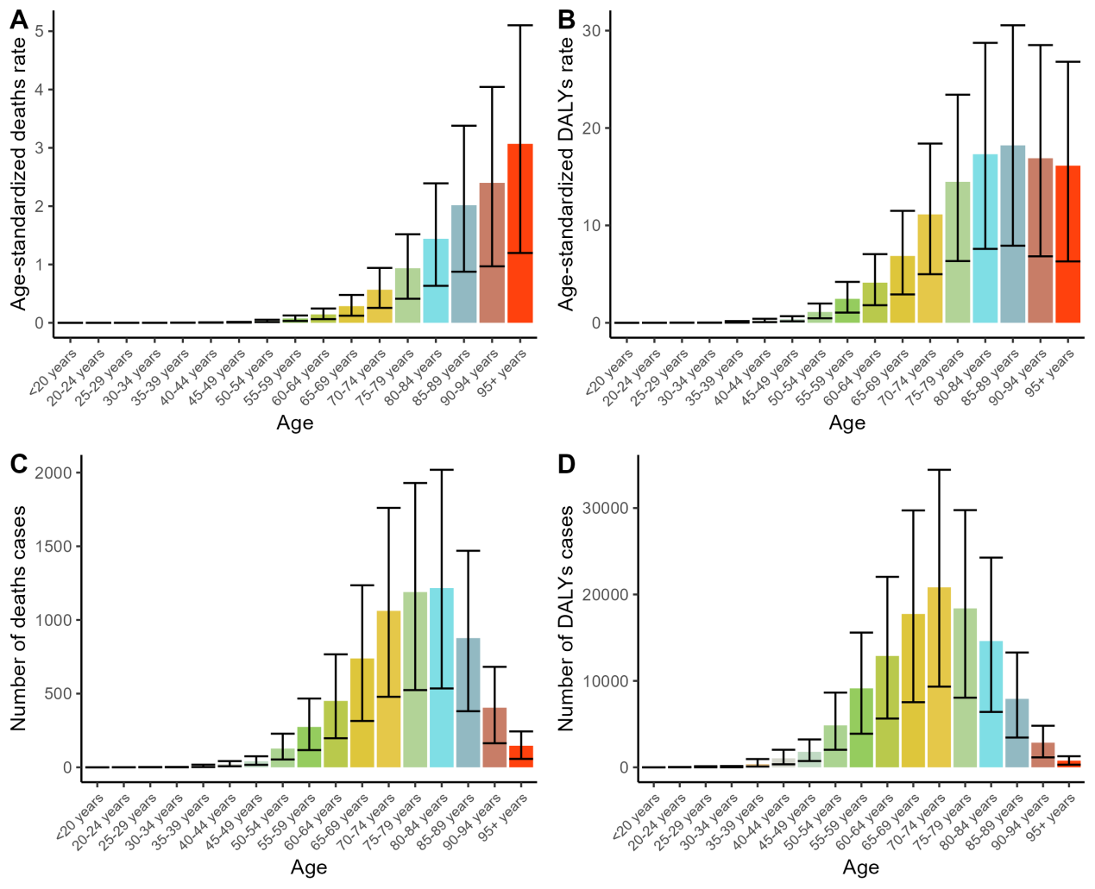
Figure S1. Numbers and age-standardized rates of ovarian cancer attributable to occupational exposure to asbestos deaths and DALYs for different age groups in 2019. Abbreviations: DALYs, disability-adjusted life years.
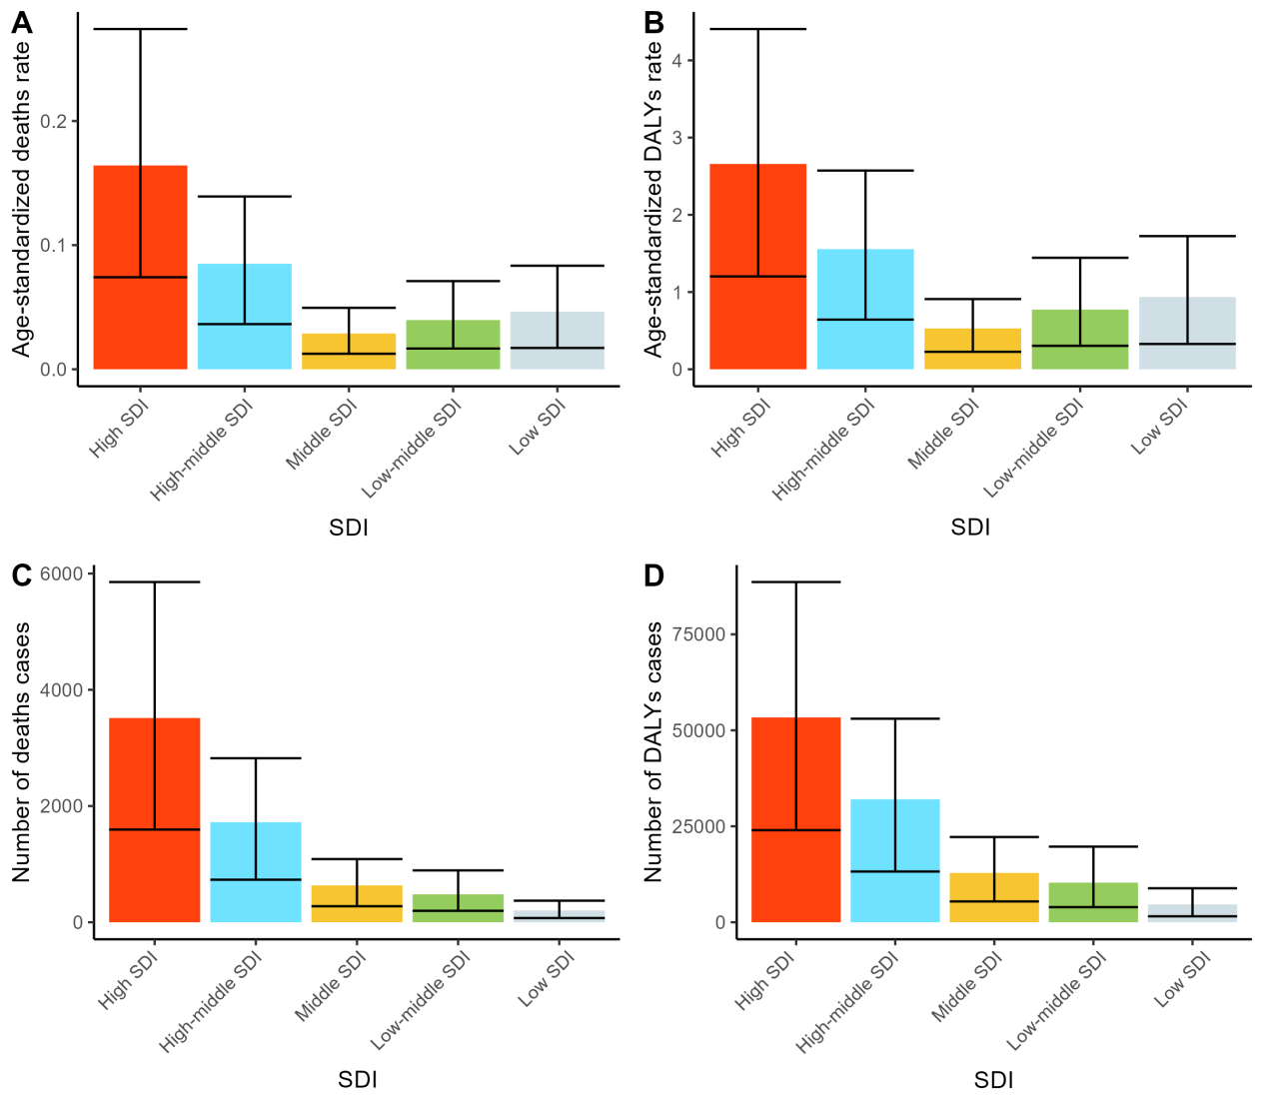Figure S2. Numbers and age-standardized rates of ovarian cancer attributable to occupational exposure to asbestos deaths and DALYs for different SDI regions in 2019. Abbreviations: DALYs, disability-adjusted life years.
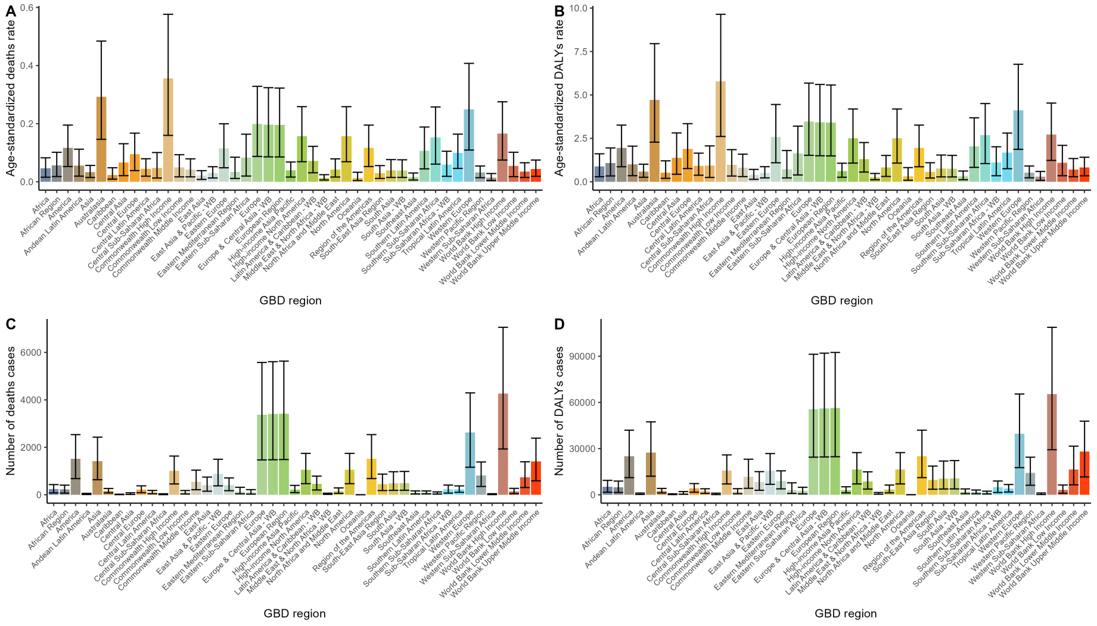
Figure S3. Numbers and age-standardized rates of ovarian cancer attributable to occupational exposure to asbestos deaths and DALYs for different GBD regions in 2019. Abbreviations: DALYs, disability-adjusted life years.
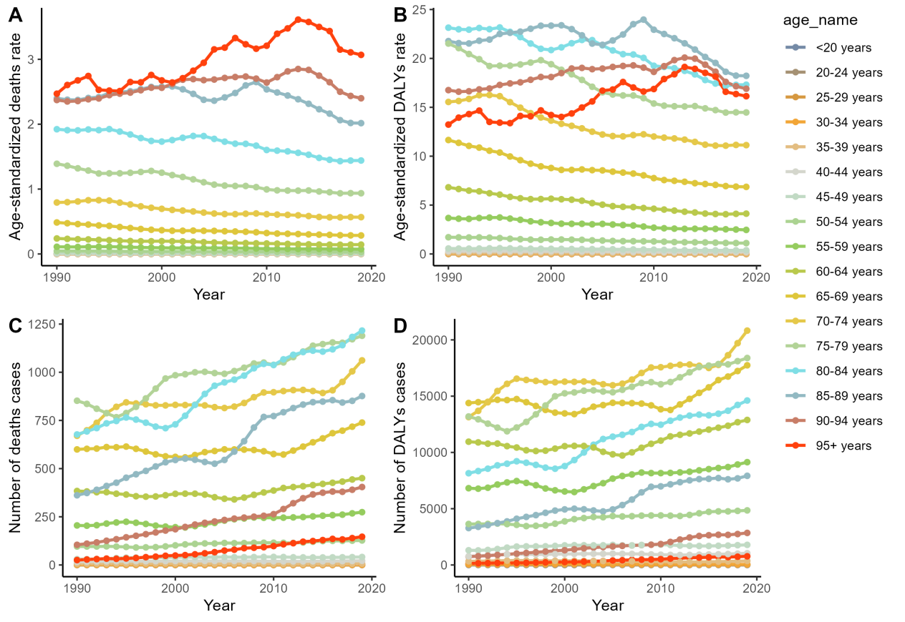Figure S4. Trends in the numbers and age-standardized rates of ovarian cancer attributable to occupational exposure to asbestos deaths and DALYs globally by age groups from 1990 to 2019. Abbreviations: DALYs, disability-adjusted-life-years.
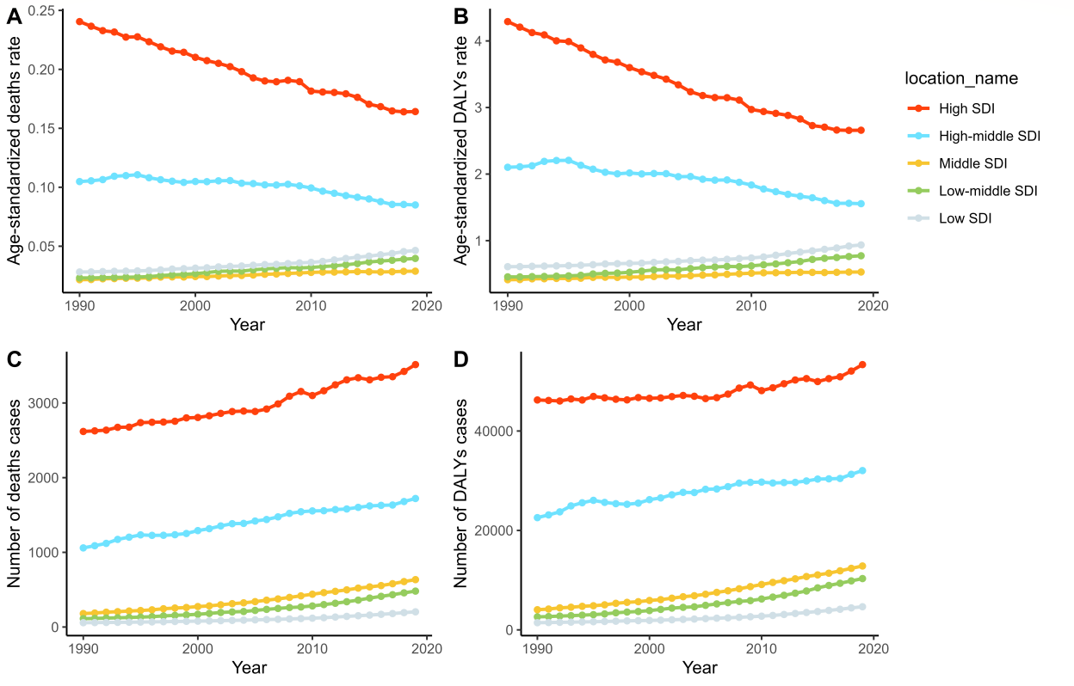Figure S5. Trends in the numbers and age-standardized rates of ovarian cancer attributable to occupational exposure to asbestos deaths and DALYs globally by SDI regions from 1990 to 2019. Abbreviations: DALYs, disability-adjusted-life-years.

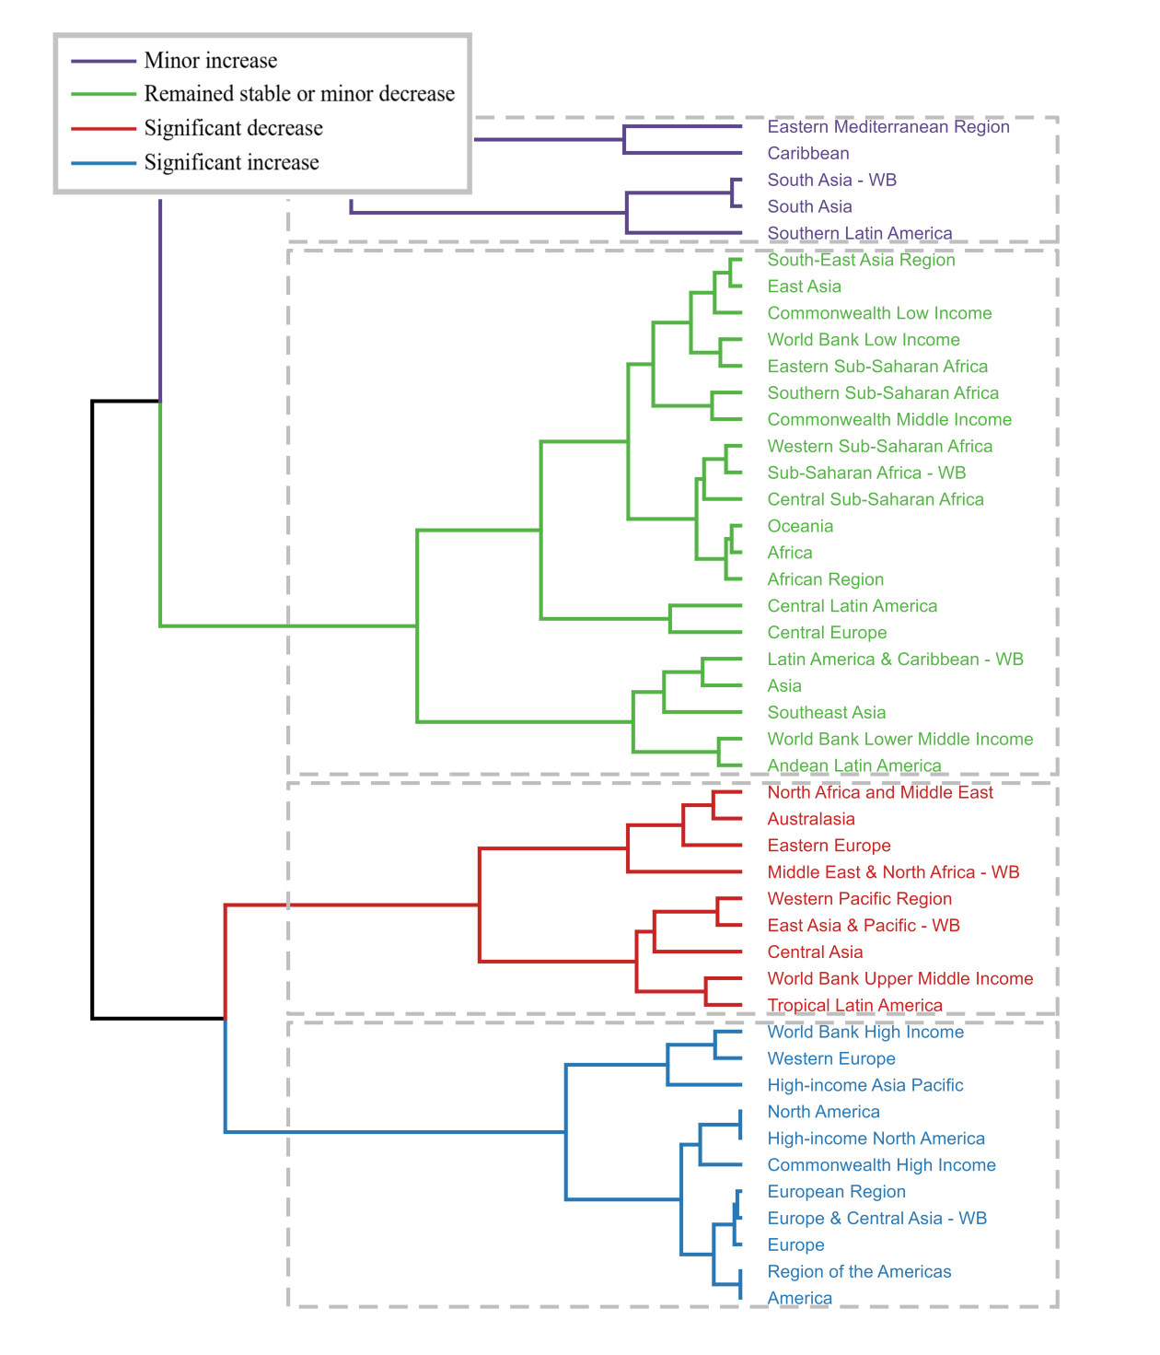Figure S6. Results of cluster analysis based on the EAPC values of the age-standardized deaths and DALYs rates of ovarian cancer attributable to occupational exposure to asbestos from 1990 to 2019. Abbreviations: EAPC, estimated annual percentage change; DALYs, disability-adjusted-life-years.

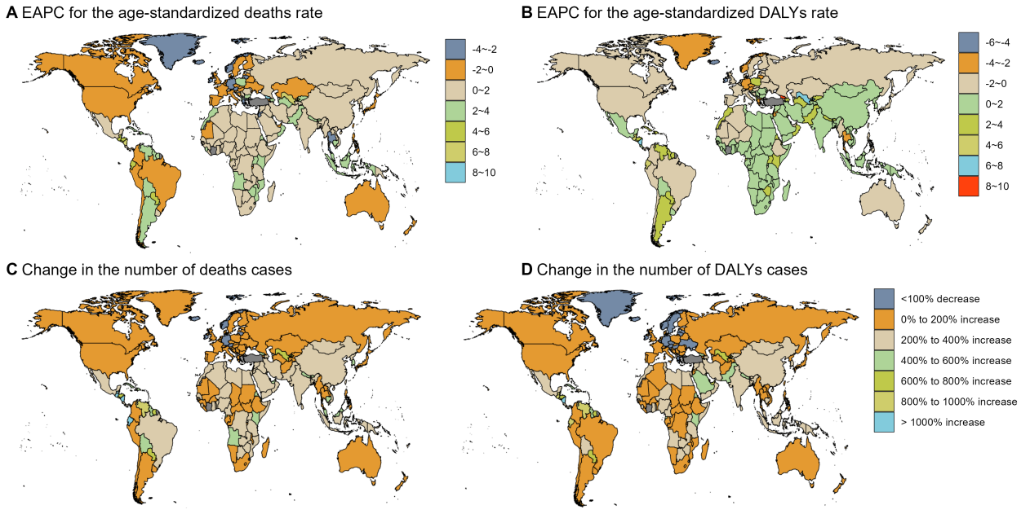Figure S7. The EAPC value for the age-standardized deaths and DALYs rates of ovarian cancer attributable to occupational exposure to asbestos from 1990 to 2019 (A and B). The relative change in the numbers of deaths and DALYs cases of ovarian cancer attributable to occupational exposure to asbestos between 1990 and 2019 (C and D). Abbreviations: EAPC, estimated annual percentage change; DALYs, disability-adjusted-life-years.

