Supporting Information of

Operando NMR Visualization of Ion Dynamics in PEDOT:PSS

Yanting Jin¹, Pieter C. M. M. Magusin¹,
Simone Sturniolo², Evan Wenbo Zhao¹, Dongxun Lyu¹, Shunsuke Yamamoto^{3,4},
George G. Malliaras³, Clare P. Grey¹

¹Department of Chemistry, University of Cambridge, Cambridge CB2 1EW, UK
²Science and Technology Facilities Council, Harwell Science and Innovation Campus, Didcot, OX11 0QX, UK
³Electrical Engineering Division, Department of Engineering, University of Cambridge, Cambridge CB3 0FA, UK
⁴Institute of Multidisciplinary Research for Advanced Materials (IMRAM), Tohoku University,
2-1-1 Katahira, Sendai 9808577, Japan

Table of Contents
Experimental and simulation details: 2
Additional data 3
1. Ex-situ ²³Na NMR of PEDOT: PSS and PSS samples 3
2. Effect of salt concentration on the quadrupolar splitting 4
3. NMR integral analysis 5
4. Capacitance of the PEDOT: PSS in operando NMR 7
6. Interpreting the charge-splitting correlation 11
7. Effect of orientation on the quadrupolar splitting 14
8. Normalized charge-splitting correlation for PEDOT:PSS films 15
9. Grid charge model: effect of Na⁺ concentration on its EFG values 15
10. Initial multinuclear ³⁵Cl, ²³Na and ¹H operando NMR data 16
11. Physical Interpretation of the ²³Na NMR splitting 17

Experimental and simulation details:

Ex-situ NMR
The data shown in Figure S1 was acquired using 2.5 mm double resonance probe, where the PEDOT:PSS film (dried overnight in 60˚C vacuum oven) was cut into pieces and packed into a 2.5 mm rotor, and then different amount of NaCl solution was added into the rotor. Operando ³⁵Cl NMR were acquired using a homemade 11-turn coil in a static probe. Both the ³⁵Cl NMR and the static ²³Na NMR experiments shown in the SI and the main text were performed on a Bruker Avance, 300 MHz spectrometer.

²³Na Multiple Quantum (MQ) MAS spectrum of PSS-Na powder (Sigma Aldrich, Mw ~ 1,000,000) was recorded with Bruker Avance III, 400 MHz spectrometer using a 2.5 mm diameter rotor spinning at 15 kHz with a recycle delay of 1 s.

²³Na Pulse Field Gradient (PFG) NMR
PFG NMR experiments were carried out using a Bruker Avance spectrometer and a Diff-50 probe head at a magnetic field strength of 7.1 T (¹H Larmor frequency at 300 MHz). The pulse gradient stimulated echo was used for diffusion measurements. The amplitude of these gradient pulses is incremented between experiments in order to get a variable attenuation of the NMR signal. The maximum g used was 17 T m⁻¹, and the effective gradient pulse duration, δ, was 2 ms. Sufficiently long delays of 1 s were inserted between PFG and radiofrequency pulses such that eddy currents did not influence diffusion measurements.

Data processing:
Operando NMR data were processed by an R script. An R package “NMR Utils” developed by Dr Josh M. Stratford was used for peak deconvolution and data visualization.

Simulation of the grid charge model:
The Python libraries Soprano and ASE¹ were used for the gird charge simulation. We created a mesh grid and randomly placed Na atoms onto the grid, then calculate the averaged EFG tensor on Na nucleus as a function of the occupation percentage by Na.

Additional data

Ex-situ ²³Na NMR of PEDOT: PSS and PSS samples
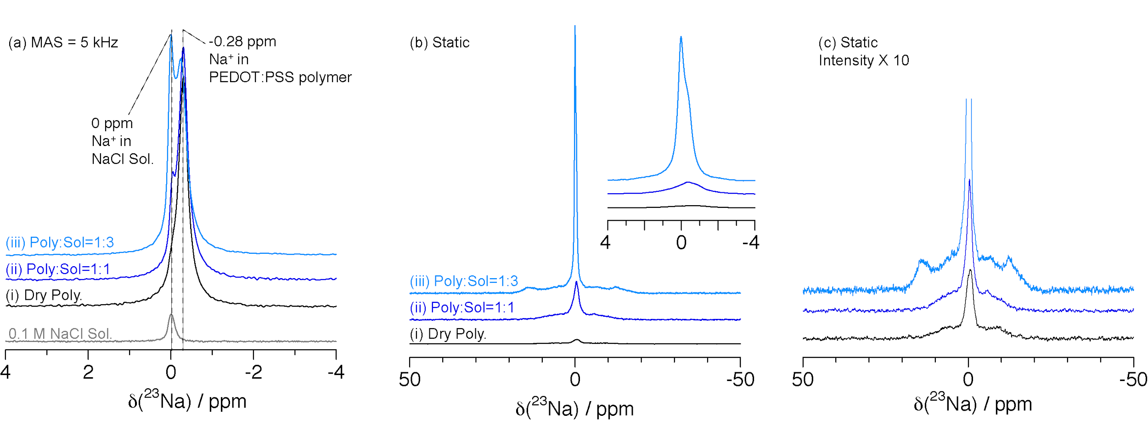
Figure S1: ²³Na NMR of the PEDOT:PSS powder samples with varying amounts of a 0.1M NaCl solution. (a) Spectra acquired with magic angle spinning (MAS) at 5 kHz. No spinning sidebands associated with the (residual) quadrupole coupling were observed in the spectra acquired at this MAS rate. (b-c) static spectra and (c) enlarged view of (i) dry polymer, (ii) polymer mixed with added 0.1 M NaCl solution with a mass ratio of 1:1, (iii) polymer and solution with a mass ratio of 1:3.
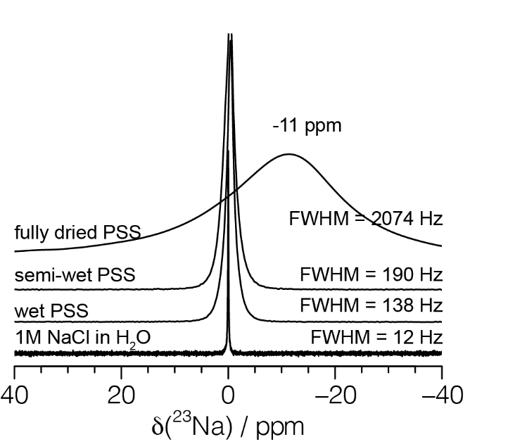

Figure S2: Static ²³Na NMR of wet vs dry PSS films, and the 1M NaCl solution itself. In an isotropic environment such as the PSS film, the ²³Na first order quadrupolar coupling is averaged to zero, thus no quadrupolar splitting. Some broadening is seen (in comparison to that of the 1M NaCl solution), which is ascribed to the heterogeneity in local environments in the film and transverse (spin-spin) ²³Na NMR relaxation due the quadrupolar interaction.

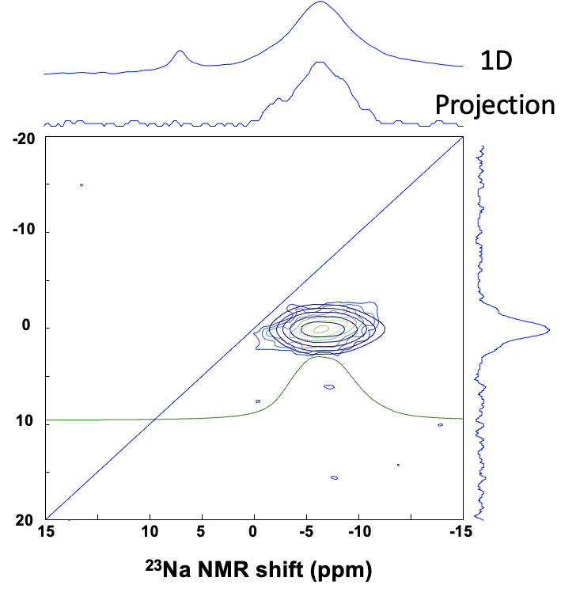

Figure S3: ²³Na MQMAS spectrum of the dry PSSNa powder (blue-green), with the fit shown in black. The green spectrum below represents a 1D slice extracted from the 2D fit to the spectrum, showing the fit with obtained with a quadrupolar coupling constant for the Na⁺ ions bound to PSS sulfonate groups of 1.3 MHz and an asymmetry parameter of 0.4.

Effect of salt concentration on the quadrupolar splitting
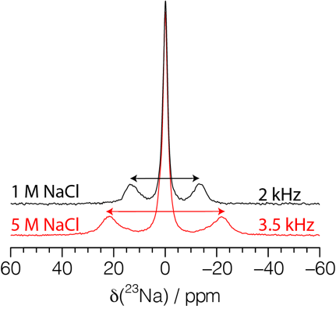
Figure S4: ²³Na NMR spectra of the vertically aligned PEDOT:PSS film soaked in 1 M and 5 M NaCl solutions.

NMR integral analysis
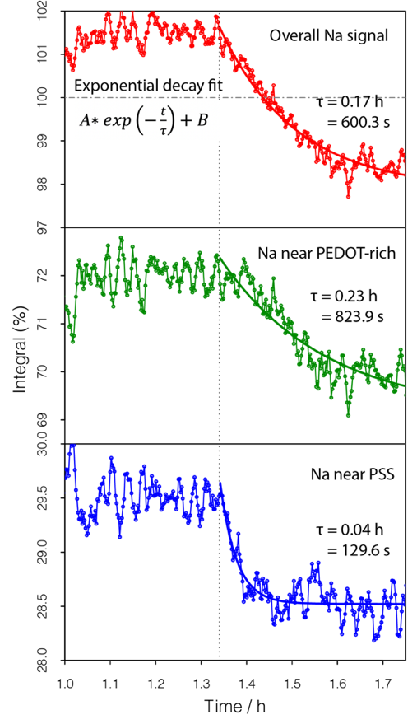
Figure S5: ²³Na NMR integral change when the bias voltage switches from -0.6V to +0.6V (zoom in of the data shown in Figure 3iv-vi, main text). The NMR integral is fitted with exponential function A$*\exp\left(-\frac{t-t_{0}}{τ}\right)+B$, with the value of $τ$ used in the fit shown in the figure. t₀ is indicated by the dotted line. The smaller value of $τ$ for Na⁺ near the PSS-rich region suggests that Na⁺ in that region move out faster than the Na⁺ ions near the PEDOT-rich region.

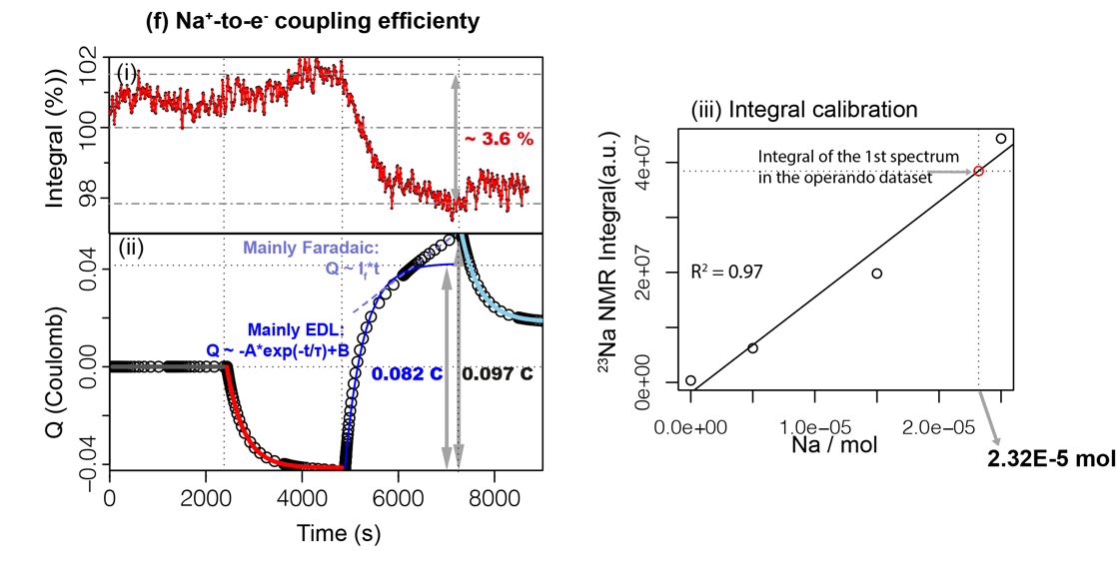
Figure S6: Quantification of Na⁺-to-electron coupling efficiency. (i) Normalized operando NMR integral, (ii) Charge inserted or extracted from the film as a function of time. The charge curve is fitted with exponential function: A$*\exp\left(-\frac{t-t_{0}}{τ}\right)+B$, coloured in blue. Deviation is observed at the tail part coloured in pale purple, which is fitted by a line: $I_{F}*(t-t_{0}')$, where $I_{F}$ is related to Faradaic reactions occurring during the voltage hold and $t_{0}'$ is the onset time of the linear fit. (iii) ²³Na NMR integral calibration using 1M NaCl solution, where the NMR signal was measured for three known volumes of NaCl. The red dot is the integral from the experimental data (the total peak integral extracted from the first slice of the operando NMR spectra) shown in Figure 3.

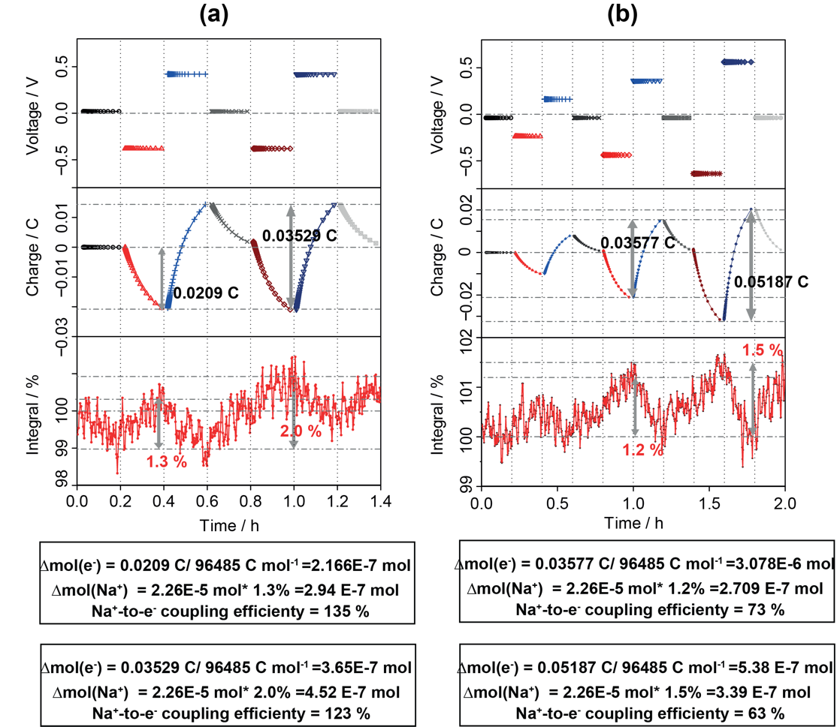
Figure S7: Quantification of Na⁺-to-electron coupling efficiency of data shown in Figures 4a-b.
While the charge injected or removed in the films, shown in Figure S6 and S7, is measured with a high degree of accuracy (from the electrochemical measurements), the ²³Na NMR integral percentage changes are rather noisy, due to the relatively poor signal to noise (S/N) of the spectra, making the accurate quantification of Na⁺ less reliable. Nevertheless, the S/N is still good enough to determine that values for the Na⁺-to-electron coupling efficiencies, which vary from 63% to 135 % ($±$ 12%), depending on the cycling history. Interestingly, when the voltage switches from -0.4V to +0.4 V in Figure S7a and b, similar charge (~ 0.035 C) is incurred, but the corresponding ²³Na integral changes are quite different (2% vs. 1.2 %) resulting the Na⁺-to-electron coupling efficiency of 123% and 63%, respectively. This variation is probably due to the previous cycling history, as all other parameters used are the same.

PEDOT doping levels:
The doping level is the average number of positive charges per monomer unit. During this operando study, the doping level is estimated below: (1) the density of the wet PEDOT:PSS film is estimated to be 1–1.46 g/cm³; (2) volume of the thick PEDOT:PSS film is approximately 0.029 cm³ (0.5 cm x0.5 cmx0.115 cm); (3) the mass of the thick PEDOT:PSS film is ~ 0.0287 g to 0.0420 g; (4) the mass percentage of PEDOT within the film is estimated to be 14% (based on the estimated mass ratio of PEDOT:PSS:GOPS = 1:2.5:3.5); (5) given the molar mass of EDOT unit (C₂H₄O₂C₄S) is 140 g/mol, the estimated moles of EDOT unit in the film is around 2.85 x 10⁻⁵ mol to 4.16 x 10⁻⁵ mol.
When a bias (from -0.6V to +0.6V) is applied, charge variation in the thick film is 0.097 C (corresponding to = 0.097 C/96485 C mol⁻¹=1.005 x 10⁻⁶ mol of electrons). If the electronic charge were all compensated by hole carriers, the charge variation corresponds to doping 2.4% to 3.5 % of the total EDOT units. In other words, one hole in 28 to 41 EDOT units was inserted to the film during the voltage bias.

Capacitance of the PEDOT: PSS in operando NMR

The PEDOT: PSS films used in this study are much thicker than the film used in typical bioelectronic devices (in the order of ten and hundreds of nanometres) because a larger sample amount is needed for obtaining a ²³Na NMR spectrum with good signal to noise ratio, so as to reduce the measurement time and to achieve good temporal resolution in operando NMR studies.

The experimental volumetric capacitance for the polymer film with a thickness of 0.35 mm (with an area of approximately 0.5 x 0.5 cm, (the area varying slightly between films and between electrodes) thus a film volume of 0.0088 cm³) is approximately $\frac{0.06C}{0.6V*(0.035*0.5*0.5){cm}^{3}}=11F/{cm}^{3}$, and the value determined for the film with a thickness of 1.15 mm is $\frac{0.04C}{0.6V*(0.115*0.5*0.5){cm}^{3}}=2.3F/{cm}^{3}$. These values are less than the reported volumetric capacitance for the 100 nm PEDOT:PSS film (39 F/cm³)², with thin film and thick film exhibiting ~29.4% and ~5.9% of this reported volumetric capacitance, respectively.

To explore whether the reduced capacitance may originate from the fact that the film does not reach equilibrium during voltage-biasing, we performed further experiments biasing the film at each voltage for a longer duration (100 min), (Figure S8). The volumetric capacitance of the thick film (1.15 mm) increases from 2.3 F/cm³ (with 20 min voltage hold as shown in Figure 3) to 2.9 F/cm³ (with 100 min voltage hold), which is still smaller than the reported volumetric capacitance.² Thus, this difference may not be solely due to kinetic effect, but rather the nature of the film. For the thick film, the electronic conduction pathway is probably poor, thus, it is difficult to achieve the theoretical volumetric capacitance. We also noted that the charge of the film shown in Figures S8 are not strictly symmetric during positive and negative voltage-biasing. The asymmetric charge could be due to slight mass and surface area imbalance between the two electrodes, as well as the previous cycling history of the electrochemical cell that merits further investigation.

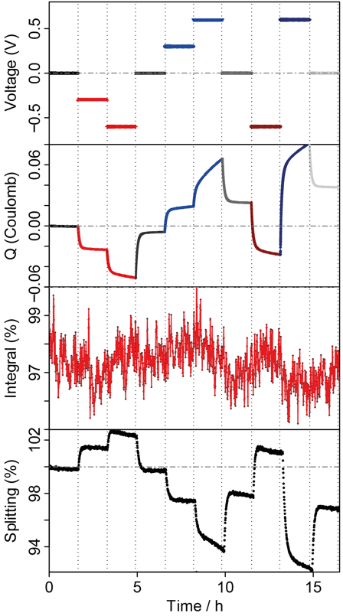

Figure S8: Operando ²³Na NMR of the PEDOT: PSS film with thickness of 1.15 mm and with each voltage hold for 100 min. The volumetric capacitance derived from this experiment is 2.90 F/cm³.

- Exponential fit of operando data
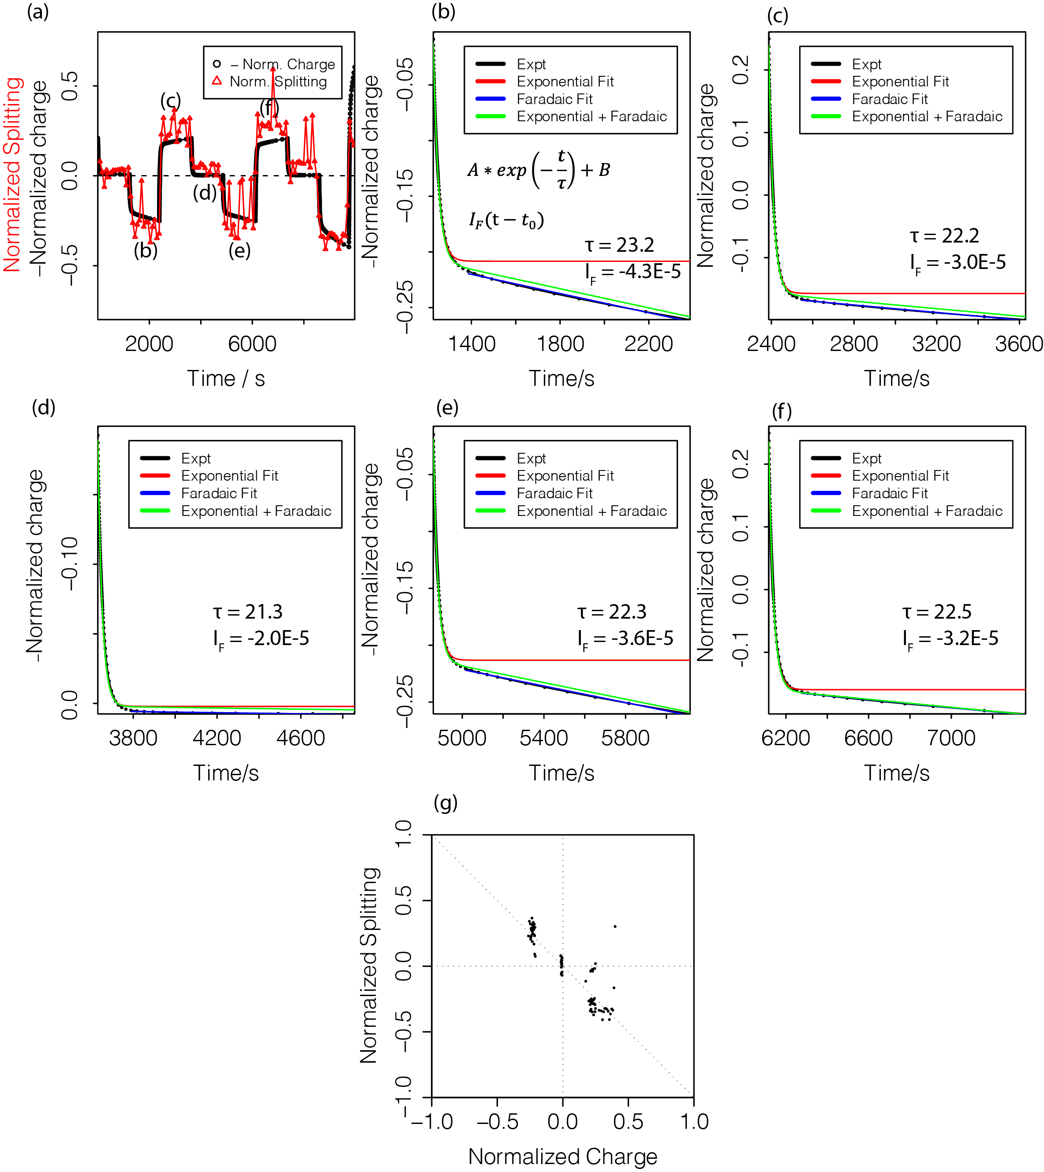

Figure S9: Exponential fit of charge/splitting in the operando measurement of the thin PEDOT: PSS film shown in Figure 4c. (a) Negative normalized charge and normalized splitting as a function of time. Charge and splitting are normalized by subtracting the initial value ($x-x_{0}$) and then dividing by the range of the variable ($\max\left(x\right)-min⁡(x)$), i.e. $\frac{(x-x_{0})}{\max\left(x\right)-min⁡(x)}$. A negative sign is applied to the normalized charge to better illustrate the negative linear correlation between charge and splitting. (b-f) Exponential fits of the normalized charge with a decay function (red): $A*\exp\left(-\frac{t-t_{0}}{τ}\right)+B$. A deviation is observed, and the tail is fitted with a linear function (blue): $I_{F}*(t-t_{0}')$, where $I_{F}$ is related to the Faradaic current and $t_{0}'$ is the onset time of the linear fitting. A combined fit of exponential and linear fit is shown in green with the function ($A*\exp\left(-\frac{t-t_{0}}{τ}\right)+B+I_{F}*(t-t_{0}')$). The corresponding values of the fitting parameters $τ$ and $I_{F}$ are shown in each figure. Note that the fitting parameters does not have units as the data has been normalized to facilitate exponential fitting. (g) The normalized charge-splitting correlation for the thin PEDOT:PSS film.
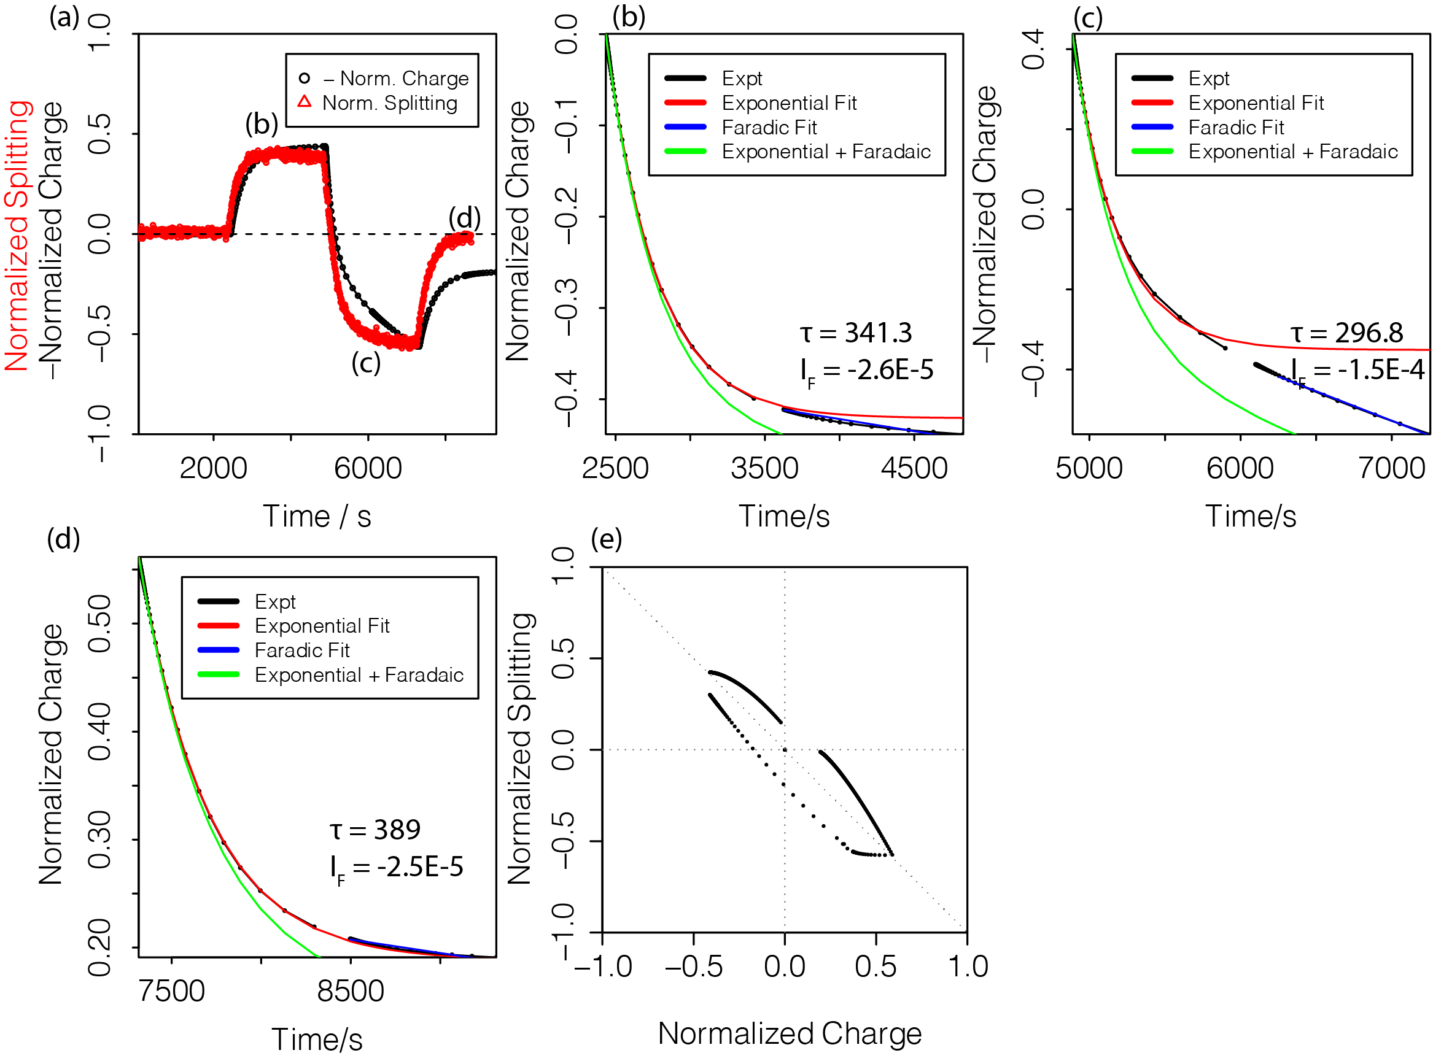
Figure S10: Exponential fit of charge observed in the operando measurement of the thick PEDOT: PSS film as shown in Figure 3c. The same fitting procedures as described in Figure S9.

The decay curve of NMR quadrupolar splitting and the charge as a function of time are fitted by an exponential decay function using $A×e^{-\frac{t}{τ}}+B$. The value of $τ$ is related to how fast Na⁺ ion can redistribute within the polymer. PFG NMR measurements of Na⁺ in the PEDOT:PSS polymer shown in Figure S11 indicates a Na⁺ ion self-diffusion coefficient of $1.13×{10}^{-9} m^{2}/s$ without external applied voltage.
- Assuming 1D diffusion, the root of the mean-squared displacement (RMSD) is given by: RMSD =$\sqrt{2Dτ}$.
- With $D= 1.13×{10}^{-9} m^{2}/s$ , for the thick film, the average value of $τ is 355$ s (charge fitting as shown in Figure S10). This gives a RMSD of 0.90 mm, which is comparable to the film thickness of 1.15 mm.
- For the thin film, the average $τ is 22$ s (charge fitting as shown in Figure S9). Then the RMSD = 0.23 mm, which is comparable to the film thickness of 0.35 mm.
In short, the estimated RMSD derived from the exponential decay and the measured diffusion coefficients fit is comparable to the polymer film thickness.

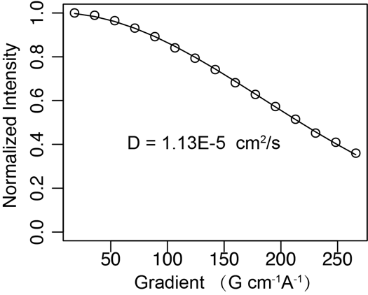
Figure S11: ²³Na PFG NMR of PEDOT:PSS film

Interpreting the charge-splitting correlation: the competitive binding and diffusive averaging model

Cationic (hole-doped) PEDOT and anionic PSS polymer chains are held together via electrostatic interactions in the polymer blend, where the negative charge on PSS sulphonyl moieties (-SO₃⁻) is compensated by holes, h⁺, along the PEDOT chains and/or Na⁺ (or H⁺) cations from the electrolyte. The as-synthesized materials contain holes, and by default, some -SO₃⁻ groups that are not compensated by Na⁺/H⁺ ions. In principle, two association equilibria apply within the PEDOT-rich pancake:
Na⁺ + -SO₃⁻ ⇌ -SO₃ Na [1a]
h⁺ + -SO₃⁻ ⇌ -SO₃ h [1b]
with respective equilibrium constants given by,
$K_{Na}= \frac{[{-SO}_{3}Na]}{[{-SO}_{3}^{-}][{Na}^{+}]}$ [2a]
$K_{h}= \frac{[{-SO}_{3}h]}{[{-SO}_{3}^{-}][h^{+}]}$ [2b]
There are also chloride anions, but, in our model, these anions simply serve for charge compensation and do not specifically bind with PEDOT holes or Na⁺ ions. The overall concentrations (free and bound species combined) are then given by:
${[{Na}^{+}]}_{O}=[{Na}^{+}]+[{-SO}_{3}Na]$ [3a]
${[h^{+}]}_{O}=[h^{+}]+[{-SO}_{3}h]$ [3b]
${[{-SO}_{3}^{-}]}_{O}=\left[{-SO}_{3}^{-}\right]+[{-SO}_{3}Na] +[{-SO}_{3}h]$ [3c]
${[{Cl}^{-}]}_{O}=[{Cl}^{-}]$ [3d]
Where the subscript “O” denotes the overall or total concentration of each species. Charge neutrality requires:
${[{Na}^{+}]}_{O}+ {[h^{+}]}_{O}={[{-SO}_{3}^{-}]}_{O}+{[{Cl}^{-}]}_{O}$ [4]

Diffusive averaging
The Na⁺ bound to sulfonate moieties is only short lived. The ions rapidly exchange between bound and free states, and quickly diffuse between sulfonate sites with varying EFG orientations. Therefore, the observed quadrupole splitting is an average resulting from this fast exchange and diffusion. We treat the system as ergodic (i.e., the time-average is equivalent to an ensemble average). Furthermore, we assume that the chemical exchange is everywhere the same within the pancake (no concentration gradients or different binding sites), so that the chemical-exchange and averaging over all space are statistically independent. Free (mobile) Na⁺ ions in the electrolyte experience an averaged net-zero quadrupole coupling ($χ^{f}$= 0). The Na⁺ bound to the PSS in the rigid state has a quadrupolar coupling $χ$. The residual quadrupole coupling constant $〈\overline{χ}〉$ then is given by:
$〈\overline{χ}〉 ={(p}_{b} χ+(1-p_{b} )χ^{f})*S$
$=$ $p_{b}χS$ [5]
where$p_{b}$ is the fraction of Na⁺ that is bound to PSS, and S is the order parameter. We discuss $p_{b}$and S in detail below. Note that $χ$ is not necessarily the same value as that for dry PSS, as the Na⁺ in the wet polymer is likely still at least partially coordinated to water, even in the bound state.

Bound-Na fraction, p_{b}
The effect of PEDOT hole doping and dedoping on the quadrupole splitting can be derived by solving Eqs. 2–4 with the overall concentrations of PSS sulfonate moieties [-SO₃⁻]_{O}, PEDOT holes [h⁺]_{O} (< [- SO₃⁻]_{O}) and chloride anions [Cl⁻]_{O} as the three parameters characterising the system. This would then yield the concentration of bound Na species [-SO₃Na] and the bound Na fraction p_{b}. However, the general solution is quite complicated to derive analytically. For illustration let us consider the simple case of strong hole binding and weak Na⁺ binding to the sulfonate moieties (K_{h} [-SO₃⁻]_{O} >> 1; K_{Na} [-SO₃⁻]_{O} << 1). Combining Eqs. 2a, 3a and 3c yields:

$p_{b}= \frac{[{-SO}_{3}Na]}{{[{Na}^{+}]}_{O} }$
$=K_{Na}\frac{[{-SO}_{3}^{-}][{Na}^{+}]}{{[{Na}^{+}]}_{O} }$
$= K_{Na}\frac{\left({[{-SO}_{3}^{-}]}_{O}-\left[{-SO}_{3}Na\right]-[{-SO}_{3}h]\right)\left({[{Na}^{+}]}_{O}-\left[{-SO}_{3}Na\right]\right)}{{[{Na}^{+}]}_{O} }$
$K_{Na}\left({[{-SO}_{3}^{-}]}_{O}-{[h^{+}]}_{O}\right)$ [6]

where it was assumed that all holes bind to sulfonate moieties, [-SO₃h] = [h⁺]_{O} and that the concentration of tightly bound Na⁺, [-SO₃Na], is small with respect to the concentration of sulfonate groups not occupied by holes, [-SO₃⁻]_{O} - [h⁺]_{O} and the overall Na⁺ concentration [Na⁺]_{O} (i.e. [-SO₃Na], << [-SO₃⁻]_{O} - [h⁺]_{O} and [-SO₃Na], << [Na⁺]_{O}). I.e., the system comprises free (hydrated) Na⁺ ions in the PSS/PEDOT matrix, that spend only a small fraction of their time more tightly bound to the PSS⁻. When they are bound, however, they “feel” or experience an electric field gradient that is no longer isotropic. This gives rise to a quadrupolar splitting, when the PSS chains are themselves in an anisotropic medium (see below). The overall hole concentration varies linearly with the charge (Q) within the system
${[h^{+}]}_{O}= {[h^{+}]}_{O}^{0}+\frac{Q}{f V_{film}F}$ [7]
where V_{film} is the volume of the polymer film, and f the volumetric fraction of the PEDOT-PSS pancakes in the film, and F the Faraday constant.
Microscopic order parameter, $S$
Macroscopic and microscopic angles in PEDOT:PSS film are illustrated in Figure S12: $θ_{LV}$ denotes the orientation of the quadrupole tensor V in the laboratory coordinate frame with the magnetic field B₀ along the z axis; $θ_{DV}$ is the microscopic orientation of V in a director frame with the z axis normal to the polymer film (Figure S12-right); $θ_{LD}$ denotes the macroscopic orientation angle between the polymer-film normal and the magnetic field B₀ (Figure S12-left, note that $θ_{LD}=θ$, where $θ$ is the angle we defined in Figure 1e in the main text). For simplicity, the quadrupole tensor and the polymer film containing the oblate ellipsoid shaped PEDOT-PSS pancake domains are presumed to be axially symmetric.
Figure S12: (left) orientation $θ_{LD}$ of the PEDOT-PSS film in the lab axis frame (LAB) with the z axis along the magnetic field axis B₀, as well as the LAB orientation $θ_{LV}$ of the ²³Na quadrupole tensor V; (right) orientation $θ_{DV}$ of the ²³Na quadrupole tensor V with principal EFG tensor values V_{zz} and V_{xx}= V_{yy} (axial symmetry) in the film Director Axes Frame (DF) with the z’ axis normal to the film. (Model drawing inspired by Ref.³)

The effect of the microscopic electric field gradient (EFG) tensor orientations can be characterized by the order parameter, S, which is defined as:
$S= <\frac{1}{2}\left(3\cos^{2}{θ_{DV}}-1\right)>$ [8]

the brackets denoting the ensemble average. For a highly oriented system S, has a narrow distribution and can be assumed to be a constant. By contrast, for a randomly oriented system with an isotropic orientation distribution the order parameter S is zero, since the quadrupolar tensors are oriented over all angles with respect to the magnetic field, as observed for the powder PSS sample shown in Figure S2. The quadrupolar coupling splitting observed for the PEDOT:PSS films is well-separated with a clearly defined value instead of a distribution of splittings, indicating that the order parameter S has a narrow distribution. This is consistent with a film, with the degree of ordering of the microstructures being similar across the whole measured volume.

Residual quadrupolar coupling:
Combining Eq. 5-7, we have:
$〈\overline{χ}〉=K_{Na}\left({[{-SO}_{3}^{-}]}_{O}-{\left[h^{+}\right]}_{O}^{0}-\frac{Q}{f V_{film}F}\right) χS$ [9]
Observed quadrupolar splitting $∆v$:
$∆v=〈\overline{χ}〉*\frac{1}{2}\left|3\cos^{2}{θ}-1\right|{=K}_{Na}\left({[{-SO}_{3}^{-}]}_{O}-{\left[h^{+}\right]}_{O}^{0}-\frac{Q}{f V_{film}F}\right) χS*\frac{1}{2}\left|3\cos^{2}{θ}-1\right|$ [10]

Eq. 10 describes how the quadrupole splitting is negatively linear correlated to the change of the hole concentration, and therefore on the charge in the system.

Effect of orientation on the quadrupolar splitting
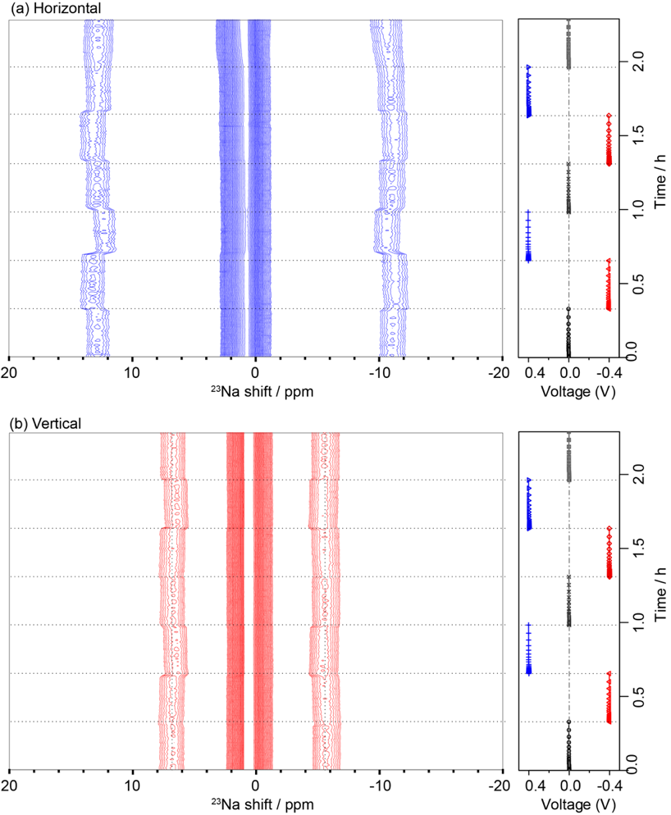
Figure S13: Orientation-dependent operando NMR spectra of the same cell that was (a) horizontally and (b) vertically placed inside the NMR coil.
Operando NMR spectra of a cells that were either horizontally or vertically placed inside the NMR coil were measured as shown in Figure S13. The macroscopic orientation angles $θ$ are equal to 0˚ and 90˚ for horizontally and vertically orientated dataset, respectively, leading to a quadrupolar splitting in the horizontal data twice the size of that measured vertically. This is consistent with Eq.10. During doping/dedoping, Eq.10 can be simplified to $d(∆v)∝ dQ* S* \left|3\cos^{2}{θ}-1\right|$. The two datasets have similar charge variation ($dQ$) in each voltage holding step, thus a splitting change of the horizonal dataset (Figure S13a) should be twice that measured for the vertical one (Figure S13b) if the S parameter remains the same during doping/dedoping. Indeed, the variation of the splitting for the horizonal dataset is much more noticeable and is qualitatively as expected.

Normalized charge-splitting correlation for PEDOT:PSS films

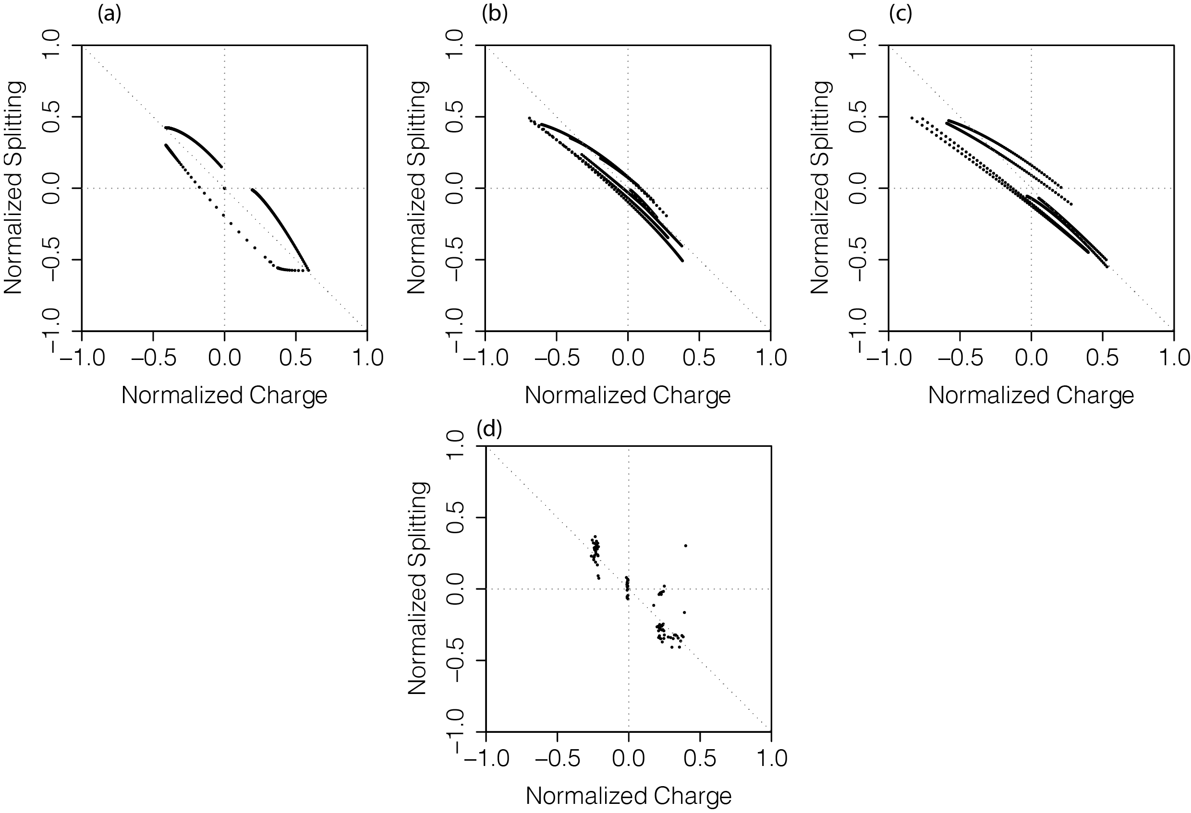
Figure S14: Normalized charge-splitting correlation observed in operando ²³Na NMR spectra of PEDOT:PSS films. (a, b, c) corresponds to data from the thick PEDOT:PSS film shown in Figure 3, 4a and 4b, respectively. (d) is from the thin PEDOT:PSS film data shown in Figure 4c . Normalization of charge and NMR splitting were performed by subtracting the data with the initial value, the value then was divided by the range of either the charge or the splitting.

Grid charge model: effect of Na⁺ concentration on its EFG values
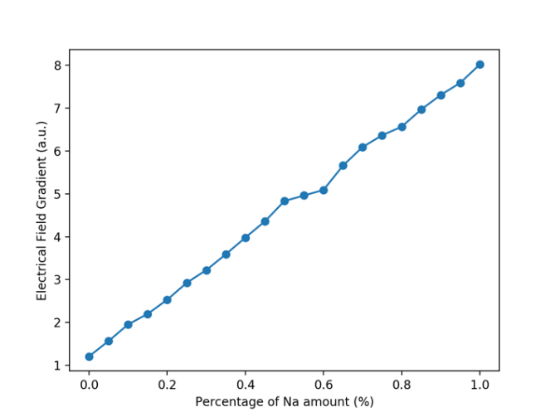
Figure S15: Simulation of the effect of Na⁺ ion content on its local electrical field gradient (EFG).
A simple theoretical model is used to understand the effect of sodium ion concentration on its EFG value. The model consists of a grid with varying concentrations of Na atoms against a fixed negative charge plane (representing the PSS plane). The EFG of Na atoms are computed, and the result is shown in Figure S15. The EFG computed from the grid charge model shows that the EFG increases as the concentration of Na increases. With a higher concentration of Na, each Na experiences a larger EFG.

The effect of ion concentrations on the quadrupolar splitting was also reported by Grundy et al.,⁵ who found that the size of the ⁷Li splitting within a lamellar polymer consists of polystyrene-b-poly(ethylene oxide) and lithium bis(trifluoromethanesulfonyl)imide (LiTFSI) salt depends on the amount of salt and the molecular weight of the polymer.

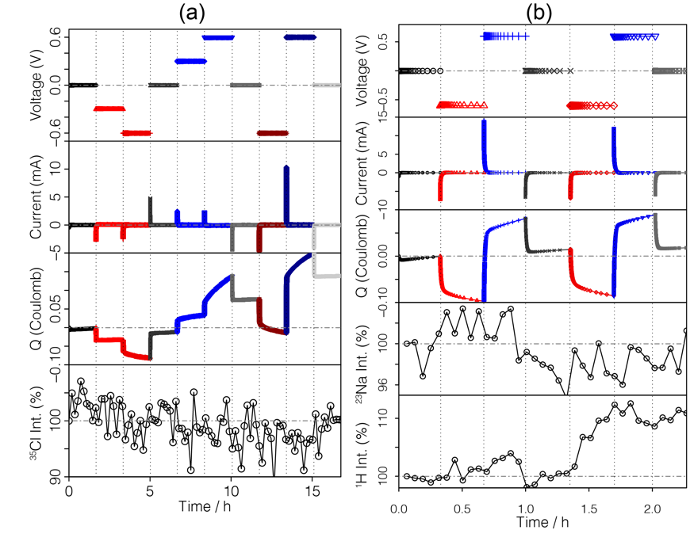
Initial multinuclear ³⁵Cl, ²³Na and ¹H operando NMR data
Figure S16: Operando ³⁵Cl, ²³Na and ¹H NMR data of PEDOT: PSS film in 1M NaCl solution biased to different voltages. The ³⁵Cl NMR spectra were acquired using a 11-turn NMR coil as the Lamour frequency of ³⁵Cl is much lower than ²³Na. The poor signal to noise ratio of the integrals is mainly due to the limitation of the NMR coil and the probe configuration used in this experiment. The ¹H and ²³Na NMR spectra were acquired on the same cell in one operando experiment simultaneously using the double channel NMR probe.

The initial attempt to monitor anion movement by operando ³⁵Cl NMR is shown in Figure S16a. The recorded spectra do not show noticeable change within the error of the experiment. Further analysis was prevented by the poor S/N of these experiments. More systematic multinuclear operando data will be acquired to study the motion of Cl⁻, H⁺, and water in the PEDOT:PSS polymer system to understand their motions.

Multinuclear operando NMR spectroscopy is possible, albeit with the challenges associated with achieving good S/N ratios and reproducible electrochemistry given the need to control multiple variables. Figure S16b shows the integral analysis of the operando ¹H and ²³Na NMR dataset recorded in one electrochemical test. The integral is noisy due to the poor sensitivity of the double resonance probe and the NMR coil used in this experiment. However, a clear increase of 10% is seen in ¹H NMR spectra when the voltage switches from 0 V to -0.6V, suggesting injection of hydrated cations into the polymer during the negative voltage biasing.

Physical Interpretation of the ²³Na NMR splitting

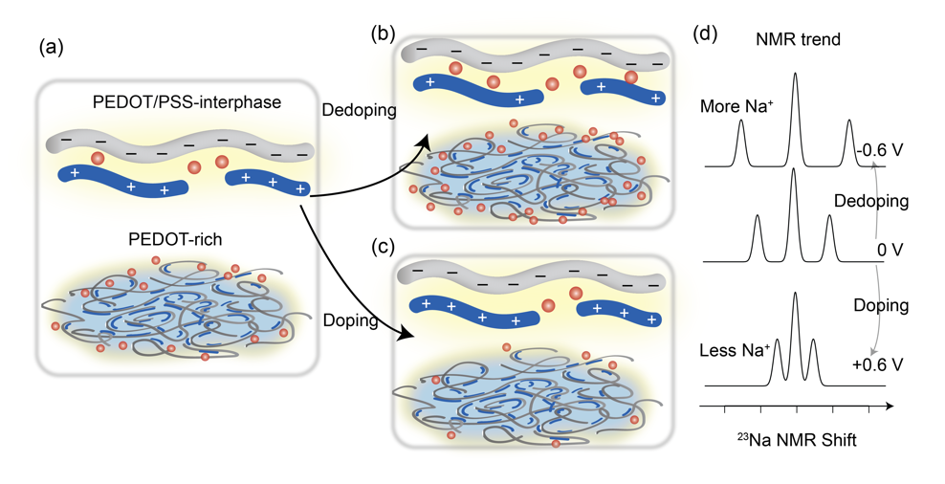

Figure S17. Schematic of PEDOT-rich ‘pancake’ structure and PEDOT/PSS interphase during doping/dedoping of the film and the corresponding NMR spectra. (a) Pristine pancake and the enlargement of PEDOT/PSS interphase (yellow) showing that PSS (grey chain) is charge compensated by holes on PEDOT (blue chain) and Na⁺ ions (red dots). (b) Dedoping and (c) doping of PEDOT induces Na⁺ injection and extraction at the PEDOT/PSS interphase, respectively, thus changing the amount of Na⁺ bound at the PEDOT/PSS interphase. (d) The corresponding ²³Na NMR spectra show an increase in quadrupolar splitting during dedoping and a decreased in splitting during doping. Cl⁻ anions and water molecules are not depicted here.

References:
(1) Simone Sturniolo. Soprano https://ccp-nc.github.io/soprano/.
(2) Rivnay, J.; Leleux, P.; Ferro, M.; Sessolo, M.; Williamson, A.; Koutsouras, D. A.; Khodagholy, D.; Ramuz, M.; Strakosas, X.; Owens, R. M.; Benar, C.; Badier, J.-M.; Bernard, C.; Malliaras, G. G. Sci. Adv. 2015, 1 (4), e1400251.
(3) Wennerström, H.; Lindblom, G.; Lindman, B. Chem. Scr. 1974, 6, ﻿97-103.
(4) Tybrandt, K.; Zozoulenko, I. V.; Berggren, M. Sci. Adv. 2017, 3 (12).
(5) Grundy, L. S.; Sethi, G. K.; Galluzzo, M. D.; Loo, W. S.; Maslyn, J. A.; Teran, A. A.; Thelen, J. L.; Timachova, K.; Reimer, J. A.; Madsen, L. A.; Balsara, N. P. ACS Macro Lett. 2019, 8 (2), 107–112.

