Integrated proteome and pangenome analysis revealed the variation of microalga Isochrysis galbana and associated bacterial community to 2,6-Di-tert-butyl-p-cresol (BHT) stress
Linke Guo ^{a,b}, Shuangwei Li ^{a,b}, Dongle Cheng ^{a,b}, Xiao Lu ^{a,b}, Xinying Gao^{a,b}, Linlin Zhang* ^{a,b}, Jianjiang Lu * ^{a,b}
a. College of Safety and Environment Engineering, Shandong University of Science & Technology, Qingdao 266510, China
b. Institute of Yellow River Delta Earth Surface Processes and Ecological Integrity, Shandong University of Science & Technology, Qingdao 266510, China
*Correspondence: linlinzhsd@126.com, lujianjiang1990@126.com

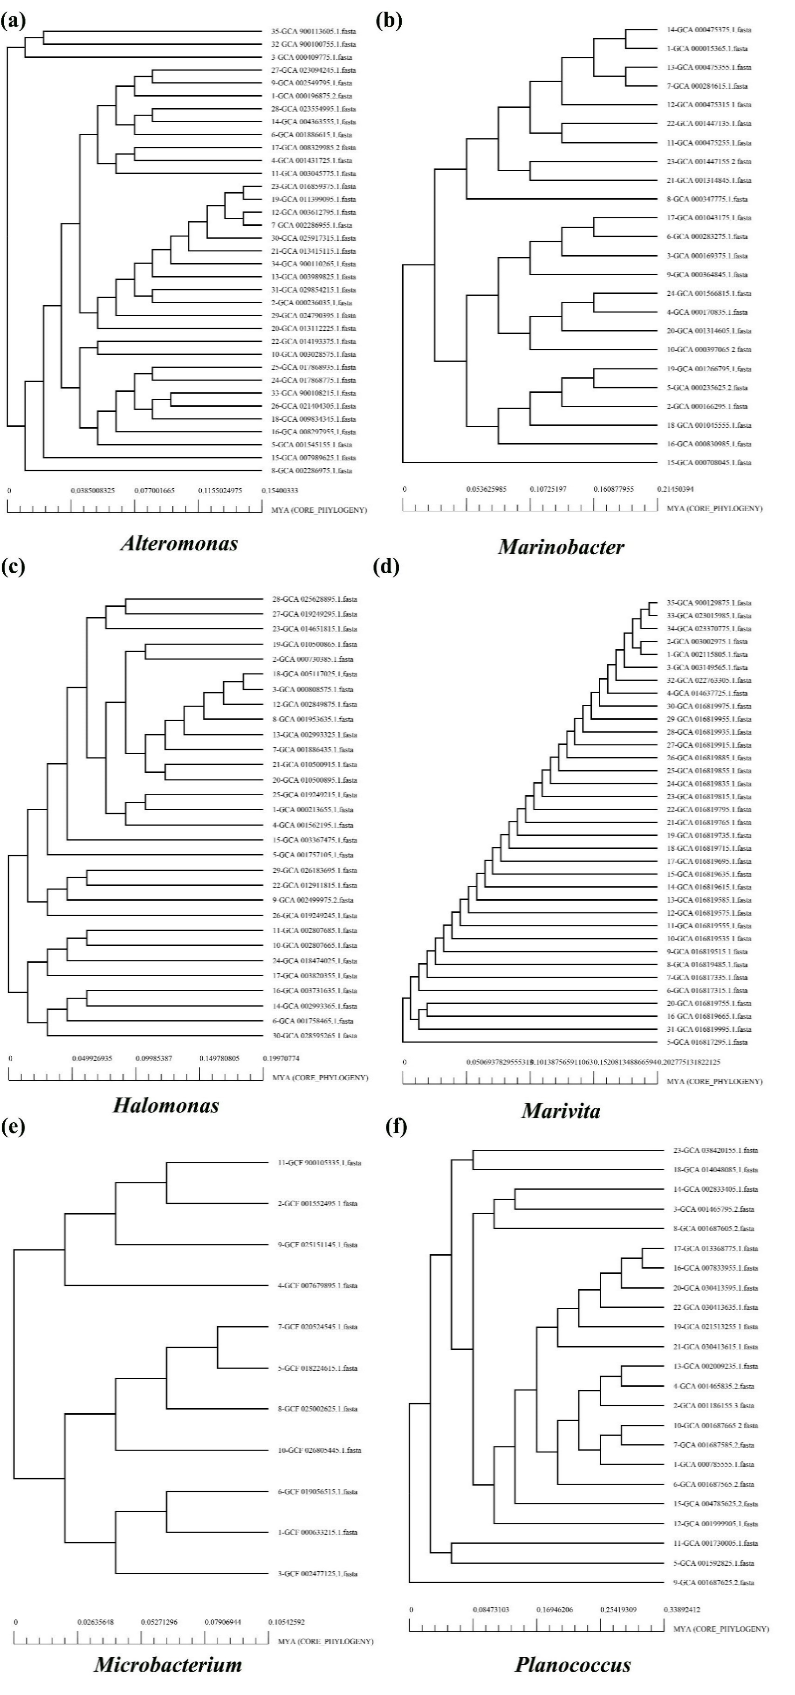
Fig. S1. (a): Phylogenomic analysis of 30 Alteromonas genotypes; (b): phylogenomic analysis of 24 Marinobacter genotypes; (c): phylogenomic analysis of 30 Halomonas genotypes; (d): phylogenomic analysis of 35 Marivita genotypes; (e): phylogenomic analysis of 11 Microbacterium genotypes; (f): phylogenomic analysis of 23 Planococcus genotypes.
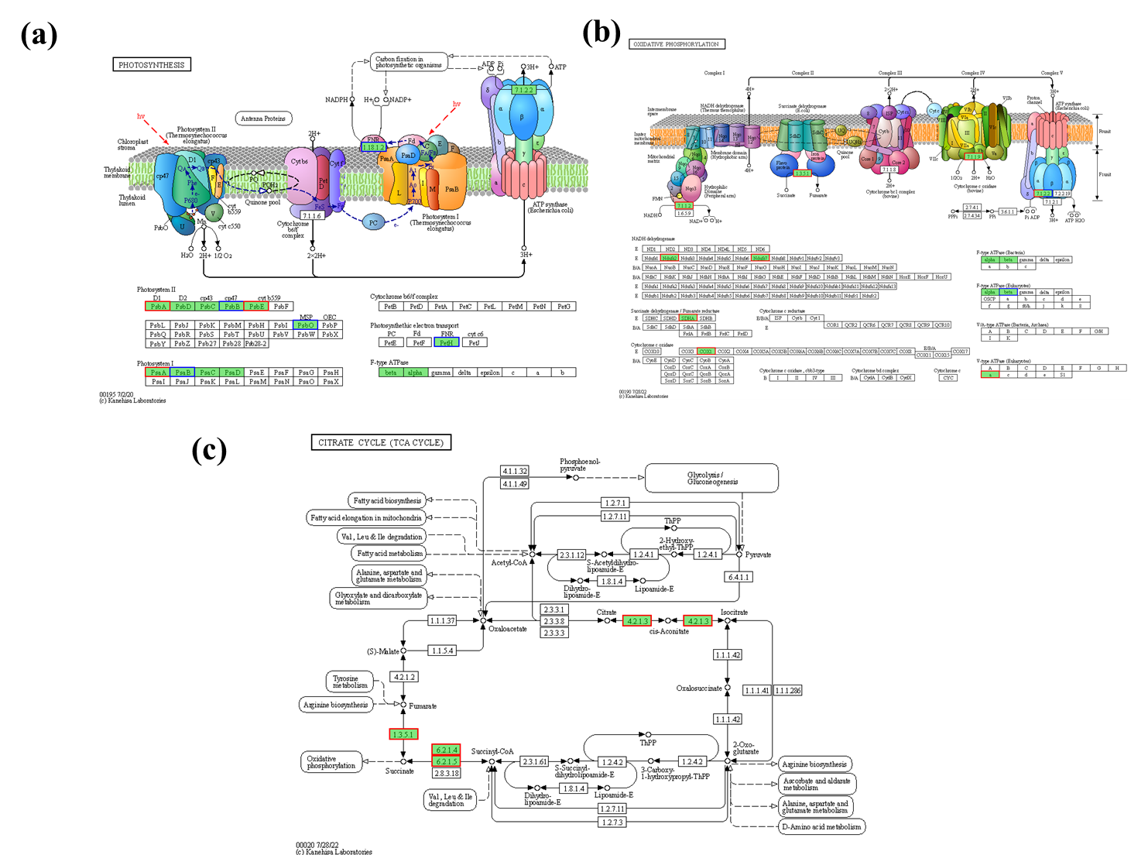
Fig. S2. DEGs annotations in the KEGG pathways under HC-BHT treatment, compared to the control group. (a): photosynthesis; (b): oxidative phosphorylation; (c): TCA cycle.

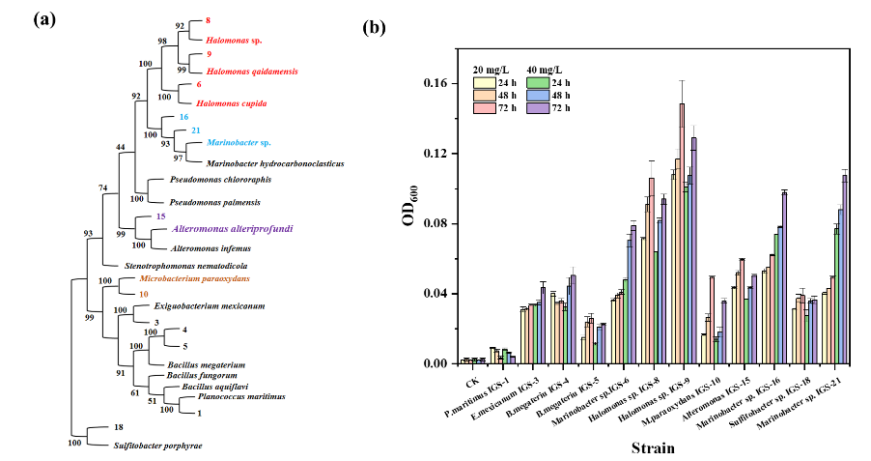
Fig. S3. (a): phylogenetic analysis of phycosphere bacteria based on the 16s rDNA gene. (b): growth analysis of phycosphere bacteria under the 20 and 40 mg/L of BHT.

