No | App name | Logo | Platform | Version | In-app payment | Year  (Last Version) | Downloads | Developer | Affiliations
1 | Sinacare |  | Android | 1.7.0 | No | 2023 | +50K | Sinacare  Available at: https://sinacare.ir | NGO
2 | Blue Circle |  | Android | 1.1 | No | 2016 | +2K | Tida Soft | Commercial
3 | Traditional Medicine - Blood Sugar | 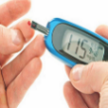 | Android | - | No | 2021 | +5K | Alahnazar Nazarimehr | Commercial
4 | What should diabetics eat? |  | Android | 1 | Yes | 2016 | +2K | Atlas Group | Commercial
5 | Ways to treat diabetes | 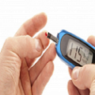 | Android | 1.1 | No | 2015 | +5K | Jalal Kooseh | Commercial
6 | iDia |  | Android | 0.9.9 | No | 2022 | +20K | Mehr Nutrition Science and Technology Development  Available at: https://idia.app | NGO
6 | iDia |  | iOS | N/A
7 | Diabetes Shop |  | Android | 9.1.3 | Yes | 2021 | +2K | Barman IT  Available at: https://diabet-shop.com/ | Commercial
8 | Ghandoon |  | Android | 2.1.1 | No | 2020 | +2K | Ghandoon Team | Commercial
9 | Diabetes Notebook |  | Android | 1.0 | No | 2020 | +2K | Nasrin Daraee | Commercial
10 | Diabetes |  | Android | 1.0.4 | No | 2020 | +100 | Farzan Knowledge, Research and Technology Development Institute | NGO
11 | Diabetes |  | Android | 1 | No | 2021 | +500 | Ali Khajvand | Commercial
12 | Diabetes |  | Android | 1.2 | No | 2015 | +1K | Hamidreza Rashidi | Commercial
13 | Asan-Chek | 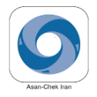 | Android | 1.9 | No | 2021 | +1K | rochediabetescaremea Available at: https://www.rochediabetescaremea.com/fa/data-management/asan-chek | NGO
13 | Asan-Chek |  | iOS | 1.10.0
14 | Destroyer of Diabetes |  | Android | - | Yes | 2018 | +100 | Chehel Tekeh | Commercial
15 | Diabetes | 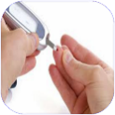 | Android | 2.2 | Yes | 2023 | +100 | Sisto Soft | Commercial
16 | Diabetes |  | Android | 1.1 | Yes | 2023 | +50 | Sisto Soft | Commercial
17 | Clinic of Diabetes Diseases | 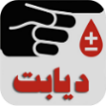 | Android | 0.0.1 | Yes | 2015 | +100 | Atlas Group | Commercial
18 | Diabetes | 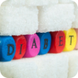 | Android | 1 | Yes | 2016 | +50 | Royal App | Commercial
19 | Diabetes Logger |  | Android | 1.0 | Yes | 2015 | +100 | Sajad Heydari | Commercial
20 | Diabetes Treatment | 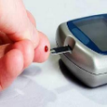 | Android | 1.0 | Yes | 2018 | +1K | Fatemeh Dastras | Commercial
21 | Diabetes | 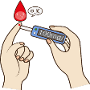 | Android | 1.1 | No | 2018 | +1K | Lotus Group | Commercial
22 | Diabetes | 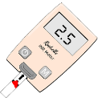 | Android | 1.1 | No | 2018 | +5K | Techno App | Commercial
23 | Ghandet |  | Android | 0.7.6 | Yes | 2022 | +100 | Ehsan Saraee  Available at: https://ghandet.com | Commercial
24 | Diabetes |  | Android | 4.2 | Yes | 2015 | +500 | Amin Besharatnia | Commercial
25 | Diabetes | 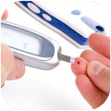 | Android | 2.1 | Yes | 2023 | +200 | Sisto Soft | Commercial
26 | Diabetes | 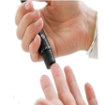 | Android | 1.1 | No | 2018 | +200 | Ashiyan | Commercial
27 | MAN |  | Android | 0.9.14 | Yes | 2024 | +10 | Man Group | Commercial
28 | Diabetes, Prevention and Control |  | Android | 3.0 | Yes | 2016 | +200 | Sadra Pardaz | Commercial
29 | Dialog |  | Android | 1.6.2 | Yes | 2024 | +100 | Avan Dialog  Available at: https://www.app-dialog.com | Commercial
29 | Dialog |  | iOS | N/A
30 | Diabetes |  | Android | 1.1.1 | No | 2017 | N/A | Arash Hatami | Commercial
31 | Diabetes |  | Android | 1.0.2 | No | 2014 | +10K | Mohammad Behnia | Commercial
32 | Shekarban |  | Android | 6 | No | 2020 | +100 | Shekarban Team  Available at: https://shekarban.net | NGO
32 | Shekarban |  | iOS | 11.0.2
33 | MY FREESENS |  | Android | 2.3.0 | No | 2024 | +10K | Farir Asa Teb  Available at: https://freesens.ir/ | Commercial
33 | MY FREESENS |  | iOS | 2.2.1
Table 1. Description of the diabetes applications (apps) included in the study

