Table 1 Six Types of Intersection Modes between Joints
Node | Parallel crack penetration | Parallel crack penetration Type
P1 | 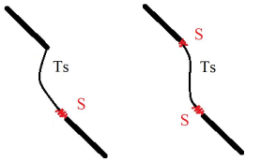 | The internal endpoints of parallel cracks produce shear cracks and are connected by secondary tensile cracks
P2 | 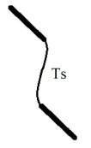 | The internal endpoints of parallel cracks are connected by secondary tensile cracks
P3 | 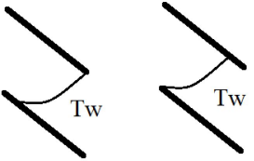 | The endpoint of the crack and the middle part of another crack are connected by a tensile wing crack
P4 | 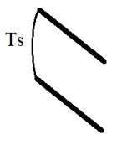 | Two cracks on the same side are connected by a tensile crack at the end
P5 | 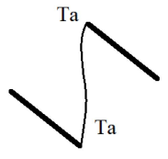 | Two cracks with opposite side ends connected by reverse tensile cracks
P6 | 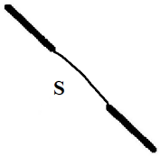 | Two coplanar cracks with different ends connected by shear cracks

Table 2 Probability distribution types of structural plane parameters
Structural plane grouping number | Number of joints | Dip angle  α/° | Dip direction  β/° | Trace length  L/mm | Joint density  P₃₂ (m²/m³)
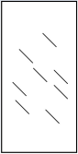 | 8 | 30 | 0 | 20 | 12.5
 | 8 | 45 | 0 | 20 | 12.5
 | 8 | 60 | 0 | 20 | 12.5
 | 8 | 75 | 0 | 20 | 12.5
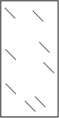 | 8 | 30 | 0 | 20 | 12.5
 | 8 | 45 | 0 | 20 | 12.5
 | 8 | 60 | 0 | 20 | 12.5
 | 8 | 75 | 0 | 20 | 12.5
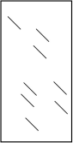 | 8 | 30 | 0 | 20 | 12.5
 | 8 | 45 | 0 | 20 | 12.5
 | 8 | 60 | 0 | 20 | 12.5
 | 8 | 75 | 0 | 20 | 12.5

Table 3 Results of Whole Rock Element Analysis of Marble
element | Weight percentage（w_{t}%） | The total confidence value of the analysis（w_{t}% Sigma）
O | 38.27 | 0.20
Mg | 2.14 | 0.05
Al | 9.3 | 0.09
Si | 31.83 | 0.16
Nb | 18.45 | 0.29
total | 100

Table 4 Strength parameters of fractured network rock mass
 | Peak stress  $σ_{c}$/MPa | Strength ratio  n | Elastic modulus  $E_{s}$/GPa | Poisson's ratio  ν
a-30 | 15.04 | 0.28 | 17.1 | 0.289
a-45 | 24.93 | 0.46 | 18.4 | 0.325
a-60 | 27.73 | 0.52 | 19.1 | 0.308
a-75 | 51.08 | 0.95 | 21.5 | 0.317
b-30 | 30.23 | 0.56 | 18.7 | 0.312
b-45 | 31.85 | 0.59 | 19.9 | 0.321
b-60 | 42.63 | 0.79 | 21.2 | 0.315
b-75 | 48.56 | 0.91 | 22.9 | 0.303
c-30 | 23.53 | 0.44 | 17.7 | 0.300
c-45 | 24.65 | 0.46 | 21.8 | 0.301
c-60 | 36.77 | 0.69 | 23.0 | 0.325
c-75 | 40.69 | 0.76 | 22.7 | 0.306

Table 5 Process and failure diagram of rock mass fracture in a series of fracture networks
Node | Failure process |  |  | Test failure figure | Failure mode
a-30 | 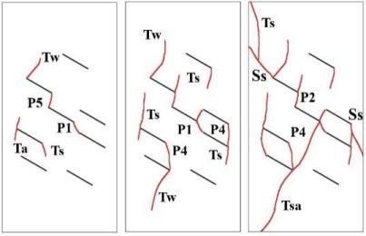 |  |  | 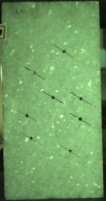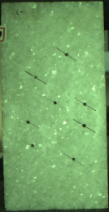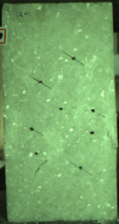 | Tensile failure, Stepped and rotation mode
a-30 | 11.24MPa | 14.0MPa | 10.5 MPa |  | Tensile failure, Stepped and rotation mode
a-45 | 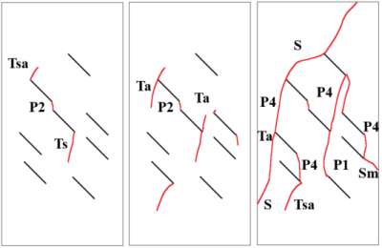 |  |  | 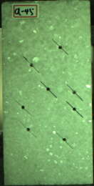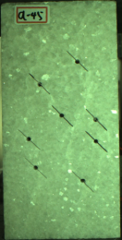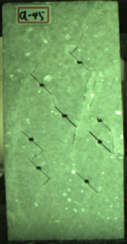 | Tensile and shear failure, Stepped and rotation mode
a-45 | 21.01 MPa | 24.5MPa | 19.5 MPa |  | Tensile and shear failure, Stepped and rotation mode
a-60 | 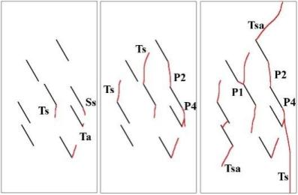 |  |  | 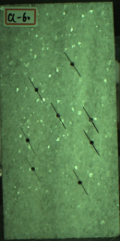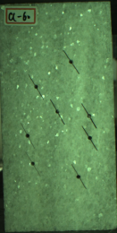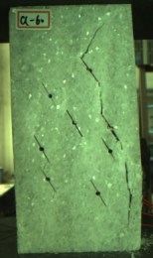 | Tensile failure, Stepped mode
a-60 | 24.35 MPa | 27.5MPa | 2.0 MPa |  | Tensile failure, Stepped mode
a-75 | 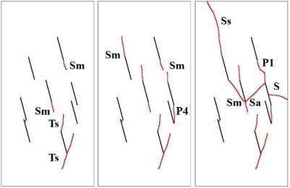 |  |  | 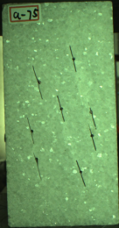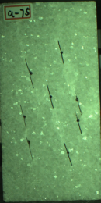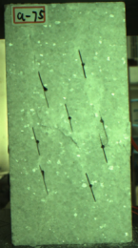 | Shear failure, Stepped mode
a-75 | 45.95 MPa | 50.5MPa | 29.9 MPa |  | Shear failure, Stepped mode

Table 6 Process and failure diagram of rock mass fracture in the b series fracture network
Node | Failure process |  |  | Test failure figure | Failure mode
b-30 | 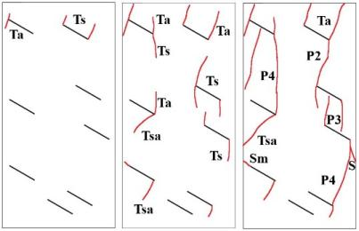 |  |  | 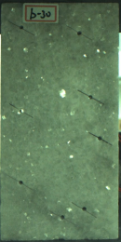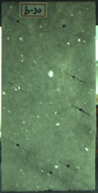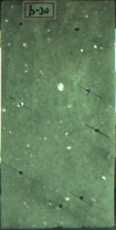 | Tensile failure, Stepped mode
b-30 | 25.93 MPa | 30.0 MPa | 10.5 MPa |  | Tensile failure, Stepped mode
b-45 | 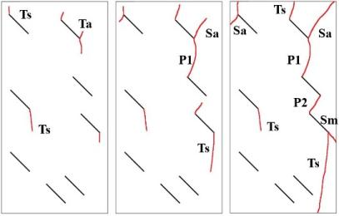 |  |  | 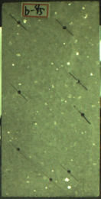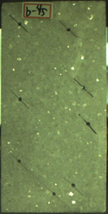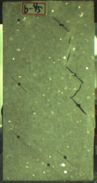 | Tensile failure, Stepped mode
b-45 | 25.28 MPa | 31.5 MPa | 20.5 MPa |  | Tensile failure, Stepped mode
b-60 | 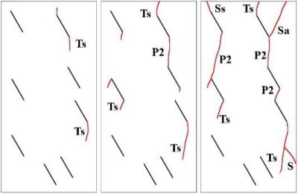 |  |  | 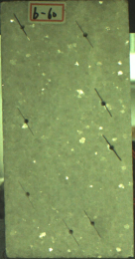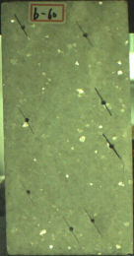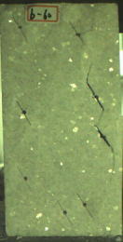 | Tensile failure, Stepped mode
b-60 | 38.34 MPa | 42.0 MPa | 28.5 MPa |  | Tensile failure, Stepped mode
b-75 | 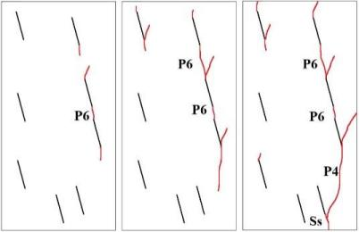 |  |  | 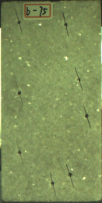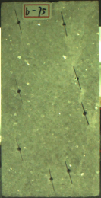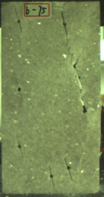 | Shear failure, Through a plane mode
b-75 | 43.06 MPa | 48.0 MPa | 3.68 MPa |  | Shear failure, Through a plane mode

Table 7 Process and failure diagram of rock mass fracture in the c-series fracture network
Node | Failure process |  |  | Test failure figure | Failure mode
c-30 | 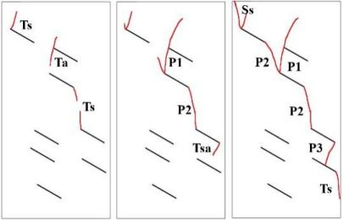 |  |  | 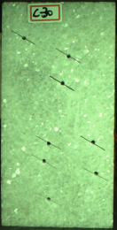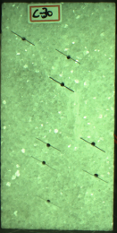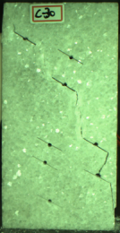 | Tensile failure, Stepped mode
c-30 | 18.67MPa | 23.0 MPa | 10.0 MPa |  | Tensile failure, Stepped mode
c-45 | 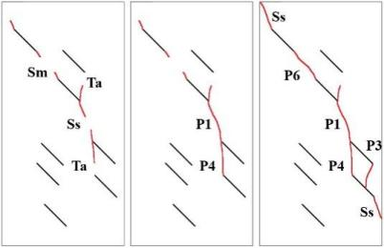 |  |  | 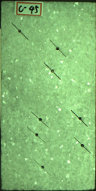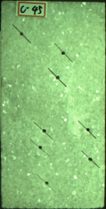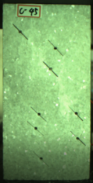 | Tensile and shear failure, Through a plane mode
c-45 | 18.83MPa | 24.0 MPa | 6.43 MPa |  | Tensile and shear failure, Through a plane mode
c-60 | 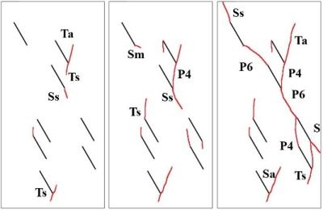 |  |  | 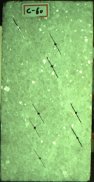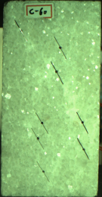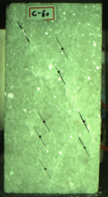 | Tensile and shear failure, Through a plane mode
c-60 | 32.94MPa | 36.0 MPa | 5.0 MPa |  | Tensile and shear failure, Through a plane mode
c-75 | 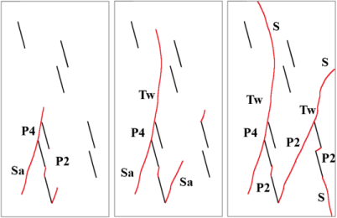 |  |  | 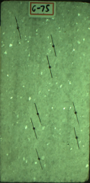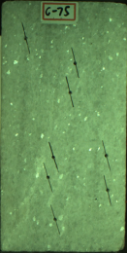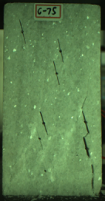 | Tensile and shear failure, Stepped and rotation mode
c-75 | 34.63MPa | 40.0 MPa | 5.0 MPa |  | Tensile and shear failure, Stepped and rotation mode

Table 8 PFC3D microscopic parameters
Particle parameters
Minimum particle size/mm | Particle size multiplier |  | Young's modulus/GPs |  | Stiffness ratio |  |  | friction coefficient |  | density/(kg·m⁻³)
1.0 | 1.66 |  | 22 |  | 2.5 |  |  | 0.5 |  | 2700
Adhesive parameters
Parallel bonding radius |  | Parallel contact/GPa |  | Stiffness ratio |  | Adhesive tensile strength/MPa |  |  | Adhesive shear strength/MPa
1 |  | 3 |  | 3 |  | 40±6.4 |  |  | 40±6.4
Smooth joint model parameters
Normal stiffness/GPa |  |  |  | Tangential stiffness/GPa |  |  | friction coefficient
2 |  |  |  | 2 |  |  | 0.7

Table 9 Macro mechanical parameters of rock specimens
 | Peak intensity/MPa | Elastic modulus/Gpa
PFC^{3D}complete | 53.82 | 24.87
Complete experiment | 54.57 | 24.65

Table 10 PFC3D numerical simulation of fracture network rock mechanics parameters
a-series |  |  | b-series |  |  | c-series
Dip/° | Peak intensity/MPa | Elastic modulus/GPa | Dip/° | Peak intensity/MPa | Elastic modulus/GPa | Dip/° | Peak intensity/MPa | Elastic modulus/GPa
30 | 32.11 | 17.63 | 30 | 27.20 | 17.19 | 30 | 28.58 | 16.93
45 | 34.02 | 18.54 | 45 | 31.64 | 18.49 | 45 | 31.80 | 17.37
60 | 36.77 | 19.71 | 60 | 35.66 | 19.39 | 60 | 36.74 | 18.25
75 | 41.46 | 20.33 | 75 | 41.87 | 20.27 | 75 | 44.21 | 19.25

Table 11 PFC failure mode diagram of a series of rock masses
Node | Test crack distribution | PFC crack distribution | Particle displacement magnitude | Particle displacement direction | Joint propagation | Failure mode
a-30 | 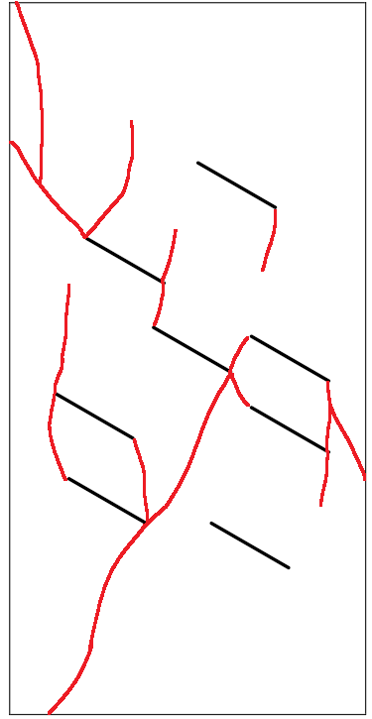 | 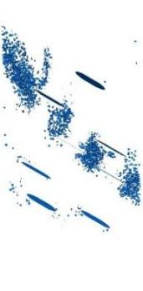 | 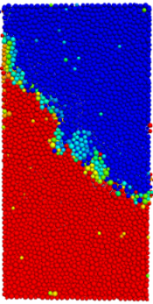 | 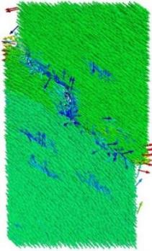 | The joints 2, 3, 4, and 6 are connected and damaged. | Stepped
a-45 | 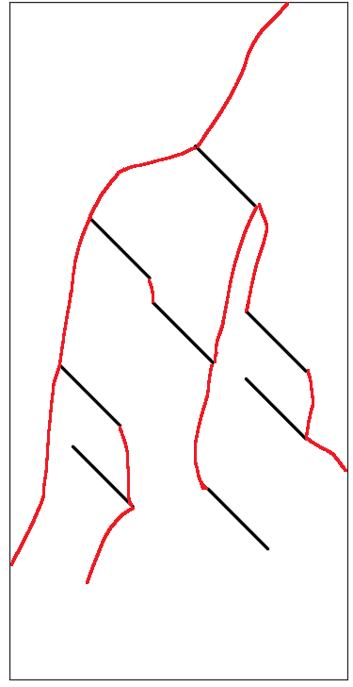 | 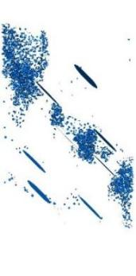 | 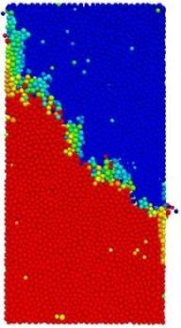 | 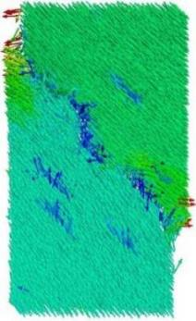 | The joints 2, 3, 4, and 6 are connected and damaged. | Stepped
a-60 | 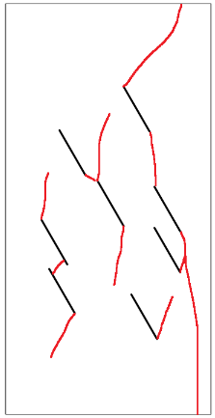 | 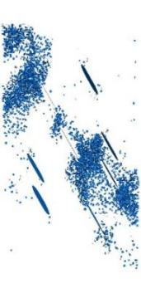 | 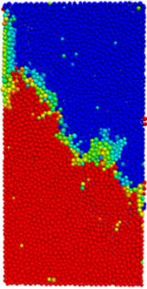 | 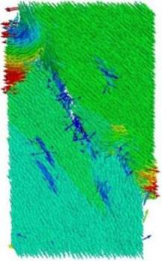 | The joints 2, 3, 4, 6 and 8 are connected and damaged. | Stepped
a-75 | 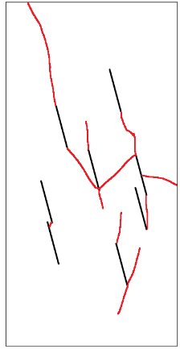 | 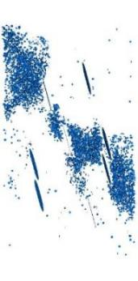 | 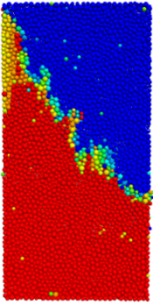 | 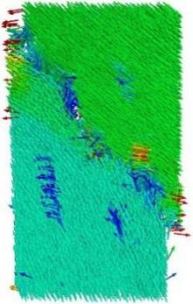 | The joints 2, 3, 4, and 6 are connected and damaged. | Stepped

Table 12 PFC failure mode diagram of b series rock mass
Node | Test crack distribution | PFC crack distribution | Particle displacement magnitude | Particle displacement direction | Joint propagation | Failure mode
b-30 | 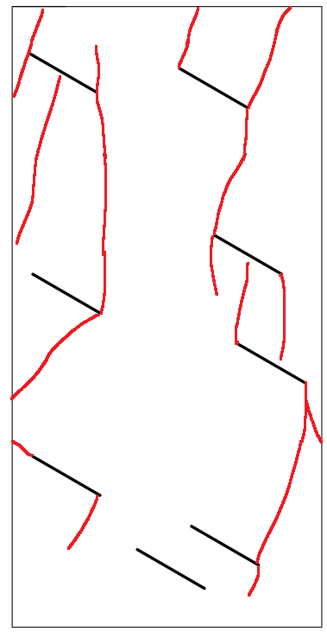 | 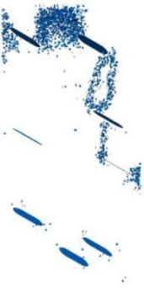 | 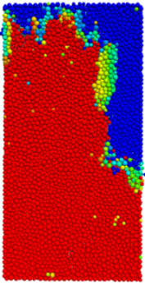 | 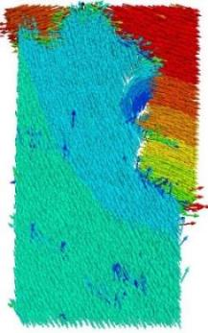 | The joints 1, 2, 4, and 5 are connected and damaged. | Stepped and rotation
b-45 | 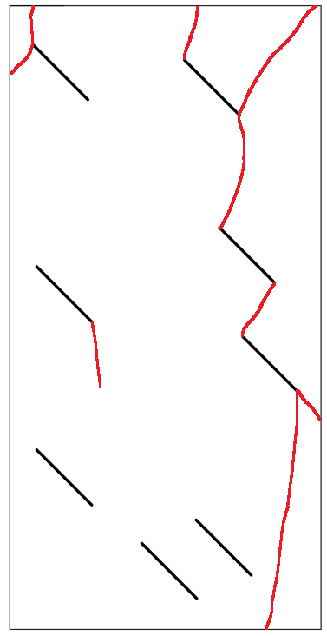 | 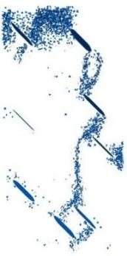 | 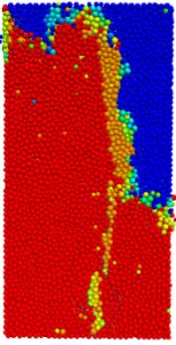 | 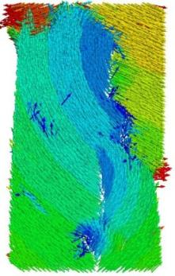 | The joints 1, 2, 4, 5 and 7 are connected and damaged. | Stepped and rotation
b-60 | 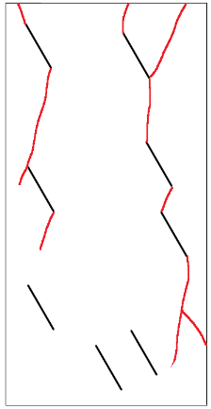 | 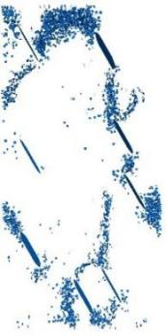 | 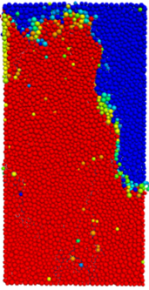 | 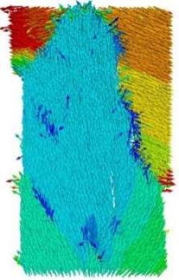 | The joints 1, 2, 4, and 5 are connected and damaged. | Stepped
b-75 | 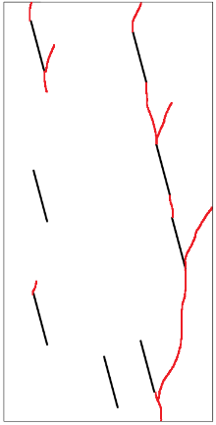 | 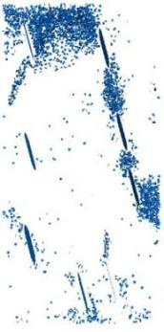 | 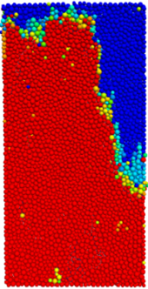 | 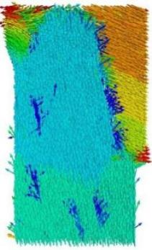 | The joints 1, 2, 4, and 5 are connected and damaged. | Through a plane

Table 13 PFC failure mode diagram of c series rock mass
Node | Test crack distribution | PFC crack distribution | Particle displacement magnitude | Particle displacement direction | Joint propagation | Failure mode
c-30 | 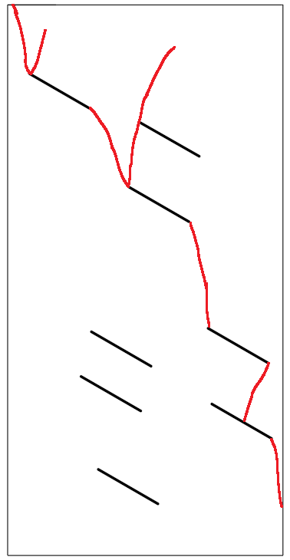 | 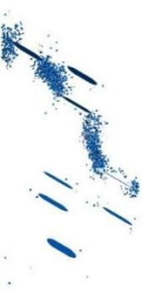 | 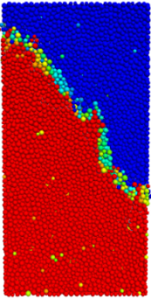 | 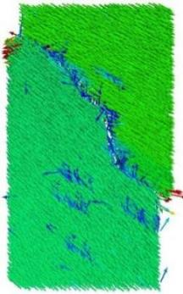 | The joints 1, 3 and 5 are connected and damaged. | Stepped
c-45 | 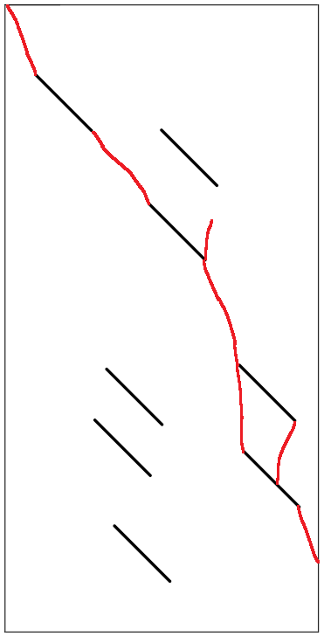 | 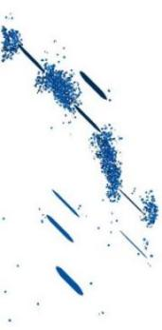 | 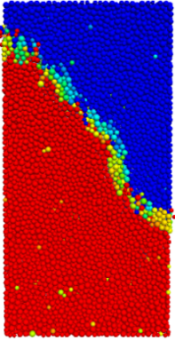 | 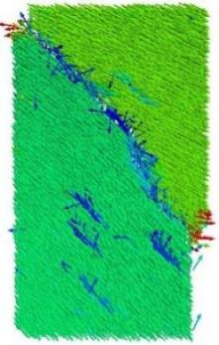 | The joints 1, 3 and 5 are connected and damaged. | Through a plane
c-60 | 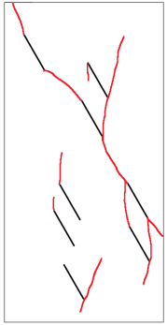 | 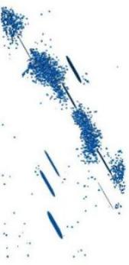 | 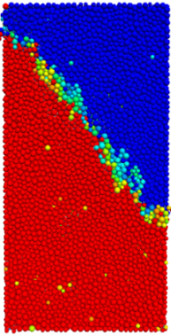 | 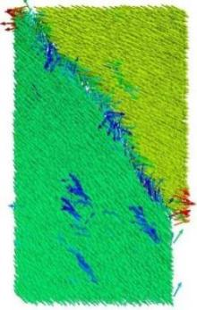 | The joints 1, 3, 5, and 7 are connected and damaged. | Through a plane
c-75 | 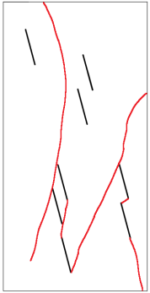 | 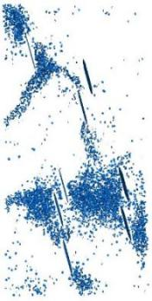 | 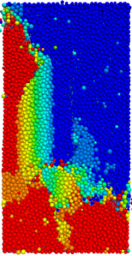 | 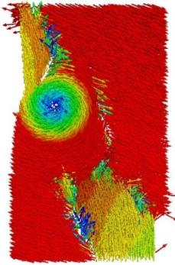 | The joints 1, 3, 5, and 7 are connected and damaged. | Rotation

Table 14 Statistical table of main mechanical parameters of discrete marble fractured rock mass
 | σ_{f}/MPa | ε_{f}/% | E* /GPa | m | ε₀/% | D₀
a-30 | 15.04 | 0.136 | 17.1 | 2.294368 | 0.195314 | 0.312397
a-45 | 24.93 | 0.196 | 18.4 | 2.708389 | 0.283154 | 0.260123
a-60 | 27.73 | 0.218 | 19.1 | 2.460035 | 0.314321 | 0.231976
a-75 | 51.08 | 0.34 | 21.5 | 2.789904 | 0.491127 | 0.13547
b-30 | 30.23 | 0.23 | 18.7 | 2.836092 | 0.332167 | 0.24806
b-45 | 31.85 | 0.241 | 19.9 | 2.443141 | 0.347382 | 0.199807
b-60 | 42.63 | 0.3 | 21.2 | 2.499655 | 0.432808 | 0.147533
b-75 | 48.56 | 0.347 | 22.9 | 2.030492 | 0.491836 | 0.079175
c-30 | 23.53 | 0.202 | 17.7 | 2.390138 | 0.290856 | 0.288271
c-45 | 24.65 | 0.198 | 21.8 | 1.784981 | 0.273929 | 0.123407
c-60 | 36.77 | 0.229 | 23.0 | 2.782696 | 0.330796 | 0.075154
c-75 | 40.69 | 0.244 | 22.7 | 3.242746 | 0.350708 | 0.087217

