A relatively accurate prediction model for the risk of developing mild cognitive impairment in patients with sarcopenia: Evidence from the CHARLS
Xinyue Liu^{a,b,#}, Jingyi Ni^{a,#}, Baicheng Wang^{a,#}, Rui Yinª, Jinlin Tang^{a,b}, Qi Chu^{c}, Lianghui Youª, Zhenggang Wuª, Yan Caoª, Chenbo Ji^{a,b,*}

ª Nanjing Women and Children's Healthcare Institute, Nanjing, Jiangsu, China.
^{b} School of Nursing, Nanjing Medical University, Nanjing, Jiangsu, China.
^{c} Sunshine Union Hospital, Weifang, Shandong, China.

#Co-first author

*Corresponding author: chenboji@njmu.edu.cn (C.B. Ji).

Journal: Aging clinical and experimental research

Data filtering
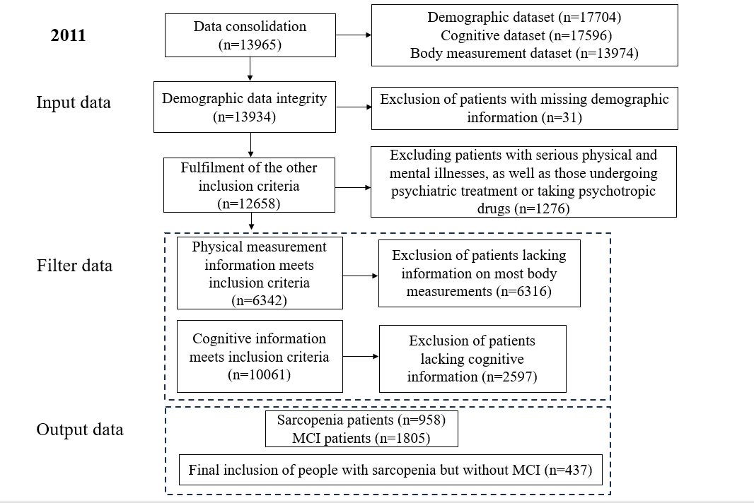
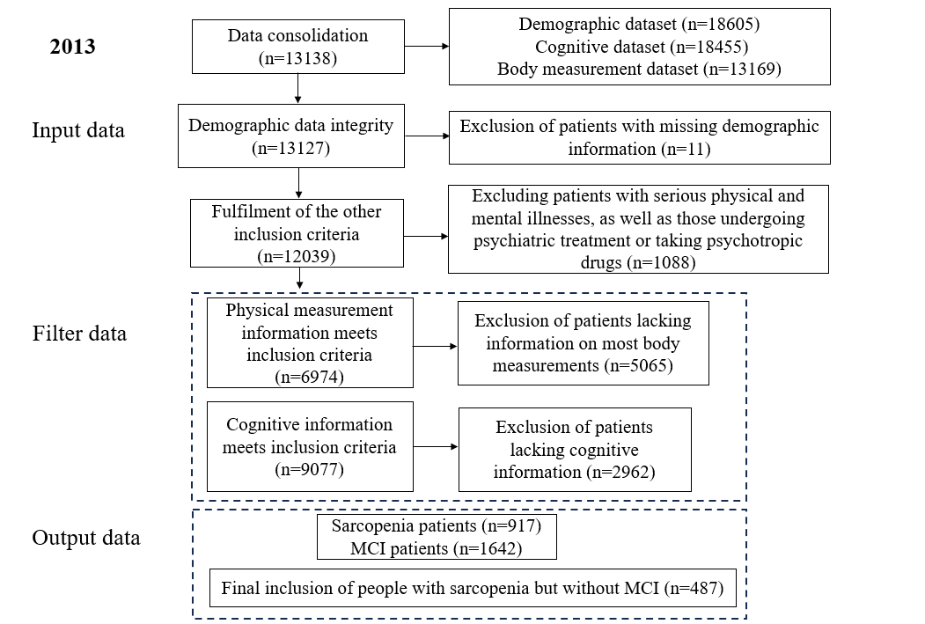
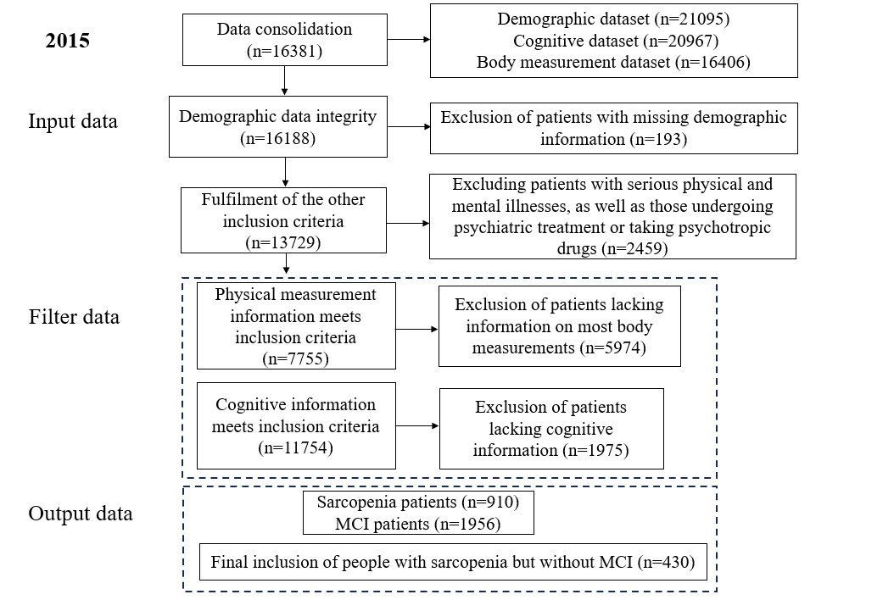
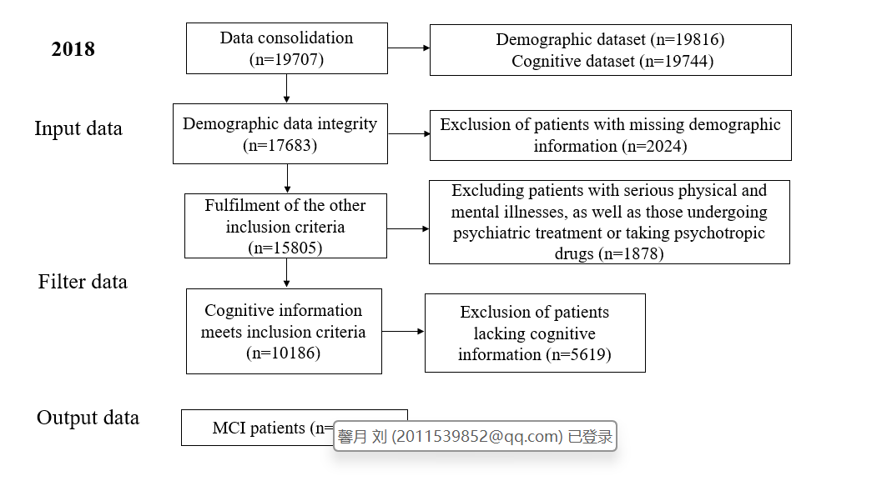

Code
R padding (R 4.2.2)
library(missForest)
setwd("C:/data")
read.csv(file="data.csv",header = T)
P1<-read.csv(file="data.csv",header = T)
P1
sum(is.na(P1))
table(is.na(P1))
P1miss<-function(x){sum(is.na(x))/length(x)*100}
apply(P1,2,P1miss)
P1$residence<-factor(P1$residence)
dummy_edu1<-ifelse(P1$Education=="1",1,0)
dummy_edu2<-ifelse(P1$Education=="2",1,0)
dummy_edu3<-ifelse(P1$Education=="3",1,0)
P1$gender<-factor(P1$gender)
P1$marital<-factor(P1$marital)
P1$hypertension<-factor(P1$hypertension)
P1$dyslipidemia<-factor(P1$dyslipidemia)
P1$diabetes<-factor(P1$diabetes)
P1$ malignancy<-factor(P1$malignancy)
P1$ chroniclungdisease<-factor(P1$ chroniclungdisease)
P1$liverdisease<-factor(P1$liverdisease)
P1$heartdisease<-factor(P1$heartdisease)
P1$stroke<-factor(P1$stroke)
P1$kidneydisease<-factor(P1$kidneydisease)
P1$stomachdisease<-factor(P1$stomachdisease)
P1$arthritis<-factor(P1$arthritis)
P1$asthma<-factor(P1$asthma)
P1$fall<-factor(P1$fall)
P1$smoke<-factor(P1$smoke)
P1$drink<-factor(P1$drink)
summary(P1)
P1.imp<-missForest(P1)
P1.imp
sum(is.na(P1.imp))
P1.imp$ximp
P1.imp$OOBerror
class(P1.imp$ximp)
write.csv(P1.imp$ximp,file="C:/data/2011.csv",quote=F,row.names=F)
write.csv(P1.imp$ximp,file="C:/data/2013.csv",quote=F,row.names=F)
write.csv(P1.imp$ximp,file="C:/data/2015.csv",quote=F,row.names=F)
write.csv(P1.imp$ximp,file="C:/data/2018.csv",quote=F,row.names=F)

Random forest: feature selection
library(rio)
library(ggplot2)
library(magrittr)
library(randomForest)
library(tidyverse)
library(skimr)
library(caret)
library(varSelRF)
library(pdp)
library(iml)
library(readxl)
B1<-read_excel("D:/R-4.2.2/library/randomForest/train.xlsx",sheet = "Sheet1")
as.data.frame(B1)
B1$gender<-factor(B1$gender,labels=c("male","female"))
B1$residence<-factor(B1$residence,labels=c("rural","urban"))
B1$marital<-factor(B1$marital,labels=c("yes","no"))
B1$hypertension<-factor(B1$hypertension,labels=c("yes","no"))
B1$dyslipidemia<-factor(B1$dyslipidemia,labels=c("yes","no"))
B1$diabetes<-factor(B1$diabetes,labels=c("yes","no"))
B1$malignancy<-factor(B1$malignancy,labels=c("yes","no"))
B1$chroniclungdisease<-factor(B1$chroniclungdisease,labels=c("yes","no"))
B1$liverdisease<-factor(B1$liverdisease,labels=c("yes","no"))
B1$heartdisease<-factor(B1$heartdisease,labels=c("yes","no"))
B1$stroke<-factor(B1$stroke,labels=c("yes","no"))
B1$kidneydisease<-factor(B1$kidneydisease,labels=c("yes","no"))
B1$stomachdisease<-factor(B1$stomachdisease,labels=c("yes","no"))
B1$arthritis<-factor(B1$arthritis,labels=c("yes","no"))
B1$asthma<-factor(B1$asthma,labels=c("yes","no"))
B1$smoke<-factor(B1$smoke,labels=c("yes","no"))
B1$drink<-factor(B1$drink,labels=c("yes","no"))
B1$fall<-factor(B1$fall,labels = c("yes","no"))
B1$mci<-factor(B1$mci, labels=c("yes","no"))
dummy_edu1<-ifelse(B1$education=="1",1,0)
dummy_edu2<-ifelse(B1$education=="2",1,0)
dummy_edu3<-ifelse(B1$education=="3",1,0)
trainsub = sample(nrow(B1),8/10*nrow(B1))
traindata = B1[trainsub,]
testdata = B1[-trainsub,]
form_reg<-as.formula(paste0("mci~",
paste(colnames(traindata)[1:30],collapse = "+")))
form_reg
set.seed(1234)
n<-ncol(B1)-5
errRate<-c(1)
for(i in 1:n){
rf_train<-randomForest(form_reg,data=traindata,
ntree=1000,
p=0.7,
mtry=i,
importance=T)
errRate[i]<-mean(rf_train$err.rate)
print(rf_train)
}
m=which.min(errRate)
print(m)
set.seed(1234)
rf_train<-randomForest(form_reg,data=traindata,
mtry=1,ntree=500,importance=T,proximity=TRUE)
rf_train
plot(rf_train,main="ERROR & TREES")
rf<-randomForest(form_reg,data = traindata,ntree =100,mtry=1,importance=TRUE)
rf
importance(rf)
varImpPlot(rf,main = "variable importance", n.var = 30)
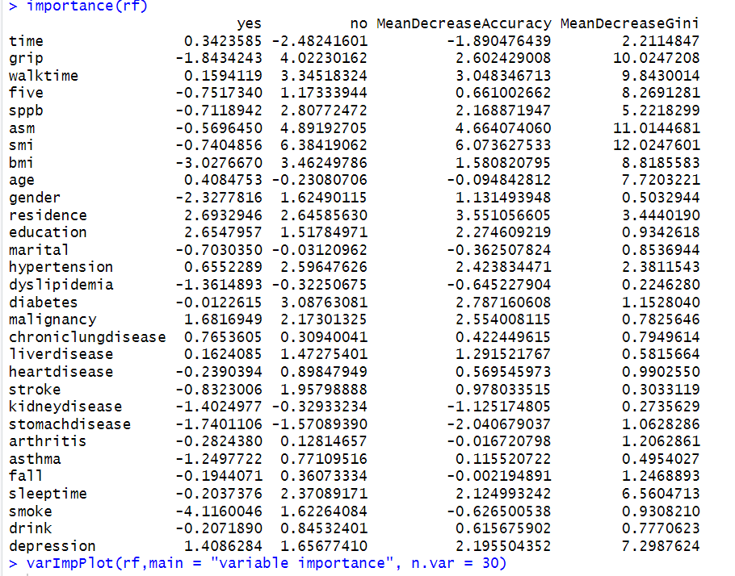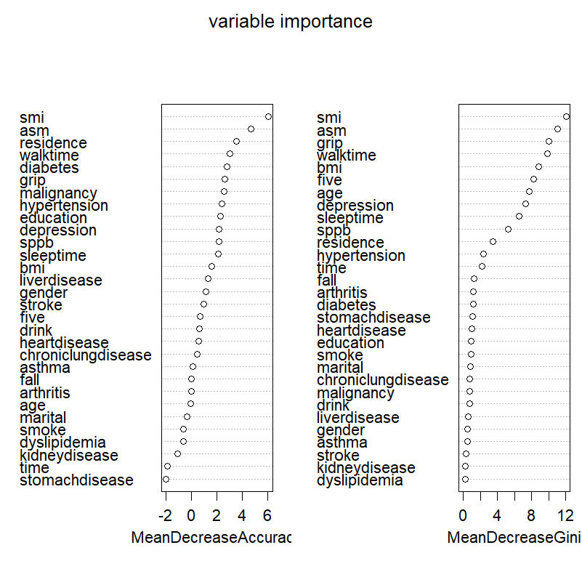

Feature elimination
library(readxl)
P1<-read_excel("D:/R-4.2.2/library/caret/data/train.xlsx",sheet = "Sheet1")
P2<c(1,1,1,2,1,2,1,2,2,1,1,2,1,2,1,2,2,1,1,2,2,2,2,2,1,2,2,2,1,2,2,2,2,2,1,2,2,1,2,1,1,2,2,2,2,1,2,2,2,2,2,2,2,2,2,1,2,2,2,2,1,1,2,2,2,2,2,2,2,1,2,2,2,2,2,2,2,2,2,2,2,1,1,2,2,1,1,2,1,2,1,2,2,1,2,2,2,1,2,2,1,2,1,2,2,2,2,2,2,2,2,2,1,2,2,2,2,2,2,2,2,1,2,2,2,2,2,2,2,1,2,2,2,1,2,2,2,2,2,2,2,2,2,1,1,1,1,2,2,1,2,2,2,2,2,2,2,2,2,1,2,2,2,2,2,1,2,2,2,1,1,2,2,2,1,1,2,2,1,2,2,2,2,1,2,2,2,2,2,2,1,2,1,2,2,1,2,2,2,2,2,2,2,2,2,2,2,2,1,2,2,2,1,2,2,2,2,2,2,2,1,2,2,2,2,2,2,1,2,2,2,2,2,2,2,1,2,2,2,1,2,2,2,2,2,1,1,2,2,1,2,2,2,2,2,1,2,2,2,2,2,2,2,1,2,2,2,2,2,2,2,2,2,1,1,1,2,2,1,1,2,2,2,2,2,1,2,2,2,2,2,1,2,2,2,2,2,2,2,2,2,2,1,1,1,2,2,2,2,2,2,2,2,2,2,1,2,2,2,2,2,2,2,2,2,2,2,2,2,2,2,2,2,2,1,2,2,1,2,1,2,2,1,1,2,2,2,1,1,2,2,2,2,2,2,2,2,1,2,2,2,2,1,1,1,2,2,1,1,2,2,2,2,2,2,2,2,2,1,2,2,1,2,2,2,1,2,2,2,2,2,2,2,2,2,2,1,2,1,2,2,1,2,1,1,1,2,1,2,2,2,2,2,2,2,2,2,2,2,2,2,2,2,1,1,2,1,2,1,2)
library(caret)
set.seed(1234)
rfeControl = rfeControl(functions = rfFuncs,
method = "cv",
number = 10
)
library(future)
plan("multisession",workers=8)
rfProfile <- rfe(P1, P2,
sizes = c(1:17),
rfeControl = rfeControl,
allowParallel = T
)
varImp(rfProfile)
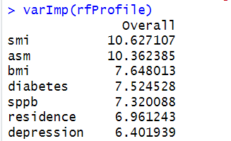

Logistic regression model
library(rms)
library(mice)
library(autoReg)
library(caret)
library(pROC)
library(rmda)
library(dplyr)
library(rrtable)
library(foreign)
library(regplot)
library(readxl)
A1<-read_excel("D:/R-4.2.2/library/rms/train.xlsx",sheet = "Sheet1")
x <- scale(A1[,-nearZeroVar(A1)])
x <- x[, -findCorrelation(cor(x), .8)]
x <- as.data.frame(x, stringsAsFactors = TRUE)
A1<-as.data.frame(A1)
head(A1)
str(A1)
A1$residence<-factor(A1$residence,labels=c("yes","no"))
A1$diabetes<-factor(A1$diabetes,labels=c("yes","no"))
A1$mci<-factor(A1$mci, labels=c("yes","no"))
head(A1)
str(A1)
attach(A1)
training.sample<-A1$mci %>% createDataPartition(p=0.8,list=FALSE)
train.data<-A1[training.sample,]
test.data<-A1[-training.sample,]
dd <- datadist(train.data)
options(datadist="dd")
fit1<-lrm(mci~.,data=train.data,x=T,y=T)
fit1
train_pred<-predict(fit1,newdata=train.data,type="fitted")
test_pred<-predict(fit1,newdata=test.data,type="fitted")
test_roc<-roc(test.data$mci,test_pred)
auc(test_roc)
ci(test_roc)
plot(test_roc)
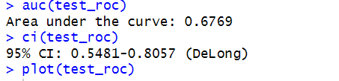
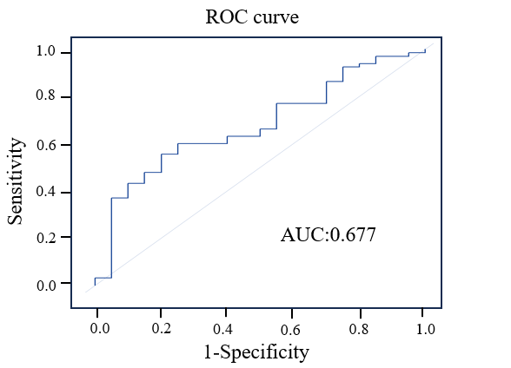

Neural network: DL mode (Pytorch2.2.1)
import torch
from torch import nn,optim
import torch.utils.data as Data
import numpy as np
import pandas as pd
import os ,re
import random
import copy
import matplotlib.pylab as plt
plt.rcParams['font.sans-serif']=['SimHei']
plt.rcParams['axes.unicode_minus']=False
import sklearn.preprocessing as preprocessing
from sklearn.model_selection import train_test_split
from sklearn.metrics import f1_score,recall_score,precision_score,roc_curve,roc_auc_score,accuracy_score,confusion_matrix
from sklearn.preprocessing import StandardScaler
import gc
import joblib

p = 0.7
l = 0.0005
Epochs = 500
input_size = 9
output_size = 1
df = pd.read_excel('train.xlsx')
df['mci'] = df['mci'].apply(lambda x:0 if x==1 else 1)
df=df.iloc[:,1:]
df = pd.get_dummies(df, columns=['residence','diabetes'])
y = df['mci']
df = df.drop(labels = 'mci',axis = 1)
df['mci'] = y
df = df.dropna()
df.shape
df = df.astype('float')
df
X_train,X_test, Y_train, Y_test =train_test_split(df.iloc[:,:-1],df.iloc[:,-1],test_size=0.2, random_state=0)
def z_score(data):
data = data.astype(float)
Mean = data.mean()
Var = ((data - Mean)**2).mean()
Std = pow(Var,0.5)
data = (data - Mean)/Std
return Mean,Std,data
Mean,Std,_ = z_score(X_train.iloc[:,:6])
import joblib
joblib.dump(Mean, 'Mean')
joblib.dump(Std, 'Std')
Mean
df.iloc[:,:6] = (df.iloc[:,:6] - Mean)/Std
df
Y_test

X_train,X_test, Y_train, Y_test =train_test_split(df.iloc[:,:-1].values,df.iloc[:,-1].values,test_size=0.2, random_state=7)

from imblearn.over_sampling import RandomOverSampler
over_sampler= RandomOverSampler()
X_train,Y_train = over_sampler.fit_resample(X_train,Y_train)
print(X_train.shape, Y_train.shape,X_test.shape, Y_test.shape)
X_train = torch.tensor(X_train,dtype = torch.float)
Y_train = torch.tensor(Y_train,dtype = torch.float)
X_test = torch.tensor(X_test,dtype = torch.float)
Y_test = torch.tensor(Y_test,dtype = torch.float)
train_loader = Data.DataLoader(
dataset=Data.TensorDataset(X_train, Y_train),
batch_size=10,
shuffle=True,
drop_last =True,
num_workers=0,
)
test_loader = Data.DataLoader(
dataset=Data.TensorDataset(X_test, Y_test),
batch_size=32,
shuffle=False,
drop_last =True,
num_workers=0,
)

def seed_torch():
seed=1029
random.seed(seed)
os.environ['PYTHONHASHSEED'] = str(seed)
np.random.seed(seed)
torch.manual_seed(seed)
torch.cuda.manual_seed(seed)
torch.cuda.manual_seed_all(seed)
class BP(nn.Module):
def __init__(self,p,input_size, output_size):
super().__init__()

self.linear1 = nn.Linear(input_size, 128)
self.linear2 = nn.Linear(128, 64)
self.linear3 = nn.Linear(64, output_size)
self.dropout = nn.Dropout(p=p)
self.relu = nn.ReLU()
def forward(self, x):
x = self.relu(self.linear1(x))
x = self.dropout(x)
x = self.relu(self.linear2(x))
x = self.linear3(x)
x = torch.sigmoid(x)
x = torch.squeeze(x)
return x

device = torch.device("cuda:0" if torch.cuda.is_available() else "cpu")
seed_torch()
model = BP(p,input_size,output_size)
model = model.to(device)
loss_function = nn.BCELoss()
optimizer = torch.optim.Adam(model.parameters(), lr=l)
scheduler = optim.lr_scheduler.StepLR(optimizer, step_size=9, gamma=0.95)
loss_dict = {}
loss_dict['train_loss'] = []
loss_dict['test_loss'] = []
loss_dict['train_acc'] = []
loss_dict['test_acc'] = []
loss_dict['train_auc'] = []
loss_dict['test_auc'] = []
AUC= 0
LOSS_TEST = 100
Len_train = len(train_loader)
Len_test = len(test_loader)
for epochs in range(Epochs):
loss_mean_train = 0
loss_mean_test = 0
acc_train = 0
acc_test = 0
Brier_train = 0
Brier_test = 0
auc_train = 0
auc_test = 0
model.train()
for data_l in train_loader:
seq, labels = data_l
seq, labels = seq.to(device), labels.to(device)
optimizer.zero_grad()
y_pred = model(seq)
single_loss = loss_function(y_pred, labels)
single_loss.backward()
optimizer.step()
loss_mean_train += single_loss.item()
acc = accuracy_score(labels.cpu().numpy(), torch.round(y_pred).cpu().detach().numpy() )
acc_train += acc
try:
Auc = roc_auc_score(labels.cpu().numpy(), y_pred.cpu().detach().numpy())
except:
Auc = 0
auc_train +=Auc
scheduler.step()
loss_mean_train = loss_mean_train/Len_train
acc_train= acc_train/Len_train
auc_train = auc_train/Len_train
loss_dict['train_loss'].append(loss_mean_train)
loss_dict['train_acc'].append(acc_train)
loss_dict['train_auc'].append(auc_train)
model.eval()
y_pred = model(X_test)
loss_mean_test = loss_function(y_pred, Y_test).item()
acc_test = accuracy_score(Y_test.cpu().numpy(), torch.round(y_pred).cpu().detach().numpy())
try:
auc_test = roc_auc_score(Y_test.cpu().numpy(), y_pred.cpu().detach().numpy())
except:
auc_test = 0
loss_dict['test_loss'].append(loss_mean_test)
loss_dict['test_acc'].append(acc_test)
loss_dict['test_auc'].append(auc_test)
print('Epochs',epochs,'loss_train',round(loss_mean_train,5),'loss_test',round(loss_mean_test,5),)
print('acc_train',round(acc_train,3),'acc_test',round(acc_test,3))
print('auc_train',round(auc_train,3),'auc_test',round(auc_test,3))
print('------------------')
if AUC < auc_test:
AUC =auc_test
torch.save(model, 'model_bp1.pth')
print('已更新保存模型')
del seq, labels,y_pred
gc.collect()
torch.cuda.empty_cache()
import matplotlib.pyplot as plt
plt.figure(dpi=150,figsize=(7,4))
plt.plot(loss_dict['train_loss'][:], label='train')
plt.plot(loss_dict['test_loss'][:], label='test')
plt.xlabel('iteration')
plt.ylabel('logloss')
plt.title('bp_Training and Testing Loss')
plt.legend()
plt.savefig('lstm_loss.jpg',dpi=150)
plt.show()
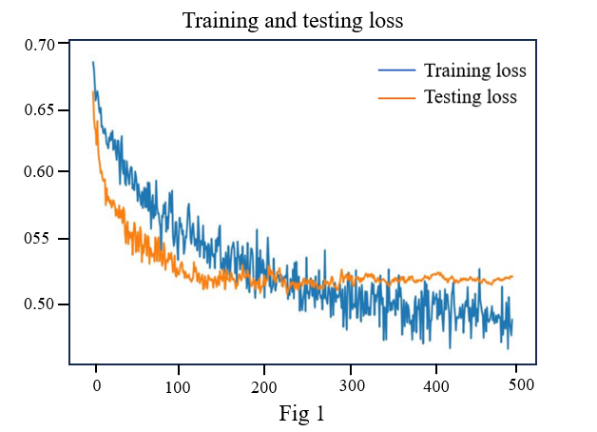
device = torch.device("cuda" if torch.cuda.is_available() else "cpu")
model = torch.load('model_bp1.pth')
model = model.to(device)
yhat = model(X_test).cpu().detach().numpy()
yhat
Y = Y_test.cpu().detach().numpy().copy()
torch.cuda.empty_cache()
FPR,recall,thresholds = roc_curve(Y,yhat,pos_label=1)
area =roc_auc_score(Y,yhat)
maxindex = (recall-FPR).tolist().index(max(recall-FPR))
recall[maxindex]
prob = pd.DataFrame(yhat)
prob.loc[prob.iloc[:,0]>=thresholds[maxindex],'y_pred'] = 1
prob.loc[prob.iloc[:,0]<thresholds[maxindex],'y_pred'] = 0
print(thresholds[maxindex])
plt.figure(figsize=(10,7))
plt.plot(FPR,recall,color='red',
label='ROC curve(area=%0.3f)'%area)
plt.plot([0,1],[0,1],color='black',linestyle='--')
plt.scatter(FPR[maxindex],recall[maxindex],c='black',s=20)
r = '%0.3f' % recall[maxindex]
plt.text(FPR[maxindex]-0.05, recall[maxindex]+0.02, r,ha='center', va='bottom', fontsize=10)
plt.xlabel('False Positive Rate',fontsize = 15)
plt.ylabel('Recall',fontsize = 15)
plt.legend(loc='lower right')
plt.savefig(fname="ROC.jpg",dpi=500)
plt.show()
Predict = [1 if yhat[j]>thresholds[maxindex] else 0 for j in range(len(Y)) ]
from sklearn.metrics import confusion_matrix as CM, precision_score as P, recall_score as R
cm = CM(Y,Predict,labels=[1,0])
ACC= (cm[0,0]+cm[1,1])/cm[:,:].sum()
precision = cm[0,0]/(cm[0,0]+cm[1,0])
F1 = 2/(1/precision+1/recall[maxindex])
dict_h = {
'accuracy':ACC,
'precision':precision,
'recall':recall[maxindex],
'F1':F1,
'area':area,
}
df_h = pd.DataFrame(dict_h,index =[0])
df_h.to_excel('Assessment indicators.xlsx')
df_h
from sklearn.metrics import roc_auc_score
from sklearn.utils import resample
import numpy as np
def bootstrap_auc(y_true, y_scores, n_bootstraps=1000):
bootstrapped_scores = []
rng = np.random.RandomState(42) # Seed for reproducibility
for _ in range(n_bootstraps):
indices = rng.randint(0, len(y_scores), len(y_scores))
if len(np.unique(y_true[indices])) < 2:
continue
score = roc_auc_score(y_true[indices], y_scores[indices])
bootstrapped_scores.append(score)
sorted_scores = np.sort(bootstrapped_scores)
lower = np.percentile(sorted_scores, 2.5)
upper = np.percentile(sorted_scores, 97.5)
return lower, upper
lower, upper = bootstrap_auc(Y, yhat)
print(' AUC95% CI',lower, upper)
print(dict_h)
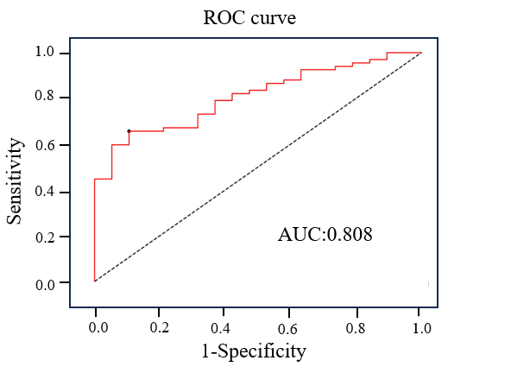
dff = pd.read_excel('validation.xlsx')
dff['mci'] = dff['mci'].apply(lambda x:0 if x==1 else 1)
dff=dff.iloc[:,1:]
dff

dff = pd.get_dummies(dff, columns=['residence','diabetes'])
y = dff['mci']
dff = dff.drop(labels = 'mci',axis = 1)
dff['mci'] = y
dff.iloc[:,:6] = (dff.iloc[:,:6] - Mean)/Std
class BP(nn.Module):
def __init__(self,p,input_size, output_size):
super().__init__()
self.linear1 = nn.Linear(input_size, 256)
self.linear2 = nn.Linear(256, 64)
self.linear3 = nn.Linear(64, output_size)
self.dropout = nn.Dropout(p=p)
self.relu = nn.ReLU()
def forward(self, x):
x = self.relu(self.linear1(x))
x = self.dropout(x)
x = self.relu(self.linear2(x))
x = self.linear3(x)
x = torch.sigmoid(x)
x = torch.squeeze(x)
return x
dff = dff.astype('float')
x = dff.iloc[:,:-1].values
y = dff.iloc[:,-1].values
x = torch.tensor(x,dtype = torch.float)
device = torch.device("cuda" if torch.cuda.is_available() else "cpu")
model = torch.load('model_bp1.pth')
model = model.to(device)
yhat = model(x).cpu().detach().numpy()
Y = y
dff = pd.DataFrame()
dff['预测结果'] = yhat
dff['真实值'] = Y
dff.to_excel('验证集预测结果.xlsx',index =False)
torch.cuda.empty_cache()
FPR,recall,thresholds = roc_curve(Y,yhat,pos_label=1)
area =roc_auc_score(Y,yhat)
maxindex = (recall-FPR).tolist().index(max(recall-FPR))
recall[maxindex]
prob = pd.DataFrame(yhat)
prob.loc[prob.iloc[:,0]>=thresholds[maxindex],'y_pred'] = 1
prob.loc[prob.iloc[:,0]<thresholds[maxindex],'y_pred'] = 0
plt.figure(figsize=(10,7))
plt.plot(FPR,recall,color='red',
label='ROC curve(area=%0.3f)'%area)
plt.plot([0,1],[0,1],color='black',linestyle='--')
plt.scatter(FPR[maxindex],recall[maxindex],c='black',s=20)
r = '%0.3f' % recall[maxindex]
plt.text(FPR[maxindex]-0.05, recall[maxindex]+0.02, r,ha='center', va='bottom', fontsize=10)
plt.xlabel('False Positive Rate',fontsize = 15)
plt.ylabel('Recall',fontsize = 15)
# plt.title('Receiver operating characteristic example',fontsize = 20)
plt.legend(loc='lower right')
plt.savefig(fname="ROC.jpg",dpi=500)
plt.show()
Predict = [1 if yhat[j]>thresholds[maxindex] else 0 for j in range(len(Y)) ]
from sklearn.metrics import confusion_matrix as CM, precision_score as P, recall_score as R
cm = CM(Y,Predict,labels=[1,0])
ACC= (cm[0,0]+cm[1,1])/cm[:,:].sum()
precision = cm[0,0]/(cm[0,0]+cm[1,0])
F1 = 2/(1/precision+1/recall[maxindex])
dict_h = {
'accuracy':ACC,
'precision':precision,
'recall':recall[maxindex],
'F1':F1,
'area':area,
}
df_h = pd.DataFrame(dict_h,index =[0])
df_h.to_excel('vaildation Assessment indicators .xlsx')
df_h
from sklearn.metrics import roc_auc_score
from sklearn.utils import resample
import numpy as np
def bootstrap_auc(y_true, y_scores, n_bootstraps=1000):
bootstrapped_scores = []
rng = np.random.RandomState(42) # Seed for reproducibility
for _ in range(n_bootstraps):
indices = rng.randint(0, len(y_scores), len(y_scores))
if len(np.unique(y_true[indices])) < 2:
continue
score = roc_auc_score(y_true[indices], y_scores[indices])
bootstrapped_scores.append(score)
sorted_scores = np.sort(bootstrapped_scores)
lower = np.percentile(sorted_scores, 2.5)
upper = np.percentile(sorted_scores, 97.5)
return lower, upper
lower, upper = bootstrap_auc(Y, yhat)
print('vaildation AUC95% CI',lower, upper)
print(dict_h)
