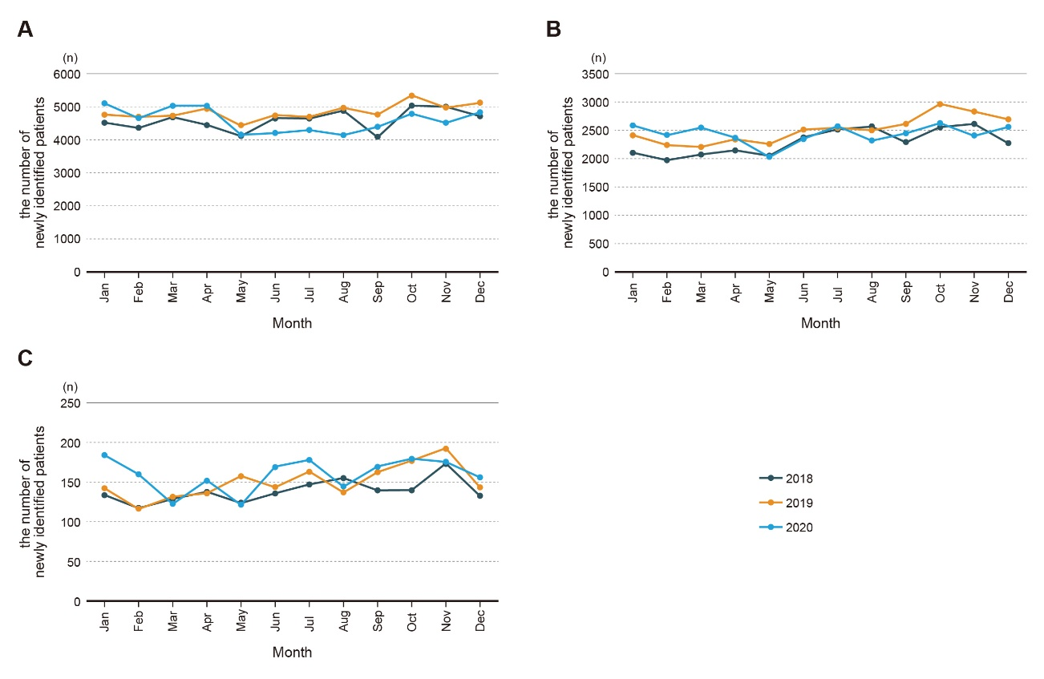
Supplementary Figure 1
Supplementary Figure 1. Monthly trends of the number of breast cancer cases in 2018, 2019, and 2020 by different numbers of comorbidity. A) none, B) 1-2, C) 3-4.

Supplementary Figure 2.
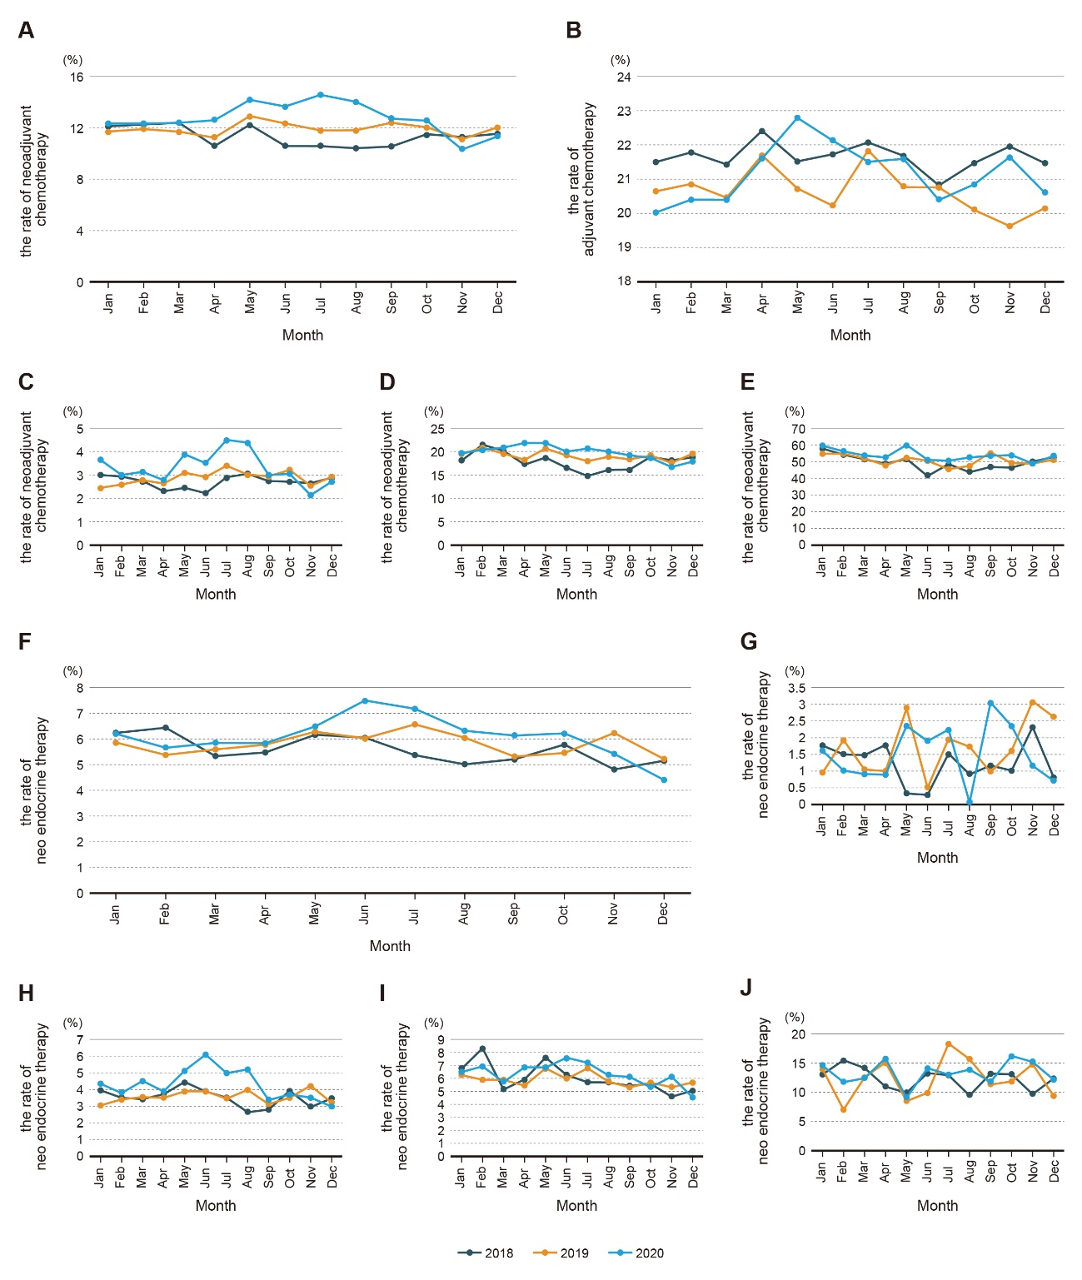
Supplementary Figure 2. Monthly trends of the rate of breast cancer cases receiving neoadjuvant chemotherapy (A) and adjuvant chemotherapy (B) in 2018, 2019, and 2020. C, D, and E indicate the rate of clinical Stage I, II, and III breast cancer cases receiving neoadjuvant chemotherapy. And monthly trends of the rate of breast cancer cases receiving neoadjuvant endocrine therapy (F) in 2018, 2019, and 2020. G, H, I, and J indicate the rate of clinical Stage 0, I, II, and III breast cancer cases receiving neoadjuvant endocrine therapy.
Supplementary Figure 3.
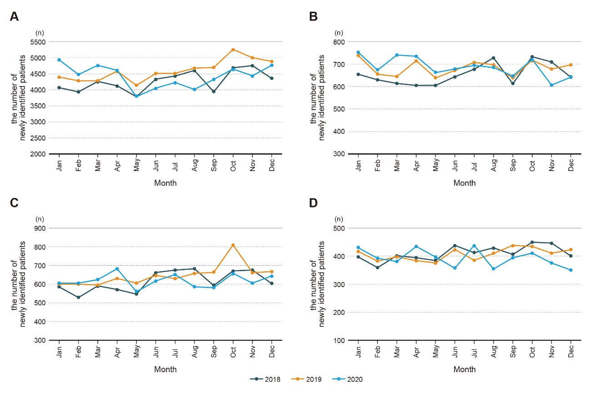
Supplementary Figure 3. Monthly trends of the number of breast cancer cases in 2018, 2019, and 2020 by different breast cancer subtypes. A) ER+ and/or PgR+, HER2−, B) ER+ and/or PgR+, HER2+, C) ER− and PgR−, HER2+, D) ER− and PgR−, HER2−.

