Table S1 Soil physicochemical properties of cropland and abandoned soil. Cropland was cultivated with corn, while annual weeds thrive in abandoned fields.

Soil physicochemical properties | Cropland | Abandoned land
pH | 5.32±0.11 | 5.32±0.03
EC | 82.03±6.21 | 20.71±2.67
TC (g·kg⁻¹) | 7.25±0.14 | 5.97±0.71
SOC (g·kg⁻¹) | 3.21±0.06 | 2.59±0.11
TN (g·kg⁻¹) | 0.81±0.05 | 0.67±0.08
NO₃⁻ (mg·kg⁻¹) | 10.52±0.99 | 3.9±0.25
NH₄⁺ (mg·kg⁻¹) | 8.91±0.61 | 8.92±0.60
TP (g·kg⁻¹) | 0.38±0.01 | 0.23±0.01
AP (mg·kg⁻¹) | 11.03±0.22 | 16.74±0.96
AK (mg·kg⁻¹) | 58.18±9.93 | 24.35±5.57
SU (mg NH₃-N·kg⁻¹ h⁻¹) | 25.25±1.33 | 23.24±0.74
SALP (mg phenol·kg⁻¹ h⁻¹) | 1.94±0.72 | 0.65±0.04
WSA | 0.72±0.10 | 0.80±0.04
MWD | 0.51±0.08 | 0.66±0.08
GMD | 0.45±0.07 | 0.53±0.06
Dm | 2.04±0.19 | 1.90±0.11

Table S2 Aboveground biomass of planted species and weeds.

Species | Plant species (g·m⁻²) | weeds (g·m⁻²)
L. chin | 977.73±170.54 | 58.80±19.29
A. hirt | 1699.80±247.72 | 5.60±1.01
E. kamo | 660.90±38.77 | 9.33±1.94
A. laxm | 1263.60±230.63 | 0.00±0.00
L. bico | 429.30±58.57 | 16.13±12.93
A. gmel | 743.47±135.71 | 0.67±0.27
A. frig | 1470.40±111.09 | 5.33±3.38
S. offi | 1086.90±89.87 | 12.13±4.49
P. chin | 439.80±40.97 | 85.33±30.20

Table S3 Physicochemical properties of soil collected from plots planted with 9 grass species.
Soil physicochemical properties | L. chin | A. hirt | E. kamo | A. laxm | L. bico | A. gmel | A. frig | S. offi | P. chin
pH | 5.79±0.04 | 5.70±0.01 | 5.73±0.04 | 5.69±0.05 | 5.68±0.01 | 5.75±0.10 | 5.65±0.16 | 5.58±0.03 | 5.7±0.02
EC | 18.96±0.57 | 17.44±2.01 | 16.32±0.68 | 23.75±3.57 | 22.83±1.71 | 17.95±1.91 | 17.04±0.48 | 20.89±1.97 | 18.25±1.60
TC (g· kg⁻¹) | 6.99±0.34 | 5.91±0.35 | 5.33±0.15 | 4.97±0.09 | 5.59±0.07 | 6.62±0.39 | 6.64±0.22 | 6.36±0.04 | 5.84±0.43
SOC (mg·kg⁻¹) | 2.70±0.23 | 2.25±0.30 | 3.73±1.34 | 2.42±0.37 | 2.82±0.10 | 2.82±0.10 | 2.53±0.06 | 2.42±0.15 | 2.42±0.06
TN (g·kg⁻¹) | 0.72±0.06 | 0.55±0.03 | 0.57±0.02 | 0.61±0.02 | 0.57±0.03 | 0.61±0.02 | 0.74±0.01 | 0.56±0.01 | 0.63±0.06
NO₃⁻ (mg·kg⁻¹) | 7.01±0.74 | 5.22±0.20 | 5.01±0.50 | 8.43±0.32 | 7.05±1.71 | 6.28±1.20 | 5.61±0.86 | 8.19±0.60 | 8.68±1.60
NH₄⁺ (mg·kg⁻¹) | 7.70±0.19 | 7.77±0.23 | 8.42±0.46 | 8.42±0.69 | 8.56±1.10 | 11.44±1.59 | 11.10±0.74 | 9.11±0.66 | 10.06±1.29
TP (g·kg⁻¹) | 0.35±0.03 | 0.26±0.01 | 0.24±0.02 | 0.33±0.02 | 0.30±0.02 | 0.26±0.03 | 0.21±0.00 | 0.25±0.02 | 0.25±0.01
AP (mg·kg⁻¹) | 15.71±0.74 | 8.03±0.33 | 7.02±0.57 | 8.76±0.76 | 11.03±0.27 | 5.25±0.27 | 9.47±0.79 | 14.06±0.44 | 12.64±0.74
AK (mg·kg⁻¹) | 35.28±1.11 | 22.23±0.58 | 25.21±3.30 | 24.85±2.57 | 28.68±3.94 | 25.49±2.07 | 16.27±0.61 | 30.03±7.92 | 19.46±0.55
SU (mg NH₃-N·kg⁻¹ h⁻¹) | 22.38±0.61 | 25.38±0.27 | 20.65±0.65 | 21.13±0.97 | 26.46±0.01 | 22.54±1.38 | 21.08±0.78 | 36.24±1.33 | 25.23±0.52
SALP (mg phenol·kg⁻¹ h⁻¹) | 0.73±0.03 | 2.25±0.54 | 1.89±0.28 | 1.17±0.51 | 1.88±0.41 | 1.54±0.15 | 2.07±0.15 | 1.72±0.18 | 1.53±0.04
WSA | 0.70±0.05 | 0.81±0.02 | 0.76±0.05 | 0.87±0.04 | 0.82±0.05 | 0.75±0.02 | 0.77±0.05 | 0.78±0.06 | 0.78±0.03
MWD | 0.56±0.04 | 0.66±0.06 | 0.64±0.15 | 0.73±0.17 | 0.57±0.06 | 0.63±0.08 | 0.50±0.05 | 0.53±0.04 | 0.56±0.07
GMD | 0.46±0.04 | 0.52±0.04 | 0.52±0.10 | 0.62±0.13 | 0.48±0.05 | 0.50±0.05 | 0.42±0.03 | 0.45±0.02 | 0.47±0.04
Dm | 2.13±0.05 | 1.89±0.05 | 1.98±0.02 | 1.80±0.12 | 1.88±0.07 | 1.98±0.13 | 1.92±0.09 | 2.03±0.11 | 2.04±0.11

Table S4 Correlation coefficient between ecological taxa in soil microbial network and soil physicochemical properties measured by mental-test.

Ecological taxa | Soil  Physicochemical  properties | r | p
Network hubs | pH | 0.141302953 | 0.101
Network hubs | EC | 0.161043813 | 0.07
Network hubs | TC | 0.086270339 | 0.122
Network hubs | SOC | -0.030948516 | 0.567
Network hubs | TN | 0.01341068 | 0.374
Network hubs | NO3- | 0.04471869 | 0.258
Network hubs | NH4+ | -0.010948634 | 0.494
Network hubs | TP | 0.147938657 | 0.04
Network hubs | AP | 0.018630778 | 0.378
Network hubs | AK | 0.170812833 | 0.049
Network hubs | SU | 0.02803592 | 0.349
Network hubs | SALP | 0.003119623 | 0.438
Network hubs | WSA | -0.013349332 | 0.504
Network hubs | MWD | -0.005304211 | 0.49
Network hubs | GMD | -0.006552688 | 0.446
Network hubs | Dm | -0.03199976 | 0.65
Connectors | pH | -0.092097067 | 0.783
Connectors | EC | 0.086064055 | 0.221
Connectors | TC | 0.175352739 | 0.036
Connectors | SOC | 0.008735625 | 0.326
Connectors | TN | -0.126750966 | 0.884
Connectors | NO3- | -0.003875461 | 0.466
Connectors | NH4+ | -0.006522794 | 0.446
Connectors | TP | 0.103982245 | 0.128
Connectors | AP | -0.038551472 | 0.63
Connectors | AK | 0.06998743 | 0.247
Connectors | SU | -0.02028458 | 0.474
Connectors | SALP | 0.088469781 | 0.224
Connectors | WSA | -0.044166291 | 0.609
Connectors | MWD | -0.018643173 | 0.482
Connectors | GMD | -0.011398104 | 0.435
Connectors | Dm | -0.095684781 | 0.869
Module hubs | pH | -0.075157029 | 0.76
Module hubs | EC | 0.060101239 | 0.209
Module hubs | TC | 0.088945345 | 0.137
Module hubs | SOC | -0.078027597 | 0.774
Module hubs | TN | -0.009007819 | 0.474
Module hubs | NO3- | 0.162748003 | 0.054
Module hubs | NH4+ | 0.041492764 | 0.264
Module hubs | TP | 0.104048813 | 0.123
Module hubs | AP | 0.157541636 | 0.024
Module hubs | AK | 0.183807522 | 0.05
Module hubs | SU | 0.029325802 | 0.326
Module hubs | SALP | 0.103571411 | 0.137
Module hubs | WSA | 0.073164617 | 0.172
Module hubs | MWD | -0.064151892 | 0.725
Module hubs | GMD | -0.033349084 | 0.544
Module hubs | Dm | -0.060814284 | 0.785
Peripherals | pH | -0.125072837 | 0.895
Peripherals | EC | 0.077795997 | 0.183
Peripherals | TC | 0.138413625 | 0.08
Peripherals | SOC | -0.037133019 | 0.478
Peripherals | TN | -0.114393272 | 0.879
Peripherals | NO3- | -0.033549008 | 0.584
Peripherals | NH4+ | -0.003189018 | 0.41
Peripherals | TP | 0.124323353 | 0.095
Peripherals | AP | 0.034431264 | 0.294
Peripherals | AK | 0.164608659 | 0.09
Peripherals | SU | -0.017247097 | 0.454
Peripherals | SALP | 0.085313855 | 0.212
Peripherals | WSA | -0.00804456 | 0.465
Peripherals | MWD | -0.030335989 | 0.54
Peripherals | GMD | -0.01569121 | 0.438
Peripherals | Dm | -0.045448722 | 0.666
Specific taxa | pH | 0.041390246 | 0.236
Specific taxa | EC | 0.036287744 | 0.298
Specific taxa | TC | 0.109326774 | 0.036
Specific taxa | SOC | 0.027537137 | 0.297
Specific taxa | TN | -0.032994976 | 0.716
Specific taxa | NO3- | 0.151222339 | 0.002
Specific taxa | NH4+ | 0.052121037 | 0.153
Specific taxa | TP | 0.110768705 | 0.02
Specific taxa | AP | 0.17708335 | 0.002
Specific taxa | AK | 0.160631575 | 0.003
Specific taxa | SU | 0.188720002 | 0.001
Specific taxa | SALP | 0.09427962 | 0.031
Specific taxa | WSA | -0.017463234 | 0.623
Specific taxa | MWD | -0.034333123 | 0.721
Specific taxa | GMD | -0.04131243 | 0.757
Specific taxa | Dm | 0.004858286 | 0.48
Others | pH | -0.071440706 | 0.705
Others | EC | 0.151893098 | 0.106
Others | TC | 0.153204008 | 0.045
Others | SOC | 0.061963225 | 0.206
Others | TN | -0.157792266 | 0.967
Others | NO3- | -0.156507277 | 0.969
Others | NH4+ | -0.066116555 | 0.724
Others | TP | 0.072682521 | 0.186
Others | AP | -0.102314707 | 0.9
Others | AK | 0.004984187 | 0.424
Others | SU | -0.071414534 | 0.725
Others | SALP | 0.001407877 | 0.477
Others | WSA | -0.106506285 | 0.837
Others | MWD | 0.168740086 | 0.087
Others | GMD | 0.159026582 | 0.104
Others | Dm | -0.045974303 | 0.679

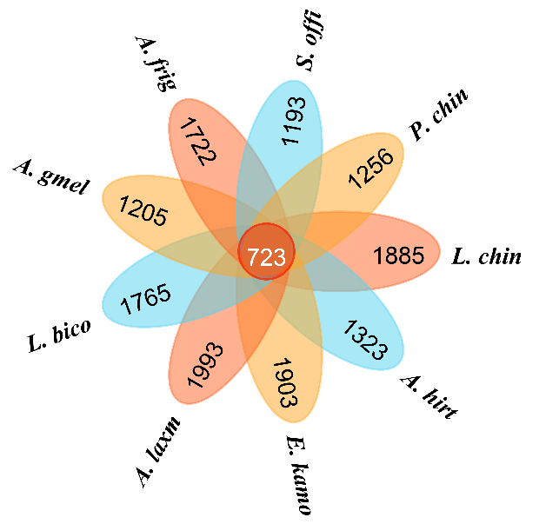
Fig. S1 Flower plots of ASVs of 9 grass specie.

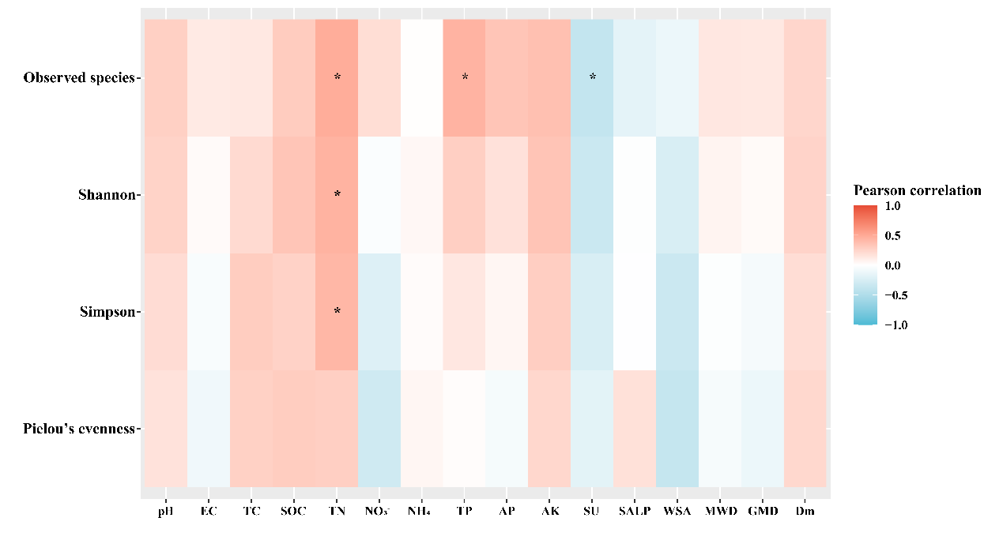
Fig. S2 Relationship between bacterial diversity and soil physicochemical properties. Pearson was used for correlation analysis. Significant (p＜0.05) are indicated by *.

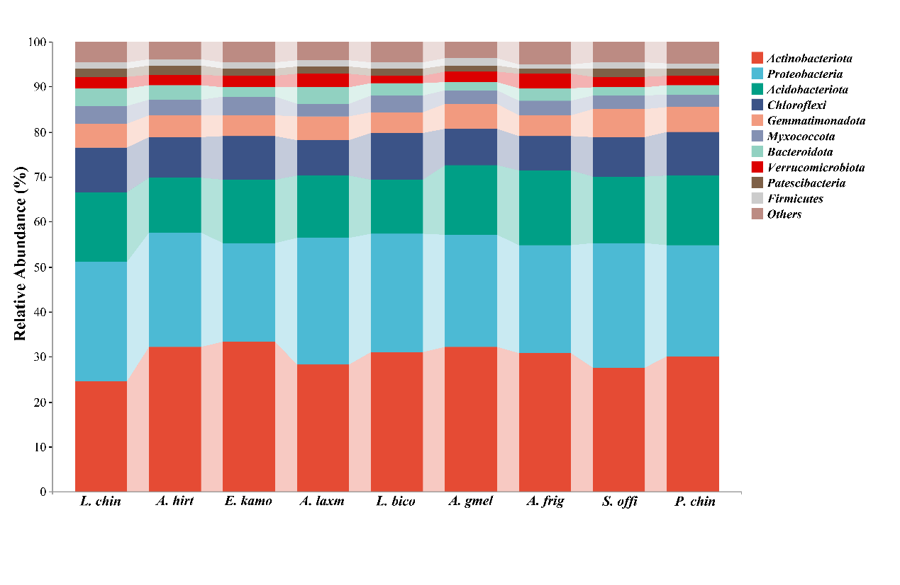
Fig. S3 Bacterial taxonomic composition of grass species at the Phylum level.

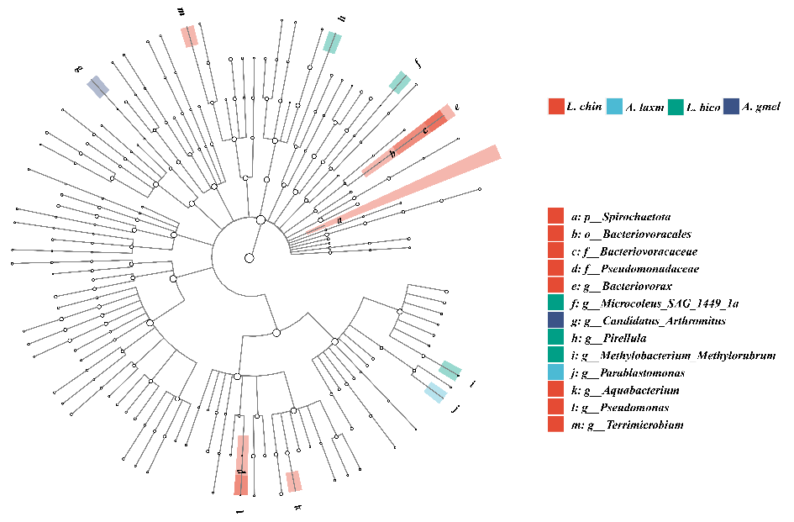
Fig. S4 The enrichment of taxa at different phylogenetic levels among 9 grass species.

