Newly synthesized 1,2,3-triazoles based on [1,4]-benzoxazin-3-one: In silico evaluation of anti-inflammatory, antibacterial, antioxidant, anticancer, and antidiabetic properties, along with molecular dynamics simulation and ADME analysis
Darifa Addichi¹, Ayoub Farihi², Noufel Hachimi³, Saliha Loughmari¹, Ali S. Alqahtani⁴, Aziz Ihammi¹, Omar M. Noman⁴, Mohamed Bouhrim^{5,6}*, Abdelaziz Ed-Dra⁵, Bruno Eto⁶, Mohamed Ellouz¹*, Fatiha Chigr⁵, Mohammed Chigr¹
¹ Laboratory of Molecular Chemistry, Materials and Catalysis (LCMMC), Faculty of Sciences and Technology, Sultan Moulay Slimane University, P.O. Box 523, Beni-Mellal 23000, Morocco. darifaadd@gmail.com (D.A); salihaloughmari@gmail.com (S.L); azizihammi@gmail.com (A.I); ellouz.chimie@gmail.com (M.E); chigrm@gmail.com (M.C).
² Oriental Center for Water and Environmental Sciences and Technologies (COSTE), Mohammed Premier University, Oujda 60000, Morocco; ayoub.farihi@uit.ac.ma (A.F).
³ Physiology and Physiopathology Team, Faculty of Sciences, Genomic of Human Pathologies Research Centre, Mohammed V University, Rabat, Morocco; noufel.hachimi@um5s.net.ma (N.H).
⁴ Department of Pharmacognosy, College of Pharmacy, King Saudi University, Saudi Arabia. alalqahtani@ksu.edu.sa (A.S.A); onoman@ksu.edu.sa (O.M.N).
⁵ Laboratory of Biological Engineering, Team of Functional and Pathological Biology; Faculty of Sciences and Technology Beni Mellal, University Sultan Moulay Slimane, Morocco. mohamed.bouhrim@gmail.com (M.B); f.chigr@usms.ma (F.C). a.eddra@usms.ma (A.E-D).
⁶ Laboratoires TBC, Laboratory of Pharmacology, Pharmacokinetics, and Clinical Pharmacy, Faculty of Pharmaceutical and Biological Sciences, B.P. 83 Lille, France. bruno.eto@univ-lille.fr (B.E).

*Correspondence: mohamed.bouhrim@gmail.com (M.B); ellouz.chimie@gmail.com (M.E)

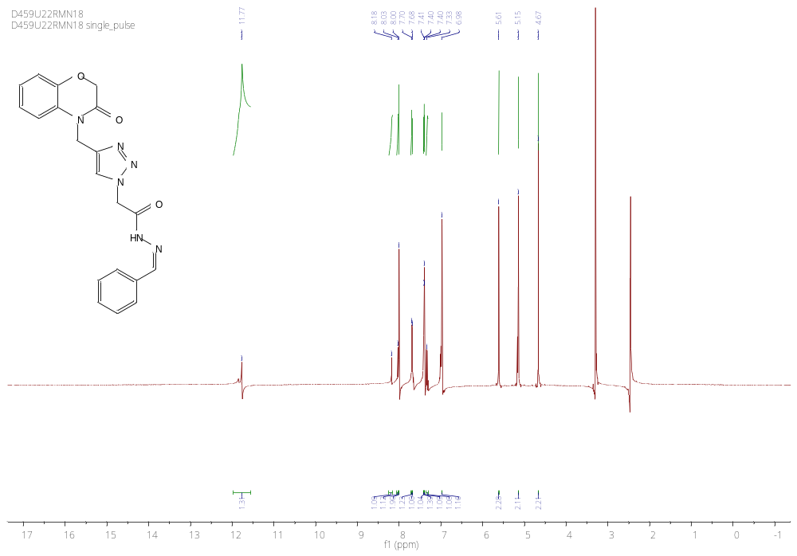
Figure S1 : ¹H NMR spectrum of the compound (4a)

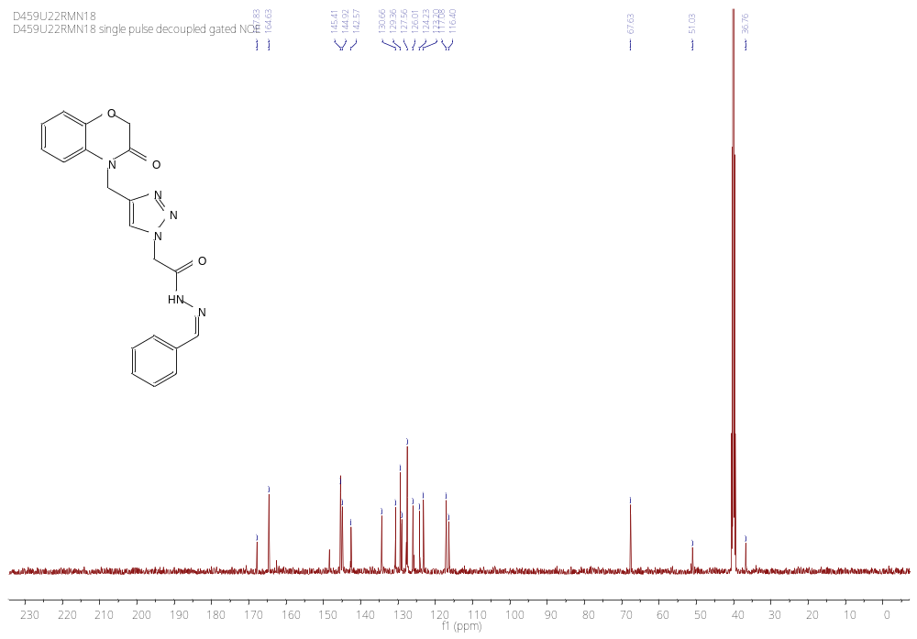
Figure S2 : ¹³C NMR spectrum of the compound (4a)

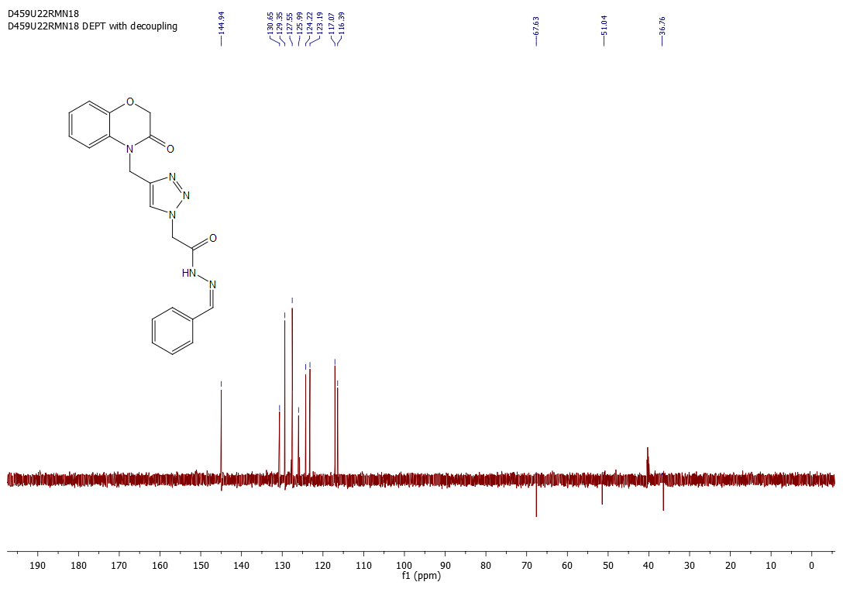
Figure S3 : DEPT-135 spectrum of the compound (4a)

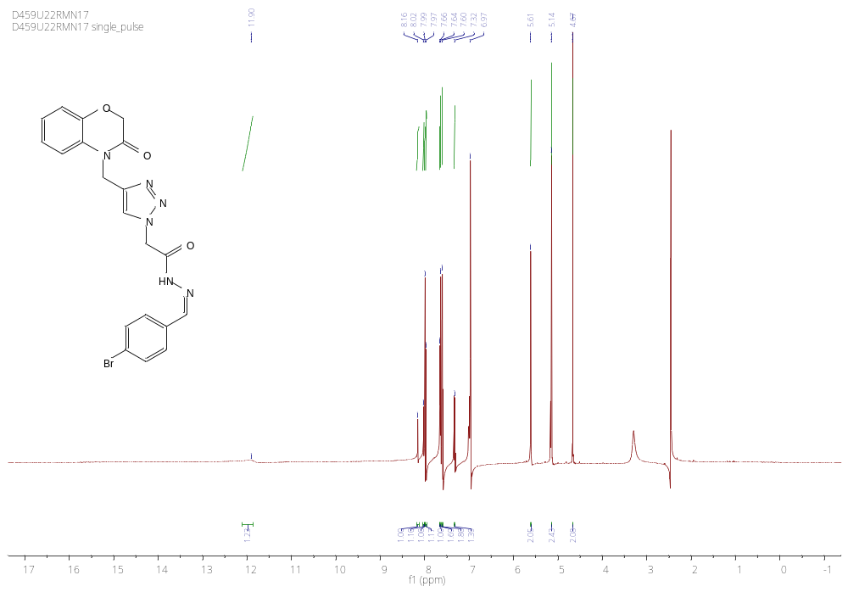
Figure S4 : ¹H NMR spectrum of the compound (4b)

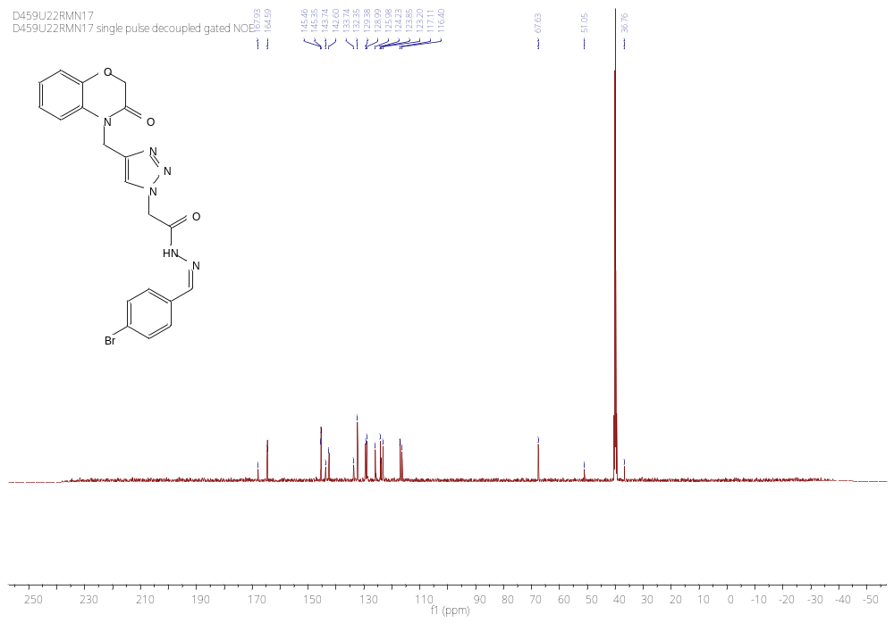
Figure S5 : ¹³C NMR spectrum of the compound (4b)

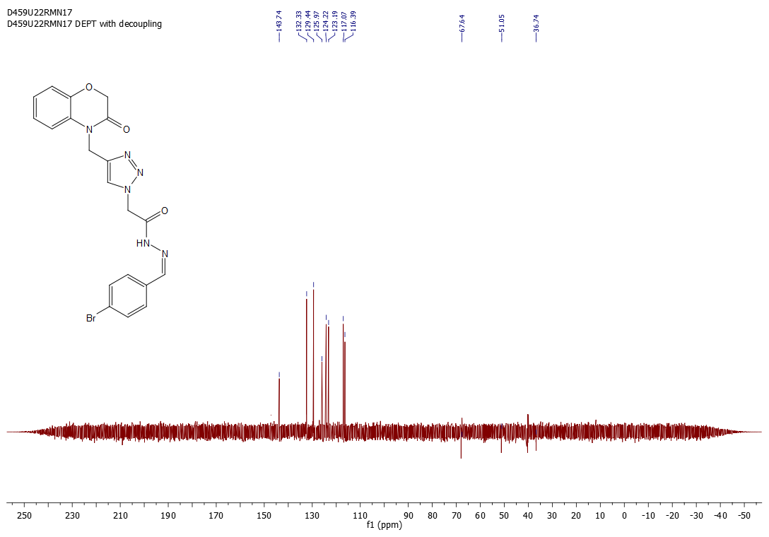
Figure S6: DEPT-135 spectrum of the compound (4b)

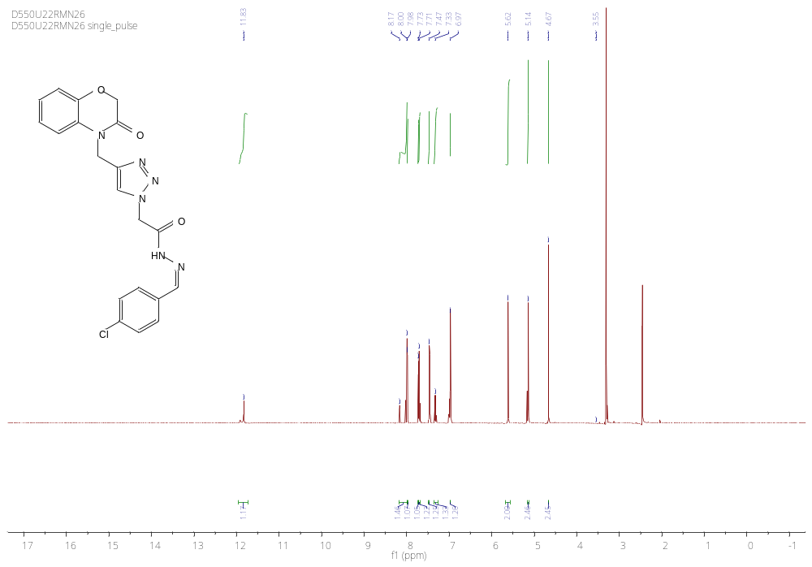
Figure S7 : ¹H NMR spectrum of the compound (4c)

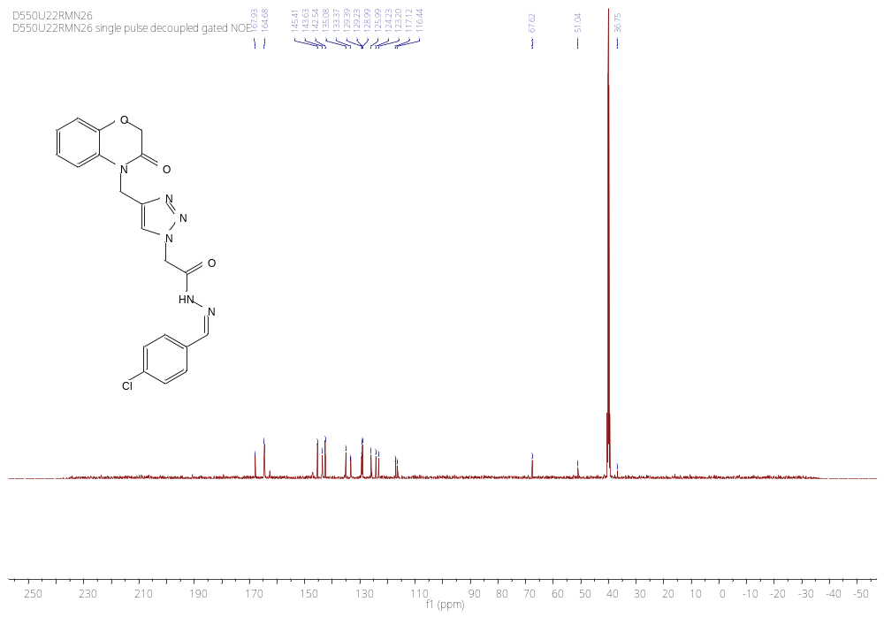
Figure S8 : ¹³C NMR spectrum of the compound (4c)

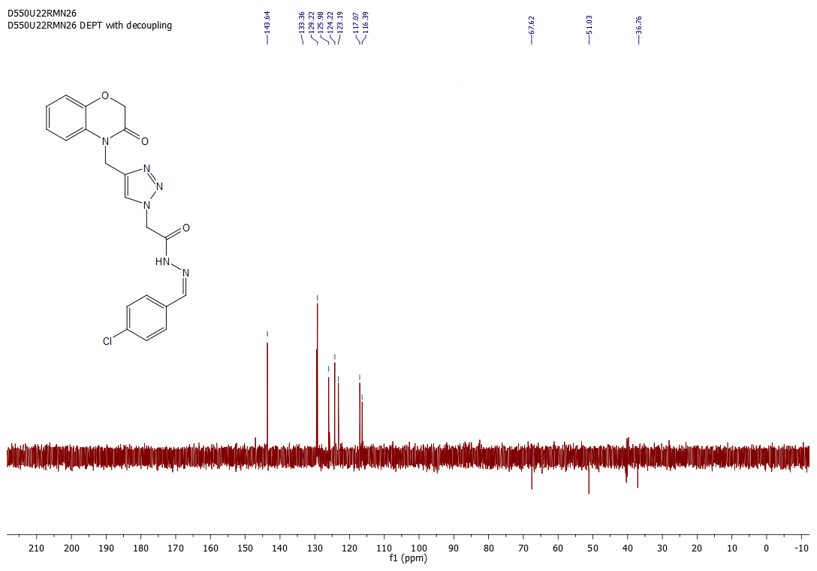
Figure S9: DEPT-135 spectrum of the compound (4c)

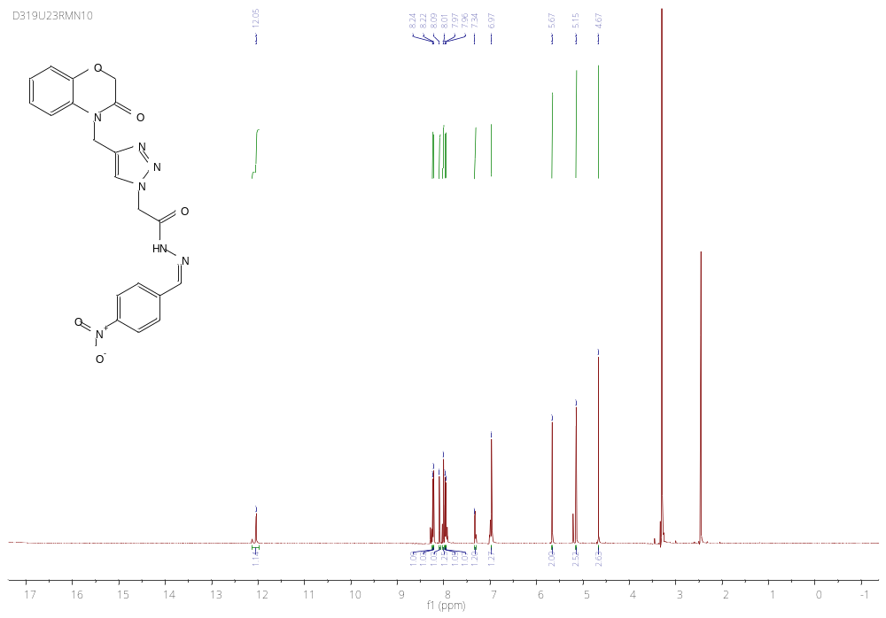
Figure S10 : ¹H NMR spectrum of the compound (4d)

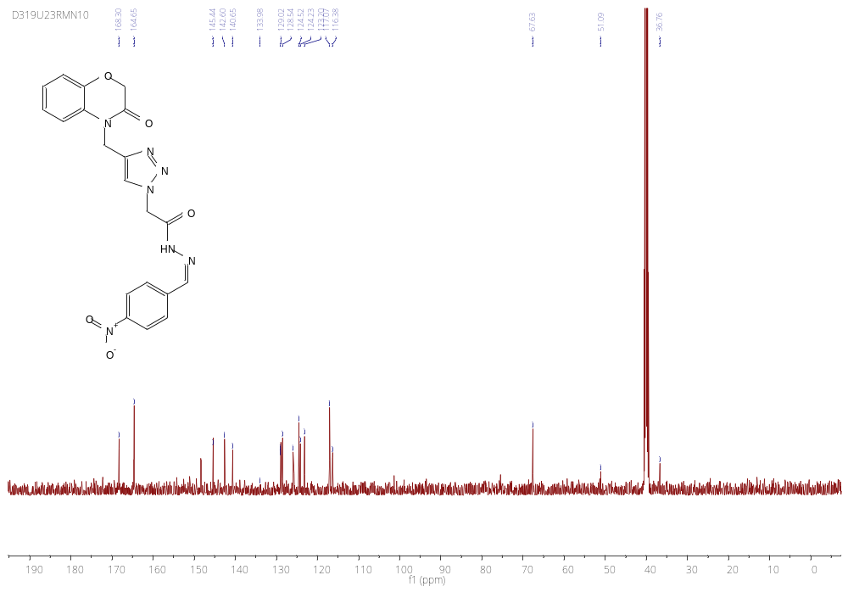
Figure S11 : ¹³C NMR spectrum of the compound (4d)

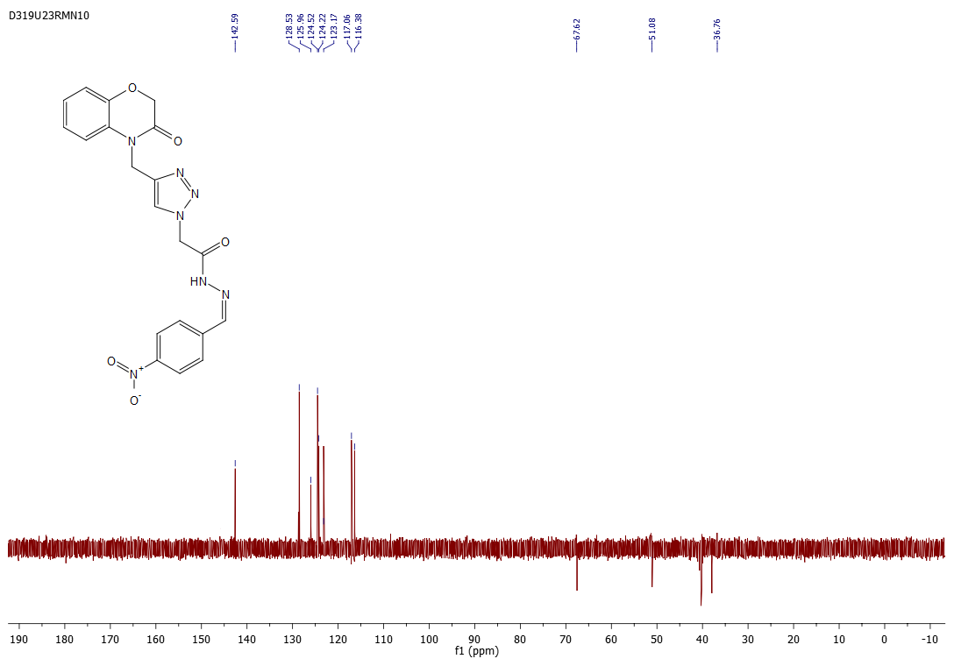
Figure S12: DEPT-135 spectrum of the compound (4d)

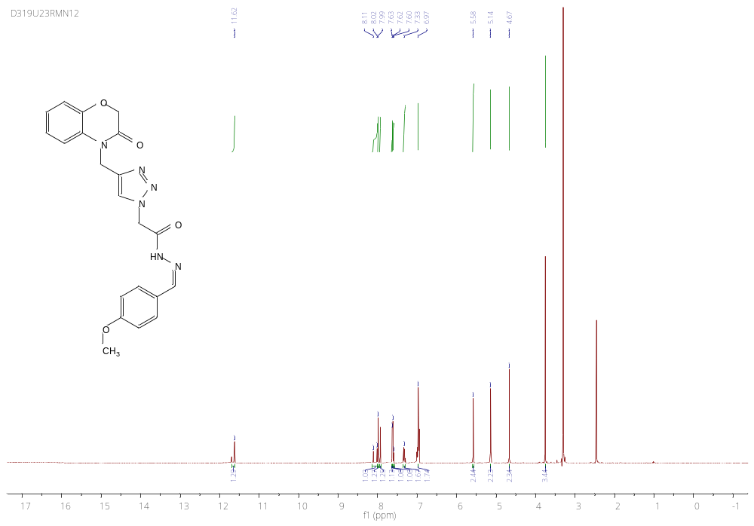
Figure S13 : ¹H NMR spectrum of the compound (4e)

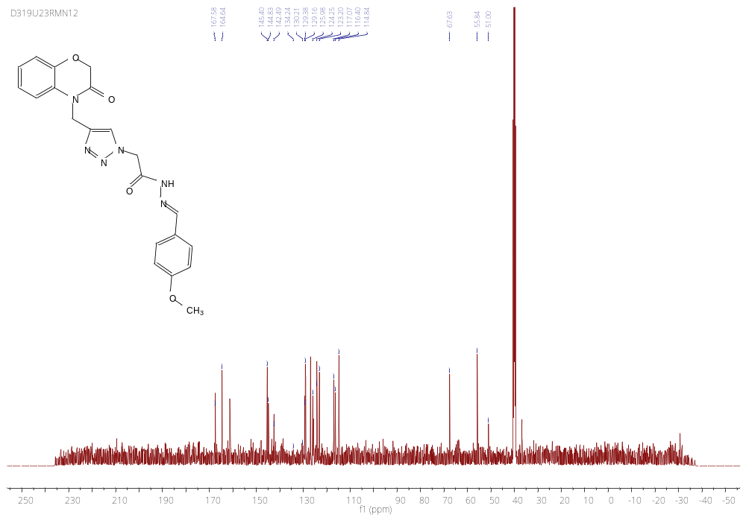
Figure S14 : ¹³C NMR spectrum of the compound (4e)

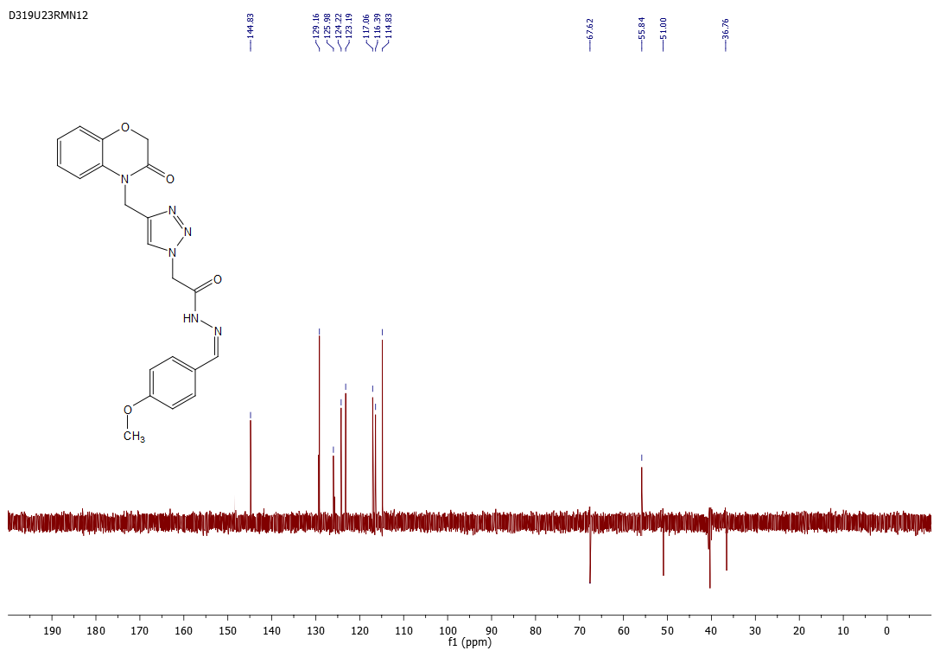
Figure S15: DEPT-135 spectrum of the compound (4e)

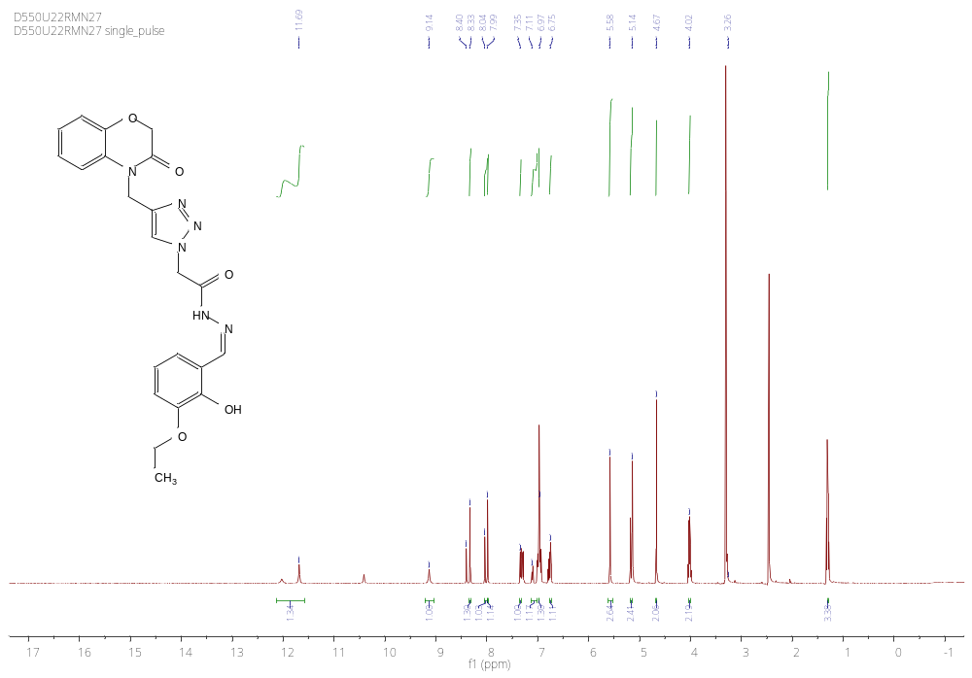
Figure S16 : ¹H NMR spectrum of the compound (4f)

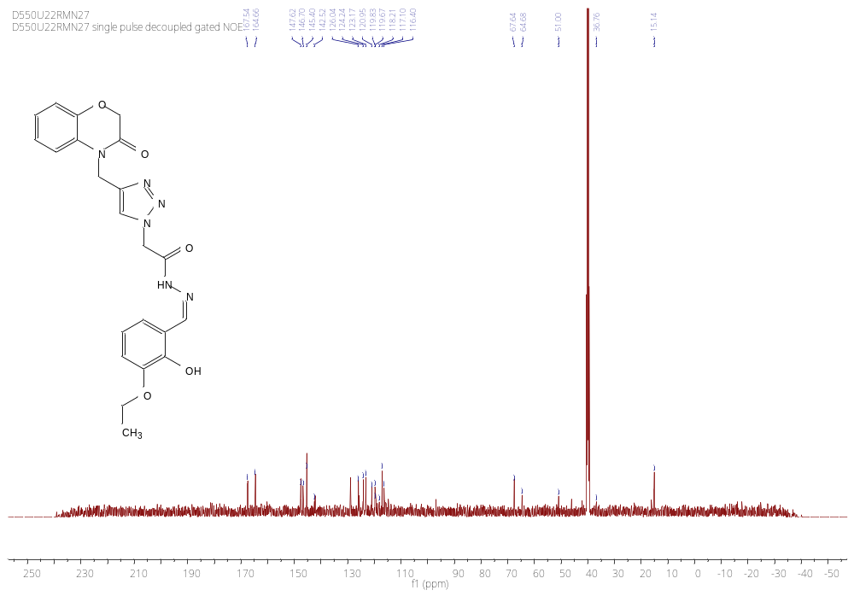
Figure S17 : ¹³C NMR spectrum of the compound (4f)

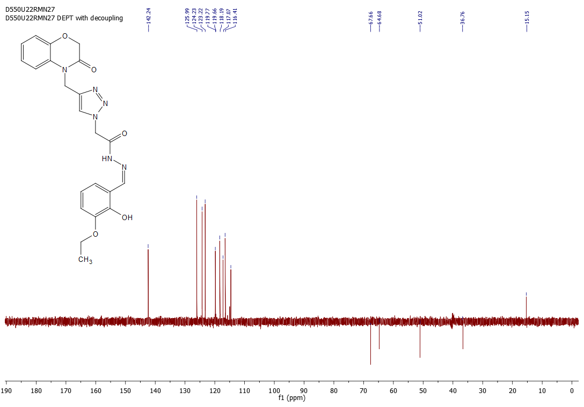
Figure S18 : DEPT-135 spectrum of the compound (4f)

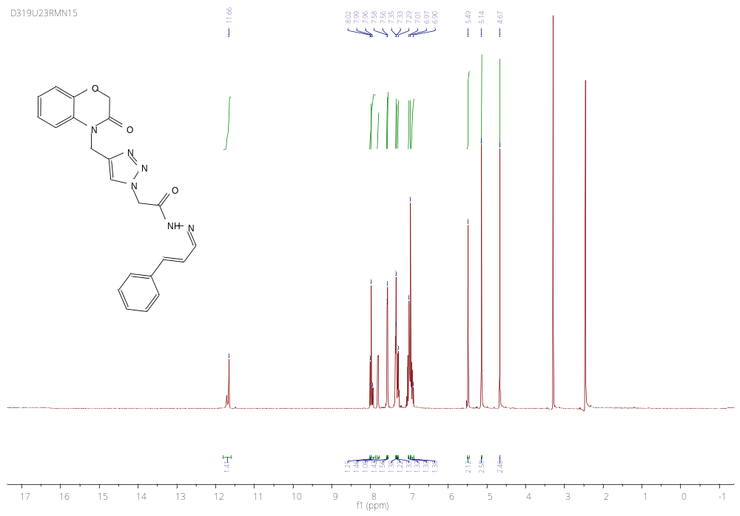
Figure S19 : ¹H NMR spectrum of the compound (4g)

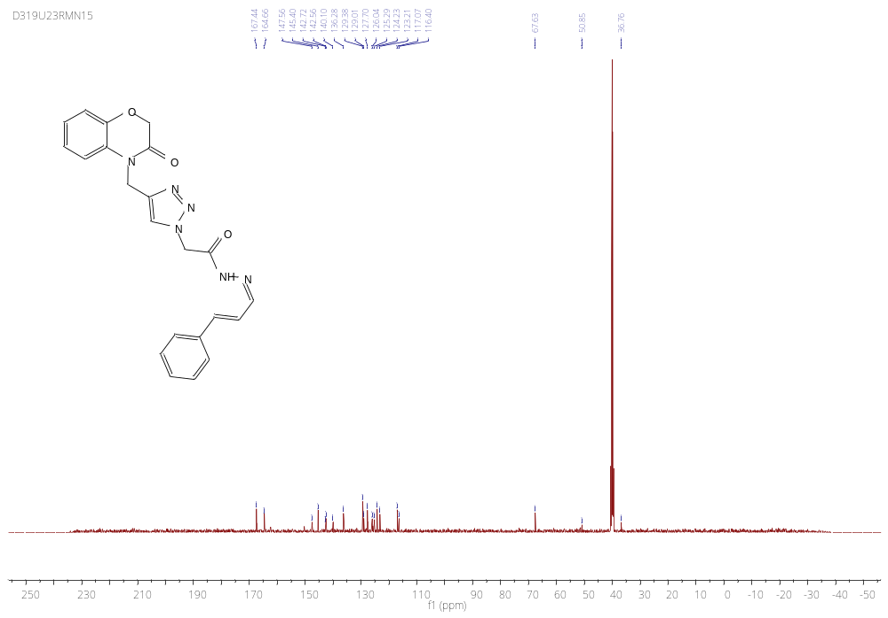
Figure S20 : ¹³C NMR spectrum of the compound (4g)

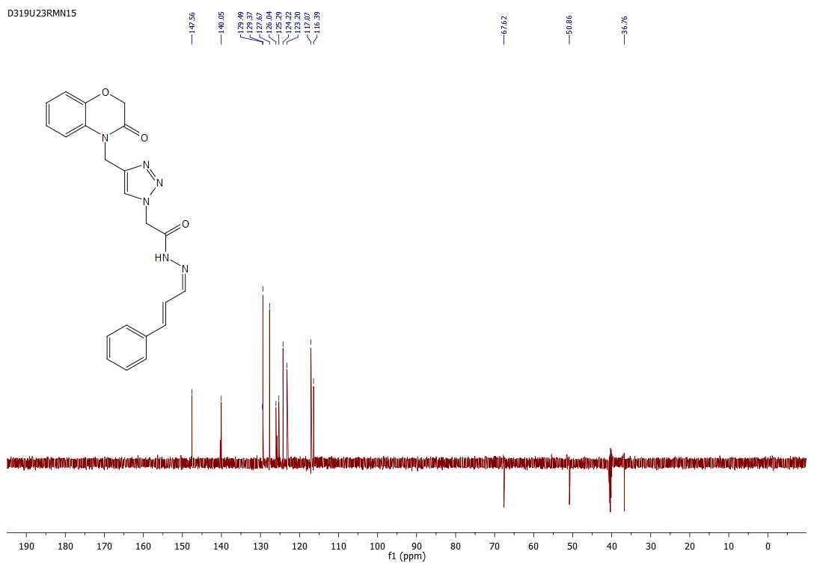
Figure S21 : DEPT-135 spectrum of the compound (4g)

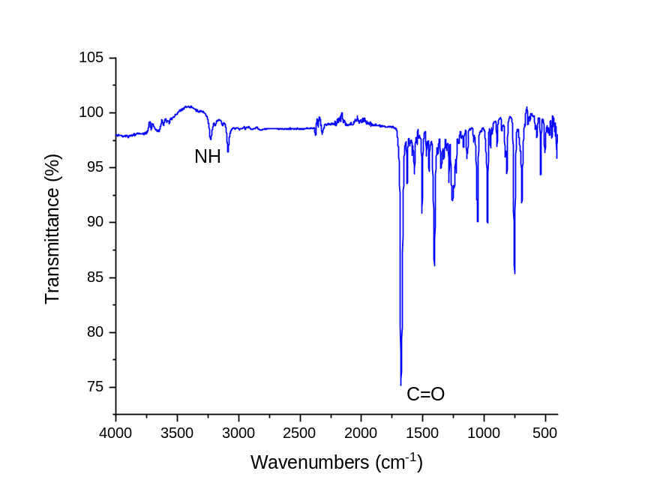
Figure S22 : IR spectrum of the compound (4g)

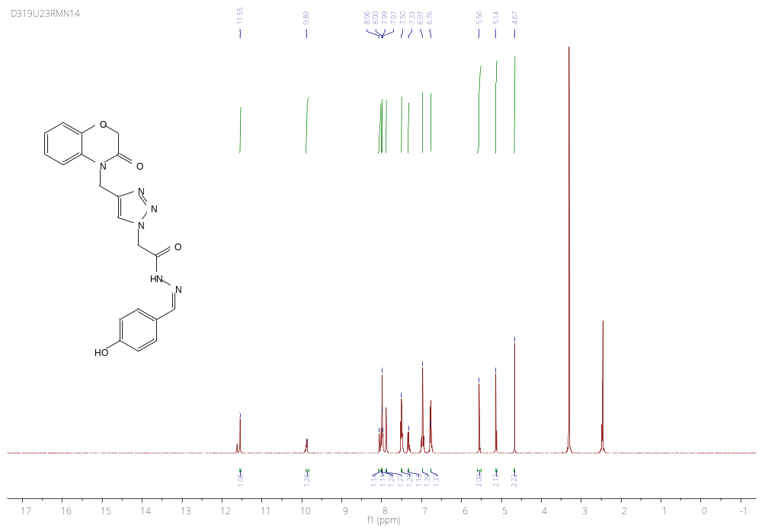 Figure S23: ¹H NMR spectrum of the compound (4h)

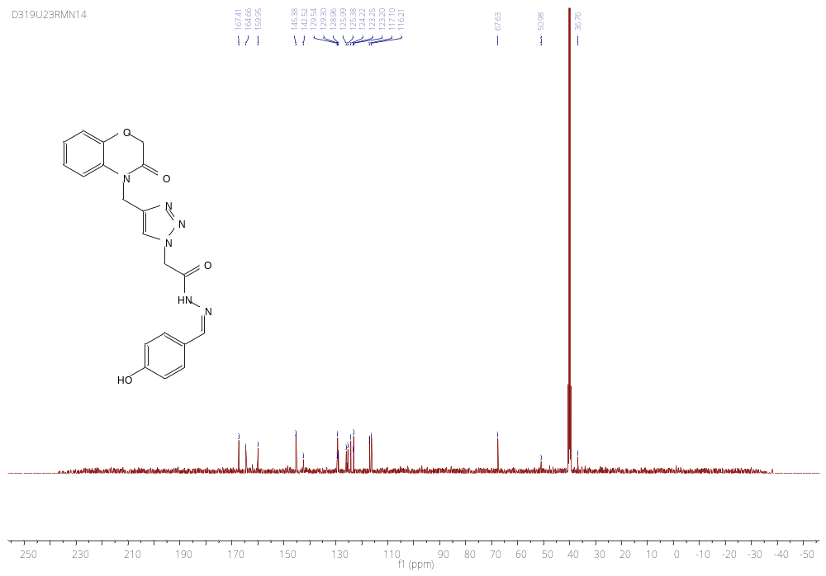
Figure S24: ¹³C NMR spectrum of the compound (4h)

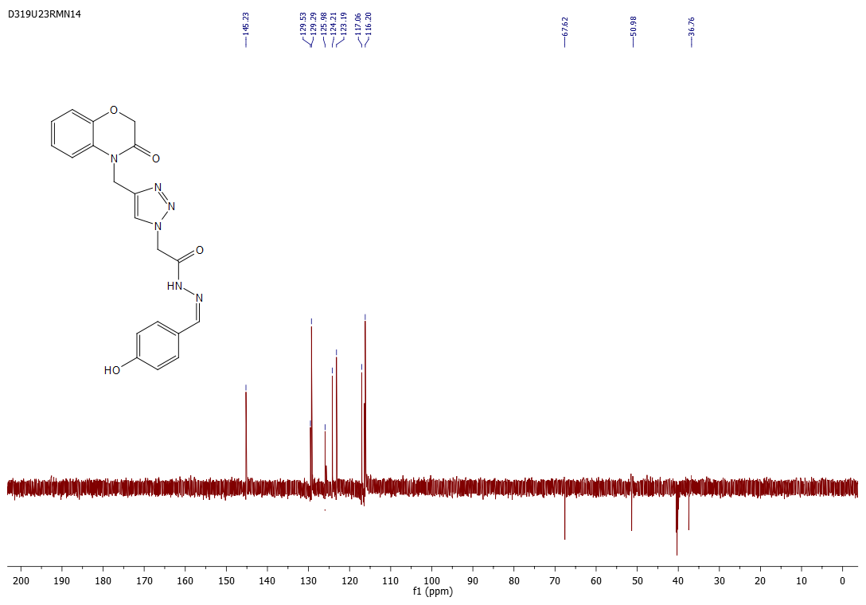
Figure S25: DEPT-135 spectrum of the compound (4h)
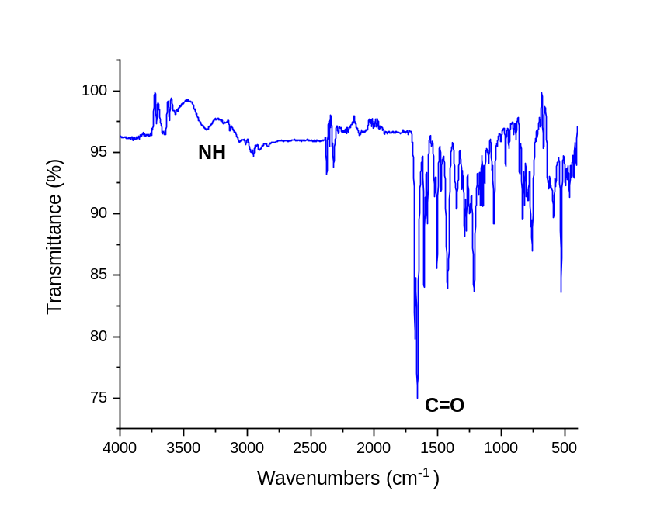
Figure S26 : IR spectrum of the compound (4h)

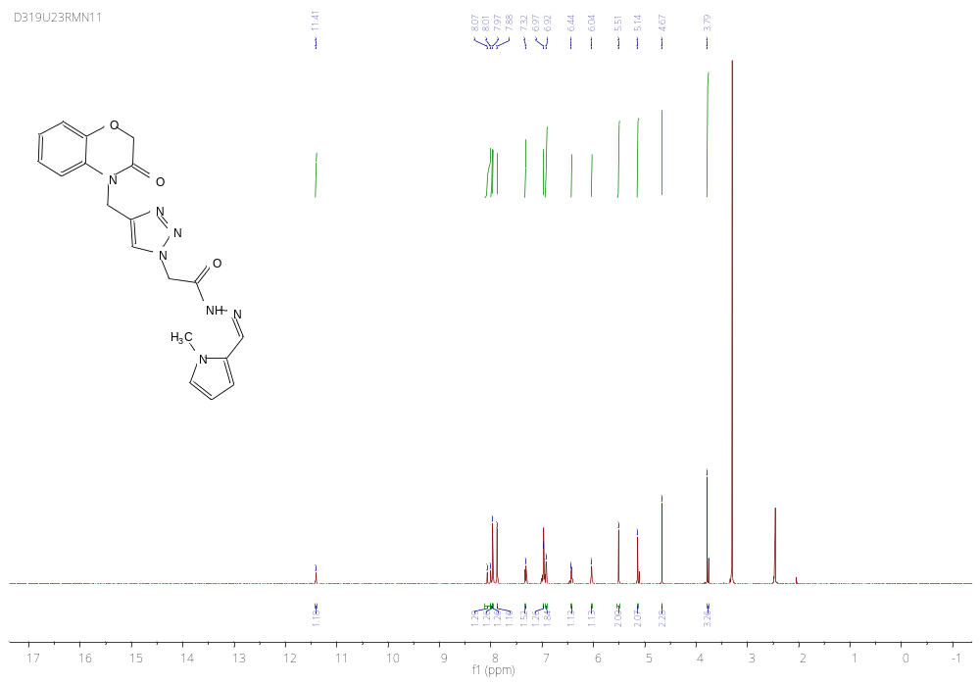
Figure S27: ¹H NMR spectrum of the compound (4i)

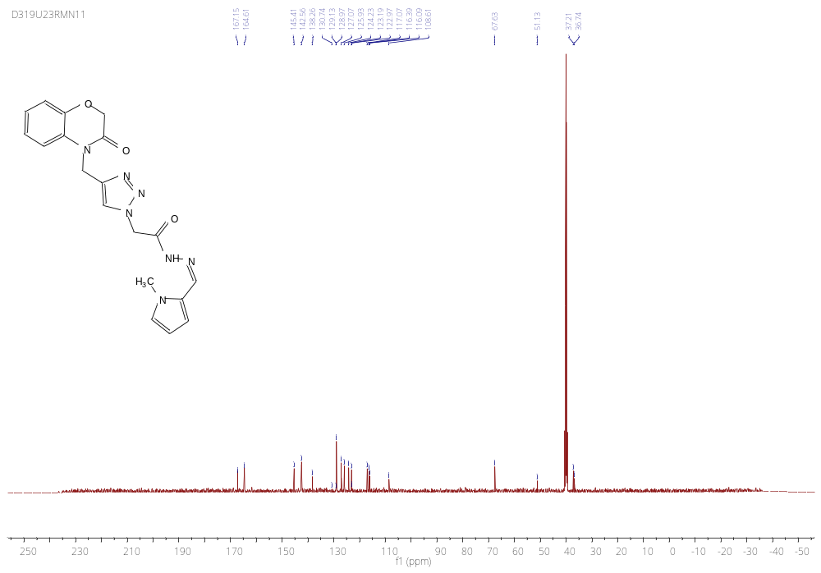
Figure S28: ¹³C NMR spectrum of the compound (4i)

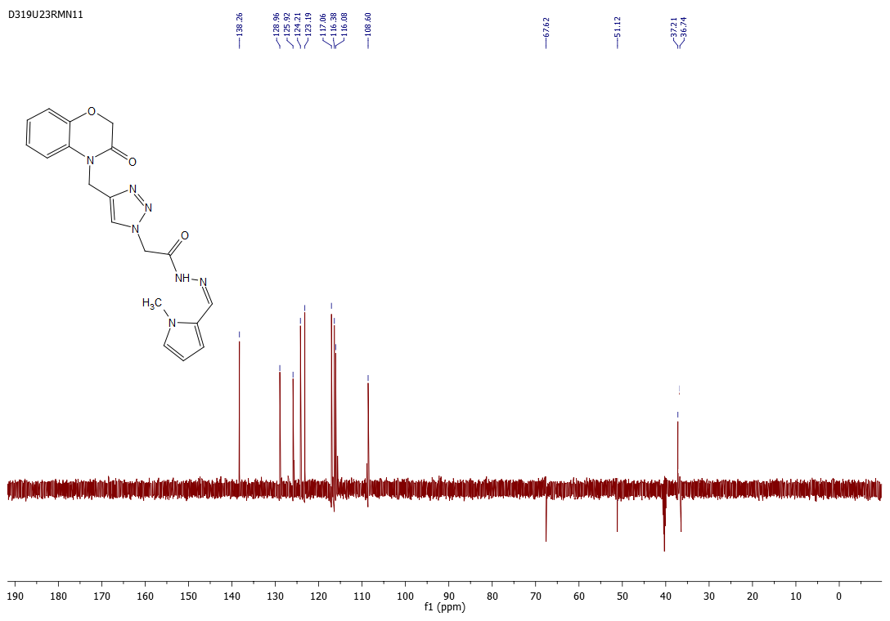
Figure S29: DEPT-135 spectrum of the compound (4i)

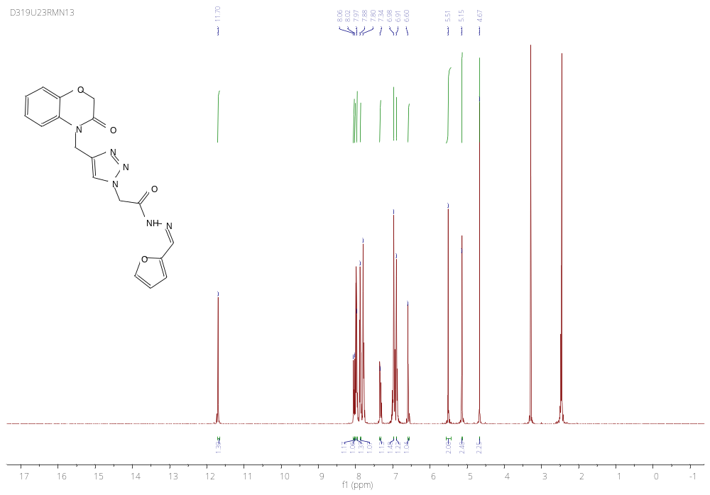
Figure S30: ¹H NMR spectrum of the compound (4j)

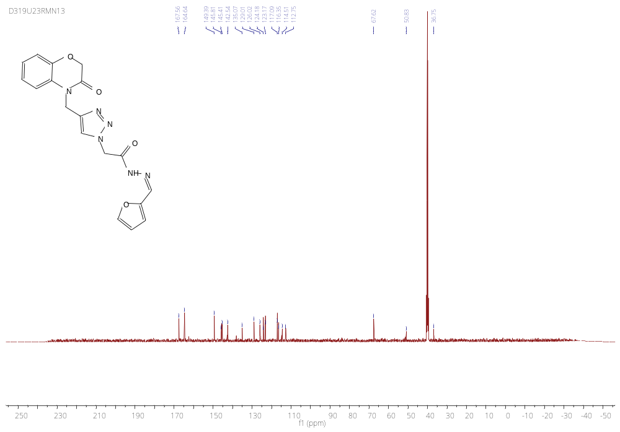
Figure S31: ¹³C NMR spectrum of the compound (4j)

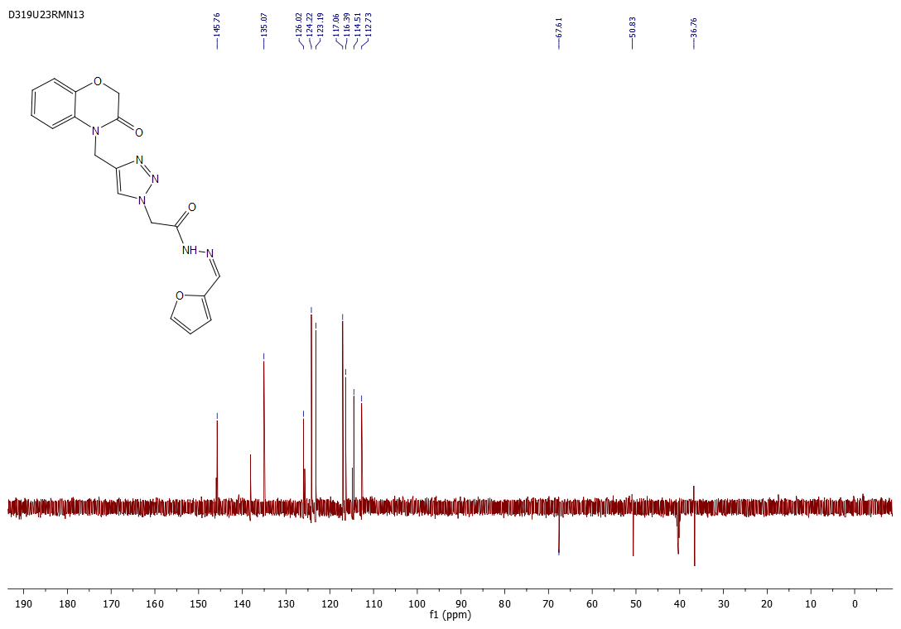
Figure S32: DEPT-135 spectrum of the compound (4j)

