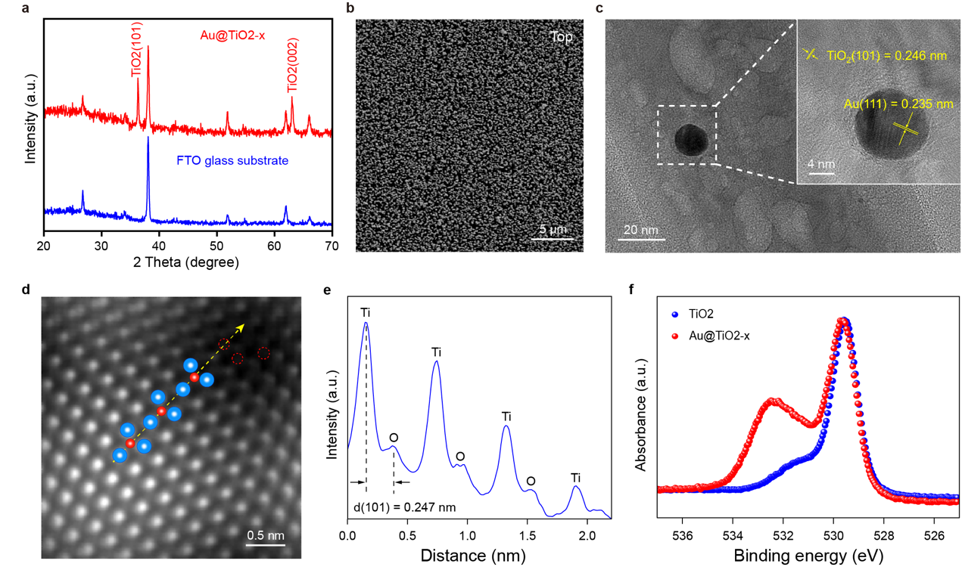
Extended Data Fig.1 | Morphology and structure characterizations of Au@TiO_{2-x}.
a, XRD pattern of FTO-coated glass substrate and Au@TiO_{2-x} grown on FTO-coated glass substrate. b, Top view of Au@TiO_{2-x}. c, TEM and the inserted HRTEM image of Au nanoparticles coated on TiO₂-NW. d, Spherical aberration-corrected HAADF-STEM image of Au@TiO_{2-x}. e, The corresponding intensity profiles extracted from the dashed yellow line in b. The blue and red balls represent the Ti and O atoms, respectively. The red dotted circles represent the oxygen vacancies. f, O 1sec XPS spectra of original TiO₂ and Au@TiO_{2-x}.

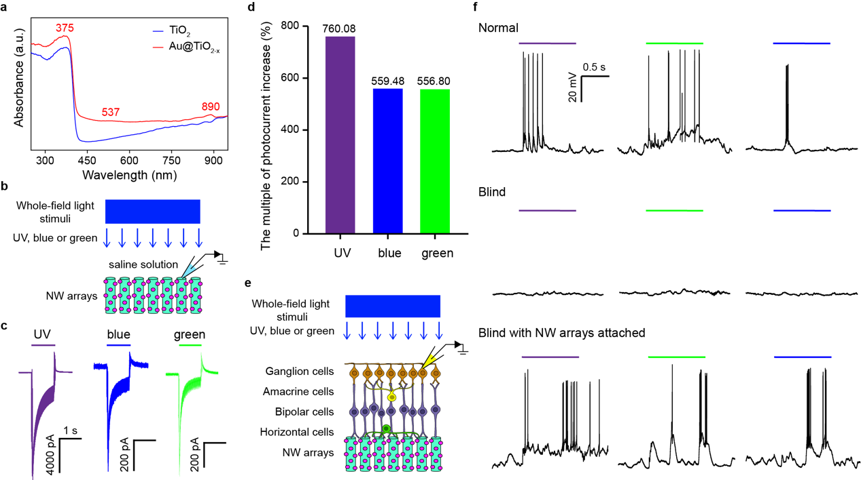
Extended Data Fig.2 | Photocurrent of Au@TiO_{2-x} NW arrays and light responses in NW arrays-interfaced RGCs in blind mice.
a, UV-visible absorbance spectra of original TiO₂ and Au@TiO_{2-x}. b, Schematic of Au@TiO_{2-x} NW arrays photocurrent measurement with UV (375/28 nm, 10 μW·mm⁻²), blue (470/20 nm, 10 μW·mm⁻²) and green (546/12 nm, 10 μW·mm⁻²) light. The photocurrents were measured by Ag/AgCl electrodes attached to the surface of the NW arrays in normal saline solution. c, Photocurrents generated by illumination of UV, blue and green light, receptively by an Au@TiO_{2-x} NW arrays. d, Compared with the published results ²⁵, the photocurrent of improved NW arrays increased by 760.08%, 559.48% and 556.80% under UV, blue and green light, receptively. e, Schematic of light responses recoding of NW arrays-interfaced RGCs in blind mice. f, Responses of RGCs in wild-type, blind and NW arrays-interfaced blind retinas. Horizontal color bars represent the light stimulation color and duration (UV, 375/28 nm, 10 μW·mm⁻². Blue, 470/20 nm, 10 μW·mm⁻². Green, 546/12 nm, 10 μW·mm⁻². Duration, 1 sec).

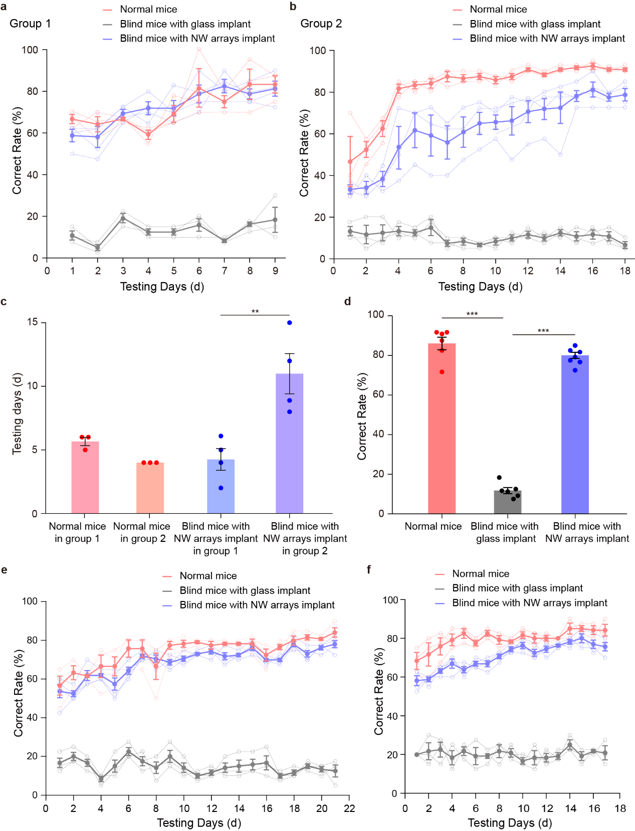
Extended Data Fig.3 | Choice-box-based behavioral test using LED light, moving bar and flash stimulus.
a, The correct rate of normal mice (n = 3), blind mice with glass implant (n = 3) and blind mice with NW arrays-implanted for 4 weeks (n = 4) in the choice-box-based behavior test using a UV LED (375/15 nm, 6.24 μW·mm⁻²) visual stimulus over 9 days. b, The correct rate of normal mice (n = 3), blind mice with glass implant (n = 3) and blind mice with NW arrays-implanted for 1 week (n = 4) in the choice-box-based behavior test using a UV LED (375/15 nm, 6.24 μW·mm⁻²) visual stimulus over 25 days. c, The number of testing days when the correct rate of normal mice in two different groups (normal mice group 1 and group 2) and blind mice with NW arrays-implanted for 4 weeks or 1 week after implantation (mice with NW arrays implant in group 1 and group 2) in the choice-box-based behavioral test reached 70% and maintained steady for 3 days. d, The correct rate of normal mice (n = 6), blind mice with glass implant (n = 6) and blind mice with NW arrays implant (n = 8) at the end of the choice-box-based behavioral test. e, The correct rate of normal mice (n = 3), blind mice with glass implant (n = 3) and blind mice with NW arrays-implanted for 1 week (n = 4) in the choice-box-based behavior test using moving light bars (5.25 degrees, 7.85 degrees/sec, 13.38 μW·mm⁻²) over a 15 days. f, The correct rate of normal mice (n = 3), blind mice with glass implant (n = 3) and blind mice with NW arrays-implanted for 1 week (n = 4) in the choice-box-based behavior test using flashing light over 17 days. * indicates a significant difference (**, P < 0.01. ***, P < 0.001, one-way ANOVA for c and d). Data are expressed as mean ± SEM.

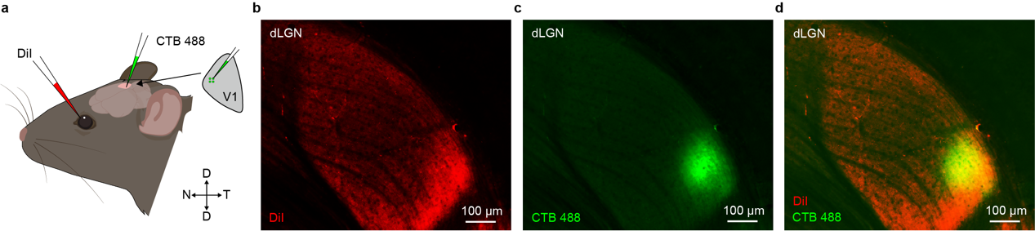
Extended Data Fig.4 | Retinotopic of visual cortex and retina.
Retinotopic of visual cortex and retina was investigated by injections of fluorescence dye (DiI) into the mouse’s dorsal retina and injection of CTB-488 into lateral V1. a, Schematics of intravitreal injection of DiI into the mouse’s dorsal retina, where NW arrays were implanted and injection of CTB-488 into the mouse’s lateral V1 area. b-d, Projection of DiI from the retina to dLGN and projection of CTB-488 from V1 to dLGN.

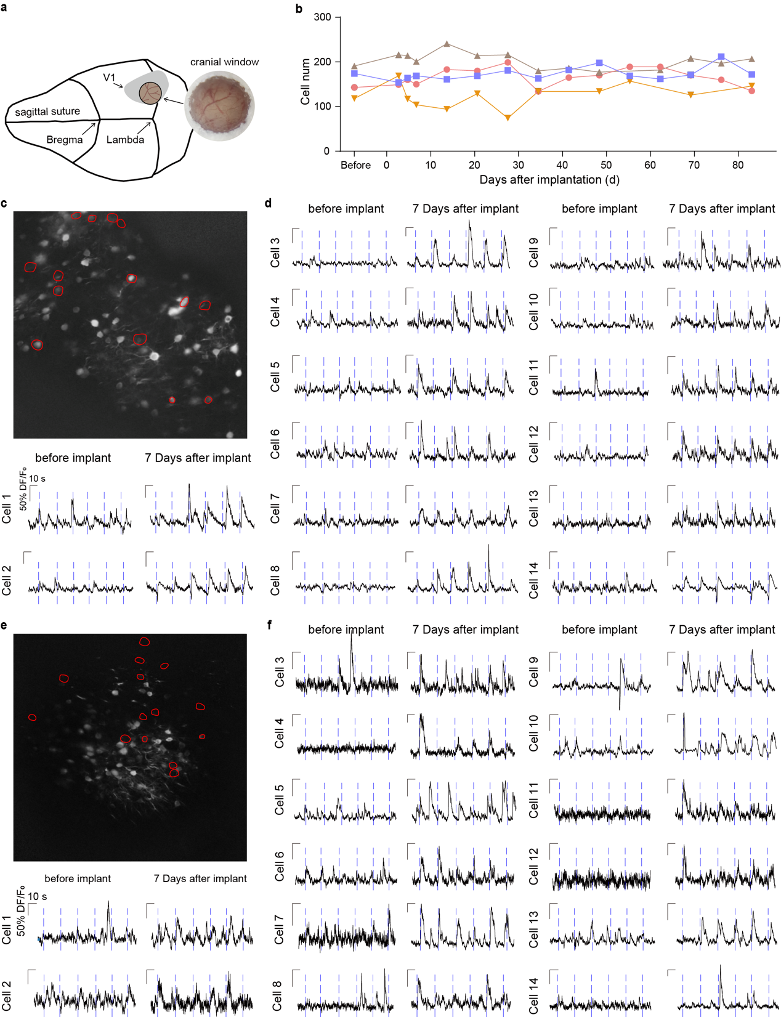
Extended Data Fig.5 | Long-term In vivo two-photon calcium recording of light-evoked responses in mice’s V1.
a, Schematic of the position of the cranial window in V1 and close-up of the completed cranial window on the day of surgery. b, The total number of neurons recorded in two-photon calcium imaging during the experiment. c and e, Grayscale image of recording field of two blind mice with NW arrays implant for 7 days. 14 representative light-responsive neurons were marked by red contour. d and f, The relative fluorescence change trace of representative neurons in Extended Data Fig.6 c, e during visual stimulation (blue LED light, 465/25 nm, 6.75 μW·mm⁻²) period. Blue dotted lines indicate stimulus on.
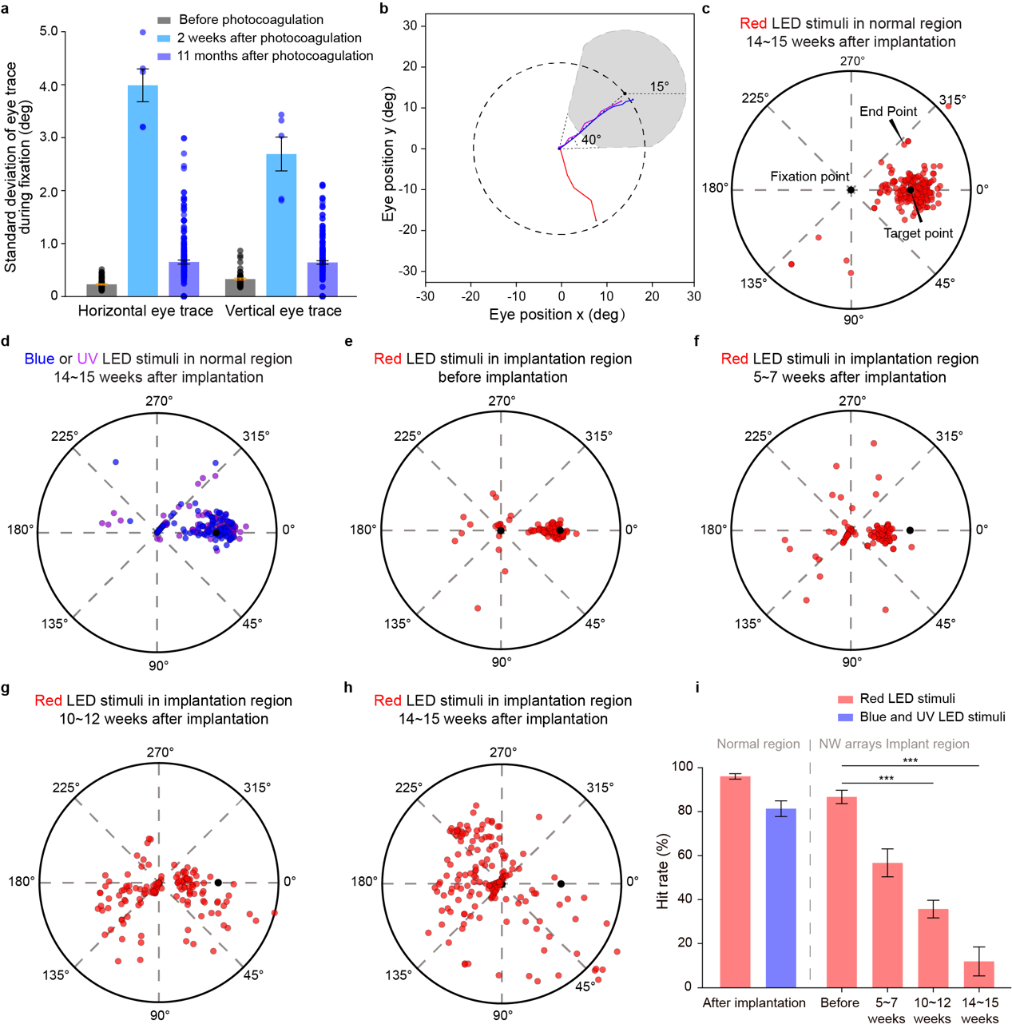
Extended Data Fig.6 | The performance of macaque in VGS task under red LED stimulation with the increase of implantation time.
a, Standard deviation of monkey’s eye trace during fixation, before, 2 weeks and 11 months after photocoagulation. b, Schematic of VGS task criteria. The gray area indicates the target area. c-d, Distribution of normalized saccadic endpoints location in normal retinal regions (eccentricities: 19 and 21 degrees, polar angles: 40, 50 and 130 degrees). e-h, Distribution of normalized saccadic endpoints location using red LED (eccentricities: 19 and 21 degrees, polar angles: 200 ~ 250 degrees) before implantation, 5 ~ 7 weeks after implantation, 10 ~ 12 weeks after implantation, and 14 ~ 15 weeks after implantation. i, Mean hit rate of VGS task in Extended Data Fig.7 c-h. * indicates significant difference (***, P < 0.001, one-way RM ANOVA for i). Red LED, 642/18 nm. UV LED, 360/15 nm. Blue LED, 465/25 nm. Data are expressed as mean ± SEM.
Extended Data Table 1 | Hit rate of visually-guided saccade task.
Positions of saccadic  target point |  | Hit Rate (%)
 |  | Before  implantation: | 14 ~ 15 weeks  after implantation:
Eccentricity  (degree) | Polar angle  (degree) | Red  LED | Red  LED | Blue  LED | UV  LED
 | 190 | 86 | 40 | 40 | 20
 | 200 | 100 | 0 | 26 | 40
 | 210 | 93 | 10 | 50 | 50
 | 220 | 66 | 10 | 46 | 60
19 | 230 | 80 | 10 | 60 | 20
 | 240 | 100 | 10 | 80 | 70
 | 250 | 73 | 30 | 85 | 70
 | 260 | 80 | 50 | 55 | 40
 | 270 | 73 | 70 | 50 | 60
 | 190 | 100 | 10 | 20 | 20
 | 200 | 100 | 0 | 30 | 30
 | 210 | 93 | 0 | 40 | 0
 | 220 | 80 | 0 | 60 | 70
21 | 230 | 86 | 0 | 40 | 80
 | 240 | 86 | 10 | 70 | 60
 | 250 | 93 | 10 | 50 | 50
 | 260 | 100 | 40 | 40 | 90
 | 270 | 100 | 60 | 60 | 70

Extended Data Movie 1 | Choice-box-based behavioral test of normal mice, blind mice with glass implant and blind mice with NW arrays implant using green LED stimulus.

Extended Data Movie 2 | Choice-box-based behavioral test of normal mice, blind mice with glass implant and blind mice with NW arrays implant using moving visual stimulus.

Extended Data Movie 3 | Choice-box-based behavioral test of normal mice, blind mice with glass implant and blind mice with NW arrays implant using flash visual stimulus.

Extended Data Movie 4 | Visual acuity and contrast sensitivity test of normal mice, blind mice with glass implant and blind mice with NW arrays implant.

Extended Data Movie 5 | Light-evoked responses in V1 neurons through two-photon calcium imaging recording of normal mice, blind mice before implantation and 7 days after implantation.

Extended Data Movie 6 | Visually-guided saccade task of monkey A with red LED stimulus in region of implantation and control.

Extended Data Movie 7 | Visually-guided saccade task of monkey A with blue LED stimulus in region of implantation and control.

