Supplementary Figure 1 External validation of mRNA levels was performed using GEO database. Below the X-axis are detailed descriptions of GEO entry numbers and their corresponding tumors. Here, we adopt the same cancer naming method as TCGA. The Y axis shows the expression amounts of genes. Note that we used a z score for the expression amounts of genes, thus correcting the expression amount to a dimensionless standardized data with an average of 0 and a variance of 1.
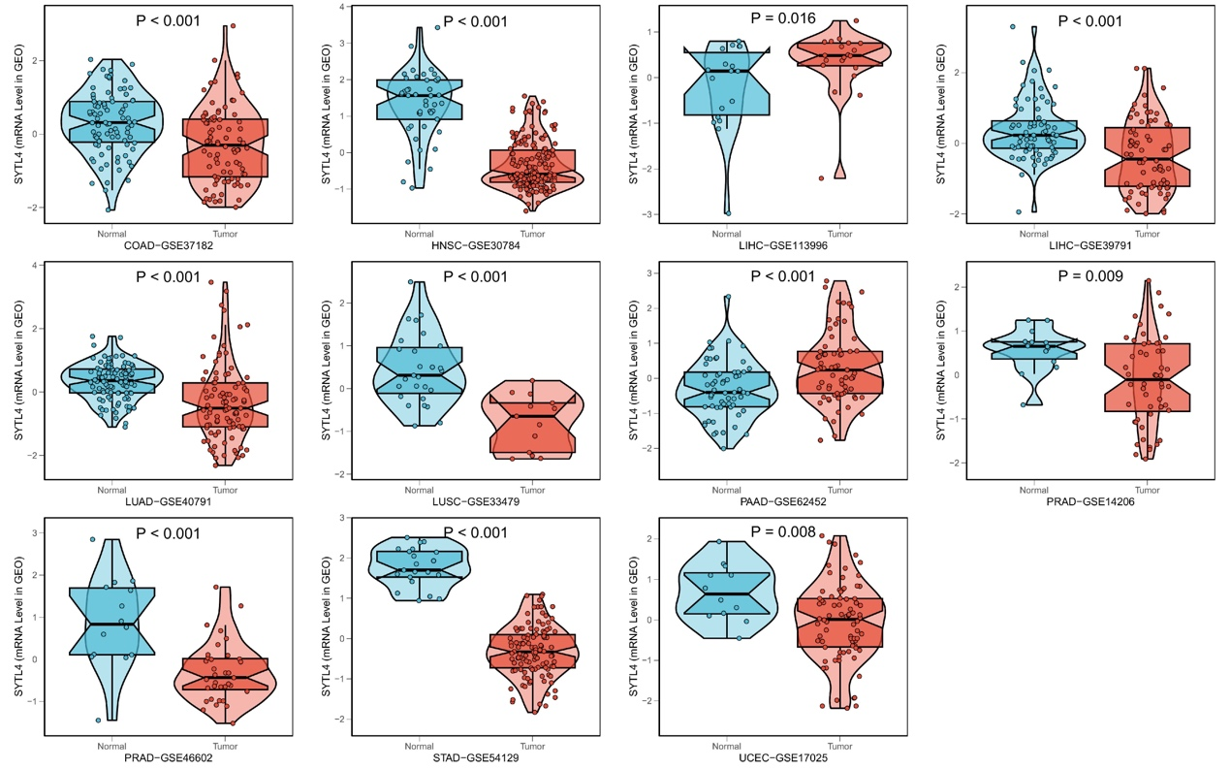

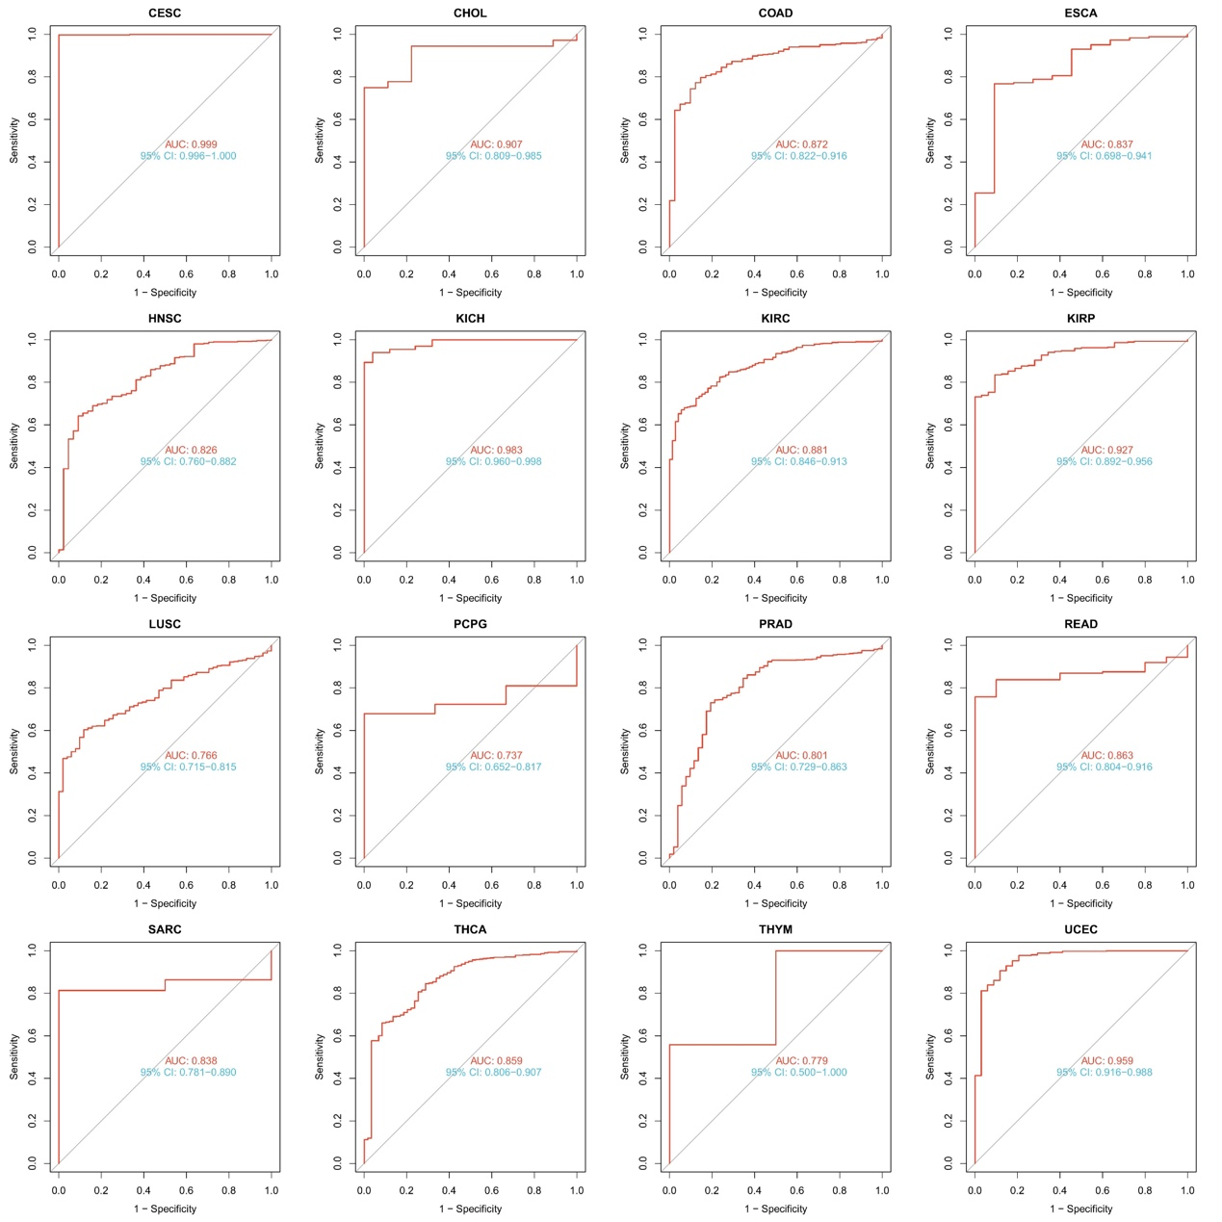
Supplementary Figure 2 Diagnostic value of SYTL4 to distinguish tumor tissues from normal tissues in TCGA. The AUC value was more than 0.7.

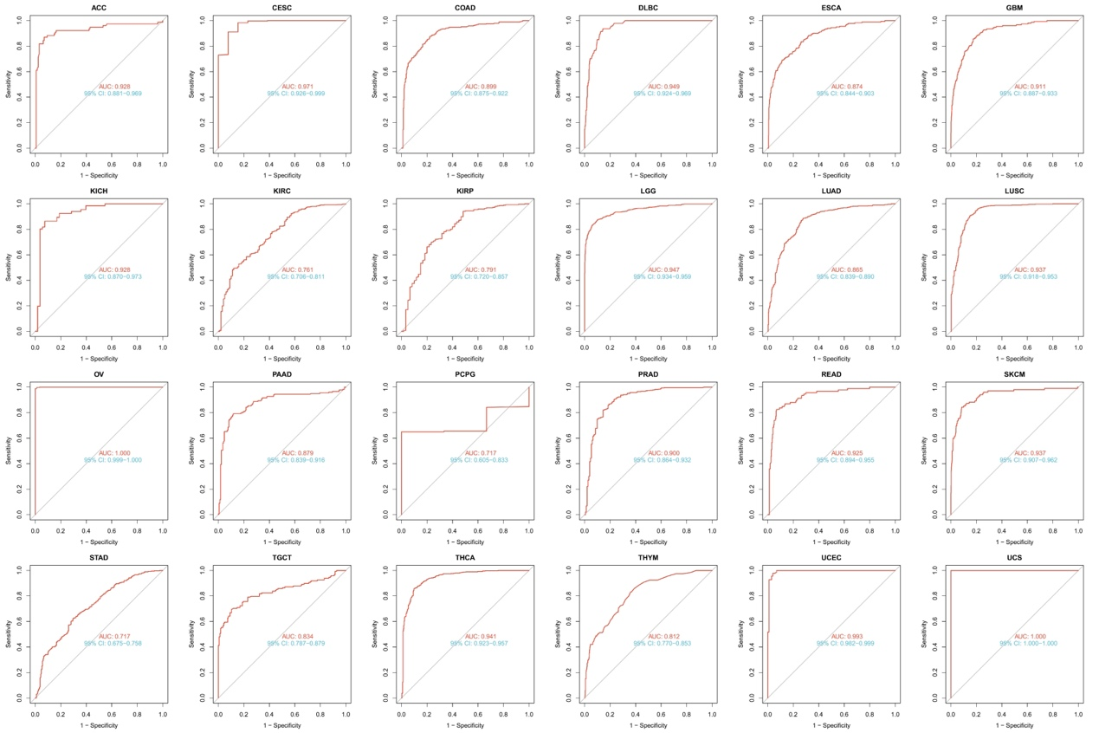
Supplementary Figure 3 Diagnostic value of SYTL4 to distinguish tumor tissues from normal tissues in TCGA-GTEx. The AUC value was more than 0.7.

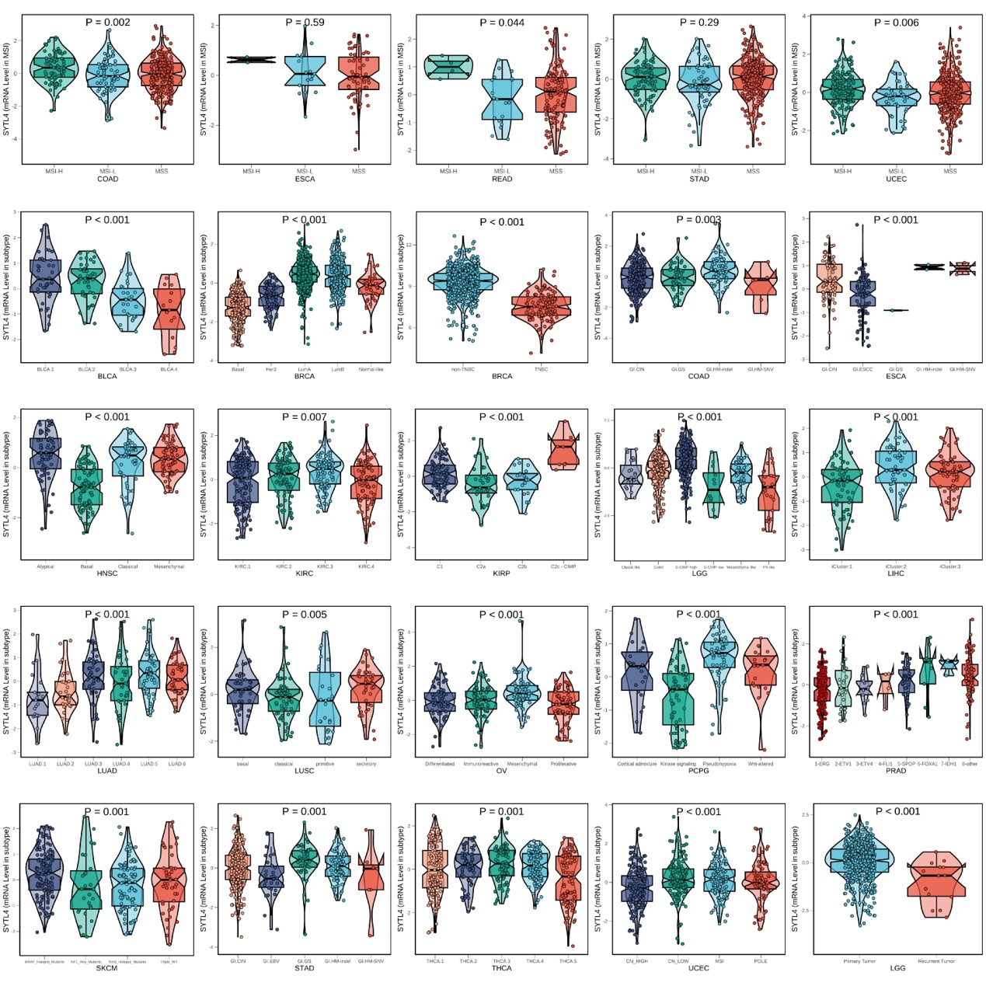
Supplementary Figure 4 Kruskal-Wallis examined the differences in SYTL4 expression in molecular subtypes.

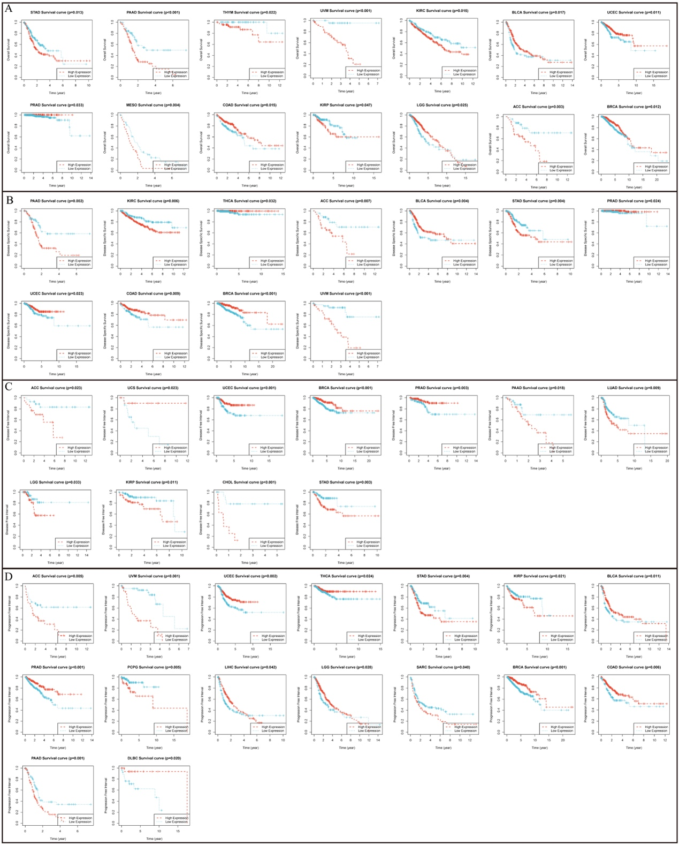
Supplementary Figure 5 Kaplan-Meier analysis and log-rank test.

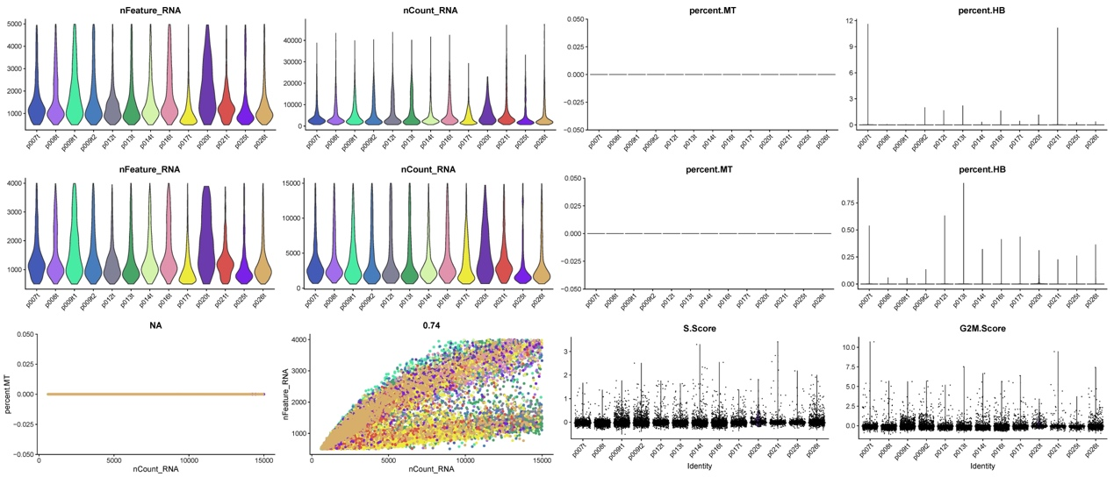
Supplementary Figure 6 Single cell quality control. The results showed that we used high quality cells for downstream analysis.

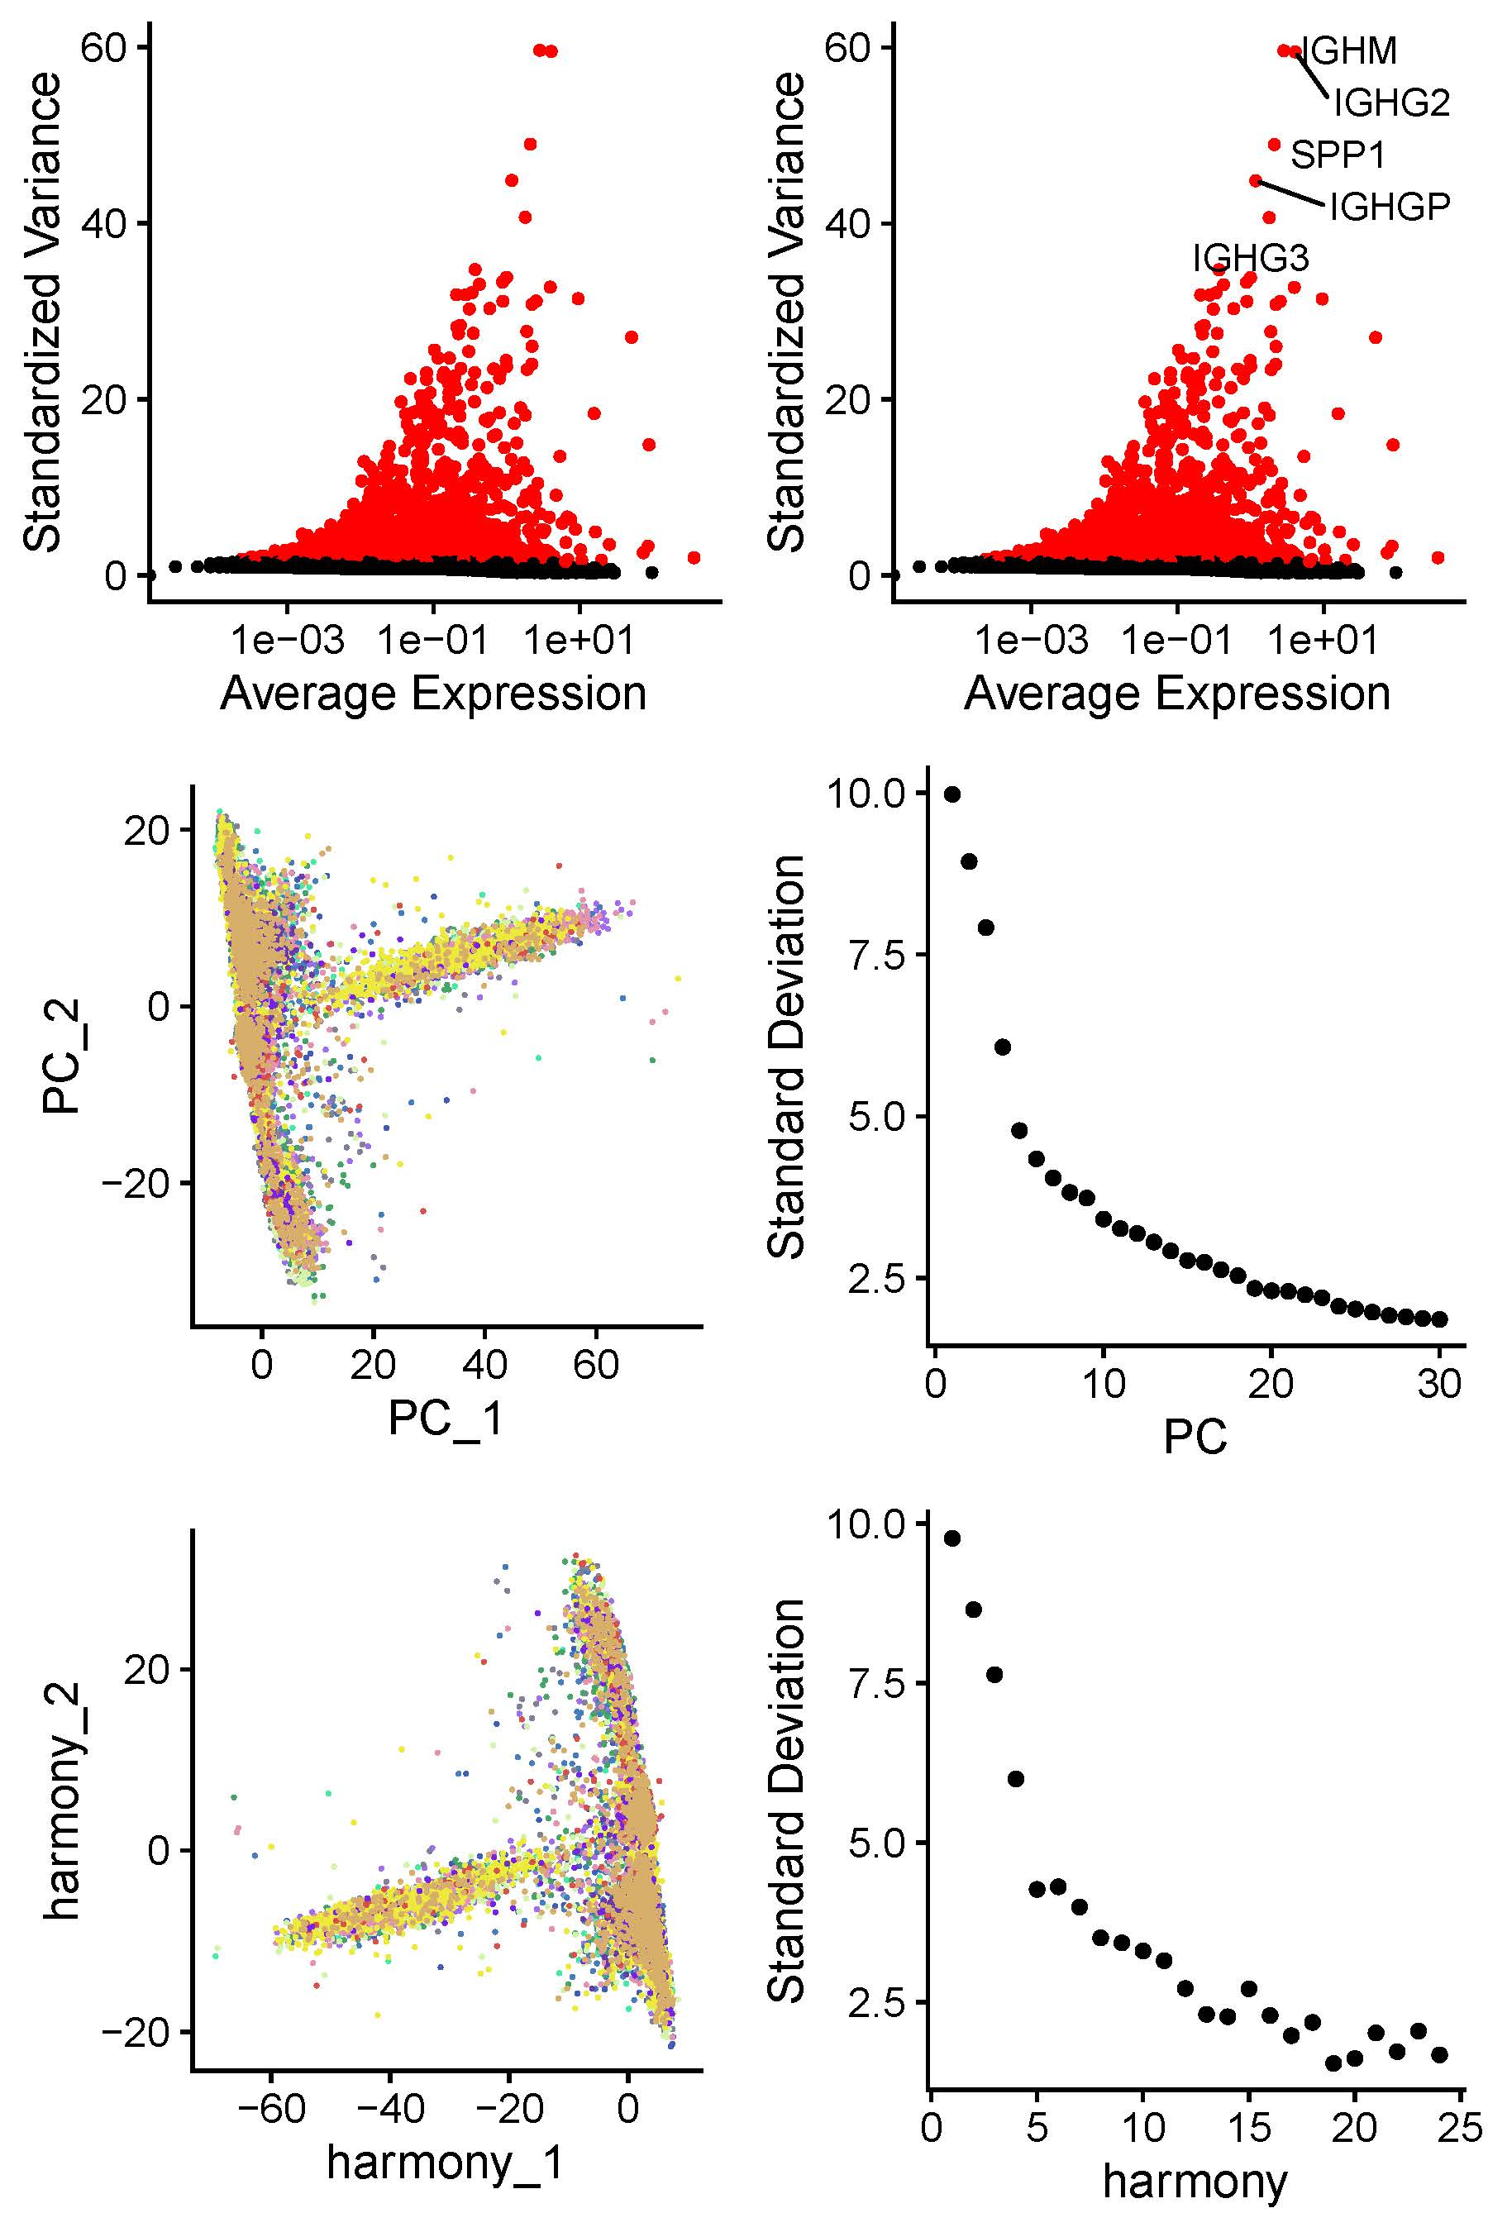
Supplementary Figure 7 Cell distribution. After integration with RunHarmony, the cells are evenly distributed between the individual samples, which means that the integration is good.

