Supplementary Information
Clean Air Act mitigate the cognitive deterioration in older adults
Yao Yao, Xiaozhen Lv, Chengxuan Qiu, Jiajianghui Li, Xiao Wu, Hao Zhang, Dahai Yue, Ehab Salah Eshak, Kaarin J. Anstey, Gill Livingston, Tao Xue, Junfeng (Jim) Zhang, Huali Wang, Yi Zeng

Contents
Supplementary Methods
Flow Chart …………………………………..………………………………………………………. Page 2
China’s Clean Air Act (CCAA) …………………………………………………………………….…. Page 3
Environmental Assessment …..…………….………………………………………………………… Page 3
Mini-Mental State Examination ………………………………….………………….………………. Page 4
Descriptions of covariates …………………………………………………………………………... Page 4
Two-pollutant exposure-response analysis ………………………………………………….………. Page 5
Table A1: STROBE Statement—Checklist for Observational Studies …………………………………. Page 6
Table A2: Targets of CCAA for local governments in our study area …………….…..…………………. Page 7
Figure A1: Trend in outcomes and PM_{2.5} exposure before the CCAA .……………………………….….. Page 9
Figure A2: Summaries for cognitive function score (MMSE) and long-term exposure to air pollutants by survey waves and group ……………………………………………………….………..………………………. Page 10
Figure A3: Sensitivity analysis of estimated effect of the CCAA on changes in global cognitive score by difference-in-differences models .……………………………………………………………………… Page 11
Figure A4: The estimated effect of the CCAA on cognitive function by subgroups …………….……… Page 12
Figure A5: The estimated associations between cognitive function and long-term air pollution exposure by further controlling seasonal effect .…………………………………………………………….……..…. Page 13
Figure A6: The estimated associations between air pollution changes and MMSE change by different subpopulations .…………………………………………………………………………………………. Page 14
Figure A7: The joint exposure-response function for PM_{2.5} and O₃ ..………………………..…………. Page 15
Figure A8: The joint exposure-response function for SO₂ and O₃ ..…………………………..…………. Page 16
Figure A9: The joint exposure-response function for PM_{2.5} and SO₂ ..………….……………..……. Page 17
Appendix References……………………………………………………………..……………….…. Page 18
Supplementary Methods

Flow chart of study participants in the Chinese Longitudinal Health Longevity Survey, 2014 to 2018
Excluded (n=4286)
- Died during the follow-up (n=2226)
- Lost of or declined follow-up (n=1503)
- With dementia, stroke, or bed-ridden
status in baseline (n=557)

Excluded (n=94)
- With missing data for MMSE and any
covariates (n=56)
- Changed of or declined to provide
residential address (n=38)
Control group
(n=561)
Intervention group
(n=2251)
Grouping according to the implementation of CCAA
Included in analysis
(n=2812)
Participants with follow-up in
8th CLHLS, 2018
(n=2906)
Participants in 7th CLHLS, 2014
(n=7192)
China’s Clean Air Act
To address severe air pollution issues and protect public health, the State Council of China promulgated the China’s Clean Air Act (CCAA) on September 10, 2013,¹ in which PM_{2.5} concentration reductions of 25%, 20%, and 15% in 2017 compared to the level in 2013 were mandated in 3 key regions: the Beijing-Tianjin-Hebei region (BTH), the Yangtze River Delta region (YRD), and the Pearl River Delta region (PRD), respectively.^{2,3}
China’s Clean Air Act (CCAA) was promulgated by the central government and has mandatory administrative power on the local authorities (i.e., Prefectural and municipal governments). To fulfil the CCAA, local governments implemented a series clean air actions and committed to devote the following years (2014-2017) to reducing, as appropriate in the regional context, particulate air pollution with regard to improving air quality and living environment. Six major measures were implemented from 2013 to 2017, they were summarized as (ⅰ) Strengthen industrial emission standards; (ⅱ) Phase out small and polluting factories; (ⅲ) Phase out outdated industrial capacity; (ⅳ) Upgrades on industrial boilers; (ⅴ) Promote clean fuels in the residential sector; (ⅵ) Strengthen vehicle emission standards. The detail of the six measures were described in previously.² As the toughest-ever clean air policy, CCAA has reduced the national population-weighted annual mean PM_{2.5} concentrations from 61.8 μg/m³ in 2013 to 42.0 μg/m³ in 2017.^{1,2} The PM_{2.5} concentration reductions in BTH, YRD, and PRD from 2013 to 2017 were 39.6%, 34.3%, and 27.7%, respectively, indicating that the local governments have generally achieved the goals of CCAA.
Environmental Assessment
We obtained air pollution data from a reanalysis product,⁴ which ensembles ground surface observations with high-resolution air quality modelling outputs using the Kalman Filter. The original database provides hourly maps in a 15 km × 15 km grid across China for six species of air pollutants (PM_{2.5,} PM₁₀, SO₂, NO₂, O₃, and CO), from 2013 to 2018, which covers our study duration. The cross-validation results show that the ensemble estimates are in a good agreement with monitoring observations, and the correlation R² is reported as 0.81, 0.72, 0.62, 0.61, 0.76, or 0.55 for PM_{2.5,} PM₁₀, SO₂, NO₂, O₃, or CO, respectively. The reanalysis dataset can be publicly accessed from http://www.en.scidb.cn/en/detail?dataSetId=696756084735475712&language=zh_CN&dataSetType=personal. We first averaged the monthly original air pollution data, and then linked them to each subject according to the survey date (year and month) and geo-coded addresses. For each subject, we further calculated the average concentrations of six species of air pollutants during the 12 months preceding the survey as the long-term exposure level.
We also obtained estimates of temperature with an original resolution of 0.1° × 0.1° by fusing the satellite measurements of land surface temperatures, in-situ observations, and simulations from a weather-forecast research model.⁵ Random cross-validations indicated that the estimates were in good agreement with the monitored values (R² = 0.96). Details of the temperature data assembly are documented previously.⁵ Individual-level monthly averages for temperature data were also calculated for each participant record before the regression analyses.
Mini-Mental State Examination
We used Chinese version of MMSE to assess the cognitive function and cognitive decline in this study, according to Standardized Mini-Mental State Examination—A user’s guide by Dr. D. William Molloy and Dr. Roger Clarnette. The Chinese version of MMSE has been widely used in epidemiologic of Chinese older population.⁶⁻⁸ MMSE, as a screening tool for cognitive impairment, is frequently used to track changes in cognitive function over time and to assess the effects of treatments on cognitive function in environmental study.⁹ MMSE includes tests of orientation to time and place (knowing where you are, and the season or day of the week), short-term memory (recall), attention and ability to solve problems (like spelling a simple word backwards), language (identifying common objects by name), comprehension and motor skills (drawing a slightly complicated shape like two pentagons intersecting). The maximum MMSE score is 30 points. Scores of 25-30 out of 30 are considered normal; the National Institute for Health and Care Excellence (NICE) classifies 21-24 as mild, 10-20 as moderate and <10 as severe impairment.¹⁰ The questionnaire of Chinese Longitudinal Healthy Longevity Survey (CLHLS) and scoring methods of MMSE can be referred to: https://sites.duke.edu/centerforaging/programs/chinese-longitudinal-healthy-longevity-survey-clhls/survey-documentation/questionnaires/.
Descriptions of covariates
We assessed a range of demographic, behavioural, and socioeconomic factors as covariates, including age, sex, education, marital status, ethnicity, rural/urban residence, occupation, physical labour, survey month, alcohol drinking, smoking, physical activity, fruit intake, vegetable intake, water quality, living condition, income source, and ambient temperature.
Age was calculated according to self-reported dates of birth. If dates were converted into Georgian calendar dates if they were based on Chinese lunar calendar dates. Education was recorded as years of schooling; and Levels of educational attainment were further grouped into three categories according to years of schooling (0, 1-5, and ≥6 years). Marital status was divided as “currently married and living with spouse” or others (widowed, separated, divorced, or never married). Ethnicity was dichotomized as “Han” or “non-Han”. Current residence was dichotomized as “urban residence” or “rural residence” according to their household registration booklet (Hukou). Alcohol drinking, smoking and physical activity were dichotomized into two responses, e.g., regular physical activity was used as an indicator of health behavior and was dichotomized into “not doing exercise” (coded as 0) and “doing exercise” (coded as 1). Living condition was grouped into 3 categories: living with family members or others, living alone, and living in an institution. Frequency of fruit intake and vegetable intake was both grouped into 4 categories: very often (at least 5 times a week), often (1-4 times a week), sometime (less than 1 time a week but more than 1 time a month), and rare (less than 1 time a month). Water quality was classified as: tap water, water from nature sources, and well water. Income source was classified as: relatives, retirement pension, social insurance, and working payment. Ambient temperature was calculated as individual-level monthly gridded estimates of temperature from the satellite measurements of land surface temperatures.

Two-pollutant exposure-response analysis
Due to the pairwise correlations between different air pollutants, interpretation on causal effect of a specific air quality indicator should be very cautious. For instance, our difference-in-difference reported a positive association between O₃ exposure and cognitive function. Ignoring the co-varied trend between PM_{2.5} and O₃ during the study period will lead to false conclusion of beneficial effect of O₃. Actually, the clean air policy, despite improving the overall quality of ambient environment, had a side effect of O₃ growth. Therefore, distinguishing the causal effect of an air pollutant should be based on the observational data, where the other pollutants are unchanged. Unfortunately, China’s clean air actions did not provide such a scenario, and thus is not appropriate for causal inference on health effect of a specific air pollutant. To further illustrate that, we conducted a post-hoc sensitivity analysis by linking MMSE change with PM_{2.5} and O₃ changes jointly, in a nonlinear model (Figure A7). The joint exposure model can estimate the conditional associations. Given the condition of constant O₃, there was a significant negative association between PM_{2.5} change and MMSE change. While, conditioned on the unchanged PM_{2.5} (which is a very rare among our observations), the overall estimate for O₃ was statistically non-significant. However, there was a weak association between O₃ increment and declined MMSE, which suggests exposing to increased concentration of O₃ alone (without the simultaneously-varied PM_{2.5}) as toxic. Analogously, we developed the joint exposure models for SO₂-O₃ (Figure A8) and SO₂-PM_{2.5} (Figure A9). The modelling results consistently suggest marginally adverse effects of air pollutants on cognitive function. We didn’t develop joint model for > 2 species of air pollutants, due to the dimensionality and the rare observations with restriction of multiple exposures as invariant. Given the possibility of high-ordered correlations, causal inference on health effects of multiple air pollutants is difficult, and beyond the scope of this study.
The drastic change of PM also increased the level of O₃, future clean air policy in China should not only focused on the PM reduction towards WHO standard, but also should cautious for the continuing increment of O₃ concentrations. Ozone (the triplet oxygen, O₃), formation depends on solar intensity that is directly associated with atmospheric temperature. Ironically, with a decrease in ambient concentrations of carbonaceous aerosols (e.g., soot), emitted from combustion of coal, diesel, and biomass, atmospheric visibility increases, and consequently solar intensity increases, favouring ozone formation.¹¹ More importantly, particulate matter (e.g., PM_{2.5}) can serve as a sink of free radicals responsible for O₃ formation. A recent study showed that a 40% reduction in PM_{2.5} from 2013 to 2017 in the North China was partly responsible for an increasing ozone trend (at 1–3 ppb per year).¹² As PM_{2.5} levels continue to fall, ozone is going to keep getting worse. In addition to the success of CCAA, results from a recent study suggest that extra efforts are needed to reduce NO_{x} and VOC emissions in order to stem the tide of ozone pollution.¹²
Table A1. STROBE Statement—Checklist for Observational Studies.
STROBE Checklist | Item No. | Recommendation | Location Addressed in Manuscript
Title and abstract | 1 | (a) Indicate the study’s design with a commonly used term in the title or the abstract | Title and abstract
Title and abstract | 1 | (b) Provide in the abstract an informative and balanced summary of what was done and what was found | Title and abstract
Introduction
Background/rationale | 2 | Explain the scientific background and rationale for the investigation being reported | Introduction
Objectives | 3 | State specific objectives, including any prespecified hypotheses | Introduction
Methods
Study design | 4 | Present key elements of study design early in the paper | Methods
Setting | 5 | Describe the setting, locations, and relevant dates, including periods of recruitment, exposure, follow-up, and data collection | Methods,  Study population
Participants | 6 | (a) Cohort study—Give the eligibility criteria, and the sources and methods of selection of participants | Methods,  Study population
Variables | 7 | Clearly define all outcomes, exposures, predictors, confounders, and effect modifiers. Give diagnostic criteria, if applicable | Methods, Supplementary Methods
Data sources/ measurement | 8 | For each variable of interest, give sources of data and details of methods of assessment (measurement). Describe comparability of assessment methods if there is more than one group | Methods, Supplementary Methods
Bias | 9 | Describe any efforts to address potential sources of bias | Methods, Discussion
Study size | 10 | Explain how the study size was arrived at | Methods, Supplementary Methods
Quantitative variables | 11 | Explain how quantitative variables were handled in the analyses. If applicable, describe which groupings were chosen and why | Methods, Supplementary Methods
Statistical methods | 12 | (a) Describe all statistical methods, including those used to control for confounding;  (b) Describe any methods used to examine subgroups and interactions;  (c) Explain how missing data were addressed;  (d) If applicable, describe analytical methods taking account of sampling strategy;  (e) Describe any sensitivity analyses | Methods,  Statistical analyses
Results
Participants | 13 | (a) Report numbers of individuals at each stage of study— e.g., numbers potentially eligible, examined for eligibility, confirmed eligible, included in the study, completing follow-up, and analysed | Results,  Methods, Supplementary Methods
Participants | 13 | (b) Give reasons for non-participation at each stage | Results,  Methods, Supplementary Methods
Participants | 13 | (c) Consider use of a flow diagram | Results,  Methods, Supplementary Methods
Descriptive data | 14 | (a) Give characteristics of study participants (e.g., demographic, social) and information on exposures and potential confounders | Results,  Methods, Supplementary Methods
Descriptive data | 14 | (b) Indicate number of participants with missing data for each variable of interest | Results,  Methods, Supplementary Methods
Outcome data | 15 | Report numbers of outcome events or summary measures | Results
Main results | 16 | (a) Give unadjusted estimates and, if applicable, confounder-adjusted estimates and their precision (e.g., 95% confidence interval). Make clear which confounders were adjusted for and why they were included;  (b) Report category boundaries when continuous variables were categorized;  (c) If relevant, consider translating estimates of relative risk into absolute risk for a meaningful time period | Results
Other analyses | 17 | Report other analyses done—e.g., analyses of subgroups and interactions, and sensitivity analyses | Results, Supplementary file
Discussion
Key results | 18 | Summarise key results with reference to study objectives | Discussion
Limitations | 19 | Discuss limitations of the study, taking into account sources of potential bias or imprecision. Discuss both direction and magnitude of any potential bias | Discussion
Interpretation | 20 | Give a cautious overall interpretation of results considering objectives, limitations, multiplicity of analyses, results from similar studies, and other relevant evidence | Discussion
Generalisability | 21 | Discuss the generalisability (external validity) of the study results | Discussion
Other information
Funding | 22 | Give the source of funding and the role of the funders for the present study and, if applicable, for the original study on which the present article is based | Author statement form

Table A2. Varying targets of CCAA for local governments (provinces) in China
Name | Target of PM_{2.5} reduction (%) | Included in CLHLS | Assignment
Beijing | 25 | Yes | Intervention group
Tianjin | 25 | Yes | Intervention group
Hebei | 25 | Yes | Intervention group
Shanxi | 20 | Yes | Intervention group
Inner Mongolia | 10 | No | -
Shanghai | 20 | Yes | Intervention group
Shandong | 20 | Yes | Intervention group
Jiangsu | 20 | Yes | Intervention group
Anhui | 10 | Yes | Intervention group
Jiangxi | 5 | Yes | Control group
Fujian | 5 | Yes | Control group
Zhejiang | 20 | Yes | Intervention group
Guangdong | 15 | Yes | Intervention group
Guangxi | 5 | Yes | Control group
Hainan | 0 | Yes | Control group
Henan | 15 | Yes | Intervention group
Hunan | 10 | Yes | Intervention group
Hubei | 12 | Yes | Intervention group
Xinjiang | 15 | No | -
Qinghai | 15 | No | -
Ningxia | 10 | No | -
Gansu | 12 | No | -
Shaanxi | 15 | Yes | Intervention group
Sichuan | 10 | Yes | Intervention group
Guizhou | 5 | No | -
Tibet | 0 | No | -
Yunnan | 0 | No | -
Chongqing | 15 | Yes | Intervention group
Heilongjiang | 5 | Yes | Control group
Jilin | 10 | Yes | Intervention group
Liaoning | 10 | Yes | Intervention group
Note: CCAA, China’s Clean Air Act; PM_{2.5}, particulate matter that has a diameter of less than 2.5 micrometres.

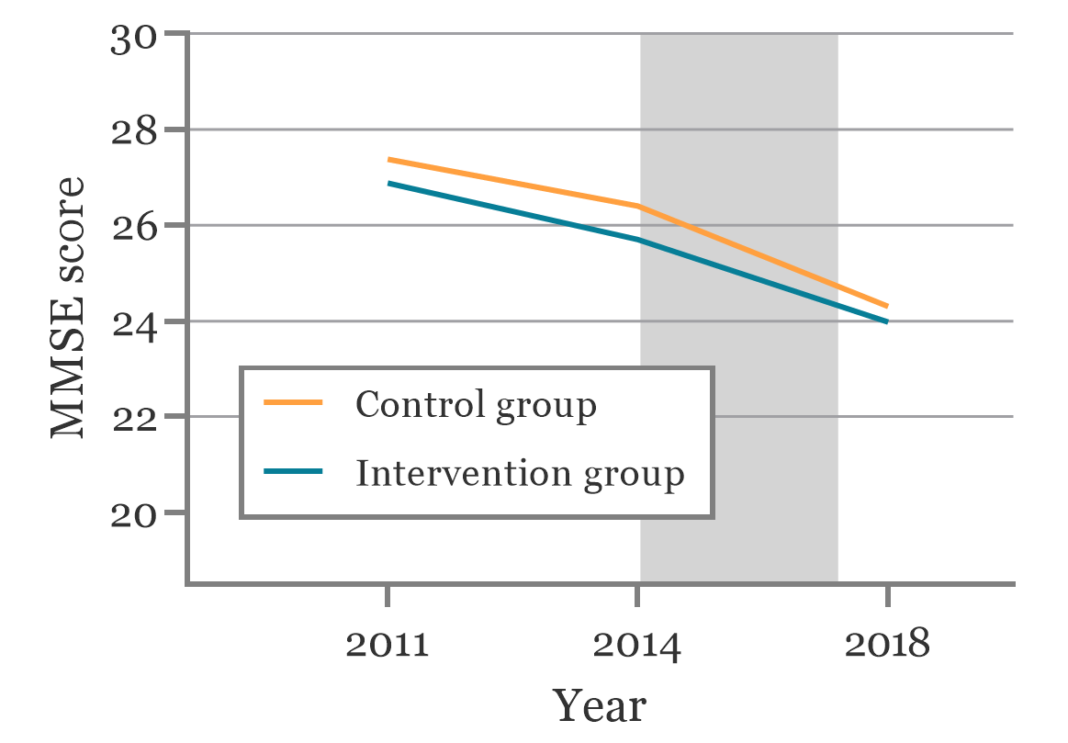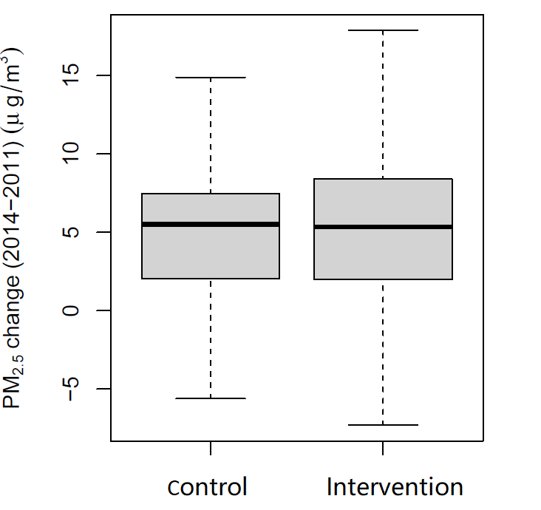
a
b
Figure A1. Trend in MMSE score and PM_{2.5} exposure before the China’s Clean Air Act (CCAA).
Linear trend of associations between cognitive function (Fig A1. a) and PM_{2.5} exposure (Fig A1. b) in intervention group versus the control group before the 2014 CCAA implementation (2011 and 2014 waves of CLHLS dataset). We assessed parallel trends in MMSE score between CCAA implementation group and non-implementation group before 2014. The unadjusted and adjusted models comparing pre-implementation trends in CCAA implementation group and non-implementation group did not reveal any significant differences for MMSE scores (P _{for unadjusted model} = 0.618 and P _{for adjusted model} = 0.277), offering support for the difference-in-differences study design. Adjusted model controlling for age, sex, education, marital status, ethnicity, rural/urban residence, occupation before retirement, survey month, alcohol drinking, smoking, physical activity, fruit intake, vegetable intake, water quality, living condition, and income source.

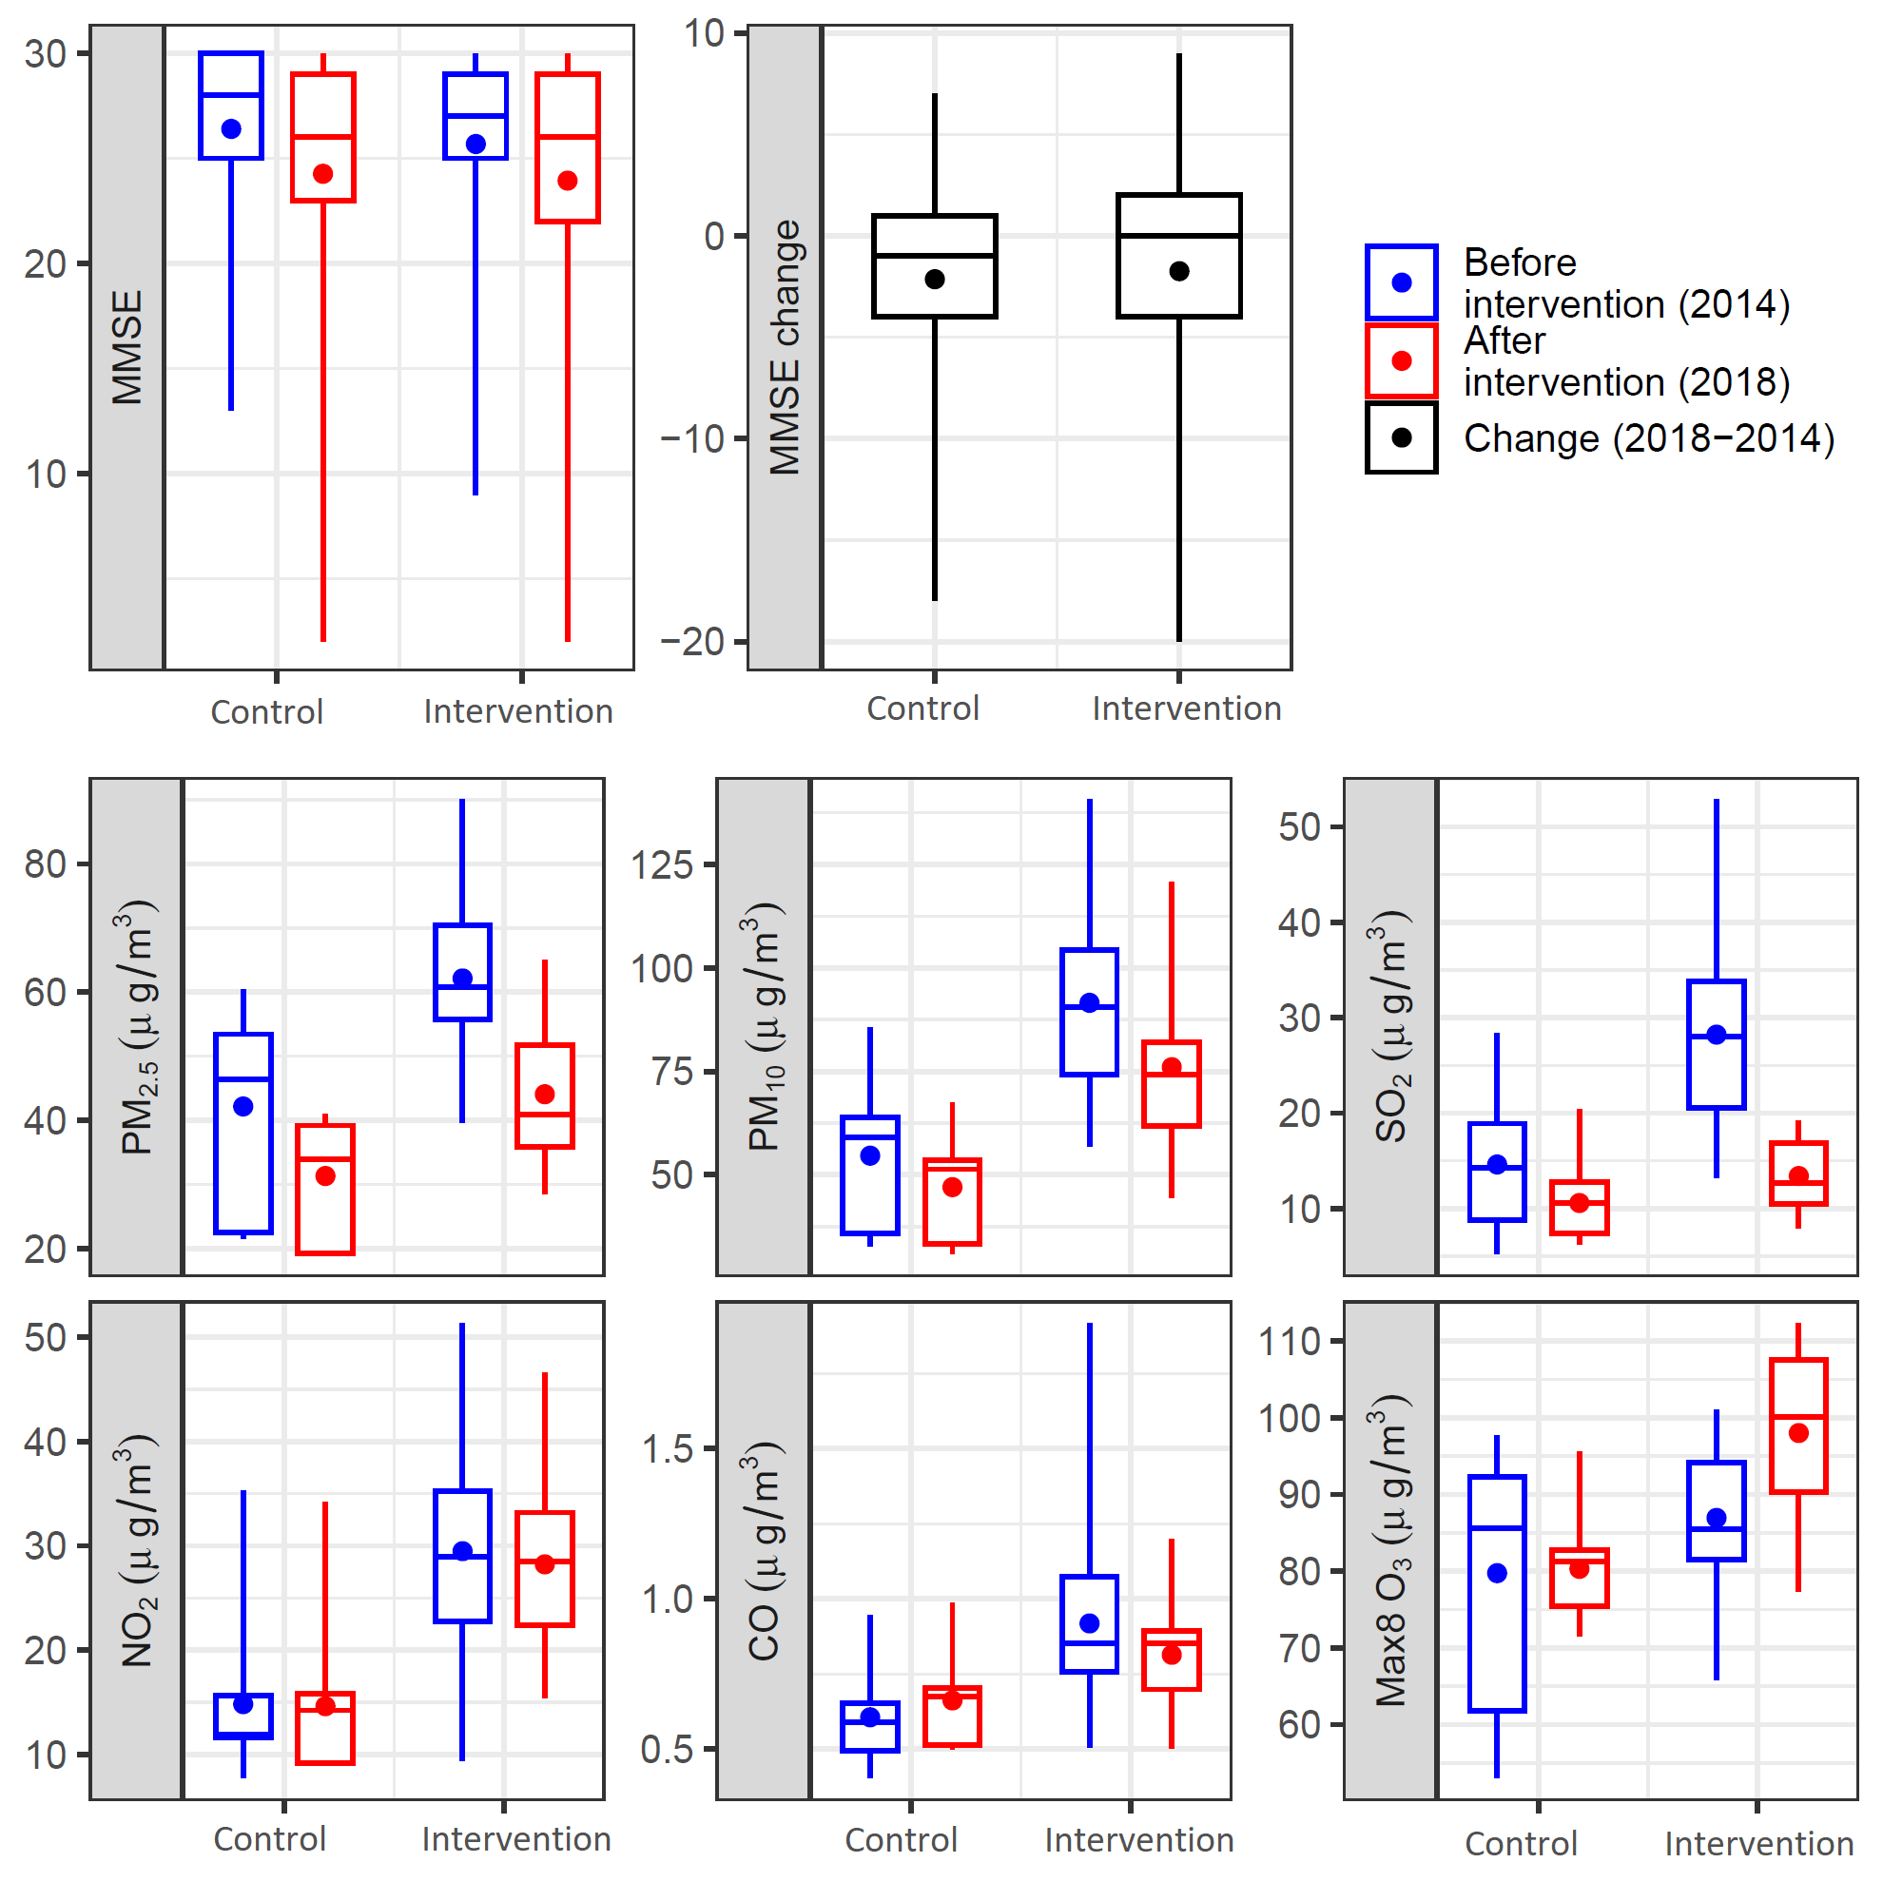Figure A2: Estimated associations of long-term exposure to air pollutants with cognitive function score (MMSE) by survey waves and groups.
Intervention group: target of annual PM_{2.5} reduction ≥ 5% under China’s Clean Air Act (CCAA); Control group: without reduction target under CCAA. MMSE: Mini-Mental State Examination. Max 8-hr O₃, max 8-hour daily average ozone measurements.

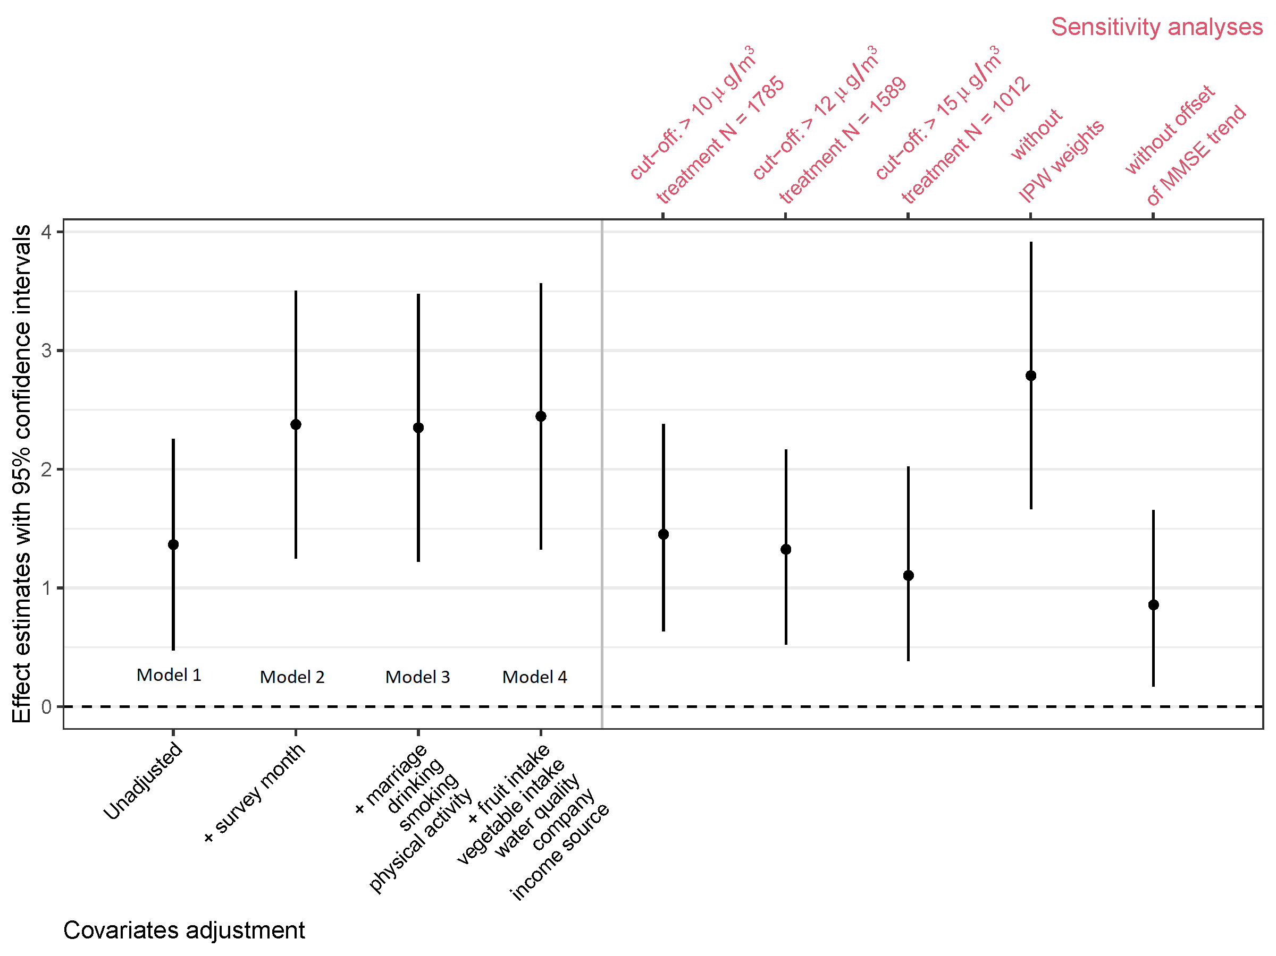
Figure A3: Sensitivity analysis of estimated effect of the CCAA on changes in MMSE score by difference-in-differences models.
 |  |  | Adjusted MMSE score (95% CI) | P _{for interaction}
Age | 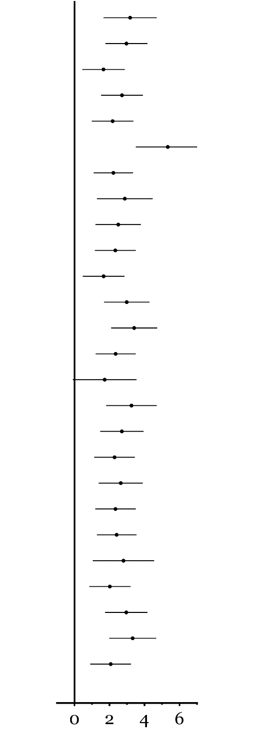  75- |  | 3.18 (1.66, 4.70) | 0.004
Age | 76~85 |  | 2.97 (1.76, 4.17) | 0.004
Age | 86+ |  | 1.66 (0.45, 2.88) | 0.004
Sex | Male |  | 2.72 (1.52, 3.91) | 0.188
Sex | Female |  | 2.18 (0.99, 3.37) | 0.188
Ethnicity | Other |  | 5.33 (3.51, 7.16) | <0.001
Ethnicity | Han |  | 2.26 (1.10, 3.35) | <0.001
Residence | Urban |  | 2.87 (1.28, 4.47) | 0.717
Residence | Sub-urban |  | 2.50 (1.20, 3.80) | 0.717
Residence | Rural |  | 2.33 (1.16, 3.50) | 0.717
Education | < 1 year |  | 1.66 (0.47, 2.86) | 0.001
Education | 1-5 years |  | 2.99 (1.69, 4.29) | 0.001
Education | > 5 years |  | 3.41 (2.09, 4.73) | 0.001
Occupation | Agriculture |  | 2.35 (1.21, 3.50) | 0.159
Occupation | Other |  | 1.72 (-0.10, 3.55) | 0.159
Occupation | Employee |  | 3.25 (1.82, 4.70) | 0.159
Smoking | Yes |  | 2.71 (1.47, 3.95) | 0.330
Smoking | No |  | 2.29 (1.13, 3.46) | 0.330
Drinking | Yes |  | 2.65 (1.39, 3.91) | 0.493
Drinking | No |  | 2.34 (1.19, 3.50) | 0.493
Physical labour | Yes |  | 2.41 (1.29, 3.54) | 0.603
Physical labour | No |  | 2.80 (1.05, 4.56) | 0.603
Marriage | No |  | 2.02 (0.84, 3.21) | 0.028
Marriage | Yes |  | 2.96 (1.75, 4.17) | 0.028
Physical activity | Yes |  | 3.32 (1.99, 4.66) | 0.018
Physical activity | No |  | 2.07 (0.91, 3.23) | 0.018

Figure A4: The estimated effect of the CCAA on cognitive function (MMSE score) by different subpopulations.
CCAA: China’s Clean Air Act. MMSE: Mini-Mental State Examination.

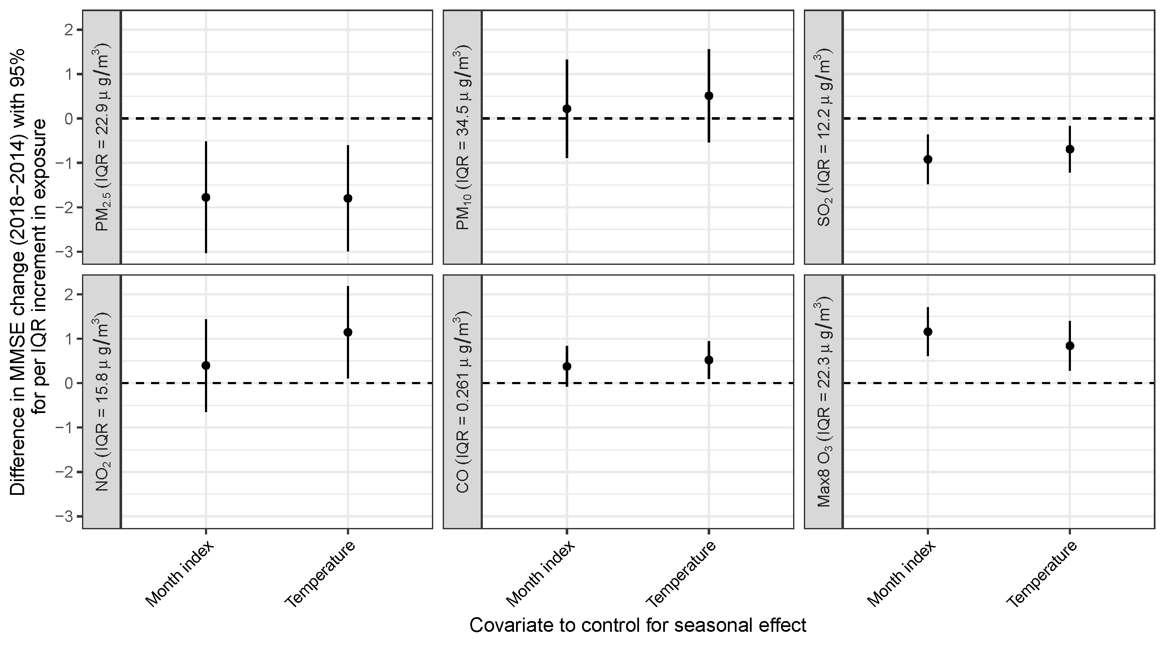
Figure A5: The estimated associations between long-term air pollution exposure and cognitive function by further controlling for exposure seasons.

Figure A6: The estimated associations between air pollution changes due to CCAA and MMSE score change by different subpopulations.

Figure A7: Estimated associations of the PM_{2.5} and O₃ joint exposures with MMSE score.
The bottom panels present the estimated association between MMSE change and exposure change for an air pollutant, given that the other pollutant is constant.

Figure A8: Estimated associations of the SO₂ and O₃ joint exposures with MMSE score.
The bottom panels present the estimated association between MMSE change and exposure change for an air pollutant, given that the other pollutant is constant.

Figure A9: Estimated associations of the PM_{2.5} and SO₂ joint exposures with MMSE score.
The bottom panels present the estimated association between MMSE change and exposure change for an air pollutant, given that the other pollutant is constant.

Appendix References
1. State Council of the People’s Republic of China. Notice of the general office of the state council on issuing the air pollution prevention and control action plan. 2013.
2. Zhang Q, Zheng Y, Tong D, et al. Drivers of improved PM2.5 air quality in China from 2013 to 2017. Proc Natl Acad Sci U S A 2019; 116(49): 24463-9.
3. Xue T, Liu J, Zhang Q, et al. Rapid improvement of PM2.5 pollution and associated health benefits in China during 2013–2017. Science China Earth Sciences 2019; 62(12): 1847-56.
4. Xiao T, Lei K, Jiang Z, et al. Data From:A Six-year long High-resolution Air Quality Reanalysis Dataset over China from 2013 to 2018. Science Data Bank; 2020.
5. Xue T, Zhu T, Zheng YX, Zhang Q. Declines in mental health associated with air pollution and temperature variability in China. Nat Commun 2019; 10.
6. Katzman R, Zhang M, Ouang Ya Q, et al. A Chinese version of the mini-mental state examination; Impact of illiteracy in a Shanghai dementia survey. Journal of Clinical Epidemiology 1988; 41(10): 971-8.
7. Zeng Y, Feng Q, Hesketh T, Christensen K, Vaupel JW. Survival, disabilities in activities of daily living, and physical and cognitive functioning among the oldest-old in China: a cohort study. Lancet 2017; 389(10079): 1619-29.
8. Lv X, Li W, Ma Y, et al. Cognitive decline and mortality among community-dwelling Chinese older people. BMC Med 2019; 17(1): 63.
9. Clifford A, Lang L, Chen R, Anstey KJ, Seaton A. Exposure to air pollution and cognitive functioning across the life course--A systematic literature review. Environ Res 2016; 147: 383-98.
10. Cummings JL. Mini-Mental State Examination: Norms, Normals, and Numbers. JAMA 1993; 269(18): 2420-1.
11. Zhang JJ, Wei Y, Fang Z. Ozone Pollution: A Major Health Hazard Worldwide. Front Immunol 2019; 10: 2518.
12. Li K, Jacob DJ, Liao H, Shen L, Zhang Q, Bates KH. Anthropogenic drivers of 2013-2017 trends in summer surface ozone in China. Proc Natl Acad Sci U S A 2019; 116(2): 422-7.

