M 1 2 3 4 5 6 7 8
bp

2000-

1000-
750-

500-

250-

100-
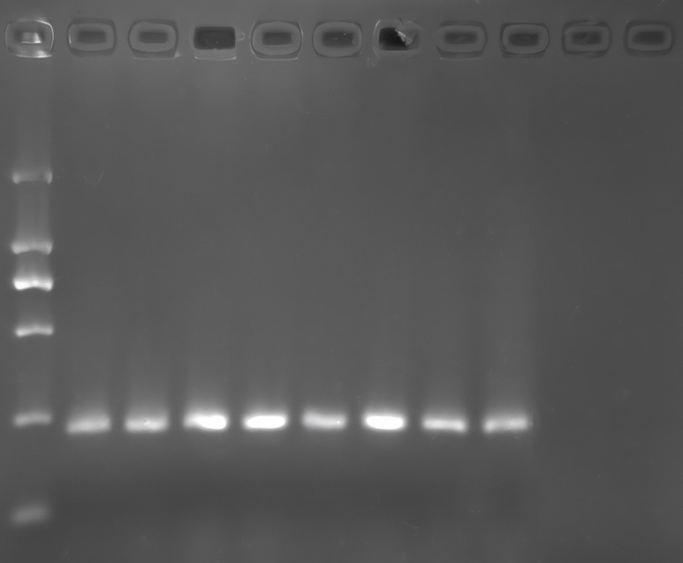
Fig. 6 Bacterial isolation and PCR identification of diseased organs. Lane M: DL2000 DNA marker; lane 1: positive control; lanes 2~8: Lkt gene PCR amplification results of bacterial colonies isolated from the blood, intestines, heart, liver, spleen, lung and kidney, respectively.

