2,7-Naphthyridine based colorimetric and fluorescent “Turn Off” chemosensors for selective detection of Ni(II) in aqueous media
Abida Ashraf,^{1,2} Muhammad Islam,¹ Zahid Shafiq,*¹ Muhammad Tayyeb Ahsan,¹ and Muhammad Yaqub, ¹

¹ Institute of Chemical Sciences, Bahauddin Zakariya University, Multan-60800, Pakistan
² Department of Chemistry, Kutchery Campus, The Women University Multan, Multan 60000, Pakistan

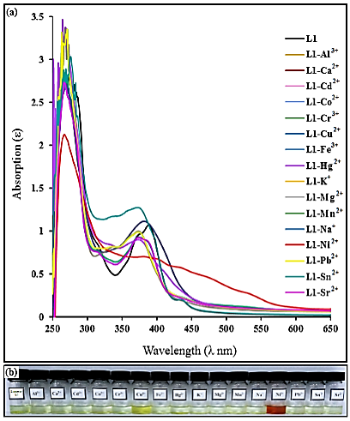
Figure S1: (a) Absorption spectral changes of L1 (20 µM) in the presence of different metal ions in DMSO–H2O (v/v 1:2, HEPES buffer pH = 7.4). (b) Visual colorimetric responses of receptors L1 upon addition of one equivalent various metal ions.
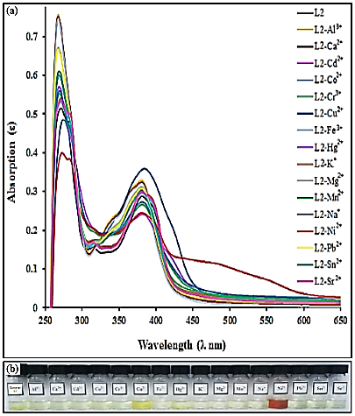
Figure S2: (a) Absorption spectral changes of L2 (20 µM) in the presence of different metal ions in DMSO–H2O (v/v 1:2, HEPES buffer pH = 7.4). (b) Visual colorimetric responses of receptors L2 upon addition of one equivalent various metal ions.
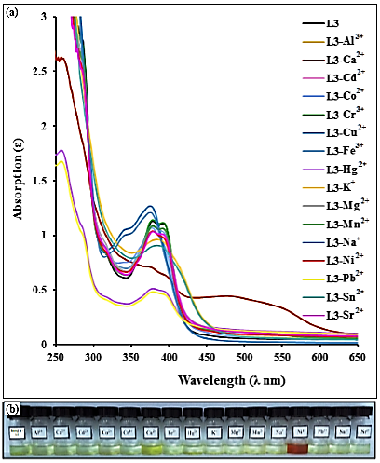
Figure S3 (a) Absorption spectral changes of L3 (20 µM) in the presence of different metal ions in DMSO–H2O (v/v 1:2, HEPES buffer pH = 7.4). (b) Visual colorimetric responses of receptors L3 upon addition of one equivalent various metal ions.

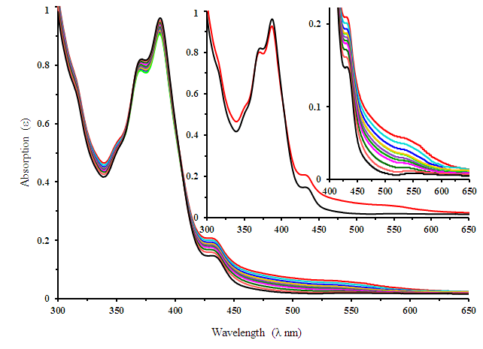
Figure S4: Absorbance titration spectra of receptor L1 (20 µM) in the presence of various concentrations of Ni²⁺ in DMSO:H₂O (v/v 1:2, HEPES buffer, pH = 7.4).
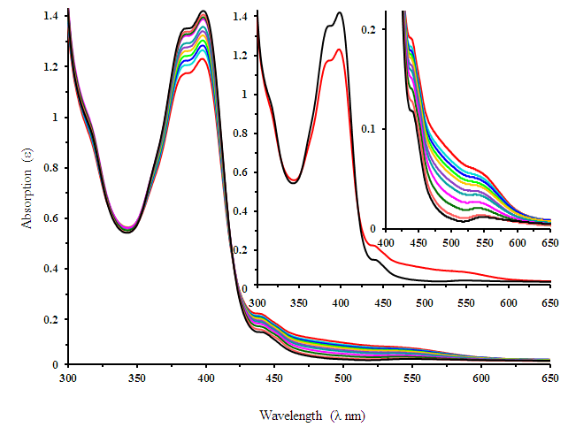
Figure S5: Absorbance titration spectra of receptor L2 (20 µM) in the presence of various concentrations of Ni²⁺ in DMSO:H₂O (v/v 1:2, HEPES buffer, pH = 7.4).

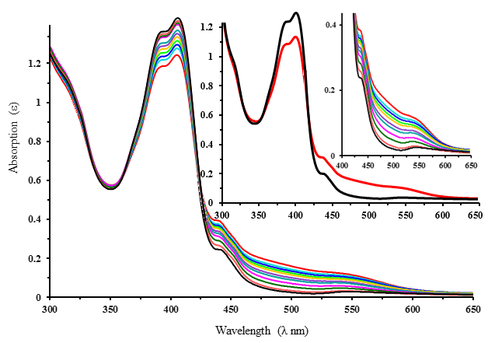
Figure S6: Absorbance titration spectra of receptor L3 (20 µM) in the presence of various concentrations of Ni²⁺ in DMSO:H₂O (v/v 1:2, HEPES buffer, pH = 7.4).
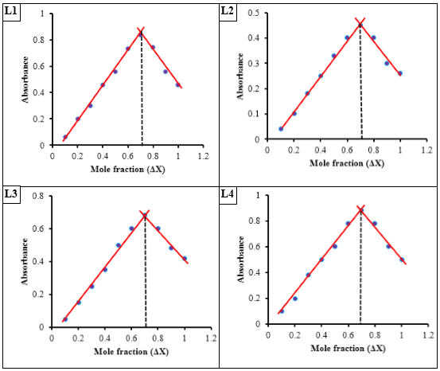
Figure S7: Job's plot of L1-L4 and Ni²⁺ in DMSO–H₂O solution (v/v 1:2, HEPES buffer, pH = 7.4)
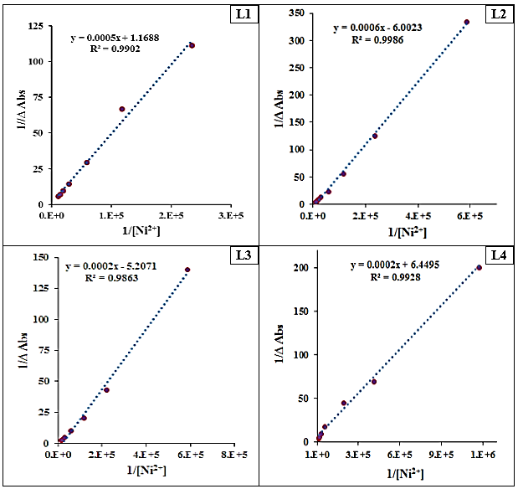
Figure S8: Benesi-Hildebrand plot UV-visible titration results for L1-L4 with Ni²⁺ ions in DMSO-H₂O (1:2 v/v, HEPES buffer pH = 7.4).
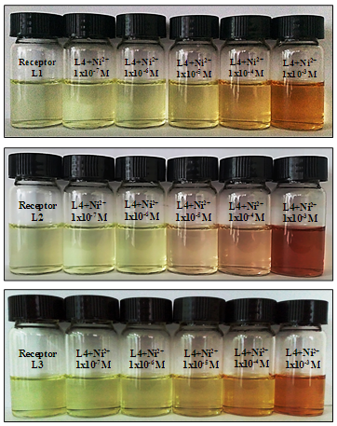
Figure S9: Naked eye detection limit for receptor L1-L3.
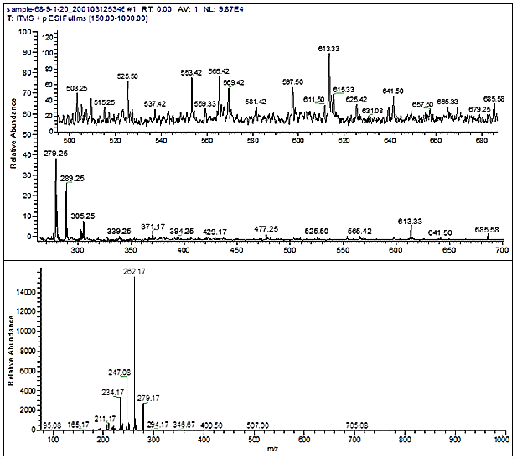
Figure S10: Positive-ion electrospray ionization mass spectrum of L4 (20 µM) upon addition of Ni²⁺ (10 µM)
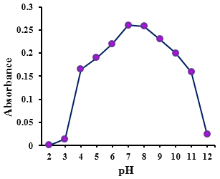
Figure S11: Absorbance at 537 nm in DMSO–H₂O (v/v 1:2) with different pH
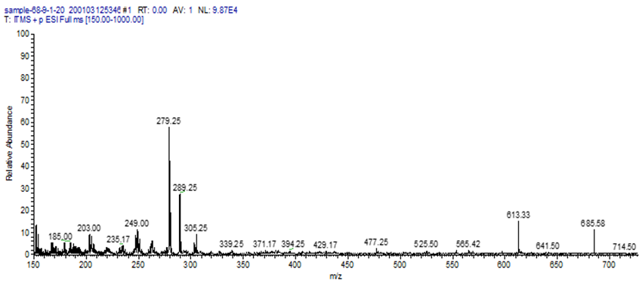
Figure S12: Positive-ion electrospray ionization mass spectrum of L4-Ni²⁺ complex.

(b)

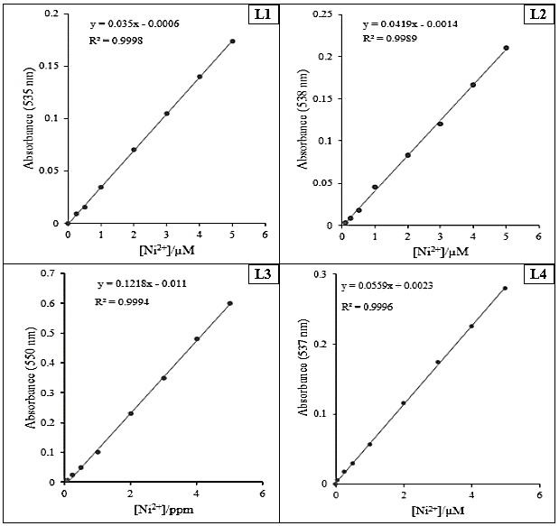
Figure S13: L1 absorbance at 535 nm for L1 as a function of Ni²⁺ ion concentration,
L2 absorbance at 538 nm for L2 as a function of Ni²⁺ ion concentration,
L3 absorbance at 550 nm for L3 as a function of Ni²⁺ ion concentration,
L4 absorbance at 537 nm for L4 as a function of Ni²⁺ ion concentration.

