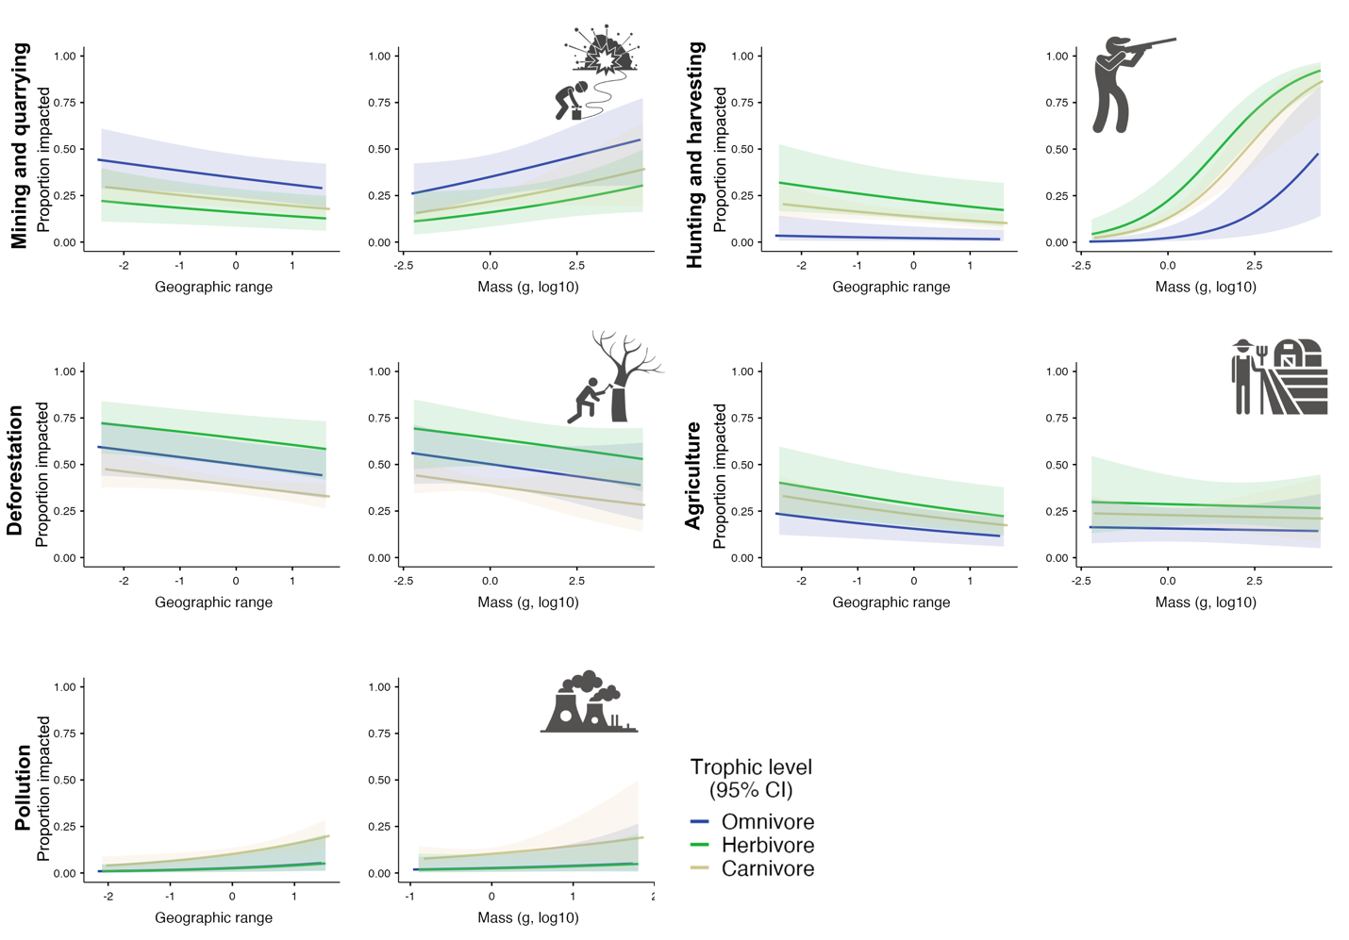
Supplementary Figure 2. Effects of geographic range, adult body mass, trophic group and island endemism on species risks to key threatening process. Complete results of the models are supplemented in Supplementary Table 5. None of the explanatory variables included in the analysis could determine species sensitivity to tourism and urbanisation (Supplementary Table 5).

