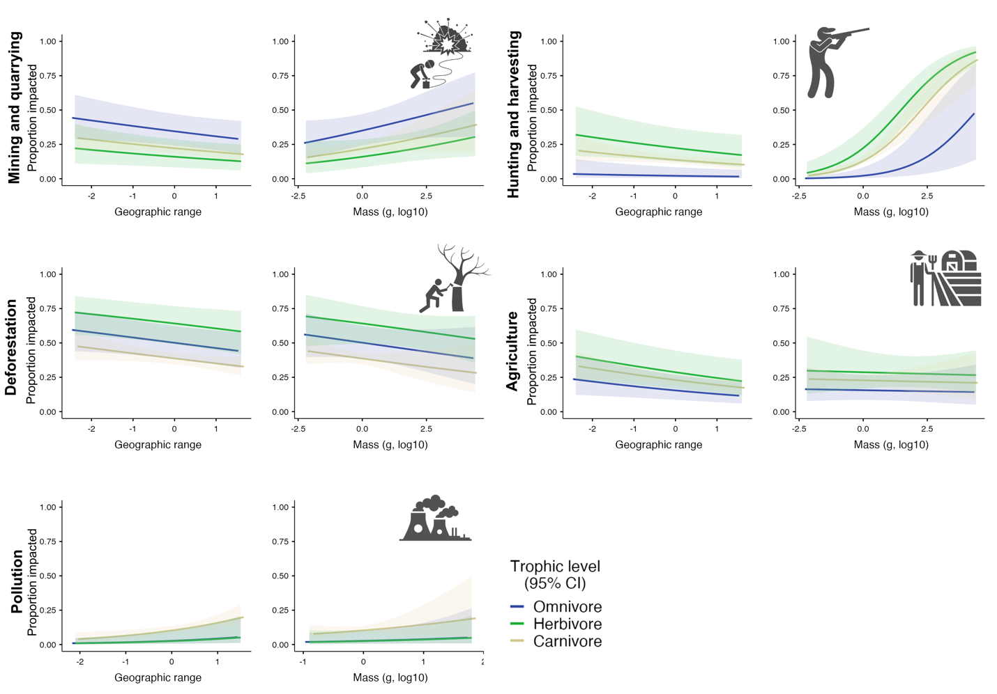
Supplementary Figure 3. Effects of geographic range, adult body mass, trophic group and island endemism on species risks to key threatening process. Complete results of the models are supplemented in Supplementary Table 4.

