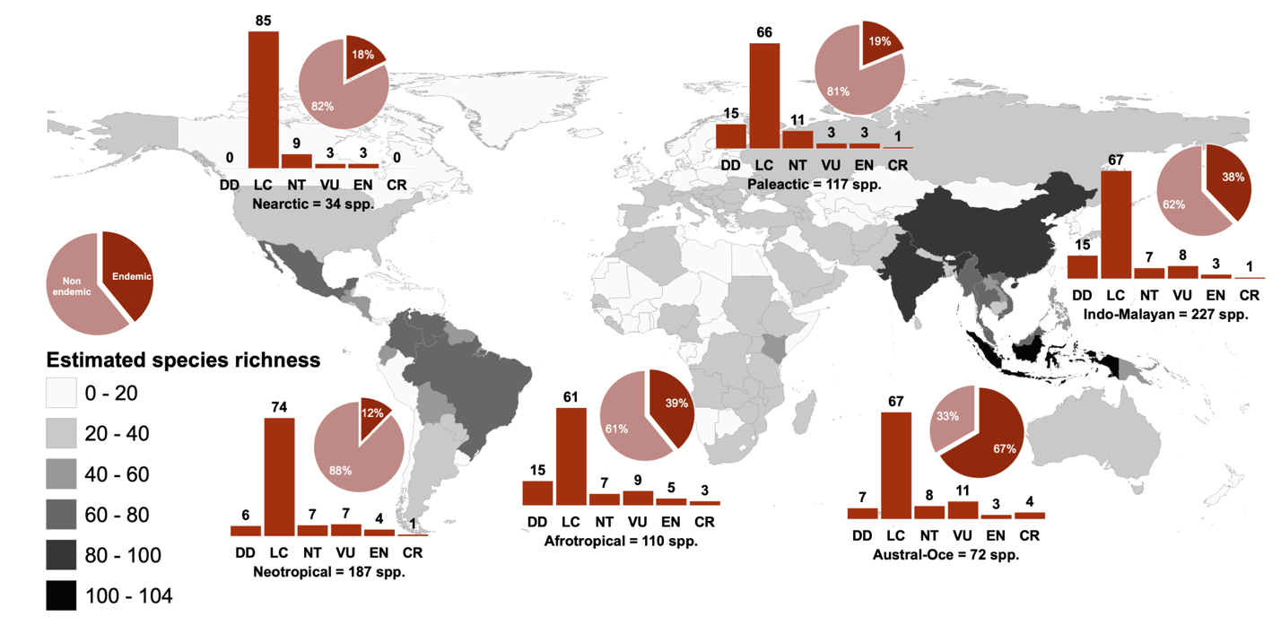
Supplementary Figure 1. IUCN-based taxonomic distribution of estimated species richness per country, and proportion of endemic (in pie graph) and conservation status (in bar graph) of global cave dwelling bats compared by biogeographical realm. Complete details per species are supplemented in Supplementary Data 1 and country species richness are supplemented in Supplementary Data 2.

